Database Systems (2006 Final Exam) -- Answer
1.
- T
- F
- F
- T
- F
- F
- T
- T
- T
- F
2.
- Select number
From Loan
Where amount between 90000 and 100000;

- Select customer-name, Borrow.loan-number, Loan.amount
From Borrower, Loan
Where Borrow.loan-number = Loan.number and Loan.branch-name = ‘DBSL’
Order by amount;

- Select distinct T.branch-name
From Branch as T, Branch as S
Where T.assets > S.assets and S.city = ‘KAO’;

- Select distinct customer-name
From Borrow
Where customer.name not in (
Select customer-name
From Depositor);
Or
Select distinct customer-name
From Borrow
Where not exists (Select *
From Depositor
Where Depositor.customer-name = Borrow.customer-name);

- Select branch-name, avg(balance)
From Account
Group by bramch-name
Having avg(balance) > 1200;

- Select branch-name, count(distinct customer-name)
From Depositor, Account
Where Depositor.account-numbe = Account.number
Group by branch-name;

- Select distinct customer-name
From Borrow
Where customer-name in (
Select customer-name
From Depositor);
Or
Select distinct customer-name
From Borrow
Where exists (Select *
From Depositor
Where Depositor.customer-name = Borrow.customer-name);

- Delete from Account
Where branch-name in (
Select branch-name
From Branch
Where city = ‘KAO’);

- Insert into Account
Values(‘A-9732’, ‘DBSL’, 1200);

- Update Account
Set balance = balance * 1.05
Where balance > select avg(balance) from Account;

3. Answer:
Since min_support = 40% and there are 5 records in the table, the number of transactions above the minsup is 2 (5 * 40% = 2).
Database DTIDItems1A B E2A B C3A C4A B D5A B D
C₁ItemsetSup.{A}5{B}4{C}2{D}2{E}1
L₁ItemsetSup.{A}5{B}4{C}2{D}2
C₂ItemsetSup.{A B}4{A C}2{A D}2{B C}1{B D}2{C D}0
L₂ItemsetSup.{A B}4{A C}2{A D}2{B D}2
C₂Itemset{A B}{A C}{A D}{B C}{B D}{C D}
C₃Itemset{A B D}
C₃ItemsetSup.{A B D}2
L₃ItemsetSup.{A B D}2
Scan D
Scan D
Scan
Maximal large ItemsetsItemsetSup.{A C}2{A B D}2
Large ItemsetsItemsetSup.{A}5{B}4{C}2{D}2{A B}2{A C}2{A D}2{B D}2{A B D}2
4.
要新增的鍵值為11, 26, 45, 20, 23, 53, 24, 35, 3。
- 40% <-> 80%
- 主要頁可放兩筆記錄。
- 滿載頁可放一筆記錄。
- N = 2

- h₀(11) = 1  - h₀(26) = 0  - h₀(45) = 1 | 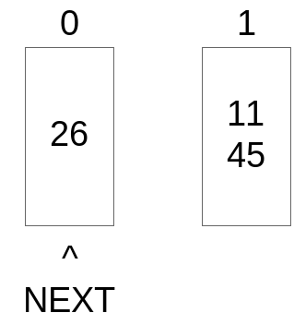

- h₀(20) = 0 | 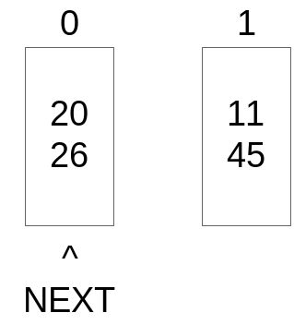

- 使用率 = 100%  - 分割0 | 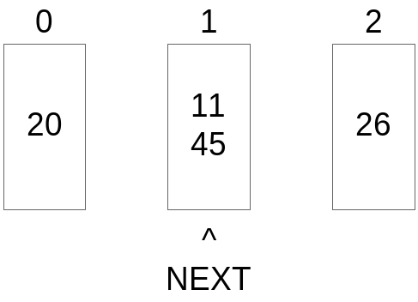

- h₀(23) = 1 | 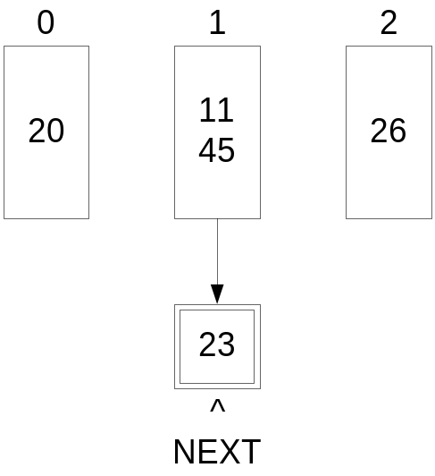
- 使用率 = 71%
- h₀(53) = 1 | 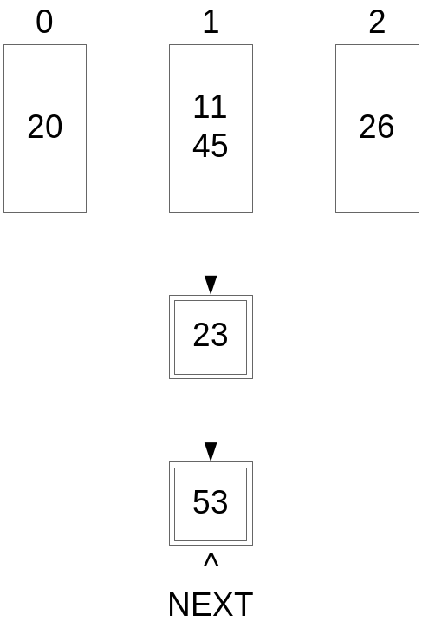

- h₀(24) = 0  使用率= 87%  分割1  NEXT >=2,  NEXT = 0,  Level = 1 | 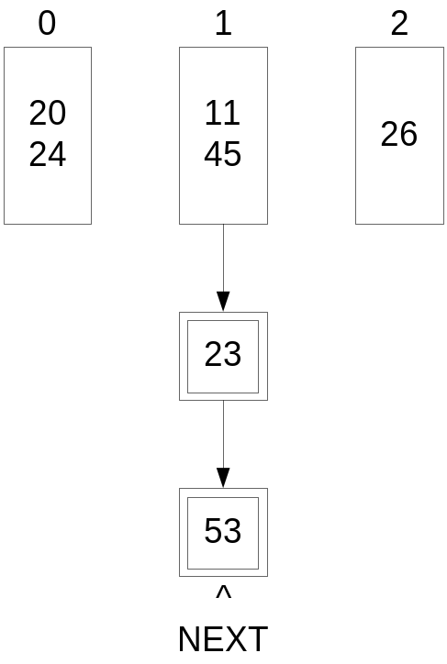

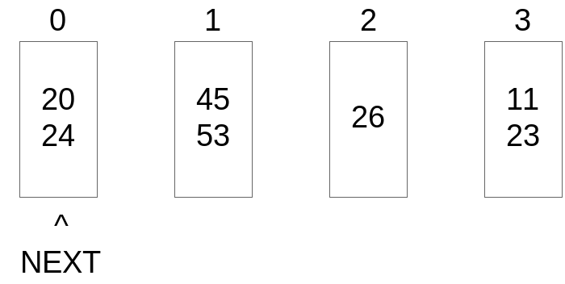
使用率= 87.5%

分割0; 使用率= 70%
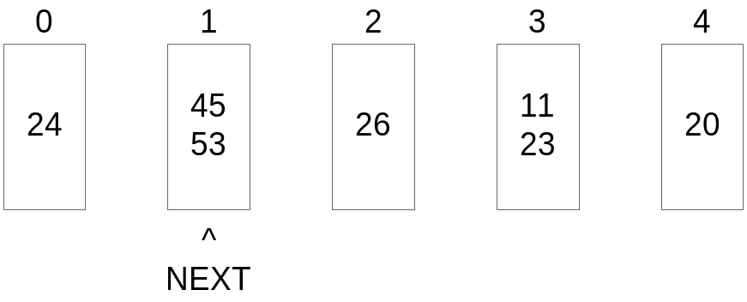

- h₁(35) = 3
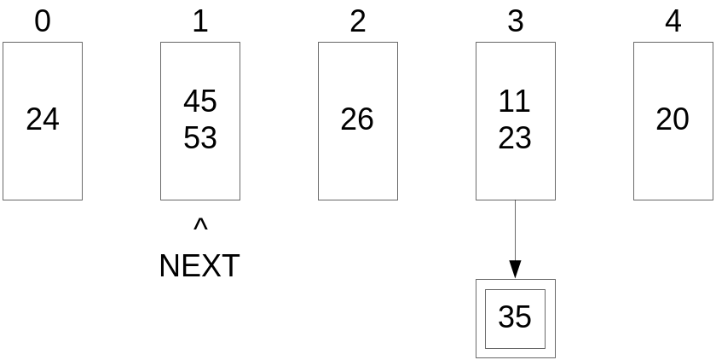
使用率= 73%
- h₁(19) = 3
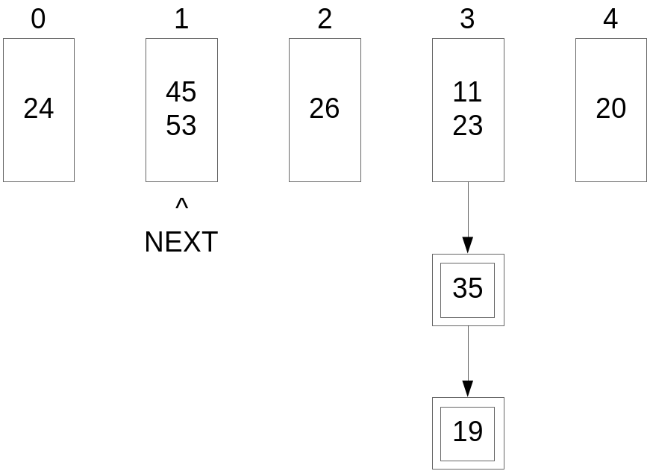
使用率= 75%

