Database Systems (2006 Final Exam) -- Answer
1.
- T
- F
- F
- T
- F
- F
- T
- T
- T
- F
2.
- select 背號, name, 棒次, 守備 from player where cid=(select cid from country where country=”TAIWAN NO.1”) order by 棒次 asc;
- Select sum(局數), sum(失分), sum(三振), sum(保送) from 投手紀錄 where playerid = (select playerid from player where name=”Shen Tai Song” and cid = (select cid from country where country=”KOREA DOG”));
- select (sum(全壘打)/sum(打數)) from 打者紀錄 where playerid=(select playerid from player where name=”大家最喜歡的鋒哥” and cid=(select cid from country where country=”TAIWAN NO.1”))
- select name, 打數, 安打, 全壘打, 打點 from player, 打者紀錄 where player.playerid = 打者紀錄.playerid and 場次=(select 場次 from game where team1 = (select cid from country where country=”TAIWAN NO.1”) and team2 = (select cid from country where country=”KOREA DOG”) and date = #2006/11/30#);
- select name, sum(失分)/sum(局數) from player, 投手紀錄 where player.playerid=投手紀錄.playerid group by player.playerid, name order by sum(失分)/sum(局數);
- SELECT name, sum(局數), sum(失分), sum(三振), sum(保送) FROM player, 投手紀錄 WHERE player.playerid = 投手紀錄.playerid and player.playerid = (select playerid from 投手紀錄 where 失分=(select max(失分) from 投手紀錄)) GROUP BY player.playerid, name;
- select country, name, sum(打點) from player, country, 打者紀錄 where player.playerid = 打者紀錄.playerid and player.cid = country.cid and 棒次=4 group by player.playerid, country, name order by sum(打點) desc;
- select sum(失分) from 投手紀錄 where 場次=(select 場次 from game where team1 = (select cid from country where country=”TAIWAN NO.1”) and team2 = (select cid from country where country=”KOREA DOG”) and date = #2006/11/30#);
- insert into player(playerid, cid, 背號, name, 棒次, 守備) select 999, cid, 0, "Shen Tai Song", 0, "主審" from country where country = "KOREA DOG";
- delete from 投手紀錄 where playerid in (select playerid from player where name = "Shen Tai Song");

3. Answer:
1. u (3), v (4), x (3), y (4), z (4), uz (3), vy (4), vz (3), xz (3), yz (3), vyz (3)
2. vyz, xz, uz
3. vyz, xz, vy, uz, z
4.
要新增的鍵值為11, 26, 45, 20, 23, 53, 24, 35, 3。
- 40% <-> 80%
- 主要頁可放兩筆記錄。
- 滿載頁可放一筆記錄。
- N = 2

- h₀(11) = 1  - h₀(26) = 0  - h₀(45) = 1 | 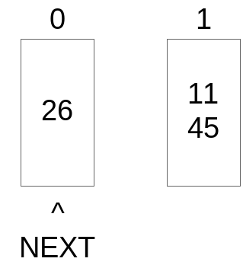

- h₀(20) = 0 | 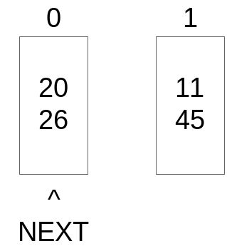

- 使用率 = 100%  - 分割0 | 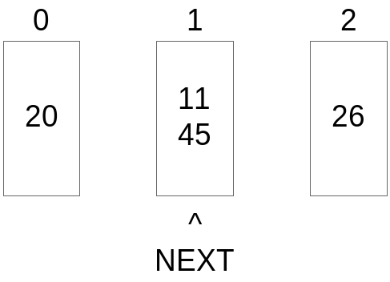

- h₀(23) = 1 | 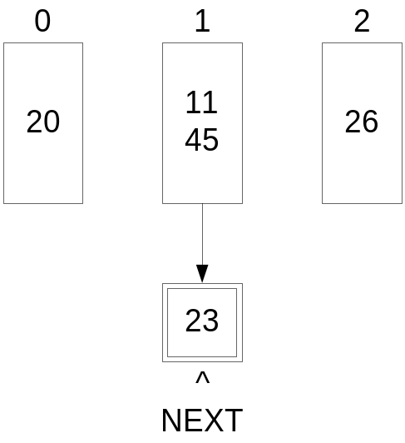
- 使用率 = 71%
- h₀(53) = 1 | 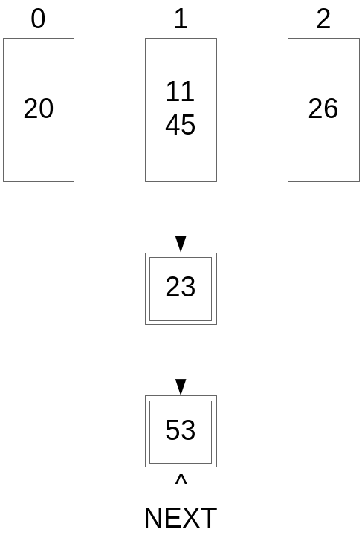

- h₀(24) = 0  使用率= 87%  分割1  NEXT >=2,  NEXT = 0,  Level = 1 | 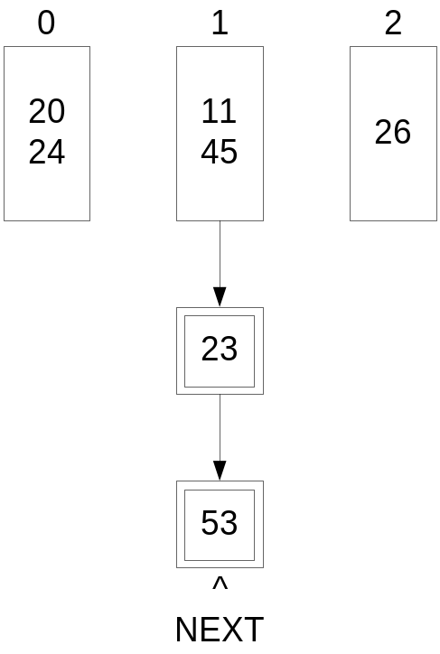

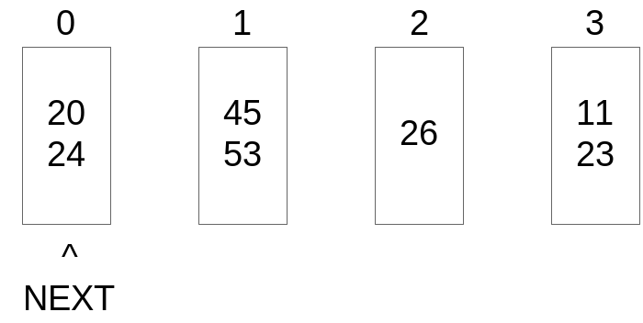
使用率= 87.5%

分割0; 使用率= 70%
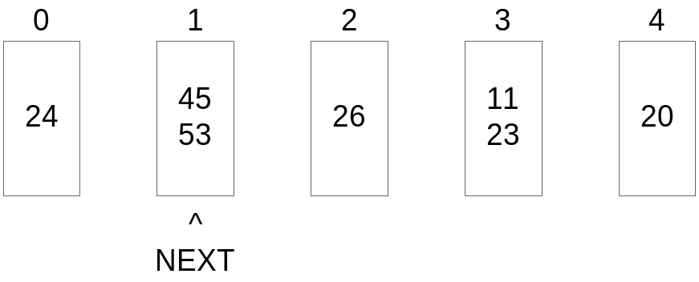

- h₁(35) = 3
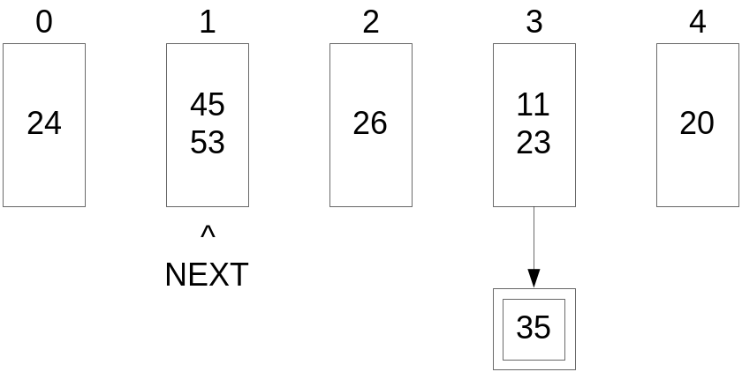
使用率= 73%
- h₁(19) = 3
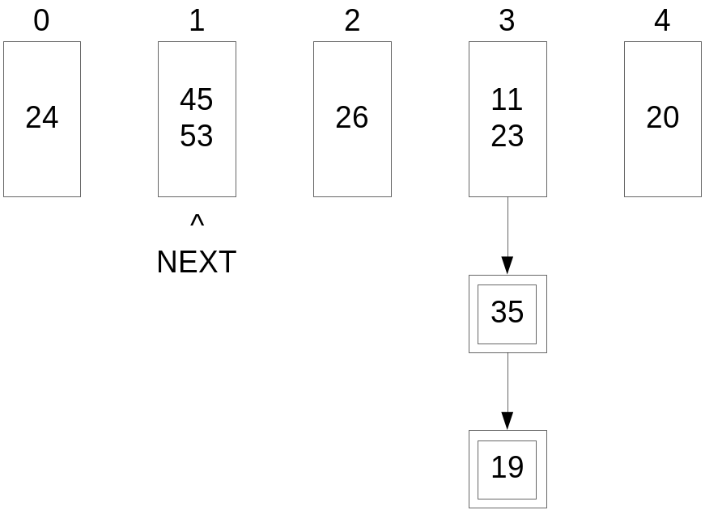
使用率= 75%

