Database Systems (2007 Final Exam)

Name: _____________________ Grade:_______________________(100 points)

1. For the following questions, answer T (true) or F (false). (30 points)

- A view is a derived table whose definition and data are stored in the system as another table.

- The updates to a view are performed on the view itself.

- If V1(S#, QTY) is a view derived from the base table SP(S#, P#, QTY), where (S#, P#) is the unique candidate key of SP, then the QTY of a particular S# in V1 cannot be updated.

- In relation R(A1, A2, A3, A4), if (A1, A2) is a candidate key, then (A1) must not be a candidate key.

- In relation R(A1, A2, A3, A4), if (A1, A2, A3) is not a candidate key, then (A1, A2, A3, A4) must not be a candidate key.

In relational database R(A1, A2, A3, A4), S(B1, B2, B3), B1 is a foreign key which matches the values in A1.
- B1 must be the primary key of S.

- A1 must be the primary key of R.

- Cardinality of B1(the number of the possible values of B1) is equal or less than the cardinality of A1.

- If x is included in B1, then it must be included in A1.

- If x is included in A1, then it must be included in B1.

2. For the following questions, answer the SQL statements. (40 ponts)
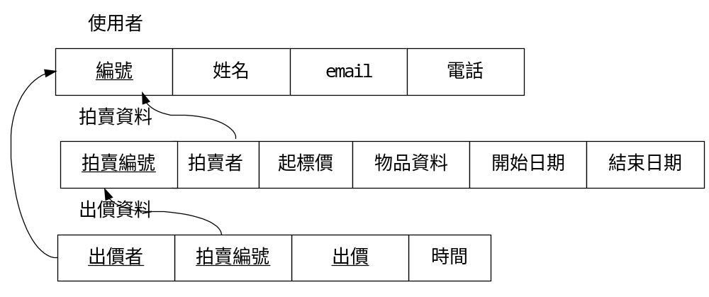
- 請列出2005/12/2時所有”正在”拍賣的物品資料(請仔細思考!).
- 請列出開始拍賣日期為2005/12/2的拍賣資料, 包括拍賣者姓名, 起標價, 物品資料, 及結束日期.
- 請列出開始日期為2005/12/2各拍賣者拍賣的件數 (拍賣者姓名及拍賣件數).
- 請列出所有 物品資料為”如何成為大師級裁縫”的 出價資料 (出價者姓名, 出價, 時間).
- 請列出拍賣件數大於10筆的使用者資料 (“使用者”這個表格).
- 請列出各筆拍賣的出價次數 (拍賣編號及出價次數).
- 請列出使用者 鄧九五 所有的”拍賣”資料.
- 請列出使用者 甘寧 所有的”出價”資料 (物品資料, 出價, 時間).
- 幫使用者 迪菲亞 新增一筆拍賣資料, 拍賣編號20, 起標價1, 物品資料’迪菲亞之劍’, 開始日期#2005/12/2#, 結束日期#2005/12/4#.
- 刪除表格“出價資料”中, 所有”拍賣”結束日期小於2005/12/2的出價資料.

3. Mining Association Rules (20 points)

TID | ITEMS
1 | abcdef
2 | acdfy
3 | beyz
4 | abefy
5 | bdef
Assume the minimum support = 50%
- Find all large itemsets.
- Find all maximal large itemsets.
- Find all closed large itemsets.

4. Linear Hashing (10 points)
Insert the records with the keys 11, 26, 45, 20, 23, 53, 24, 35, 3 into a file using linear hashing with the primary pages having a capacity of two records and overflow pages having a capacity of one record.
Let N=2 initially with space utilization bounds of (40 percent, 80 percent) and, etc.
Please write down the process step by step.

