深度視覺Final Project結果分析
M113040064 李冠宏
Data preparation
這邊首先會先掛載google drive，並且將需要的資料解壓縮。

Training Section
Import packages
這邊首先引入一些必要的套件
import pandas as pd
import numpy as np
import cv2
import matplotlib.pyplot as plt
import torch
import torchvision
import torchvision.transforms as transforms
import csv
import os
import random
from torch import nn
from torch.utils.data import Dataset, DataLoader
from tqdm import tqdm
from PIL import Image
Augmented functions
這邊定義了做隨機資料增量的函式，其中包括了深度改變、邊緣小範圍裁切、長寬比改變、雜訊、平面旋轉和深度傾斜
# 隨機做資料增量之function
def random_transform(image):

#整體深度改變
picked = random.choice([True, False])
if(picked):
rand = random.randint(-300, 300)
to_tensor = transforms.ToTensor()
image = to_tensor(image)
image += rand
to_PIL = transforms.ToPILImage()
image = to_PIL(image)

#邊緣小範圍裁切
picked = random.choice([True, False])
if(picked):
random_number = random.randint(285, 295)
transform = transforms.CenterCrop((random_number, random_number))
image = transform(image)

#長寬比小範圍改變
# picked = random.choice([True, False])
# if(picked):
# random_number = random.randint(285, 295)
# transform = transforms.RandomResizedCrop((random_number, random_number))
# image = transform(image)

# 定義目標寬度和高度
target_width = random.randint(290, 310)
target_height = random.randint(290, 310)
# 計算當前圖像的寬度和高度
current_width, current_height = image.size
# 計算調整後的寬度和高度
if current_width / current_height > target_width / target_height:
# 圖像的寬度比目標寬度大，根據目標高度計算新的寬度
new_width = int(target_height * (current_width / current_height))
new_height = target_height
else:
# 圖像的寬度比目標寬度小，根據目標寬度計算新的高度
new_width = target_width
new_height = int(target_width * (current_height / current_width))
# 調整圖像大小以適應新的寬度和高度
resized_image = image.resize((new_width, new_height))
# 計算裁剪區域的邊界
left = (new_width - target_width) // 2
top = (new_height - target_height) // 2
right = left + target_width
bottom = top + target_height
# 裁剪圖像
image = resized_image.crop((left, top, right, bottom))

#雜訊(高斯雜訊或少量鹽噪點)
picked = random.choice([True, False])
if(picked):
transform = transforms.GaussianBlur(7,2)
image = transform(image)

#平面旋轉(約 15°內)
picked = random.choice([True, False])
if(picked):
transform = transforms.RandomRotation(degrees=(-15, 15))
image = transform(image)

#深度傾斜
picked = random.choice([True, False])
if(picked):
transform = transforms.RandomAffine(degrees=0, shear=(-20, 20))
image = transform(image)

return image
而以下的函式將圖片的尺寸都變成300*300
def resize(image):
transform = transforms.Compose([transforms.Resize((300, 300))])
resized_image = transform(image)

return resized_image

Test the augmented image
這邊會測試剛剛的增量函式
# 測試資料增量之圖片
image = Image.open("/content/Mydata/images/1V727/0017.png")
image = random_transform(image)
image

結果:

CSV file with Anchor, Positive and Negative
這邊會將原本的圖片做資料增量，以產生positive，並挑選一張和anchor不一樣的圖片當作是negative，最後將這些檔案的路徑都寫進CSV檔案。

首先將標題寫進CSV檔案中
# 將標題列寫入CSV檔中
with open("/content/Mydata/train.csv", 'w', newline="") as csvfile:
writer = csv.writer(csvfile)
writer.writerows([["Anchor", "Positive", "Negative"]])

with open("/content/Mydata/valid.csv", 'w', newline="") as csvfile:
writer = csv.writer(csvfile)
writer.writerows([["Anchor", "Positive", "Negative"]])

這邊定義了一些變數和計算走訪資料夾的總數量
# variables
count = 0
total = 0
limit = float('inf')
pre = ""
valid_data = False

# 計算總資料數量
DATA_DIR = '/content/Mydata/images/'
for root, dirs, files in os.walk(DATA_DIR):
for file in files:
total += 1

以下是做資料增量產生positive，挑選negative和將檔名寫進CSV檔案
# 做資料增量 + 將檔名寫入CSV檔
for root, dirs, files in os.walk(DATA_DIR):
for file in files:
file_path = os.path.join(root, file) #檔案路徑
current_dir = file_path[:-8] #現在處於的資料夾 -> /content/Mydata/images/1UR77/
current_file_name = file_path[-8:-4] #現在的檔案名稱 -> 0013
count += 1 #總檔案數量

#產生資料增量之圖片(positive)
image = Image.open(file_path)
augmented_image = random_transform(image)
positive_path = current_dir + current_file_name + "_pos.png"
augmented_image.save(positive_path)

#挑選negative
file_list = os.listdir(current_dir)
if len(file_list) <= 1:
filtered_files = file_list
else:
# alternative: file[-8:] != file_path[-8:] and file[-7:] != "pos.png"
# file[-8:] != file_path[-8:] and file[-12:] != f"{file_path[-8:-4]}_pos.png"
filtered_files = [file for file in file_list if file[-8:] != file_path[-8:] and file[-7:] != "pos.png"]
if filtered_files:
for i in range(len(filtered_files)):
filtered_files[i] = current_dir[23:] + filtered_files[i]

#判斷要寫入 train data 還是 valid data
if count > 50000 and pre[23:29] != file_path[23:29]:
valid_data = True

#將檔案寫入CSV檔中
for i in range(len(filtered_files)):
if valid_data:
with open("/content/Mydata/valid.csv", 'a', newline="") as csvfile:
writer = csv.writer(csvfile)
writer.writerows([[file_path[23:], positive_path[23:], filtered_files[i]]])
else:
with open("/content/Mydata/train.csv", 'a', newline="") as csvfile:
writer = csv.writer(csvfile)
writer.writerows([[file_path[23:], positive_path[23:], filtered_files[i]]])

pre = file_path

#tdqm
print('\r' + 'Augmenting images progressing :[%s%s]%.2f%%;' % (
'█' * int(count*20/total), ' ' * (20-int(count*20/total)),
float(count/total*100)), end='')

if count > limit:
break

執行結果:

之後印出CSV檔案裡面的內容，確定有寫進去
#從CSV檔案載入train data
train_df = pd.read_csv(TRAIN_CSV_FILE)
train_df = train_df.sample(n=10000, replace=True, random_state=1)
train_df.head()
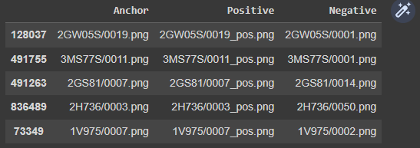

#從CSV檔案載入valid data
valid_df = pd.read_csv(VALID_CSV_FILE)
valid_df = valid_df.sample(n=3000, replace=True, random_state=1)
valid_df.head()
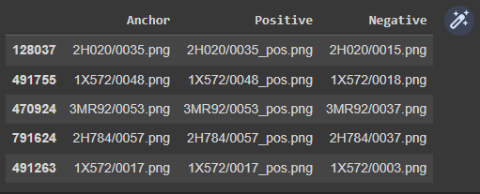

Visualization of Anchor, Positive and Negative
這部分會視覺化原本的圖片，做過資料增量之positive和negative
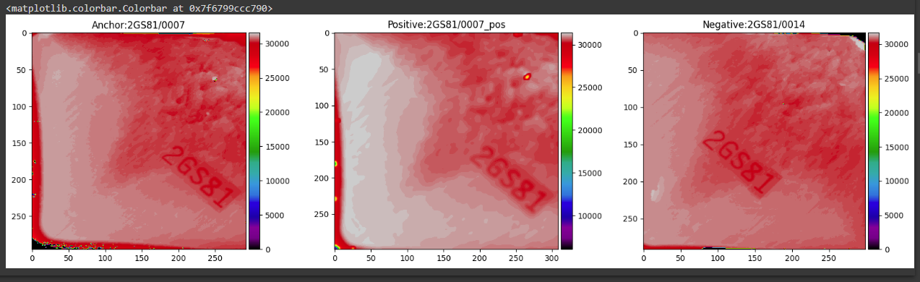

Dataset and Dataloader
這邊將資料載入dataset，之後再透過dataloader做批次處理

Model
定義了model
(ResNet50)
#定義model class
class Model(nn.Module):
def __init__(self):
super(Model, self).__init__()
self.prelayer = nn.Conv2d(1, 3, kernel_size=1, bias=False)
self.net = torchvision.models.resnet50()
def forward(self, images):
images = self.net(self.prelayer(images))
return images

(ResNet + Attention)
class AttentionModule(nn.Module):
def __init__(self, in_channels):
super(AttentionModule, self).__init__()
self.query_conv = nn.Conv2d(in_channels, in_channels // 8, kernel_size=1)
self.key_conv = nn.Conv2d(in_channels, in_channels // 8, kernel_size=1)
self.value_conv = nn.Conv2d(in_channels, in_channels, kernel_size=1)
self.gamma = nn.Parameter(torch.zeros(1))

def forward(self, x):
# Reshape input tensor
batch_size, channels, height, width = x.size()
query = self.query_conv(x).view(batch_size, -1, height * width).permute(0, 2, 1)
key = self.key_conv(x).view(batch_size, -1, height * width)
value = self.value_conv(x).view(batch_size, -1, height * width)

# Calculate attention map
attention_map = F.softmax(torch.bmm(query, key), dim=2)

# Apply attention map to value
attention_out = torch.bmm(value, attention_map.permute(0, 2, 1))
attention_out = attention_out.view(batch_size, channels, height, width)

# Apply scaling factor and add to original input
out = self.gamma * attention_out + x

return out

class ResNetWithAttention(nn.Module):
def __init__(self, num_classes=1000):
super(ResNetWithAttention, self).__init__()
self.prelayer = nn.Conv2d(1, 3, kernel_size=1, bias=False)
self.resnet = models.resnet50()
self.attention = AttentionModule(2048)
self.fc = nn.Linear(2048, num_classes)

def forward(self, x):
x = self.prelayer(x)
x = self.resnet.conv1(x)
x = self.resnet.bn1(x)
x = self.resnet.relu(x)
x = self.resnet.maxpool(x)

x = self.resnet.layer1(x)
x = self.resnet.layer2(x)
x = self.resnet.layer3(x)
x = self.resnet.layer4(x)

x = self.attention(x)

x = self.resnet.avgpool(x)
x = torch.flatten(x, 1)
x = self.fc(x)

return x
由於用ResNet50的訓練結果(大約76%準確率)比ResNet + Attention(大約68%準確率)好，因此最後採用ResNet50來當作訓練模型
Train and Evaluation Function
這邊定義了訓練的方式

Training
進行訓練，以下為訓練過程
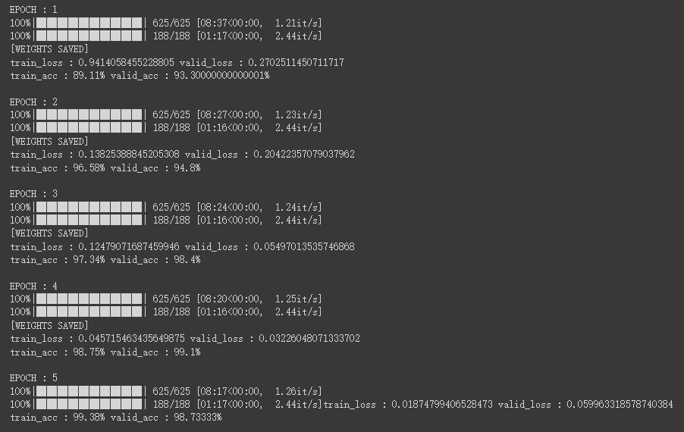

Training Learning Curve
以下為訓練過程中training data和valid data的loss及accuracy變化
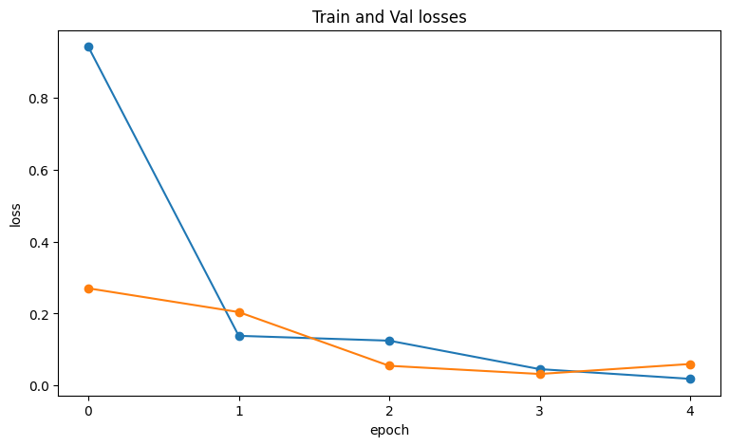
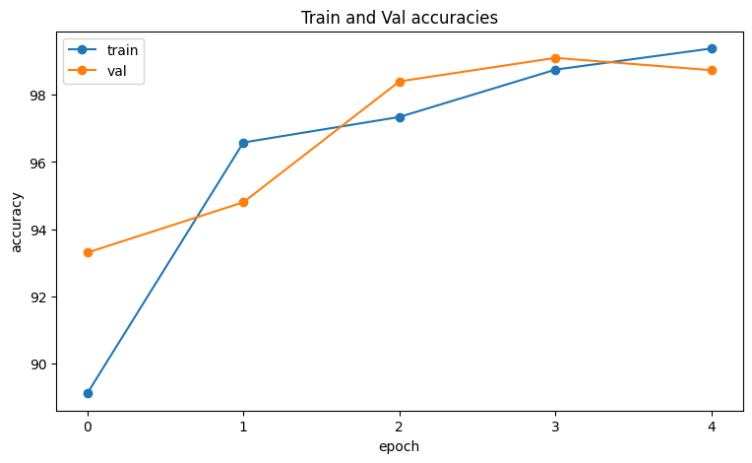
Test Section
最後是測試的部分，一樣也是先引入套件，定義好model，最後進行測試
def dist(a_emb, b_emb):
dist = a_emb - b_emb
dist = np.dot(dist, dist.T)
dist[dist < 0] = 0
dist = np.sqrt(dist)[0][0]
return dist

def test(model, folder, candidates):
query_img = torch.from_numpy(cv2.imread(DATA_DIR + folder + 'query.png', -1).astype(np.int32)).unsqueeze(2).permute(2, 0, 1) / 65535.0
query_img = query_img.unsqueeze(0).to(DEVICE)
query_emb = model(query_img)
dists = {}
for cand in candidates:
cand_img = torch.from_numpy(cv2.imread(DATA_DIR + folder + cand, -1).astype(np.int32)).unsqueeze(2).permute(2, 0, 1) / 65535.0
cand_img = cand_img.unsqueeze(0).to(DEVICE)
cand_emb = model(cand_img)
dists[cand] = dist(query_emb.cpu().detach().numpy(), cand_emb.cpu().detach().numpy())
return len(candidates)-1, np.count_nonzero(list(dists.values()) > dists['pos.png'])

testcases = os.listdir(DATA_DIR)
total_eval = 0
total_corr = 0

for testcase in testcases:
testcase += '/'
files = os.listdir(DATA_DIR + testcase)
files.remove('query.png')
eval, corr = test(model, testcase, files)
total_eval += eval
total_corr += corr
tz = timezone(timedelta(hours=+8))
print(f'Current time: {datetime.now(tz)}')
print(f'Number of test cases: {len(testcases)}')
print(f'Test accuracy: {round(total_corr/total_eval, 7)*100}%')

測試結果:
