深度視覺 HW5
M113040064 李冠宏

Data Preparation and Visualization
這邊的工作和HW4是一樣的，因此不再贅述

Layer Definition
其他地方都和HW4一樣，除了FullyConnectedLayer的backward，新增了dx的計算，因為out的值是由x*w+b來的，因此對x微分會變成w，因此dx的算法為backprop乘上w的轉置
def backward(self, backprop):
N, F = backprop.shape
dx = None
dw = None
db = None

####################
# TODO:
# 1. Derive the gradient of bias, i.e., d(out)/d(b)
# 2. Multiply d(out)/d(b) with `backprop` due to chain rule, and then store the AVERAGED result in variable `db`
# 3. Then, derive the gradient of weights, i.e., d(out)/d(w)
# 4. Multiply d(out)/d(w) with `backprop` due to chain rule, and then store the AVERAGED result in variable `dw`
# 5. Finally, derive the gradient of the input, i.e., d(out)/d(x)
# 6. Multiply d(out)/d(x) with `backprop` due to chain rule, and then store the result in variable `dx`
# HINT: Shapes of `db`, `dw` and `dx` should be (F,), (D, F) and (N, D) respectively
####################
# -----START OF YOUR CODE-----
x, w, b, out = self.cache
db = torch.mean(backprop, dim=0)
dw = torch.div(torch.matmul(torch.transpose(x, 0, 1), backprop), x.shape[0])
dx = torch.matmul(backprop, torch.transpose(w, 0, 1))
# ------END OF YOUR CODE------

return dx, dw, db

執行結果: (通過測試)

而ReLU和Softmax_CrossEntropy的部分也和HW4一樣。

這邊則是在做Network的測試，會印出每層權重和偏移量(bias)的shape
from _utils import Network_Test

def test_classifier(x, y, dim_in, dim_out, dim_hidden):
assert isinstance(dim_hidden, list), 'Parameter dim_hidden should be a list'
np.random.seed(0)
dim_hidden.append(dim_out)
fc_i = 1
params = {f'w{fc_i}': torch.from_numpy(np.random.randn(dim_in, dim_hidden[0])*0.8),
f'b{fc_i}': torch.zeros(dim_hidden[0])}
net = [FullyConnectedLayer()]
for layer_i in range(len(dim_hidden)-1):
fc_i += 1
params[f'w{fc_i}'] = torch.from_numpy(np.random.randn(dim_hidden[layer_i], dim_hidden[layer_i + 1])*0.8)
params[f'b{fc_i}'] = torch.zeros(dim_hidden[layer_i + 1])
net.append(ReLU())
net.append(FullyConnectedLayer())
loss_func = Softmax_CrossEntropy()

print('Network architecture and shapes of parameters:')
fc_i = 1
layer_out = net[0].forward(x, params[f'w{fc_i}'], params[f'b{fc_i}'])
print(f' {net[0].__name__()}: w1({params[f"w{fc_i}"].shape}), b1({params[f"b{fc_i}"].shape})')
for layer_i in range(1, len(net), 2):
# ReLU
layer_out = net[layer_i].forward(layer_out)
print(f' {net[layer_i].__name__()}')
# FullyConnectedLayer
fc_i += 1
layer_out = net[layer_i + 1].forward(layer_out, params[f'w{fc_i}'], params[f'b{fc_i}'])
print(f' {net[layer_i + 1].__name__()}: w{fc_i}({params[f"w{fc_i}"].shape}), b{fc_i}({params[f"b{fc_i}"].shape})')
_, loss = loss_func.forward(y, layer_out)

params_grad = {}
dout = loss_func.backward()
dout_dx, dout_dw, dout_db = net[len(net) - 1].backward(dout)
params_grad[f'w{fc_i}'] = dout_dw; params_grad[f'b{fc_i}'] = dout_db
for layer_i in range(len(net)-2, 0, -2):
# ReLU
dout = net[layer_i].backward(dout_dx)
# FullyConnectedLayer
fc_i -= 1
dout_dx, dout_dw, dout_db = net[layer_i - 1].backward(dout)
params_grad[f'w{fc_i}'] = dout_dw; params_grad[f'b{fc_i}'] = dout_db
Network_Test(params, params_grad)

dim_in = 5; dim_out = 3
dim_hidden = [8, 4, 2]

np.random.seed(0)
x = torch.from_numpy(np.random.randn(2, dim_in))
y = np.array([0, 1])
test_classifier(x, y, dim_in, dim_out, dim_hidden)

執行結果: (通過測試)
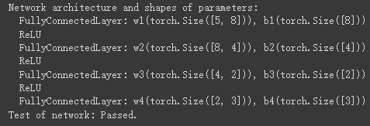

Optimizer
這邊我們是要建立各種不同的優化器，用來更新權重和偏移量(bias)

首先是SGD (Stochastic Gradient Descent)，是最基本的優化器，他的更新方式也最簡單，對於每個權重和偏移量，每次更新扣掉learning rate * 梯度即可
class SGD(object):
def __init__(self, learning_rate=1e-3):
self.lr = learning_rate
def step(self, params, params_grad):
for key, val in params.items():
if key not in params_grad.keys():
raise KeyError(f'params_grad[\'{key}\'] is missing')
if val.shape != params_grad[key].shape:
raise ValueError(f'Expected shape of params_grad[\'{key}\'] {params[key].shape} but got {params_grad[key].shape}')

####################
# TODO:
# 1. Update each parameter `params[key]` with its gradient `params_grad[key]`
####################
# -----START OF YOUR CODE-----
params[key] -= self.lr * params_grad[key]
# ------END OF YOUR CODE------

執行結果: (通過測試)
再來是SGD + momentum，他透過加上一個所謂的動能來使得更新的方向能更精確，更新方式是先算出動能，動能是每次更新時乘上一個momentum的值再減去learning rate * 梯度，最後再將權重加上動能
class SGD_Momentum(object):
def __init__(self, learning_rate=1e-3, momentum=0.9):
self.lr = learning_rate
self.momentum = momentum
self.velocity = {}
def step(self, params, params_grad):
for key, val in params.items():
if key not in params_grad.keys():
raise KeyError(f'params_grad[\'{key}\'] is missing')
if val.shape != params_grad[key].shape:
raise ValueError(f'Expected shape of params_grad[\'{key}\'] {params[key].shape} but got {params_grad[key].shape}')
if key not in self.velocity.keys():
self.velocity[key] = torch.zeros_like(params[key])

####################
# TODO:
# 1. Update each velocity `self.velocity[key]` of each parameter
# 2. Update each parameter `params[key]` with its velocity
####################
# -----START OF YOUR CODE-----
self.velocity[key] = self.momentum * self.velocity[key] - self.lr * params_grad[key]
params[key] += self.velocity[key]
# ------END OF YOUR CODE------

執行結果: (通過測試)

最後是Adam，三者中最複雜的方式，基本上它是momentum + RMSprop，再加上”bias corrections”的方法。首先要先算出momentum和動能，接下來透過bias corrections的方式算出m_hat和v_hat，最後用這兩個變數去更新權重。
class Adam(object):
def __init__(self, learning_rate=1e-3, beta1=0.9, beta2=0.999, epsilon=1e-8):
self.lr = learning_rate
self.beta1 = beta1
self.beta2 = beta2
self.epsilon = epsilon
self.momentum = {}
self.velocity = {}
self.t = 0

def step(self, params, params_grad):
self.t += 1
for key, val in params.items():
if key not in params_grad.keys():
raise KeyError(f'params_grad[\'{key}\'] is missing')
if val.shape != params_grad[key].shape:
raise ValueError(f'Expected shape of params_grad[\'{key}\'] {params[key].shape} but got {params_grad[key].shape}')
if key not in self.momentum.keys():
self.momentum[key] = torch.zeros_like(params[key])
if key not in self.velocity.keys():
self.velocity[key] = torch.zeros_like(params[key])
####################
# TODO:
# 1. Update each momentum `self.momentum[key]` and velocity `self.velocity[key]` of each parameter
# 2. Calculate the bias-corrected momentum and velocity, this step should NOT change the value in `self.momentum` nor `self.velocity`
# 3. Update each parameter `params[key]` with its bias-corrected momentum and velocity
####################
# -----START OF YOUR CODE-----
self.momentum[key] = self.beta1 * self.momentum[key] + ((1-self.beta1) * params_grad[key])
self.velocity[key] = self.beta2 * self.velocity[key] + ((1-self.beta2) * (params_grad[key] ** 2))
m_hat = self.momentum[key] / (1 - (self.beta1 ** self.t))
v_hat = self.velocity[key] / (1 - (self.beta2 ** self.t))
params[key] -= self.lr * (m_hat / ((v_hat ** (1/2)) + self.epsilon))
# ------END OF YOUR CODE------

執行結果: (通過測試)

Network Definition
這個部分是定義model，因程式碼冗長因此就不放上來

Test Optimizers
這個部份是要測試優化器
from _utils import load_small_dataset
small_train_dataset, small_valid_dataset = load_small_dataset()

BATCH_SIZE = 16
DIM_HIDDENS = [128]
LR = 2e-4
REG = 0.0

optimizers = {'SGD': SGD(learning_rate=LR), 'SGD_Momentum': SGD_Momentum(learning_rate=LR), 'Adam': Adam(learning_rate=LR)}
train_loss = {}; train_acc = {}
valid_loss = {}; valid_acc = {}
for optim_name, optim in optimizers.items():
model = Classifier(IN_DIM, OUT_DIM, DIM_HIDDENS, device=DEVICE)
small_train_dataloader = Dataloader(small_train_dataset, batch_size=BATCH_SIZE)
small_valid_dataloader = Dataloader(small_valid_dataset, batch_size=BATCH_SIZE)
tl, ta, vl, va = model.training(small_train_dataloader, small_valid_dataloader, epochs=100, optimizer=optim, reg_lambda=REG, verbose=101)
idx = np.int32(np.array(vl).argmin())
print(f'{optim_name}: Training accuracy: {format((ta[idx]), ".2f")}%, validation accuracy: {format((va[idx]), ".2f")}%\n\tTraining loss: {format((tl[idx]), ".4f")}, validation loss: {format((vl[idx]), ".4f")}')
train_loss[optim_name] = tl; train_acc[optim_name] = ta
valid_loss[optim_name] = vl; valid_acc[optim_name] = va

執行結果:
用以下的結果來看，效果是Adam > SGD_Momentum > SGD
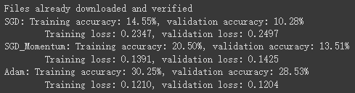

接下來是training loss和validation loss的測試
cand = list(optimizers.keys())

train = list(train_loss.values()); valid = list(valid_loss.values())
plot_curves(cand, 'loss', train, valid)

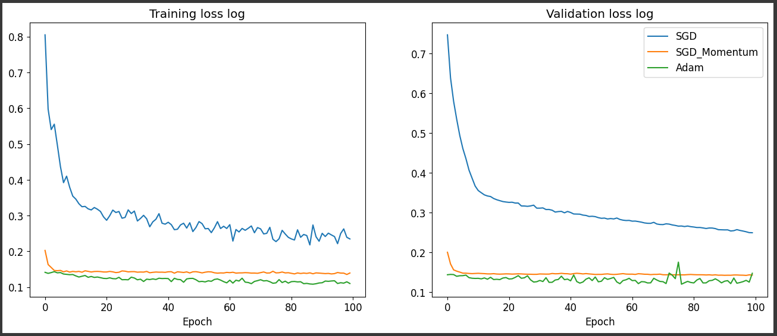

training accuracy和validation accuracy的測試
train = list(train_acc.values()); valid = list(valid_acc.values())
plot_curves(cand, 'accuracy', train, valid)
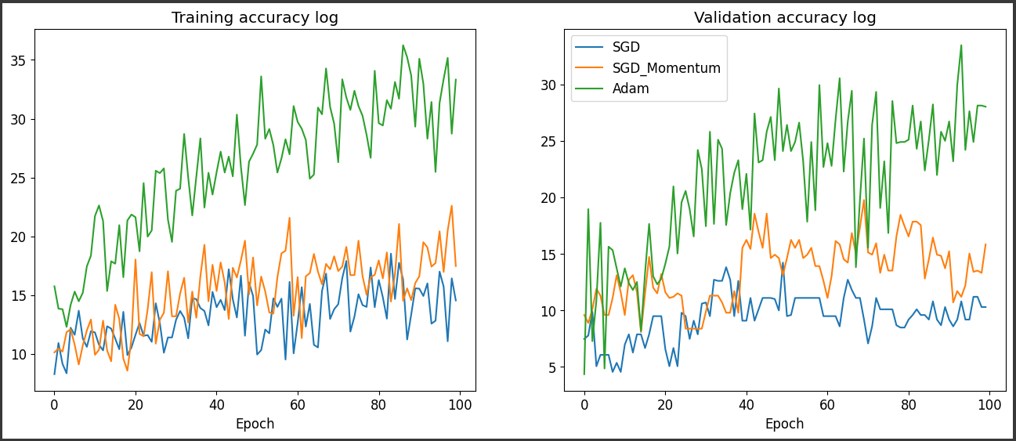

Training with Best Hyperparameters
Hyperparameters
# Please set your hyperparameters here
BATCH_SIZE = 8
LR = 0.01
DIM_HIDDENS = [256, 64]
REG = 0.0001
OPTIMIZER = SGD(learning_rate=LR)
train_dataloader = Dataloader(train_dataset, batch_size=BATCH_SIZE)
valid_dataloader = Dataloader(valid_dataset, batch_size=BATCH_SIZE)
model = Classifier(IN_DIM, OUT_DIM, DIM_HIDDENS, device=DEVICE)
model.print_param_shape()

執行結果:
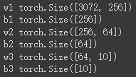

訓練
train_loss, train_acc, valid_loss, valid_acc = model.training(train_dataloader, valid_dataloader, optimizer=OPTIMIZER, reg_lambda=REG)
plot_result(train_loss, train_acc, valid_loss, valid_acc)

執行結果: (只取最後幾個EPOCHS)
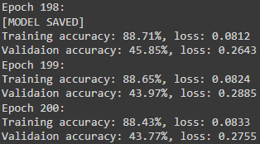
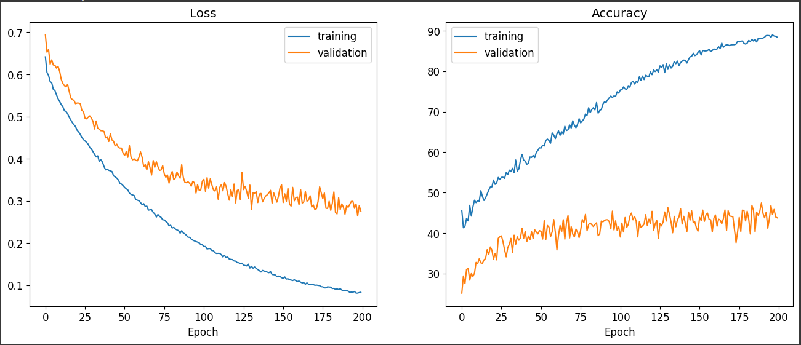

最後將test data當作input的準確率為46.52%
test_dataloader = Dataloader(test_dataset)
model.load_model(MODEL_PATH)
model.test(test_dataloader)

