深度視覺 HW4
M113040064 李冠宏

Data Preparation and Visualization
首先是一些先前工作，例如引入資料夾及其檔案，引入套件並使用GPU來做訓練，並載入dataset。這次做的是cifar10，因此會有10個classes。
from google.colab import drive
drive.mount('/content/drive')
import sys
sys.path.append('/content/drive/MyDrive/HW4/')
# You may change `MODEL_DIR` to a existing local directory if you are not using Colab
MODEL_DIR = '/content/'
MODEL_PATH = MODEL_DIR + 'model.pt' if MODEL_DIR.endswith('/') else MODEL_DIR + '/model.pt'
from _utils import load_data, Dataset, Dataloader, FCL_Tests, ReLU_Tests, SCE_Tests, plot_curves, plot_result
import numpy as np
import matplotlib.pyplot as plt
import random
import torch
if torch.cuda.is_available():
DEVICE = 'cuda'
print(f'Using torch {torch.__version__}, device = {torch.cuda.get_device_name(0)}')
else:
DEVICE = 'cpu'
print(f'Using torch {torch.__version__}, device = cpu')
images, labels, classes = load_data()
print(f'Data type of images: {images.dtype} (value range: [{images.min()}, {images.max()}])')
print(f'Shape of images: {images.shape}')
print(f'Shape of labels: {labels.shape}')
print(f'Number of classes: {len(classes)}')
print(f'Classes: {classes}')
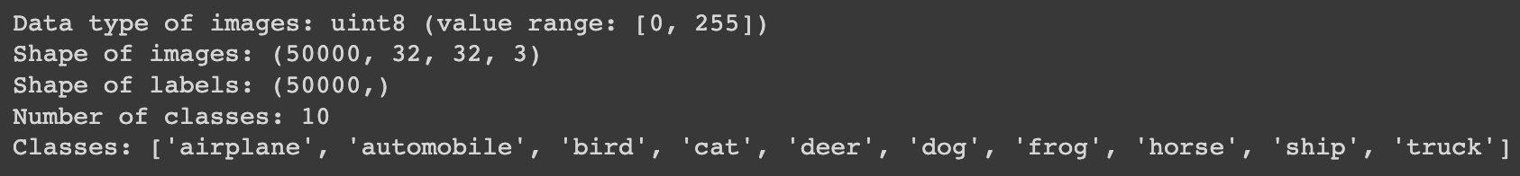
這邊是測試dataset是否有被正確載入進來，並做視覺化。
# Display samples of each class
plt.rcParams['figure.figsize'] = (16, 16) #設定圖片尺寸
num_classes = len(classes) # 10
num_example = 10 #要列出每一個class的數量
for label, class_name in enumerate(classes):
idxs = np.flatnonzero(labels == label)
idxs = np.random.choice(idxs, num_example, replace=False)
for i, idx in enumerate(idxs):
plt_idx = i * num_classes + label + 1
plt.subplot(num_example, num_classes, plt_idx)
plt.imshow(images[idx]); plt.axis('off')
if i == 0:
plt.title(class_name)
plt.show()

接下來將資料切割為training data，validation data和test data，比例是60% : 20% : 20%
# 將資料切割為 training data, validation data, test data
# Data splitting with numpy array slicing
num_data = images.shape[0]
split_ratio = {'train': 0.6, 'valid': 0.2, 'test': 0.2}
num_valid_data = round(num_data * split_ratio['valid'])
num_test_data = round(num_data * split_ratio['test'])
num_train_data = num_data - (num_valid_data + num_test_data)

#設定 training data
start_idx = 0
train_dataset = Dataset(images[start_idx:start_idx+num_train_data], labels[start_idx:start_idx+num_train_data])
start_idx += num_train_data

#設定 valid data
valid_dataset = Dataset(images[start_idx:start_idx+num_valid_data], labels[start_idx:start_idx+num_valid_data])
start_idx += num_valid_data

#設定 test data
test_dataset = Dataset(images[start_idx:start_idx+num_test_data], labels[start_idx:start_idx+num_test_data])

print(f'Number of training data: {len(train_dataset)}')
print(f'Number of validation data: {len(valid_dataset)}')
print(f'Number of test data: {len(test_dataset)}')

執行結果：
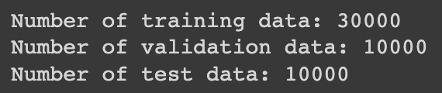

Layer Definition
接下來是定義全連接層、激勵函數(ReLU)和損失函數(Cross Entropy Softmax)

首先是全連接層，它的forward主要是要將input乘上權重，並加上一個偏移量bias，因此我們利用torch.matmul函式將tensor做相乘再用torch.add將偏移量加上去。而backward的部分，算偏移量梯度時，偏移量的偏微分部分會變成常數1，因此算出平均即可，而權重的偏微分會變成input x的轉置乘上backprop再算平均，以得到權重的梯度
class FullyConnectedLayer(object):
def __init__(self, device='cpu'):
self.dv = device

def forward(self, x, w, b):
N, D = x.shape #input 為 N*D
Dw, F = w.shape #第一層權重的維度為 D*H
assert Dw == D, f'Wrong shape of weights, expected ({D},{F}) but got ({Dw},{F})'
Fb = b.shape[0] #bias的維度為 H
assert Fb == F, f'Wrong shape of bias, expected ({F},) but got ({Fb},)'
out = torch.zeros((N, F)).to(self.dv)

####################
# TODO:
# 1. Implement fully connected layer with `w` * `x` + `b` and store the result in variable `out`
####################
# -----START OF YOUR CODE-----
out = torch.add(torch.matmul(x, w), b)
# ------END OF YOUR CODE------

self.cache = (x, w, b, out)
return out

def backward(self, backprop):
N, F = backprop.shape
dw = None
db = None
# print("backprop:",backprop) # tensor([[0.5759, 0.9293, 0.3186, 0.6674], [0.1318, 0.7163, 0.2894, 0.1832], [0.5865, 0.0201, 0.8289, 0.0047]], dtype=torch.float64)
# print("backprop.shape:", backprop.shape) #[3, 4]

####################
# TODO:
# 1. Derive the gradient of bias, i.e., d(out)/d(b)
# 2. Multiply d(out)/d(b) with `backprop` due to chain rule, and then store the AVERAGED result in variable `db`
# 3. Then, derive the gradient of weights, i.e., d(out)/d(w)
# 4. Multiply d(out)/d(w) with `backprop` due to chain rule, and then store the AVERAGED result in variable `dw`
# HINT: Shapes of `db` and `dw` should be (F,) and (D, F) respectively
####################
# -----START OF YOUR CODE-----
x, w, b, out = self.cache
db = torch.mean(backprop, dim=0)
dw = torch.div(torch.matmul(torch.transpose(x, 0, 1), backprop), x.shape[0])
# ------END OF YOUR CODE------

return dw, db

測試的結果為通過
layer = FullyConnectedLayer()
FCL_Tests(layer)

接下來是激勵函數(ReLU)，激勵函數的主要目的是要使得分類從線性變成非線性，而ReLU是將小於0的input都設為0，其他的維持一樣，也就是ReLU(x) = max(0, x)，因此forward的部分是將小於0的透過torch.clamp都設為0即可。Backward的部分則是算出ReLU的偏微分，他的偏微分是若input小於0則輸出為0，若input大於0則輸出為1，因此我們把out的非0部分都改成1並乘上backprop來反向傳遞。
class ReLU(object):
def __init__(self):
pass

def forward(self, t):
out = t.clone()
####################
# TODO:
# 1. Implement ReLU on `t` and store in variable `out`
####################
# -----START OF YOUR CODE-----
out = torch.clamp(t, min=0.0)
# ------END OF YOUR CODE------
# print("t:",t)
# print("out:", out)
self.cache = (t, out)

return out

def backward(self, backprop):
dt = torch.zeros_like(backprop)

####################
# TODO:
# 1. Derive d(out)/d(t)
# 2. Multiply d(out)/d(t) with `backprop` due to chain rule, and then store the result in variable `dt`
####################
# -----START OF YOUR CODE-----
t, out = self.cache
out[out != 0] = 1
dt = out * backprop
# ------END OF YOUR CODE------

return dt

測試的結果為通過
layer = ReLU()
ReLU_Tests(layer)

最後是loss function損失函數cross entropy softmax，forward的部分，首先實作出softmax函式，算出每個類別可能的機率，接下來再實作cross entropy，透過機率來算出loss。Backward的部分則是算出cross entropy softmax的偏微分並計算平均。
class Softmax_CrossEntropy(object):
def __init__(self):
pass

def forward(self, y, net_out):
N, F = net_out.shape
prob = torch.zeros_like(net_out)
# print("net_out:",net_out)
# print("net_out.shape:",net_out.shape)

####################
# TODO:
# 1. Implement Softmax and store the result in variable `prob`
# HINT: Shape of `prob` should be (N, F)
####################
# -----START OF YOUR CODE-----
prob = torch.exp(net_out) / torch.sum(torch.exp(net_out), dim=1).view(-1, 1)
# ------END OF YOUR CODE------

self.cache = (y, prob)
pred_y = prob.argmax(dim=1) #我們所猜測的值 #tensor[1,0,0,1,0]

y_one_hot = torch.zeros_like(net_out) #(5,2)
y_one_hot[np.arange(N), y] = 1
loss = torch.zeros(1).to(DEVICE)

####################
# TODO:
# 1. Implement cross-entropy loss and store the result in variable `loss`
####################
# -----START OF YOUR CODE-----
loss = torch.div(-torch.sum(y_one_hot * torch.log(prob)), prob.shape[0])
# ------END OF YOUR CODE------

return pred_y, loss

def backward(self):
y, grad = self.cache
N, F = grad.shape
# print("grad.shape:",grad.shape)
# print("y.shape:",y.shape)
# print("grad:",grad)
# print("y:",y)

####################
# TODO:
# 1. Derive the gradient of `net_out` and store the result in variable `grad`
####################
# -----START OF YOUR CODE-----
grad[range(y.shape[0]), y] -= 1
grad = torch.div(grad, y.shape[0])
# ------END OF YOUR CODE------

return grad

測試的結果為通過
layer = Softmax_CrossEntropy()
SCE_Tests(layer)

Network Definition
這個階段為訓練模型，透過剛剛定義好的類別來經過全連接層、激勵函數和用損失函數來計算loss，並不斷的forward再backward來調整參數(權重及偏移量)。
每經過一個batch，就會將權重和偏移量減去learning rate * 梯度來更新。
class Classifier(object):
def __init__(self, dim_in, dim_hidden, dim_out, device='cpu'):
self.dv = device
np.random.seed(0)

#初始化參數
self.params = {'w1': torch.from_numpy(np.random.randn(dim_in, dim_hidden)*0.8).to(self.dv),
'b1': torch.zeros(dim_hidden).to(self.dv),
'w2': torch.from_numpy(np.random.randn(dim_hidden, dim_out)*0.8).to(self.dv),
'b2': torch.zeros(dim_out).to(self.dv)}

#定義layer
layer1 = FullyConnectedLayer() #layer1
activation = ReLU() #activation function
layer2 = FullyConnectedLayer() #layer2
self.net = [layer1, activation, layer2] #the layer list
self.loss_func = Softmax_CrossEntropy() #loss function

#儲存模型參數
def save_model(self, path):
torch.save(self.params, path)

#載入模型參數
def load_model(self, path):
checkpoint = torch.load(path, map_location=self.dv)
self.params = checkpoint

#訓練model
def training(self, train_dataloader, valid_dataloader, epochs=200, learning_rate=1e-3, learning_rate_decay=0.95, verbose=1):
print(f'Training with batch_size={train_dataloader[0][0].shape[0]}, hidden_dim={self.params["w1"].shape[1]}, learning_rate={learning_rate}, learning_rate_decay={learning_rate_decay}')
train_loss_log = []
train_acc_log = []
valid_loss_log = []
valid_acc_log = []
best_val_loss = None

for epoch in range(epochs):
if verbose > 0 and (epoch+1) % verbose == 0:
print(f'Epoch {epoch+1}:')

single_epoch_log = ''
train_loss = 0.0
train_corr = 0.0; train_eval = 0.0

for batch_idx in range(len(train_dataloader)):
### Model Input and Loss Calculation ###
batch_data = train_dataloader[batch_idx]
batch_img, batch_label = batch_data
layer1_out = self.net[0].forward(torch.from_numpy(batch_img).to(self.dv), self.params['w1'], self.params['b1']) #layer1
layer1_out = self.net[1].forward(layer1_out) #activation function (ReLU)
layer2_out = self.net[2].forward(layer1_out, self.params['w2'], self.params['b2']) #layer2
pred_y, loss = self.loss_func.forward(batch_label, layer2_out) #loss function
train_loss += loss.cpu().numpy()
train_corr += torch.count_nonzero(pred_y == torch.from_numpy(batch_label).to(self.dv)).cpu().numpy()
train_eval += batch_img.shape[0]
### Backpropagation and Optimization ###
params_grad = {}
dloss_dout2 = self.loss_func.backward() #loss function
dout2_dw2, dout2_db2 = self.net[2].backward(dloss_dout2) #layer2
params_grad['w2'] = dout2_dw2; params_grad['b2'] = dout2_db2 #更新參數之梯度
dout2_dout1 = self.net[1].backward(dloss_dout2.mm(self.params['w2'].T)) #activation function
dout1_dw1, dout1_db1 = self.net[0].backward(dout2_dout1) #layer1
params_grad['w1'] = dout1_dw1; params_grad['b1'] = dout1_db1 #更新參數之梯度

####################
# TODO:
# 1. Update model parameters, i.e., `self.params`, by gradient descent
####################
# -----START OF YOUR CODE-----
self.params['w1'] -= learning_rate * params_grad['w1']
self.params['b1'] -= learning_rate * params_grad['b1']
self.params['w2'] -= learning_rate * params_grad['w2']
self.params['b2'] -= learning_rate * params_grad['b2']
# ------END OF YOUR CODE------

train_loss_log.append(train_loss/train_eval)
train_acc_log.append(100*train_corr/train_eval)
single_epoch_log += f'Training accuracy: {format(train_acc_log[-1], ".2f")}%, loss: {format(train_loss_log[-1], ".4f")}\n'
train_dataloader.shuffle()

valid_loss = 0.0
valid_corr = 0.0; valid_eval = 0.0
for batch_idx in range(len(valid_dataloader)):
### Model Input and Loss Calculation ###
batch_data = valid_dataloader[batch_idx]
batch_img, batch_label = batch_data
layer1_out = self.net[0].forward(torch.from_numpy(batch_img).to(self.dv), self.params['w1'], self.params['b1']) #full connected layer1
layer1_out = self.net[1].forward(layer1_out) # activation function: ReLU
layer2_out = self.net[2].forward(layer1_out, self.params['w2'], self.params['b2']) #full connected layer2
pred_y, loss = self.loss_func.forward(batch_label, layer2_out)
valid_loss += loss.cpu().numpy()
valid_corr += torch.count_nonzero(pred_y == torch.from_numpy(batch_label).to(self.dv)).cpu().numpy()
valid_eval += batch_img.shape[0]
valid_loss_log.append(valid_loss/valid_eval)
valid_acc_log.append(100*valid_corr/valid_eval)
single_epoch_log += f'Validaion accuracy: {format(valid_acc_log[-1], ".2f")}%, loss: {format(valid_loss_log[-1], ".4f")}'
if best_val_loss is None or valid_loss < best_val_loss:
best_val_loss = valid_loss
self.save_model(MODEL_PATH)
if verbose == 1:
single_epoch_log = '[MODEL SAVED]\n' + single_epoch_log
if verbose > 0 and (epoch+1) % verbose == 0:
print(single_epoch_log)

learning_rate *= learning_rate_decay # update learning_rate every epoch

return train_loss_log,train_acc_log,valid_loss_log,valid_acc_log

def test(self, test_dataloader):
total_corr = 0; total_eval = 0
for batch_idx in range(len(test_dataloader)):
### Model Input ###
batch_data = test_dataloader[batch_idx]
batch_img, batch_label = batch_data
layer1_out = self.net[0].forward(torch.from_numpy(batch_img).to(self.dv), self.params['w1'], self.params['b1'])
layer1_out = self.net[1].forward(layer1_out)
layer2_out = self.net[2].forward(layer1_out, self.params['w2'], self.params['b2'])
pred_y, _ = self.loss_func.forward(batch_label, layer2_out)
total_corr += torch.count_nonzero(pred_y == torch.from_numpy(batch_label).to(self.dv)).cpu().numpy()
total_eval += batch_img.shape[0]
print(f'Got {total_corr} correct prediction in {total_eval} test data, accuracy: {format((total_corr*1.0/total_eval)*100, ".2f")}%')

Searching for Best Hyperparameters
這個階段主要是要測試不同hyperparameters所帶來的訓練影響，變因有以下四個
Batch size | Learning rate | Learning rate decay | Hidden layer dimension
# Configurations
IN_DIM = np.prod(images[0].shape)
OUT_DIM = len(classes)
# Hyperparameters
BATCH_SIZE = 16
LR = 1e-3
LR_DECAY = 0.95
HIDEEN_DIM = 64
首先我們先對learning rate做測試
lr_cand = [1e-2, 1e-3, 1e-4]
train_acc = []
valid_acc = []

for lr in lr_cand:
train_dataloader = Dataloader(train_dataset, batch_size=BATCH_SIZE)
valid_dataloader = Dataloader(valid_dataset, batch_size=BATCH_SIZE)
model = Classifier(IN_DIM, HIDEEN_DIM, OUT_DIM, device=DEVICE)
_, ta, _, va = model.training(train_dataloader, valid_dataloader, epochs=80, learning_rate=lr, learning_rate_decay=LR_DECAY, verbose=0)
train_acc.append(ta); valid_acc.append(va)

plot_curves(lr_cand, train_acc, valid_acc)

執行結果：
我們可以發現在三個learning rate中，0.01的準確率是最高的，因為過小的learning rate可能會導致更新速度太慢，使得結果不好，以此例來看，0.01的learning rate效果最好
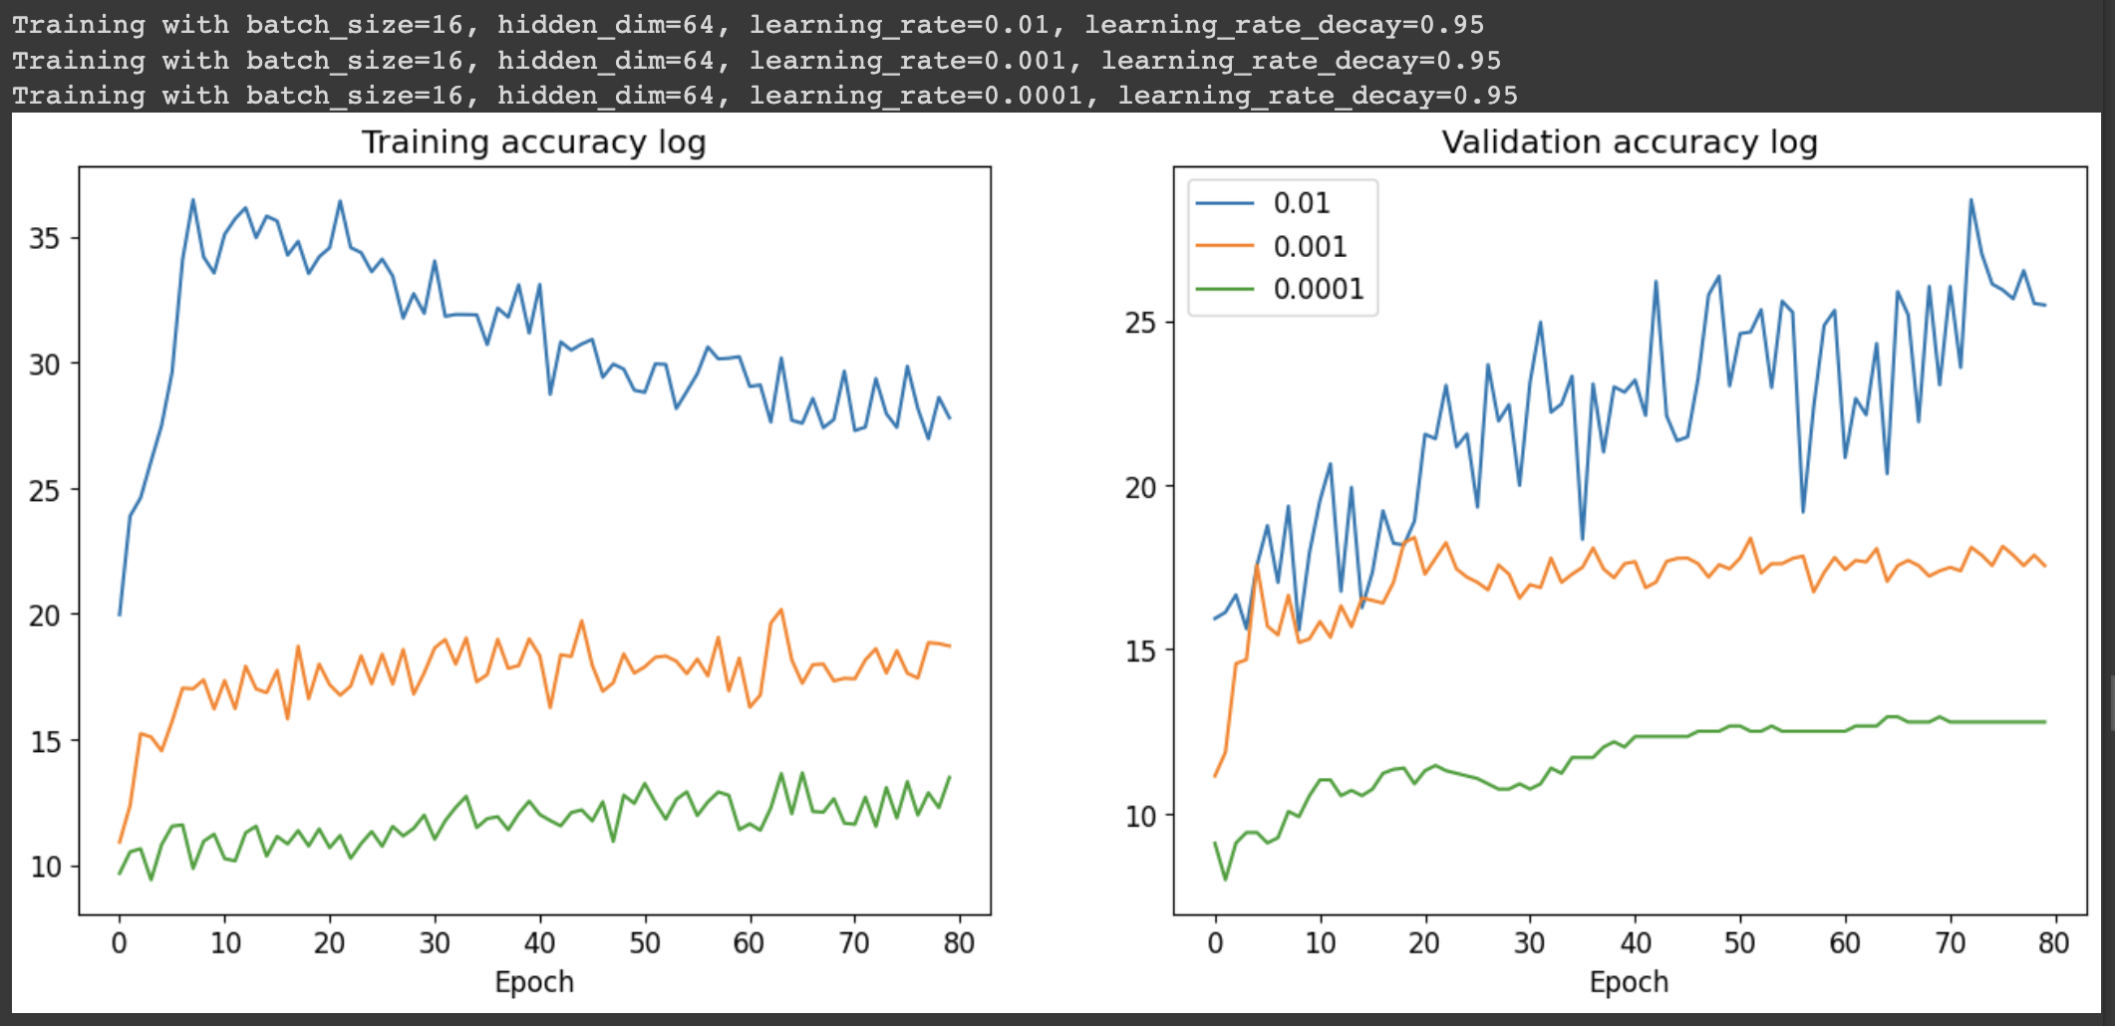

再來是batch size的測試
bs_cand = [8, 16, 100]
train_acc = []
valid_acc = []

for bs in bs_cand:
train_dataloader = Dataloader(train_dataset, batch_size=bs)
valid_dataloader = Dataloader(valid_dataset, batch_size=bs)
model = Classifier(IN_DIM, HIDEEN_DIM, OUT_DIM, device=DEVICE)
_, ta, _, va = model.training(train_dataloader, valid_dataloader, epochs=80, learning_rate=LR, learning_rate_decay=LR_DECAY, verbose=0)
train_acc.append(ta); valid_acc.append(va)

plot_curves(bs_cand, train_acc, valid_acc)

執行結果：
我們可以發現batch size為8的準確率最高，而過大的batch size可能會導致更新參數的速度較慢，且會使得隨機性較低，訓練出來的模型準確率會有不夠高的問題。在此例中，batch size為8的效果最好。
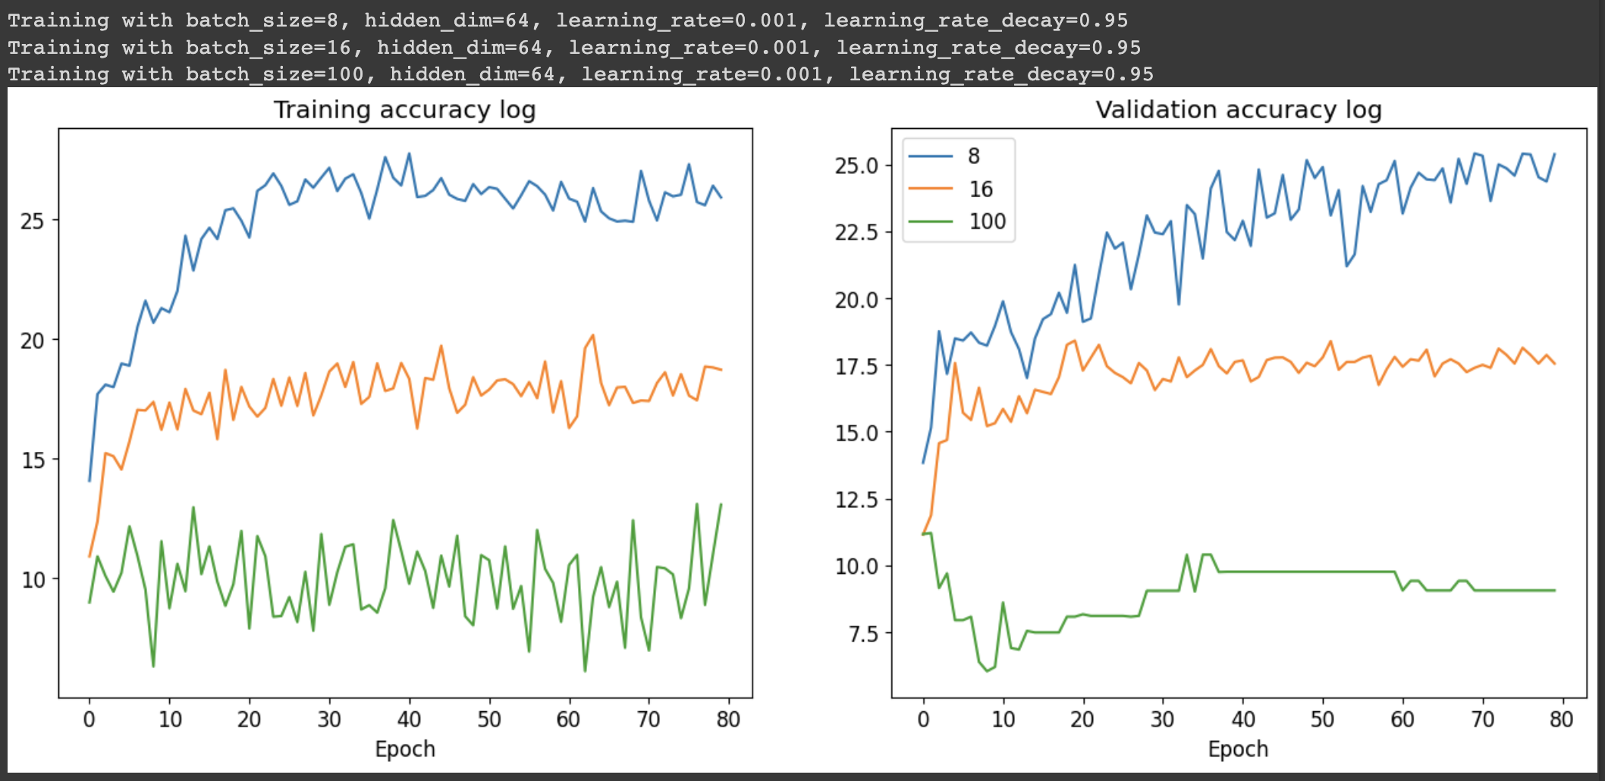

再來是hidden layer dimension的部分
hd_cand = [32, 64, 256]
train_acc = []
valid_acc = []

for hd in hd_cand:
train_dataloader = Dataloader(train_dataset, batch_size=BATCH_SIZE)
valid_dataloader = Dataloader(valid_dataset, batch_size=BATCH_SIZE)
model = Classifier(IN_DIM, hd, OUT_DIM, device=DEVICE)
_, ta, _, va = model.training(train_dataloader, valid_dataloader, epochs=80, learning_rate=LR, learning_rate_decay=LR_DECAY, verbose=0)
train_acc.append(ta); valid_acc.append(va)

plot_curves(hd_cand, train_acc, valid_acc)

執行結果：
我們可以發現隱藏層的維度愈高，模型的準確率也會愈高，這是因為如果隱藏層複雜(也就是參數愈多)，則訓練出來的模型會更完善，準確率也較高。
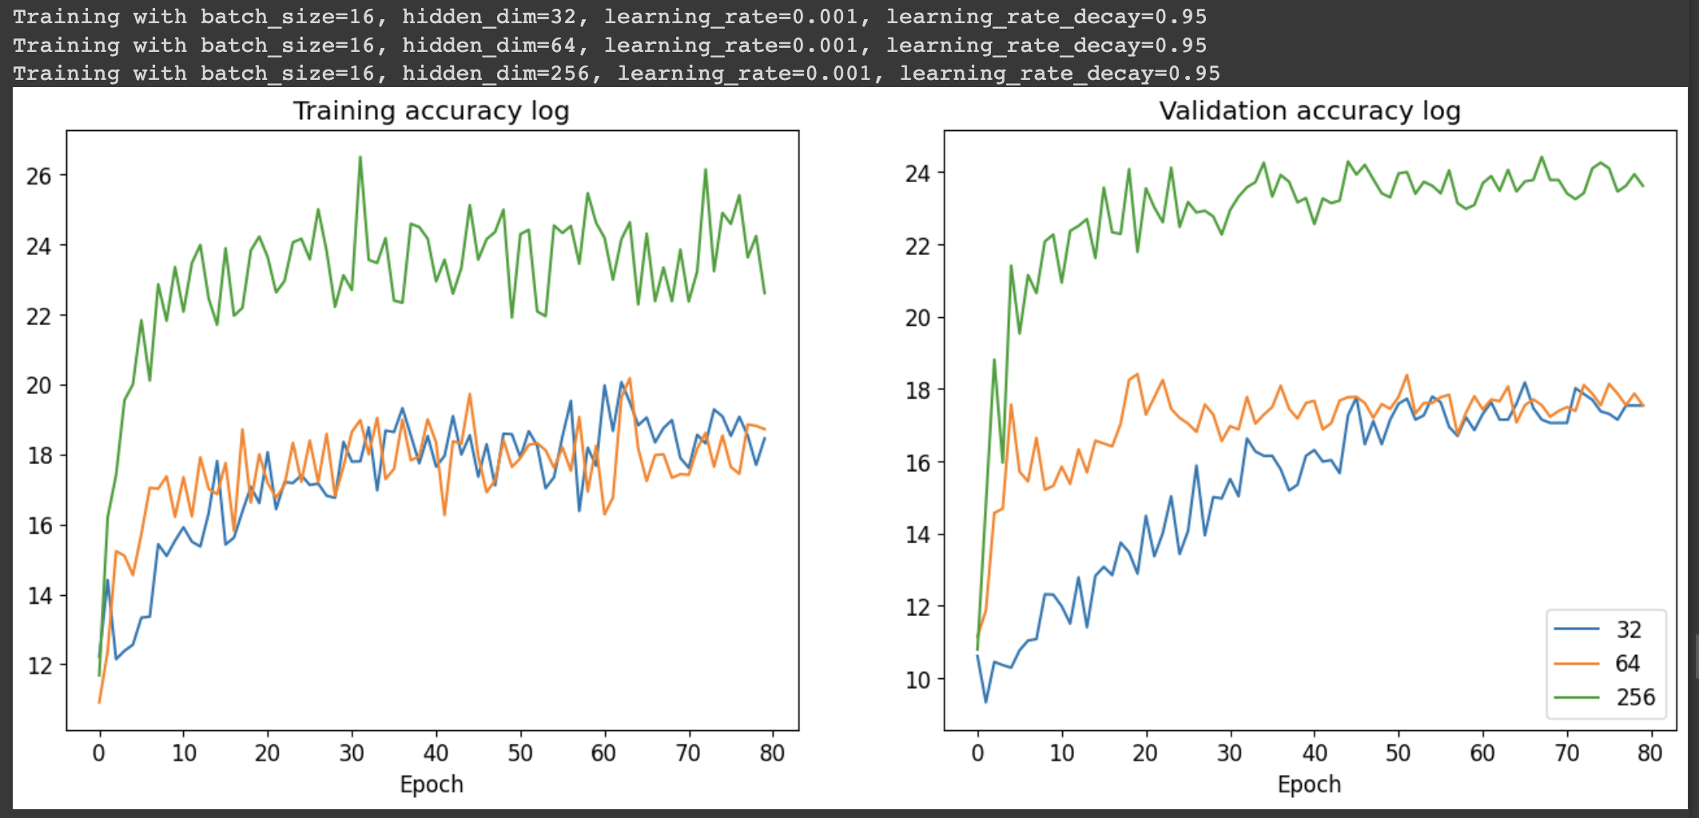

最後是learning rate decay的測試
lr_decay_cand = [1.0, 0.95, 0.9]
train_acc = []
valid_acc = []

for lrd in lr_decay_cand:
train_dataloader = Dataloader(train_dataset, batch_size=BATCH_SIZE)
valid_dataloader = Dataloader(valid_dataset, batch_size=BATCH_SIZE)
model = Classifier(IN_DIM, HIDEEN_DIM, OUT_DIM, device=DEVICE)
_, ta, _, va = model.training(train_dataloader, valid_dataloader, epochs=80, learning_rate=LR, learning_rate_decay=lrd, verbose=0)
train_acc.append(ta); valid_acc.append(va)

plot_curves(lr_decay_cand, train_acc, valid_acc)

執行結果：
以此例來看，learning rate decay為1最好(也就是每回合不去更改learning rate)，因為在先前我們測試learning rate是0.01的結果已經是裡面比較好的了，因此如果我們在中途去讓learning rate變低的話，可能會使的模型訓練的準確率沒有那麼高，因此不更動learning rate或許是一種好方法。
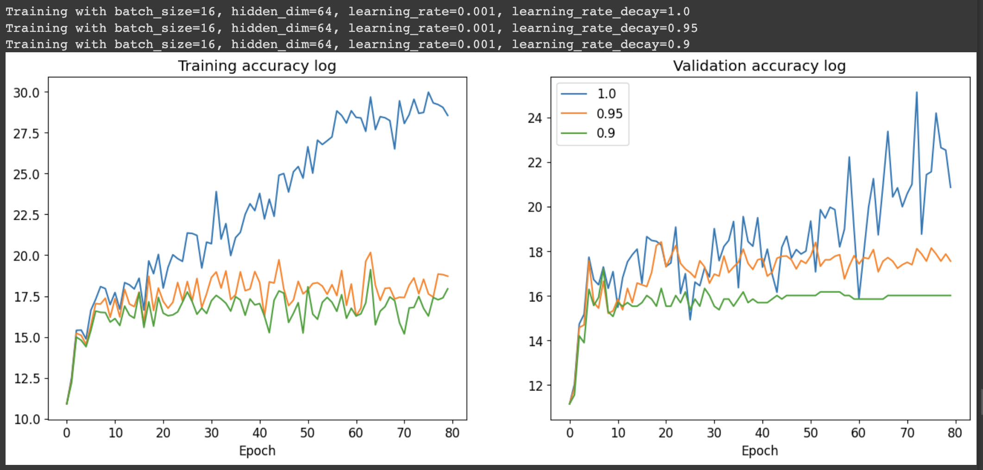

Training with Best Hyperparameters
就上述觀察，我們可以發現四個hyperparameters用以下的配置會有局部最好的結果
Batch size = 8
Learning rate = 0.01
Learning rate decay = 1.0
Hidden layer dimension = 256

因此我們使用以上配置來訓練看看
# Configurations
IN_DIM = np.prod(images[0].shape)
OUT_DIM = len(classes)
# Please set your hyperparameters here
BATCH_SIZE = 8
LR = 1e-2
LR_DECAY = 1.0
HIDEEN_DIM = 256
train_dataloader = Dataloader(train_dataset, batch_size=BATCH_SIZE)
valid_dataloader = Dataloader(valid_dataset, batch_size=BATCH_SIZE)
model = Classifier(IN_DIM, HIDEEN_DIM, OUT_DIM, device=DEVICE)
train_loss, train_acc, valid_loss, valid_acc = model.training(train_dataloader, valid_dataloader, learning_rate=LR, learning_rate_decay=LR_DECAY)
plot_result(train_loss, train_acc, valid_loss, valid_acc)

執行結果：(只擷取最後幾個EPOCHS的結果)
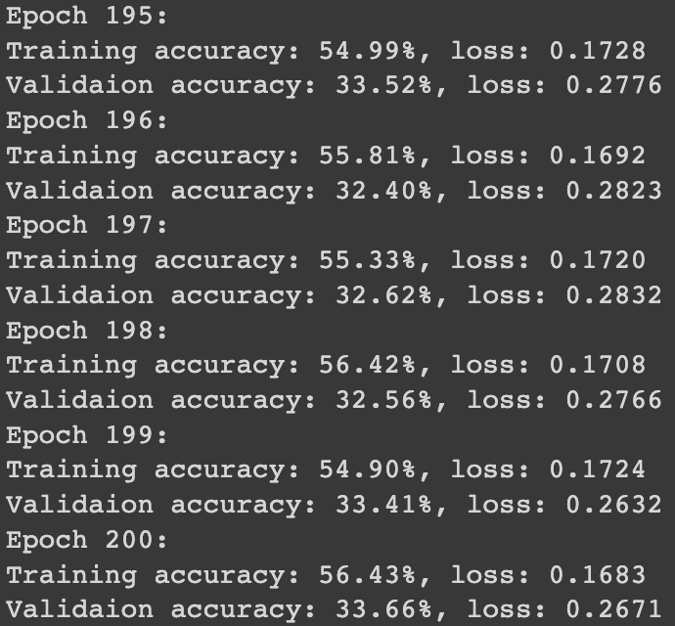
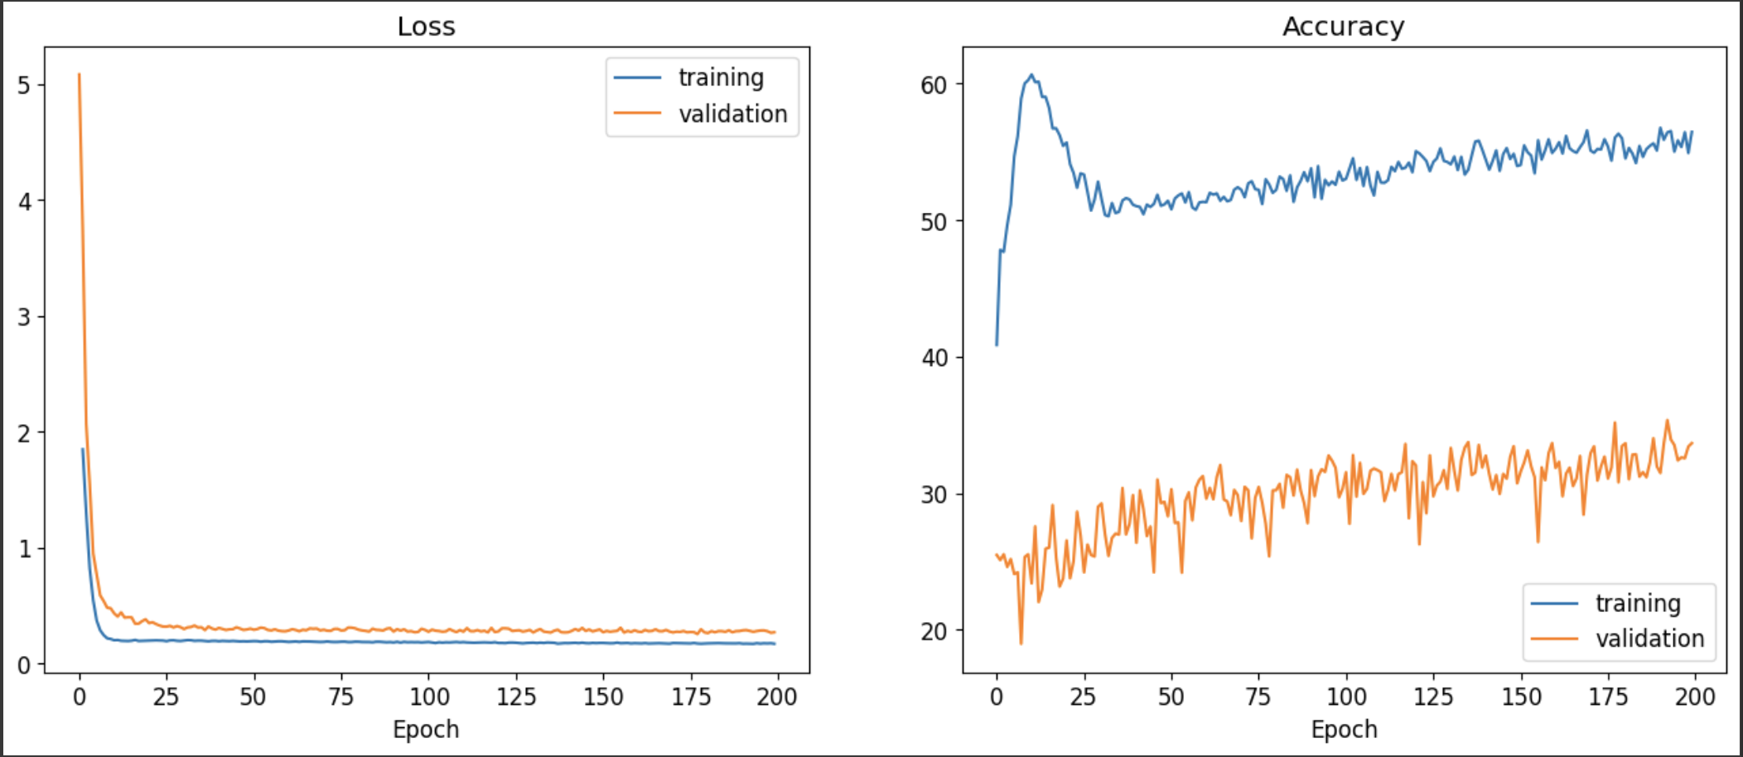

最後的準確率為34.49 %
test_dataloader = Dataloader(test_dataset)
model.load_model(MODEL_PATH)
model.test(test_dataloader)

若將learning rate改成0.0001，則準確率會大幅下降，變成26.68 %
# Please set your hyperparameters here
BATCH_SIZE = 8
LR = 1e-4
LR_DECAY = 1.0
HIDEEN_DIM = 256

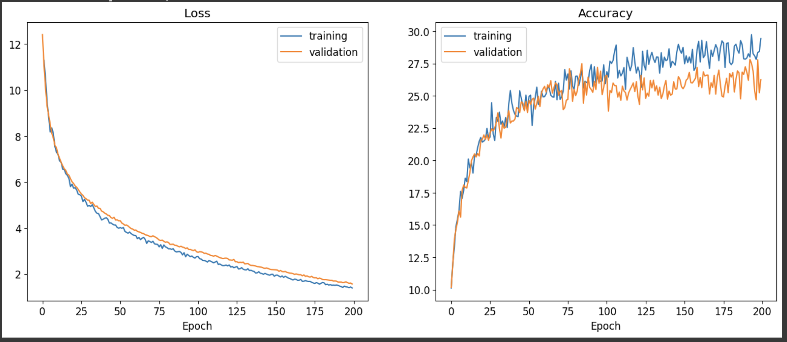
test_dataloader = Dataloader(test_dataset)
model.load_model(MODEL_PATH)
model.test(test_dataloader)

而若調大batch size、調低learning rate和learning rate decay以及降低hidden layer dimension，以上述結果來看，都會使得結果準確率降低，因此目前我們可以推論，最好的hyperparameter為：
Batch size = 8
Learning rate = 0.01
Learning rate decay = 1.0
Hidden layer dimension = 256

額外嘗試：將batch size改小變成4，準確率會更高，為35.42 %
(因為batch size = 4不在範例的候選名單內，因此程式碼的最終版本用batch size = 8的版本)
