深度視覺 HW2
M113040064 資工碩 李冠宏
執行結果分析
- Data Preparation and Visualization
首先將colab連結到google drive，新增路徑並引入相關套件，最後下載用來訓練和測試的train data和test data以及他們對應的label
from google.colab import drive
drive.mount('/content/drive')

import sys
sys.path.append('/content/drive/MyDrive/HW2/')

from _utils import load_data
import numpy as np
import matplotlib.pyplot as plt

train_data, train_label, test_data, test_label, classes = load_data()

印出所需資料的shape及class長度
print(f'Shape of training data: {train_data.shape}')
print(f'Shape of training labels: {train_label.shape}')
print(f'Shape of test data: {test_data.shape}')
print(f'Shape of test labels: {test_label.shape}')
print(f'Number of classes: {len(classes)}')
執行結果
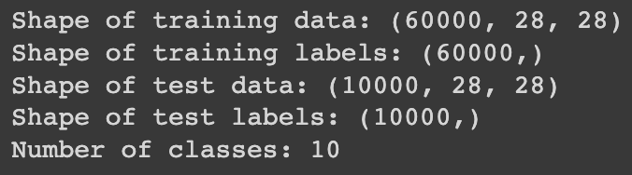

- 測試training data和testing data各一筆
這階段透過matplotlib.pyplot套件來畫子圖，測試我們的資料是否有正確地被引入進來
- # Display samples of training data and test data with their classes
- plt.rcParams['figure.figsize'] = (8, 5)
- plt.rcParams['image.cmap'] = 'gray'
- fig, (ax1, ax2) = plt.subplots(1, 2)
- ax1.imshow(train_data[0]); ax1.set_title(f'Class of training data:\n{classes[train_label[0]]}')
- ax2.imshow(test_data[0]); ax2.set_title(f'Class of test data:\n{classes[test_label[0]]}')
- fig.show()

執行結果：
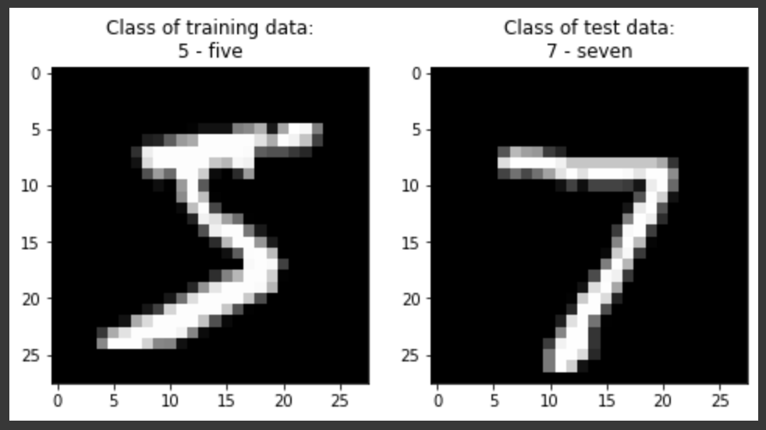

3. 測試所有training data
這階段將所有train data進行測試，並印出每個class中屬於此類別的train data
# Display samples of training data from every classes
plt.rcParams['figure.figsize'] = (12, 8)
num_classes = len(classes)
num_example = 8 #每一個類別的數量
for label, _ in enumerate(classes):
idxs = np.flatnonzero(train_label == label) #flatnonzero會回傳非0元素的index
idxs = np.random.choice(idxs, size=num_example, replace=False) #代表從idxs中隨機抽取num_example的"不重複"數字
for i, idx in enumerate(idxs):
plt_idx = i * num_classes + label + 1
plt.subplot(num_example, num_classes, plt_idx) #plt.subplot(row, column, index)
plt.imshow(train_data[idx]); plt.axis('off')
if i == 0:
plt.title(label) #印出類別的index
plt.show()

執行結果：
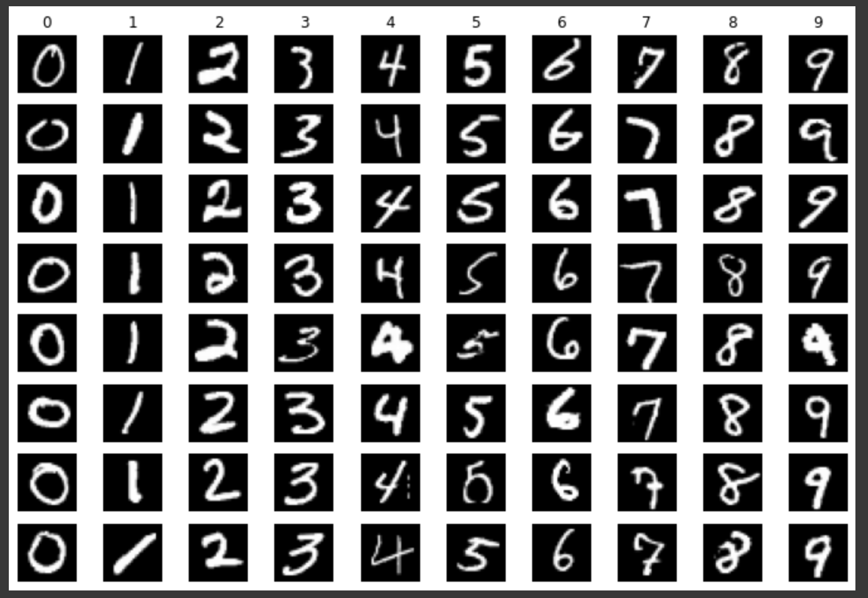

4. KNN Implementation
這階段是建構模型，在knn類別中，我們首先在建構式定義好train data的大小、資料本身和label。
接下來定義predict方法，這裡分為L1和L2，其中公式定義如下：
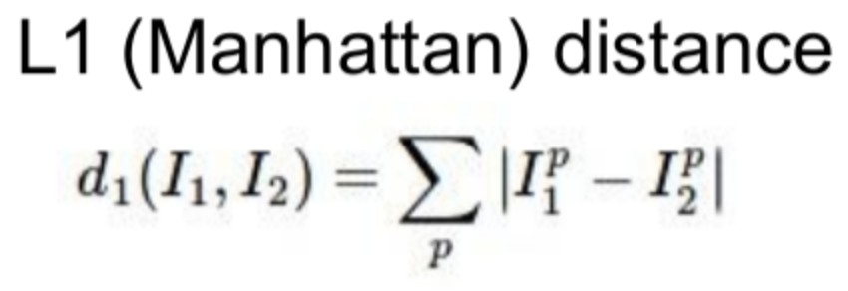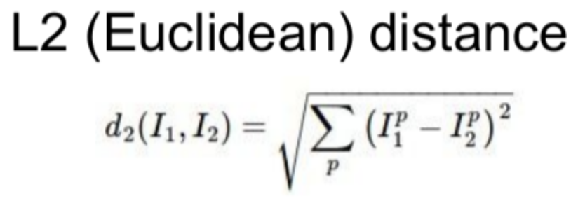
在L1和L2分別計算好test data和train data的距離後，存入名為dists的numpy 2d array中，有了這個array後，對於每一筆test data，我們就可以在這裡面找5個距離最小的點、取得他們的index，最後取得他們的label並找出現頻率最高的label作為我們預測的label，再存回preds中
class knn(object):
def __init__(self, data, label):
self.num_train_data = data.shape[0] #5000
self.train_data = data.reshape(self.num_train_data, -1) #訓練資料
self.train_label = label #訓練解答

def predict(self, test_data, dist_metric='l1', k=1):
num_test_data = test_data.shape[0] #500
dists = np.zeros((num_test_data, self.num_train_data)) #dist為num_test_data * num_train_data大小的二維矩陣
if dist_metric == 'l1':
####################
# TODO:
# 1. Flatten test_data, that is, change its shape from (num_test_data, test_data_height, test_data_width) to (num_test_data, flatten_test_data)
# 2. Caculate L1 distances between test data and all the training data for each test data, and then store distances in variable `dists`
####################

# -----START OF YOUR CODE-----
test_data.reshape(num_test_data, -1) #flatten the numpy array
for test_idx in range(num_test_data):
for train_idx in range(self.num_train_data):
dists[test_idx][train_idx] = np.sum(np.abs(test_data[test_idx] - train_data[train_idx]))
# ------END OF YOUR CODE------

elif dist_metric == 'l2':
####################
# TODO:
# 1. Flatten test_data, that is, change its shape from (num_test_data, test_data_height, test_data_width) to (num_test_data, flatten_test_data)
# 2. Caculate L2 distances between test data and all the training data for each test data, and then store distances in variable `dists`
####################

# -----START OF YOUR CODE-----
test_data.reshape(num_test_data, -1) #flatten the numpy array
for test_idx in range(num_test_data):
for train_idx in range(self.num_train_data):
dists[test_idx][train_idx] = np.sqrt(np.sum(np.square(test_data[test_idx] - train_data[train_idx])))
# ------END OF YOUR CODE------

else:
raise ValueError("dist_metric can only be 'l1' or 'l2'")

preds = np.zeros(num_test_data)
####################
# TODO:
# 1. Take majority vote from k closest data to assign each test data a label, and then store labels in variable `preds`
####################

# -----START OF YOUR CODE-----
# min_index = np.where(dists[0] == min(dists[0]))
for test_idx in range(len(test_data)):
indexs = np.argpartition(dists[test_idx], k) #最近k個點的index
labels = []
for idx in indexs[:k]:
labels.append(train_label[idx])
max_value = np.bincount(labels).argmax() #找頻率最高的
# min_index = np.where(dists[test_idx] == min(dists[test_idx]))
preds[test_idx] = max_value
# ------END OF YOUR CODE------

return preds

5. 執行單筆資料測試
# Run a single test
single_test_data = test_data[:1] #test_data的第一筆資料
num_test_data, test_data_height, test_data_width = single_test_data.shape

#建立model
classifier = knn(train_data, train_label)
#猜測
predicted_label = classifier.predict(single_test_data, k=1, dist_metric='l2')[0].astype(np.int32)

#畫圖
plt.rcParams['figure.figsize'] = (3, 3)
plt.imshow(single_test_data.reshape(test_data_height, test_data_width)); plt.title(f'Predicted class: {classes[predicted_label]}')
plt.show()
執行結果：
(預測正確)
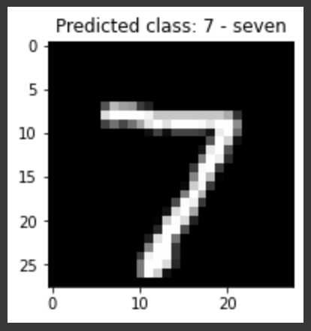

6. Applied in Small Dataset
測試train data和test data分別的數量，並建立knn model
small_train_data = train_data[:5000]
small_train_label = train_label[:5000]
small_test_data = test_data[:500]
small_test_label = test_label[:500]
classifier = knn(small_train_data, small_train_label)
print(f'Number of training data: {small_train_data.shape[0]}')
print(f'Number of test data: {small_test_data.shape[0]}')

執行結果：
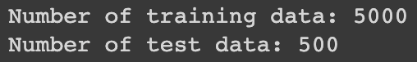

在較小的dataset中進行訓練及測試
num_test_data = small_test_data.shape[0]
for dm in ['l1', 'l2']:
print(f'Using {dm.upper()} distance metric:')
for kv in [2, 3, 4, 10, 20]:
preds = classifier.predict(small_test_data, k=kv, dist_metric=dm)
num_correct = np.sum(preds == small_test_label)
accuracy = float(num_correct) / num_test_data
print(f'k = {kv}, accuracy = {accuracy}')
print('')

執行結果：
在k值相同的情況下，L1的準確度比L2高很多，而在k相異的情況下，k一般來說不要太大結果會比較好
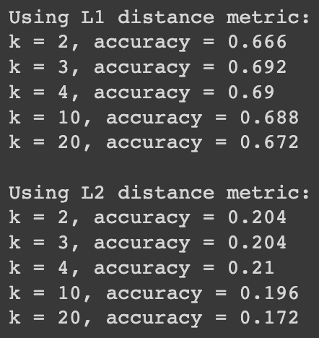

7. Applied in Whole Dataset
為了要找到最好的算距離方法以及k，在此用了一段程式去訓練就上述而言所有的可能性，並在每一回合更新最好高準確率的k值，最後有最高準確率的組合為使用L1且k值為4
num_test_data = test_data.shape[0]
best_k = 0
best_method = ""
highest_accuracy = 0

for dm in ['l1', 'l2']:
for kv in [2, 3, 4, 10, 20]:
preds = classifier.predict(test_data, k=kv, dist_metric=dm)
num_correct = np.sum(preds == test_label)
accuracy = float(num_correct) / num_test_data
print(f'Using {dm.upper()} distance metric, k = {kv}\nAccuracy = {accuracy*100}%')
if highest_accuracy < accuracy:
highest_accuracy = accuracy
best_method = dm
best_k = kv
print(f"目前最好的組合為: {best_method} + k={best_k}, 其準確率為: {highest_accuracy*100}%\n")
print("---------------------------------------------\n")

執行結果：
L1 + k=4有最高的準確率
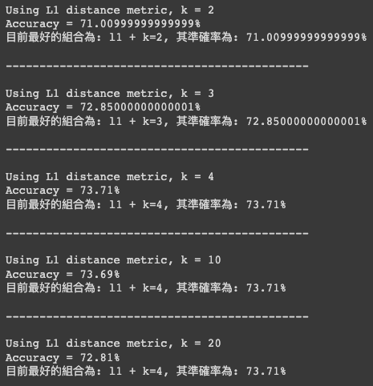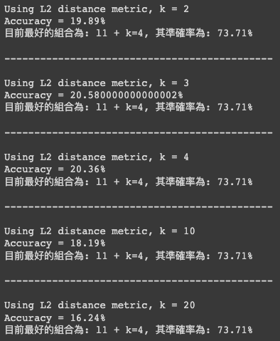

最後將kv值改為4，dm改為L1，得到最佳解
# -----You may change values here-----
kv = 4
dm = 'l1'
# ---------------------------------------

num_test_data = test_data.shape[0]
preds = classifier.predict(test_data, k=kv, dist_metric=dm)
num_correct = np.sum(preds == test_label)
accuracy = float(num_correct) / num_test_data
print(f'Using {dm.upper()} distance metric, k = {kv}\nAccuracy = {accuracy}')

執行結果：
