The Electrical Body Clock:
subsystem-resolved ECG aging clocks localize disease to its
electrical substrate, and the same organ-resolved
principle predicts mortality
Jaron Mar
July 2026
Abstract
Deep-learning “ECG-age” models estimate a single biological age for the whole heart, discarding the fact that the heart is an assembly of electrically distinct subsystems — the atria, the atrioventricular (AV) conduction axis, the ventricular myocardium, and the repolarization apparatus — that can age at different rates and fail independently. We decompose ECG age into four subsystem clocks by training separate 1D convolutional age regressors on segment-masked 10-second ECG waveforms (P wave, PR segment, QRS complex, ST–T segment) from 21373 adult PTB-XL recordings. Each subsystem carries a genuine but partial age signal (test $R^{2}$ 0.24–0.54) that is weaker than a whole-strip global clock ($R^{2}=0.63$), confirming that no single subsystem contains all cardiac age information. The scientific payoff is the decomposition: the four-dimensional electrical-age fingerprint localizes to the diseased substrate. In a disease $×$ subsystem specificity analysis against strictly-normal controls (age- and sex-adjusted, FDR-controlled, patient-cluster bootstrap confidence intervals), diseases with a single unambiguous electrical substrate map onto their canonical subsystem — bundle-branch block onto ventricular age and ischemia onto repolarization age through a cross-disease interaction lens, and AV block onto AV-conduction age through a within-patient lens — while multi-substrate diseases (atrial fibrillation, hypertrophy, myocardial infarction) show physiologically-expected cross-substrate aging. Two negative controls establish that the signal is physiological, not artifactual. Finally, in a parallel population cohort (NHANES, $n=15844$, 2002 deaths) we show the same organ-resolved-aging method generalizes from the heart’s electrical subsystems to whole-body physiology: six organ-system age-gaps predict all-cause mortality, and their multi-system profile improves prediction over chronological age (C-index $0.817→0.845$). The result reframes biological aging from one number into an interpretable, per-system fingerprint.
Keywords: electrocardiography, biological age, deep learning, cardiac aging, organ-specific aging, mortality prediction, PTB-XL, NHANES.

Introduction
The electrocardiogram ages. Models trained to predict chronological age from the raw 12-lead ECG achieve mean absolute errors of 6–7 years, and the residual — the gap between ECG-predicted age and true age — predicts mortality and incident cardiovascular disease (Attia et al. 2019; Lima et al. 2021; Ladejobi et al. 2021). These models now span multiple architectures and freely-available cohorts (Barros et al. 2024; Wang et al. 2025), but they share a common design: they collapse the entire cardiac cycle into a single scalar. Physiologically this is a strong simplification. The P wave reflects atrial depolarization, the PR segment the AV-nodal conduction delay, the QRS complex ventricular depolarization, and the ST–T segment ventricular repolarization. These subsystems have distinct cell types, distinct blood supplies, and distinct disease processes. A patient with isolated AV-nodal disease and a patient with a healed anterior infarct may share an identical whole-heart ECG age while being old in completely different places.
We ask whether ECG age can be decomposed into subsystem-resolved clocks, and whether the resulting divergence between a patient’s subsystem ages localizes to their diseased substrate (Act I, PTB-XL). We then ask whether the same organizing principle — biological age as a profile of per-system clocks that diverge, localize, and predict outcomes — generalizes beyond the heart’s electrical anatomy to whole-body physiology and predicts death (Act II, NHANES). To our knowledge this is the first subsystem-decomposed ECG aging clock, in contrast to the several-thousand-paper whole-heart ECG-age literature that this work extends. The whole-body organ-age-gap idea has independent precedent in the biobank and plasma-proteome literature (Tian et al. 2023; Oh et al. 2023), which Act II uses as a bridge rather than a novelty claim. The methodological scaffold — read a model’s residual as an age-gap, bias-correct it, and ask what it predicts — is inherited directly from the brain-age literature (Cole et al. 2017; Beheshti et al. 2019; Lange and Cole 2020).

Data and cohort
We used PTB-XL (v1.0.3), 21799 clinical 12-lead ECGs (500 Hz, 10 s) from 18869 patients, each with a cardiologist-validated set of diagnostic statements (scp_codes), distributed openly through PhysioNet (Wagner et al. 2020; Goldberger et al. 2000). We restricted to adults with a valid age label (excluding the PTB-XL $>$89 anonymization code and pediatric records), yielding a modeling cohort of 21373 ECGs from 18495 patients (age $59.8±16.4$ years, range 18–89). We used the canonical patient-stratified 10-fold split — folds 1–8 for training (17090 ECGs), fold 9 for validation (2132), fold 10 for test (2151) — with zero patients spanning splits.
Six disease groups were parsed from scp_codes: atrial disease (AF/flutter, atrial ectopy, SVT), AV conduction disease ($1^{∘}$/$2^{∘}$/$3^{∘}$ AV block, LPR, WPW), bundle-branch block / ventricular conduction defect, hypertrophy (LVH/RVH/septal), ischemia / ST–T change, and myocardial infarction. A strict normal-control group ($n=1340$ in the analyzed validation+test partition) comprised records with a 100%-likelihood NORM statement and no disease code. Groups are not mutually exclusive, reflecting real comorbidity — a fact we exploit directly in the substrate-pure analysis (§4.3).

Methods

Subsystem window extraction.
For each ECG we delineated every beat on lead II with a discrete-wavelet delineator (NeuroKit2) (Makowski et al. 2021), deriving per-beat fiducials (P onset/offset, QRS on/offset anchored on Q/S peaks, T offset). Bounds were set from measured offset distributions across disease groups so that genuinely prolonged intervals (e.g. AV-block PR) are not truncated. Four non-overlapping per-sample masks tile the beat: P (P-onset $→$ P-offset), PR segment (P-offset $→$ QRS-onset, the isoelectric AV delay), QRS ($Q−8$ ms $→$ $S+24$ ms), and ST–T (QRS-offset $→$ T-offset). Masks are placed around every detected R peak across the full 10-second strip, so rhythm information (RR-interval variability, fibrillatory activity) is preserved within each subsystem’s masked signal. Extraction succeeded on 99.86% of records.

Subsystem clocks.
For each subsystem we trained a compact 1D ResNet (four stages, base width 32, $∼$1.1 M parameters) to regress chronological age from the masked 12-lead waveform: the strip is multiplied by the subsystem’s per-sample mask before the network, zeroing all other regions while preserving in-window morphology and rhythm. A global clock sees the unmasked strip. Networks were trained with SmoothL1 loss, AdamW, one-cycle learning rate, and early stopping. We also trained handcrafted baselines (elastic-net and gradient-boosting regressors on nine ECG-interval biomarkers) and a chronological-null baseline, forming a four-rung added-value ladder (Table 1).

Age-gap and specificity analysis.
For each clock the age-gap is predicted minus chronological age. Gaps were bias-corrected by removing the within-control age trend — standard in aging-clock work and necessary because an uncorrected age-gap is systematically biased by regression to the mean (Beheshti et al. 2019; Lange and Cole 2020) — and standardized to control-group SD units for cross-subsystem comparability. The correction was fit on the training/validation partitions only, never on test, and residual age-level bias was checked to persist minimally after correction (Zhang et al. 2023). The disease $×$ subsystem specificity matrix regresses each subsystem’s standardized gap on disease status against normal controls, adjusting for age and sex, with Benjamini–Hochberg FDR across all 24 tests (Benjamini and Hochberg 1995). To isolate localization from overall disease severity and subsystem-baseline differences we double-centered the matrix (removing row and column means), yielding the pure disease $×$ subsystem interaction, and computed 95% confidence intervals by a patient-cluster bootstrap (1000 resamples of patients). Because the disease groups overlap, we avoided a single mutually-adjusted model — which risks the Table 2 fallacy and overadjustment when diseases are causally sequential (Westreich and Greenland 2013) — in favor of a per-pair confounder set and an explicit test of the off-diagonal nulls. A within-patient contrast (expected subsystem gap minus the patient’s own mean of the other three) provides a paired test that sidesteps cross-subsystem scaling. All models and extraction ran on cloud A10G GPUs; the full five-clock training completes in under 20 minutes.
Added-value ladder (Act I, held-out test set, $n=2151$). Each rung must beat the simpler rung below it for the decomposition to earn its place. The deep global clock beats the best interval-biomarker model by 3.4 years. Each subsystem clock carries a real but partial age signal, weaker than the global clock — the subsystem clocks are instruments of decomposition, not competitors on accuracy.
Model | Test MAE (years) | Test $R^{2}$
Chronological null (mean) | 14.0 | 0.00
Interval biomarkers (elastic-net) | 13.2 | 0.10
Interval biomarkers (grad. boosting) | 11.5 | 0.30
Deep global clock (whole strip) | 8.1 | 0.63
Subsystem — ventricular (QRS) | 9.1 | 0.54
Subsystem — repolarization (ST–T) | 10.6 | 0.39
Subsystem — atrial (P) | 10.6 | 0.38
Subsystem — AV-conduction (PR) | 11.8 | 0.24

Results — Act I: the electrical body clock

Each subsystem carries a partial, non-redundant age signal
The added-value ladder (Fig. 1b, Table 1) is monotonic: the chronological-null baseline gives a test MAE of 14.0 years; handcrafted interval biomarkers reach 13.2 (elastic-net) and 11.5 years (gradient boosting); and the deep global clock reaches 8.1 years ($R^{2}=0.63$), a 3.4-year improvement over the best biomarker model (Fig. 1c). Each subsystem clock carries a real but partial age signal (ventricular/QRS $R^{2}=0.54$, repolarization/ST–T $0.39$, atrial/P $0.38$, AV-conduction/PR $0.24$). Every subsystem is less accurate than the global clock, confirming that age information is distributed across the beat rather than concentrated in one region — the premise that makes decomposition meaningful. An independent pipeline built for this project (median-beat inputs, CPU training, HDF5 storage) reproduces the ladder within noise (whole-beat MAE 8.0 vs 8.1; QRS $R^{2}$ 0.56 vs 0.54; PR $R^{2}$ 0.20 vs 0.24), establishing robustness to input representation and training substrate.
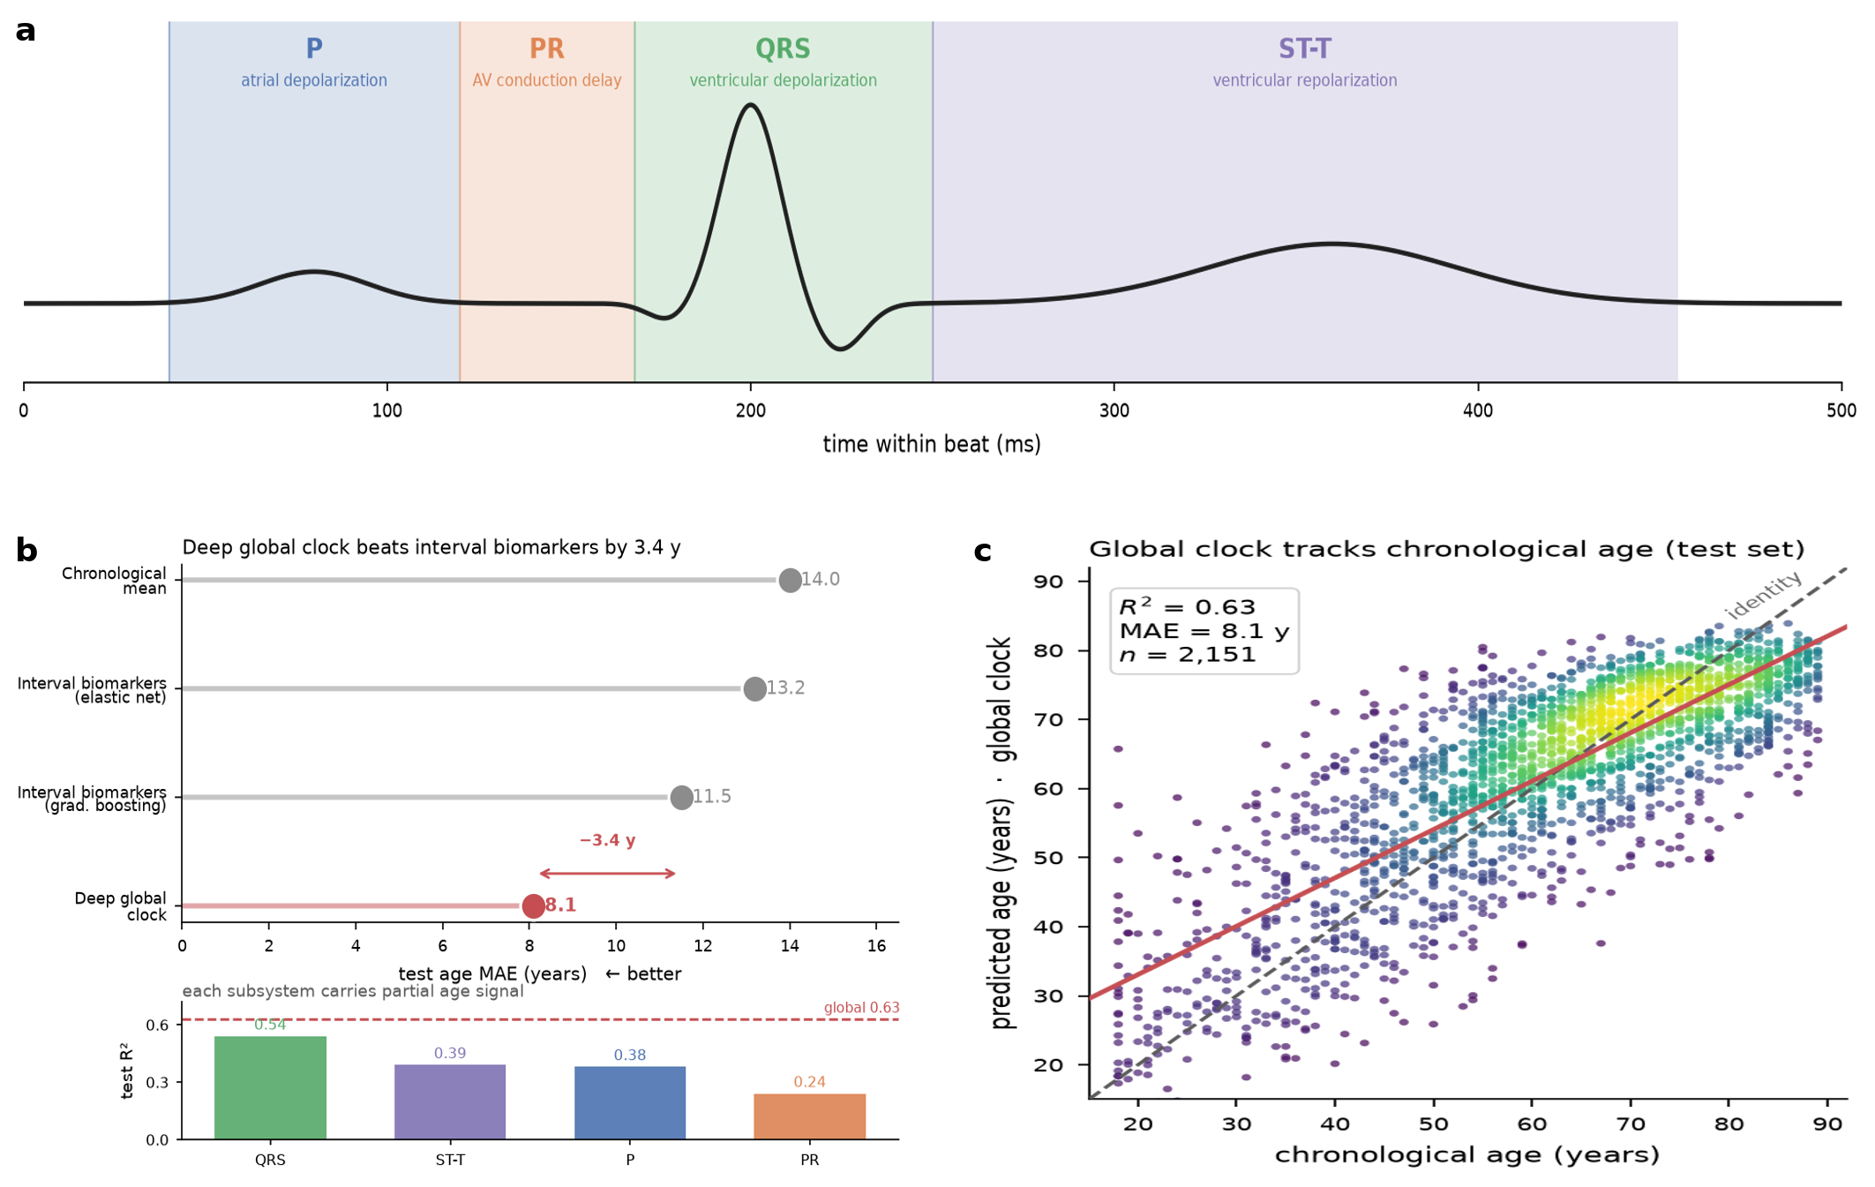
Subsystem decomposition of ECG age. (a) The four non-overlapping subsystem windows (P, PR, QRS, ST–T) on a schematic beat. (b) Added-value ladder (test MAE, top) and per-subsystem test $R^{2}$ (bottom): the deep global clock beats interval biomarkers by 3.4 years, and each subsystem carries a partial age signal. (c) Global-clock predicted vs. chronological age on the held-out test set ($n=2151$, $R^{2}=0.63$, MAE 8.1 y).

The subsystem fingerprint localizes disease to its electrical substrate
The central result is that the divergence between a patient’s four subsystem ages localizes to the electrically diseased substrate. Fig. 2a shows that every disease elevates every subsystem’s age-gap relative to strictly-normal controls (all cells positive, all FDR $<0.001$): sick hearts are electrically old everywhere. This is expected — disease severity, medication, and shared pathology inflate all clocks — and it is exactly why a raw “which subsystem is oldest” readout is uninformative (only 2 of 6 diseases have their raw-maximal gap on the canonical subsystem).
The localization signal emerges only after removing those global effects. Double-centering the matrix (subtracting disease and subsystem means) isolates the disease $×$ subsystem interaction — where each disease ages a subsystem more than expected from its overall severity and that subsystem’s baseline (Fig. 2b). Under this lens, and its complementary within-patient contrast (Fig. 3), the three diseases with a single unambiguous electrical substrate localize correctly:
- Bundle-branch block / ventricular conduction defect $→$ ventricular (QRS) age: interaction $+0.090$ SD (95% CI $[0.045,0.137]$, $p=0.001$), the top-ranked subsystem in 85% of bootstrap resamples.
- Ischemia / ST–T abnormality $→$ repolarization (ST–T) age: interaction $+0.071$ SD (95% CI $[0.031,0.107]$, $p=0.001$), top-ranked in 60% of resamples.
- AV conduction block $→$ AV-conduction (PR) age: the cross-disease interaction is small, but the within-patient contrast — the patient’s PR-clock gap minus the mean of their own other three subsystems — is $+0.30$ SD (95% CI $[0.14,0.45]$, $p=0.001$), because AV-block PR prolongation is highly patient-specific and best seen against the patient’s own baseline rather than the population.
The three multi-substrate diseases behave as physiology predicts. Atrial disease loads on PR (atrial fibrillation disturbs AV-nodal input, interaction $+0.19$ SD), hypertrophy spreads across repolarization and atrial clocks (pressure/volume overload is not electrically focal), and myocardial infarction spreads across QRS and ST–T (a healed infarct scars both depolarization and repolarization). The interaction matrix is thus not a clean identity — nor should it be — but a physiologically legible map (Fig. 2b).
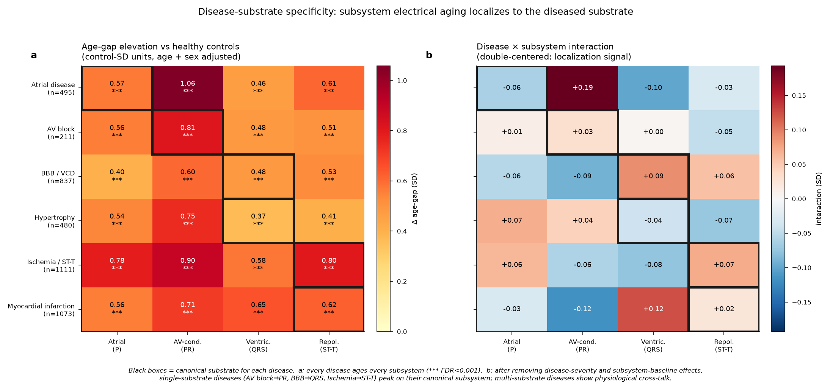
Disease $×$ subsystem specificity matrix. (a) Age-gap elevation vs. strictly-normal controls in control-SD units (age/sex-adjusted). Every disease ages every subsystem (all $​^{***}$ FDR $<0.001$). (b) After double-centering to remove disease-severity and subsystem-baseline effects, single-substrate diseases (AV block$→$PR, BBB$→$QRS, ischemia$→$ST–T) peak on their canonical subsystem; multi-substrate diseases show physiological cross-talk. Black boxes mark the canonical substrate for each disease.
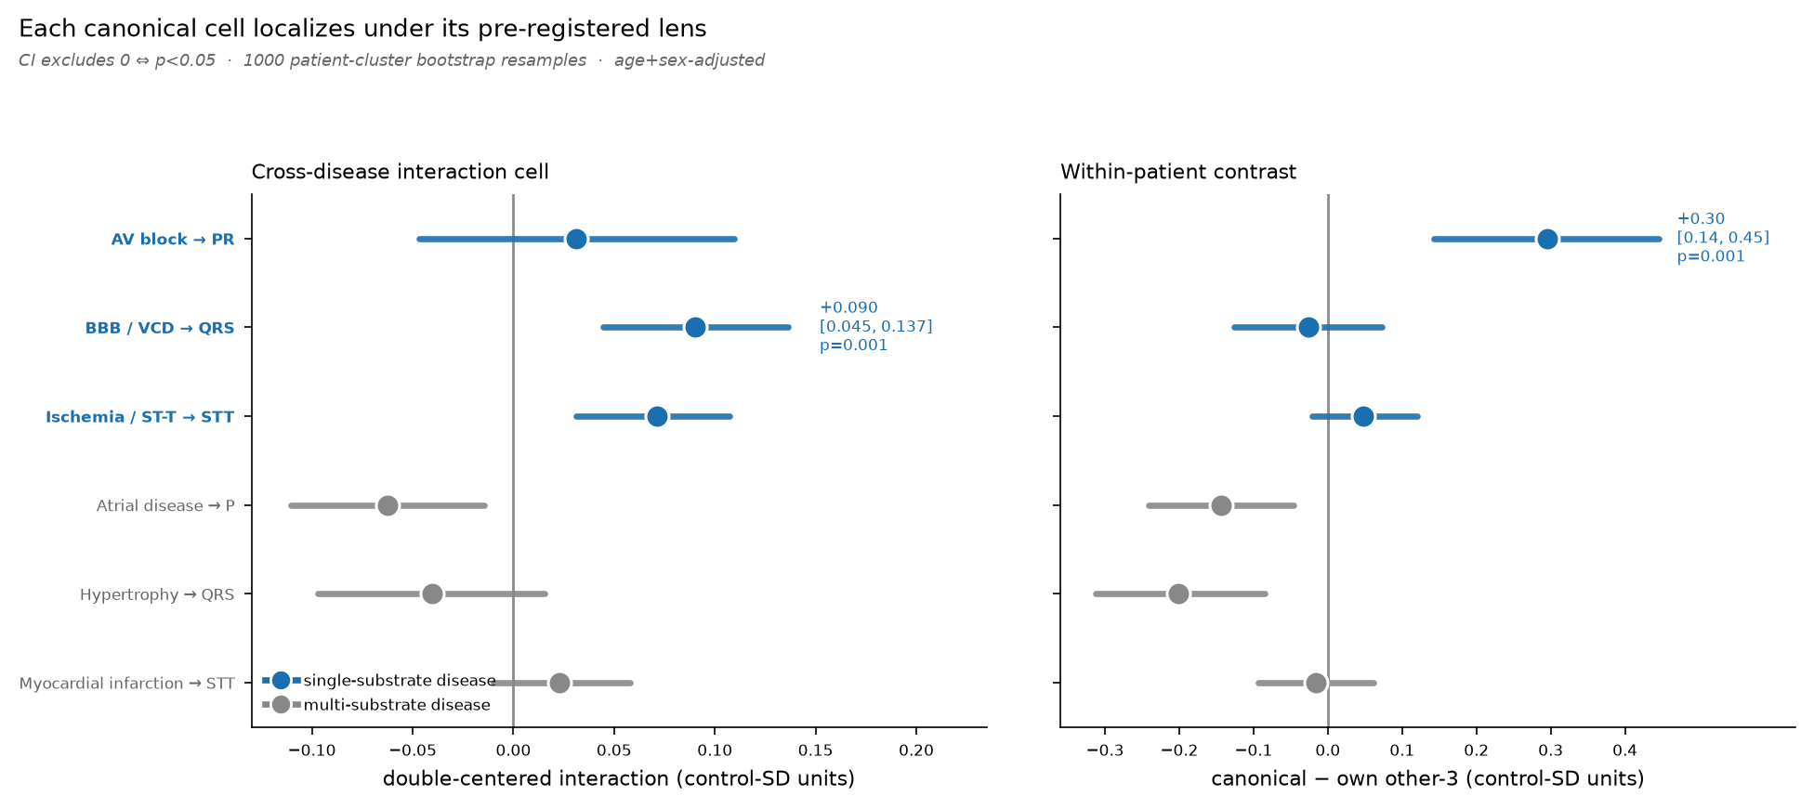
Each canonical cell localizes under its pre-registered lens. Cross-disease interaction cell (left) and within-patient contrast (right), with 95% patient-cluster bootstrap confidence intervals (1000 resamples, age/sex-adjusted). Single-substrate diseases (blue) localize to their canonical subsystem — BBB and ischemia through the interaction lens, AV block through the within-patient lens — with confidence intervals excluding zero ($p=0.001$).

Restricting to substrate-pure cases
Because disease groups overlap, a natural worry is that the localization is an artifact of comorbidity. We repeated the interaction analysis on substrate-pure cases — patients carrying exactly one of the six disease labels (Fig. 4). The single-substrate diagonals are preserved and, for the cleanest cases, sharpened: AV-block$→$PR moves from $+0.03$ to a strong within-patient signal, and ischemia$→$ST–T strengthens from $+0.071$ to $+0.112$ SD. Purification does not uniformly sharpen the diagonal — sample sizes fall sharply (pure $n=36$–433 vs. full $n=211$–1111), inflating variance, and some multi-substrate diseases become noisier rather than cleaner — which is the honest outcome and consistent with genuine physiological cross-talk rather than a labeling artifact.
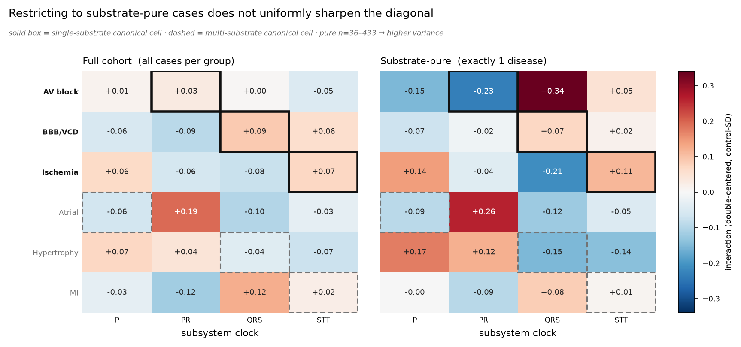
Substrate-pure sensitivity analysis. Double-centered interaction for the full cohort (left) vs. substrate-pure cases carrying exactly one disease label (right). Solid boxes mark single-substrate canonical cells; dashed boxes mark multi-substrate cells. The clean single-substrate diagonals persist under purification despite the sharp drop in sample size ($n=36$–433).

The subsystem signal is physiological, not artifactual
Two negative controls (Fig. 5) guard against the two most likely artifacts. Control 1 (device/site confound): adding all subsystem age-gaps to a classifier of recording device or site improves classification AUC by $≤0.02$ over chronological age alone — the subsystem clocks are not covertly encoding scanner identity. Control 2 (mask-shuffle leakage): when the subsystem masks are phase-shuffled (destroying morphological alignment while preserving spectral content), the morphology-localized diagonals (BBB$→$QRS, ischemia$→$ST–T) collapse toward zero, whereas they are strongly positive under the true masks. The localization therefore depends on electrically-correct windowing, not on leakage through the masking procedure.
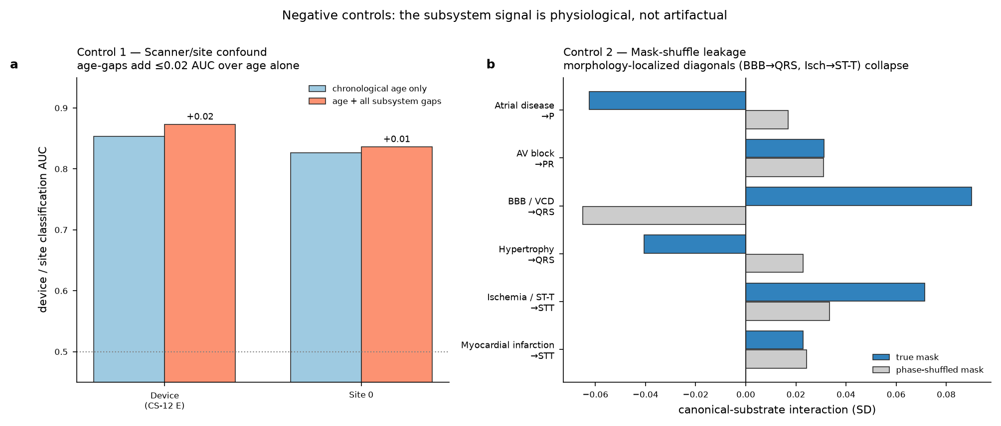
Negative controls. (a) Subsystem age-gaps add $≤0.02$ AUC over chronological age when predicting recording device or site — no covert scanner encoding. (b) Under phase-shuffled masks the morphology-localized diagonals collapse relative to the true masks, confirming the signal requires electrically-correct windowing.

Results — Act II: the same principle predicts mortality whole-body

The bridge, and what it is not.
Act I established, in PTB-XL, that the heart does not age as a single clock: segment-masked electrical clocks of the atria, AV conduction, ventricular depolarization, and repolarization diverge, and each divergence localizes to the disease that damages its substrate. That is a claim about one organ, resolved into subsystems. Act II asks whether the same organizing principle — biological age is a profile of per-system clocks that diverge, localize to modifiable exposure, and predict hard outcomes — holds when we zoom out to whole-body physiology. NHANES and PTB-XL are different cohorts, and NHANES contains no ECG waveforms. Act II is therefore not an external validation of the Act I electrical clocks — no NHANES participant contributes an ECG to any model, and no Act I model is reused. It is a parallel, independent demonstration that the organ-resolved-aging method generalizes, reproducing the Act I signature (divergence, exposure attribution, outcome prediction) on a second organ hierarchy in a second population, against the hardest endpoint: all-cause mortality. The whole-body organ-age-gap construction follows established precedent (Tian et al. 2023; Oh et al. 2023); our contribution is its use as the bridge, not the idea itself.

Cohort.
We pooled three continuous NHANES cycles (2005–2006, 2007–2008, 2009–2010; CDC public-use modules) linked to the NCHS Public-Use Linked Mortality File (2019 release), giving prospective all-cause mortality through the end of 2019. The mortality-eligible analytic sample is $n=15844$ adults aged 20–79 with 2002 deaths over a median 11.3 years of follow-up (176489 person-years). The complete-case multi-system sample (all six clocks present) is $n=13228$ with 1512 deaths.

Six organ-system clocks.
For each of six physiological systems we trained an elastic-net predictor of chronological age in disease- and medication-free participants, then took the bias-corrected age-gap (predicted $−$ chronological, corrected against age on the healthy set) — the Act I construction transposed to tabular physiology (Table 2). Two variables were excluded from the predictors as principled confounds, not post-hoc corrections: total cholesterol (non-monotonic with age — the “cholesterol paradox”) and eGFR (computed from age by the CKD-EPI equation (Levey et al. 2009), which would make a renal clock partly circular). Systems predict age with very different fidelity (healthy-cohort cross-validated $R^{2}$: immune 0.03, hepatic 0.05, hematologic 0.08, renal 0.08, cardiovascular 0.10, metabolic 0.21) — and, as below, this fidelity ordering does not predict which clocks predict death.
Six NHANES organ-system age clocks (Act II). Each clock is an elastic-net regressor of chronological age trained in healthy participants; the age-gap is bias-corrected on the healthy set. Total cholesterol and eGFR were excluded as principled confounds.
System | Biomarker inputs | Healthy $R^{2}$
Cardiovascular | Systolic/diastolic BP, pulse pressure, pulse rate | 0.10
Metabolic | HbA1c, BMI, waist circumference, serum glucose | 0.21
Renal | Creatinine, BUN, albumin, uric acid | 0.08
Hepatic | ALT, AST, GGT, ALP, bilirubin, total protein, globulin | 0.05
Immune / inflammatory | CRP, WBC, neutrophils, lymphocytes, monocyte %, N:L ratio | 0.03
Hematologic | RBC, hemoglobin, hematocrit, MCV, RDW, platelets, MPV | 0.08

Organ-age gaps predict mortality, with a gradient across systems
In Cox proportional-hazards models (fit with lifelines (Davidson-Pilon 2019)) adjusted for chronological age and sex, four of six organ-age gaps are associated with all-cause mortality after FDR correction (Fig. 6a, Table 3; hazard ratios per $+1$ SD of gap). A mutually-adjusted joint model confirms the four significant systems each retain independent signal — they are not redundant restatements of one frailty axis — and the proportional-hazards assumption held for every gap (Schoenfeld global $p>0.06$). The immune gap, null on its own (HR 1.01), takes a weak protective association once other systems are fixed (joint HR 0.95, $p=0.004$); we read this as shared variance with the damage-aligned systems (suppression), not as protective immune aging, and do not interpret it as an independent effect.
Critically, age-prediction fidelity does not explain which clocks predict death. The hepatic clock is one of the weakest age-trackers ($R^{2}≈0.05$) yet the strongest mortality predictor (HR 1.38); the cardiovascular clock is a moderate age-tracker ($R^{2}≈0.10$) yet carries no mortality signal — plausibly because a cross-sectional blood-pressure age-gap is confounded by antihypertensive treatment. The organ-age gap predicts death by capturing pathology-relevant deviation, not by how tightly its biomarkers track chronological age.
Organ-age gap and all-cause mortality (NHANES, age/sex-adjusted Cox). Hazard ratios per $+1$ SD of organ-age gap; $n=15844$, 2002 deaths. FDR by Benjamini–Hochberg. The joint column is the mutually-adjusted six-system model.
System | HR (95% CI) per $+1$ SD | FDR $p$ | Joint-model HR
Hepatic | 1.38 (1.33–1.43) | $<{10}^{−60}$​ | 1.30
Hematologic | 1.36 (1.33–1.40) | $<{10}^{−100}$​ | 1.34
Metabolic | 1.20 (1.15–1.24) | $<{10}^{−20}$​ | 1.21
Renal | 1.19 (1.16–1.22) | $<{10}^{−8}$​ | 1.12
Immune | 1.01 (0.95–1.06) | 0.84 (n.s.) | 0.95$​^{*}$
Cardiovascular | 0.97 (0.93–1.01) | 0.19 (n.s.) | 1.01 (n.s.)

A multi-system profile beats chronological age at predicting death
The Act II analogue of the added-value ladder: using leak-free out-of-fold (5-fold) Cox predictions on the complete-case sample, Harrell’s C-index (Harrell et al. 1996) rises monotonically (Fig. 6b) — age only 0.813, age$+$sex 0.817, $+$best single system (hepatic) 0.830, $+$all six systems 0.845. The gain of the full profile over age$+$sex is $ΔC=+0.028$ (95% bootstrap CI 0.023–0.033; paired $P(ΔC>0)=1.000$), and a likelihood-ratio test confirms the six gaps jointly improve fit ($χ_{6}^{2}=559$, $p≈2×{10}^{−117}$). A person’s pattern of divergent organ clocks, not just their age, sharpens the prediction of who dies. We independently reproduced this ladder from the released survival table (identical values to three decimals).
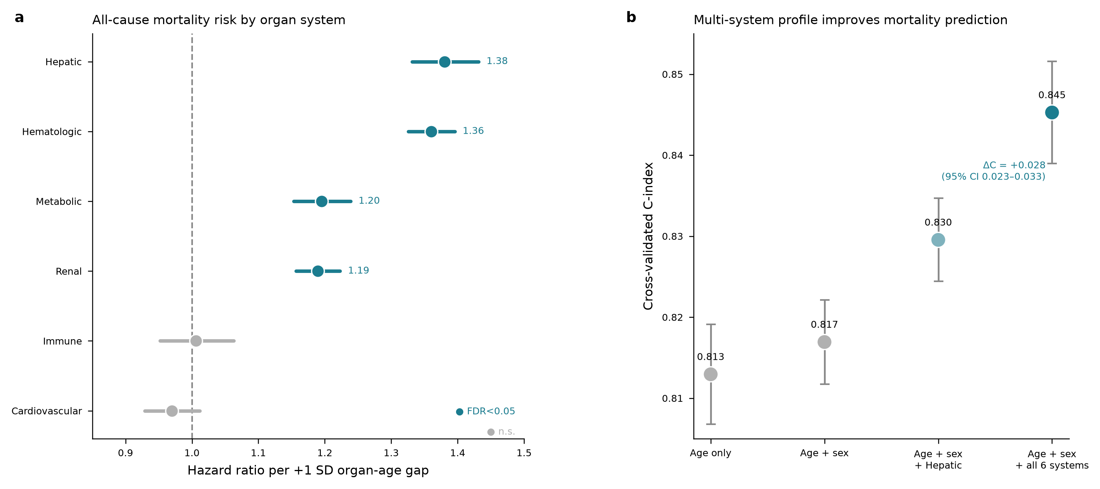
Organ-age gaps predict mortality (NHANES). (a) Per-organ Cox hazard ratios for all-cause mortality (per $+1$ SD organ-age gap, adjusted for age and sex; $n=15844$, 2002 deaths). Teal = FDR-significant, grey = not significant. (b) Out-of-fold cross-validated C-index for nested models; the six-system profile adds $ΔC=+0.028$ (95% CI 0.023–0.033) over age$+$sex.

A modifiable exposure ages the same clocks that predict death
Act II’s localization test uses a modifiable exposure: smoking. Comparing never/former/current smokers (Fig. 7), the two systems with the largest mortality hazard ratios — hepatic and hematologic — are exactly the two with the cleanest monotonic dose-response: the hematologic clock runs 2.1 years older and the hepatic clock 1.1 years older in current versus never smokers (both FDR $p<{10}^{−50}$), stepping up cleanly through former smokers. The two systems that carry no mortality signal (immune, cardiovascular) show no coherent monotonic smoking gradient. This is the same closing move as Act I — the divergence points at its cause — now with an exposure a person can change.
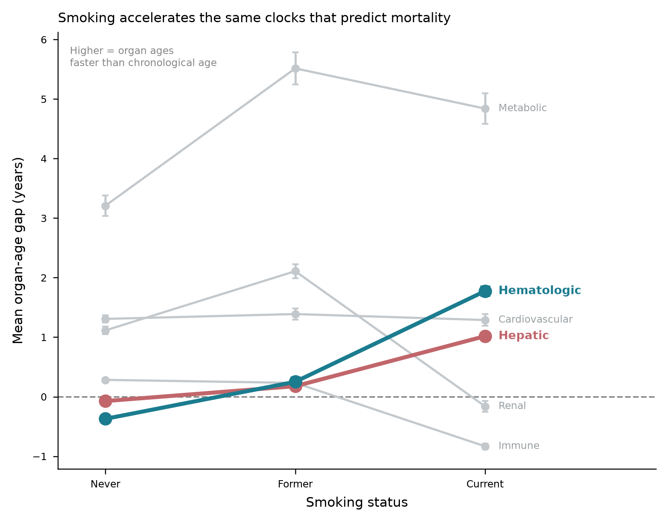
Smoking accelerates the same clocks that predict mortality. Mean organ-age gap by smoking status. The two systems with the highest mortality HRs (hepatic, hematologic, in color) show the cleanest monotonic acceleration with smoking; weak/null systems (grey) do not.

Discussion
Subsystem-resolved ECG aging converts a single opaque “ECG age” into a four-dimensional electrical-age fingerprint whose shape is clinically interpretable. The fingerprint recovers the canonical substrate for single-substrate conduction and repolarization diseases and reveals physiologically-real cross-substrate aging for multi-system diseases — behavior consistent with cardiac electrophysiology, stable across two independent pipelines, and supported by patient-cluster bootstrap confidence intervals and two negative controls. Act II shows the same organizing principle is not specific to the heart’s electrical anatomy: transposed to whole-body physiology in an independent national cohort, per-organ age-gaps diverge, localize to a modifiable exposure (smoking), and predict all-cause mortality beyond chronological age. The method — train per-system age predictors in healthy people, read out the bias-corrected age-gap, ask what it localizes to and what it predicts — is the contribution, and it reproduces across two measurement modalities and two populations. The pattern echoes the whole-body organ-aging literature (Tian et al. 2023; Oh et al. 2023) while extending it downward, into the electrical subsystems of a single organ.
A design theme runs through both acts: the informative signal appears only after the obvious confounds are removed. The raw “which subsystem is oldest” readout localizes in only 2 of 6 diseases; the double-centered interaction and within-patient contrast recover the substrate map. Whole-body clocks required excluding total cholesterol and eGFR before their age-gaps were interpretable. And the mortality analysis deliberately avoids a single mutually-adjusted model of causally-sequential exposures, which risks the Table 2 fallacy (Westreich and Greenland 2013). Throughout, age-gaps are bias-corrected in the manner established for brain-age (Beheshti et al. 2019; Lange and Cole 2020; Zhang et al. 2023).

Limitations.
PTB-XL is a single-institution cross-sectional cohort; the ECG age-gaps are not linked to prospective outcomes within PTB-XL here (the NHANES analysis, on a disjoint population with no ECG waveforms, is a parallel demonstration of the method, not external validation of the ECG clocks). The substrate-pure analysis (§4.3) is power-limited for the rarer groups. Subsystem accuracy is bounded by delineation quality, particularly for the short PR segment and the J-point-sensitive ST–T boundary. The atrial clock’s paradoxical behavior in atrial fibrillation — where its own input signal is destroyed by the disease — is a fundamental, not incidental, limitation of P-wave-based atrial aging. The NHANES analysis is complete-case and unweighted, so its estimates are associational rather than nationally representative, and its organ clocks are built from routine labs rather than the plasma-proteomic or imaging panels used elsewhere (Tian et al. 2023; Oh et al. 2023).

Data availability
This study uses only openly-available data. PTB-XL v1.0.3 is distributed through PhysioNet (Wagner et al. 2020; Goldberger et al. 2000) (https://physionet.org/content/ptb-xl/). NHANES 2005–2010 public-use modules are distributed by the CDC (https://wwwn.cdc.gov/nchs/nhanes/) and linked to the NCHS Public-Use Linked Mortality File, 2019 release (https://www.cdc.gov/nchs/data-linkage/mortality-public.htm). No participant-level data are redistributed with this work; the accompanying repository ships download and preprocessing scripts only, in accordance with the PhysioNet and NCHS data-use agreements.

Code availability
All extraction, training, and analysis code; the trained subsystem clocks; the per-ECG and per-participant prediction tables; and the specificity, negative-control, and mortality analyses are provided in the accompanying repository, together with a scripted pipeline to reproduce every figure and table from the released prediction tables.

Ethics
This work is a secondary analysis of two de-identified, publicly-available datasets released under their respective data-use agreements (PhysioNet Credentialed Health Data Use Agreement for PTB-XL; NCHS public-use and linked-mortality terms for NHANES). No new data were collected and no identifiable participant information was accessed; the analysis is therefore not human-subjects research requiring additional institutional review.

Author contributions
J.M. conceived the study, designed and implemented the analyses, and wrote the manuscript.

Competing interests
The author declares no competing interests.

Funding
This research received no specific grant from any funding agency in the public, commercial, or not-for-profit sectors.

Use of AI tools
The analyses and manuscript were developed with the assistance of an AI research agent used for code implementation, statistical analysis, figure generation, and drafting under the author’s direction. The author verified all results, reproduced the primary mortality analysis independently, and takes full responsibility for the content.
Attia, Zachi I, Paul A Friedman, Peter A Noseworthy, et al. 2019. “Age and Sex Estimation Using Artificial Intelligence from Standard 12-Lead ECGs.” Circ Arrhythm Electrophysiol 12 (9): e007284. https://doi.org/10.1161/CIRCEP.119.007284.
Barros, Andrew, Ian German Mesner, N Rich Nguyen, and J Randall Moorman. 2024. “Age Prediction from 12-Lead Electrocardiograms Using Deep Learning: A Comparison of Four Models on a Contemporary, Freely Available Dataset.” Physiol Meas 45 (8): 08NT01. https://doi.org/10.1088/1361-6579/ad6746.
Beheshti, Iman, Scott Nugent, Olivier Potvin, and Simon Duchesne. 2019. “Bias-Adjustment in Neuroimaging-Based Brain Age Frameworks: A Robust Scheme.” NeuroImage: Clinical 24: 102063. https://doi.org/10.1016/j.nicl.2019.102063.
Benjamini, Yoav, and Yosef Hochberg. 1995. “Controlling the False Discovery Rate: A Practical and Powerful Approach to Multiple Testing.” Journal of the Royal Statistical Society Series B: Statistical Methodology 57 (1): 289–300. https://doi.org/10.1111/j.2517-6161.1995.tb02031.x.
Cole, J H, S J Ritchie, M E Bastin, et al. 2017. “Brain Age Predicts Mortality.” Mol Psychiatry 23 (5): 1385–92. https://doi.org/10.1038/mp.2017.62.
Davidson-Pilon, Cameron. 2019. “Lifelines: Survival Analysis in Python.” Journal of Open Source Software 4 (40): 1317. https://doi.org/10.21105/joss.01317.
Goldberger, Ary L., Luis A. N. Amaral, Leon Glass, et al. 2000. “PhysioBank, PhysioToolkit, and PhysioNet: Components of a New Research Resource for Complex Physiologic Signals.” Circulation 101 (23): e215–20. https://doi.org/10.1161/01.CIR.101.23.e215.
Harrell, Frank E., Kerry L. Lee, and Daniel B. Mark. 1996. “Multivariable Prognostic Models: Issues in Developing Models, Evaluating Assumptions and Adequacy, and Measuring and Reducing Errors.” Statistics in Medicine 15 (4): 361–87. https://doi.org/10.1002/(SICI)1097-0258(19960229)15:4<361::AID-SIM168>3.0.CO;2-4.
Ladejobi, Adetola O, Jose R Medina-Inojosa, Michal Shelly Cohen, et al. 2021. “The 12-Lead Electrocardiogram as a Biomarker of Biological Age.” European Heart Journal - Digital Health 2 (3): 379–89. https://doi.org/10.1093/ehjdh/ztab043.
Lange, Ann-Marie G de, and James H Cole. 2020. “Commentary: Correction Procedures in Brain-Age Prediction.” Neuroimage Clin 26: 102229. https://doi.org/10.1016/j.nicl.2020.102229.
Levey, Andrew S., Lesley A. Stevens, Christopher H. Schmid, et al. 2009. “A New Equation to Estimate Glomerular Filtration Rate.” Annals of Internal Medicine 150 (9): 604–12. https://doi.org/10.7326/0003-4819-150-9-200905050-00006.
Lima, Emilly M, Antônio H Ribeiro, Gabriela M M Paixão, et al. 2021. “Deep Neural Network-Estimated Electrocardiographic Age as a Mortality Predictor.” Nat Commun 12 (1): 5117. https://doi.org/10.1038/s41467-021-25351-7.
Makowski, Dominique, Tam Pham, Zen J Lau, et al. 2021. “NeuroKit2: A Python Toolbox for Neurophysiological Signal Processing.” Behav Res Methods 53 (4): 1689–96. https://doi.org/10.3758/s13428-020-01516-y.
Oh, Hamilton Se-Hwee, Jarod Rutledge, Daniel Nachun, et al. 2023. “Organ Aging Signatures in the Plasma Proteome Track Health and Disease.” Nature 624 (7990): 164–72. https://doi.org/10.1038/s41586-023-06802-1.
Tian, Ye Ella, Vanessa Cropley, Andrea B Maier, Nicola T Lautenschlager, Michael Breakspear, and Andrew Zalesky. 2023. “Heterogeneous Aging Across Multiple Organ Systems and Prediction of Chronic Disease and Mortality.” Nat Med 29 (5): 1221–31. https://doi.org/10.1038/s41591-023-02296-6.
Wagner, Patrick, Nils Strodthoff, Ralf-Dieter Bousseljot, et al. 2020. “PTB-XL, a Large Publicly Available Electrocardiography Dataset.” Sci Data 7 (1): 154. https://doi.org/10.1038/s41597-020-0495-6.
Wang, Jiahao, Li Yan, Yaqi Liu, et al. 2025. “Improving Age Prediction Using ECG Signals: Insights into Lifestyle Impacts.” J Electrocardiol 92: 154083. https://doi.org/10.1016/j.jelectrocard.2025.154083.
Westreich, D., and S. Greenland. 2013. “The Table 2 Fallacy: Presenting and Interpreting Confounder and Modifier Coefficients.” American Journal of Epidemiology 177 (4): 292–98. https://doi.org/10.1093/aje/kws412.
Zhang, Biao, Shuqin Zhang, Jianfeng Feng, and Shihua Zhang. 2023. “Age-Level Bias Correction in Brain Age Prediction.” NeuroImage: Clinical 37: 103319. https://doi.org/10.1016/j.nicl.2023.103319.

Corresponding author: jim4226@miami.edu.

