Support Site Screen Shots  
Jim Baldwin

The main things to look at are Fig. 3, Firmware Download, and Fig. 4, Data Sheet download.

The firmware download page is highly configurable from the database based on business requirements, the "download" button can be replaced with a "call support" message, various messages and related files can be present or not.

The md5 has is generated automatically when the firmware is uploaded by the admin, it is recalculated if the firmware is replaced.

The Data Sheet download section features the ability to download individual documents by clicking on the title, or building a zip file by checking boxes.

The displays for data sheets and other documents are mirrored from the Drupal database on the main site. I had to figure out the Drupal SQL queries (which are extremely complicated) and get them to populate a simpler flat file in the support database, which I would use for sorting and searching, etc.

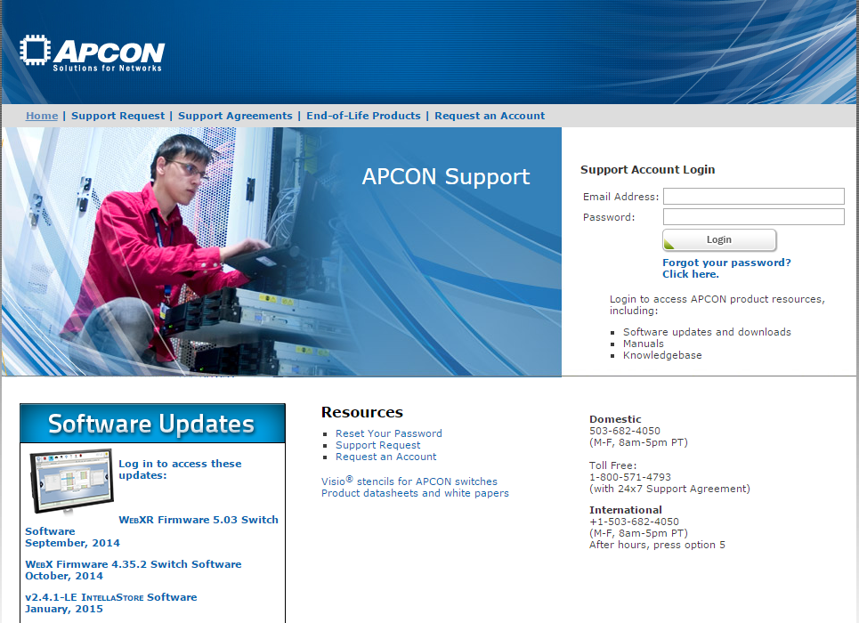

Fig. 1 – Support Home

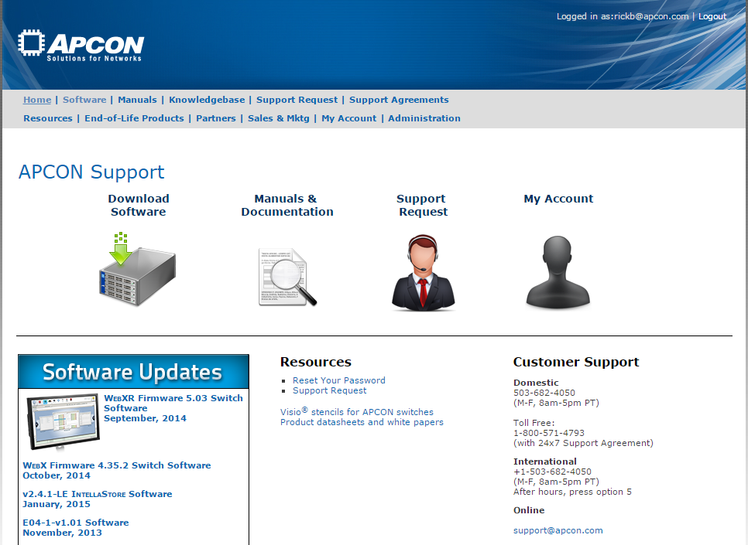

Fig. 2 – Support home, logged in

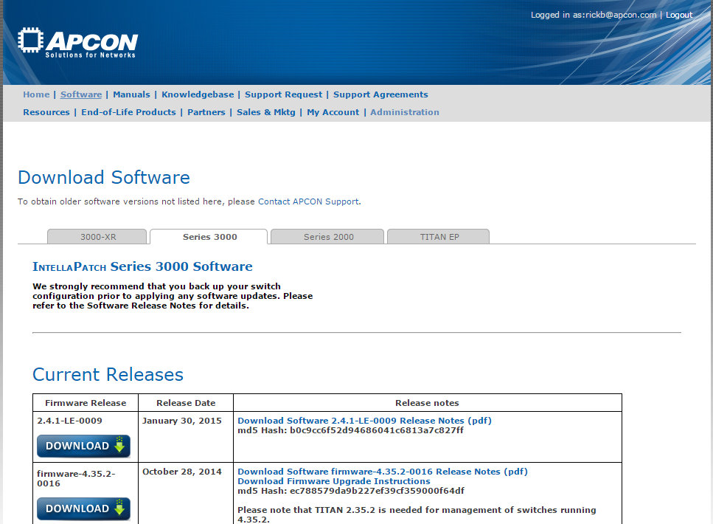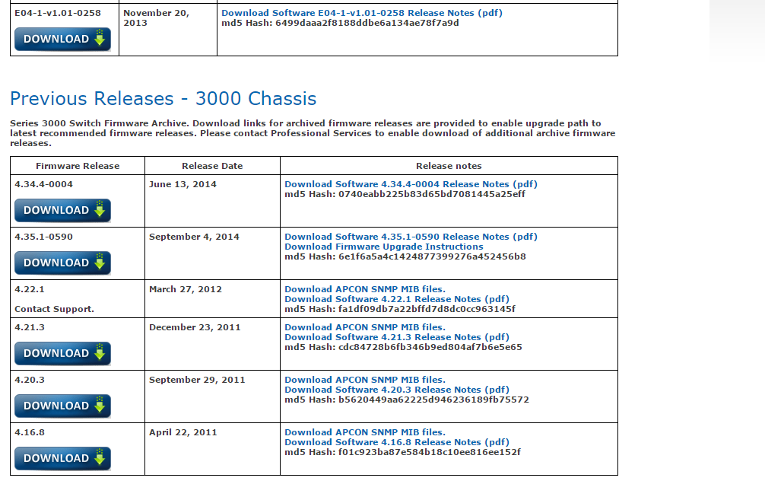  
Fig. 3 – Firmware Download  
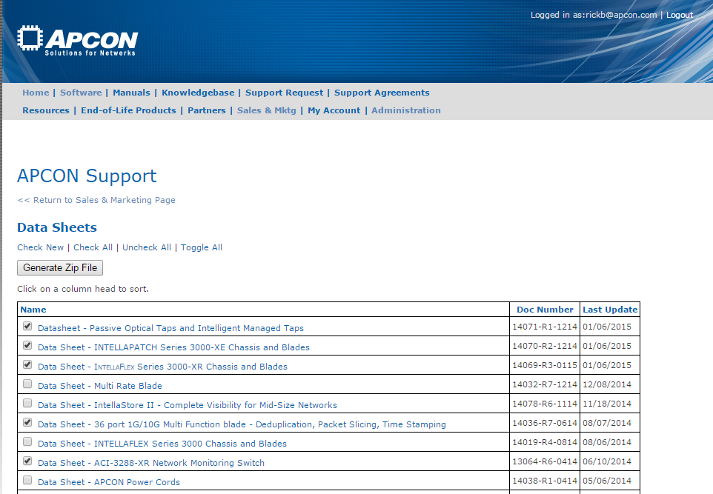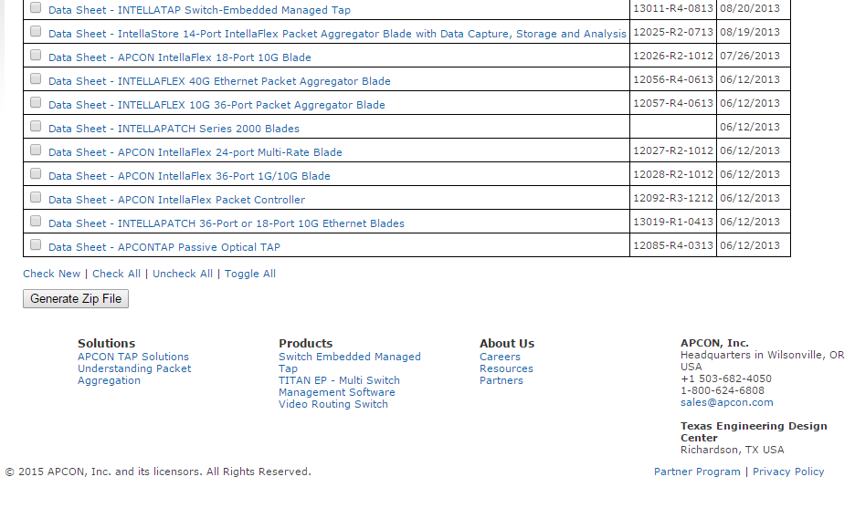  
Fig. 4 – Data Sheet download