
HELP CENTRE
User Guide
Step-by-step guidance for club managers and department leaders

Publication edition · August 2026
The truth behind every visit

How to use this guide
This handbook follows the order a club team actually works in: get oriented, keep the member and visit records right, act on what comes back, run golf and events, then configure the system behind it.
Every article names the exact menu path to the screen it describes, and every screenshot is taken from the Club Vero dashboard itself. Where the menu name and the screen title differ — Overview is titled Member Experience, for instance — the menu name is the one to navigate by.
SECTION | WHAT IT COVERS
1. Getting started | Signing in, finding your way around the five menu groups, and the short management rhythm the product is designed for.
2. Members, visits and surveys | The records that decide who is eligible for a survey, and the screens that show what was sent and what came back.
3. Intelligence and action | What Club Vero does with the feedback once it arrives: service recovery, coaching, and early warning on members.
4. Golf and events | Post-round golf feedback, the crossover between golf and dining, and feedback from club functions.
5. Setup and administration | The configuration that decides who gets surveyed, what they are asked, who answers for it, and what it costs.

BEFORE YOU START Screenshots in this edition were taken from the Club Vero dashboard signed in as a General Manager, using demonstration data for a single club. Your own club name, outlets and figures will differ; the layout, the menu names and the buttons will not.

SECTION 1

Getting started
Signing in, finding your way around the five menu groups, and the short management rhythm the product is designed for.
HELP ARTICLE 01

Sign in and understand your access
Purpose: Get into Club Vero and understand why two people at the same club see different screens.
Where to find it: Your club’s Club Vero address
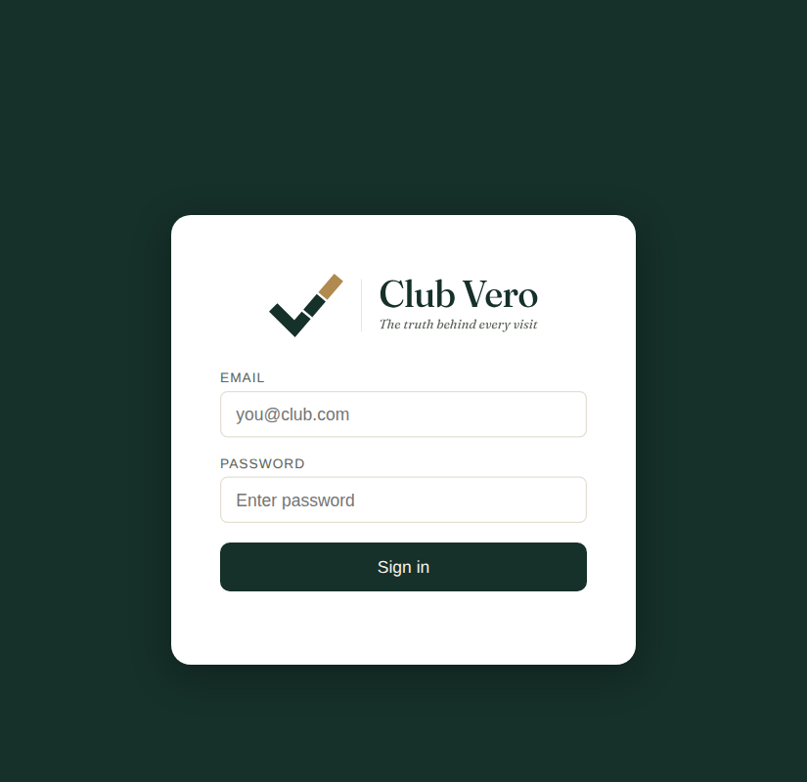
The Club Vero sign-in screen.

Steps
- Enter your email address and password, then select Sign in.
- If this is your first sign-in, or an administrator has reset your password, you are asked to set a new one before the dashboard opens.
- Check the role badge in the top right of the dashboard — it names your role and what it gives you, for example General Manager · Full Access.
- The role also decides which menu items exist for you. Club Vero has six roles: Super Admin, General Manager, F&B Director, Department Head (read-only), Shift Manager and Golf Shift Manager.
- A Shift Manager signs straight into Upload and a Golf Shift Manager straight into Golf, because those are the only screens their role needs.
- If something described in this guide is not on your menu, it is almost always the role rather than a fault. Ask whoever administers your club to check it in Setup → Settings → Team members.
- Select Sign out at the bottom of the left-hand menu when you have finished on a shared computer.

GOOD PRACTICE Give each person the lowest role that still lets them do their job. Members’ names and contact details are only visible to General Manager and above.

HELP ARTICLE 02

Find your way around
Purpose: Learn the five menu groups so you can find any screen in one step.
Where to find it: The left-hand menu, on every screen
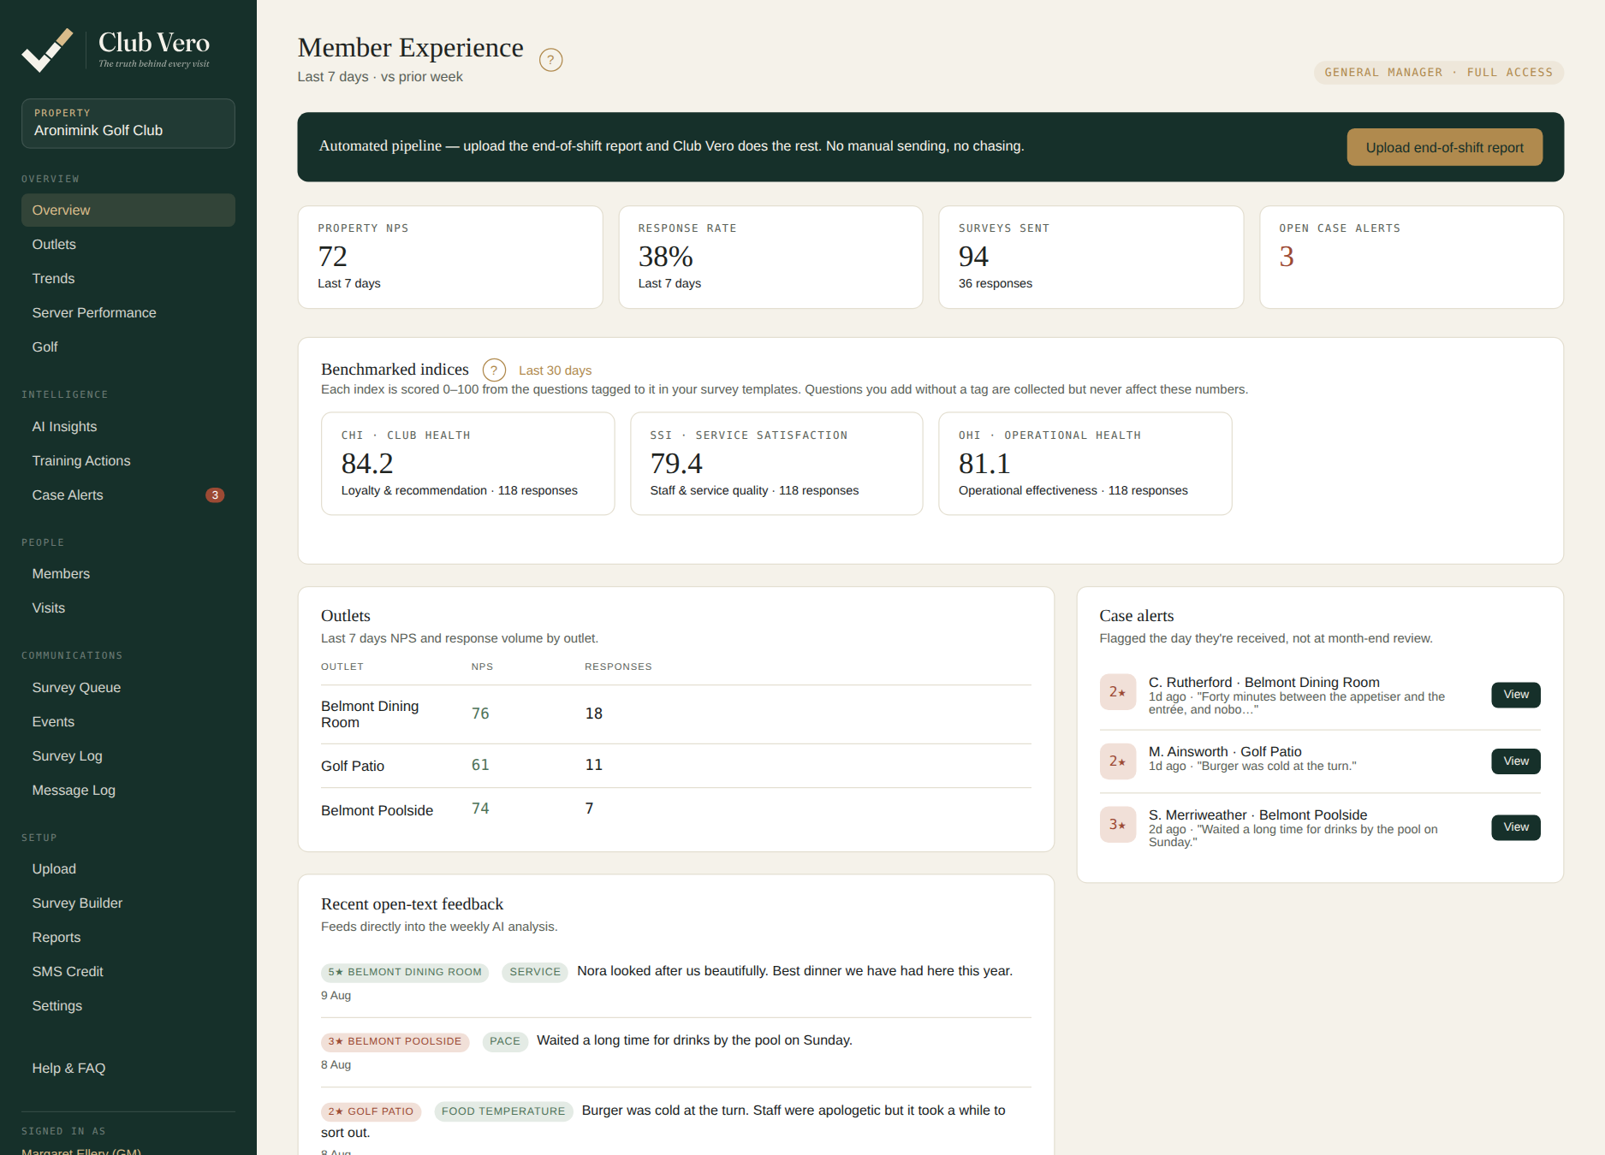
The Member Experience overview, with the five menu groups down the left.

Steps
- Overview holds the screens you read: Overview, Outlets, Trends, Server Performance and Golf.
- Intelligence holds what Club Vero has worked out for you: AI Insights, Training Actions and Case Alerts.
- People holds your records: Members and Visits.
- Communications holds everything about sending and what was sent: Survey Queue, Events, Survey Log and Message Log.
- Setup holds configuration and money: Upload, Survey Builder, Reports, SMS Credit and Settings.
- Two menu items carry a count when there is something waiting — Case Alerts shows open cases in red, Survey Queue shows how many surveys are queued.
- Help & FAQ sits on its own at the bottom of the menu, and every role can open it — including the screens that role cannot otherwise reach.
- The ? button beside any screen title explains what that screen is built from, and links to the step-by-step article for it.

GOOD PRACTICE The screen title is not always the menu name. Overview is titled Member Experience, and Survey Queue is titled Survey Queue but its panel is headed Queued surveys — the menu name is the reliable one.

HELP ARTICLE 03

A daily and weekly rhythm
Purpose: Use Club Vero without adding another reporting burden to the week.
Where to find it: Across Setup, Communications and Intelligence

Steps
- Daily: upload the end-of-shift report in Setup → Upload, unless your POS already sends it automatically.
- Daily: open Intelligence → Case Alerts, assign each new case to a person, and call the members whose cases are close to their call-back window.
- Daily: record the call with Log call, and select Resolve only once the matter is actually finished.
- Weekly: read Overview for NPS, response rate and the three indices, then Outlets and Trends for the direction of travel.
- Weekly: read Intelligence → AI Insights and work through Intelligence → Training Actions.
- Weekly: look at Overview → Server Performance for who to coach and who to recognise, and at People → Members for the Member Health call list.
- Monthly or per committee cycle: build the report in Setup → Reports and export it.
- Close the weekly review by agreeing what will be recognised, corrected, investigated or simply watched.

GOOD PRACTICE A short consistent routine beats constant checking. Everything on the daily list should take a manager under ten minutes on an ordinary day.

SECTION 2

Members, visits and surveys
The records that decide who is eligible for a survey, and the screens that show what was sent and what came back.
HELP ARTICLE 04

Add, import and edit members
Purpose: Keep the membership list that survey eligibility and delivery both depend on.
Where to find it: People → Members
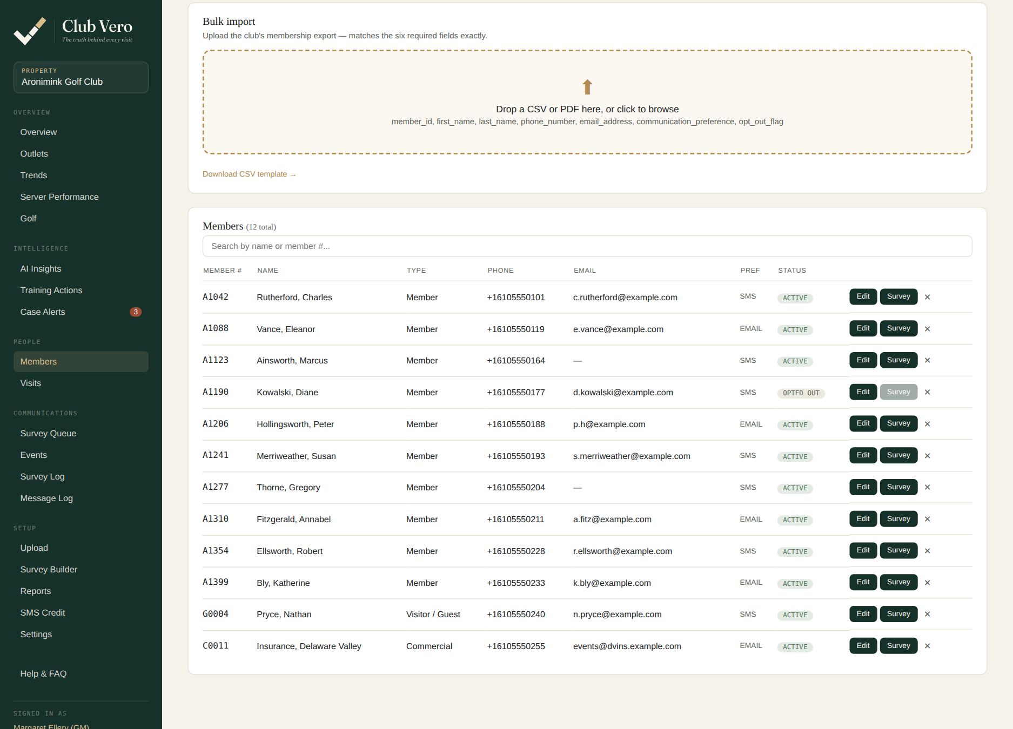
People → Members. The list carries a type, a contact preference and an opt-out status for every record.

Steps
- To add one person, complete Add a member: member number, first name, last name, phone in E.164 format, email, communication preference and type.
- Type is the same vocabulary Visits uses — Member, Visitor / Guest, Commercial or Other. Golf is a valid stored type but is never offered here, because golf records are created by the tee sheet importer.
- Tick Opted out of surveys if the person has asked not to be contacted, then select + Add member.
- For a whole roster, use Bulk import and drop in the club’s CSV export. The columns are member_id, first_name, last_name, phone_number, email_address, communication_preference and opt_out_flag.
- Select Download CSV template → if you need the exact header row to hand to whoever produces the export.
- To change a record, search by name or member number, select Edit, make the change and save.
- Select the status pill to switch a member between Active and Opted out without opening the record.

GOOD PRACTICE Write phone numbers in international format, for example +16105551234. A number stored any other way may look fine on screen and still fail at the carrier.

HELP ARTICLE 05

Upload the end-of-shift report
Purpose: Turn the day’s takings into survey opportunities without anyone reviewing a list.
Where to find it: Setup → Upload, or Upload end-of-shift report on the Overview screen
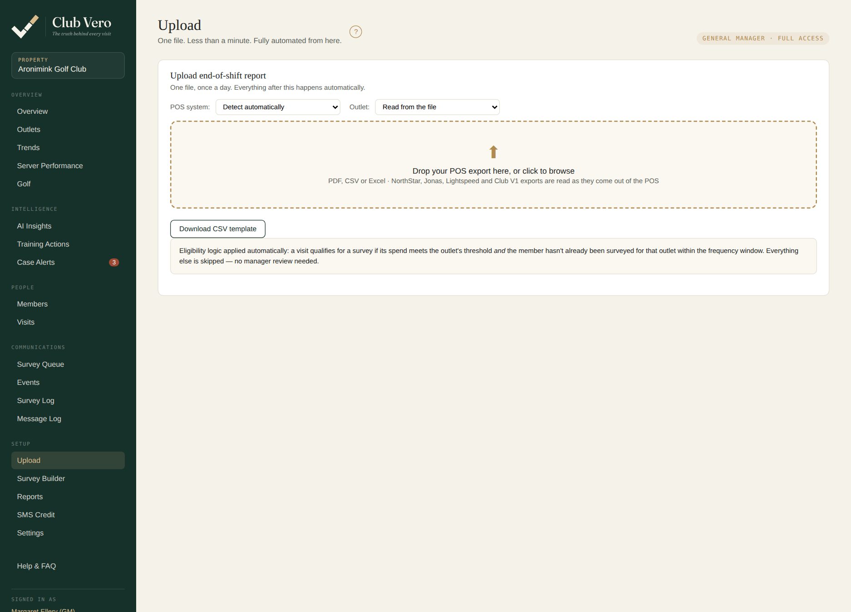
Setup → Upload. One file a day is the whole of the daily routine.

Steps
- Open Setup → Upload, or use the Upload end-of-shift report button in the banner at the top of Overview.
- Leave POS system on Detect automatically unless the export has had its branding stripped; Club Vero reads NorthStar, Jonas, Lightspeed and Club V1 exports as they come out of the POS.
- Leave Outlet on Read from the file when the report covers several outlets, or choose one outlet if the file is for a single room.
- Drop the export into the dashed area, or select it to browse. PDF, CSV and Excel are all read by the server.
- Read the result. Club Vero applies each outlet’s minimum spend and re-survey window itself, so qualifying visits go into the Survey Queue and everything else is simply filed.
- If the parse looks wrong, the diagnostics under the upload area name the outlet, the row count and anything it could not read.

GOOD PRACTICE One file, once a day. Nobody should be reviewing individual visits — that is what the thresholds in Setup → Settings are for.

HELP ARTICLE 06

Log a visit by hand and read the Visit log
Purpose: Record visits that never reach the POS export, and answer the question “why did this member not get a survey?”
Where to find it: People → Visits
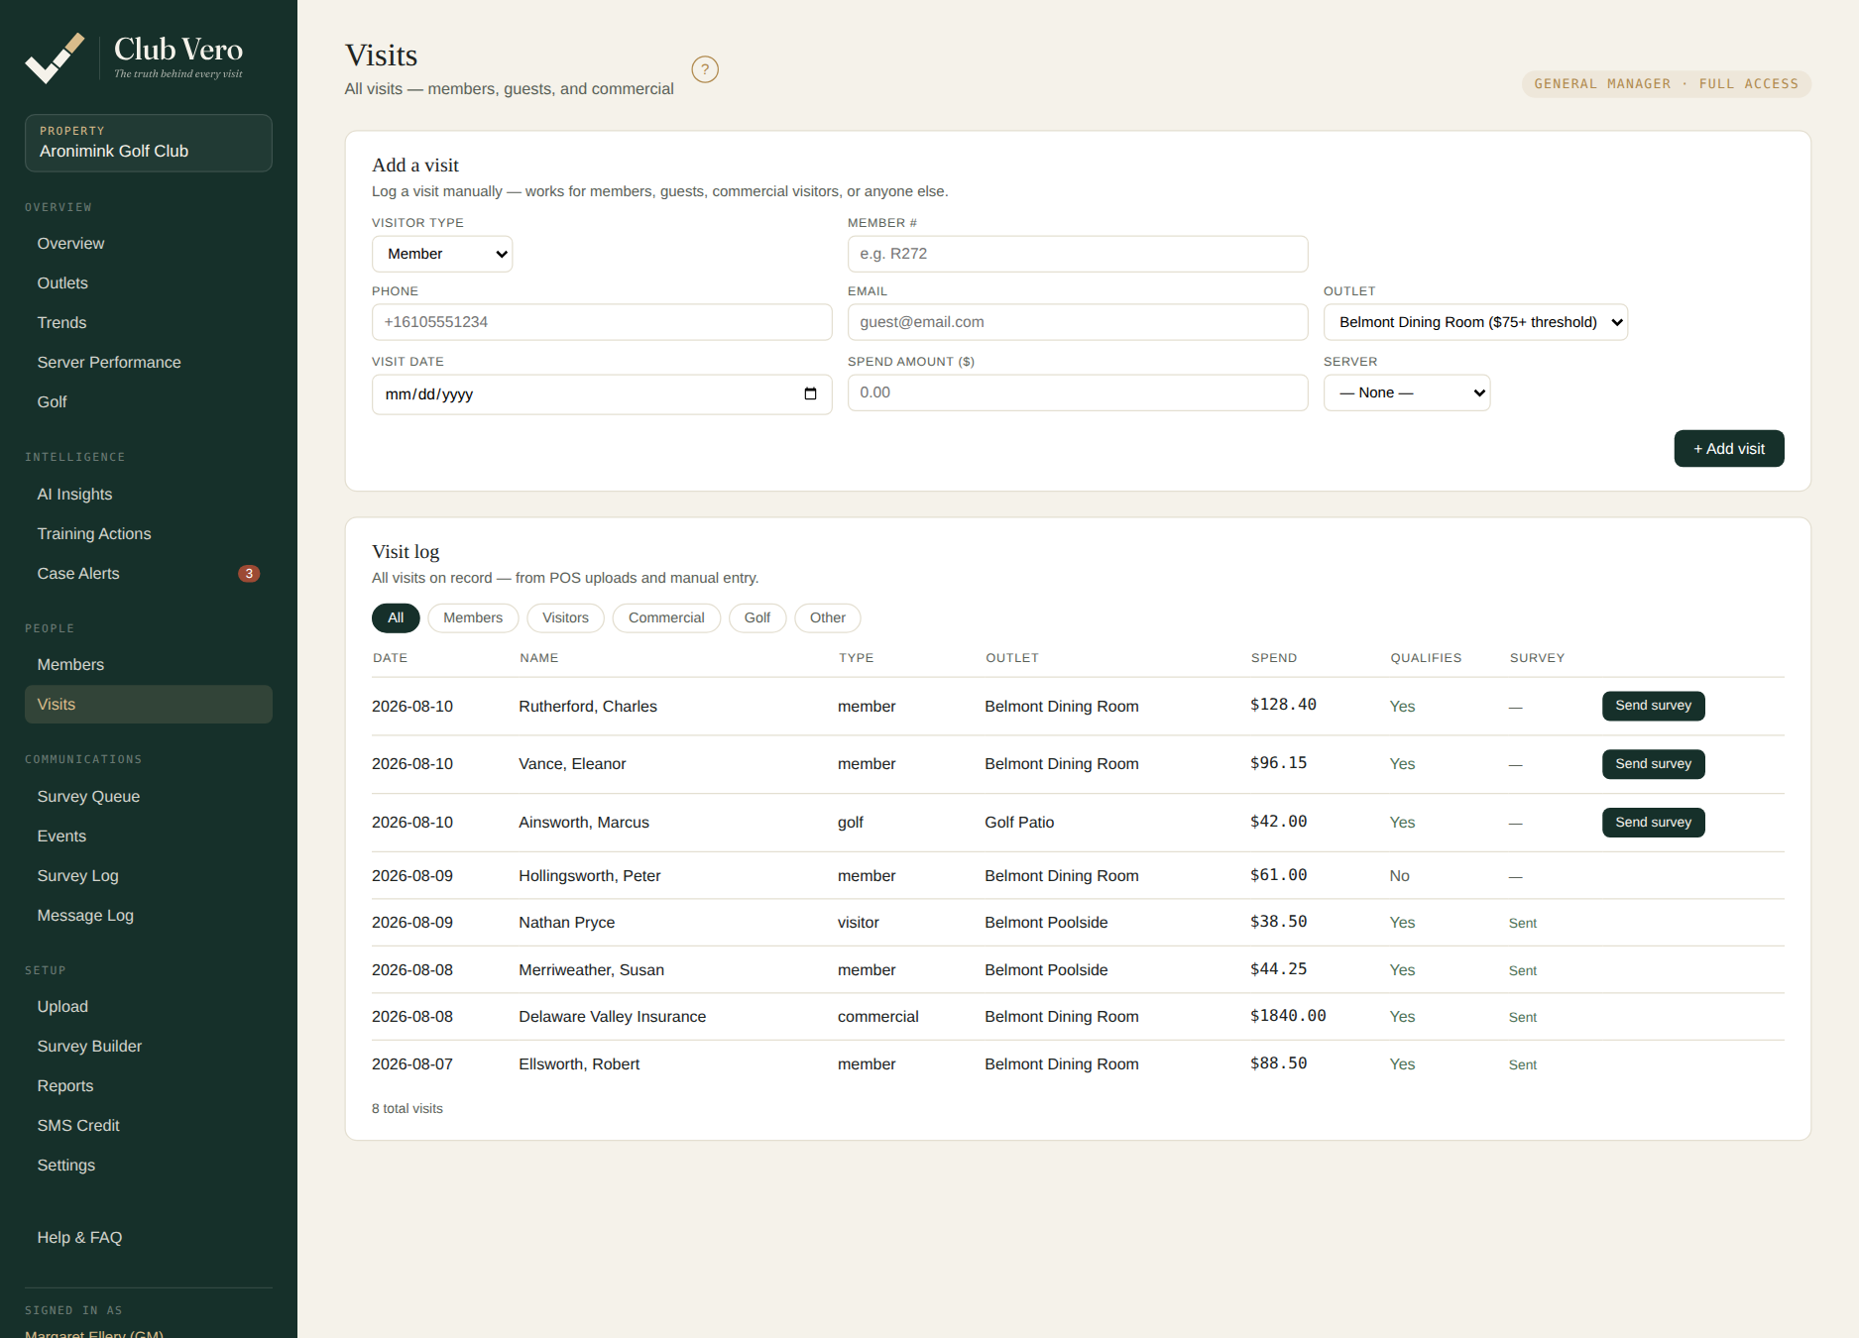
People → Visits. Add a visit at the top, every visit on record underneath.

Steps
- In Add a visit, choose the visitor type: Member, Visitor / Guest, Commercial or Other.
- For a member, start typing the member number or name and pick them from the lookup — this attaches the visit to the right record rather than creating a loose one.
- For anyone else, enter the name and either a phone number or an email address.
- Choose the outlet, the visit date and the spend amount, and the server if you know who it was.
- Select + Add visit.
- Use Visit log underneath to check any visit. Qualifies says whether it met the outlet threshold and the re-survey rule; Survey says whether a survey has gone out.
- Use the filter tabs — All, Members, Visitors, Commercial, Golf, Other — to narrow the log.
- Where a visit qualifies and nothing has been sent, Send survey appears on the row.

GOOD PRACTICE Start here when someone asks why a survey did or did not go out. The Visit log answers it in one line, before you open the Survey Queue or the Message Log.

HELP ARTICLE 07

Work the Survey Queue
Purpose: See who is due to receive a survey, when it will send, and why anything is stuck.
Where to find it: Communications → Survey Queue
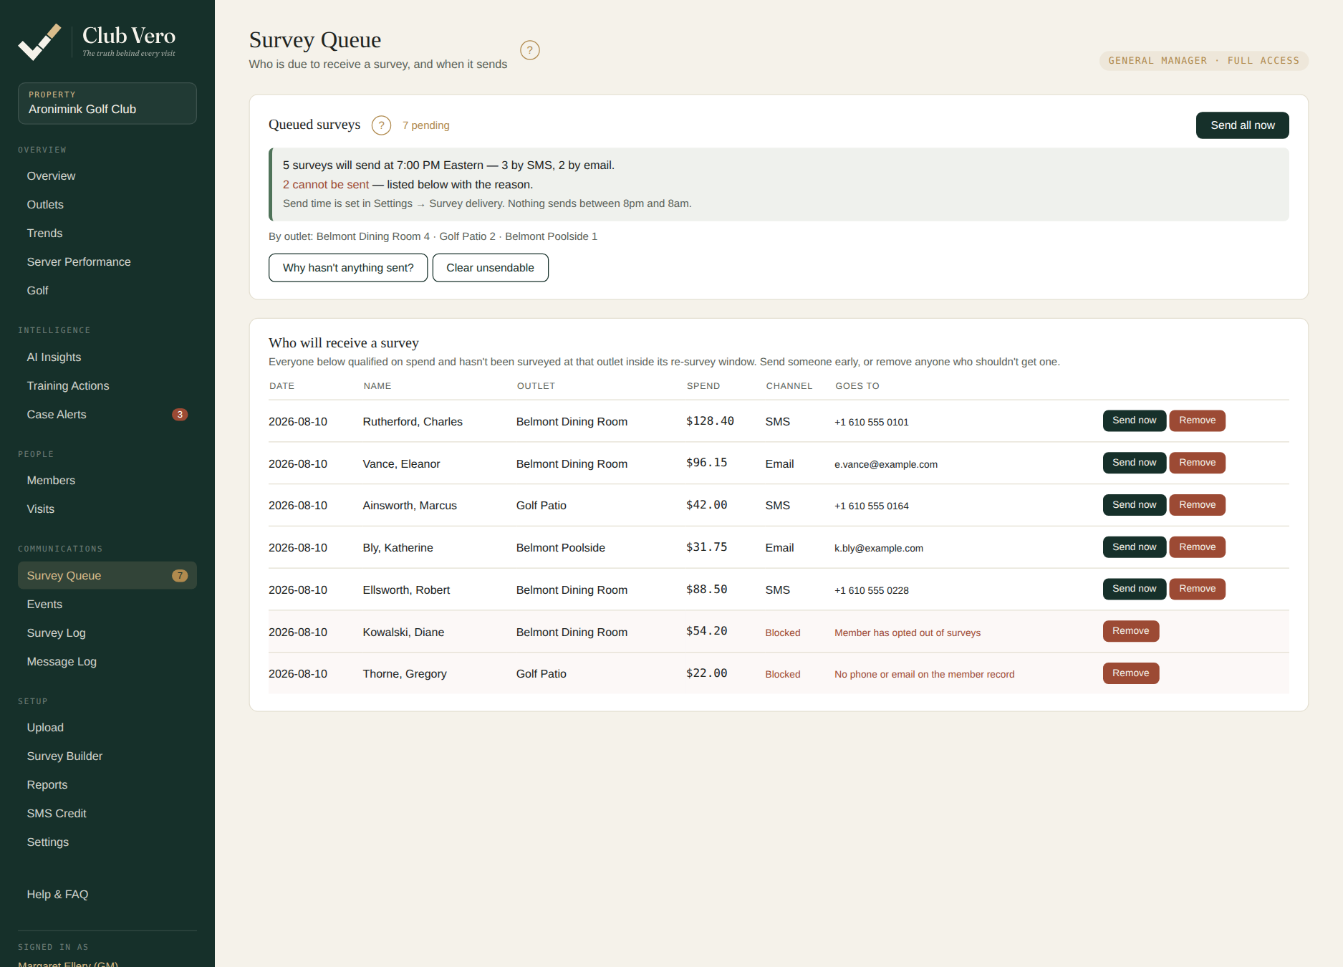
Communications → Survey Queue. Ready rows sit above blocked ones, each blocked row carrying its reason.

Steps
- Read the banner first. It says how many surveys will send, at what time, and how the batch splits between SMS and email.
- Check the by-outlet line underneath for where today’s volume is coming from.
- Work down the table: date, name, outlet, spend, channel and the number or address the survey will go to.
- Blocked rows are shaded and carry the reason in place of the recipient — opted out, no phone or email, or a member number not on your list.
- Send now on a row sends that one survey immediately. Remove takes the row out of the queue but keeps the visit for reporting.
- Send all now sends the whole ready batch immediately rather than waiting for the scheduled time. Use it deliberately.
- Why hasn’t anything sent? runs a check across eligibility, contact details, provider configuration, send time and SMS credit, and tells you which one is the problem.
- Clear unsendable removes every blocked row at once — useful after a membership import has fixed the underlying records.

GOOD PRACTICE Manual sending should be the exception. The queue exists so you can see the automation working, not so you can drive it by hand.

HELP ARTICLE 08

Check the Survey Log
Purpose: Confirm what was asked, what came back, and chase what did not.
Where to find it: Communications → Survey Log
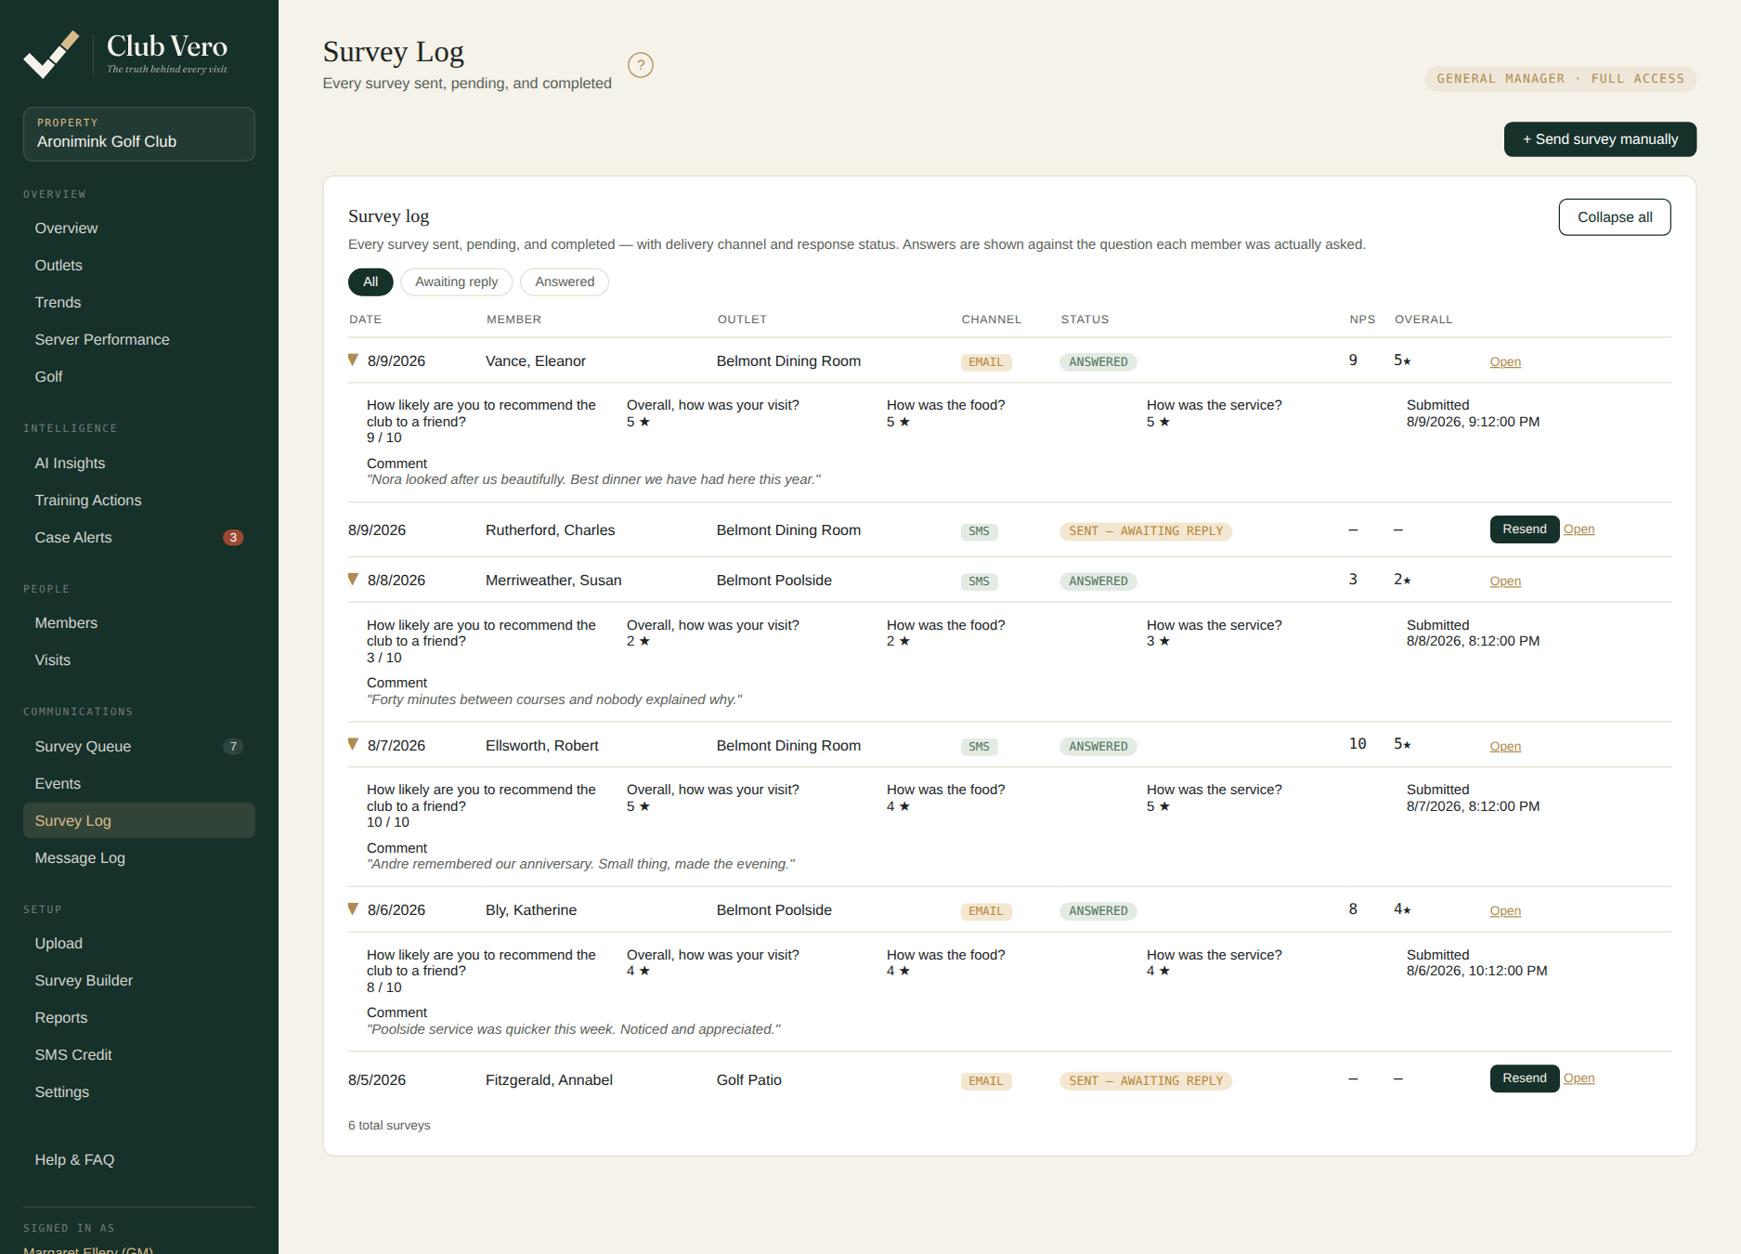
Communications → Survey Log, with a completed response expanded against the questions that member was actually asked.

Steps
- Use the filter tabs to move between All, Awaiting reply and Answered.
- Each row shows the date, member, outlet, channel, status, NPS and overall score.
- Status has three states: Not sent yet, Sent — awaiting reply, and Answered. They mean different things and are worth reading carefully.
- Select the arrow on an answered row to expand it. The answers are labelled with the questions that member actually received, so a golf response reads as pace of play rather than food quality.
- Resend appears on anything sent but unanswered.
- Open shows the survey exactly as the member sees it.
- + Send survey manually, at the top of the screen, sends a one-off survey to a member or a guest — choose the recipient, the outlet, the channel and which survey they should receive.

GOOD PRACTICE The Survey Log tells you about the survey. If a survey looks like it never arrived, the Message Log tells you about the delivery attempt.

HELP ARTICLE 09

Check the Message Log
Purpose: See every message Club Vero has actually sent, and what happened to it.
Where to find it: Communications → Message Log
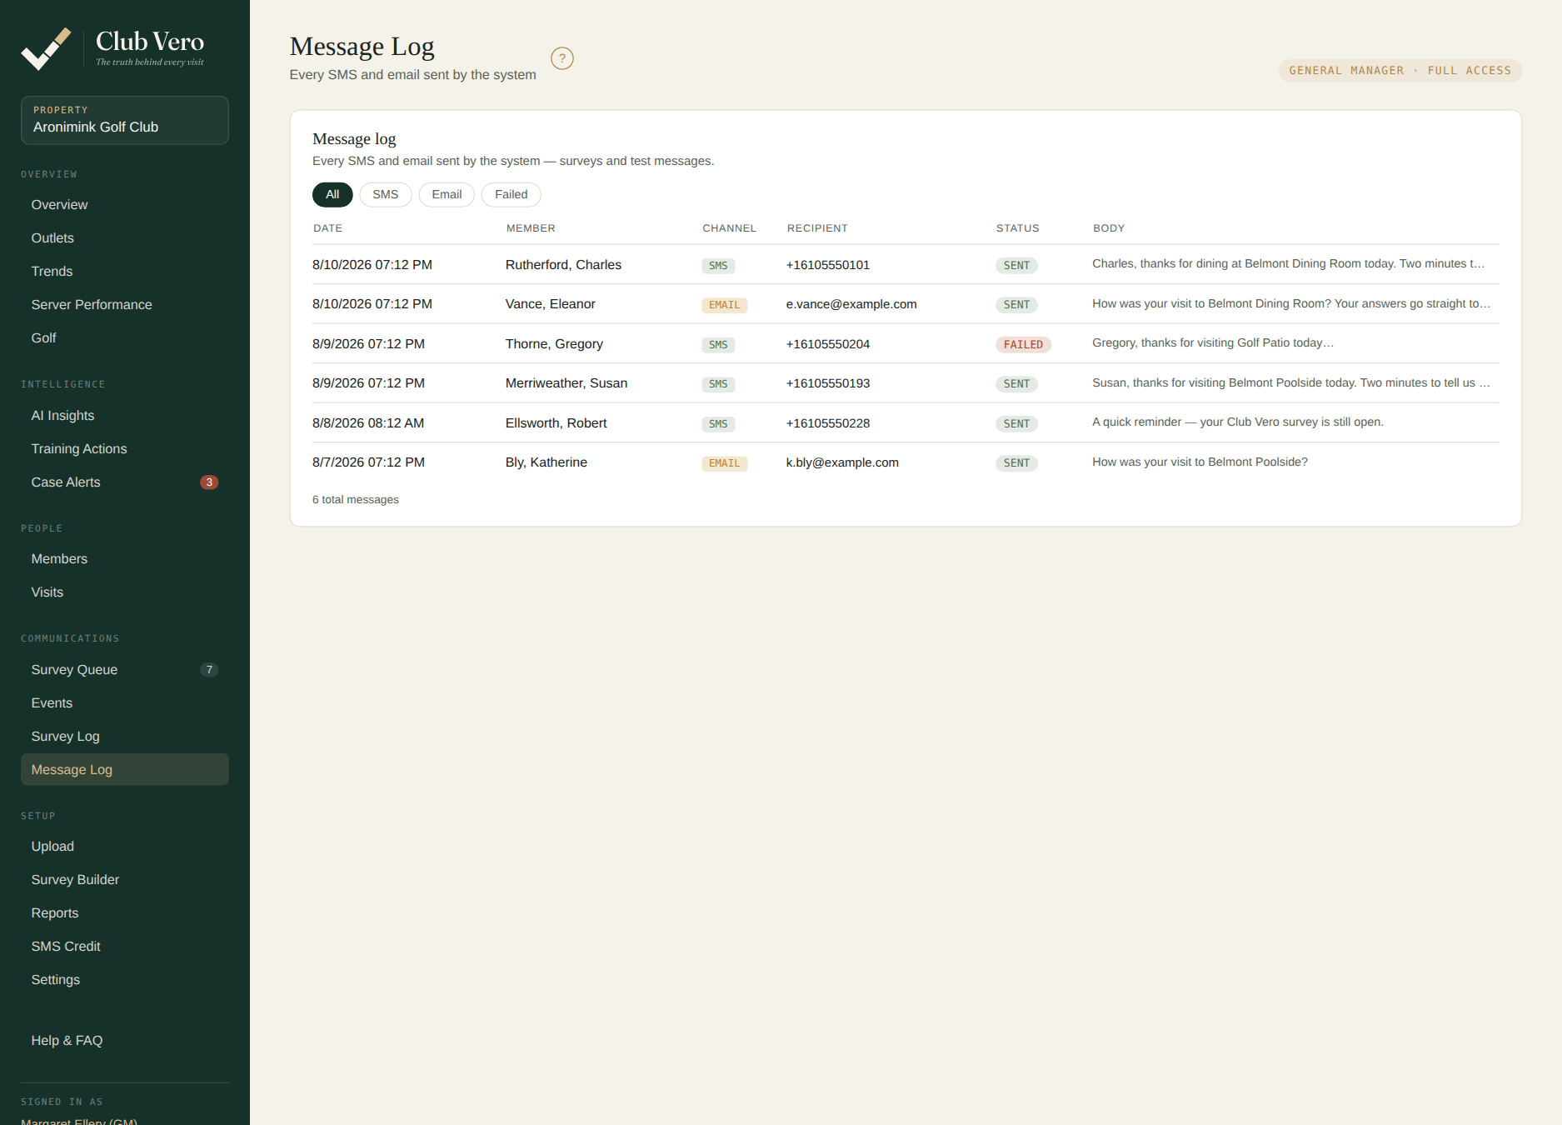
Communications → Message Log. Every SMS and email, with the recipient and the delivery result.

Steps
- Filter by All, SMS, Email or Failed.
- Each row shows the date and time, the member, the channel, the exact number or address used, the status, and the message body.
- Failed rows are the ones to act on — usually a wrong number format, a dead mailbox, or SMS credit having run out.
- Hover a body to read the full message text.
- Use the Message Log and the Survey Log together: one says whether the message went, the other whether the survey was answered.

GOOD PRACTICE A failure here is a data problem far more often than a system problem. Fix the member record, and the next send picks them up.

SECTION 3

Intelligence and action
What Club Vero does with the feedback once it arrives: service recovery, coaching, and early warning on members.
HELP ARTICLE 10

Respond to Case Alerts
Purpose: Recover a member who has had a poor visit, and record what was done about it.
Where to find it: Intelligence → Case Alerts
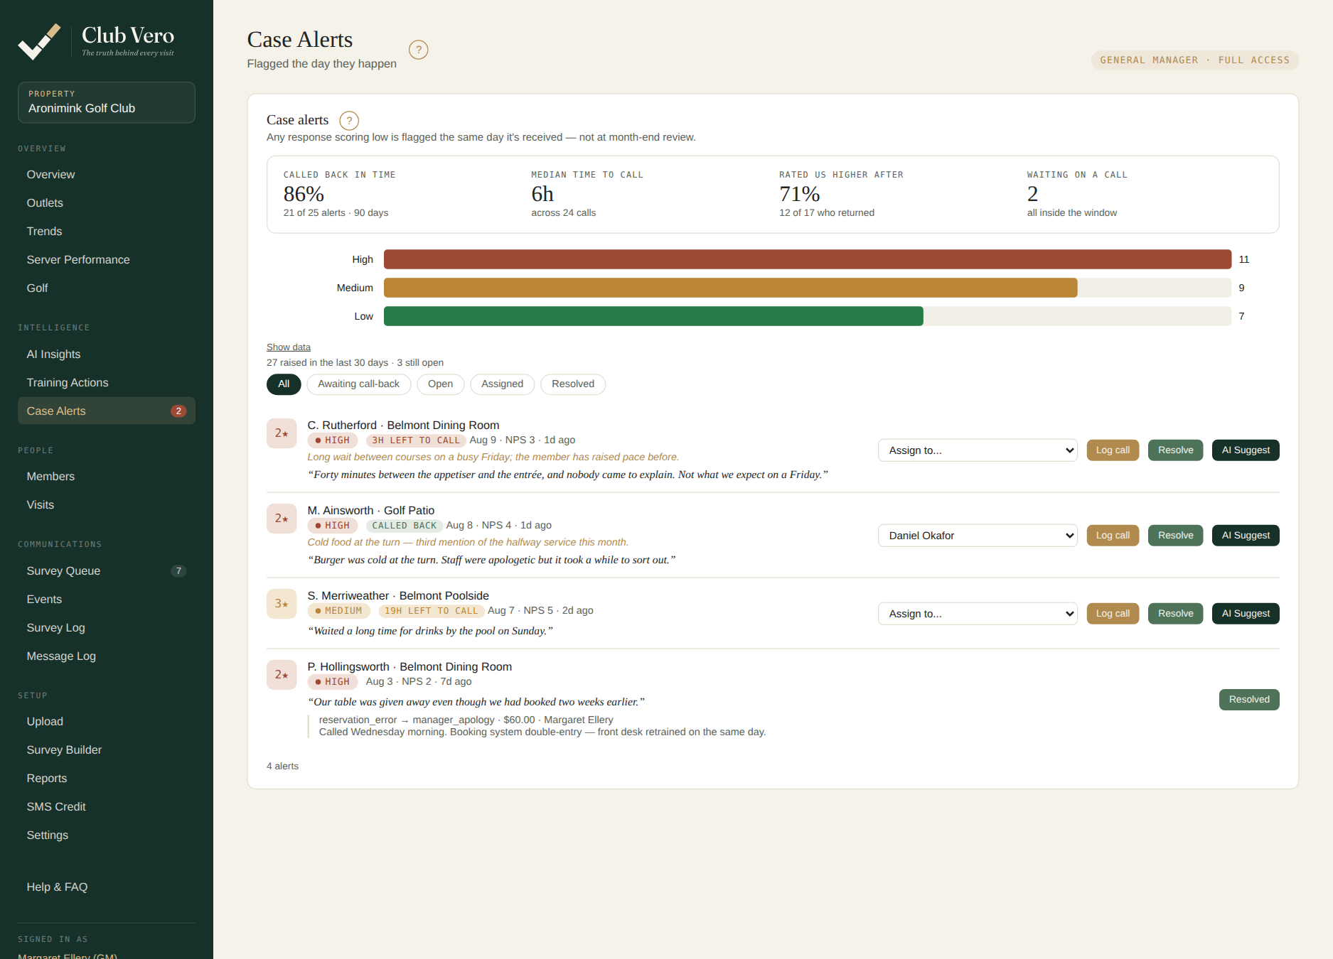
Intelligence → Case Alerts. The strip along the top measures the recovery itself, not just the volume of complaints.

Steps
- Read the four figures at the top: how often members are called back inside the window, the median time to that call, how many rated the club higher afterwards, and how many are still waiting.
- The bars underneath show the last 30 days of alerts by severity, and how many of each are still open.
- Filter the list with All, Awaiting call-back, Open, Assigned or Resolved.
- Each case shows the member, the outlet, the severity, the scores, the member’s own words, and a countdown chip such as 3h left to call.
- Use the Assign to… dropdown to give the case an owner. Where an outlet has an owner set in Settings, new cases are assigned and emailed to that person automatically.
- Call the member. Then select Log call and record the channel, how the member sounded and any notes.
- AI Suggest drafts a response you can use as a starting point for the conversation.
- When the matter is genuinely finished, select Resolve and record the root cause, the action taken, any goodwill given and a note. That summary then sits on the case for anyone reading it later.

GOOD PRACTICE Logging a call records what happened inside Club Vero. It does not send anything to the member — the call is still yours to make.

HELP ARTICLE 11

Read AI Insights
Purpose: See the themes running through the week’s comments instead of reading every one.
Where to find it: Intelligence → AI Insights
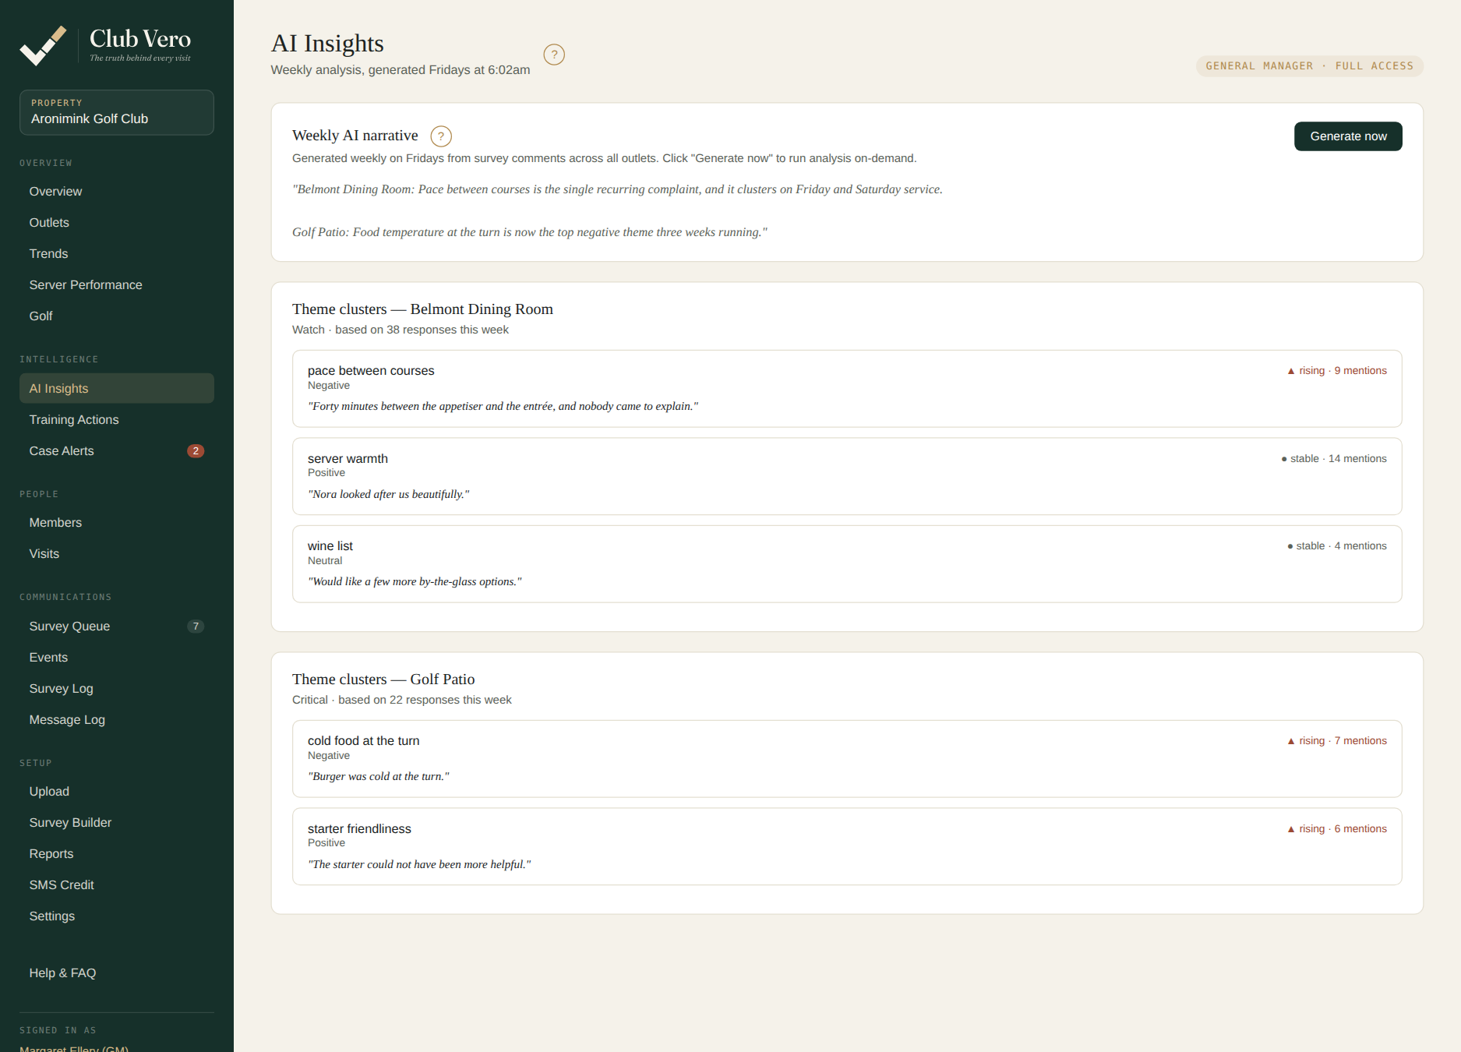
Intelligence → AI Insights. One narrative for the club, then theme clusters per outlet.

Steps
- Read the Weekly AI narrative at the top — one line per outlet, summarising what the week’s comments actually said.
- Work down the theme clusters. Each outlet panel is marked Critical, Watch or Maintain, and says how many responses it is based on.
- Each theme carries its sentiment, whether it is rising, stable or falling, how many members mentioned it, and one representative quote.
- A rising negative theme with a handful of mentions is the thing to act on; a stable positive one is what to protect.
- The analysis runs weekly on the day and time set in Setup → Settings. Generate now runs it immediately when you need it before that.

GOOD PRACTICE Always read the quote under a theme before acting on it. The cluster tells you what is being said; only the quote tells you what it means.

HELP ARTICLE 12

Work Training Actions
Purpose: Turn the week’s feedback into a short list of things the team will actually do.
Where to find it: Intelligence → Training Actions
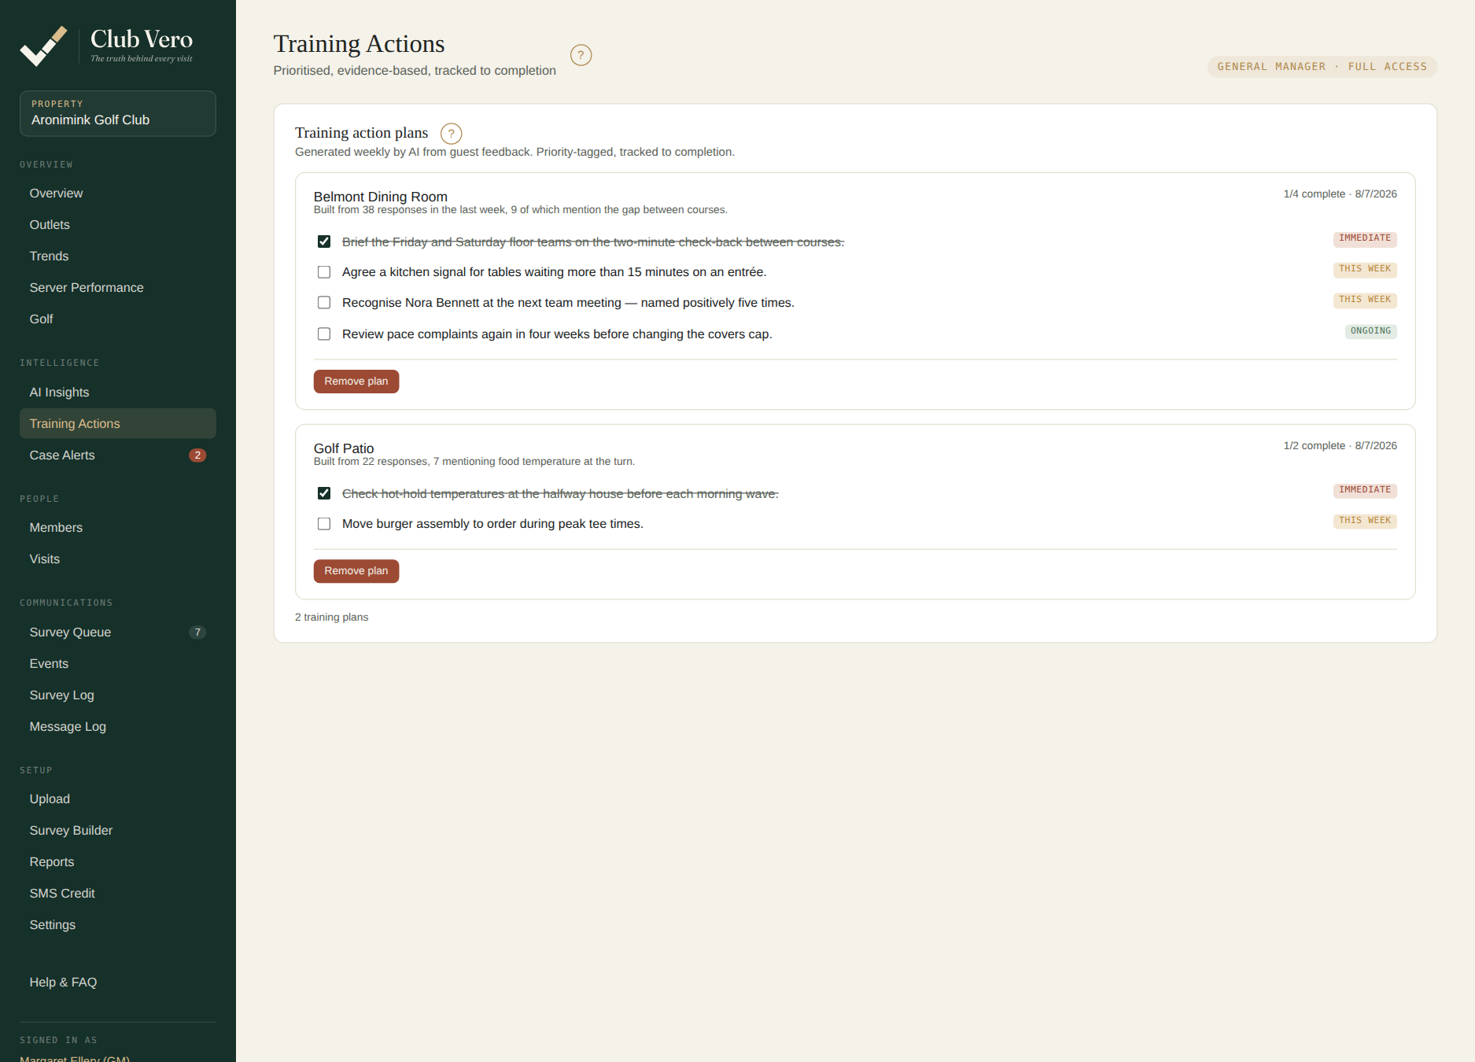
Intelligence → Training Actions. One plan per outlet, each step tagged by urgency and ticked off as it is done.

Steps
- Each plan names its outlet and says what it was built from — for example 38 responses, 9 of them mentioning the gap between courses.
- Steps are tagged Immediate, This week or Ongoing.
- Tick a step as the team completes it. The count in the plan header updates.
- Plans are written by the weekly analysis. An outlet with no responses that week gets no plan rather than an empty one.
- Remove plan clears a plan that has been overtaken or completed in full.

GOOD PRACTICE Four steps that get done beat twelve that do not. If a plan is not going to be worked, remove it rather than leaving it open.

HELP ARTICLE 13

Coach with Server Performance
Purpose: Use what members said and what the team said about the same shifts.
Where to find it: Overview → Server Performance
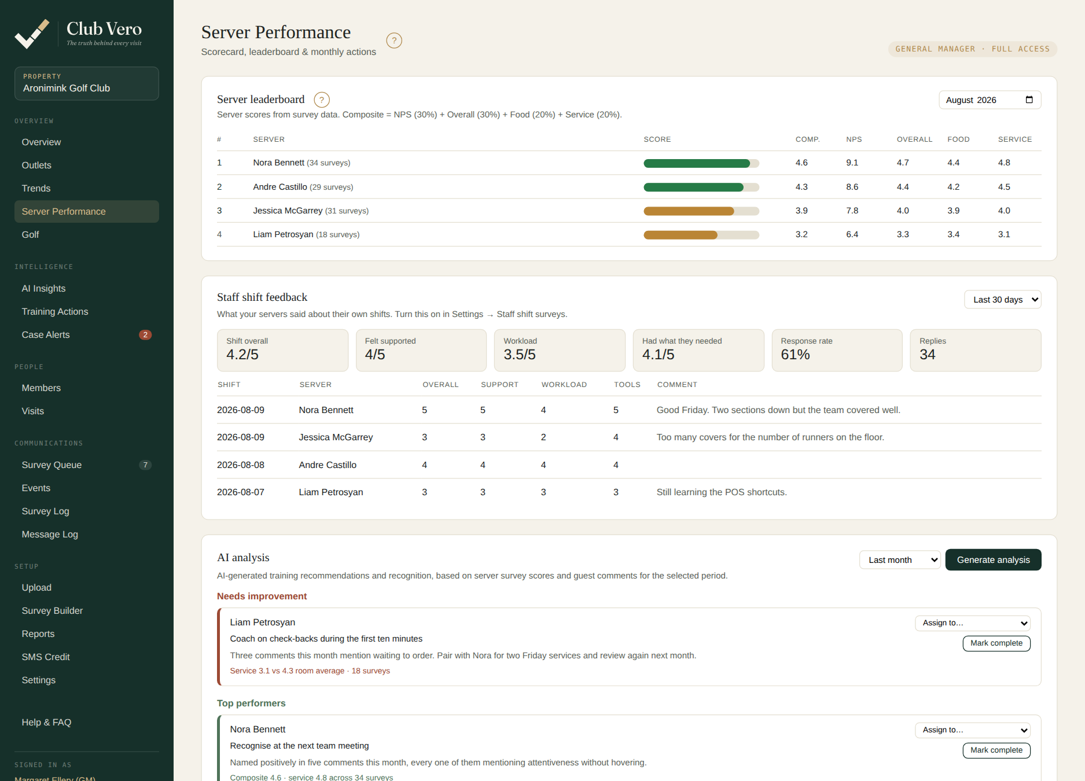
Overview → Server Performance: the leaderboard, the team’s own shift feedback, and the month’s coaching and recognition actions.

Steps
- Choose the month at the top right of Server leaderboard.
- Read the composite score, which is NPS 30% + Overall 30% + Food 20% + Service 20%, and the survey count beside each name — a high score on six surveys is not yet a finding.
- Read Staff shift feedback underneath: how the shift went overall, whether the server felt supported, whether the workload was manageable and whether they had what they needed.
- Look for the places where the two move together. A room whose service scores dip in the same week its team reports an unmanageable workload is a staffing question, not a performance one.
- Select Generate analysis to produce the month’s actions. They come back in two lists — Needs improvement and Top performers.
- Assign an action to a manager and mark it complete when it has been done.

GOOD PRACTICE Use this as a coaching and recognition tool. It measures a period of service, not a person, and it should never be the only evidence in a formal conversation.

HELP ARTICLE 14

Use Member Health
Purpose: Find the members who have quietly stopped coming, before they resign.
Where to find it: People → Members (the panel above the member list)
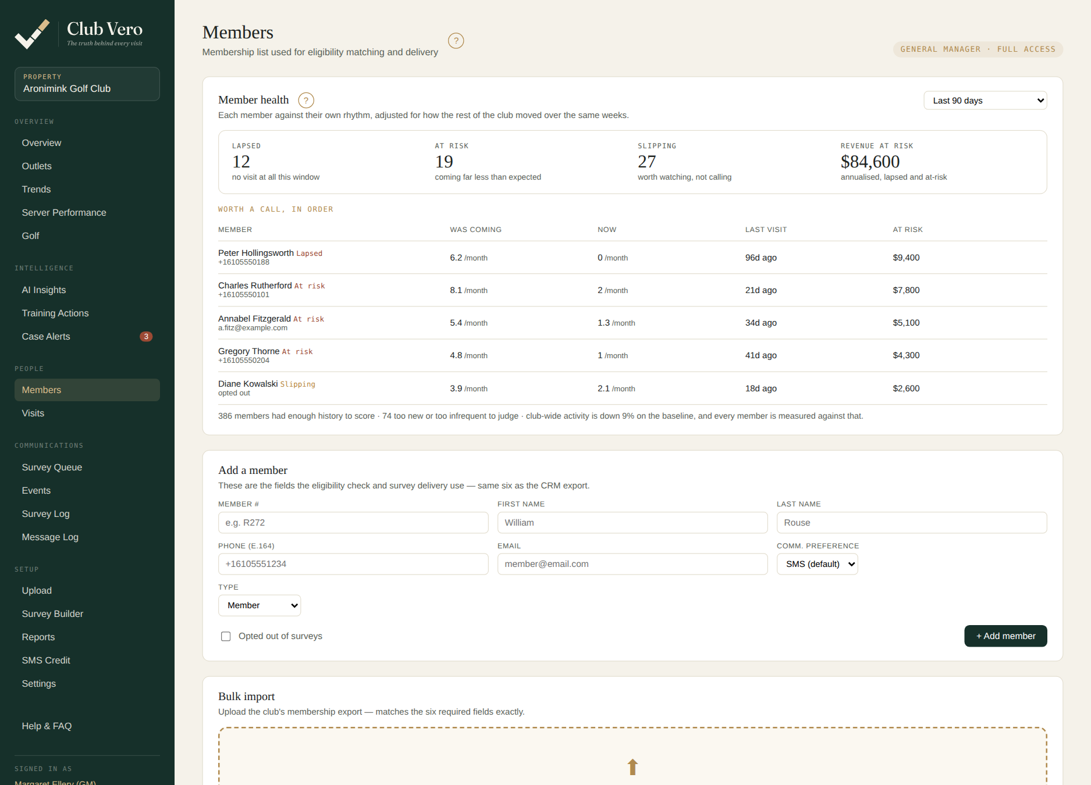
Member Health sits at the top of People → Members: four figures, then the call list in priority order.

Steps
- Choose the window at the top right of the Member health panel.
- Read the four figures: Lapsed, At risk, Slipping, and the annualised revenue those first two represent.
- Every member is measured against their own rhythm, then adjusted for how the whole club moved over the same weeks — so a quiet August does not turn the list into noise.
- Work down Worth a call, in order. It is ranked by what the member is worth, not by how steep the drop looks.
- Each row shows how often they used to come, how often they come now, how long since their last visit, and how to reach them. A member who has opted out is marked, because a survey is not the way to reach them.
- Read the line under the list. It says how many members had enough history to score, how many were too new to judge, and whether a seasonal adjustment was applied.

GOOD PRACTICE This is a prompt for a conversation, not a conclusion. Check the member’s recent visits and any open case before you pick up the phone.

HELP ARTICLE 15

Watch Outlets and Trends
Purpose: Separate a bad week from a real movement.
Where to find it: Overview → Outlets and Overview → Trends
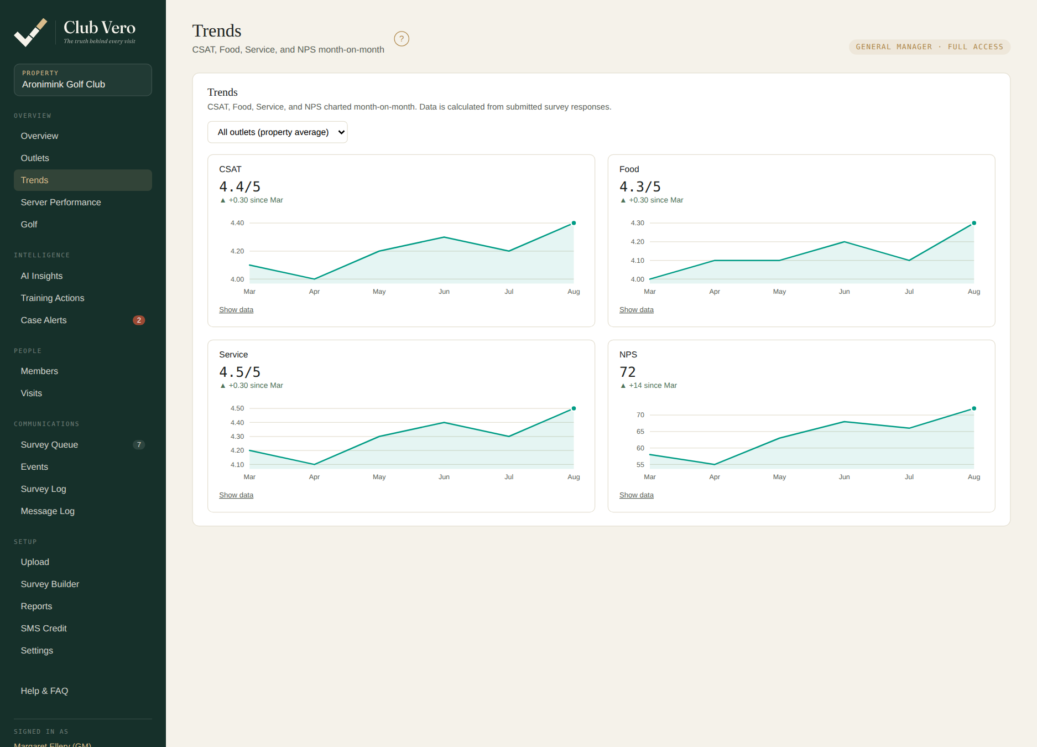
Overview → Trends. CSAT, Food, Service and NPS month on month, for the property or for one outlet.

Steps
- Overview → Outlets scores each room over the current period and marks it Maintain, Watch, Critical or New.
- A room marked New has no scored responses yet — that is a coverage problem, not a service one.
- Overview → Trends charts CSAT, Food, Service and NPS month on month.
- Use the dropdown to switch between the property average and a single outlet.
- Each card leads with the latest figure and the change since the start of the window, so a flat month reads as flat.
- Select Show data under any chart to read the underlying numbers as a table.
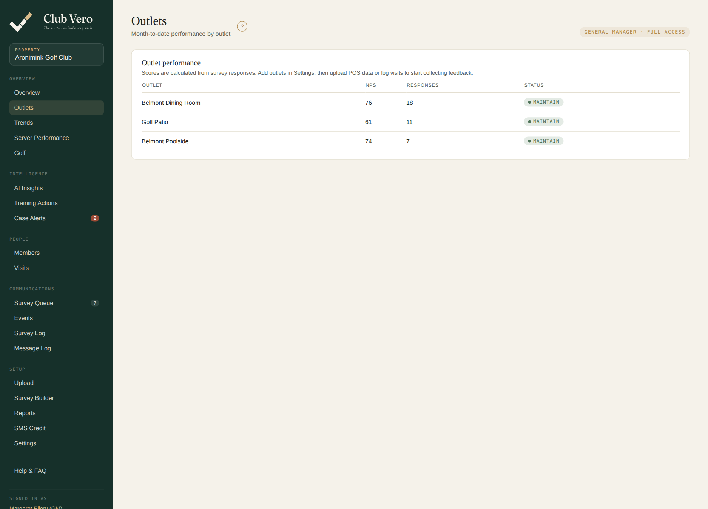
Overview → Outlets gives the same period as a status per room.

GOOD PRACTICE Look at a trend before reacting to a score. One weak week in a rising line is usually one weak week.

SECTION 4

Golf and events
Post-round golf feedback, the crossover between golf and dining, and feedback from club functions.
HELP ARTICLE 16

Run golf surveys from the tee sheet
Purpose: Measure the golf experience after play, from the sheet you already produce.
Where to find it: Overview → Golf
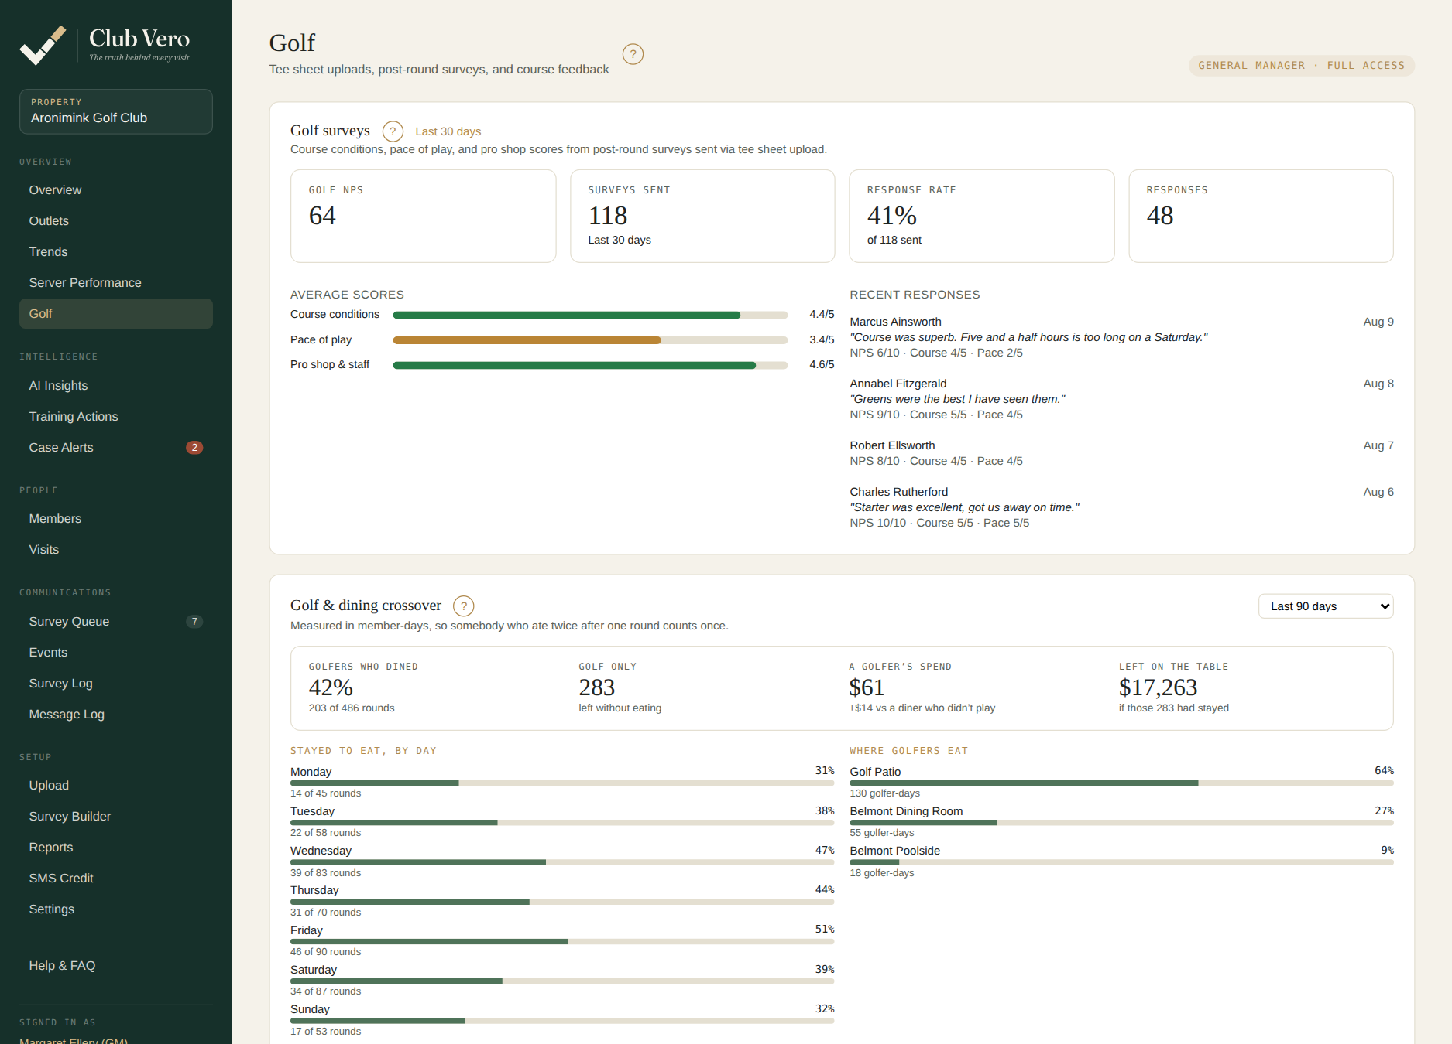
Overview → Golf. Golf NPS, response rate and the three post-round scores, with the latest responses alongside.

Steps
- Read the top panel for Golf NPS, surveys sent, response rate and responses over the last 30 days.
- Average scores breaks the round into course conditions, pace of play, and pro shop and staff, each out of five.
- Recent responses shows the latest rounds with the member’s own comment.
- Scroll to Upload tee sheet and drop in the day’s sheet as PDF, CSV or Excel. Club Vero pulls out member numbers and names and detects the date itself.
- Use Override date only when the sheet’s own date is wrong or missing.
- Golf survey log shows who was sent a golf survey, whether it is completed or pending, and the three scores where they answered.
- Golf survey questions, at the bottom, is where the post-round questions are edited. Changes apply to future golf surveys, not to ones already sent.
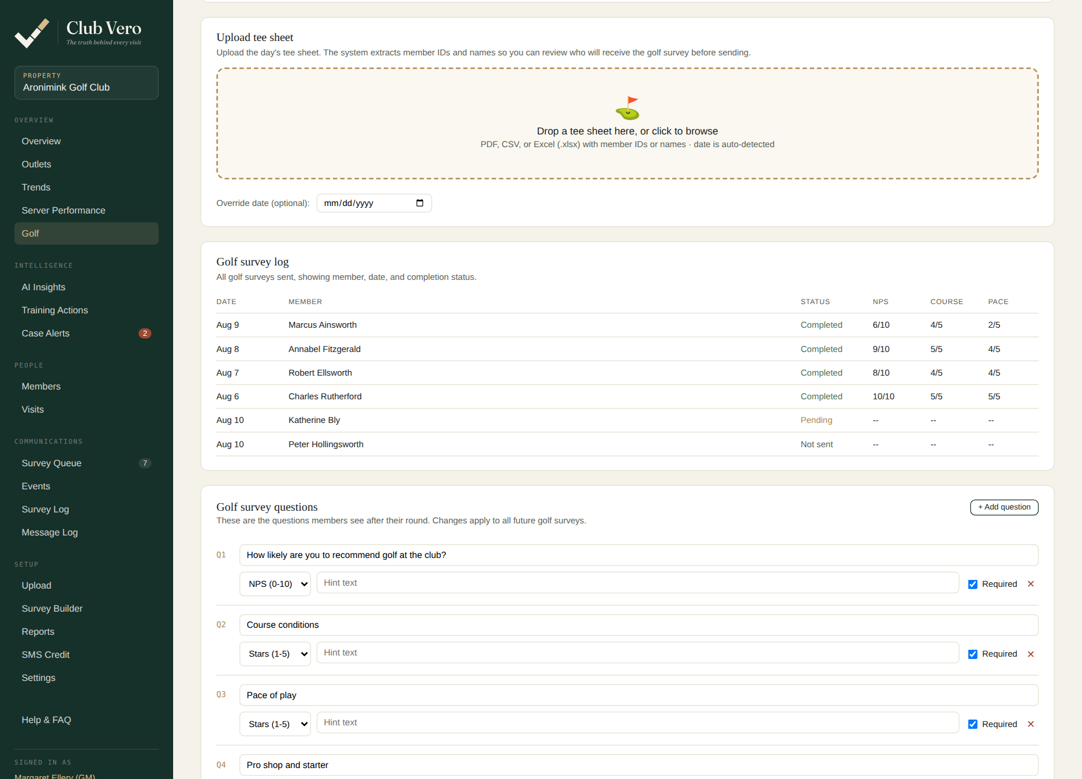
Further down the same screen: the tee sheet upload, the golf survey log, and the golf questions themselves.

GOOD PRACTICE Keep the core golf questions stable. Every time the wording changes, the trend before and after it stops being comparable.

HELP ARTICLE 17

Use Golf & dining crossover
Purpose: See how much golf converts into food and beverage, and where it stops.
Where to find it: Overview → Golf (the Golf & dining crossover panel)
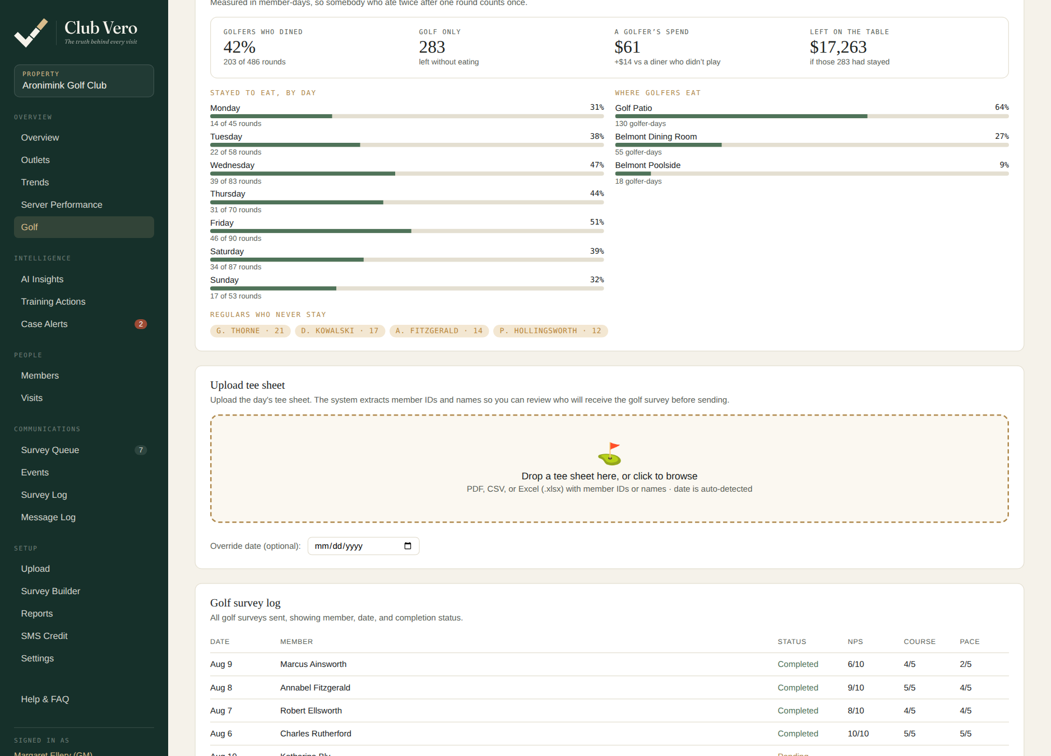
Golf & dining crossover, measured in member-days so one round followed by two orders counts once.

Steps
- Choose the period at the top right of the panel.
- Golfers who dined is the headline: how many rounds were followed by food or drink at the club.
- A golfer’s spend compares what a golfer spends in the dining room against a member who did not play that day.
- Left on the table values the golf-only days at what the club already achieves when a golfer stays. It is an estimate and is labelled as one.
- Stayed to eat, by day shows which day of the week loses golfers between the eighteenth and the dining room.
- Where golfers eat shows which room they choose when they do stay.
- The list at the bottom names members who play regularly and never stay — the useful list to hand to the F&B team.
- The panel counts members only. A guest without a member number cannot be matched between the round and the meal, so counting them would invent crossover that did not happen.

GOOD PRACTICE A member who golfs and dines on the same day now receives one survey, alternating between golf and dining. This panel is the only place the full picture of that day is visible.

HELP ARTICLE 18

Create an event and survey attendees
Purpose: Collect feedback on a function without distorting the outlet scores.
Where to find it: Communications → Events
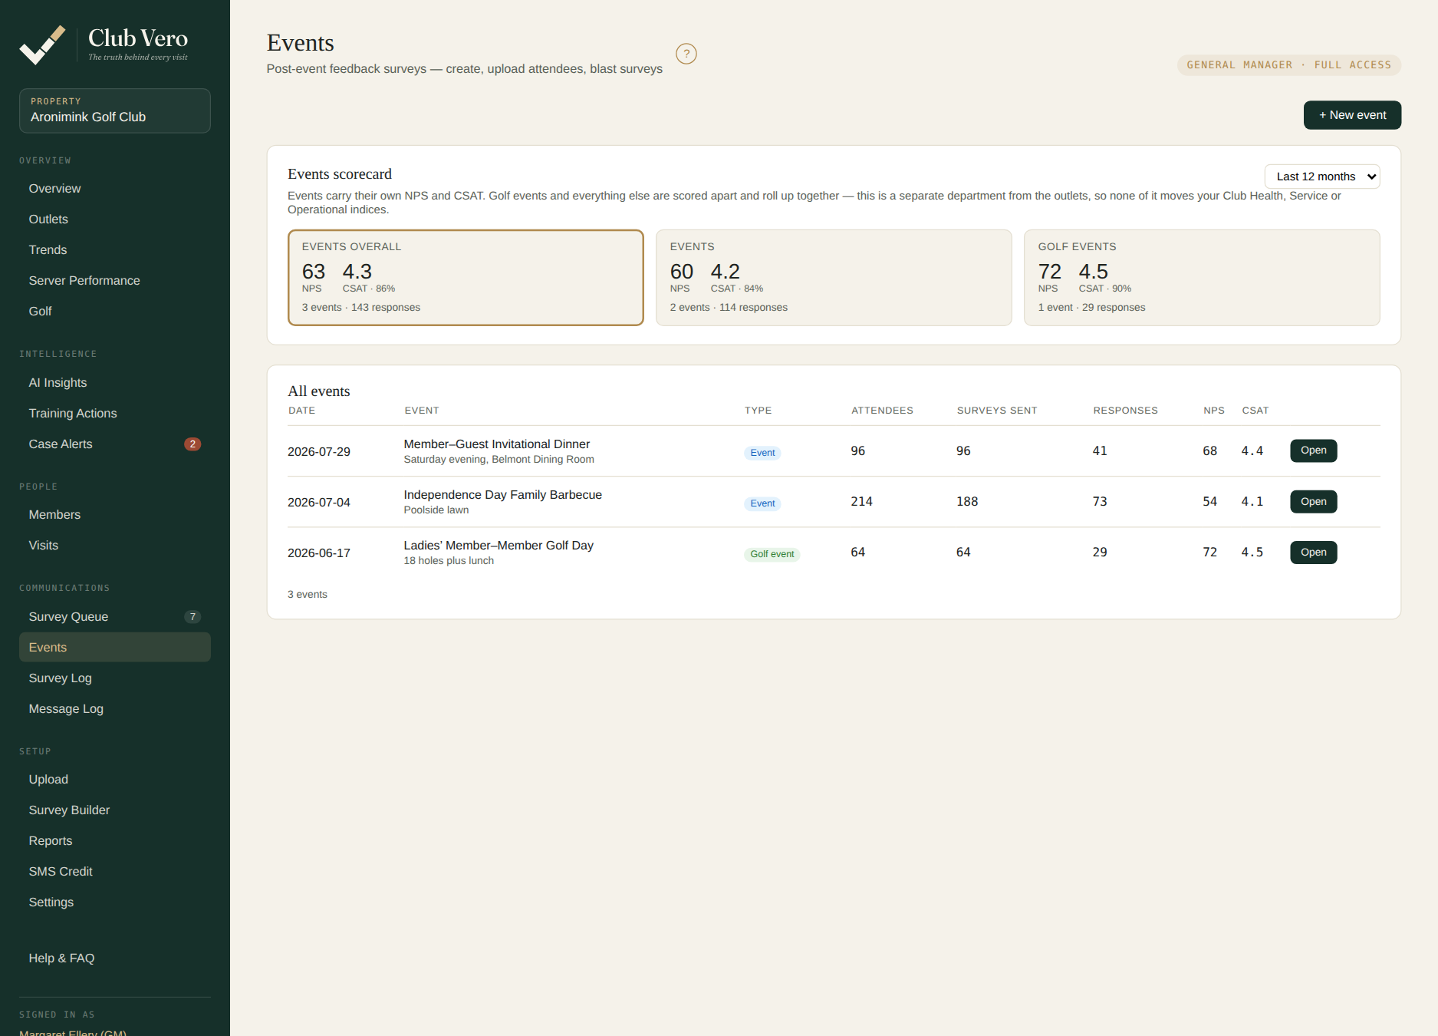
Communications → Events. Events are scored as their own department, apart from the club indices.

Steps
- Read Events scorecard first — events carry their own NPS and CSAT, and golf events are scored apart from everything else.
- Select + New event and enter the name, the date, an optional description, the type (Event or Golf event) and which questions to ask.
- Select Create, then open the event.
- Add attendees by pasting member numbers, by uploading a CSV with a member_id column, or by adding guests individually with their name and contact details.
- Check the attendee list, then select Send surveys to all.
- The event page then tracks attendees, surveys sent, responses, NPS and CSAT.
- Select Analyse feedback to generate a written summary of what worked and what should change next time.

GOOD PRACTICE Event scores never move CHI, SSI or OHI. A wet marquee on one Saturday does not drag down the dining room’s operational health.

SECTION 5

Setup and administration
The configuration that decides who gets surveyed, what they are asked, who answers for it, and what it costs.
HELP ARTICLE 19

Build and maintain survey templates
Purpose: Control what members are asked, without breaking the benchmarked indices.
Where to find it: Setup → Survey Builder
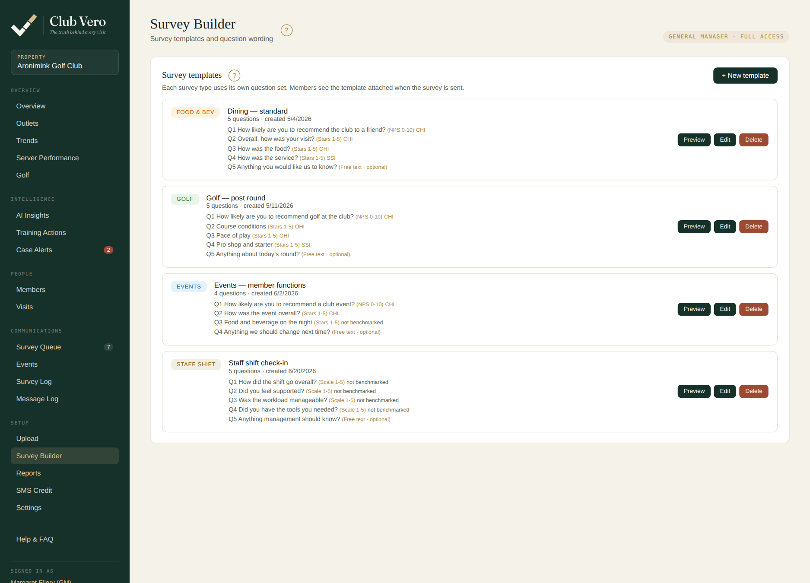
Setup → Survey Builder. Every question is listed with its type and, where it has one, the index it feeds.

Steps
- Each template is one of four types: Food & Bev, Golf, Events or Staff shift.
- Select + New template, name it, choose the type, and add the questions.
- Each question has a type — NPS 0–10, Stars 1–5, or free text — and can be required or optional.
- Only questions tagged to CHI, SSI or OHI move those indices. Anything else is marked not benchmarked: the answers are collected and reported, but the indices are unaffected.
- Select Preview to see the survey exactly as the member receives it.
- Edit changes the questions for future sends. Surveys already sent keep the questions they were sent with, which is why the Survey Log can label old answers correctly.
- A template is attached to an outlet in Setup → Settings, or left on the default for the visit type.

GOOD PRACTICE Add questions freely; change the benchmarked ones rarely. The index is only comparable over time if the questions behind it hold still.

HELP ARTICLE 20

Configure the club, outlets and survey timing
Purpose: Set the rules that decide who qualifies, who is told, and when anything sends.
Where to find it: Setup → Settings
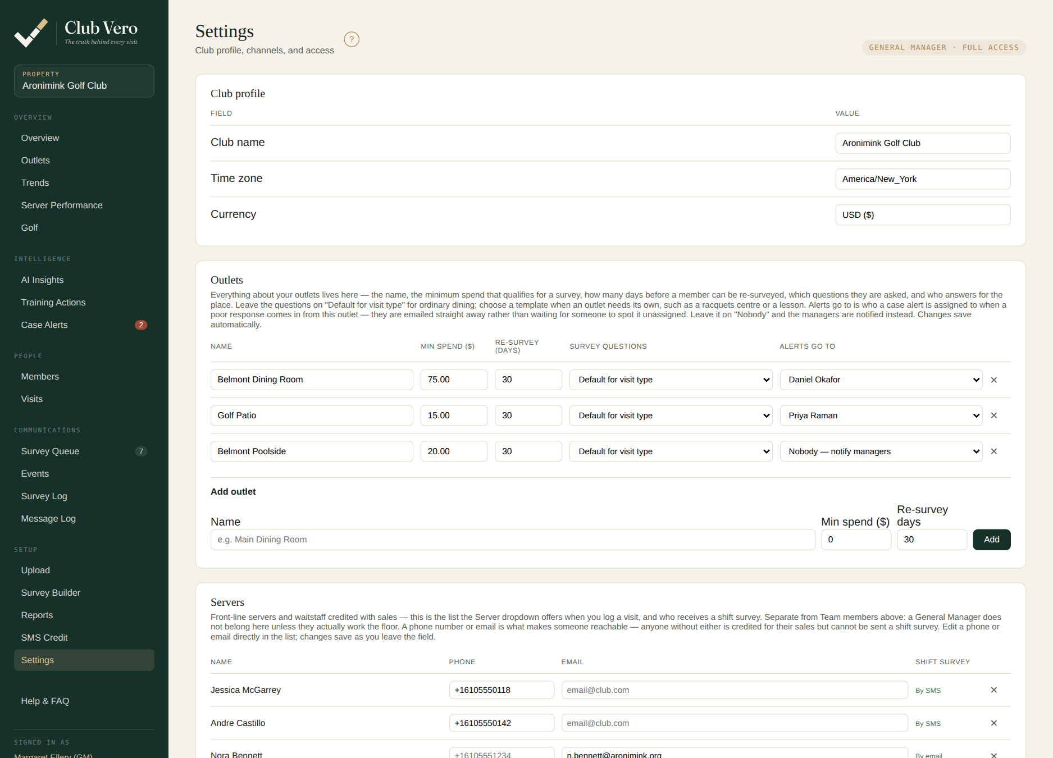
Setup → Settings. Club profile at the top, then every outlet with its own thresholds and owner.

Steps
- Check Club profile: club name, time zone and currency.
- For each outlet set the name, the minimum spend that qualifies for a survey, and how many days must pass before that member can be re-surveyed at that outlet.
- Leave Survey questions on Default for visit type for ordinary dining, or attach a template where a room needs its own.
- Set Alerts go to so a poor response from that outlet is assigned and emailed to the right manager straight away. Left on Nobody, the managers are notified instead. Outlet changes save as you leave the field.
- Under Survey delivery, set the time surveys go out. Nothing is ever sent between 8pm and 8am. Changing the time takes effect immediately — if the new time has already passed today, that batch goes within a minute.
- Under Weekly analysis, set the day and time AI Insights and Training Actions are written. Run now produces them on demand.
- Under How often one member can be surveyed, set the club-wide cap — at most so many surveys per member every so many days. Several cheques at the same outlet on the same day already count as one visit; this caps a member who used different outlets, and the highest-spend visit is the one surveyed.
- Under Staff shift surveys, switch the team’s own end-of-shift survey on or off and set its send time. Nothing sends between 11pm and 11am. Send now triggers it immediately.
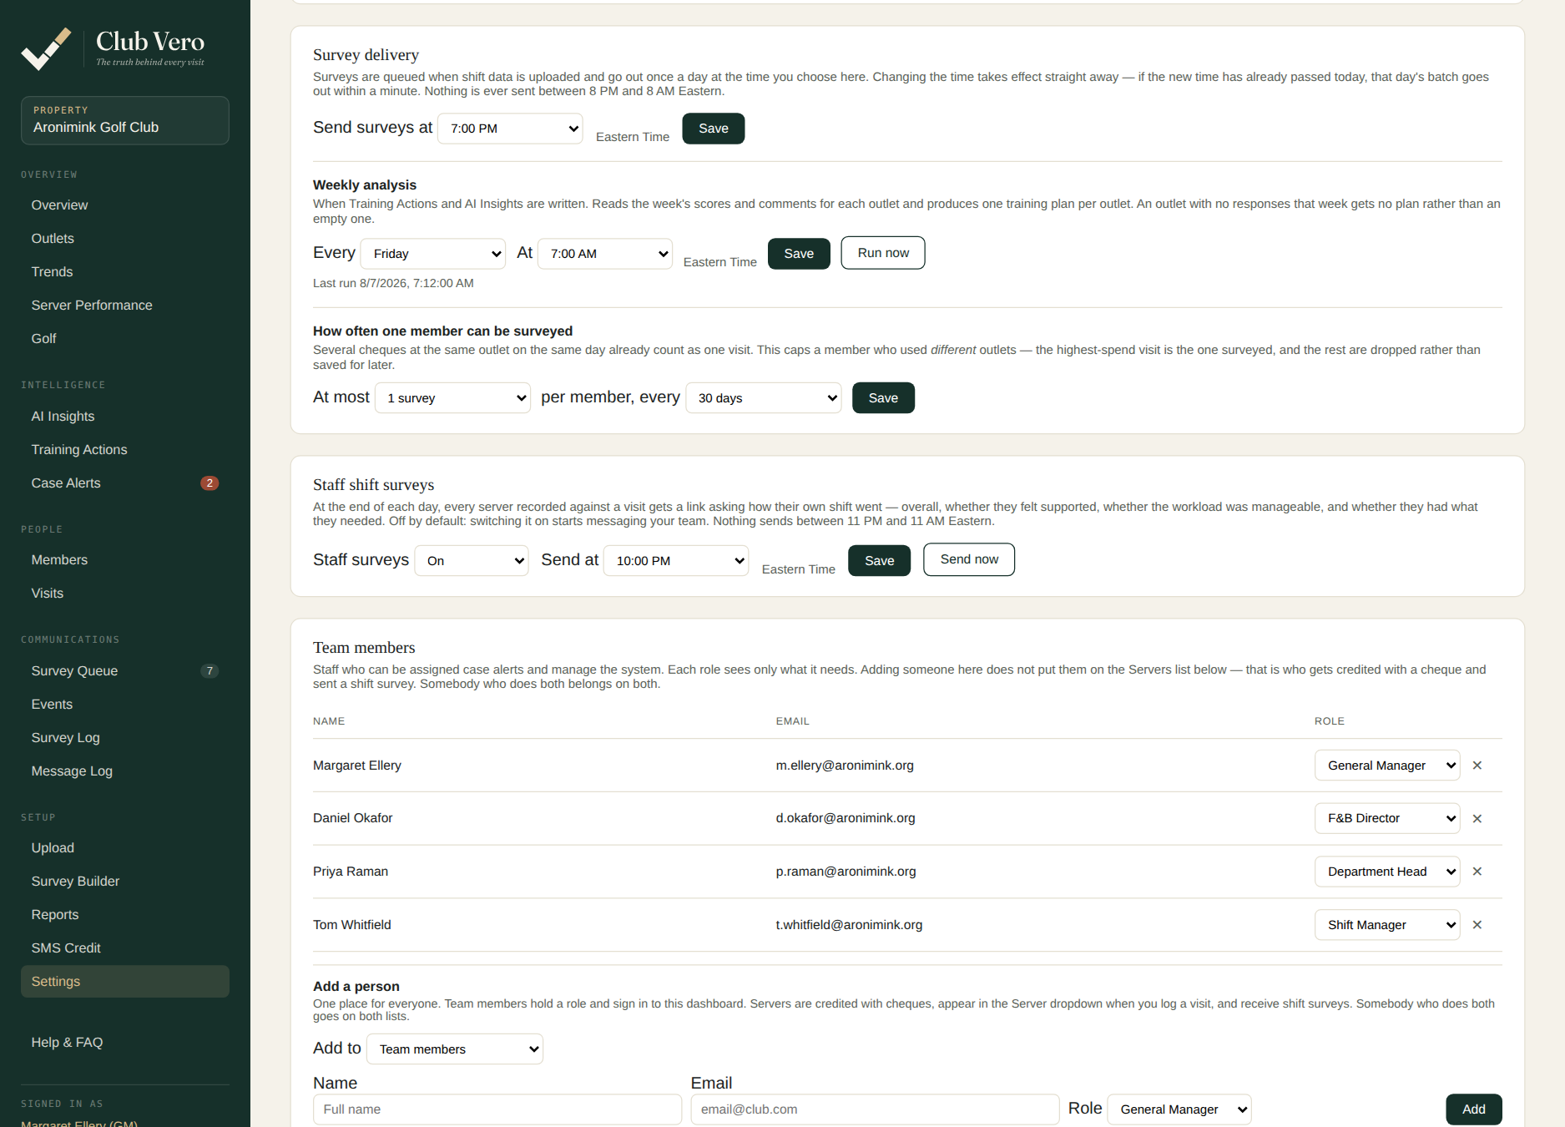
Further down: survey delivery, weekly analysis, the per-member cap, and staff shift surveys.

GOOD PRACTICE These settings shape the data itself. Change them deliberately and note when you did — a threshold changed mid-quarter will show up as a trend that never happened.

HELP ARTICLE 21

Manage team members, servers and logins
Purpose: Keep dashboard access, alert ownership and the front-line roster correct.
Where to find it: Setup → Settings (Team members, Servers and User accounts)
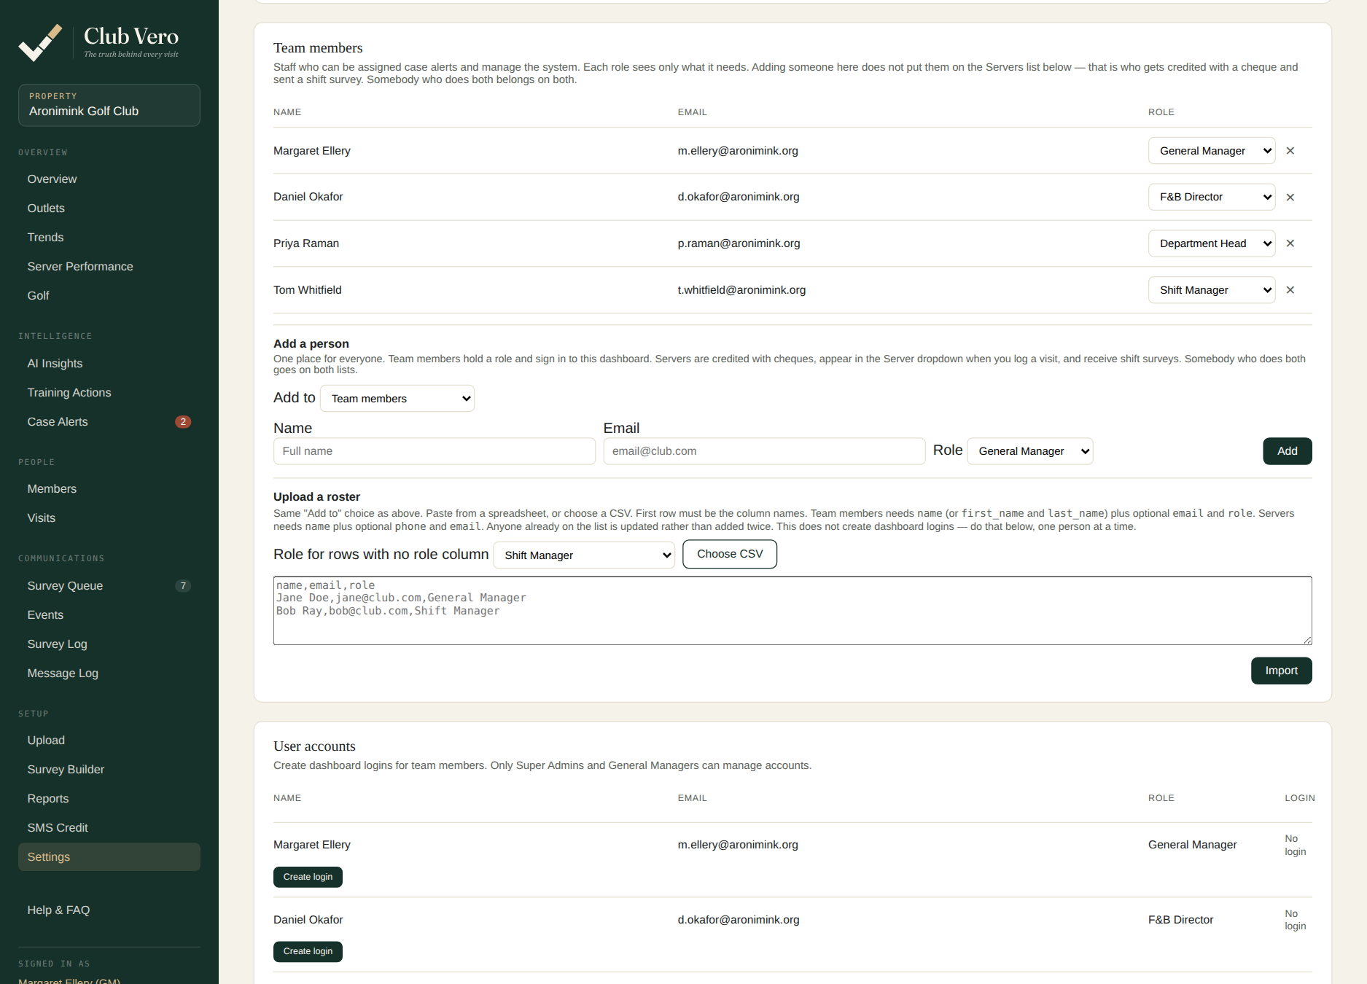
Team members hold roles and can own case alerts. Servers are credited with cheques and receive shift surveys.

Steps
- Team members are the people who can be assigned a case alert and can sign in. Each one holds a role, which decides what they see.
- Servers are the people credited with cheques on a visit. They appear in the Server dropdown when a visit is logged, and they are who receives a shift survey.
- They are two different lists, and someone who does both belongs on both. A General Manager who never works the floor belongs only on Team members.
- Use Add a person and choose which list to add to.
- A server needs a phone number or an email address to be reachable. Anyone without either is still credited with their sales but is marked Unreachable and cannot be sent a shift survey. Phone and email are editable in place.
- Names credited with sales that have no server record are listed separately, so they can be added rather than quietly scored and never contacted.
- Use Upload a roster to add many people at once, pasted or as a CSV.
- Importing someone does not create a dashboard login. Use User accounts → Create login for that, one person at a time.

GOOD PRACTICE Check the Servers list after any POS change. A renamed server in the POS becomes an unmatched name here, and their scores stop accumulating against the right person.

HELP ARTICLE 22

Keep SMS credit topped up
Purpose: Stop text delivery from pausing because the balance reached zero.
Where to find it: Setup → SMS Credit
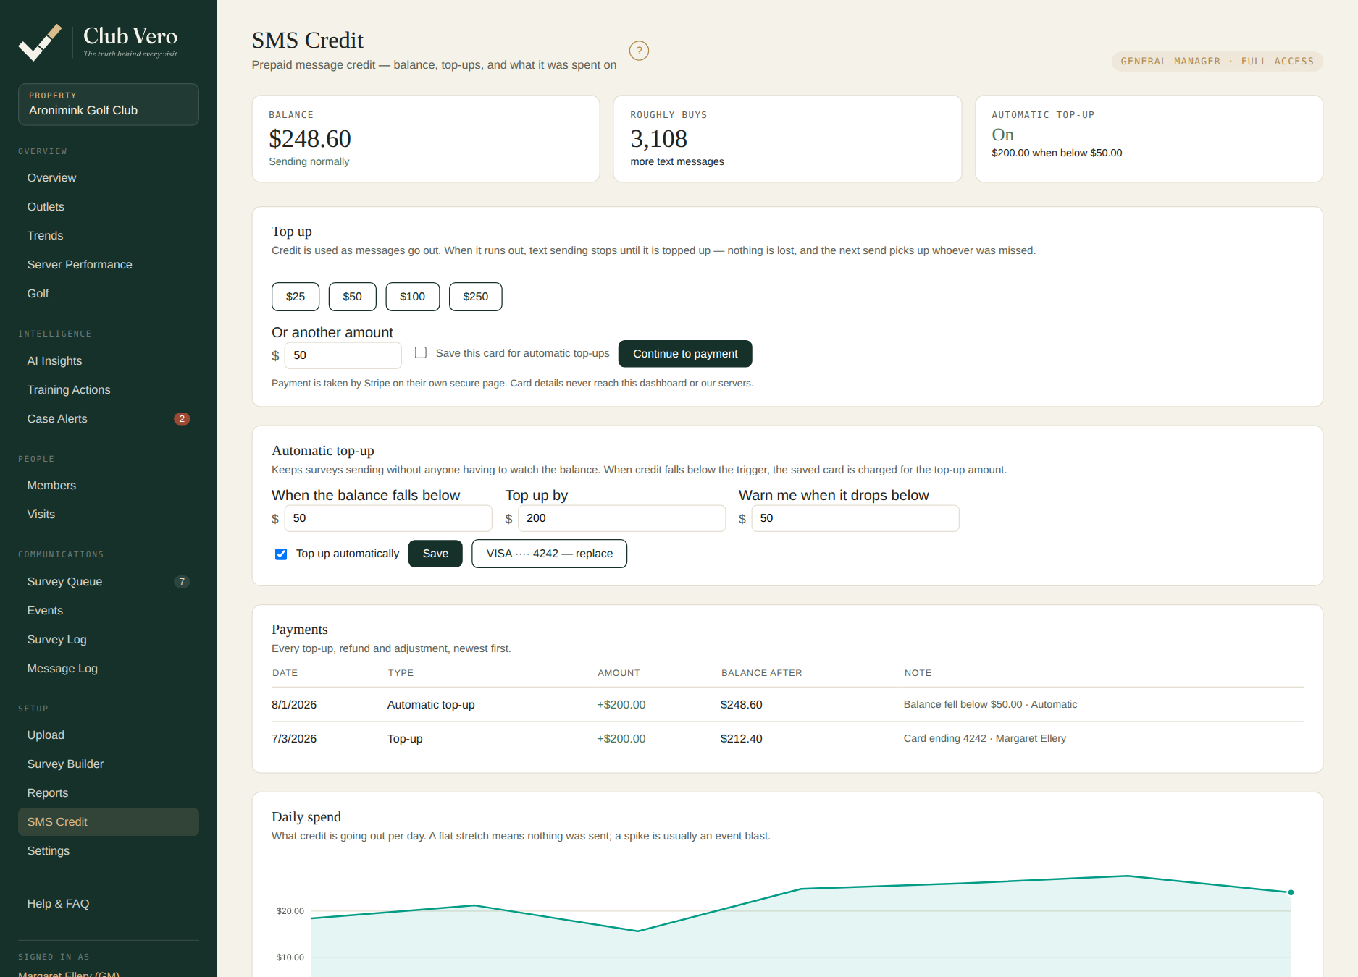
Setup → SMS Credit. Balance, roughly how many messages it buys, and automatic top-up.

Steps
- Read the balance, roughly how many more messages it buys, and whether automatic top-up is on.
- To top up now, choose $25, $50, $100 or $250 — or type another amount — then select Continue to payment. Payment is taken by Stripe on their own page; card details never reach the dashboard or the club’s server.
- Tick Save this card for automatic top-ups if you want the same card used automatically in future.
- Under Automatic top-up, set the balance that triggers a charge, how much to charge, and the level at which you want a warning. Tick Top up automatically and save.
- Payments lists every top-up, refund and adjustment with the balance after it.
- The daily spend chart and the table underneath show where the credit went, by day and by message type.

GOOD PRACTICE If credit runs out, text sending pauses — nothing is lost. Anyone who could not be reached is picked up by the next send once credit is restored. Email is unaffected.

HELP ARTICLE 23

Produce the period report
Purpose: Give the board or committee the same numbers the dashboard shows, in one document.
Where to find it: Setup → Reports
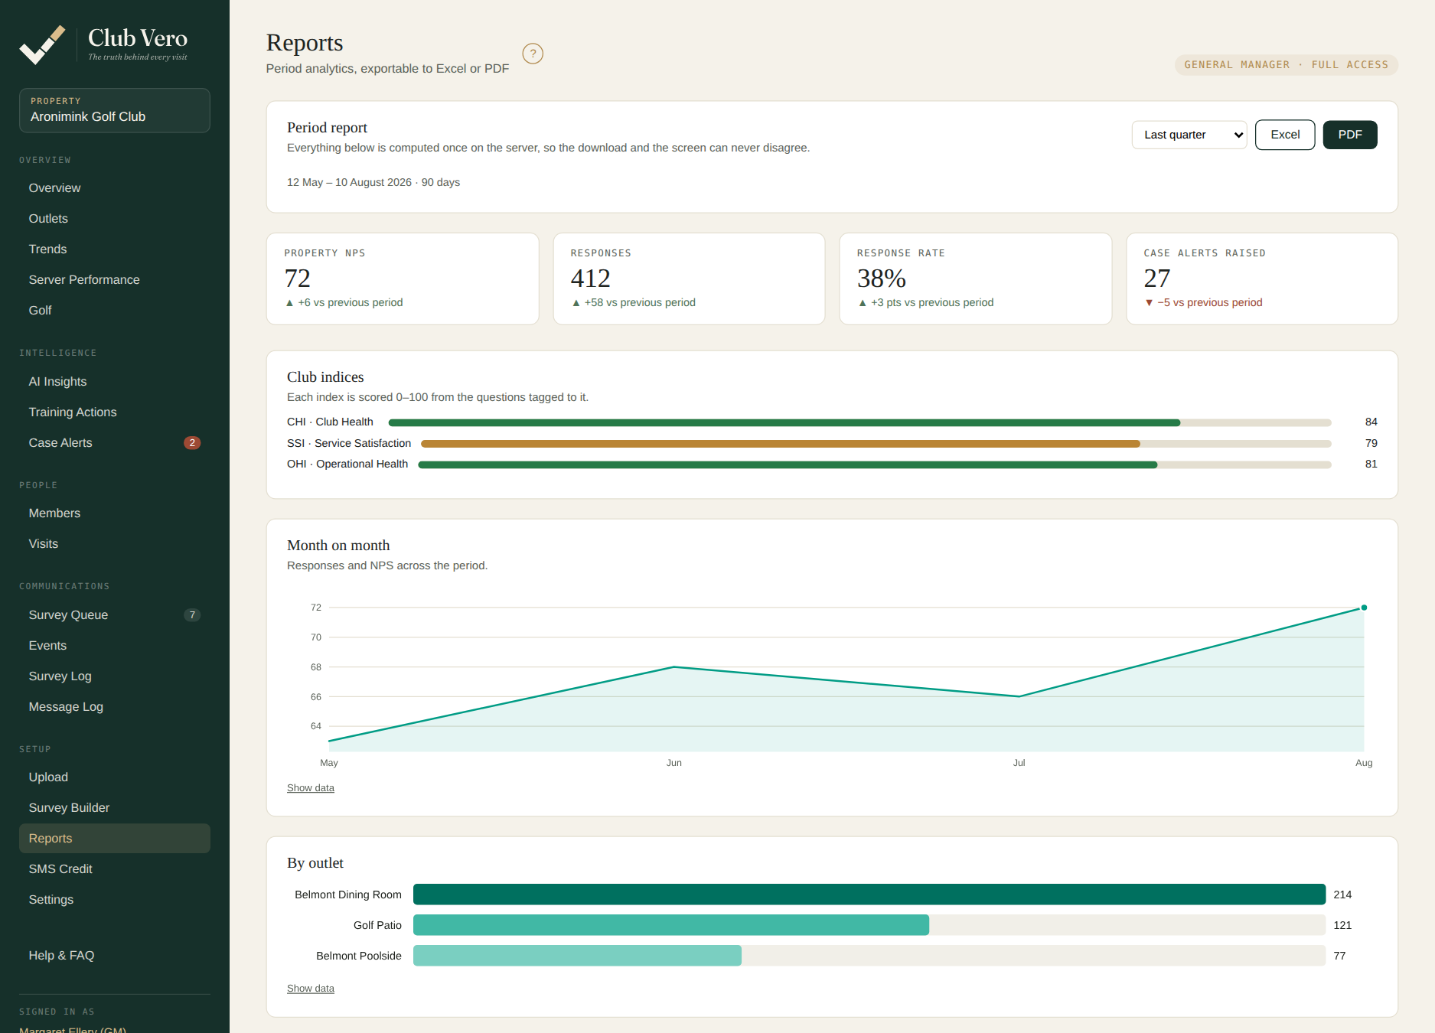
Setup → Reports. Everything is computed once on the server, so the export and the screen cannot disagree.

Steps
- Choose the period: last 30 days, last quarter, last 6 months or last 12 months.
- Read the headline figures, each with its change against the previous period of the same length.
- Club indices gives CHI, SSI and OHI for the period.
- Month on month charts NPS across the period; By outlet gives response volume per room.
- The tables underneath rank servers and summarise case alerts raised, resolved and still open by severity.
- Check the figures on screen, then export: Excel for further analysis, PDF for a fixed management report.
- Anything with no data in the period is named under the period line rather than shown as a zero.

GOOD PRACTICE Send the report with a short note on what was done about it. A score without an action reads as a scoreboard; a score with an action reads as management.

Quick troubleshooting
Each of these is answered by a screen rather than by a support ticket. Work down the path in the right-hand column and stop at the first thing that looks wrong.
IF THIS HAPPENS | WHERE TO LOOK
A member did not receive a survey | People → Visits to confirm the visit qualified, then Communications → Survey Queue for a blocked reason, then Communications → Message Log for the delivery attempt. Why hasn’t anything sent? on the queue checks all of it at once.
Nothing at all is sending | Communications → Survey Queue → Why hasn’t anything sent?. It checks contact details, provider configuration, send time and SMS credit and names the one that is failing.
A survey was sent but no response is showing | Communications → Survey Log for the status, and Communications → Message Log for whether the message itself was delivered or failed.
A poor score needs following up | Intelligence → Case Alerts. Assign an owner, call the member, Log call, then Resolve once the action is complete.
Case alerts are going to the wrong person | Setup → Settings → Outlets, and set Alerts go to for that outlet.
Golf surveys are not appearing | Overview → Golf. Check the tee sheet upload read the member numbers and the date, then check the Golf survey log.
A server is not receiving shift surveys | Setup → Settings. Confirm Staff shift surveys is On, and that the server has a phone number or email — anyone without either shows as Unreachable.
A server’s name is not on the leaderboard | Setup → Settings → Servers. Names credited with sales but with no server record are listed there and can be added in one click.
Someone cannot see a screen described here | Setup → Settings → Team members, and check their role. Members, Survey Builder, Settings and SMS Credit are restricted below General Manager.
SMS surveys have stopped | Setup → SMS Credit. Check the balance and whether automatic top-up is switched on.
A number in a report does not match the dashboard | Check the period. The report is computed once on the server for the period chosen, and the dashboard defaults to the last 7 days.

Publishing notes for the Help Centre
The 23 help articles in this handbook are written to stand alone, so each one can become a single searchable article on the Help Centre site. Keep the five section names as the top-level categories — they match the five menu groups in the product, which is what a user is looking at when they go looking for help.
Each article already carries the two things a Help Centre article needs at the top: what it is for, and the exact menu path to the screen. Keep both when the articles are moved onto the site.
MAINTENANCE When a screen changes, update that one article and re-take its screenshot rather than rewriting the handbook. The screenshots here were taken from the dashboard build of August 2026; if a menu name changes, search this document for the old name — the menu paths are written out in full in every article, so nothing is left implied.
Club Vero · Member Experience Intelligence · The truth behind every visit
Interface checked against the Club Vero dashboard build of August 2026.

