# The basic graph command and some simple examples

The most basic command for creating graphs and charts in Stata is graph. This command has a number of sub-commands and options. The major sub-commands describe different varieties of plot - such as twoway, box plot, and the sub-types of twoway such as scatter and line. For some reason there is also a small collection of graphs that are independent of either graph or twoway including histogram.

Our first example graph is a box plot of a numeric variable. The examples use the built-in auto dataset.

library(Statamarkdown)  
  
sysuse auto  
histogram mpg

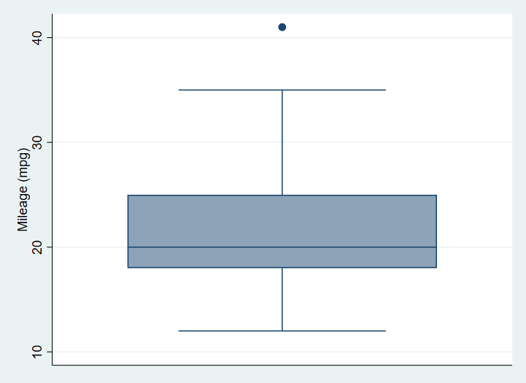

A box plot graph of the mpg variable from the auto dataset with no options specified.

This simple graph has no options specified. We begin by specifying a Title.

sysuse auto  
  
graph box mpg, ///  
 title("A Simple Box Plot")

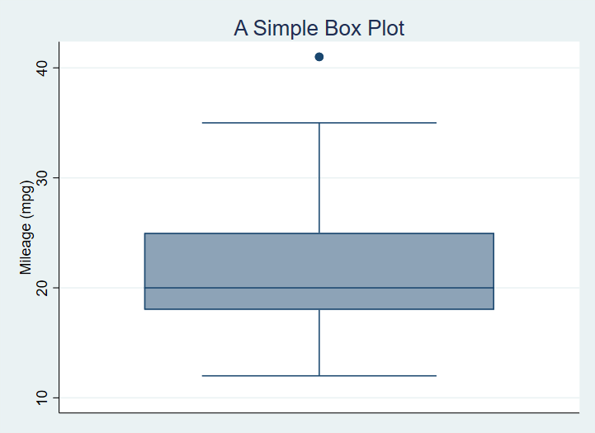

A box plot graph of the mpg variable from the auto dataset with title added.

sysuse auto  
  
graph box mpg, title("A Simple Box Plot") ///  
 subtitle("There is only one group in this graph.") ///  
 note("In later graphs we will subset the data.")

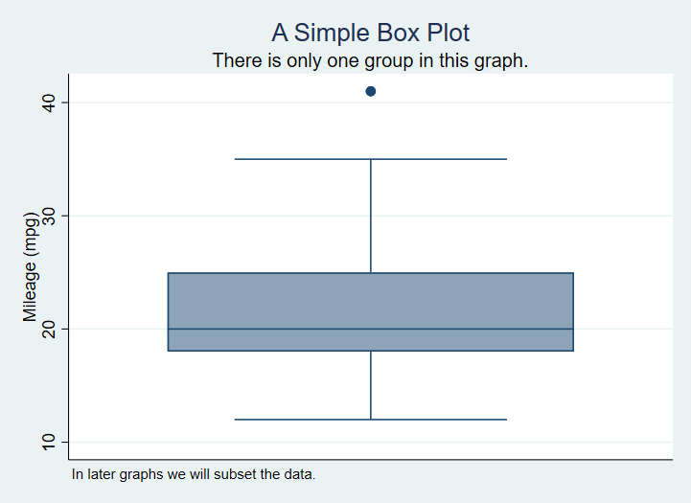

A Box Plot with Title, Subtitle and Note

No we subset the data using the categorical variable foreign.

graph box mpg, title("A Simple Box Plot") ///  
 subtitle("There is only one group in this graph.") ///  
 over(foreign)

Which produces[1]

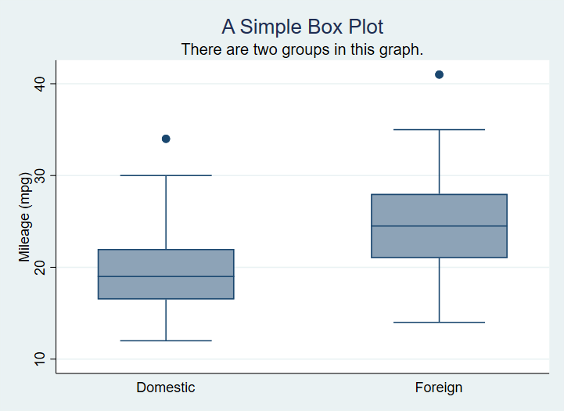

A Box Plot with data grouped based on a nominal variable.

We can switch to horizontal boxes with

sysuse auto, clear  
  
graph hbox mpg, ///  
 title("A Simple Box Plot") ///  
 subtitle("There are two groups in this graph.") ///  
 over(foreign)

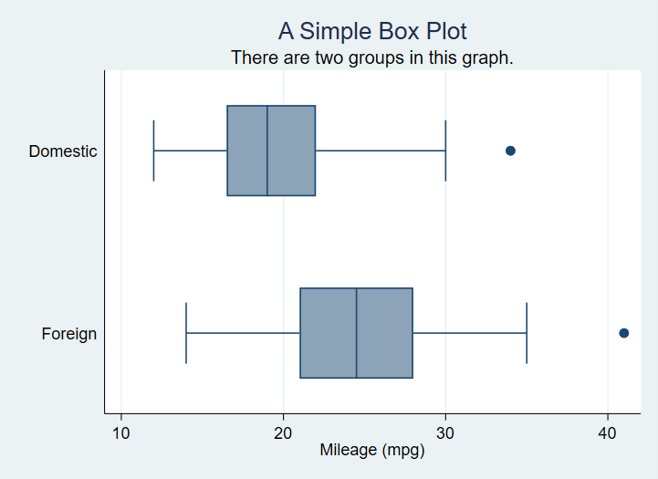

A horizontal box plot with grouped data

Now we will use color to distinguish the groups. It is important to note that the option asyvars causes Stata to treat the groups as seperate ***y variables***.

graph box mpg, ///  
 title("A Simple Box Plot") ///  
 subtitle("There is only one group in this graph.") ///  
 over(foreign) ///  
 asyvars

This gives us

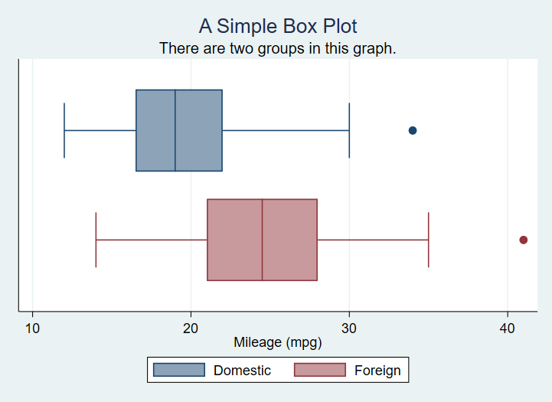

A horizontal box plot with ‘asyvars’ to assign colours.

Most of the options introduced so far for the box plot type will apply equally to bar plots as well.

1. Remember to distinguish **by()** which repeats a command over subsets of data and **over()** which performs on action on subsets of data.