Better Stata Graphing Scripts

Jim Tyson

# Intro

Stata graphing is **easy** if you use the interactive graph editor.

Stata graphing is **hard** if you script. The documentation is exhaustive and highly structured. And a complete rabbit hole. The cheatsheet is a great help!

You should script because graphs that are scripted are

* repeatable;
* modifiable;
* programmatically exportable to Word, HTML and so on.

The problem is the huge variety of options available (1,700?) to what are at base a small number of basic graphing commands, and knowing which options can apply to which graph types. I haven’t mastered either of these.

Instead, I want to show you some simpler and some slightly more complicated graph scripts with explanations of the options and then explain how to export your output to reports.

# The basic graph command and some simple examples

The most basic command for creating graphs and charts in Stata is graph. This command has a number of sub-commands and options. The major sub-commands describe different varieties of plot - such as twoway, box plot, and the sub-types of twoway such as scatter and line. For some reason there is also a small collection of graphs that are independent of either graph or twoway including histogram.

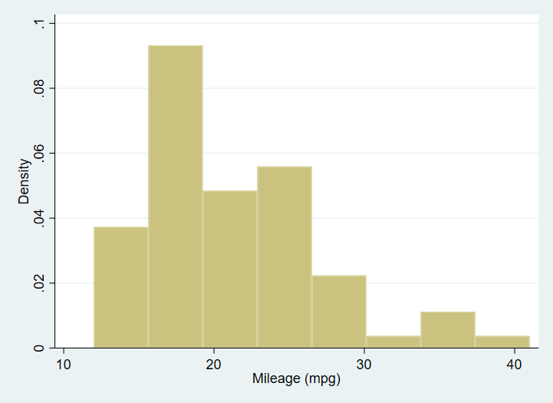

A simple histogram of the mpg variable from dataset auto.

## Ceating a graph adding elements and changing defaults: box plot examples

Next an equally simple box plot:

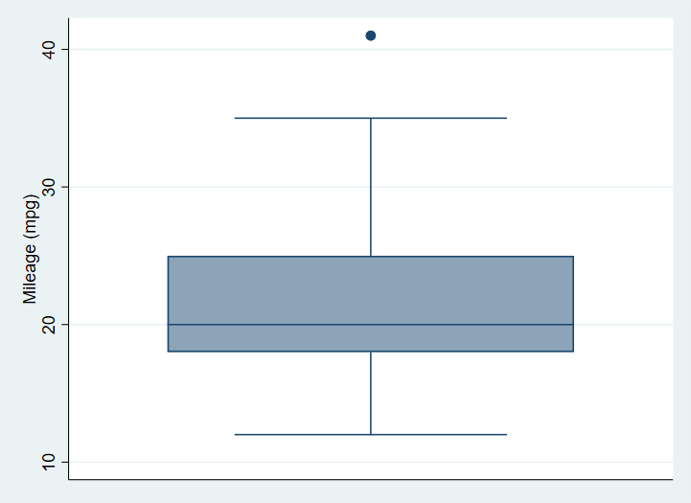

A box plot graph of the mpg variable from the auto dataset with no options specified.

This graph has no options specified. We begin by specifying a Title. When creating a graph from a script, it makes code easier to read if each option is on a separate line, and if we indent options. To break a command over more than one line in a Stata do file, we must use the line extender code: ///.

sysuse auto  
  
graph box mpg, ///  
 title("A Simple Box Plot")

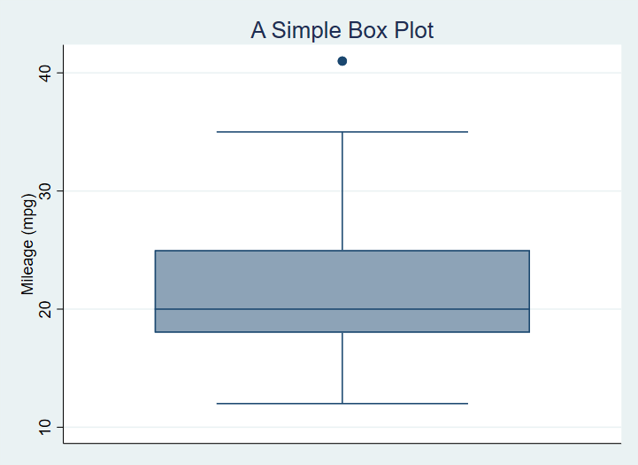

A box plot graph of the mpg variable from the auto dataset with title added.

Now, we add a sub-title and a note on the graph:

sysuse auto  
  
graph box mpg, title("A Simple Box Plot") ///  
 subtitle("There is only one group in this graph.") ///  
 note("In later graphs we will subset the data.")

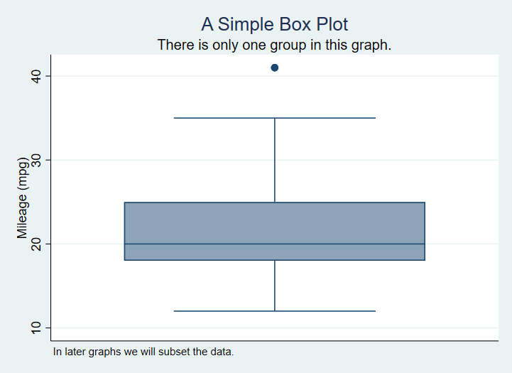

A Box Plot with Title, Subtitle and Note

No we subset the data using the categorical variable foreign.

graph box mpg, title("A Simple Box Plot") ///  
 subtitle("There is only one group in this graph.") ///  
 over(foreign)

Which produces[1]

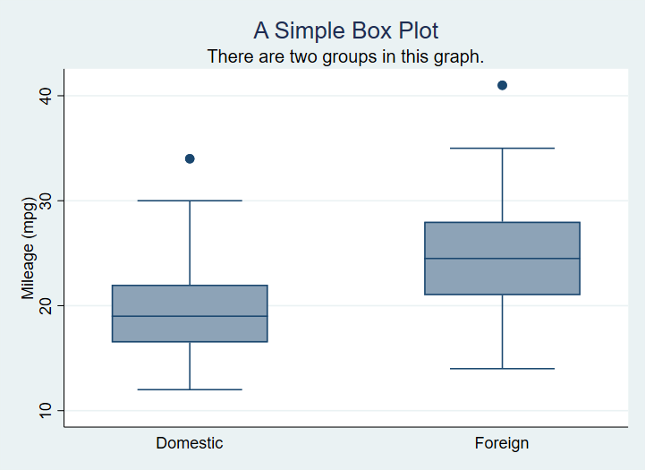

A Box Plot with data grouped based on a nominal variable.

We can modify this to exclude the ticks and gridlines - since this is a box plot we are only modifying the **y-axis** gridlines since no grid is the default for the **x-axis**.

sysuse auto  
  
graph box mpg, ///  
 title("A Simple Box Plot") ///  
 subtitle("There are two groups in this graph.") ///  
 over(foreign) ///  
 ylabel(,nogrid noticks)  
 asyvars

which produces

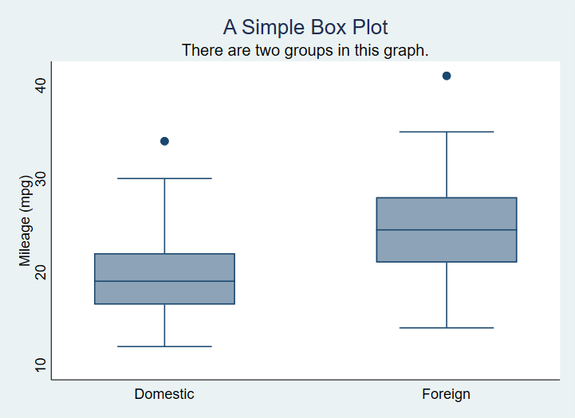

A Box Plot with gridlines supressed.

We can switch to horizontal boxes with

sysuse auto, clear  
  
graph hbox mpg, ///  
 title("A Simple Box Plot") ///  
 subtitle("There are two groups in this graph.") ///  
 over(foreign)

And now we will introduce color by factor variable levels. Note that the command that achieves this, asyvars, is technically instructing Stata to treat the first grouping variable as separate y axis variables.

sysuse auto, clear  
  
graph box mpg, ///  
 title("A Simple Box Plot") ///  
 subtitle("There are two groups in this graph.") ///  
 over(foreign) ///  
 asyvars

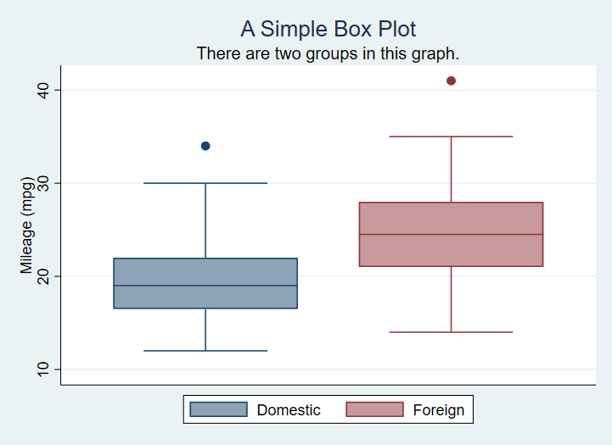

A box plot with factor shown by color of box.

Here is the code for a graph with custom colours set for several of the plot regions.

graph box mpg, ///  
 title("A Simple Box Plot") ///  
 subtitle("There are two groups in this graph.") ///  
 over(foreign) ///  
 asyvars ///  
 graphregion(fcolor(gs13)) ///  
 plotregion(fcolor(cranberry)) ///  
 plotregion(icolor(ltblue))

Produces

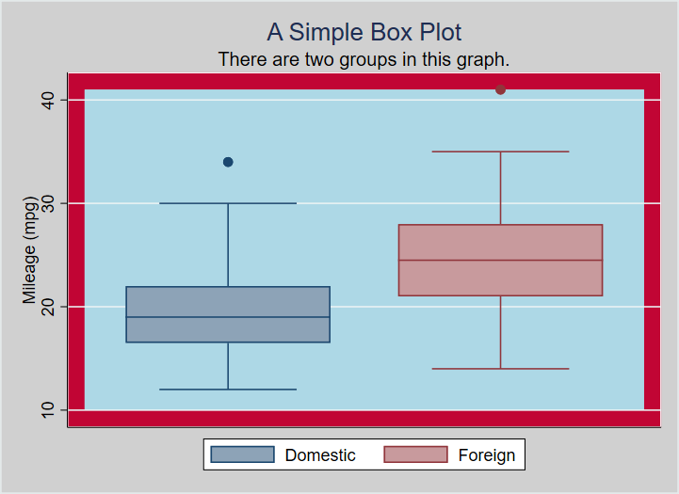

A box plot with a number of custom color options.

It is worth noting that the undocumented command bgcolor appears to override custom color specifications, thus

graph box mpg, ///  
 title("A Simple Box Plot") ///  
 subtitle("There are two groups in this graph.") ///  
 over(foreign) ///  
 asyvars ///  
 bgcolor(white)  
 graphregion(fcolor(gs13)) ///  
 plotregion(fcolor(cranberry)) ///  
 plotregion(icolor(ltblue))

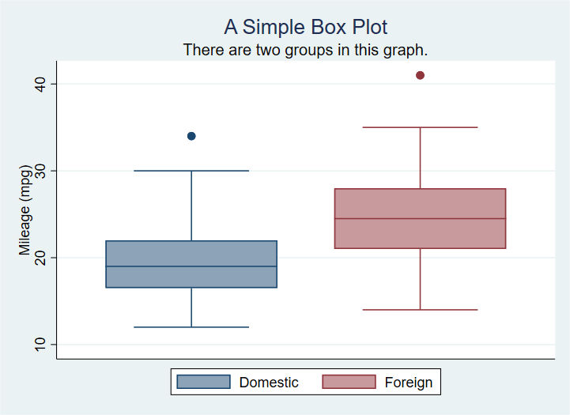

A box plot with a number of custom color options.

## Adding elements and changing defaults: scatter plot examples

First the most basic scatter plot of two continuous variables:

sysuse auto  
  
scatter mpg weight

This using Stata defaults produces:

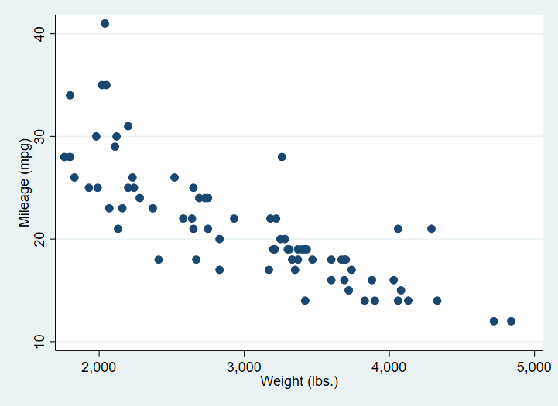

A simple scatter plot of two continuous variables.

In the next version, we first of all separate the mpg values into groups based on the rep variable.

sysuse auto, clear  
  
separate mpg, by(rep) shortlabel  
  
scatter mpg? weight, ///  
 title("Miles per gallon as a function of Weight") ///  
 subtitle("Showing a plausibly strong, negative relationship") ///  
 plotregion(fcolor(bluishgray))

Where **?** in mpg? is a wildcard for the numeric suffix of the list of mpg variables created by separate.

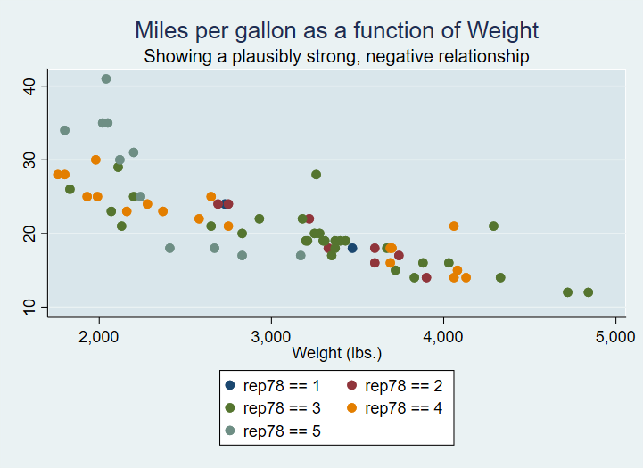

A scatter plot of two continuous variables with varying marker shapes and colour use.

We can change the markers, but note we must add **msymbol()** specifications for each group.

sysuse auto, clear  
  
separate mpg, by(rep)  
  
scatter mpg? weight, ///  
 msymbol(O D T S X)  
 title("Miles per gallon as a function of Weight") ///  
 subtitle("Showing a plausibly strong, negative relationship") ///  
 plotregion(fcolor(bluishgray))

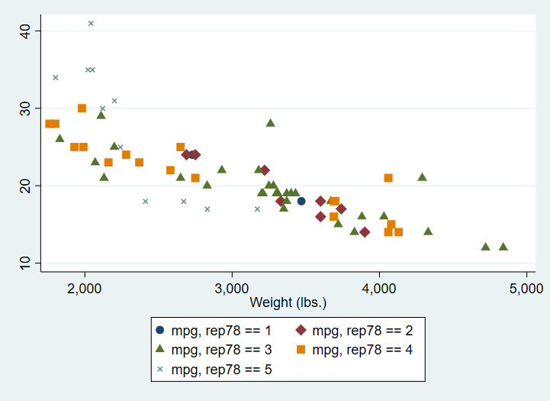

A scatter plot of two continuous variables with varying marker shapes and colour use.

## Using a Stata graph scheme

A Stata graph scheme is a collection of pre-determined choices you can apply easily to any Stata graph. All aspects of the appearance can be controlled from the scheme.

There are a number of built-in schemes available and there are also user contributed schemes.

In the code below, I apply the scheme plottig from the scheme package blindschemes which I have previously installed in Stata with the command

ssc install blindschemes, replace all

Now the graph code:

sysuse auto  
  
graph box mpg, ///  
 title("A Simple Box Plot") ///  
 subtitle("There are two groups in this graph.") ///  
 over(foreign) ///  
 asyvars ///  
 scheme(plottig)

And the result:

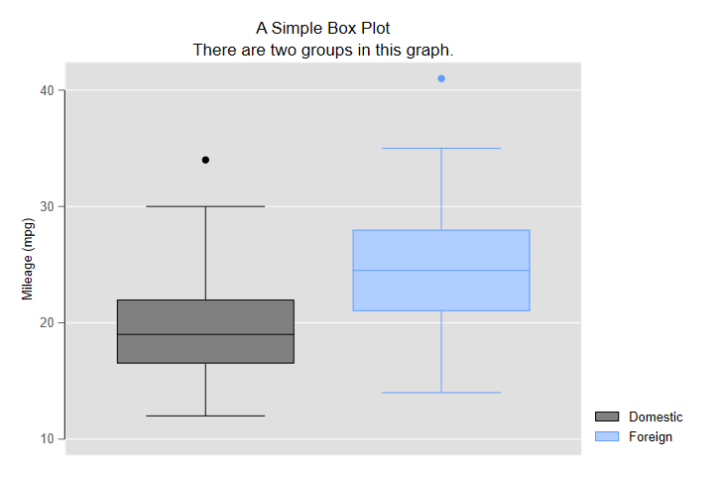

A box plot with the scheme plottig applied.

This scheme is heavily inspired by the default appearance of graphs produced by ggplot2.

And here is a scatter plot with the plotplain scheme applied and the legend cleaned up a bit by applying variable labels:

sysuse auto, clear  
  
separate mpg, by(rep)  
  
label variable mpg1 "Fuel Consumption1"  
label variable mpg2 "Fuel Consumption2"  
label variable mpg3 "Fuel Consumption3"  
label variable mpg4 "Fuel Consumption4"  
label variable mpg5 "Fuel Consumption5"  
  
scatter mpg? weight, ///  
 msymbol(O S D T X) ///  
 title("Miles per gallon as a function of Weight") ///  
 subtitle("Showing a plausibly strong, negative relationship") ///  
 plotregion(fcolor(bluishgray)) ///  
 scheme(plottig)

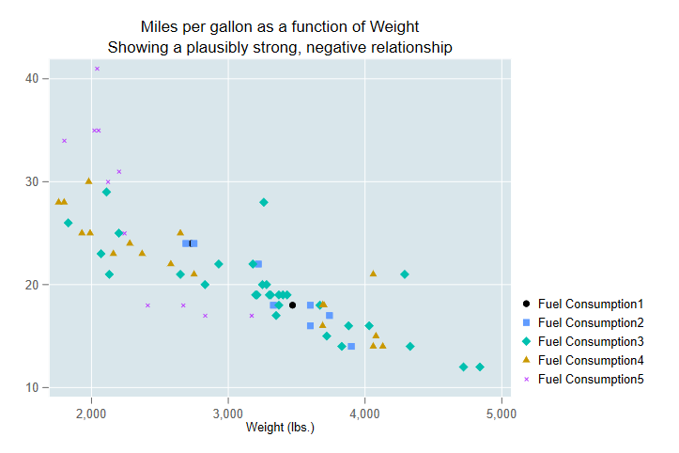

A scatter plot with group membership indicated by markerhape and scheme plotplain applied.

Once you are familiar with using schemes and with the graph options you may consider using [these guidelines to modify a scheme to suit your own preferences](https://medium.com/the-stata-guide/stata-schemes-5ef99d099585).

## Exporting the graph to Word from your script

The following code creates a box plot with a variety of options set, and saves the output as part of a Word document also created by the script.

sysuse auto, replace  
cd "c:\Users\DELL\Documents\Data\Stata\TablesTutorial\StataGraphing\"  
putdocx clear  
putdocx begin  
  
// Create paragraphs  
putdocx paragraph  
putdocx text ("Create and embod your graph"), style(Heading1)  
putdocx paragraph  
putdocx text ("This is a graph created by a script and exported to Word.")  
  
// Embed a graph  
graph box mpg, ///  
 title("A Simple Box Plot") ///  
 subtitle("There are two groups in this graph.") ///  
 over(foreign) ///  
 asyvars ///  
 graphregion(fcolor(gs13)) ///  
 plotregion(fcolor(cranberry)) ///  
 plotregion(icolor(ltblue))  
   
graph export "C:\Users\DELL\Documents\Data\Stata\TablesTutorial\StataGraphing\mgpbox7.png", as(png)  
  
putdocx image "C:\Users\DELL\Documents\Data\Stata\TablesTutorial\StataGraphing\mgpbox7.png"  
  
putdocx save myreport.docx, replace

As you continue to create visualistions you can change the otpion on putdocx save from replace to append.

1. Remember to distinguish **by()** which repeats a command over subsets of data and **over()** which performs one action on subsets of data.