TROC16_ISA.docx
Tagged Register Oriented Computer
James Brakefield
Instruction set architecture for 16-bit Register Oriented Computer supporting 16, 24 and 32-bit instructions on thirty-two 16-bit registers. Herein only the 16-bit instructions are detailed. It is a 16-bit rendition of the full TROC ISA with half-word aligned instructions and data. There are several sections:
- 16-bit instructions using full encoding of immediate values, that is small values within the five bit register field, 16-bit values using an additional half-word. A different encoding is used for 24 and 32-bit instructions.
- 24-bit instructions supporting the majority of the instruction set.
- 32-bit instructions providing three operand instructions and three additional op-code bits.
- 8-bit instructions from the 32-bit instruction code space for Trap, Breakpoint, PC word alignment and Cache or DRAM line PC alignment: WIP revision needed
- Remaining encoding space reserved for 40 and 48-bit instructions.
- Slots for all possible instructions for ease of exploration.
- TROC16 normally has a minimum number of 24 & 32-bit instructions. The 16-bit FUNCT instructions contain register indirect load instructions for each data type and a single store instruction. At this time no 24 or 32-bit instructions are supported.
The 32-register 16-bit register file is augmented with two “tag” bits for data type and two exponent “tag” bits additional on each register. The data types are: unsigned, signed, floating point and a fourth data type which could be a second floating point format or fixed point logarithm or something entirely different. The program counter (PC) and a “residue” register are logically part of the register file (registers 31 and 28) but implemented as distinct registers. The residue register captures the carry from unsigned add/subtract, the signed carry/overflow from signed add/subtract, the upper half of multiply and the remainder from divide.
Floating-point arithmetic and conversion between memory and register formats not yet formally defined. Expectation is that several float formats will be supported. The other “floating-point” type may instead be fixed-point logarithm or pointers for variable length arithmetic.

TROC16 instruction formats are:
16-bit instruction specifies N or S, D and the op-code
sssss ddddd xxxxx1
nnnnn ddddd xxxxx1 n: -15…+15
nnnnnnnn nnnnnnnn 10000 ddddd xxxxx1 -32768…32767
The X are the op-code bits. The least significant instruction bits are arranged so that an all zero instruction is a trap, e.g. the processor has encountered an invalid instruction.
D and S are five bit register selectors.
N is either a five bit signed immediate value (n) or the 16-bit value (N) from the next memory location.
I is the N when used with ALU instructions, can always use either n or N.
For branch instructions n is used as a relative address and N is used as an absolute address.
For Troc16 all instructions use half-word addressing and half-word displacements/absolute addresses.
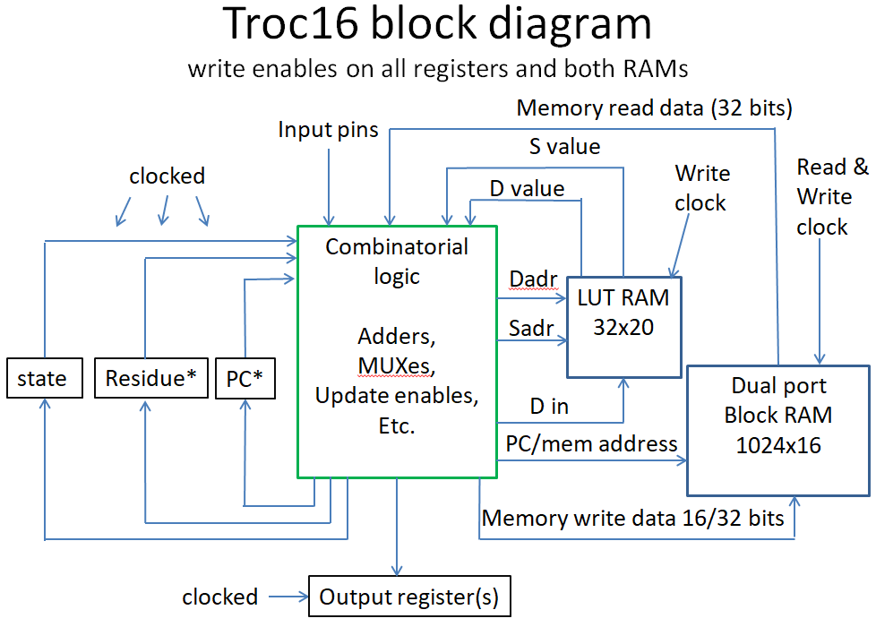
Using two port register file
*Residue and *PC multiplexed onto LUT RAM outputs

16-bit instruction table for Troc16
LSBs: xxx001 xxx011 xxx101 xxx111
MSBs n N n N S n N
000xx1 IN LD SHFT EXTRCT ADD ADDI ibid
001xx1 OUT ST FUNCT INSRT SUB SUBI ibid
010xx1 BSR ibid LD M(S)->D MUL MULI ibid
011xx1 MOV S->D ST D->M(S) DIV DIVI ibid
100xx1 BRZ ibid LDIU ibid AND ANDI ibid
101xx1 BRNZ ibid LDIS ibid OR ORI ibid
110xx1 BRP ibid LDIF ibid XOR XORI ibid
111xx1 BRM ibid LDIF2 ibid CMP CMPI ibid
8-bit Instruction table for Troc16
“00000000” p1TRAP Illegal instruction trap, save current PC in internal save register
“01000000” p1BKPT Debug trap, save current PC in internal save register
“10000000” p1ALGNW Full word align, e.g. add one to next PC and clear LSB
“11000000” p1ALGNC 256 bit Cache line align, e.g. add 15 to next PC and clear four LSBs
Troc16 FUNCT operations for Troc16

00 p2SETU
01 p2SETS
02 p2SETF
03 p2SETF2
04 p2ABS
05 p2NABS
06 p2fTAG
07 p2fITAG
0C p2fLDU
0D p2fLDS
0E p2fLDF
0F p2fLDF2
11 p2fST
1C p2CVTU
1D p2CVTS
1E p2CVTF
1F p2CVTF2
(14) Unused
codes

8-bit Instruction descriptions: not quite right WIP
Op-code R? Mnemonic Precise description (R? column indicates residue update)
“00000000” N p1TRAP Illegal instruction trap, save current PC in internal save register
Branch to illegal instruction handler, undefined instructions use different handler
“01000000” N p1BKPT Debug trap, save current PC in internal save register
Branch to debug handler location
“10000000” N p1ALGNW Skip to next word aligned instruction.
Word size is implementation defined or set by configuration bit.
“11000000” N p1ALGNC Skip to next cache line or DRAM line aligned instruction
16-bit Instruction descriptions:
If the destination register is residue, the normal residue result is not recorded.
16-bit instructions use -15 to +15 or 16-bit N interpretation.
For Troc16 all instructions use half-word addressing and half-word displacements.
Op-code R? Mnemonic Precise description (R? column indicates residue update)
“000001” N p2IN Store value of input port N into D if N is in the range from -15 to +15.
Negative N signifies internal ports, positive N external ports. D’s tag bits set to unsigned.
“000001” N p2LDT When n is outside the range from -15 to +15 load D from absolute
memory location N. Load the tag bits from location N+1. No format conversion needed.
“001001” N p2OUT Place D into output port N if N is in the range from -15 to +15.
Negative N signifies internal ports, positive N external ports.
“001001” N p2STT When n is outside the range from -15 to +15 store D into absolute
memory location N and store the tag bits into location N+1.
“010001” N p2BSR Branch to PC + n or to N, save address of next instruction in D
“011001“ N p2MOV Move register S to D, tag bits moved as well
“100001” N p2BRZ Branch to PC + n or to N if D is zero
“101001” N p2BRNZ Branch to PC + n or to N if D is non-zero
“110001” N p2BRP Branch to PC +n or to N if D is positive (MSB is zero)
“111001” N p2BRM Branch to PC + n or to N if D is negative (MSB is one)
“000101” Y p2ADD Add S to D, if types differ is currently unimplemented trap
Residue register captures the carry, for signed ADD, carry can be either zero, +1 or -1
For floating-point ADD residue register captures round-off error
Floating-point ADD makes use of and may modify the exponent tag bits
“001101” Y p2SUB Subtact D from S, if types differ is currently unimplemented trap
Residue register captures the carry, for signed SUB, carry can be either zero, +1 or -1
For floating-point SUB residue register captures round-off error
Floating-point SUB makes use of and may modify the exponent tag bits
“010101” Y p2MUL Multiply D by S and store in D, if types differ is unimplemented trap
Residue register captures upper half of product for signed or unsigned multiply
For floating-point MUL residue register captures round-off error
Floating-point MUL makes use of and may modify the exponent tag bits
“011101” Y p2DIV Divide D by S and store in D, if types differ is unimplemented trap
Residue register captures remainder for signed or unsigned divide
For floating-point DIV residue register captures a floating-point remainder
Floating-point DIV makes use of and may modify the exponent tag bits
“100101” N p2AND Logical AND between S and D to D irrespective of data types
“101101” N p2OR Logical OR between S and D to D irrespective of data types
“110101” N p2XOR Logical exclusive or between S and D to D irrespective of data types
“111101” ~Y p2CMP S subtracted from D and placed in residue register
“000111” Y p2ADDI Add I to D, I converted to register format of D before add
Residue register captures the carry, for signed ADDI, carry can be either zero, +1 or -1
For floating-point ADDI residue register captures round-off error
Floating-point ADDI makes use of and may modify the exponent tag bits
“001111” Y p2SUBI Subtract D from I, I converted to register format of D before SUB
Residue register captures the carry, for signed SUBII, carry can be either zero, +1 or -1
For floating-point SUBI residue register captures round-off error
Floating-point SUBI makes use of and may modify the exponent tag bits
“010111” Y p2MULI Multiply D by I and store in D, I assumes the type code of D.
Residue register captures upper half of product for signed or unsigned multiply
For floating-point MULI residue register captures round-off error
Floating-point MULI makes use of and may modify the exponent tag bits
“011111” Y p2DIVI Divide D by I and store in D, I assumes the type code of D.
Residue register captures remainder for signed or unsigned divide
For floating-point DIVI residue register captures a floating-point remainder
Floating-point DIVI makes use of and may modify the exponent tag bits
“100111” N p2ANDI Logical AND between I and D to D irrespective of data types
“101111” N p2ORI Logical OR between I and D to D irrespective of data types
“110111” N p2XORI Logical exclusive or between I and D to D irrespective of data types
“111111” ~Y p2CMPI D subtracted from I and placed in residue register
“100011” N p2LDI load unsigned immediate, set tag bits to unsigned
“101011” N p2LDIS load signed data immediate, set tag bits to signed
“110011” N p2LDIF load float data immediate, convert I to register format
“111011” N p2LDIF2 load float2 data immediate, convert I to register format
“010011” N p2SOB Decrement D and branch to PC + n or to N if D not zero
“010011” N p2LD Load D from memory location S using D’s current type
“011011” N p2AOB Increment D and branch to PC + n or to N if D not zero
“011011” N p2ST Store D to Memory location S
“000011” Y p2SHFT If n is in the range from -15 to +15 shift or adjust exponent by signed n.
For signed or unsigned D shift left or right per sign of n. For floating-point add signed n
to the exponent.
“000011” ~Y p2EXTRCT If n is not in the range from -15 to +15 extract field from D and place in
Residue per N (uu0000wwww00mmmm). Operation is irrespective of tag bits. U is data
type of the result? W is the width of the field extracted. If W is “0000” then width is
16. M is the starting bit of the field. For unsigned, bit field zero extended to register
width. For signed data type, bit field sign extended to register width.
“001011” N p2INSRT If n is not in the range from -15 to +15 insert field from residue into D
per N (uu0000wwww00mmmm): M is the residue shift amount, W is the insert width. If W is “0000” then width is 16.
“001011” p2FUNCT If n is in the range from -15 to +15 do a one operand function fn(D) => D
“001011” N “00000” p2fSETU If n is “00000” set D type to unsigned
“001011” N “00001” p2fSETS If n is “00001” set D type to signed
“001011” N “00010” p2fSETF If n is “00010” set D type to float
“001011” N “00011” p2fSETF2 If n is “00011” set D type to float2
“001011” “00100” p2fABS If n is “00100” take the absolute value of D
“001011” “00101” p2fNABS If n is “00101” take the negative absolute value of D
“001011” Y “00110” p2fTAG If n is “00110” place D’s tag bits into residue
“001011” N “00111” p2fITAG If n is “00111” place residue’s tag bits into D
“001011” “01100” p2fLDU If n is “01100” Load residue with unsigned from M(D)
“001011” “01101” p2fLDS If n is “01101” Load residue with signed from M(D)
“001011” “01110” p2fLDF If n is “01110” Load residue with float from M(D)
“001011” “01111” p2fLDF2 If n is “01111” Load residue with float2 from M(D)
“001011” ~Y “10001” p2fST If n is “10001” convert and store Residue to M(D)
“001011” ~Y “11100” p2fCVTU If n is “11100” convert D to unsigned
“001011” ~Y “11101” p2fCVTS If n is “11101” convert D to signed
“001011” ~Y “11110” p2fCVTF If n is “11110” convert D to float
“001011” ~Y “11111” p2fCVTF2 If n is “11111” convert D to float2
“001011” “xxxxx” Room for 14 more functions
PC in the D register field:
The PC is made part of the register file to eliminate several distinct instructions: MOV can be used to jump to an address in a register. LD can be used to jump to an address in memory. ADD, ADDI, SUB, SUBI can be used for unconditional relative branches. LD instruction supports implementation of dispatch tables. An IN instruction to the PC can be used to return from an interrupt. There are many instructions where it does not make sense to have the PC as the D register. In these cases an illegal instruction trap is taken.
More on interrupts:
There are several kinds of interrupts, each with an associated branch location:
Reset: PC set to zero.
TRAP: PC set to x20 and set the save register to current PC.
BRKPT: PC set to x40 and set the save register to current PC.
Illegal: PC set to x60 and set the save register to current PC.
Undefined instruction: PC set to x80 and set the save register to current PC.
The trap locations are spaced out to allow space for one or more registers to be saved and restored and to provide space for a branch to the interrupt handler.
More on internal registers:
It is expected that one or more additional internal registers will be needed for configuration (such as: rounding modes, type code options and interrupt options). In particular there is need for floating point status bits (such as: overflow, underflow, inexact, NaN operand, interrupt status, etc.). A total of fifteen internal registers are possible and could be implemented as a register file that could also serve for ISA variant declaration.
Relation to larger word size ISAs:
It is relatively straight forward to use TROC16 as a subset of 24 and 32 bit size instructions when the word size is greater than 16. In such cases the addressing is to the byte size of the larger word size. And branch displacements are always relative. It can be anticipated that byte sizes could be 8, 9, 12 or 21 bits along with word sizes of 24, 32, 36, 42, 48 or 64 bits. A Harvard implementation could have 16, 24 and 32 bit instructions along with 16, 18, 21, 24, 32, 36, 42, 48 or 64 bit words.
The 16-bit instructions can be used along with 24 and 32-bit instructions on larger than 16-bit word sizes. The 16-bit IN, OUT, SHFT and FUNC instructions retain their behavior with shifts limited to 15-bits, e.g. “n” can be from -15 to +15. The INSRT and EXTRCT instruction N values have enough bits for up to 64-bit words. The 24 and 32-bit instructions always use variable length immediate values of any necessary length providing means to have full capability IN, OUT, SHFT and FUNC operations part of the 24-bit instruction set. The 16-bit instruction relative branches become byte displacements with the N displacement being +/- 327687 bytes and the n displacement being +/- 15 bytes.
The larger word sizes use additional tag bits to handle floating point needs of additional mantissa bits.
The intent of the TROC architecture is to support four data types, four data sizes and the same ISA across all of these options. Additionally data type tag bits simplify and unify the number of necessary instructions thereby eliminating the need for additional op-code bits.
The residue register performs the important role of supporting multiple word data sizes and a uniform approach to ALU result status.
Currently there are 36 16-bit instructions with the FUNC instruction supporting 31 single operand functions, a total of 66 instructions. The 24 and 32-bit instructions support 48 instructions each and both provide a FUNC with even greater capabilities. The 32-bit instruction set includes a 24-bit subset that provides 32 of the 24-bit instructions with three additional “option” bits one of which is typically a residue register update enable.
Troc16 instruction selection process:
The 24 and 32-bit instruction sizes support ~44 distinct instructions each. Among them is the single operand group with up to 32 op-codes. 20 of the 44 instructions are the load and store to/from memory. Sixteen unused 24 and 32-bit instruction codes are reserved for 40 and 48-bit instructions.
The selection process is for “useful” instructions that may or may not be implemented. The FUNC operations provide a raft of elementary functions that can be difficult to implement. For some of the three operand operations that have limited usage, they have reserved slots for those applications where they can be justified. The slots for 40 and 48-bit instructions are there for multi-media and vector operations where additional register fields are necessary.
This leaves 32 slots for 16-bit instructions. The register select fields are kept at five bits each. Troc16 is weak on load/store instructions but otherwise has a complete ISA, the initial thinking being that 24 and 32-bit load/store instructions could be supported if needed for indexed or base plus offset load/store.
The necessary instructions are the eight ALU instructions: ADD, SUB, MUL, DIV, AND, OR, XOR and CMP along with their immediate value versions. Add to this the basic conditional branches: BRZ, BRNZ, BRP and BRM. There are four load immediate instructions, one for each data type. ADDI and LDI to the PC provide the unconditional branches. There are two IO instructions IN and OUT. As it is not anticipated to have a large number in IO locations, the 16-bit N values are repurposed for absolute address load and store of a register value and its type code. And there are two other standard instructions SHFT and FUNCT. These are overloaded based on the value of “n” to provide EXTRCT and INSERT. Of the four remaining slots LD and ST are used for memory load/store. MOV is used to move a register to another location. BSR is used for subroutine calls.
At this time the SHFT, EXTRCT, INSRT and FUNC takes 77% more LUTs as without them. This is a considerable penalty for supporting a set of instructions that can be implemented in a few other instructions (mostly MULI, ANDI and ORI). AOB and SOB are currently not included in order to support the LD and ST instructions (ADDI/SUBI and BRNZ are replacements).
The single operand FUNCT group is used for type conversion and coercion as well as for several ad-hoc instructions.
By virtue of the type codes, this limited ISA also supports unsigned, signed, floating point and a TBD data type.
It was decided to use two five bit register fields in preference to three register fields on a smaller set of registers as using a smaller register file would have fundamentally changed the character of the ISA and made software compatibility with 24 and 32-bit instructions difficult.

