D-Day Memoir

As seen by fictional character of the 501st PIR
By Jim Brendlinger
1,906 words

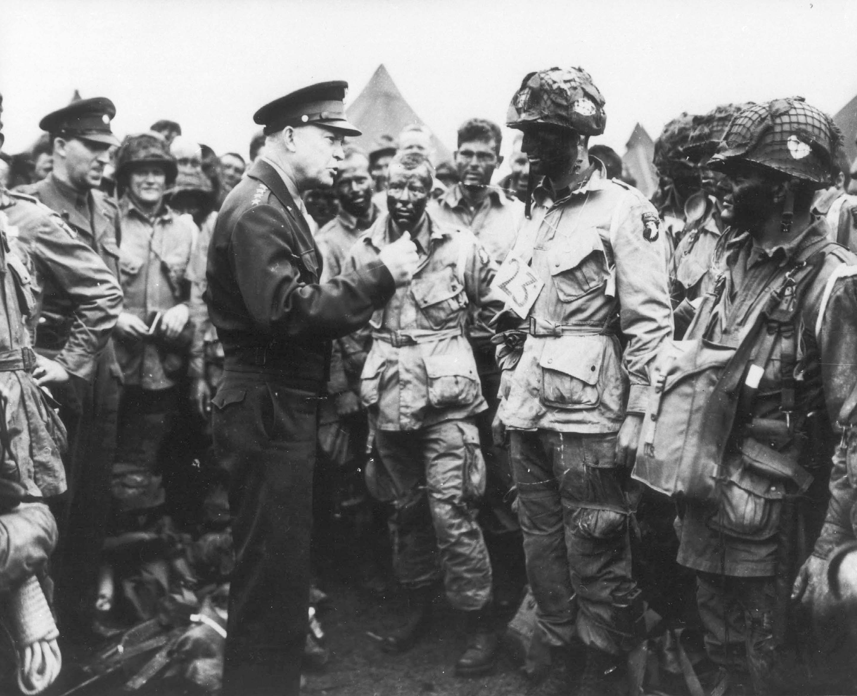

Gen Dwight D Eisenhower talking to troops of the 502nd in England on June 6 1944
I am a freelance photographer. I’m twenty-two years of age, and have lived in Baltimore all my life. My name is John Steele. I have been doing work for various newspapers around Baltimore, my hometown. Until, news of the second Great War allured me to volunteer as a paratrooper and join the army. Placed into the 501st PIR (or parachute infantry regiment), I was then transported to Georgia, where I went through basic training at Camp Toccoa. After training was over in Camp Toccoa my regiment reproachfully marched 105 miles to Atlanta, on our way to further training in Fort Brenning, Georgia (in March, year 1943). That is where all the army men who were not previously qualified in jumping were jump trained.
The regiment’s first assignment was Camp MacKall, North Carolina… the Airborne Command. There the boys engaged in humdrum exercises and maneuvers, taking place over the expanses of states North Carolina, Louisiana, and Tennessee. Training in NC went on until January 1944. At this time, the 501st was officially deployed to Britain. On our trip overseas we processed out of Camp Myles Standish, Maryland. It was in this deployment the soldiers in the 501st PIR were permanently attached to the 101st Airborne Division.
On arriving in England, we underwent further and more vigorous training. Our training was oriented to accommodate an airborne assault, perhaps in the near future. Interestingly enough, at this point we had no idea of the operation to come. On about June 4, 1944 (under strict restrictions of our camps) we were informed of (not only our own) but the entire 101st’s role on D-Day.
The briefings were elaborately detailed, and precise right down to the minute of what will happen…
The purposes for the airborne landings were to slow or totally eliminate the Germans launching an effective counterattack. By, taking over key causeways (bridges i.e.) to slow a German response. If the German’s were successful in launching a full force counterattack, it might have well been capable of suppressing the invasion. The landings were also intended to allow allied forces coming in from the beaches to gain territory, and in some cases expand the area of the beachhead.
The 101st Division’s general mission (identical to the 82nd’s) was to neutralize these key objectives mostly on the western flank of the beaches. The British 6th Airborne Divisions would take care of objectives on the eastern flank (and they were slightly more successful, they were the first to successfully liberate a town). The 101st’s plan, or Operation Chicago, was to:
- Secure the four causeway exits behind Utah Beach
- Disrupt German communications
- Setup roadblocks to hamper German movements
- Capture Sainet-Come-de-Mont
- Destroy coastal batteries including the Saint-Germain-de-Varreville battery
- Capture and destroy bridges on the Carentan causeway, and those spanning the Douve River at Brevands
- Capture Douve River lock at la Barquette
- Reach Highway 13 at Les Forges
- Link up with the 82nd Airborne
- Secure the Douve River valley

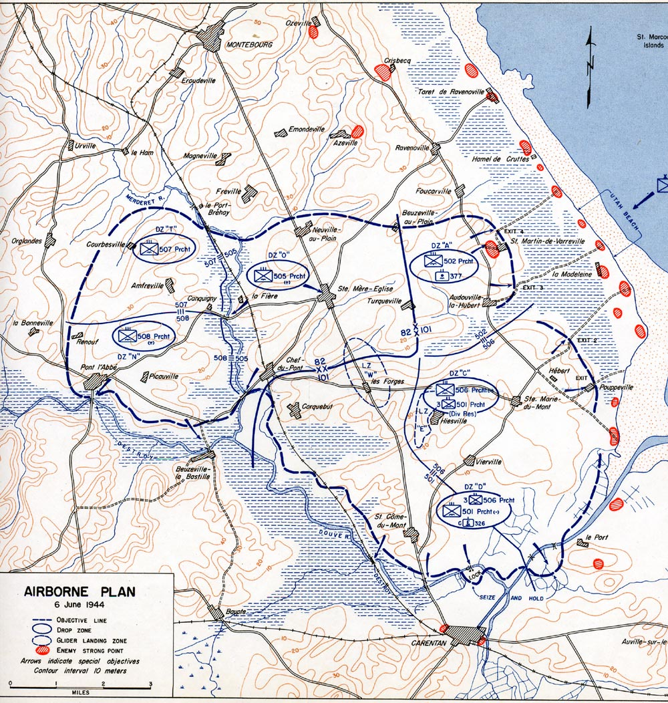
While under strict lockdown of the camp, the men were not allowed to send mail, or make contact with anyone not involved. Also, after the briefings were over, all of the non-flying personnel were segregated from the flying personnel. This put the 501st regiment and me in a separate base. On the same day of the briefings, it was noticed that our aircraft were painted with “invasion stripes,” or black and white stripes of paint. The stripes painted across the wings made the ally aircraft very distinct so that forces on the ground and sea could identify ally from foe.
On the evening of June 4, Operation Overlord was postponed. The planning date for the invasion was determined by the weather. The ideal conditions for the invasion were; a full moon to give light for the aircraft pilots (and for the spring tide, which allowed a smooth landing of amphibious vehicles). But, on June 5, the originally planned date for the assault was moved forward. This was because there was wind, high seas, and low clouds.
The result was, all the airborne troops were moved on to a separate base (which included paratroopers), still under full restrictions. There was a massive backflow of troops, because of the postponing. Many men that night slept in cots within the hangars. However on June 5th, the plan was resumed. The initial airborne assault was to take place 5 hours before the assaults on the beaches.
The first wave of paratroopers set out on only 11 C-47’s a little before 2100. They, the pathfinders, were to mark out the landing zones behind Utah beach for the regiments coming in. After that, all crews, and all airborne pathfinders of the 101st reported to their aircraft at 2200 hours. It took about 40 minutes to get the 6,789 paratroopers into their respective craft; a fleet of over 400 C-47’s. The reason it took 40 minutes was because each paratrooper had to ready their 70-pound packs…
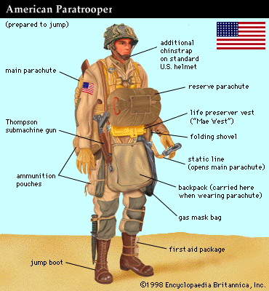

The planes’ engines started at 2240 hours and began to taxi into take-off position. Once all planes were in formation, the planes took off at 2300 hours. There were certain predetermined routes our planes were to take to get to the destinations. The planes were to remain in formation. However certain variables contributed to a scatter of forces. Visibility was one; some of the planes’ formation lights were dimmed to low, not allowing other craft to acknowledge their own position within the formation. There were also some low clouds, making it hard for the pilots to navigate. Another, key variable, was the German anti-aircraft fire, that caused the planes to take evasive measures, and others to take damage. 38 C-47’s are believed to be downed on that flight.
Then some time later, the red light within the craft flashed on. This signaled all the paratroopers to “get up and strap up.” Many of the men, having trained over a year for this moment, had no idea it would be as chaotic as it was. No one was sure of where we were. Loud explosions frequently rocked the aircraft, and the emotion that took over was obviously fear. But, once the pilots thought we were over our drop zones, the green light came, and we did what we were trained to do- we began to drop. Some of the paratroopers were scared that they might collide with another ally aircraft. Others, that they might land right in the middle of a German placement, and some did and were killed. It was all luck, and some were unlucky enough to land in the deadly water.
I watched as soldiers jumped, and then it was my turn. I jumped from the C-47 and my parachute deployed, all in the blink of an eye. While falling, I was lucky enough to see some of my allies falling near me as well. The gushing wind was being drowned out by the background noise of anti-aircraft guns. As my chute neared the ground, German gunfire was sounding very clearly. Their guns were easily identifiable for their high rate of fire, and ally guns were of a lower resonance. I hit the ground and my knees buckled, though my training was useful and I was ready for it. I pulled out my knife from its strap above my boot and cut myself out of my parachute strings, which became tangled. I could then hear gunfire a few hundred yards away. As I fell I had seen a few other Americans land near me. I made my way to link up with them. In the night it was extremely difficult to know where you were. The maps, photographs, and landmarks we were drilled to learn were of only little help. While making my way to the other troops, I heard a “crick.” I knew what this meant; I pulled out my own cricket, a metal device, which I pressed to make two cricks in response. This was a signal to show the American troops who made the first crick that I was an ally.
The men were not on my plane, but we headed off together, slowly linking up with more men. It was in no way how we organized it to be. But, every parachutist knew their objectives. We had formed a small ad hoc group of about 20 men, and were making our way south. By miming out words, and pointing at the map, the troops learned where we were from the local French. We were a few miles north of Carentan. We made our way towards the bridge causeways and Douve river lock near Carentan. We ran into a few german patrols of only about two men, which the soldiers who had taken point downed in a couple of shots from their rifles (M1 Garands).
It was now about 4:00 am, and dawn was approaching. We finally ran into Colonel Johnson. He was the ranking officer, and was gathering a large force. We linked up with him and continued heading towards our objective. After gathering a force of 150 men, we had reached the Douve River lock at La Barquette. About 50 men were sent to take the objective, and did so successfully. Patrols were sent out to assess the situation. The Colonel was hoping we would continue to press forward and take out the bridges as well, but we would need reinforcements. A patrol also reported that Major Allen had a force near Addeville. Colonel Johnson and about 50 men left to make contact with them (he arrived there at 0900 hours), while I stayed with the defensive force at the lock. It was reported that Major Allen had rallied a force of about 100 men and was attacking the enemy to the north and west. And, Colonel Ballard was leading a force of 250 men from 2nd battalion, 501st PIR towards Les Droueries. However, because of thick resistance, they did not risk joining forces.
Colonel Johnson arrived back to our position at the now slightly more clear lock with a larger force. We pushed farther in, avoiding the heavy german placements reportedly to the west. Position was set up 100 yards south of the lock. At 2000 hours night patrols of about 20 men were set out to try and make contact with division headquarters. A report came back of Captain Shettle’s force holding out at Le port, at the cost of most of the men set out on the night patrol.

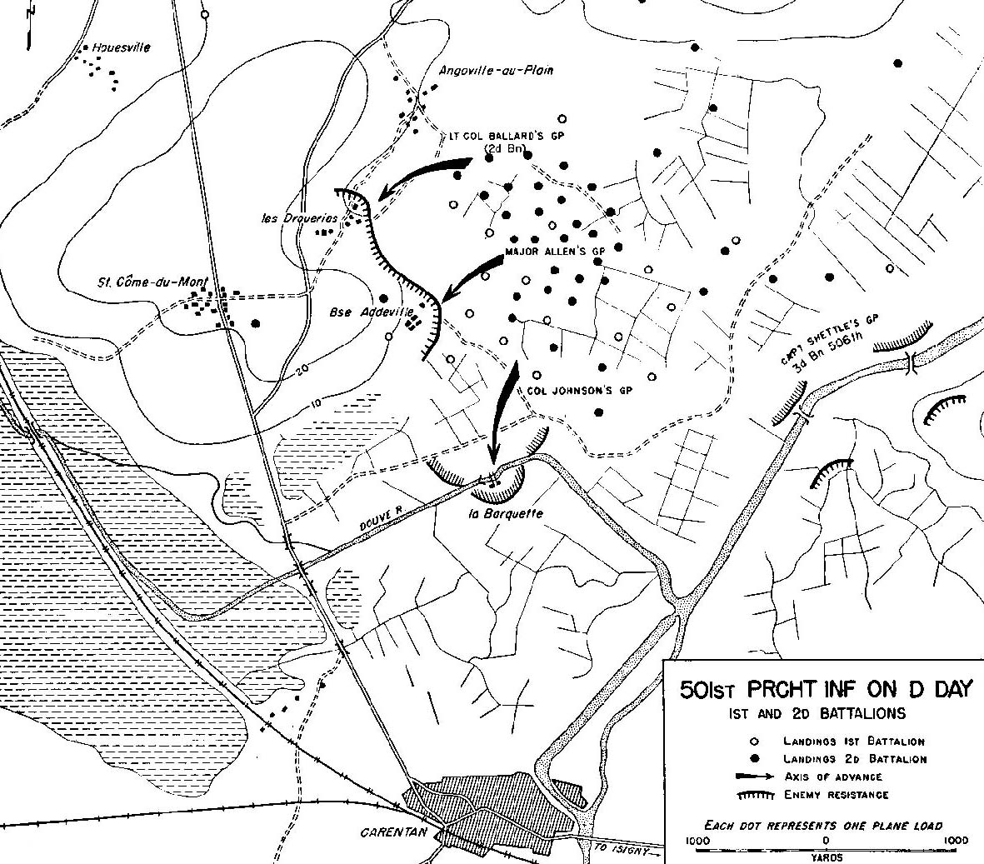
At the end of the day we had only completed a part of the mission, and the bridges to our right flank could not be taken out. As our position was heavily fortified, I slept there that night, waking up the next morning at 0500 hours to continue the invasion…

(only 2,500 of the 6,000 rallied. Final casualties for 101st were 1,240 men, about %20 of forces. The causeway exits to Utah beach were secured. The 101st captured Carentan on June 12.)

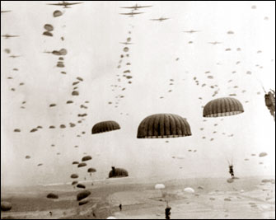

(I named my character after John Steele, who was a real paratrooper, while falling his parachute was caught on the steeple of a village church. He was later rescued.)
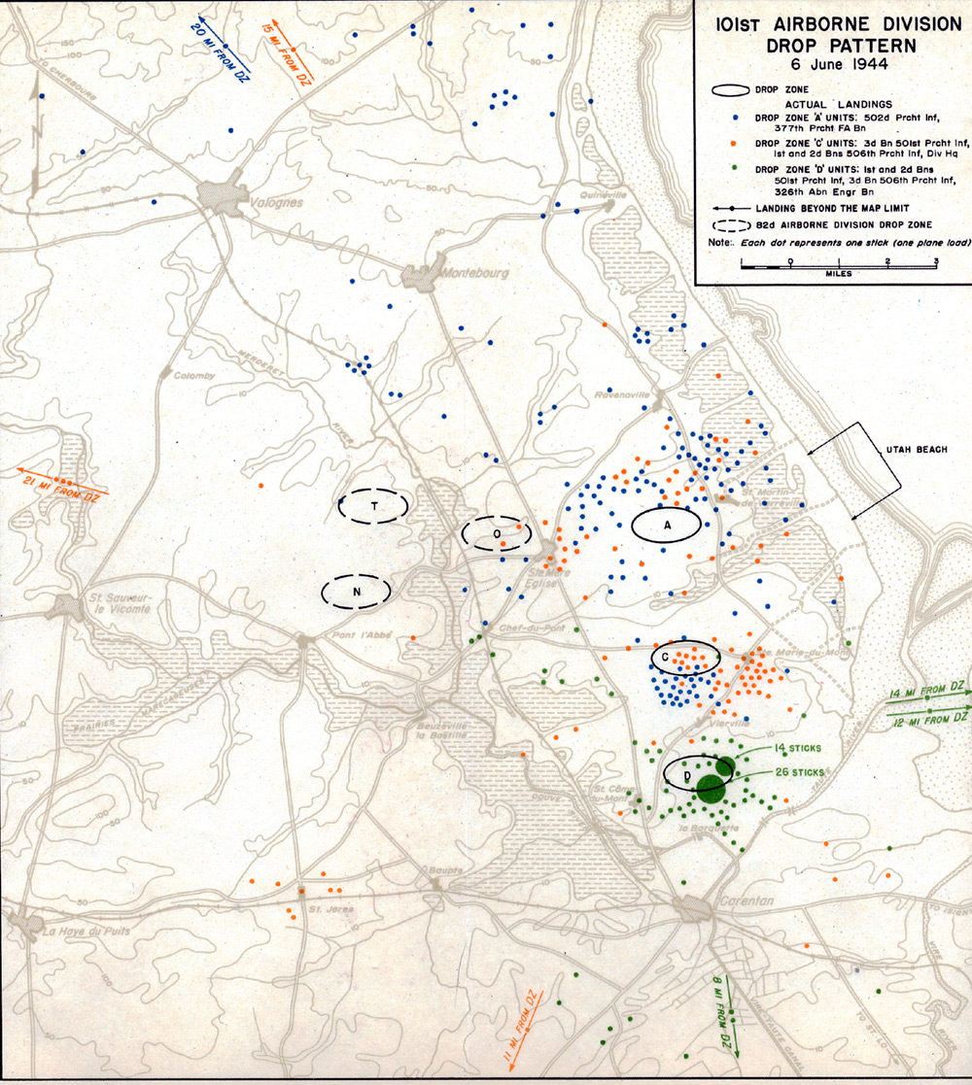
This map gives a glimpse of how off target the landings were…
(each dot represents one plane load)

