電通二乙微處理器實驗 實驗結報

實驗名稱 | 溫濕度MCSCloud
組別 |  | 組員 | 陳彥廷

- 實驗目的
學會用arduino與timer上傳至mcs
- 實驗步驟
讓DHT-11可以一直量測溫濕度
整合 Timer與DHT-11測量溫濕度
使用Timer每隔10秒將溫濕度上傳MCS
- 程式碼
Hw1
#include "DHT.h"
#define DHTPIN 7
#define DHTTYPE DHT11

DHT dht(DHTPIN, DHTTYPE);

void setup() {
Serial.begin(9600);
Serial.println(F("DHTxx test!"));
dht.begin();
}

void loop()
{

delay(2000);

float h = dht.readHumidity();
float t = dht.readTemperature();

Serial.print(F("Humidity: "));
Serial.print(h);
Serial.print(F("% Temperature: "));
Serial.print(t);
Serial.println(F("°C "));
}

Hw2
#include "Arduino.h"
#include "LTimer.h"
#include "DHT.h"
#define DHTPIN 7
#define DHTTYPE DHT11

DHT dht(DHTPIN, DHTTYPE);

LTimer timer1(LTIMER_1);
double h;
double t;

void _callback1(void *usr_data)
{

Serial.print(F("Humidity: "));
Serial.print(h);
Serial.print(F("% Temperature: "));
Serial.print(t);
Serial.println(F("°C "));
}
void setup()
{
Serial.begin(9600);
dht.begin();
timer1.begin();
timer1.start(1000, LTIMER_REPEAT_MODE, _callback1, NULL);
}
void loop()
{
h = dht.readHumidity();
t = dht.readTemperature();
}

Hw3
#include "Arduino.h"
#include "LTimer.h"
#include "DHT.h"

#include <LWiFi.h>
#include "MCS.h"

#define DHTPIN 7
#define DHTTYPE DHT11

#define _SSID "06050676"
#define _KEY "06050676"

MCSDevice mcs("D4CXhJdQ", "ymft7zCIewvnQiHZ");
MCSDisplayInteger temp("01");
MCSDisplayInteger humid("02");

DHT dht(DHTPIN, DHTTYPE);

LTimer timer1(LTIMER_1);
double h;
double t;

void _callback1(void *usr_data)
{
Serial.print(F("Humidity: "));
Serial.print(h);
Serial.print(F("% Temperature: "));
Serial.print(t);
Serial.println(F("°C "));
}
void setup()
{
Serial.begin(9600);
mcs.addChannel(temp);
mcs.addChannel(humid);
while(WL_CONNECTED != WiFi.status())
{
Serial.print("WiFi.begin(");
Serial.print(_SSID);
Serial.print(",");
Serial.print(_KEY);
Serial.println(")...");
WiFi.begin(_SSID, _KEY);
}
Serial.println("WiFi connected !!");

Serial.begin(9600);
dht.begin();
timer1.begin();
timer1.start(10000, LTIMER_REPEAT_MODE, _callback1, NULL);
}
void loop()
{
while (!mcs.connected())
{
mcs.connect();
if (mcs.connected()) { Serial.println("MCS 已重新連線"); }
}
mcs.process(100);
h = dht.readHumidity();
t = dht.readTemperature();
temp.set(t);
humid.set(h);
}

- 實驗結果及分析
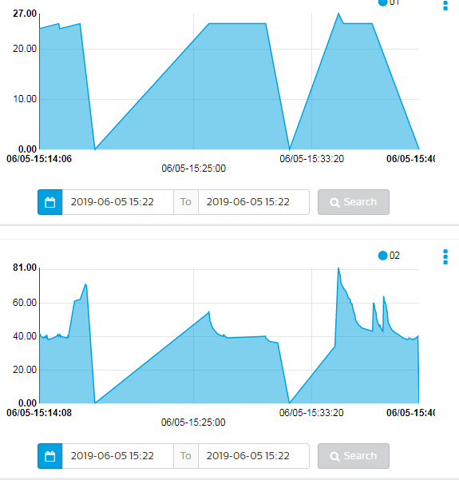
- 心得討論
用Timer有點麻煩，程式碼放的位置有點複雜

