GrepNova2 Users’ Guide

A Utility for Amateur Supernova Patrolling

for Greek Supernovae Survey Team

Version 1

Coded by

Cooknas

for Greek Supernovae Search Team (GSST)

Thessaloniki

GR

Email: cooknas@gmail.com

Initial Concept & Initially Coded (as grepnova) by

Dominic Ford

Trinity College

Cambridge

CB2 1TQ

UK

Email1: dcf21@mrao.cam.ac.uk & dcf21-www@dcford.org.uk

October 2018

Contents
Chapter 1 4
Introduction 4
1.1 Overview for grepnova 4
1.2 Overview for Grepnova2 4
1.3 Acknowledgements 5
1.4 Legal matters 5
1.5 Why “GrepNova”? 6
Chapter 2 7
Using GrepNova2: The Graphic Interface 7
2.1 Introduction 7
2.2 Loading new images 9
2.3 Changing how images are displayed 9
2.3.1 The display transformation 9
2.3.2 The brightness of images 10
2.4 Outputting images 10
2.5 Processing large batches of images 11
2.6 Viewing Images in Real Time 12
2.7 Resize Template 12
2.8 Details window 12
2.8.1 Zoom window 12
2.8.2 Find Brightest Stars 12
2.9 Annotations 13
2.10 FTP Server connection 13
2.11 The Menu contents 14
2.12 Other Windows 16
2.12.1 Grepnova2 Configuration 17
2.12.2 Image Statistics 18
2.12.3 Bitmap Filtering 18
2.12.4 Stretch Image 18
2.12.5 Star Graph 19
2.12.6 grepnova Configuration 20
2.12.7 Images Headers 21
2.12.8 The Full-Screen window 21
2.13 Automated search 22
2.13.1 Search for Candidates 22
2.13.2 Auto-Search the Loaded Batch 22
2.14 Plate Solving 23
2.14.1 Direct contacting Astrometry.net 23
2.14.2 Using AllSkyPlateSolver 23
Chapter 3 25
Building GrepNova variants 25
3.1 GrepNova2 for Windows 25
3.2 Building grepnova 1.0.0 (gui and align) in Windows 25
3.3 grepnova for Windows 26
3.4 grepnova for Linux 26
Chapter 4 28
Configuring grepnova 28
4.1 Generating the configuration file 28
4.2 Editing the config file 28
4.3 Version check 28
4.4 The file paths 30
4.5 The FTP Server’s settings 30
4.6 JPEG Illustration Options 30
4.7 Subject/Template selection 30
4.8 Hot Pixel Combing 31
4.9 Warnings 31
4.10 Negative Results 31
4.11 Verbosity Settings 31
4.12 Numerical settings 31
4.13 Blinking time 31
4.14 Optimization steps 31
Chapter 5 33
Using GrepNova II: The Commandline 33
5.1 grepnova-align.bin.exe 33
Chapter 6 34
Changelog 34
6.1 For grepnova 34
6.2 For GrepNova2 34
6.3 ToDo List 34
Chapter 7 35
APPENDIX 35
7.1 Mathematical definitions 35

Chapter 1

Introduction

1.1 Overview for grepnova

GrepNova is an image manipulation tool which aids the image comparison tasks which are required for amateur nova/supernova hunting. It is operated by supplying pairs of images, each consisting of a reference library image of an object and a newly obtained image of the same object. GrepNova will align the two images into a common orientation and then and blink them, allowing easy visual comparison, as is necessary when visually searching images of galaxies for new sources which might be nova/supernova candidates. Because such patrolling, by its very nature, involves searching large numbers of images, GrepNova includes features to ease the processing many pairs of images in quick succession.

GrepNova accepts image files in two formats: FITS (preferred) and JPEG. In either case, GrepNova only works with monochrome images, and color JPEGs will be greyscaled upon being loaded. The first input image, henceforth called the template, should be a library image of the target galaxy, in which it is assumed that there are no supernovae. The second image, henceforth called the subject, is the new image that is to be searched for new objects. These two images do not need to be of the same size, but they do need to be of the same magnification (i.e. each pixel width must correspond to the same angle on the sky in both images). They may also be at any arbitrary orientation with respect to each other, as GrepNova is able to correct for any relative translation (lateral shift) or rotation between the two images, using a pattern recognition algorithm applied to field stars to align them. It should be noted that there is a modest requirement on the size of the region of overlap between the images to ensure that a sufficient number of common field stars are identified for this pattern recognition to succeed. GrepNova is also able to detect and correct for any differences between the seeing and sky transparency conditions of the two images.

It is hoped that a future version of GrepNova might be able to perform fully automated searching of images for supernovae. The last version, 1.0.0, however, serves only to assist with the task of aligning pairs of images at speed and blinking them, leaving the user to visually search for nova/supernova candidates.

GrepNova is available for multiple platforms. A graphical interface is available for the Microsoft Windows and Linux operating systems. A Linux/UNIX command-line utility version is also available for grepnova.

1.2 Overview for Grepnova2
Grepnova2 initially started as grepnova version 1.0.0, re-coding Dominic’s code, as this code (version 0.6.0) was kindly published under GNU General Public License. Although the code was understandable and finely commented, the main obstacle was the GTK disadvantages under Windows, if someone intended to extend grepnova’s GUI for this platform (as I was). So Grepnova2 started from scratch in C# (don’t ask me why I chose this C variant), keeping in mind Dominic’s concept and GUI layout. As GSL library could not be ported in Windows development environment (like Visual Studio 2017, where I had to compile it’s source from scratch in Windows), I decided to use parts of grepnova’s routines and code (especially Dominic’s likelihood.c) as a standalone executable (compiled under Linux as Windows executable) to calculate the displacement and rotation angle for the aligned templates. I truly admit that Dominic’s alignment code under Linux is so lightning fast that no development under Windows could even come close to it. On the other hand, the only library I succeeded to find to replace CFITSIO for C# was the CSharpFITS package, that is a pure C# .NET port of Tom McGlynn’s nom.tam.fits Java package. It provides native C# support for reading and writing FITS files.

Respecting Dominic Ford’s grepnova (as this was an inspiration source) I kept the Users’s Guide template and format according to initial Dominic’s Guide. I also kept intact Dominic’s wording in all places of this Guide that refer to original grepnova.

1.3 Acknowledgements

The author would like to credit the creator of grepnova Dominic Ford and his inspirational code, which was the initiator of author’s engagement in this story.

The author would also like to credit the creators of the following free code libraries, of which GrepNova2 makes use. All were used under terms of the GNU General Public License. For grepnova’s grepnova-align.bin.exe:
- LibGSL – The Gnu Scientific Library.

- LibJPEG – The Independent JPEG Group’s JPEG file handling library.

- LibCFITSIO – A library of routines pro-viding easy manipulation of files in FITS format, developed by HEASARC at the NASA Goddard Space Flight Center.

For Grepnova2:

- CSharpFITS – A C# .NET port of Tom McGlynn’s nom.tam.fits Java package, written by Virtual Observatory

- AForge – A C# framework designed for developers and researchers in the fields of Computer Vision and Artificial Intel-ligence - image processing, neural net-works, genetic algorithms, machine learn-ing, robotics, etc, including Controls, Imaging and Math

- Circular Progress Indicator – a Firefox like circular progress indicator by Nitoc3 in Code Project under CPOL (The Code Project Open License)
- Accord.NET libraries - The core of the Accord.NET Framework, which contains basic classes such as general exceptions and extensions used by other framework libraries, including Math and Extensions
- AstrometryNet - Library that allows to use the astrometry.net plate solve service from a .NET application, written by Julien Tschäppät
- MathNet Numerics - Is the numerical foundation of the Math.NET project, written by C. Ruegg, M. Cuda, J. Van Gael, aiming to provide methods and algorithms for numerical computations in science, engineering and every day use. Supports .Net Framework 4.0 or higher and .Net Standard 1.3 or higher, on Windows, Linux and Mac.

The following manual is in no sense complete, however comments would be welcome. The next chapter provides an overview of how to use GrepNova’s graphical interface.
Subsequent chapters provide more technical details of how to compile and configure the software.

1.4 Legal matters

This Users’ Guide, and the software it describes, are subject to copyright, and are distributed under the GNU General Public Li-cense. The full text of this license may be found at http://www.gnu.org/copyleft/ gpl.html. In brief summary, this is free software which you are at liberty to use, copy, modify and redistribute freely. However, the originals authors (for grepnova and Grepnova2) must be credited, and the program source code must accompany any redistribution.

Any astronomical discoveries made with this software are entirely yours, however the authors would be very pleased to hear of news of any.

As a final warning, this Program is provided “as is”, and with absolutely no warranty. The end user uses this software at his own risk.

1.5 Why “GrepNova”?
I leave Dominic Ford’s words intact, as he is the godfather of grepnova.

Before you ask, here’s an explanation of the origin of the name “GrepNova”.

The word “grep” has become what you

might call a “geek-speak” verb, roughly equivalent in meaning to the verb “search” in the non-geekish dialect of the English language. It stems from a powerful search tool which was developed for the UNIX operating system in the 1970s which went by that name. Because the name was so short, simple and easy-to-say, grep’s users began to use it as a verb, rather as you might now say “to Google”, meaning “to search the Internet for”. More specifically, the
verb “grep” implies a high-speed automated search using a computer. It was recognized by the Oxford English Dictionary as a new word in 2003.

Whilst “grep” normally refers to searching a large number of text files for references to a particular word, to “grep for novae” might, by extension, mean “to search a large number of images for novae”. Hence the name, “GrepNova”. “GrepSupernova”, whilst more accurate, wouldn’t have sounded so good, somehow.

“GrepNova2” is for the second attempt for grepnova.

Chapter 2

Using GrepNova2: The Graphic Interface

2.1 Introduction

GrepNova2’s graphic interface may be launched under Windows by running grepnova2.exe. This executable can be found in the folder grepnova2/bin/Release or grepnova2/bin/Debug, in case you compile it yourself, or in the installation directory, if you choose to install it by its setup program.

The Grepnova2 graphic interface is shown in figure 2.2. On startup, the Main window pops up, as shown in the figure. All error messages and other textual alerts are displayed in the Logging textbox at the bottom of Main window.

The Main window displays (at tabbed pages) the images which are presently being worked upon, as well as containing all of the controls used to drive GrepNova2.

The menu of the software is displayed at the top of the main window. The main part of the window, below this, is the image view-box, which shows the present working image. Upon startup, no image is loaded, and so this image view-box is blacked.

As discussed in chapter 1, GrepNova2 takes two images as input: a template and a subject. In this graphic interface, four tabs above the image view-box, shown in figure 2.1, select which of these images is viewed. The left-most

two tabs allow the user to view either the presently loaded template or subject images. The third tab, “Aligned Template”, displays a re-orientated copy of the template image, rotated and shifted to match the subject images' orientation; the power of GrepNova2 lies in the ready production of such images for easy visual comparison with subject images.

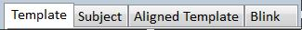
Figure 2.1: A series of four tabs, located above the image view-box, are used to select which image is displayed.
The re-alignment process takes a few seconds, and is performed on each template-subject pair at image loading time. It is achieved by using a simple pattern recognition algorithm, which is applied to the stars in each of the two images; it matches similar patterns of stars in the two images.

The rightmost tab, “Blink”, blinks the image view-box between the subject image and the re-aligned template image with a period of the milliseconds entered at “Blink delay” text-box, allowing easy visual comparison of the two images. Once a pair of images are loaded, this is in most cases the most powerful display mode for visually searching for nova/supernova candidates.

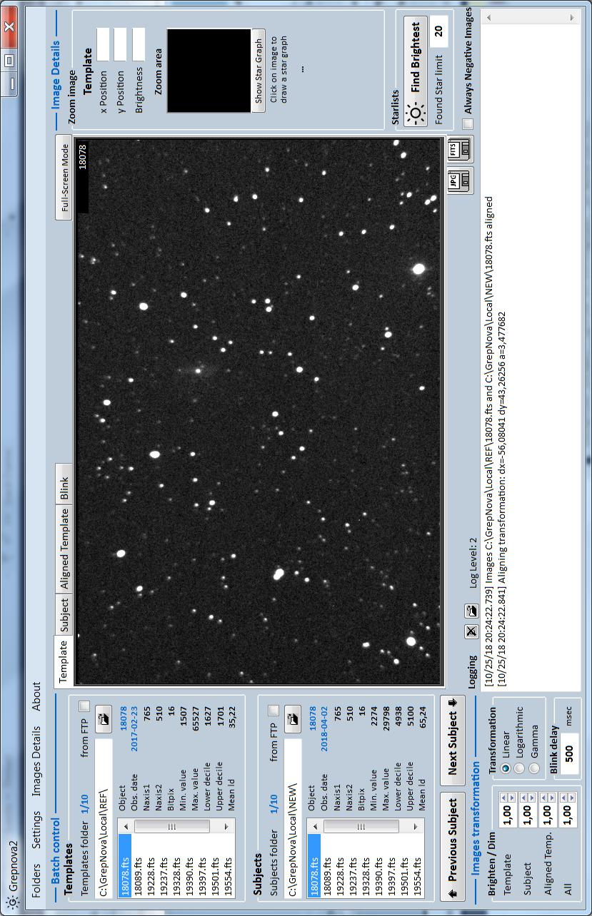
Figure 2.2 The GrepNova2 Main Window (graphic interface)

2.2 Loading new images

Before Grepnova2 can be usefully used, it is necessary to load in a pair of images. There are two ways to achieve this, which are listed below. In all cases, images are loaded in place of all tabs in the image view-boxes.

Files may be loaded in any of the following ways:

- By “Previous Subject” / “Next Subject” buttons at left of image-view (see figure 2.3).
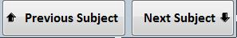

Figure 2.3: To load a FITS image into GrepNova, press any of these buttons to advance foreward or back-wards to the listed in list-boxes images

- By clicking on either list-boxes items at left of image-view (see figure 2.4).
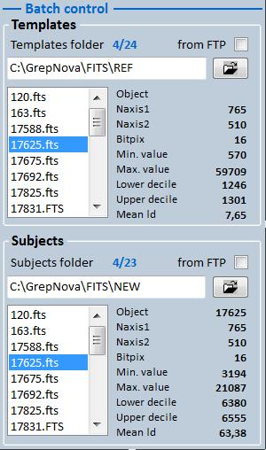
Figure 2.4: To load a FITS image into GrepNova2, click on any item on these two list-boxes where tem-plates and subjects reside

If the newly loaded image is too large to be displayed in the image view-box, scroll bars will appear to allow you to navigate around the image. If it is more convenient, you may resize the GrepNova2 window in the usual way, so that a larger portion of the image will be displayed at any one time. Beside list-boxes of 2.4 there are some information for the selected images (either template or subject), that are extracted from the FITS headers, such as:
- Object name, as recorded on the header

- Naxis1, which is the width of the image

- Naxis2, which is the height of image

- Bitpix, which is the bits of every pixel of the image

- Minimum value, meaning the darkest value on all the image

- Maximum value, which is the value of the brightest point on the image

- Lower decile, meaning the highest value of the 10% darkest points of image

- Upper decile, which is the lowest value of the brightest 10% points of image

- Mean ld, which is the mean value of the image, if the brightest and darkest poits are removed.

2.3 Changing how images are displayed

2.3.1 The display transformation

By default, images are displayed linearly. This means that the displayed brightness of each part of the image is directly proportional to the brightness recorded in the input data. This gives the truest impression of the image data, but the faintest structures may be too faint to see in images which have very large dynamic ranges. Using the toggle buttons in the bottom-right corner of the graphic interface, it is possible to change the way in which the data is displayed (see figure 2.5).

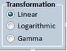
Figure 2.5: Three toggle buttons in the lower-right corner of the GrepNova2 window allow the user to select how images should be displayed.

Three alternatives are available:

- Linear – The displayed brightness is directly proportional to the brightness recorded in the input file (default). This gives the truest impression of the data stored in the input file, but as stars will typically be very much brighter than the rest of the image, the result may tend to be dominated by them.

- Logarithmic – The displayed brightness is proportional to the logarithm of the brightness in the input file. This brings out faint details in the images.
- Gamma Transform – An alternative transformation for bringing out the fainter details in images, which is slightly less severe than a logarithmic transform. It has the advantage that it can often bring faint details into view, without excessively amplifying the noise in the process – a common cause of graininess when logarithmic transformations are used.

The curious user may find mathematical definitions of each of these transformations in figure 7.1. In all three cases, the brightness of the resultant image can be tuned, using the brightness controls down the left-side of the image window (beside Transformation), as discussed in the next section.

2.3.2 The brightness of images

In addition to changing the transformation which is used to display image data on the screen, it is also possible to brighten and dim images, making it easier to visually inspect faint features. This is achieved using the Brightness Control panel down the left-hand side of the image view-box.

First, controls are provided for changing the brightness of each individual image. This allows the user to match the brightness of the template and subject images, making visual comparison easier. The controls used for this are shown in figure 2.6 – for each image, a pair of buttons is provided to brighten and dim the image. In addition, it is possible to enter a numerical value for the brightness, which is set by pressing enter. Lower values yield brighter images.

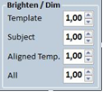
Figure 2.6: Buttons are provided which allow the user to brighten or dim the template and subject images individually, or all of them at the same time
A value of around 1.0 provides GrepNova2’s best guess at the most appropriate brightness level.

In addition, global brighten and dim controls are provided, which effect all images displayed by GrepNova2 (see figure 2.6). When blinking between template and subject, these controls allow faint details to be inspected in both images simultaneously.

2.4 Outputting images

It may be useful to output images from Grep-Nova2, in a standard graphic image format, for use in another application. This allows you, for example, to examine a realigned template image in another FITS image viewer, and generate display images. For this reason, it is possible to output images in either FITS or JPEG format. For scientific purposes, the use of FITS files is recommended, as they retain the full information of the original file, however JPEG images are more widely compatible when using images for display purposes.

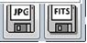
Figure 2.7: To output an image from GrepNova2 for use in another application, enter a suitable filename in the Save image to file box, and click on either “Save to JPEG” or “Save to FITS” to make a JPEG or FITS file respectively
This may be achieved by first selecting the image that you wish to output, such that it is displayed in the image view-box. In the case of creating JPEG files, you should also set the brightness controls as required, as the image is saved exactly as it is displayed on the screen. In the case of creating FITS images, as the data is stored exactly as it was found in the original file, the brightness controls have no effect. Having selected the desired image, now click a suitable button (see figure 2.7) and you will be prompted by a dialog box to select a file name where to save the file. Note that in either case, the standard path for JPEG illustrations from grepnova.config will be used as the initial folder (see section 4.4). In case of JPEG save you can select from a a number of image formats as BMP, EMF, GIF, JPG, PNG, TIFF and WMF. Also in this case you will be asked if you prefer to save image annotations together with your image of selected bitmap format.

2.5 Processing large batches of images

As supernova patrolling is, by its nature, a very repetitive task, GrepNova2 (as grepnova does) has facilities to ease the processing of large batches of images, provided that these images are filed in a systematic fashion. It is assumed that the user has stored the template images and subject images in separate directories. The images may be spread between several directories, but each must contain only templates or subjects.

To initiate the process, it is necessary to load in a batch of template images and subject images.

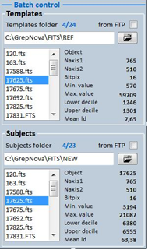
Figure 2.8: Batch control panel

Image loading can be achieved either locally or from an FTP Server (needs internet connection), by means of the “from FTP” check boxes (see section FTP Server connection for connection settings).

After selecting the source of images (either Local or from FTP), the loading can be achieved by clicking on “Folder” button under the from FTP check boxes of the Batch control panel (for Templates and/or Subjects respectively). Clicking on these buttons opens a file browser window. Select the directory in which the images to be loaded are placed, and click “OK”.

A blue text beside the Templates folder or Subjects folder labels indicates how many templates and subjects are loaded into the batch controller. Initially, when the software is started up, these counters shows the first images in the batch list, if the local FITS path has been entered in the grepnova2.cfg file.

When images are loaded using the Folder button, provided this operation is successful, the number of loaded images will increase. For example, the counters line might read “1/24)”, indicating that 24 images are loaded and the batch controller is already in use.

At startup the program tries to fill the batch control with images stored at the path that grepnova2.cfg points to (remember that in grepnova.config the relative field of FITS path must be empty). In this case, the Template images and Subject images must be in different subdirectory. If these subdirectories are not found (and if FITS file path is not set in grepnova.config as it should be) then the batch control will be left empty and images’ selection must be done manually.

Once a collection of images have been imported, and both the template and subject status lines indicate that a non-zero number of images are loaded, the batch controller may be activated by clicking on “Next Subject >”. After clicking this button, the subject status line might read “Using (1/52)”, indicating that the first subject image has been loaded into the main image view-box, and that there are a total of 52 subject images presently loaded into the batch controller. When FITS images are loaded, they are ordered either alphabetically in the batch controller by their file names or chronologically by their observation date/time; JPEG images, also, are sorted alphabetically.

In addition to loading the next subject image, the batch controller also searches through all of the loaded template images, searching for one which is of the same filename as the selected subject. For all JPEG images, GrepNova2 will attempt to match images by searching the filename for the object name. This presently requires the object name to be present in the image’s filename, and to be of the form xxx where xxx is any sequence of digits. If still no object name can be found, then the batch controller will not be able to match the image to a suitable template and it will advance to the next subject.

The <Prev Subject button is behaves in the same manner as the Next Subject> button, but moves through the loaded subject images in the opposite direction.

In addition, to aid navigation, it is possible to select a subject image of a particular object, or jump to a particular object in the sequence of subject images. These tasks can be achieved by either clicking on Subjects ListBox or Templates one.

The user can discard the loaded collection of template or subject images, prior to loading a fresh batch of images, by the menu commands

Folders->Clear Templates Folder or
Folders -> Clear Subjects Folder.
In each case the user will be prompted to choose if wants to discard images or not.

2.6 Viewing Images in Real Time

Suppose that you are observing in real time, downloading images from a CCD into a folder, and want to import them into GrepNova2 as they come from the telescope for immediate checking. To do this, it is necessary for the batch controller to rescan all of the folders which you have loaded into it, checking for new images. This can be achieved using the menu item Folders->Refresh Batch button.
Clicking on this checks for new images in all of the folders which you have loaded into the batch controller, and imports any which it finds. They are then placed in their appropriate place in the sequence of images.

2.7 Resize Template

Under the Settings->Resize Template
when needed there is the possibility for resizing Template so to fit the Subject size (in case these two are not equal). The user can choose to Resize Templates either (at running time) by checking this menu item or initially by checking the Resize Template if necessary check button in GrepNova2 Settings (see section GrepNova2 Settings).

2.8 Details window

2.8.1 Zoom window

On the upper right corner of the application window there is the Details window which shows the image area (of size 128x128 pixels) under the mouse pointer, magnified by X2.
Under this image area the user can select
which information will be shown when clicking on Template or Subject or Aligned Template image. This can be achieved by the check button immediately under the Zoom Image box.
This information can be either to Show Histogram or to ShowStar Graph, as shown on the next figures 2.9 and 2.10.

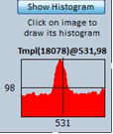
Figure 2.9: Selected star Histogram

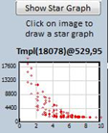
Figure 2.10: Selected star StarGraph

2.8.2 Find Brightest Stars

Under the Zoom window resides the Starlists panel (figure 2.11) where the user can ask the application to find a number of brightest stars in the selected image (Template, Subject or Aligned Template).
The number of brightest stars to find is selected in the panel’s text-box just under the button Find Brightest.

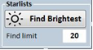
Figure 2.11: The Find Brightest panel
The brightest star are enclosed in circles with a cross in star’s center and a number aside each circle indicating its ranking on the image (see next figure 2.12).

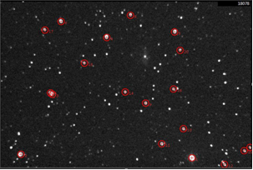
Figure 2.12: The selected image with the 20 brightest stars

2.9 Annotations

Apart of the above annotations (for the n brightest stars) there are also two other types of annotations on any of the three images (Template, Subject or Aligned Template):

- Star Centroids annotation

- Candidate SN annotation

The first one is drawn whenever the user clicks on an image near a star. If the click happens in the near vicinity of a star then the centroid of this star is marked with a red cross and the relative Star Graph is plotted at the right of main image area (see Figure 2.10 and Figure 2.19)

The second annotation can be achieved my clicking (with mouse) over the Subject image in the near vicinity of a star holding the Ctrl key pressed. In this case, instead of a cross, a mark of candidate SuperNova2 is drawn as seen on next Figure 2.13.

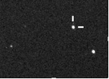
Figure 2.13: A SuperNova2 candidate mark
The Brightest Stars annotations and the Star Centroid annotations can be as many as the user desire, but the Candidate SN annotation can be only one and only on Subject image (it seems unlikely to find two SN on one image!!!). Annotations are removed when the images are changed (e.g. moving forward or backward in Batch control) or by the relative items in Image Details menu.

2.10 FTP Server connection

For connection in an FTP Server the following parameters must be known:

- Server URL (e.g databank.gr)

- Path of FITS files in the server (e.g /gsst/)

- User name

- Password

These parameters are stored in the grepnova.config file through menu Settings -> Configure (or Ctrl-C).

In order to connect to the configured FTP server and download images, the user has to check the from FTP check-box in the Templates or/and Subjects Batch Panels. If server connection is successful then the following selection window pops up (figure 2.14) to select the folder from where the user will download Templates or Subjects.
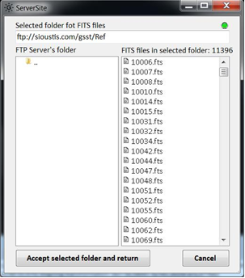
Figure 2.14: The FTP folders browsing window, after a successful connection to the FTP server

On the left panel of this FTP folders browser the user can see the existing folders and in the right panel the existing files (if there are any) in the selected folder. Selection of a folder is done by double-clicking on its name (on the left panel). On the top-right corner of the FTP browser there is an icon showing the connection status (red for not connected and green for connected to the FTP server). You cannot select anything on the right panel (although the user can click on any item on it), as the selection refers to the total contents of the selected folder.

Just above the right panel we can see the number of files that the selected folder contains. As this number of files can be very large, after folder selection the files are not downloaded to the user’s machine, as this could take enormous time (if number of contained files in the folder is really big).

Each file is downloaded to the user machine at the time that the user selects this file on the Batch Panel of the Main Window (download on demand). During this downloading a Circular Progress Indicator is shown next to the Object label of the relative Batch Panel.

2.11 The Menu contents

The program has a Menu section that contains the following items:

- Folders
– Folders

    - Select Templates folder: Invokes the Template selection routine (same as clicking the button ’Add Templates folder’)
    - Select Subjects folder: Invokes the Subject selection routine (same as clicking the button ’Add Subjects folder’)

– Blank Subject: Every time a new image pair is loaded, the Subject image is blanked at outside the Aligned Templates boundaries)

– Refresh Batch: Updates the image contained in Templates and Subjects Batch Panel (see section Viewing Images in Real Time for details)

– Clear Templates folder: Clears the Templates’ structures in Templates folders, leaving Templates Batch Panel empty. This menu item deletes the files contained in Templates folder, so be very careful when using it
– Clear Subjects folder: Clears the Subjects’ structures in Subjects folders, leaving Subjects Batch Panel empty. This menu item deletes the files contained in Subjects folder, so be very careful when using it

– Quit: Exits application

- Search
– Search for Candidates: searches selected Template-Subject pair for SN candidate (see section 2.13 for details)

– Auto-Search the Loaded Batch: searches the whole batch of images for SN candidates (see section 2.13 for details)
- Find SNe: searches to find SN using the grepnova's functions, using the following procedure: First of all it blanks the Subject if it is not already done by menu choice. Then extracts 100 brighter stars form aligned template. After calculates the PSF of Subject and finally looks for peak in image, which is most promising SNe candidate (excluding noise blips).

- Settings

– GrepNova2 Settings: Invokes the ’Configuration Grepnova2 file’ window to manipulate the ’grepnova2.cfg’ file and the main application settings
– GrepNova Settings: Invokes the ’Configuration Grepnova file’ window to manipulate the ’grepnova2. config’ file
– Resize Template when needed: Sets or unsets the resize-template flag to resize (or not) the Template image whenever its dimensions differ from the Subject’s ones (see section Re-size Template for details). This flag can be set in GrepNova2 configuration file.

– Cursor on images: Selects the cursor type (cross or circle) that the pointer turns to when it is over a Template, Subject or Aligned Template image. It has two options: Cross or Circle

- Image Details
– Show Images Headers: Shows the stored information in fits files headers for both Template and Subject. User can refer to Other Windows section for details about Images Headers dialog window
– Remove annotations (brightest, centroids): Each time the user click on an image to find a star’s centroid or when Find Brightest is clicked, annotations are written on the image, which are kept until the Batch control advances to another image or this menu item is selected.

– Remove SN candidate: Each time the user click on an image with the Ctrl key pressed, annotation of SuperNova candidate is written on the image, which is kept until the Batch control advances to another image or this menu item is selected.

– Image Statistics: Pops up a window that shows (in numbers and graph) statistic details of the image shown at this time in main Image Area (see section Other Windows for more details)

– Bitmap Filtering: Pops up a window that gives the user the ability to manipulate the loaded image, using build-in filters like Median Filter, Negative Filter, Color Balance, Noise Removal e.t.c. (see section Other Windows for more details)

– Stretch Image: Pops up a window that gives the user the ability to manipulate the loaded image, in terms of Contrast and Brightness (see section Other Windows for more details).
– Image Curve: Pops up a window that gives the user the ability to manipulate the loaded image, by mapping each pixel's intensity into another value, following a double curved line.
– Sharpen FITS: Pops up a window that gives the user the ability to manipulate the loaded image, in terms of sharpening, changing the values of Sharpening Factor and Sharpening Shift. Modified images can be restored to their previous status by the buttons Restore Current or Restore All.

– Wavelength: Selects from a list of various wavelength filters to apply on all loaded images each time. The predefined values are None (default, for no filter applied), Green, Teal, Red, Blue, Gold, Copper, Purple, Ocher, Pink and Silver

- Utilities
– Alignment Method: this menu item lets the user select which alignment method will be used for each loaded image. Options are:
- grepnova-align.bin.exe: the old good alignment method written by D. Ford. Lightning fast, using GSL library, but its drawback here is the large number of needed other libraries (Linux type), as it came from Linux environment. If user excludes this method then he/she can get rid of all the lib-something libraries.
- Grepnova2 (Accord optimization): this is a set of two alternative alignment methods written internally, which follows the optimization concept provided by D. Ford. This approach uses the native C# library of Accord.NET to optimize the translation, rotation and scaling of Template image, using either the Nelder-Mead procedure or the COBYLA one (Constrained Optimization by Linear Approximation). Comparing these methods with the grepnova-align.bin.exe, one can say that these are less fast by some hundreds of milliseconds.
– Save As Template: Gives to the user the opportunity to save the currently selected Subject as Template, replacing the one already exists in the Templates folder. Beware that only a Subject can be saved as new Template.
– Solve Plate: Pops up the Plate Solve window that is described in details in section 2.14 'Plate Solving'
– Download from DSS: Searches the Digitized Sky Survey (produced by Space Telescope Science Institute) and downloads the respective image that has the same center with selected image. The application contacts the Milkuski Archive for Space Telescopes and post a request by using the RA and Dec of the center of the currently selected image (as it is defined in image header), a width of (currently) 12.9 arcmin and a height of 8.6 arcmin (resulting in a 765X510 pixels image size) aiming at the POSS2 survey at Red band. The downloaded image (for the moment) is saved at the folder where the application executable resides. In the future this search will gain its own selection window.
– VisieR: Contacts the VisieR site and downloads information for objects contained in the currently selected image. The results are presented by a list containing all downloaded data on a new window.

- Utilities (testing)
It's a set of menu items that are placed in this position only for testing purposes (sometimes their results are not even visible). As these items will change continuously, no description is given in this guide. This menu can be hidden by un-checking the 'Testing Menus Visible' check-box in GrepNova2 Settings.

- Python (testing)
This is also another menu for testing purposes. It's sub-items are Python scripts that can be triggered through GrepNova2. It's obvious that in order to run these scripts the Python interpreter must be installed in user's system. This menu can be hidden by un-checking the 'Testing Menus Visible' check-box in GrepNova2 Settings

- About
– Help: Shows this document. PDF file ’grepnova2.pdf’ must exist in application’s folder
– About grepnova: Shows an About dialog with information about the grepnova-gui application and libraries used by it

– About GrepNova2: Shows an About dialog with information about the Grepnova2 application (this program) and libraries used by it.
– Hot Keys: Pops up a new window showing to the user the already defined hot keys, giving the opportunity to change them at his/her will. Select Modifier key and Keyboard key for each given action. Modifiers can be <Shift>, <Ctrl>, <Alt> or <None>. Selecting a Modifier other than <None> means that the action will be invoked by simultaneously pressing both Modifier AND Keyboard keys.

2.12 Other Windows

This section presents other windows (apart the Main Window or Main GUI) that program uses to perform various tasks.

2.12.1 Grepnova2 Configuration

This configuration window gives to the user the ability to set up some startup parameters and properties, which (most of them) can be also be set during program execution.

The first two text-boxes keeps the Local Templates and Subjects Paths. These paths are used by the program as the directories where the downloaded images (during FRP session) are saved.
The next two text-boxes keeps the startup Templates and Subjects Paths. These paths are used by the program at startup to load the first batch of images.
The user can select also the startup transformation type from the next triplet:

- Linear
- Logarithmic
- Gamma

The calculation formulas for these three type of transformation are presented at APPENDIX (given by D. Ford in his grepnova User’s Guide)
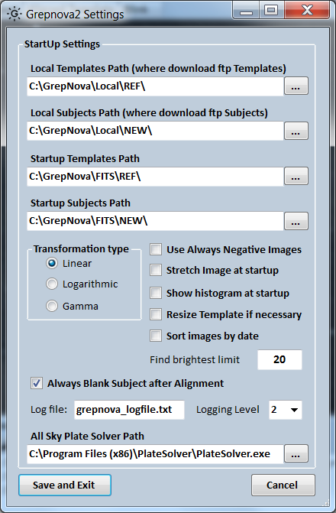
Figure 2.15: The Configuration Settings window for the grepnova2.cfg file
Besides, there is a list of On/Off attributes like:

- Use Always Negative Images - if set it turns automatically all the loaded images to negative, for better blinking. This attribute can be changed at runtime on the Main Window

- Stretch Image at startup - if set the Stretch Image window pops-up at startup at the left of the Main Window, letting the user to manipulate brightness and contrast of the selected image. This also can be achieved the relative menu item at Images Details
- Show histogram at startup - if set, then the program starts with pre-selecting the Show Histogram check-button in Zoom Image panel. If not set then the program starts with pre-selecting the Show Star-Graph check-button

- Resize Template if necessary - if set the program tries to resize Template each time it loads one brom batch with dimensions differing from the Subject ones. This also can be changed during runtime by the relative menu item in Settings.

- Sort Images by date - if set, the Batch Controller sorts Subjects according to observing date/time instead of sorting by filename.

- Always Blank Subjects - if set every time a new pair is loaded by the Batch Control, the Subject image is blanked outside the Aligned Template’s borders.

There is also the startup number of brightest stars to find, which of course can be changed during runtime by the relative text-box in Starlists panel.

During the program execution several messages are printed in the Logging area at the bottom left side of the Main Window. These messages can be saved as text file or can be cleared if user selects so. The importance level of these messages can be set by the Logging level selection box with proper values from 0 (least messages) to 3 (all of possible messages).
For Plate Solving, the application can use two similar ways to accomplish solving, either by the AstrometryNet procedure (contacting Astrometry Net site) or by employing the Giovanni Benintende's All Sky Plate Solver application which must be already installed and initialized in the user's system. In this case the path where PlateSolver resides is written in the All Sky Plate Solver Path.

Finally these settings can be saved at grepnova2.cfg file, to be used by the program.

2.12.2 Image Statistics

The Statistics window reveal some existing in header or calculated data for the image been displayed in the Main Window. The graph represents the counts of each specific intensity value existing on this image.
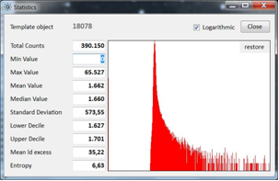
Figure 2.16: The Statistics window for the selected image

2.12.3 Bitmap Filtering

The Bitmap Filtering window allows the user to manipulate the selected image (seen as bitmap) using several pre-defined filters.
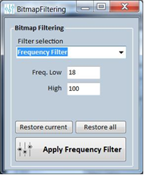
Figure 2.17: The Bitmap Filtering window for the manipulation of the selected image
Some of these filters need some parameters which should be given by the user. The filters are:

• None
- Median Filter
- Negative Filter
- Color Balance
- Noise Removal
- Histogram Equalize
- Threshold Filter
- Equalize
- Normalization
- Linear Levels
- Pixelate-Blur
- Frequency Filter
Of course, the user can reset the manipulated image (or all images together) to its original status by the buttons Reset current and Reset All. In any case the image data contained in the fits files are not changed in any way.

2.12.4 Stretch Image

Stretch Image window let the user to manipulate the brightness and/or the contrast of the selected image.

The two triangle (red and green) under the image intensity graph can slide left or right to change the brightness and the contrast of the image. The same task can be achieved by entering directly the needed values in the left and right text-boxes. Pressing the R button these sliders returns to their initial position and the selected image to its initial status.

Both Bitmap Filtering and Stretch Image are windows docked to the left of Main Window and move with it any time the user moves the Main Window.
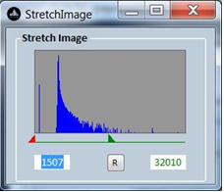
Figure 2.18: The Stretch Image window for manipulating the brightness and contrast of the selected image

2.12.5 Star Graph

The StarGraph window presents the intensities of all neibour sub-pixels around the centroid of the selected star. The examining area is a circle of 10 pixels radius around the centroid.
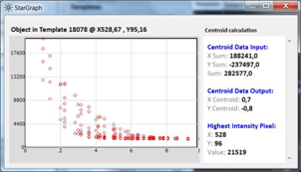
Figure 2.19: The Star Graph window for the selected star
This window is purely informative for the user.

2.12.6 grepnova Configuration

The grepnova Settings window help to modify the grepnova.config file which is essential for the operation of grepnova (version 1.0.0) and especially the alignment program grepnova-align.bin.exe.

As GrepNova2 uses only one of the bunch of executables that grenova creates (and this is grepnova-align.bin.exe), some of grepnova.config parameters are used by the GrepNova2. As these we can name:

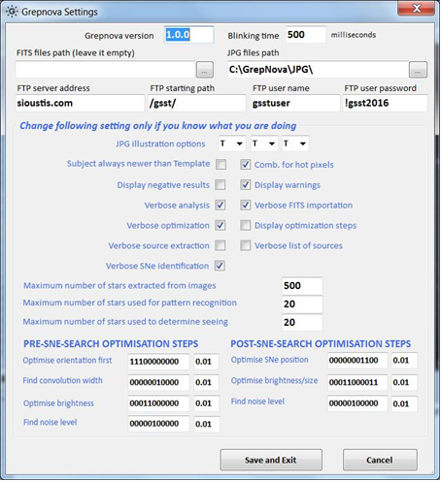
Figure 2.20: The Configuration Settings window for the grepnova.config file

- the Blinking time

- the FTP server’s settings (address, path, usename and password)

- the three Maximum number of stars

- the Pre-SNe Search Optimisation Steps

- the Post-SNe Search Optimisation Steps

Details for all the parameters contained in this window and in grepnova.config file will be discussed in details in the Chapter 4 ”Configuring grepnova”.

2.12.7 Images Headers

Images Headers window shows the FITS header data for both the selected Template and Subject images (refer to NASA High Energy Astrophysics Science Archive Research Center (HEASARC) site for details about the fields naming and their purpose).

Every time the header is modified and saved by the program (by clicking Save button) the modification procedure adds a History field to the header with the text ’Modified by GrepNova2’.

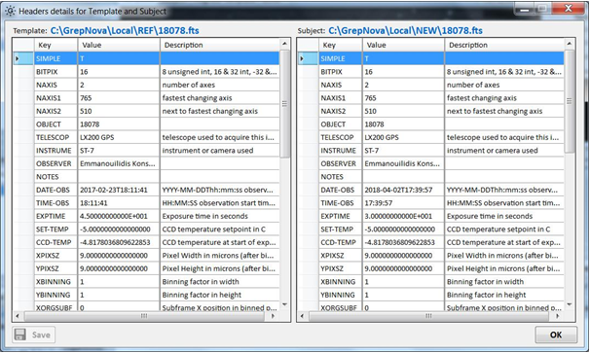
Figure 2.21: The FITS headers window for the selected Template and Subject images

Although this window is mainly informative, the user can change headers’ values by double-clicking in each table field and enter his/her own data (key, value or description). The updated header can be saved by clicking the Save button.

This window has two panels, the left one for the Template’s header and the right one for the Subject’s header. Each time the user clicks on a field in one panel the relative panel is selected in the other panel too.

The user can change any parameter on each field (key, value or description) providing he/she knows what is doing, because it’s easy to destroy a FITS file.

2.12.8 The Full-Screen window

Over the right-top corner of the images area in the Main Window there is the button named Full-Screen Mode. Clicking on this button the Main Window turns into a full screen one
with all the images maximized (keeping their aspect ratio) for better seeing and blinking.
The user can return to normal window by clicking the Back to Normal button or by pressing the ESC key.

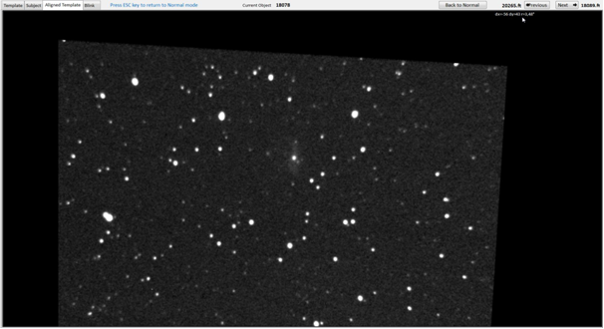
Figure 2.22 The full-screen view of application

The possible action on this window are:

- Navigate between the Template, Subject, Aligned Template and Blink tabs by selecting the relative tab

- Navigate to the Next image of the Batch Control images of the Main Window

- Navigate to the Previous image of the Batch Control images of the Main Window
The Next and Previous buttons can also be invoked by pressing the Alt+N and Alt+P keys respectively.
On this screen there are also some information about the Current Object being displayed, the previous (at the left of the Previous button) and the next (at the right of the Next button) filenames in the Batch Control.

This screen can also Blink the Subject and Aligned Template images.

2.13 Automated search

The program has the ability to automate the searching for SN candidates. The user can activate this ability by the two Search menu items:
- Search for Candidates
- Auto-Search the Loaded Batch

The first one searches for SN candidates in the selected Template-Subject image pair while the second repeats this task for all the images in the Batch control.

2.13.1 Search for Candidates

This menu item search between the currently
selected Subject and the respective Aligned Template for differences brighter than the Aligned Template’s lower decile, following the
next steps:
• Finds the 20 (this number can be changed) brightest stars in the Subject image.
• For each of these brightest stars it checks in the respective coordinates of the Aligned Template if the intensity of this point is higher than the lower decile of Aligned Template.
• If the intensity is higher than the lower decile it is prompted as Candidate (ObjectName: Candidate FOUND at x=nnn y=nnn. PLEASE CHECK IT)
• If not, then it is recorded as checked but not candidate (Candidate checked at x=xxx y=nnn with intensity Is=nnnn (It=nnn). Not a SuperNova.)
Attention: This function has not been tested thoroughly, so is not to be trusted yet!!!

2.13.2 Auto-Search the Loaded Batch

This menu item performs the above search for

each Subject contained in the Batch Control,

prompting only if a Candidate is found.
In this Auto-Search the number of brightest stars mentioned above is increased to 100.

2.14 Plate Solving

By Plate Solving the application tries to Solve
the currently selected image. This solving can be done either by directly contacting the Astrometry.net or by using the AllSkyPlateSolver application (written by Giovanni Benintende)

2.14.1 Direct contacting Astrometry.net

By selecting this option (Figure 2.24) the application exposes only one button called "Solve Plate". Pressing this button the application contacts astrometry.net and post a series of requests. The App first logs in using an API key and if is logged successfully it uploads the file of currently selected image. The site solves the uploaded plate for the user and returns the results to the application. Astrometry Plate Solve using Astrometry.net APIs takes about 30-60 seconds to solve a plate and return the results.

2.14.2 Using AllSkyPlateSolver
AllSkyPlateSolver is an application written by Giovanni Benintende and it is a complete application for plate solving. It's obvious that the Benintende's application must be installed on user's system before using this option.
By selecting this option (Figure 2.23) the buttons revealed are:
Solve Plate: It acts the same way as in previous section, but instead of contacting astrometry.net directly it uses the AllSkyPlateSolver as a proxy for plate solving.
Run AllSkyPlateSolver: Instead of running ASPS undercover, this button starts the ASPS which then tries to solve the currently selected image. User must be familiar with this application use.
Save Plate: In this case, application asks for a file name to save the currently solved image with all solving information drawn.
ASPS Index Wizzard: It runs the Index Wizard of the AllSkyPlateSolver. This is essential for the ASPS to operate as it needs tables and indices of all Astrometry.net databases to solve a plate. This procedure may take a long time (but it has to be done only once) depending on which part of site's databases the user wants to use. The index installation wizard is used to select and download the astrometric indexes range. The Astrometry.net project works using indexes, related to the field of view (FOV) of your imaging equipment. If the user owns more focal lengths and/or chip sizes, he/she needs to run the wizard once for each field of view. The size of all the indices can be several GB.
Configure PlateSolver: This button runs directly the ASPS Configure window, letting the user to set ASPS parameters.

The Plate Solve window has also a check-box with the name 'Request objects from VisieR'. As one can understand, checking this box the application contacts VisieR site and downloads all known objects in the vicinity of user's image center, which in turn draws them on the already shown image.

Figure 2.23 Plate Solver using the AllSkyPlateSolver application

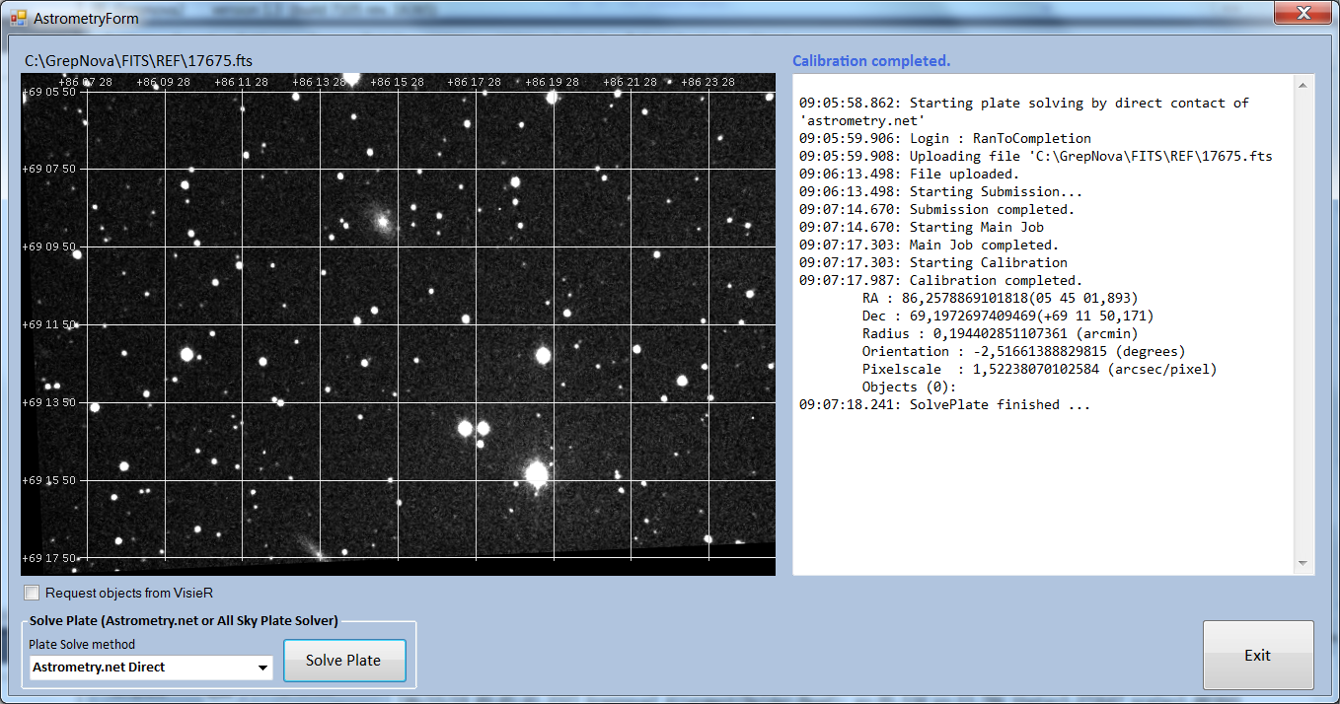
Figure 2.24 Plate Solve by directly contacting Astrometry.net site

Chapter 3

Building GrepNova variants

3.1 GrepNova2 for Windows

A Windows installable version of the GrepNova2 is provided with the distribution at \publish\GrepNova2\setup.exe, and if this alone is sufficient, then there’s no need to read the rest of this chapter. The setup also installs the grepnova-align.bin.exe executable that is needed for images’ alignment at running time of GrepNova2. There is no command-line version of the GrepNova2 program, as it is simply a Windows application.

Beside the installable version, the distribution also contains the source code written in C# with Microsoft Visual Studio 2017 (as grepnova2.sln) under the distribution folder Grepnova2 containing under Grepnova2\ grepnova2 the folders bin, obj, Properties and Resources together with all the source code files. Also in this folder the user can find the doc folder needed to produce the current User Guide pdf file.

For those who desire to recompile and/or tweek GrepNova2 here are the steps that must be followed:

• Transfer the GrepNova2 content in a folder of your choice (say c:\Users\user1\source\ grepnova2).
The file grepnova-align.bin.exe must be in bin\Release or bin\Debug folder

• Open Microsoft Visual Studio 2017 (not tested in other VS versions) and open the grepnova2 solution by selecting grepnova2.sln file. The solution should open properly in VS SDK.

- In VS2017 Go to Tools->NuGet package Manager-> Manage NuGet packages for Solution and install the following packages:

– AForge
– AForge.Controls

– AForge.Imaging
– AForge.Math
– CSharpFITS v1.1
– Accord
– Accord.Math
– Accord.Math.Core
– AstrometryNet

That’s all. Run the compilation and linking the usual way.

For those who desire to recompile and/or tweek grepnova-align.bin.exe, they can follow Dominic Ford’s guide for how to compile grepnova under Windows or Linux, keeping in mind that they must use the newer relative source files that this distribution contains (even the file Makefile) to ensure creation of the proper grepnova-align.bin.exe file.

3.2 Building grepnova 1.0.0 (gui and align) in Windows

Unfortunately I didn’t succeed to compile and link D. Ford's grepnova in native Windows and what I really did was to use Eclipse (Kepler version with C installed) just to edit the grepnova files (user can use whichever SDK is familiar with) and then use MSYS2 (a Linux hybrid which runs under Windows) to compile and link the edited C files using the command make or make install (having already modified the Makefile file for this purpose).

So here are the suggested steps for installation on 64bit machines:

- Run file ’msys2-x86_64-20161025.exe’ or newer to install msys2 (we suppose that the installation is in C:\msys64)

- Run the mingw64.exe file (it is inside msys64 folder) to start a shell session

- In this shell session run:

$ pacman -Syu (to update msys2. It will ask you to close the shell - not quiting - to continue the update)

- after restarting a new shell (running again the mingw64.exe) run:
$ pacman -Su (to finish up the update)

$ pacman -S mingw-w64-x86_64-gtk2

(to install gtk+ ver. 2.0 needed by the application)

$ pacman -S mingw-w64-x86_64-gtk3

(not obligatory)

$ pacman -S mingw-w64-x86_64-toolchain base-devel (to install the development tools like gcc compiler and linker for mingw64)

$ pacman -S mingw-w64-x86_64-gsl

(to install the GNU Scientific Library)

- Compile and install the cfitsio headers and libraries:
Copy folder cfitsio at msys64 root directory (C:\msys64\cfitsio). Under msys2 shell run the next commands:

$ cd /cfitsio

- make install (this will compile cfitsio and install the necessary files)

6. Copy sne2 folder into (preferably) c:\msys64\usr\local
Now the working (code) folder is under c:\msys64\usr\local\sne2

- In msys2 shell run:

$ cd /usr/local/sne2
$ make install

The executables will be installed in c:\msys64\mingw64\grepnova\bin

- Copy files ’cursor_circle.png’, ’cursor_cross.png’ and ’grep-nova.config’ into the installation folder (c:\msys64\mingw64\grepnova\bin) as the application will ask for these files.

- In msys64 shell run:

$ cd /mingw64/grepnova/bin

$ ./grepnova-gui.bin.exe (to run the application)

- While application is running go to menu Settings->Configure and in Configure change the FITS Folder to suit your needs

Now we have not only grepnova-align.bin.exe but also the grepnova.config.

From what we’ve seen the produced grepnova-gui.bin.exe (version 1.0.0) it’s not stable due to some peculiarities in GTK with Windows and that was the main reason I decided to re-write the whole project in C#. Anyway, what is left from this effort was finally the alignment module (grepnova-align.bin.exe). In newer version (1.3 onward) a complete new internal alignment method is written, which became the primary alignment choice by the application, that needs no more this grepnova's executable

It’s not so simple but surely can be done (at least I did it).

The following two section are taken from Dominic’s Users Guide written for grepnova’s version 0.6.0

3.3 grepnova for Windows

All of the libraries which GrepNova links to are available as binaries for the Win32 platform. These are: LibJPEG, LibCFITSIO, LibGTK and LibGSL.

3.4 grepnova for Linux

The following libraries need to be installed before you attempt to compile grepnova: LibGSL (recommended version 1.5), LibJPEG (recommended version 6.2), LibCFITSIO (recommended version 2.5), LibGTK (recommended version 1.2). The first three of these can be built from source relatively painlessly, in the usual way:

./configure

make

make install (as root)

Note that CFITSIO has a slight oddity in its installation procedure in that you need to supply the installation path on the command-line to ./configure, e.g. ./configure --prefix=/usr/local.

GTK+ is a fairly unpleasant library to try to build from source, and so is probably best in-stalled from rpm where possible. Of course the user can avoid to use this library if he wants to build only grepnova-align.bin.exe by properly changing the Makefile file to compile and link only this executable instead of the whole package.

Grepnova itself is built in a similar way:
./configure

make

Assuming that all compiles smoothly, a number of executables are generated:

- grepnova.bin – a command-line tool, which takes two FITS/JPEG files as input on the command-line, and performs a full supernova search on them, returning textual results to stdout. Optionally, a third filename may be supplied, in which case a diagram of the completed search may also be output, in JPEG format. The exact operation of this command depends upon the configuration defined in grepnova.config – see next chapter.

Syntax:

grepnova.bin input1.fit input2.fit <output.jpg>.
this file is NOT needed for GrepNova2.

- grepnova-align.bin – a cutdown version of the above command-line tool. Once again, it takes two FITS files as input on the command-line, but this time it merely realigns the template image to match the subject image’s orientation. The version contained in this distribution creates one or two text-files (depending on command switches) containing the transformation and rotation parameters for aligning and the aligned image FITS file in text format respectively.
Syntax:
grepnova-align.bin input1.fit
input2.fit output.jpg
intOutTextFile.
the only file needed for GrepNova2.

- grepnova-fits2jpeg.bin – a simple tool for converting images in FITS format into JPEG format.

Syntax:
grepnova-fits2jpeg.bin input.fit output.jpeg.

this file is NOT needed for Grep-Nova2.

Chapter 4

Configuring grepnova

This chapter is left the same with the one Dominic Ford included in his grepnova version 0.6.0, with the exception of adding the newer fields that are included in grepnova version 1.0.0

4.1 Generating the configuration file

Advanced use of GrepNova requires an under-standing of how to configure it. All of the pro-gram’s settings are stored in a small text file, which, by default is called grepnova.config, and lives in the same directory as the binary executable. For Windows binary distributions, this file is shipped with GrepNova. Windows users may therefore largely skip the remainder of this section, though section 4.2 below re-mains relavant to advanced users. For Linux distributions, by contrast, a working configu-ration file must to be created before GrepNova can be used. The software will not function before this is done, as the software is not able to fall back upon a default configuration in the absense of a configuration file. The easiest way to obtain a template for this file is to generate a copy of the default configuration file, which may be done automatically with the following command:

./grepnova.bin -d > grepnova.config

The flag “-d” instructs the software to output the default configuration file to std-out, and the “>” saves this to the file grepnova.config.

By default, whenever the grepnova executable is called, it expects to find its configuration file by the name of “grepnova.config” in the current working directory. This means that if you are using the commandline version from several working directories, you need a separate copy of grepnova.config in each working directory. This allows you to straight-forwardly set different configurations for each directory.
As an alternative, when using any of the GrepNova executables, with the exception of grepnova-gui.bin, it is also possible to specify an alternative location for the con-figuration file as a commandline option using the “-c” flag, e.g.:

grepnova.bin -c /home/dcf21/foo input1.fit input2.fit <output.jpg>

The above command would use the file /home/dcf21/foo in place of the default grepnova.config.

4.2 Editing the config file

This section describes the functions of the various settings in GrepNova’s configuration file. A listing of the default file is shown in figure 4.2.

Note that each of the lines starting with “##” are comment lines. They provide brief explanation of what each setting does. There are a number of optional features in GrepNova which may be turned on or off by setting one of the lines of this file to TRUE or FALSE, as well as a number of numerical settings. Note that the line numbering of this file is critical, and so no lines should be added, removed, or swapped around.

4.3 Version check

Line 02 of the configuration file contains the string “1.0.0”. This is the present version of GrepNova. As the precise format of the configuration file is very likely to change between versions, this simply ensures that the version number of the executable being used matches that for which the configuration was intended.

Figure 4.1: The default GrepNova configuration file

01 | ## GREPNOVA CONFIGURATION FILE. COMPATIBLE WITH THE FOLLOWING VERSION NUMBER
 | 1.0.0
 | ## FILE PATH FOR FITS INPUT FILES (DON'T FORGET \ AT THE END)
05 | ## FILE PATH FOR JPEG OUTPUT ILLUSTRATIONS (DON'T FORGET \ AT THE END)
 | C:\GrepNova\JPG\
 | ## FTP SERVER ADDRESS (e.g. databank.gr)
 | sioustis.com
 | ## FTP SERVER START DIRECTORY (START-END WITH SLASHES)
10 | /gsst/
 | ## FTP USER-NAME
 | gsstuser
 | ## FTP PASSWORD
 | !gsst2016
15 | ## JPEG ILLUSTRATION OPTIONS
 | TTT
 | ## SUBJECT ALWAYS NEWER THAN TEMPLATE (var SUBJECT_ALWAYS_NEWER)
 | FALSE
 | ## COMB FOR HOT PIXELS (var FITS_COMB_HOTPIXELS)
20 | FALSE
 | ## DISPLAY NEGATIVE RESULTS (var DISPLAY_NEGATIVES)
 | FALSE
 | ## DISPLAY WARNINGS (var DISPLAY_WARNINGS)
 | TRUE
25 | ## VERBOSE ANALYSIS (var MAIN_VERBOSE)
 | TRUE
 | ## VERBOSE FITS IMPORTATION (var GREPNOVA_FITS_VERBOSE)
 | TRUE
 | ## VERBOSE OPTIMISATION (var LIKELIHOOD_VERBOSE)
30 | TRUE
 | ## DISPLAY OPTIMISATION STEPS (var LIKELIHOOD_STEPS)
 | FALSE
 | ## VERBOSE SOURCE EXTRACTION (var STAR_VERBOSE)
 | FALSE
35 | ## VERBOSE LIST OF SOURCES (var SOURCE_LIST)
 | FALSE
 | ## VERBOSE_SNE_IDENTIFICATION (var SNEFIND_VERBOSE)
 | TRUE
 | ## MAXIMUM NUMBER OF STARS EXTRACTED FROM IMAGES
40 | 500
 | ## MAXIMUM NUMBER OF STARS USED FOR PATTERN RECOGNITION
 | 20
 | ## MAXIMUM NUMBER OF STARS USED TO DETERMINE SEEING
 | 20
45 | ## BLINKING TIME
 | 500
 | ## PRE-SNE-SEARCH OPTIMISATION STEPS
 | 11100000000 0.01 # Optimise orientation first
 | 00000010000 0.01 # Find convolution width
50 | 00011000000 0.01 # Optimise brightness
 | 00000100000 0.01 # Find noise level (do this last)
 | ## POST-SNE-SEARCH OPTIMISATION STEPS
 | 00000001100 0.01 # Optimise SNe position
 | 00011000011 0.01 # Optimise brightness / size
55 | 00000100000 0.01 # Find noise level (do this last)
 | ## END

4.4 The file paths
Whenever grepnova is passed the filename of a input file, either to grepnova.bin on the command-line, or to grepnova-gui.bin via its filename entry box, this filename is assumed to be relative to the base path supplied in line 04.
For example, sup-pose line 04 reads “C:/MyFitsFiles/” and then the filename “M82.fit” was entered into grepnova-gui.bin’s filename entry box.
The file read would have the full filename
C:\MyFitsFiles\M82.fit

[Speaking about GrepNova2:
this line MUST be left empty, as grepnova-align.bin.exe that is used by GrepNova2 needs a full-path file arguments in its syntax]

Line 06 works in a similar fashion. The path supplied here is prefixed to all filenames supplied for output illustrations, either as the third entry on the command-line to grepnova.bin or grepnova-align.bin, the second entry on the command-line to grepnova-fits2jpeg.bin, or in the filename entry box of grepnova-gui.bin.

4.5 The FTP Server’s settings

new in version 1.0.0

Lines 07 to 14 are dedicated to FTP Server connection settings, in order to connect to a server with FITS files. These settings are server specific and must be given by the server administrator. Note that FTP SERVER START DIRECTORY must begin and end with a back-slash.

These server settings are:

- Server address: This is usually a URL starting with ftp (e.g. ftp. but it can be any valid ftp server’s url

- Server start directory

- User name

- Password

4.6 JPEG Illustration Options

This setting (line 08) is mostly only relevant to grepnova.bin, though in some cases it may also affect the behaviour of grepnova-align.bin. It takes the form of a three letter code, e.g. TTT. These letters define what data will be displayed in any JPEG output diagram which is generated. The three characters refer to the blue, green and red channels of the image respectively, and define what data is plotted on each of these channels. Possible letters to choose from are listed in table 4.1. As a special combination, the code FFF may be used, in which case a copy of image D, a map of the degree of misfit (see table 4.1), is output in FITS format. No JPEG image is produced in this case.

Table 4.1 JPEG Illustration Options
T | The re-aligned template image is displayed
S | The subject image is displayed
D | The ”degree of misfit” is displayed. White means subject much brighter than tem-plate, and black vice versa. These are the easiest images in which to spot supernovae, as they should stand out as bright white sources.
L | Same as above, only the best supernova candidate identified by software is high-lighted with a cross-hair
0 | No data

The program grepnova-align.bin produces, by default, a JPEG copy of the realigned template image, regardless of the setting of this variable. However, it does take
notice of the code FFF, in which case this image is output in FITS format rather than the usual JPEG.
As an example, the string “TS0” would over-lay a red copy of the template image over a green copy of the subject image. “LDD” plots a map of the misfit between the two images, with a red cross-hair over the best supernova candidate.

4.7 Subject/Template selection

The following section applies only to FITS in-put files, and not to JPEG images. All FITS image files contain a header-block containing information about the image. There is usually a time-stamp included, detailing when the image was taken. It is normally the case that the subject image is a recent patrol image, whilst the template is an older library image. If the setting Subject always newer than tem-plate, line 10, is set to TRUE, this consideration overrides the order in which the FITS images are supplied by the user (and this applies to all flavours of GrepNova, including the graphic interface). In other words, if the template is newer than the subject, the images are swapped, and an appropriate warning issued. If this setting is FALSE, a warning is issued if the template is found to be newer than the subject, but no action is taken, and analysis continues.

Note: The setting Subject always newer than template is ignored by grepnova-align.bin, which always realigns the template image as specified first on the command-line.

4.8 Hot Pixel Combing

When FITS files are opened in grepnova.bin, grepnova-align.bin, and grepnova-gui.bin, the size of the point spread function is determined by averaging over the brightest 20 stars. All stars identified in the image, with point spread functions narrower than 80% of this point spread function are erased, assumed to be hot pixels. This process can be disabled by setting the option Comb for hot pixels, line 20, to FALSE.

4.9 Warnings

Occasionally, GrepNova issues warning mes-sages. These are cases where something slightly surprising has happened, but which does not appear to prevent successful analysis. An example would be finding the template image to be newer than the subject (see above). Setting Display Warnings, line 16, determines whether these are displayed or not. The ad-vantage is that they can provide useful information, the downside is that they can clutter the output, especially if pipeline processing is being considered.

4.10 Negative Results

Setting Display Negative Results, line 14, exists with future pipelining in mind. If set to TRUE, a summary text is displayed at the end of anal-ysis if no promising supernova candidates were identified. If set to FALSE, no text is returned in the case of a negative. It should probably be set to TRUE for the time being.

4.11 Verbosity Settings

There are a large number of settings which de-fine how much text is produced during analy-sis. They allow the exact operation of the pro-gram to be debugged, and should generally be left untouched. A list describing each available setting is given in table 4.2.

4.12 Numerical settings

There are a few of these...

4.13 Blinking time

In line 45-46 is the delay in switching between Subject and Aligned-Template. This time is in milliseconds

4.14 Optimization steps

The fit between the two images is optimized before and after the identification of the most promising supernova candidate(s). The fit is optimized by a process of applying a minimizer to the degree of misfit between the two images, whilst varying 11 parameters. As it is not practical to vary all 11 at once, they are varied in groups defined by the optimization steps listed here. Each step takes the form of an 11-digit binary number and a convergence parameter. The binary number defines the parameters to be varied. The convergence parameter may either be > 1, in which case it is the number of optimization steps to perform, or < 1, in which case it defines the desired accuracy to be reached, relative to some defined natural scale length of each parameter. The default value of 0.01 means that each

Table 4.2: Verbosity settings

Name | Line | Description
MAIN_VERBOSE | 18 | Provides a commentary as GrepNova works.
GREPNOVA_FITS_VERBOSE | 20 | Displays information about the FITS files being worked upon, as they are opened.
STAR_VERBOSE | 26 | GrepNova extracts a list of point sources in both images, with the primary purpose of applying pattern recognition to these to align the template image with the subject. A commentary may be provided on this process.
SOURCE_LIST | 28 | Similar to above, but also displays a list of all of the point sources identified in each image.
LIKELIHOOD_VERBOSE | 22 | To fine-tune the fitting between the two images, GrepNova applies a minimizer to a measure of the degree of misfit between them, whilst varying groups of parameters in turn. This step provides a list of the parameters varied during minimization, including how long each took to converge.
LIKELIHOOD_STEPS | 24 | Similar to above, only in this case a complete list of every measurement made by the minimizer is given.
SNEFIND_VERBOSE | 30 | Provide verbose analysis whilst the two optimally fit images are searched for point-sources which are good SNe candidates.

parameter is optimized to within 1% of its natural scale length.

From left-to-right, the parameters which may be optimized are:
- x_offset: The x-offset of the subject wrt the template.

- y_offset:The y-offset of the subject wrt the template.

- theta: The rotation angle of the template wrt the subject (rotation is performed about the image’s top-left corner).

- background: The excess background level in the subject image relative to the tem-plate. This is amount is added into the template. A measure of sky transparency.

- brightness: The ratio of the exposures of the two images. The template image data is multiplied by this ratio.

- noise: A measure of the noise level in the fit between the two images. This noise is assumed Poisson distributed.

- convolution: The Gaussian convolution which needs to be applied to the template to bring its PSF to match that of the subject image. Assumes uniform Gaussian PSFs for both images. A measure of the relative seeing of the two images. A negative value implies it is the subject which requires blurring.
- SNe_x: The x-coordinate of the most likely supernova candidate.
- SNe_y: The y-coordinate of the most likely supernova candidate.
- SNe_brightness: The brightness of this supernova candidate.
- SNe_size: The PSF width of this super-nova candidate.

Chapter 5

Using GrepNova II: The Commandline
This chapter describes only the new grepnova-align.bin.exe as it is modified for Grepnova2's needs

5.1 grepnova-align.bin.exe

It takes two FITS files as input on the command-line, first the template image and then the subject. But in this case it merely realigns the template image to match the subject image’s orientation. A copy of this image is then output in JPEG format, if the name of a third file is supplied. If this third file is ’null’ then it is ignored (default value, if no 3rd argument is given, is ’null’). Finally there is a fourth argument which must be 0 or 1 or 2 (default is 0 if no 4th argument is given) having the following meaning:

- 0 - Do nothing more than what is described above

- 1 - Except of what is described above, this version creates two text-files:

– likelihood.txt that contains the x-y translation and the rotation of the Aligned Tem-plate image.

– likelihood2.txt that contains the intensities (one by one) of the Aligned Template image.

- 2 - Except of what is described in value 1, it also tries to resize the Template (if its dimensions differ fron the Subject ones) before aligning the images.

Remember that the first two fits files must be entered with their full-path filenames and the fourth line in grepnova.config must be empty.
Syntax:

grepnova-align.bin template.fit subject.fit [output.jpg [0 or 1 or 2]]

Commandline options:

-h --help Display help text.
-v --version Display version number and compile date.

-t --trans Select transformation type for JPEG output:
0 Linear
1 Logarithmic (default)
2 Gamma transform
-g --gamma Set factor (brightness) for output.
-c --config Set filename of configuration file to use (default = ‘grepnova.config’).
-d --default Display default configuration file.

Chapter 6

Changelog

6.1 For grepnova

Version 1.0.0 (2018 October 30) Cooknas

- Menu facility added with File, Settings, Information and Help items.

- FITS header information added in menu Information

- Log file viewing added in Information menu.

- User’s guide added in Help menu (opening grepnova.pdf file).

- About dialog added in Help menu.

- List boxes for Template and Subject images added (now selection can be done either by clicking Next or Prev Subject or by selecting a list item).

- Mouse pointer changes to cross when mouse enters image area.

- Details window (zoomed X2) added with intensity histogram, showing the area pointed by mouse.

- Configure window added for configuring application.

- Resize Templates facility added.

grepnova-align.bin changed to output the alignment’s translation and rotation in a text file

6.2 For GrepNova2

Version 1.0.0 (2018 October 30) Cooknas

• First GrepNova2 release.

6.3 ToDo List

List of things I need to do...

- Automated SNe searching needs a lot doing and testing, but it would be the holy grail...

Nothing else I could think of at this time...

Chapter 7

APPENDIX

7.1 Mathematical definitions

Figure 7.1: Mathematical definitions of the three available display transformations (by Dominic Ford)

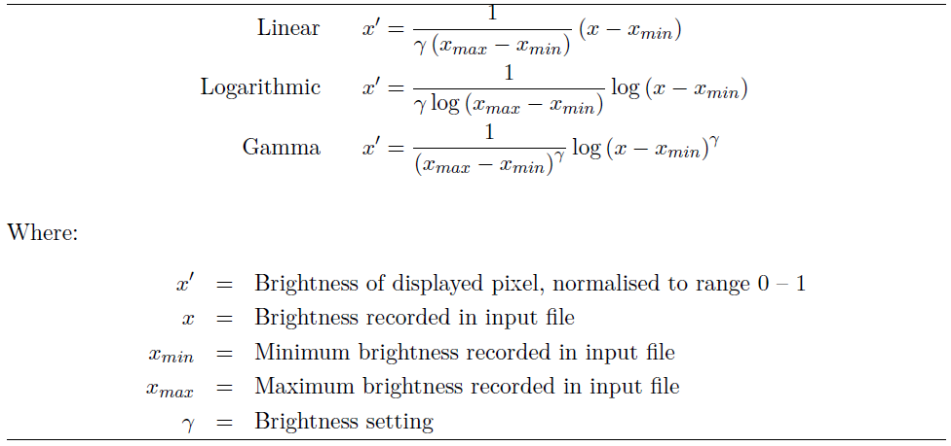

http://archive.stsci.edu/fits/fits_ standard/
https://www.nuget.org/packages/CSharpFITS/
³ https://in-the-sky.org/software.php
http://www.aforgenet.com/framework/
ttps://www.codeproject.com/Articles/30625/ Circular-Progress-Indicator
http://accord-framework.net
https://www.elendil.software/en/softwares/ libs/astrometry-net-client.html
https://numerics.mathdotnet.com
This program takes no commandline options, though it does require a valid and up-to-date copy of the configuration file grepnova.config (see chapter 4) to be in the same directory as the binary executable (or the current working directory if launched from the command-line or a DOS prompt). This file is shipped with all GrepNova2 Windows binary releases, and first-time users can ignore this.
coded by Dominic Ford at grepnova
https://www.codeproject.com/Articles/30625/ Circular-Progress-Indicator
http://www.rapidtables.com/web/color/RGB_ Color.htm
http://archive.stsci.edu
http://webviz.u-strasbg.fr
http://www.astrogb.com/astrogb/ All_Sky_Plate_Solver.html
http://astrometry.net
http://www.astrogb.com
http://gnuwin32.sourceforge.net/packages/ jpeg.htm
http://ledas-www.star.le.ac.uk/lheasoft/ fitsio/fitsio.html
http://www.gimp.org/~tml/gimp/win32/ – note that LibGTK has a large number of dependencies, but that all of the necessary dlls are linked from this site
http://service-spi.web.cern.ch/service-spi/external/GSL/1.4/win32_vc71/ – unfortunately it does not seem possible to download these files by FTP. However, the binaries for the more recent version 1.6 on the sourceforge website seem very buggy.
http://www.gnu.org/software/gsl/
http://www.ijg.org/
http://heasarc.gsfc.nasa.gov/docs/software/ fitsio/fitsio.html
http://www.gtk.org/
Note: This file was written on the Linux/UNIX platform, and so uses UNIX linefeeds. This means it may not – indeed, will not – display on some Windows text editors such as Notepad. Use of Notepad++ or Crimson Editor are recommended, (download later from http://www. crimsoneditor.com/)
Set by SEEING_MAX, line 44
Set by SNEFIND_MINIMUM_PSF in grepnova.h

