MetroScope Gen 3.5

Technical Reference

Who this is for:

Anyone programming MetroScope, but should also be useful for anyone preparing input data, running scenarios, or analyzing output data.

Additional documentation can be found in “MetroScope Operator Guide” and “MetroScope Theory and Practice”.

Contents:

* Overview
* Files and Directories
* Glossary / Lookup Tables
* Detailed Table Definitions
* Detailed Function Definitions

Draft 4/24/2013 Jim Cser, Metro Economic and Land Use Forecasting

**MetroScope Gen 3.5 Overview**

Draft 4/24/2013 Jim Cser, Metro Economic and Land Use Forecasting

How MetroScope works

MetroScope is an integrated set of econometric, land use, and transport models, currently used at Metro for producing regional forecasts and evaluating a wide range of policy scenarios.

For each forecast year, regional control totals for demographics, households, and employment are provided from an econometric model. The land use model takes these forecasts and distributes them spatially over the buildable land capacity for the entire region. A transport module is integrated with the land use model, so that the household and employment distributions can respond to changes in travel time.

For both the core residential and non-residential modules, market forces determine both the supply and demand for real estate. If supply is less than demand, then prices are increased to make it more profitable to build. Likewise, if supply is greater than demand, prices are decreased to make housing more affordable. The modules are then iterated until supply matches demand.

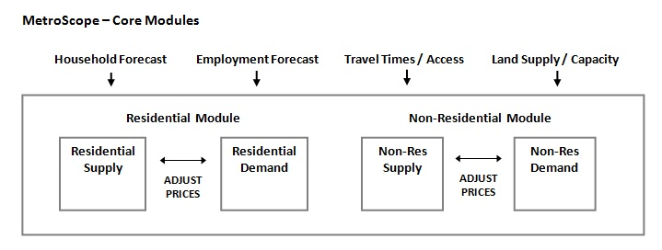

MetroScope main directory:

All the required R scripts and data table are contained in the main directory, “metroscope_3-5-0”. This directory can be copied to any other place on your machine , but make sure to edit the pathname in your scripts.

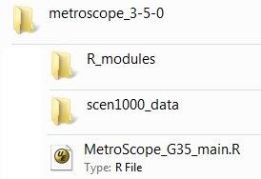

“MetroScope_G35_main.R” is the main control script. More details can be found in “MetroScope Operators Guide”.

R modules sub-directory:

“**R_modules”** contains the R scripts for the MetroScope core functions. See the Detailed Function Definitions section in this document for more details.

G35_globals.R = global constants

G35_IO_functions.R = data input/output functions

G35_nonres_demand_module.R = non-residential demand module

G35_nonres_demand_calcNonresAccess.R = non-residential demand travel access

G35_nonres_supply_module.R = non-residential supply module

G35_nonres_supply_calcNonresSupply.R = non-residential supply functions

G35_res_demand_module.R = residential demand module

G35_res_demand_functions.R = residential demand functions

G35_res_supply_module.R = residential supply module

G35_res_supply_functions.R = residential supply functions

Scenario data directories:

“**/scen1000_data**” contains all the input and output file tables for a MetroScope scenario, (in this case #1000). For each new MetroScope scenario, a directory with the new scenario ID number must be manually created. This directory must contain the following subdirectories.

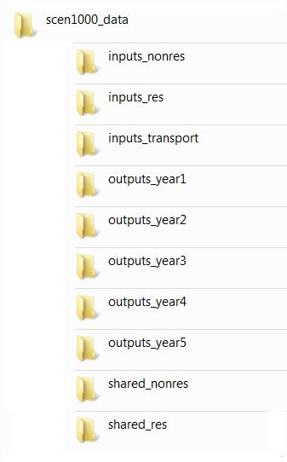

**/inputs_nonres** = inputs for non-residential module

**/inputs_res** = inputs for residential module

**/inputs_transport** = res and non-res travel times

**/outputs_year1** = all outputs for each year

**/outputs_year2** = ‘’

**/outputs_year3** = ‘’

**/outputs_year4** = ‘’

**/outputs_year5** = ‘’

/shared_nonres = temporary files, for model use only

/shared_res = temporary files, for model use only

All data tables are text files in the Comma-Separated-Variable (CSV) format. See Detailed File Descriptions section in this document.

**/inputs_nonres**

Inputs required for each of the model years. These are generally what you change to create new scenarios.

nonres_supply_acres_added_yearN Non-residential acres, added in current model year.

nonres_demand_emp_controls_yearN Regional employment control totals

Inputs common to all model years. These generally will not change from scenario to scenario.

nonres_general_params Parameters for both residential and non-residential modules

nonres_demand_access_param Access parameters

nonres_demand_access_time_param Access parameters nonres_demand_baseline_distribution_param Share of emplcass employment into re types.

nonres_demand_baseline_sqft_emp Baseline value of square feet per employee.

nonres_demand_crossprice_elasticity Cross price elasticity between real estate types

nonres_demand_directprice_elasticity Direct price elasticity, by empclass

nonres_demand_directsqft_elasticity Direct sqft elasticity, by empclass and re type

nonres_demand_hh_year0 Households by ezone for the calibration model year

nonres_locationprice_year0 Non-residential location price in calibration year

nonres_supply_baselandvalue Base non-residential land value, in dollars per sqft.

nonres_supply_capitalcost Base non-residential capital cost, in dollars per sqft.

nonres_supply_capitalsubsidy Base non-residential capital subsidy, in dollars per sqft.

nonres_supply_cbdfactor Paramters for adjusting nonres supply in the CBD

nonres_supply_farclass_param Nonres supply module parameters for each FAR class

nonres_supply_landcost Base non-residential land cost, in dollars per sqft.

nonres_supply_retype_param Nonres supply module parameters for each FAR class.

nonres_supply_totalsupply_year0 Total sqft supply in calibration year.

**/inputs_res**

Inputs required for each of the model years. These are generally what you change to create new scenarios.

res_supply_acres_added_yearN Land use supply accounting for current model year.

res_demand_khia_shares_yearN Regional household shares by KHIA

res_demand_hh_controls Regional totals for households and dwelling units

Note: for the demand hh controls, there is only one input file, with one row for each model year.

Inputs common to all model years. These generally will not change from scenario to scenario.

res_general_params General parameters

res_general_rzone_lut Lookup table for the ezones to rzones

res_demand_accessindex_nscore Location weights for auto access, neighborhood

res_demand_binshares_year0 Housing price bin weights from calibration year

res_demand_emp_yearN Employment by ezone from non-residential model

res_demand_hedonic_params Parameters for residential housing cost calculation.

res_demand_housesize_params Parameters for residential housing size choice.

res_demand_housingtype_params Parameters for residential housing type choice.

res_demand_khia_categories Values for each KHIA market segment

res_demand_khia_params Parameters for each KHIA market segment

res_demand_kshare_params Location weights for households with children.

res_demand_locationchoice_params Parameters for residential location choice.

res_demand_lotsize_params Parameters for residential location choice.

res_demand_tenure_params Parameters for residential tenure choice.

res_locationprice_year0 Residential location price from calibration year

res_supply_base_bldgcost Base building cost

res_supply_base_lotprice Base lot price

res_supply_basesalesfraction Base fraction for land supply availability

res_supply_feesubsidy Cost or subsidy to building cost of each unit.

res_supply_zclass_lotsize Available lot sizes for each zoning class

res_totalsupply_year0 Total DU supply from calibration year

**/inputs_transport**

Inputs required for each of the model years. These are generally what you change to create new scenarios.

nonres_traveltime_yearN Non-residential ezone-to-ezone travel times

res_traveltime_yearN Residential ezone-to-rzone travel times

**/outputs_yearN** (one file for each model year)

nonres_supply_acres_consumed_yearN Nonres acres, consumed in model year

nonres_supply_acres_remaining_yearN Nonres acres, consumed in model year

nonres_demand_emp_yearN Total employment demand, by ezone, emplcass,

and real estate type

nonres_demand_empclass_emp_yearN Total employment demand, by ezone and emplcass

nonres_demand_hh_yearN Households by ezone, from residential model

nonres_demand_sqft_yearN Total square foot demand

nonres_locationprice_yearN Non-residential location price

nonres_sqft_newsupply_yearN New regular sqft supply built in model year

nonres_sqftUR_newsupply_yearN New UR sqft supply built in model year

nonres_supply_totalsupply_yearN Total sqft supply

res_supply_acres_consumed_yearN Residential regular acres, consumed in model year

res_supply_acres_remaining_yearN Residential regular acres, consumed in model year

res_demand_avghedonic_bin_yearN Average hedonic prices for each housing bin

res_demand_avghousesize_bin_yearN Average house size for each housing bin, in sqft

res_demand_avglotsize_bin_yearN Average lot size for each housing bin, in sqft

res_demand_binshares_yearN Location weights for each housing price bin

res_demand_RzBin_yearN Total demand, by rzone and housing bin

res_demand_RzEz_yearN Total demand, by rzone and ezone

res_demand_RzKHIA_yearN Total demand, by rzone and KHIA

res_demand_rzone_yearN Total demand, by rzone

res_locationprice_yearN Residential location price

res_newsupply_yearN New regular households built in model year

res_newsupplyUR_yearN New UR households built in model year

res_totalsupply_yearN Total households in model year

Glossary and Category Definitions

From Residential Model:

**Res** Residential

**Regular** Land supply not given a building cost subsidy.

**UR, Urban** **Renewal** Land supply given a building cost subsidy

**Rzones** Residential zones, used by the residential model. Metro currently uses 425 residential zones, based on Year 2000 US Census tracts.

**Zclass** Residential zoning classes. Each class defined by minimum and maximum lot sizes per dwelling unit. Refer to input table "res_supply_zclass_lotsize"

**Htypes** Residential housing types:

**OSF** Owner, Single Family

**OMF** Owner, Multi Family

**RSF** Renter, Single Family

**RMF** Renter, Multi Family

**Bins** Residential housing value bins. These are groupings of KHIA categories into eight value classes to allow more realistic supply and demand of different market segments. See "MetroScope Theory and Practice".

**HH, DU** Households, Dwelling Units. At Metro, the forecast is in households, then dwelling units are estimated by adding a 5% vacancy rate. Note: in the documentation and code, sometime the terms are used interchangeably.

**K, H, I, A, KHIA** Residential market segments, based on US Census categories. School-age children present (K), Household size (H), Income (I), Age of household head (A); collectively referred to as "KHIA".

Categories currently used at Metro:

**K = School Age Children Present**

k0 no kids 0

k1 with kids 1

**I = Income**

i1 Less than $14,999 10000

i2 $15,000 to $24,999 20000

i3 $25,000 to $34,999 30000

i4 $35,000 to $44,999 40000

i5 $45,000 to $59,999 52500

i6 $60,000 to $74,999 67500

i7 $75,000 to $99,999 87500

i8 $100,000 or more 125000

**H = Household Size**

h1 1 person 1

h2 2 persons 2

h3 3 persons 3

h4 4 persons 4

h5+ 5 or more persons 5.5

**A = Age of Household Head**

a1 Under 25 20

a2 25 to 44 35

a3 45 to 54 50

a4 55 to 64 60

a5 65 & over 70

From Non-Residential Model:

**Nonres** Non-Residential

**Emp** Employment Note: in the documentation and code, "emp" and "nonres" are sometimes used interchangeably.

**Regular** Land supply not given a building cost subsidy.

**UR, Urban** **Renewal** Land supply given a building cost subsidy

**Ezones** Employment zones, used by the non-residential model. Metro currently uses 72 employment zones, which are groups of residential zones.

**FAR** Floor-to-Area ratio categories, used by non-residential model. A measure of building square footage allowed for a given land supply acreage. Refer to table "nonres_supply_farclass_param".

**RE, RE types** Non-residential real estate types:

**Man** Manufacturing

**War** Warehousing

**Ret** Retail

**Gen** General Office

**Med** Medical

**Gov** Government

**ManWar** Industrial land supply type. The non-residential model splits these into Manufacturing and Warehousing square footage types.

**RetGen** Commercial land supply type. The non-residential model splits these into Retail and General Office square footage types.

**MedGov** Institutional land supply type. The non-residential model splits these into Medical and Government square footage types.

**Empclass** Employment classes, defined by North American Industry Classification System (NAICS).

Employment class values currently used at Metro:

**Emp Class Industry NAICS**

1 Agriculture, timber 11, 21

2 Construction 23

3 Nondurable manufacturing 311, 312-316, 322, 323-327, 511

4 Durable man., metals, paper 321, 331, 332, 333, 335, 336, 337, 339

5 High tech manufacturing 334

6 Transport and warehousing 48, 49

7 Communications and utilities 22, 512, 515, 517, 518, 519

8 Wholesale trade 42

9 Retail trade 44, 45, 72

10 Finance, insurance, real estate 52, 53, 55

11 Consumer services 56, 71, 81

12 Health services 62

13 Business, professional services 54, 61

14 Other government Gov ownership (not NAICS 6111 in es202)

15 K-12 education Gov ownership (NAICS 6111 in es202)

GNU General Public License

MetroScope Land Use / Transportation Model. Copyright (C) 2013 Metro

This program is free software: you can redistribute it and/or modify

it under the terms of the GNU General Public License as published by

the Free Software Foundation, either version 3 of the License, or

(at your option) any later version.

This program is distributed in the hope that it will be useful,

but WITHOUT ANY WARRANTY; without even the implied warranty of

MERCHANTABILITY or FITNESS FOR A PARTICULAR PURPOSE. See the

GNU General Public License for more details.