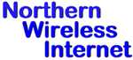
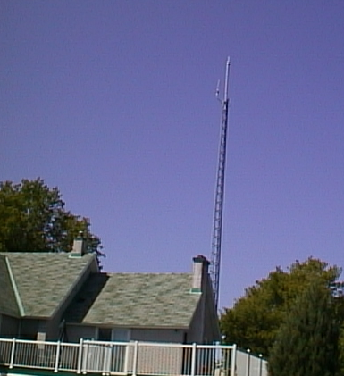
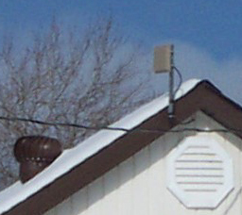
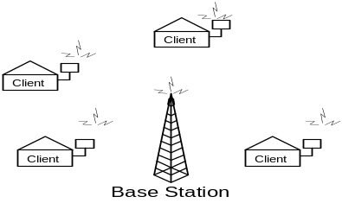
Jim Cox
jcox@northernwireless.ca

Stephane Gauvin
sgauvin@northernwireless.ca

New Address xxxxxxxxxx
Ottawa, Ontario
Canada
xxxxxxx
613-823-4218

www.NorthernWireless.ca

Typical Client Antenna

Option 1- ISP or Local Investor Ownership
We sell you a complete out of the box. You install the wireless system or you hire NWI to do it. NWI gives the first two months of support for free. Support after that is provided on a per hour charge basis.
What do I need?

Wireless Ethernet Bridge client for the user with integral or external antenna (includes all cables). The cost of a fifty user system is = $18,000. We normally sell clients directly to the end users. This makes the installation more financially feasible as a startup as less capital is needed to begin the operation. We also have found that most clients prefer owning their own equipment. A second option is for the owner to purchase the client radios and rent them out to the users.

Base Station. The cost of a 50 user system is $9,000. Comes with standard or amplified radio with external antenna and all cables. Bandwidth control unit also supplied.

Backbone to the Internet can be a satellite dish or T1 or wireless link to other connection. If ISP services are required we can provide the entire ISP out of the box. The ISP can be remotely or locally operated.

Option 2– NWI in revenue sharing partnership with a local ISP or Investor/Community
- NWI adds a wireless system to a local existing dial-up or other ISP infrastructure. The system is operated and maintained by the local ISP. The local ISP is also responsible for advertising, sales, installations and local customer technical support. NWI technically supports the ISP.
- New ISP and Wireless System. An investor/community forms a business partnership with NWI to implement a wireless high speed internet access system. This solution involves the creation of a new ISP. The ISP portion includes (web servers, mail servers, RADIUS servers, security.)

What does a typical system look like?
The Wireless provider location has a tower erected or an existing tower is used. The tower can be 30 to 70 ft high. This tower has the base station, which broadcasts and receives wireless signals. The base station consists of a radio transmitter/receiver connected to an antenna. The radio is then connected to Ethernet and then to the internet via T1, satellite etc..
Typical Base Station
The clients have an external directional antenna mounted on their roof pointed at the base station (external antennas not always required). The radio is connected to the antenna and the client’s computer via Ethernet.

Typical Business Plans

Call us at NWI or visit us at our website.

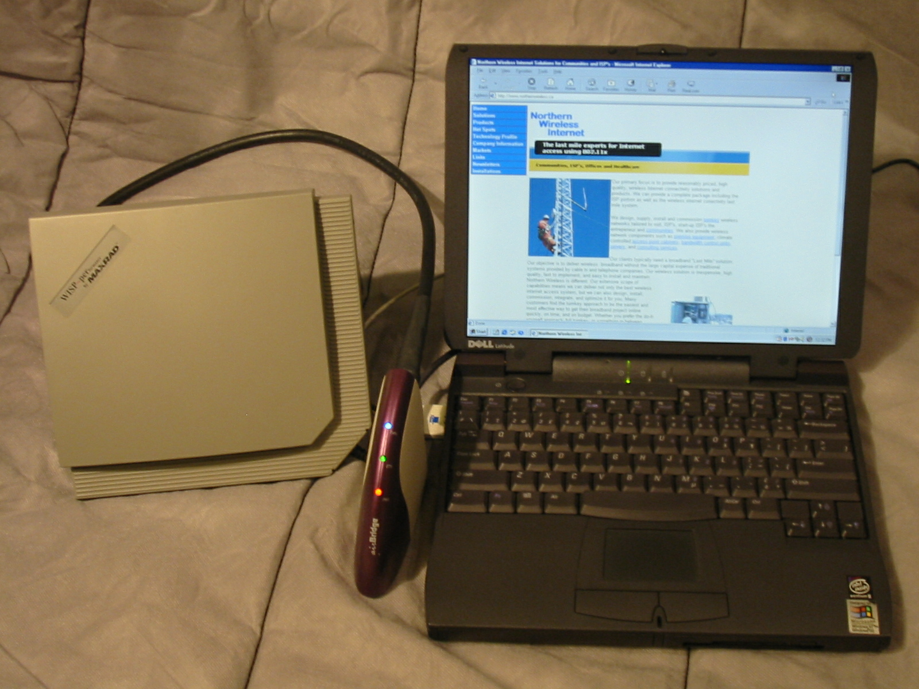
We can help you. We are Northern Wireless Internet. We specialize in designing wireless LANs for outdoor point to point or point to multipoint systems. Our designs are used to provide Broadband Internet and VoIP (Voice over IP) to business and residences. Whether you want to link two building LANs together or provide Broadband internet to your end users, we have the products and knowledge to meet your needs.
We use low cost high quality wireless equipment in our network designs. Our last miles links are typically 802.11a,b,g 2.4G-5Ghz systems or in 2004 802.16a. Our backhauls and backbones are typically higher bandwidth systems in the 5Ghz plus frequencies and T1, satellite etc...
Our two-year experience as a WISP WISP (Wireless Internet Service Provider) and five years as an ISP allows us to offer dependable proven designs.
We can assist you in planning the business side of the system so you start with a realistic business plan. We can provide ongoing technical support for your network.

Affordable Wireless Broadband Delivery Systems – pre configured “last mile” solutions
Need a system quickly?
Northern Wireless Internet can supply you with a complete wireless system out of the box, ready to install. We have pre-designed system ready to go. All the equipment is pre-configured and everything is provided, ready to assemble at site. This means no extensive engineering expenses or lengthy construction delays. We can provide the wireless system only, or a complete ISP business. The ISP portion can be locally or remote installed.
If you are interested in a custom design we have the capability to offer custom-engineered solutions to meet your requirements.

- Do You want Broadband high speed Internet in your community? Is your local ISP in need of an affordable highspeed last mile system?
- Do You want to invest in your own highspeed system? Become a WISP (Wireless Internet Service Provider) now by talking to NWI? See reverse Business Plan Option 1.
- Are you an ISP provider who wants to move to offer Broadband but doesn't have the expertise to do so and or the large capital required for traditional and proprietary wireless systems? See reverse Business Plan Option 1 or 2.
- Want a system that is easy to understand and no harder to maintain than a LAN (Local Area Network)? Based on open IEEE standards, Ethernet, Wi-Fi etc.

Go to our website for more information and a downloadable pdf brochure.
www.NorthernWireless.ca
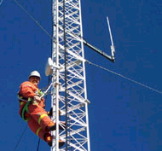
Typical client. Wireless Ethernet Bridge shown with external Antenna

