# Artificial Intelligence Coursework

## Abstract:

In this coursework, three algorithms will be analysed and explained. An algorithm is basically a system for solving a problem. The problem that will be looked at in this coursework is finding the shortest route from one node to another, to which many solutions exist. Specifically, this coursework will include a description for Dijkstra’s algorithm, A Star, and Breadth-First Search.

## Methods

### Dijkstra’s Algorithm

Dijkstra’s algorithm was invented by a Dutch computer Scientist “Edsger Dijkstra” in 1956, and it was published in 1956. Dijkstra’s algorithm will always find the shortest route from the start to the end node if a route exists for a map with nonnegative edge path costs.

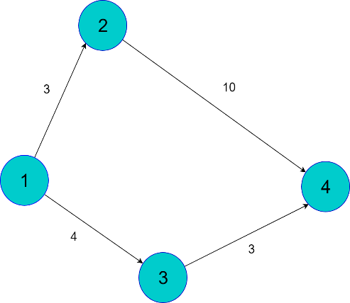For the purposes of this report, a small map has been drawn (See Figure 1). The blue circles represent nodes and the black lines are node paths. Each path from node to node has a direction, and a cost associated with it. Each node in the figure has a label, and the numbers on the nodes do not represent the cost of each node. The arrows display which direction the algorithm is allowed to take when travelling from node to node.

Figure 1:

The problem here is to find the most efficient route from Node 1 to Node 4. The numbers next to the lines represent the “cost” of going between nodes. The shortest path in this scenario is from Node 1 to Node 2, and from there to Node 4, which is the end goal. Specifically, the cost to get there is 7(4+3), while for the other path it is 13(3+10). For this example, it’s quite easy to figure out the shortest route, but for more complex maps it would take more time, which is the reason algorithms are used. Dijkstra’s algorithm will find all viable routes to the goal from a map, compare them, and output the shortest path to the route.

In detail, this algorithm finds the path with the lowest cost between one node and every other node. To start with, we have a list of unvisited nodes. After we choose the starting node in a graph, we set the cost in the list for that node to be 0. We set all the other nodes to have a distance of infinity from the starting node to begin with. The next step is updating the list with the cost of getting to the neighbouring nodes from the current one. After processing all the nodes and all the possible paths, the algorithm compares all the distance travelled to get to a specific node and returns the path with the shortest possible distance.

### A*

A* is an informed search algorithm, and the best known form of best-first search. Best-first search is a search algorithm which explores a graph by expanding the most promising node chosen according to a specific rule(heuristic). In order to choose the node, A* uses the following formula:

**f(n)=g(n)+h(N)**

* **g(n):** The cost to reach the node(so far)
* **h(n):** The estimated cost to get from the node to the goal
* **f(n):** Estimated total cost of the path through the end goal

### Depth and Breadth-First Searches

## Explanation

Because Dijkstra’s algorithm does all the possible calculations in order to find the shortest path in each map, it is not as efficient as other algorithms calculation-wise, which is why it wasn’t used for this coursework.