**EXPLORING USER EXPERIENCES IN DESIGNING AN INTUITIVE CAR RENTAL SYSTEM WITH FLEXIBLE PAYMENT OPTIONS TZ CAR RENTAL**

A Capstone Project

Presented to the Faculty of the

College of Computer Studies

Perpetual Help College of Pangasinan

In Partial Fulfillment of the

Requirements for the Degree of

Bachelor of Science in Information Technology (BSIT)

CENTENO JR, VICTOR A.

INOGACIO, VENCENT F.

LUSANIA, MARY GRACE B.

PARAGAS, AARON CHRISTIAN

CCS 4-A

October 2024

**ABSTRACT**

**Title :** Exploring User Experiences in Designing an Intuitive Car Rental System with Flexible Payment Options TZ Car Rental

**Proponents :** Victor A. Centeno Jr., Vencent F. Inogacio,

Mary Grace B. Lusania, and Aaron Christian Paragas

**Type of Document :** Capstone Project

**Name of Institution :** Perpetual Help College of Pangasinan- JONELTA

**Degree Conferred :**  Bachelor of Science in Information Technology

**Year Completed :**

**Technical Adviser :** Jessa F. Untalan

**Number of Pages :**

Exploring User Experiences in Designing an Intuitive Car Rental System with Flexible Payment Options TZ Car Rental is an online platform developed to integrate flexible payment options, providing customers with a convenient way to rent cars and make payments. The development of the system followed the System Development Life Cycle Model (SDLC), which included phases such as Requirements, Planning, Designing, Development, Testing, and Implementation.

The technologies used in developing the system were Xampp-MySql for the database and PHP for the functions of the system and CSS for the design of the system. The questionnaire was used to evaluate the efficiency of the proposed system as evaluated by the end-users. The result of the evaluation which based on the ISO 25010 standard, which showed that the proposed system received the highest mean scores for Reliability and Portability, followed by high scores for Functional suitability. The system also received good scores for Performance efficiency, Compatibility, Usability, Security, and Maintainability.

The development system offers several features, such as car renting, making feedback and payment. Customers can register and log in to the system, browse cars and choose their desired date of renting. The system also has available rent history and payment process feature, allowing customer to make payments hassle-free.

Exploring User Experiences in Designing an Intuitive Car Rental System with Flexible Payment Options TZ Car Rental provides reliable and efficient platform for car renting and making payments. The system streamlines the car renting process, choosing desired date, reducing wait times, enhancing customer satisfaction. The recommendations for further enhancement include Digitalization of Customer Requirements in Car Renting Systems, GPS Tracking for Rented Vehicles, and API Payment Gateway for GCash Integration.

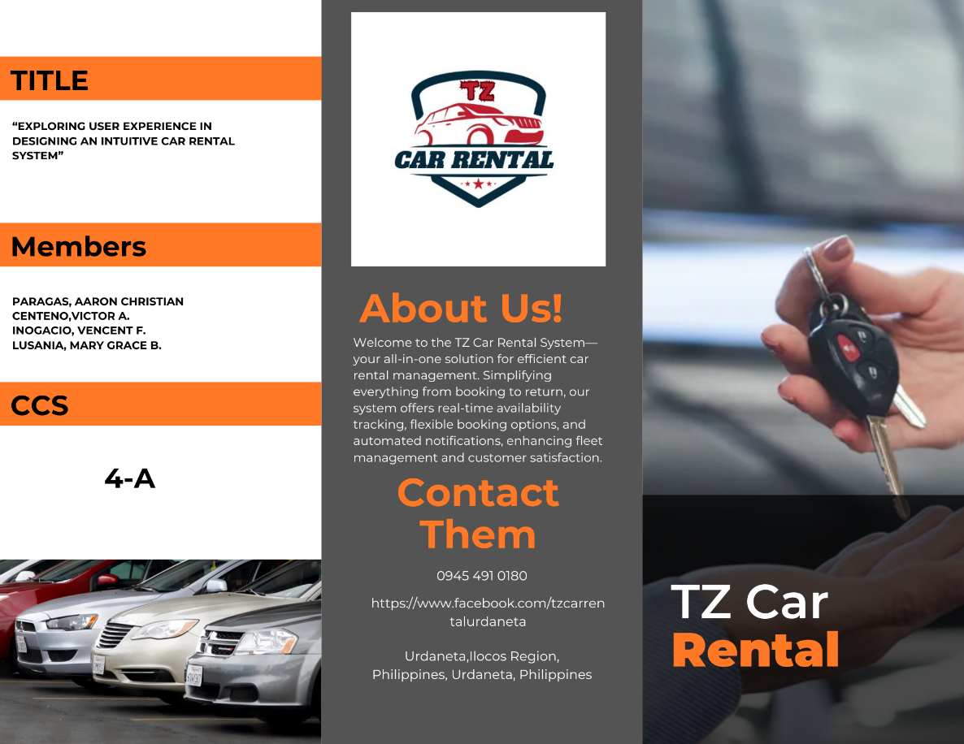

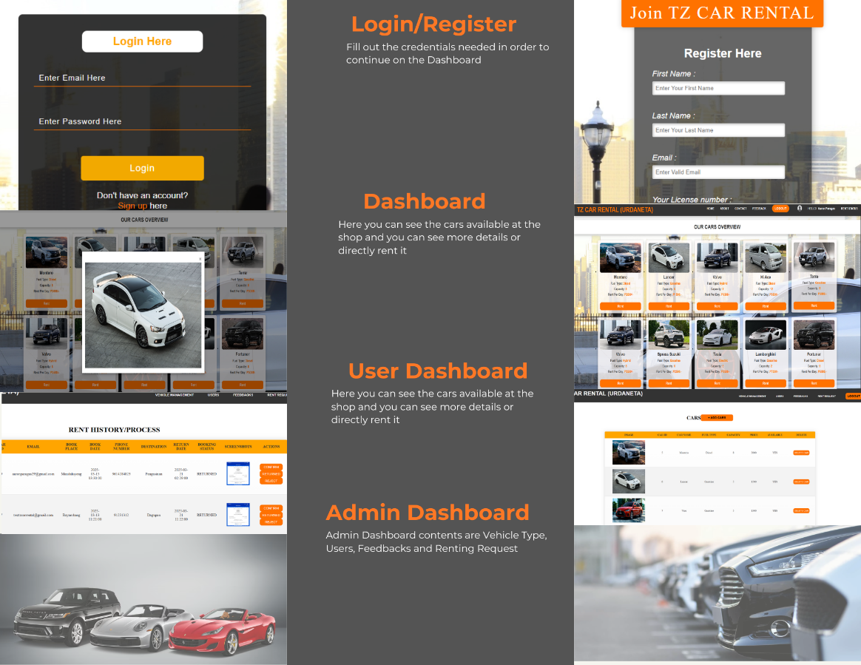

**Diagrams**

**Use Case Diagram**

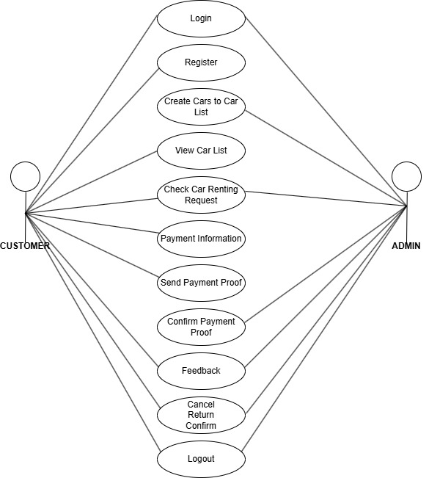

**System Architecture**

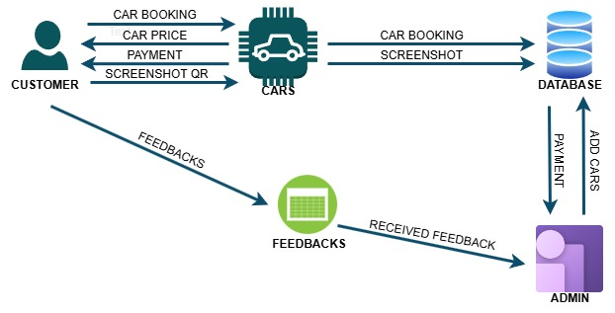

**System Architecture**

**Customer Actions:**

* The customer books a car, checks the car price, makes a payment, and uploads a screenshot Payment for confirmation.
* These interactions go through the "Cars" system.

**Car System & Database:**

* The "Cars" system processes bookings and updates the database with car booking details and screenshots.
* The database stores this information for future reference.

**Admin Role:**

* The admin can add new cars to the system.
* Payments are processed through the admin.
* Admin receives feedback from customers.

**Feedback System:**

* Customers submit feedback.
* The feedback is sent to the admin for review and improvements.

**Database Schema**

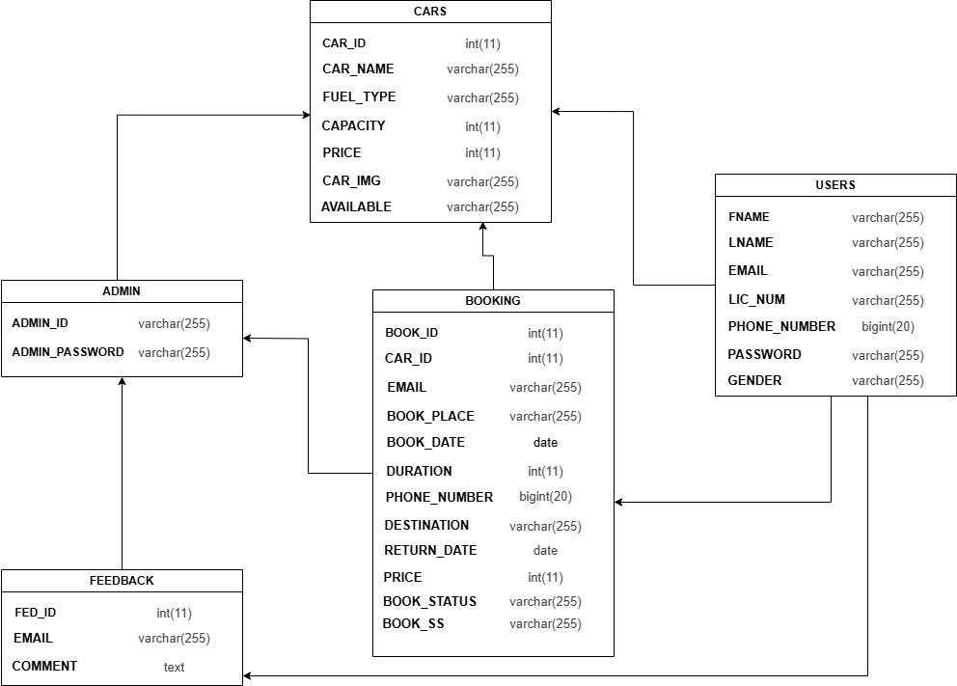

This database schema represents a car rental system, including tables for Admins, Users, Cars, Bookings, and Feedback. The Admin manages cars and bookings, while Users can book cars and leave feedback. The Booking table connects users with rented cars, storing details like rental duration, destination, and status. The Feedback table allows users to submit comments related to their experience. The relationships ensure a structured and efficient rental system.

**Activity Diagram**

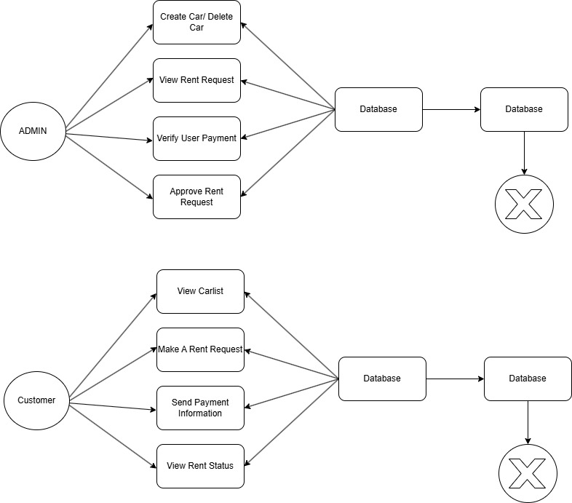

Log out

Log out

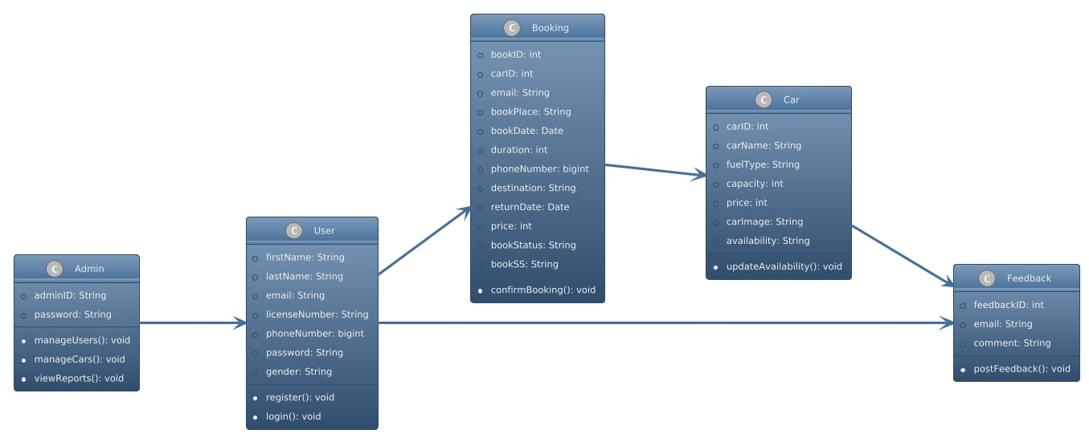**Class Diagram**

This UML class diagram illustrates a Car Rental System, where an Admin manages users and cars, Users can register, log in, and make bookings, Bookings are associated with specific cars, and Users can provide feedback on their rental experience. The relationships between these entities ensure smooth management of the rental process.

