|  |  |  |  |
| --- | --- | --- | --- |
| FSM name : | QE_generator_FSM.sv | Date: | Feb 2021 |
| Section : | 1 of 1 | Author | Jim Herd |
| Notes : |  | | |

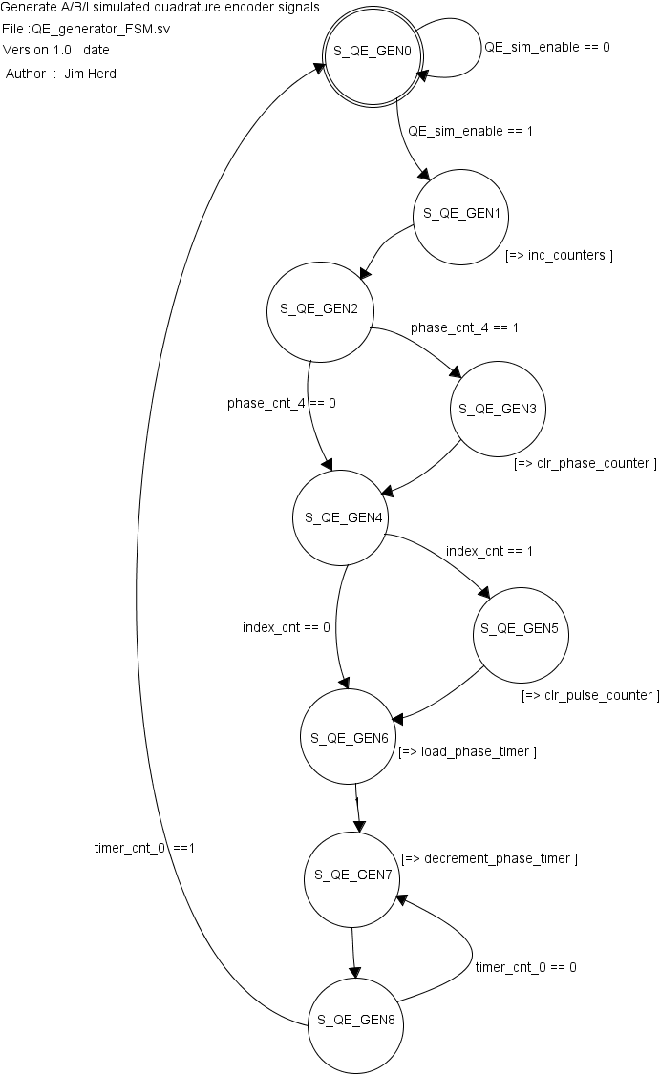

State Objects

|  |  |
| --- | --- |
| **States** | Notes |
| S_QE_GEN0 | Initial state. |
| S_QE_GEN1 | Increment phase counter and pulse counter |
| S_QE_GEN2 | Test for phase counter >3 |
| S_QE_GEN3 | Clear phase counter |
| S_QE_GEN4 | Test pulse counter |
| S_QE_GEN5 | Clear pulse counter |
| S_QE_GEN6 | Load phase timer |
| S_QE_GEN7 | Decrement phase timer |
| S_QE_GEN8 | Test phase timer |

Input objects

|  |  |  |
| --- | --- | --- |
| **Inputs** | Type | Notes |
| QE_sim_enable | binary | Bit 16 of PWM configuration register |
| phase_cnt_4 | binary |  |
| index_cnt | binary |  |
| timer_cnt_0 | binary |  |

Output objects

|  |  |  |
| --- | --- | --- |
| **Outputs** | Type | Notes |
| inc_counters | binary |  |
| clr_phase_counter | binary |  |
| clr_pulse_counter | binary |  |
| load_phase_timer | binary |  |
| decrement_phase_timer | binary |  |