|  |  |  |  |
| --- | --- | --- | --- |
| FSM name : | bus_FSM.sv | Date: | Feb 2021 |
| Section : | 1 of 1 | Author | Jim Herd |
| Notes : |  | | |

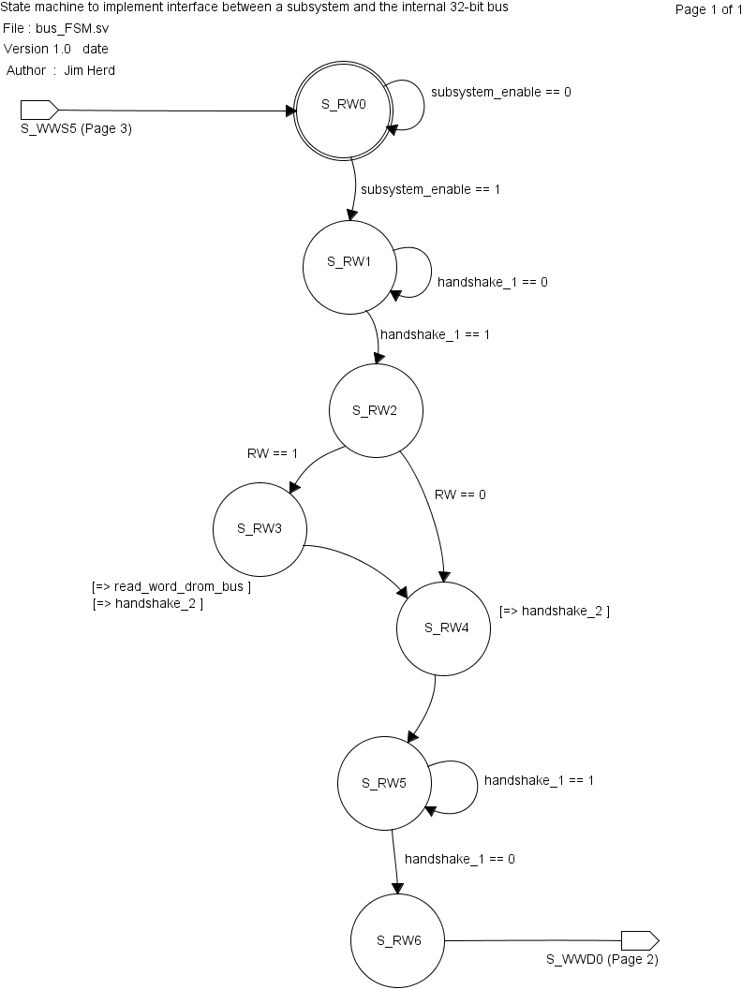

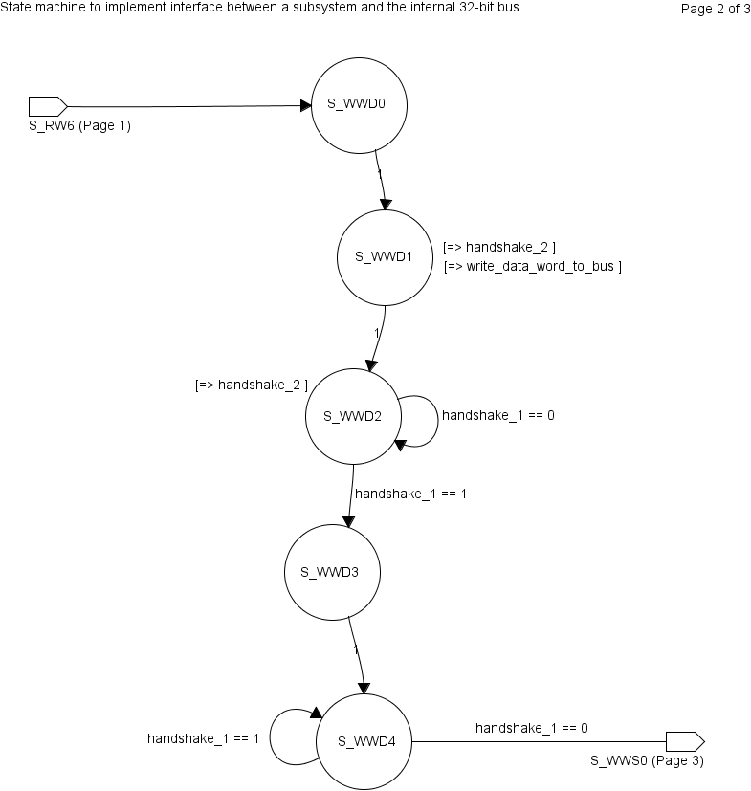

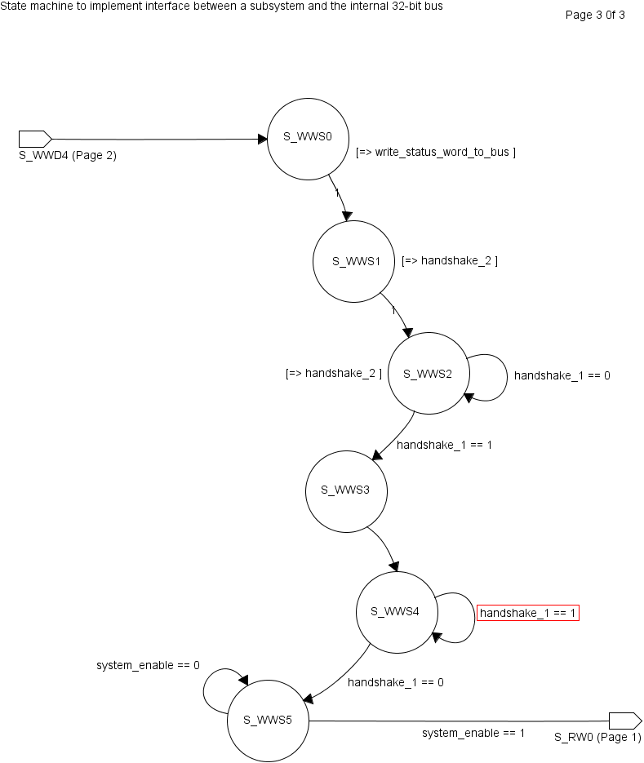

State Objects

|  |  |
| --- | --- |
| **States** | Notes |
| **S_RW0** | Initial state.  Wait for ‘system-enable’ signal to be asserted. This implies that the subsystem has been addressed. |
| **S_RW1** | Wait for ‘handshake_1’ signal to be asserted. This is the first phase of the handshake of the data across the 32-bit bus. |
| **S_RW2** | Check whether this transaction is a READ from a SUBSYSTEM REGISTER or a WRITE to a SUBSYSTEM REGISTER.  0 == WRITE  1 == READ |
| **S_RW3** | Assert READ_WORD_FROM_BUS signal to input 32-bit value to addressed register |
| **S_RW4** | Assert ‘handshake_1’ signal to indicate read/write of word is complete |
| **S_RW5** | Wait for ‘handshake_2’ signal to be de-asserted to indicated that handshake has been accepted by the uP. |
| **S_RW6** | One clock delay to allow everything to settle. This completes the uP to FPGA transfer part of the command execution process.  *** may not be needed. To be checked. |
|  |  |
| **S_WWD0** | Assert signal to write a 32-bit data value on the bus. This signal will remain asserted through states **S_WWD1** and **S_WWD2**. |
| **S_WWD1** | Assert ‘handshake_2’ to indicate first part of the transfer handshake. |
| **S_WWD2** | Wait for signal ‘handshake_1’ to indicate that uP has detected handshake. |
| **S_WWD3** | One clock delay to allow everything to settle.  *** may not be needed. To be checked. |
| **S_WWD4** | Wait for ‘handshake_1’ signal to be de-asserted to indicate that handshake has been completed.  Go to state **S_WWSO** if to send status word to uP if compile time parameter ‘INCLUDE_32_BIT_STATUS_RETURN’ has been defined. Otherwise go to state **S_WWS5**. |
|  |  |
| **S_WWS0** | Assert signal to write a 32-bit status value on the bus. This signal will remain asserted through states **S_WWD1** and **S_WWD2**.  This status transfer phase may be disabled. |
| **S_WWS1** | Assert ‘handshake_2’ to indicate first part of the transfer handshake. |
| **S_WWS2** | Wait for signal ‘handshake_1’ to indicate that uP has detected handshake. |
| **S_WWS3** | One clock delay to allow everything to settle.  *** may not be needed. To be checked. |
| **S_WWS4** | Wait for ‘handshake_1’ signal to be de-asserted to indicate that handshake has been completed. |
| **S_WWS5** | Wait for ‘system_enable’ signal to be de-asserted before returning to initial state. |

Input objects

|  |  |  |
| --- | --- | --- |
| **Inputs** | Type | Notes |
| **Subsystem_enable** | binary |  |
| **RW** | binary |  |
| **Handshake_1** | binary |  |

Output objects

|  |  |  |
| --- | --- | --- |
| **Outputs** | Type | Notes |
| **Handshake_2** |  |  |
| **Write_data_word_to_bus** |  |  |
| **Write_status_word_to_bus** |  |  |