|  |  |  |  |
| --- | --- | --- | --- |
| FSM name : | Count_FSM.v | Date: | Feb 2021 |
| Section : | 1 of 1 | Author | Jim Herd |
| Notes : |  | | |

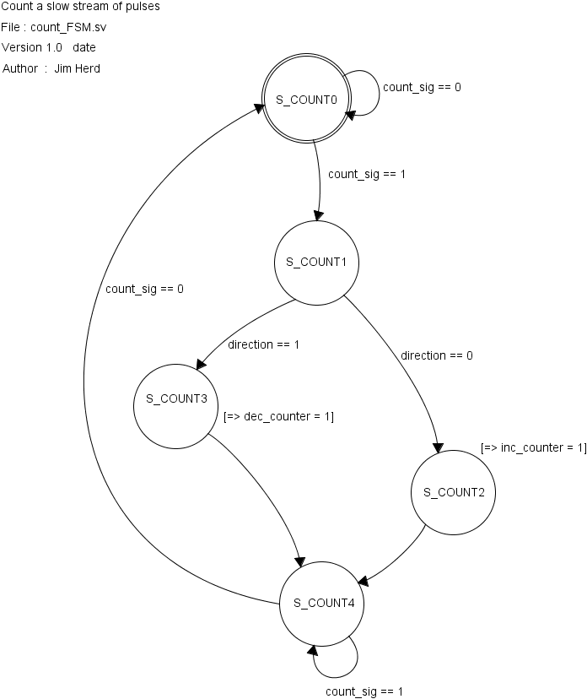

State Objects

|  |  |
| --- | --- |
| **States** | Notes |
| S_COUNT0 | Initial state.  Wait for rising edge of signal |
| S_COUNT1 | Test direction |
| S_COUNT2 | Generate increment signal |
| S_COUNT3 | Generate decrement signal |
| S_COUNT4 | Wait for falling edge of signal. |

Input objects

|  |  |  |
| --- | --- | --- |
| **Inputs** | Type | Notes |
| count_sig | binary | Stream of slow pulses to be counted. Count takes place on rising edge of signal. |
| direction | binary | Direction signal.  0 = increment  1 = decrement |

Output objects

|  |  |  |
| --- | --- | --- |
| **Outputs** | Type | Notes |
| inc_counter | binary | Set to high to increment pulse counter |
| dec_counter | binary | Set to high to decrement pulse counter |