|  |  |  |  |
| --- | --- | --- | --- |
| FSM name : | pwm_FSM.sv | Date: | Feb 2021 |
| Section : | 1 of 1 | Author | Jim Herd |
| Notes : |  | | |

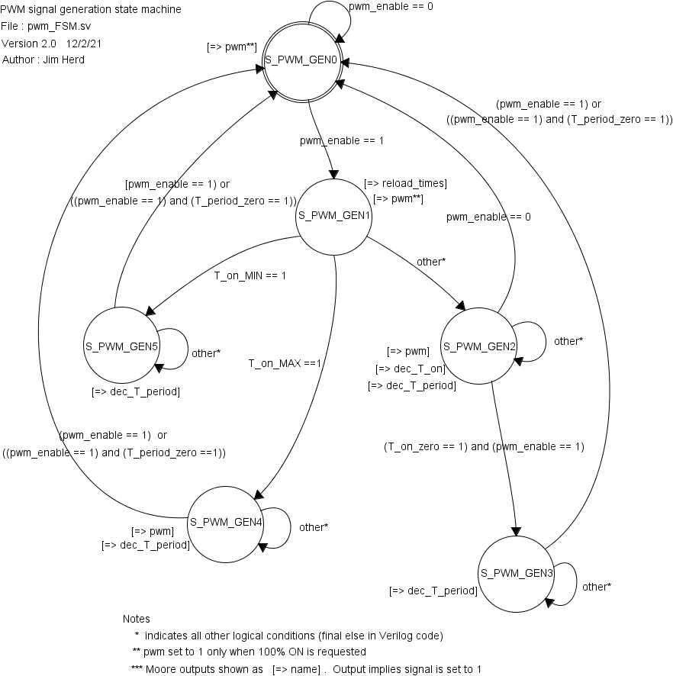

State Objects

|  |  |
| --- | --- |
| **States** | Notes |
| S_PWM_GEM0 | Power-on state |
| S_PWM_GEM1 | Select mode :: 0%, 100% or other ON time |
| S_PWM_GEM2 | Generate ON time in normal mode |
| S_PWM_GEM3 | Generate OFF time in normal mode |
| S_PWM_GEM4 | Special case : continuous ON for 100% case.  Necessary to stop small glitches in PWM signal. |
| S_PWM_GEM5 | Special case : continuous OFF for 0% case.  Necessary to stop small glitches in PWM signal. |

Input objects

|  |  |  |
| --- | --- | --- |
| **Inputs** | Type | Notes |
| pwm_enable | binary | From PWM configuration bit 0 |
| T_on_zero | binary | 1 when ON period is complete |
| T_period_zero | binary | 1 when period is complete |
| T_on_MIN | binary | Indicates ON time > 100nS |
| T_on_MAX | binary | Indicates ON time is > (period – 100nS) |

Output objects

|  |  |  |
| --- | --- | --- |
| **Outputs** | Type | Notes |
| reload_times | binary |  |
| dec_T_on | binary |  |
| dec_T_period | binary |  |
| pwm | binary | PWM output signal.  Note the special case where pwm signal is switched on in states S_PWM_GEN0 and S_PWM_GEN0 when the request is for a 100% ON signal. |

Notes

* Smallest PWM signal is 100ns.
* Largest PWM signal is the period minus 100nS
* Within these limits, the PWM signal has a resolution of 20nS