|  |  |  |  |
| --- | --- | --- | --- |
| FSM name : | QE_speed_measure_FSM.sv | Date: | Feb 2021 |
| Section : | 1 of 1 | Author | Jim Herd |
| Notes : |  | | |

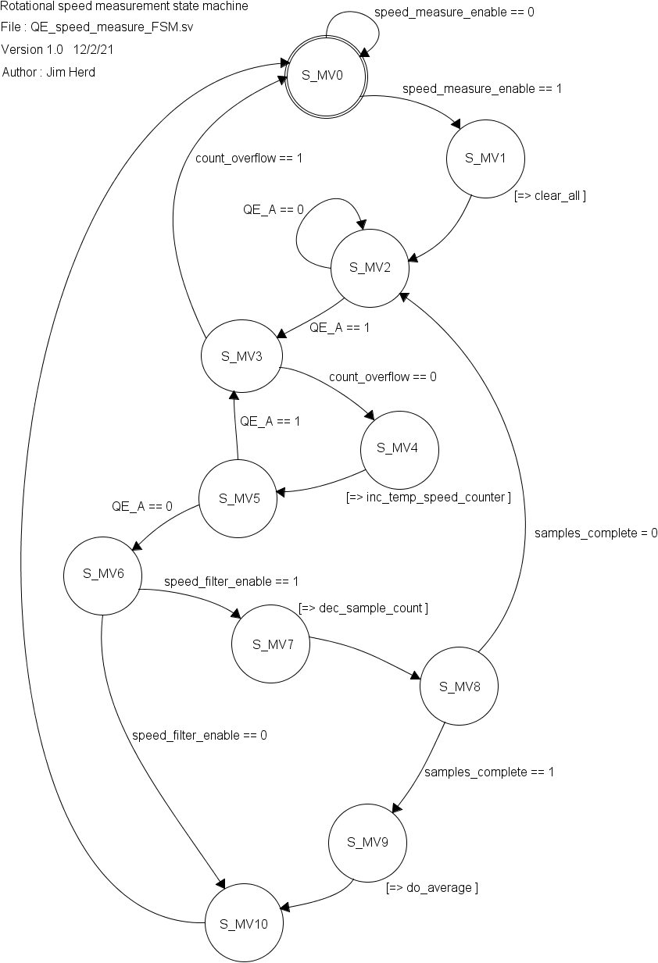

State Objects

|  |  |
| --- | --- |
| **States** | Notes |
| S_MV0 | Power-on state |
| S_MV1 |  |
| S_MV2 |  |
| S_MV3 |  |
| S_MV4 |  |
| S_MV5 |  |
| S_MV6 |  |
| S_MV7 |  |
| S_MV8 |  |
| S_MV9 |  |
| S_MV10 |  |

Input objects

|  |  |  |
| --- | --- | --- |
| **Inputs** | Type | Notes |
| speed_measure_enable | binary |  |
| QE_A | binary | A input from the quadrature encoder |
| count_overflow | binary |  |
| speed_filter_enable | binary | Enable averaging filter. Allows averaging of 2, 4, 8, 16, or 32 consecutive speed readings. Value will have been set in subsystem configuration register. |

Output objects

|  |  |  |
| --- | --- | --- |
| **Outputs** | Type | Notes |
| clear_all | binary |  |
| inc_temp_speed_counter | binary |  |
| dec_sample_count | binary |  |
| do_average | binary |  |