|  |  |  |  |
| --- | --- | --- | --- |
| FSM name : | RC_servo_channel_FSM.v | Date: | Feb 2021 |
| Section : | 1 of 1 | Author | Jim Herd |
| Notes : |  | | |

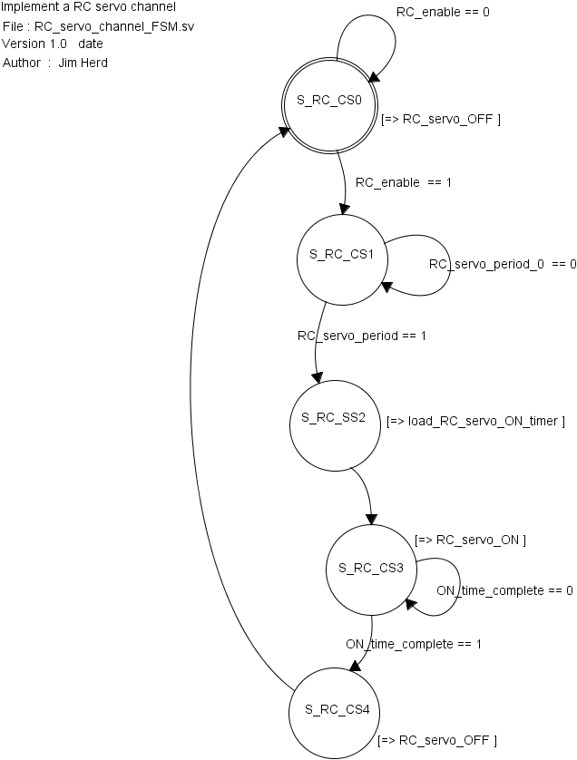

State Objects

|  |  |
| --- | --- |
| **States** | Notes |
| S_RC_CS0 | Initial state. |
| S_RC_CS1 | Wait for start of RC servo period |
| S_RC_CS2 | Load servo ON pulse timer |
| S_RC_CS3 | Set servo HIGH and wait for end of ON pulse time |
| S_RC_CS4 | Set servo LOW |

Input objects

|  |  |  |
| --- | --- | --- |
| **Inputs** | Type | Notes |
| RC_enable | binary | == 0 : disable  == 1 : enable |
| RC_servo_period_0 | binary | Signal that indicates the start of the RC servo period.  1 when start of RC period  Common to all RC servo channels |
| ON_time_complete | binary | 1 when RC ON pulse complete |

Output objects

|  |  |  |
| --- | --- | --- |
| **Outputs** | Type | Notes |
| RC_servo_OFF | binary | Set servo HIGH |
| RC_servo_ON | binary | Set servo LOW |
| load_RC_servo_ON_timer | binary | Load pulse on timer |