**GEOM075**

**ADVANCED REMOTE SENSING**

**Project 3: Image Integration and Fusion Techniques**

**Project Learning Objectives:**

* Red-Green-Blue (PCI Task: RGB) Colour Space
* Intensity Hue Saturation (PCI Task: IHS) Colour Space.
* Principal Component Analysis (PCI Task: PCA)
* Merging high resolution panchromatic imagery with lower resolution multispectral imagery in IHS colour space.
* Merging high resolution panchromatic imagery with lower resolution multispectral imagery in RGB colour space.
* Merging high resolution panchromatic imagery with lower resolution multispectral imagery via Principal Component Analysis
* Histogram Matching (PCI Task: FUN) via Look-Up-Tables (PCI Task: LUTS)
* Image Sharpening – High Pass Filtering (PCI Task: FSHARP)
* Merging high resolution panchromatic imagery with lower resolution multispectral imagery using PCI Task PANSHARP.

**Instructions:**

* This lab is worth 15% of your final grade in the course.
* This assignment has 7 questions and is graded out of 11. The value of each question is indicated next to the question.
* There is a bonus question at the very end of this lab.
* This lab is due at the start of your Lab Period in Week 7
* Submit a digital copy of your answers in a ***single*** Word file into the provided Project 3 D2L drop-box.
* Use your surname, followed by first initial and “Project3” to name your word file. (e.g. KennyFProject3.docx)
* Note the digital timestamp of your submission will be used to determine your time of submission

References:

1. Chavez, P.S., Sides, S.C., and Anderson, J.A., 1991. Comparison of three different methods to merge multiresolution and multispectral data: Landsat TM and SPOT Panchromatic. Photogrammetric Engineering and Remote Sensing Vol. 57, No. 3, March 1991, p.295-303. *(Note: This paper contains the image merging foundational elements necessary to understand Image Fusion)*
2. Zhang, Yun. (2002). "Problems in the fusion of commercial high-resolution satellite as well as Landsat 7 images and initial solutions". In *ISPRS*, Vol. 34, Part 4, *GeoSpatial Theory, Processing and Applications*, Ottawa, Canada. *(Note: This paper describes a very modern approach and the current implementation with PCI Geomatica (Task: PANSHARP))*

**Lab prerequisite:** It is first necessary to read the attached paper by Chavez et al. (1991). This project is based entirely on this paper. It is a relatively easy read.

**Note:** Most GIS/Image Analysis software packages have single button GUIs that will do exactly the tasks described here – but that is too easy we want to do it the hard way! As you will see by going through the processing steps, there are many enhancement opportunities that would be lost if you were to depend on the defaults given within such GUIs. As an additional point as a GIS professional it is expected that you understand what is happening behind the GUIs – this will separate you from the desk-top users.

**Imagery Provided.**

The imagery provided here is a **Landsat 5 Thematic Mapper (TM) image from April 29th, 1985, a SPOT Panchromatic Image acquired June 4, 1985**. The raw Landsat imagery was **acquired at 28 metres resolution but resampled to 10 metre resolution to match the resolution of the SPOT image**. These data are for a common headwater area, just north of Toronto, on the Oak Ridges Moraine. The largest lake within the image is Mussellman’s Lake. Four versions (OakRidgesV*.pix) of this database are provided here – one copy for each portion of this project. *Note Version 3 (OakRidgesV3.pix) is slightly different – as a I have done some preprocessing to streamline this exercise.*

**File names: OakRidgesV1.pix, OakRidgesV2.pix, OakRidgesV4.pix**

Channel Description Bits/Channel

1 SPOT Panchromatic, June 4, 1985 8

2 Landsat TM Band 1 (Blue), April 29, 1985 8

3 Landsat TM Band 2 (Green) 8

4 Landsat TM Band 3 (Red) 8

5 Landsat TM Band 4 (Near Infrared) 8

**File name: OakRidgesV3.pix**

Channel Description Bits/Channel

1 Landsat TM Band 4 (Near Infrared) 8

2 Landsat TM Band 3 (Red) 8

3 Landsat TM Band 2 (Green) 8

4 Landsat TM Band 1 (Blue), April 29, 1985 8

5 **SPOT Panchromatic, June 4, 1985 16**

**Objectives of Merging:**

The objective of image fusion is to take advantage of the spatial resolution of the higher resolution Panchromatic image (in our case a SPOT Panchromatic image) while at the same time retaining the spectral (colour) characteristics of the spatially coarser, multi-spectral imagery (in our case Landsat TM imagery). In this lab, we will evaluate four methods, 1) Intensity channel replacement in Intensity Hue Saturation (IHS) colour space, 2) Arithmetic merging techniques in Red Green Blue (RGB) colour space, 3) Principal Component Analysis (PCA) substitution and 4) PCI’s operational pan-sharpening implementation (PCI Task: PANSHARP). By largely retaining the multi-spectral characteristics in the merged images, one’s experience interpreting Landsat colour composite images can be fully utilised in interpreting the “higher resolution” merged/fused images.

For this exercise the Landsat imagery, which was originally at 28 metres spatial resolution, has been resampled, (using a cubic convolution resampling technique) to 10 metres to match the spatial resolution of the SPOT Panchromatic band. Also, important to note is that all images have the same spatial origin.

To prevent image distortions caused by temporal landscape and phenological changes it is highly desirable that images be acquired at or near the same date. The images we will be merging here were acquired just over one month apart in 1985. We will be doing our comparisons using “standard” false colour composites (which for Landsat 5 TM is Red: TM Band4, Green: TM Band3 and Blue: TM Bband2)

The provided paper by Chavez et al. 1991, contains three distinct fusion methods. Understanding each of these methods will provide you with a good basis in Image Fusion. In the last part of this project, we going to jump ahead to the most modern of Image Fusion implementations and explore the most recent implementation in PCI Geomatica 2018, Task PANSHARP.

### Part 1) Image Merging using Intensity Hue Saturation (IHS) Method

**Notes:**

This type of merging can be done very effectively as a substitution in IHS (Intensity, Hue, Saturation) colour space (see course notes). As a first step, it is necessary to translate the RGB multispectral imagery into IHS colour space. After this you can then substitute the higher resolution image (in our case a SPOT Panchromatic image) with the Intensity channel and then translate the resulting composite back into RGB colour space. It should be noted that although this merging produces effective visual results, some spectral distortion has occurred. Advanced versions of this approach are employed, within many GIS systems and are imbedded in simple to use preprogrammed GUIs (including in ArcGIS).

**Processing Steps:**

1. Review IHS method in Chavez et al. 1991 (provided).
2. Load each of the bands provided from file OakRidges**V1**.pix in Grayscale. Zoom into the imagery and compare the resolution of the Landsat imagery to that of the SPOT imagery.
3. Also load a “Standard False Colour Composite from the Landsat TM Imagery. (Red: TM Band4, Green: TM Band3 and Blue: TM Bband2)
4. Convert your Landsat bands R:4, G:3 and B:2 to IHS colour space. ***(******from under Tools 🡪 Algorithm Librarian 🡪 Task IHS).*** For InputR: Red Layer, select TM Band 4, for InputG: Green Layer select TM Band 3, and For InputB: blue Layer, select TM Band 2. Write your IHS files at the base of OakRidgesV1.pix (see below). From under Input Param, select a *CYLINDER* IHS Model and an *8-bit Unsigned* Output Type. Run Module IHS.

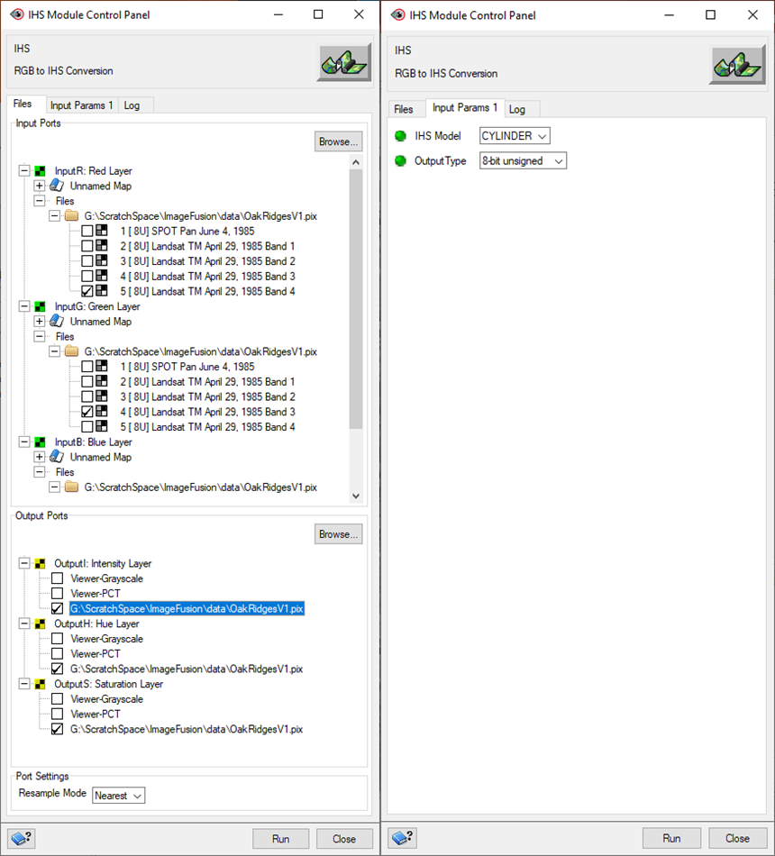

1. Note, 3 8-Bit channels have been created and added to OakRidgesV1.pix, titled Intensity, Hue and Saturation. Load as Grayscale Images and view your three newly created IHS Colour space images.
2. View the histograms of your SPOT Panchromatic Channel and your Intensity Channel (From under the Maps tab – Right-Click on the image, followed by Histogram) . As a next step, we will match our SPOT Panchromatic Histogram to our Intensity Image, to acquire an image of the same variance and average (PCI Task: FUN). Ensuring these channels have the same variance and average, should keep spectral artifacts to a minimum.
3. Initiate PCI Task FUN (***from under Tools 🡪 Algorithm Librarian 🡪 Task FUN)*** to generate the necessary Look-Up-Table. For Input: Select the *SPOT* Panchromatic layer, For InputHC: Histogram Matching Layer, Select your *Intensity* Layer. (as below). For Output, write your LUT, back to OakRidgesV1.pix. From under the Input Params 1 tab, for **Enhancement Function**, select *MATCHING*. And give your new LUT (Look Up Table), a meaningful Name and Description. Run Module Fun.

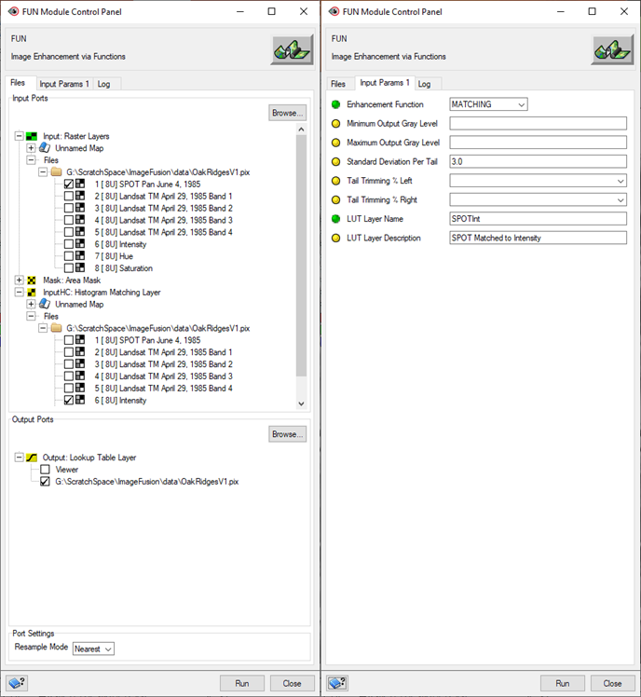

***Question 1: Describe what PCI Geomatica task FUN is accomplishing here – and why the application of this function is necessary (2 marks).***

1. Now we will use our derived LUT to stretch the SPOT Panchromatic Image to “Match” our Intensity Image. From the Algorithm Library, now select task **LUT**. Select your SPOT Image as Input, for InputLUT, specify your recently created LUT – and write your Output back to OakRidgesV1.pix. Run Module LUT. After LUT runs, from under the Files Tab – rename your image to something meaningful (such as *SPOT to Intensity*

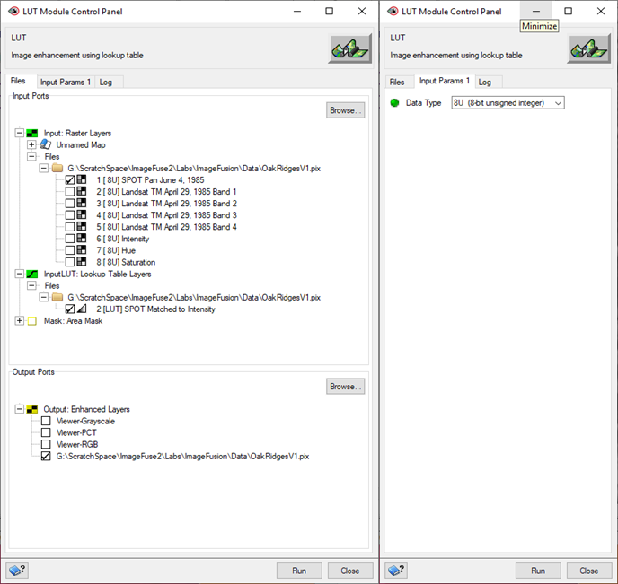

**Question 2: Create a three-part figure of your histograms from the SPOT Panchromatic Band, the Landsat Intensity Band and your LUT modified SPOT Panchromatic Band. Provide a descriptive caption to your figure. (1 marks)**

1. Now we will substitute your LUT enhanced SPOT band for the Intensity Channel (leave your Hue and Saturation Channels as they are). And then, we will bring this IHS composite back to RGB colour space. ***(***using ***Algorithm Librarian Task RGB).*** For **InputI: Intensity Layer**, select your LUT modified SPOT Image. For **InputH: Hue Layer** and **InputS: Saturation Layer**, select your original Hue and Saturation layers as they were written coming out of task IHS. For Output write your files back to *OakRidgesV1.pix*. From under Input Param, select a CYLINDER IHS Model and an 8-bit Unsigned Output Type. Run Module RGB.

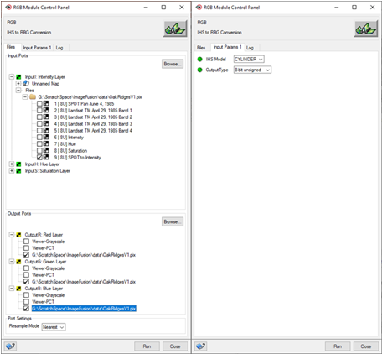

1. From your merged Landsat and SPOT output R/G/B Imagery, create a “Standard False Colour Composite” and examine your results.

**Question 3. From your IHS merged Landsat and SPOT output R/G/B Imagery, create a “Standard False Colour Composite”. Provide a descriptive caption for your figure. Where within this image are you seeing any unrealistic spectral (colour) artifacts or anomalies? (2 marks)**

1. And finally save your Project as Part1.gpr for later reference.

**Part 2) Arithmetic Merging Technique in Red, Green, Blue (RGB) colour space: (**Called HPF method in Chavez et al. 1991)

**Notes:**

The first step is to apply a 7 by 7 Laplace filter (high pass) on the SPOT image before integration. The application of this filter on the SPOT image has two major advantages.

* Firstly, the high frequency component, which largely corresponds to spatial information, will be enhanced and when integrated with the Thematic Mapper data, will produce a sharper image.
* Secondly by use of the Laplace filter, the low frequency component, which largely corresponds to spectral information, will be reduced, producing a more spectrally neutral image, that when integrated with the Landsat imagery will not significantly adversely influence its spectral characteristics.

The choice of a 7 by 7 filter size was selected to adequately merge the SPOT imagery into more than one original Landsat TM pixel. The final step is to arithmetically sum the filtered SPOT image with each Landsat band.

**Processing Steps:**

1. Review HPF method in Chavez et al. 1991 (provided).
2. Start a new PCI Focus session and load the files from OakRidgesV2.pix.
3. Run a 7 by 7 high-pass sharpening filter on the SPOT Panchromatic Band ***(Algorithm Librarian Task FSHARP).*** Write the result back into OakRidgesV2.pix (as below).

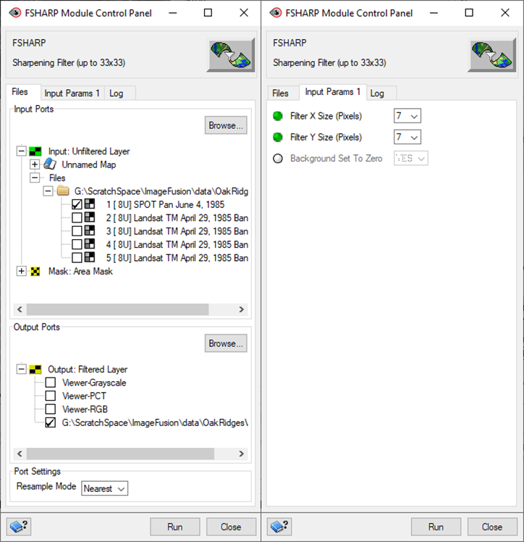

1. Once run to completion, back at the Focus Files Tab, rename this file *SPOT Sharpe (7 by 7)*. Examine your results with reference to your unfiltered SPT Panchromatic image.
2. Arithmetically sum each of the Landsat TM channels (TM Band4, TM Band3, and TM Band2) with the filtered SPOT Channel. ***(Algorithm Librarian Task ARI) Hint***: after each run rename the channel eg. ARITM4, etc.

1. After you have Fused the filtered SPOT image into each of the three targeted Landsat TM Bands (4, 3 and 2), display your merged results in a RGB composite, using a “standard” false colour assignment (R:”band4”, G:”band3”, B:”band2”).
2. Finally save your project as Part2.gpr and exit your Focus Window.

**Question 4. From your arithmetically merged Landsat and SPOT output R/G/B Imagery, create a “Standard False Colour Composite”. Provide a descriptive caption for your figure. (1 marks)**

**Part 3) Merging High Resolution Panchromatic Imagery with Lower Resolution Multispectral Imagery via PCI Geomatica’s PANSHARP Algorithm.**

1. In this portion of the project, we are going to Fuse these same images using an imbedded PCI Algorithm - *PANSHARP* Within the PCI help the provided reference is Zhang, Yun. (2002), which I located and have provided here. Read through Zhang – is a quick read and additionally reinforces the previous sections of this project. You will notice Zhang does not provide a lot of detail on his algorithm – and this is common of Pan Fusion methods across software providers. Is obviously a very robust algorithm – and is probably treated somewhat of a trade-secret or competitive advantage. However, having just completed the previous sections in this lab – you should have a fair idea of what this algorithm is doing and how it works!
2. Open a new Focus Window and load the images within OakRidges4.pix. From the Algorithm Library locate and activate PANSHARP. Using the on-line help, read about PANSHARP.
3. For PANSHARP, for **Input**, specify all your lower-resolution Landsat TM multi-spectral images (Bands 1-4). For **InputPan**, we will specify SPOT Panchromatic Image. **InputRef: Reference Image Channels**, is asking about spectral wavelength overlap between your Panchromatic Band and your Multi-Spectral Bands. Because the SPOT Panchromatic Bands covers the Green, Red and Near-Infrared, select Landsat TM Bands 2, 3 and 4 for this field. Write your files back to a new file called *PanFUSE.pix*. Run Module PANSHARP.

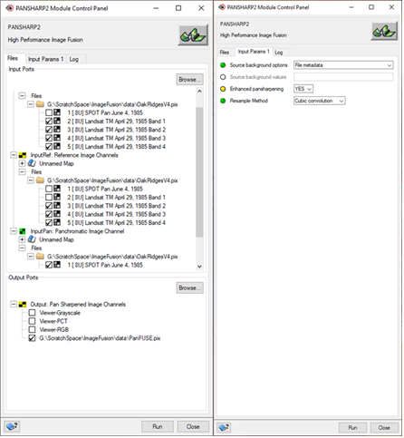

1. Generate a True Colour and a Standard False Colour Composite from the provided merged bands within PanFUSE.pix.

**Question 5: Select a sub-area of your study area – with an on-screen of 1:30,000 or greater. Generate a two-part graphic displaying both a Fused True Colour Composite and Fused Standard False Colour Composite resultant from the application of PCI task PANSHARP. Add a descriptive caption to your figure. (2 marks)**

**Part 4)** **Merging High Resolution Panchromatic Imagery with Lower Resolution Multispectral Imagery via Principal Component Analysis (PCA).**

Notes: Almost any Image Processing software or GIS Raster capable GIS system can generate Principal Components from input imagery. To return however to the original spectral space (as is necessary in Image Fusion) is not a function commonly found. This functionality is not contained in PCI Geomatica, ESRI Products, GRASS or SAGA (I checked!). As well, PCI’s Principal Component transformations contains a post-processing data-shift that is undocumented - thus preventing the use of these data within Image Fusion.

We are however not without options. Fortunately, the PCI Geomatica Principal Component Analysis module (Task PCA) produces in it’s log file the parameters (Eigenvectors of Covariance Matrix and the Eigenvalues) necessary to reconstruct the original imagery spectral space. How to interpret and reconstruct the original spectral space using linear algebra from these parameters is demonstrated in the course lecture notes. We will apply these techniques here. Note I have pre-processed and re-ordered the bands within file OakRidgesV3.pix (i.e. this .pix file is different from the other provided .pix files) – to make this part of the Project run smoother.

1. Review PCA method in Chavez et al. 1991 (provided).
2. Start a Focus window and bring the OakRidgesV3.pix into it. Display the SPOT image in Grayscale and the Landsat TM as a Standard False Colour Composite.
3. We will conduct a Principal Component Analysis on Landsat TM Bands 2, 3 and 4. But because PCI applies an undocumented post-processing data shift to these results – we will not be using these results – but we will however use the Log File, as it contains *Eigenvectors of Covariance Matrix* to conduct our own Principal Component Analysis. We are going old-school here.
4. Locate and initiate PCI Task PCA (***from under Tools 🡪 Algorithm Librarian 🡪 Task PCA).*** For *Input*: select the Landsat TM Bands 2, 3 and 4. For Output select a new file (such as PCA.pix) in your local directory. From under the Input Params 1, specify output *Eigenchannels Layer Numbers* 1,2,3 – select an **Output Raster Type** as *32R* (32 Bit Real), select a **Report Type** *Long* and via **Report Mode**, write your report to your local directory (as below). Note, for **Report Mode** - you may have to manually enter your directory location.

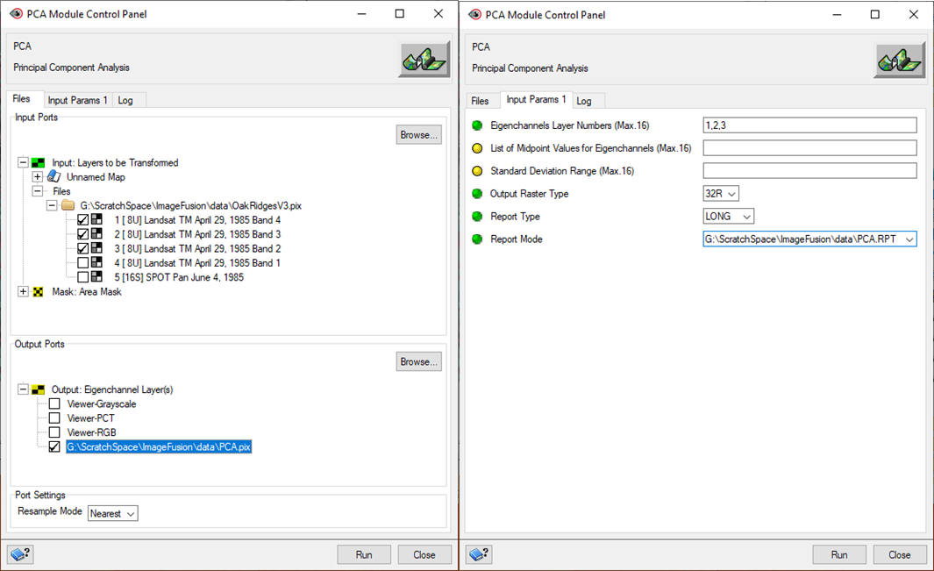

1. Run Module PCA. Load your PCA .pix file (in my case PCA.pix) and in Grayscale examine your three Principal Components. While these results are good, they contain an undocumented shift to centre the resultant distribution to 127.5. The real value here is in the Log file – which will enable us to generate the results – but without the data shift.
2. Open your PCA Log file and examine your results. To help understand these results, refer to the course notes and the PCI on-line help. Examine the *Eigenvectors of Covariance Matrix* coefficients – which we will use to derive the three Principal Components. Below, I have provided in Linear Matrix form the “forward” transformation to Principal Component coordinate space and the “inverse” transformation back the original coordinate space. Going forward with calculations in this project, use the matrix coefficients and image orders shown here – as there is a gremlin within Task PCA – where sometimes the band order gets shuffled without letting you know!

Principal Component Analysis – with Eigenvectors of the Covariance Matrix

|  |  |  |  |  |  |  |  |  |  |  |  |  |
| --- | --- | --- | --- | --- | --- | --- | --- | --- | --- | --- | --- | --- |
|  | PC1 |  |  |  | -0.7148 | -0.5732 | -0.4007 |  |  |  | Band4 |  |
|  | PC2 |  | EQ |  | 0.6971 | -0.6303 | -0.3418 |  | * |  | Band3 |  |
|  | PC3 |  |  |  | 0.0567 | 0.5236 | -0.8501 |  |  |  | Band2 |  |

Inverse Principal Component Analysis (i.e. Transformation back to original orthogonal space) – with Inverse Eigenvectors of the Covariance Matrix.

|  |  |  |  |  |  |  |  |  |  |  |  |  |
| --- | --- | --- | --- | --- | --- | --- | --- | --- | --- | --- | --- | --- |
|  | "Band 4" |  |  |  | -0.7148 | 0.6971 | 0.0567 |  |  |  | PC1 |  |
|  | "Band 3" |  | EQ |  | -0.5732 | -0.6303 | 0.5236 |  | * |  | PC2 |  |
|  | "Band 2" |  |  |  | -0.4007 | -0.3418 | -0.8501 |  |  |  | PC3 |  |

**Question 6: Using the above provided Linear Matrixes, derive the transformation equations (both forward and reverse) for PC1, PC2 and PC3 and “Band4”, “Band 3” and “Band 2”. Attach these equations within your D2L submitted Word file. (keep these equations close to conduct the following PCA steps). (1 marks)**

**Question 7: Create a 3-Part figure of your Principle Components 1, 2 and 3 images. Attach a descriptive caption to your figure. What percentage of overall scene variance is contained within Principle Component 1, 2 and 3? (2 marks)**

This concludes the hand-in portion of this project. The following steps/tasks – are those required to finish the Principle Component data merging as outlined with Chavez et al. 1991 (PCA method). For those that can make it all the way to end of this project – there is a bonus question.

1. Initiate the Raster Calculator (***Tools 🡪 Raster Calculator***) and generate the 1st, 2nd and 3rd Principal Components (as shown below). Ensure you specify for **Output**, a *32-bit real channel*, write your result back to your OakRidgesV3.pix and call your **Layers**: *PC1, PC2 and PC3.* Ensure your syntax is correct, and that your coefficients are correct (double-check!) and that you are accessing the channels from OakRidges3.pix. Extra care is required here – and the potential to introduce error is very high – triple-check all entries.

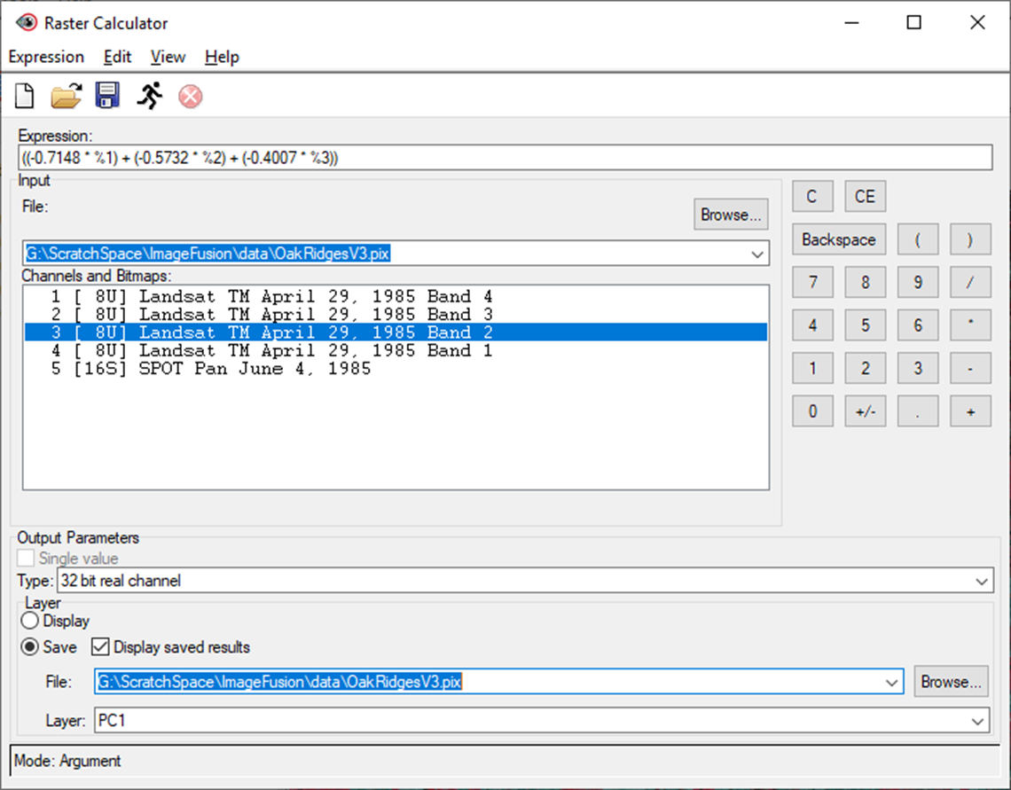

Figure: Equation, source files and syntax required to generate Principal Component 1 for study area. Similarly generate Principal Component 2 and 3.

1. Like we did for with the IHS substitution method, we will substitute the SPOT Panchromatic band for the First Principal Component. But first, we need to Match the Histogram of the SPOT Panchromatic image to that of the first Principal Component image (PC1). This is very similar to what we did Part 1) matching the SPOT Panchromatic image to the IHS Intensity image.
2. Locate and initiate PCI Task FUN (***from under Tools 🡪 Algorithm Librarian 🡪 Task FUN).*** For **Input**, specify your *SPOT* Panchromatic Band, and for **InputHC**: Histogram Matching Layer, select *PC1*. Write your LUT back to OakRidgesV3.pix. From under *Input Params 1*, ensure you select MATCHING and provide an appropriate **LUT Layer Name** and **LUT Layer Description** (as below). Run Module FUN.

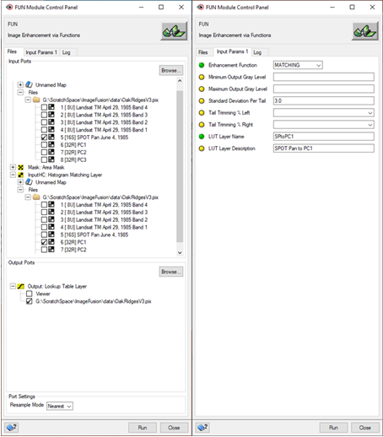

1. With the required LUT created, we will now apply it to our SPOT Panchromatic Image via PCI Task **LUT**. Via the Algorithm Library, open Task **LUT**. For Input Raster, select your SPOT Panchromatic Band and for **InputLUT**, select your recently created LUT. Write the new image back into OakRidgesV3.pix. And lastly from under the **Input Params 1** tab, ensure you select a Data type of *32R (32-bit real)*. Run Module LUT.
2. At the completion of Task LUT, from under the Focus *Files* tab, rename your stretched SPOT image *SPOT Histogram Matched*. Examine your SPOT histogram before and after and compare it your PC1 Histogram.
3. Now we are ready to reconstruct our original image coordinate system – with the substitution of our stretched SPOT Panchromatic Band in place of PC1. Using the equations, you developed earlier in Step 5 employ the raster calculator again and re-transform your images back to the original orthogonal spectral space.
4. Using the Raster Calculator reconstruct “Bands 4, 3 and 2”. Ensure you write your “Band_” files back into OakRidgesV3.pix, and that you ensure they are **Type** *32 Bit Real* Channels.

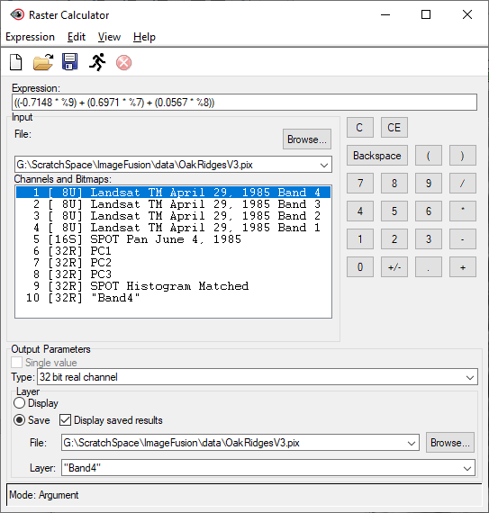

1. After you have reconstructed your “Bands 4, 3 and 2” display these reconstructed bands as a Standard False Colour Composite. Save your Part3.gpr Project and close your Focus Window.

**Bonus Question:** Attach to your Word report the derived Standard False Colour composite resultant from the Principle Component Integrated Landsat TM/SPOT Panchromatic image. Provide a descriptive caption to your figure (0.5 mark)

**Optional Part II**

If anyone wants to try to implement Part 1 (IHS Transformation) and Part 2 (Arithmetic Integration) of this lab using PCI Modeler – attached here are the required PCI Modeler Processing data flows

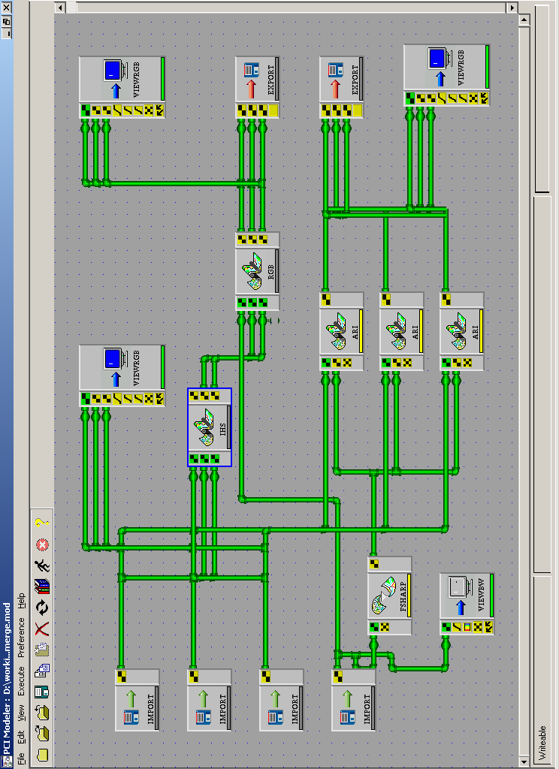

Figure: PCI Modeler image processing steps required to integrate/fuse high spatial resolution SPOT Panchromatic Imagery with lower resolution Landsat 5 TM Multi-Spectral Imagery. The two methods outlined here, are an IHS Transformation method and an Arithmetic Integration Method - both as outlined by Chavez et al. 1991.