WAYWARD
Brand & Visual Direction
Version 1.1 - Visual Canon Update

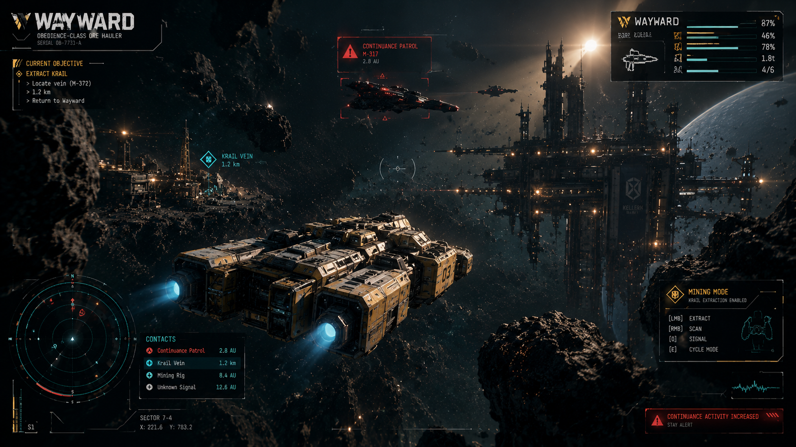
Current gameplay visual target: restrained HUD, long-form Wayward silhouette, industrial cyberpunk frontier.
ONE-LINE DIRECTION
Industrial cyberpunk in a dying frontier: a stolen ore hauler, patched together with old technology, moving through a world of surveillance, scarcity and pursuit.

Current visual canon
- Long, low Wayward silhouette with a pronounced prow and central hull spine.
- Propulsion split into side / rear engine pods; no large central rear engine dominating the silhouette.
- Amber / orange painted hull over charcoal and graphite structure, with off-white industrial markings.
- Third-person gameplay framing with more negative space and less HUD noise than the first explorations.
- Teal communicates useful information; amber communicates player ownership / action / mining; red communicates threat and Continuance.
- Neon is a localized cyberpunk accent, mainly in human settlements and corporate districts, not a global palette.
- Baseline gameplay presentation does not use crew portraits or crew panels as a visual identity pillar.
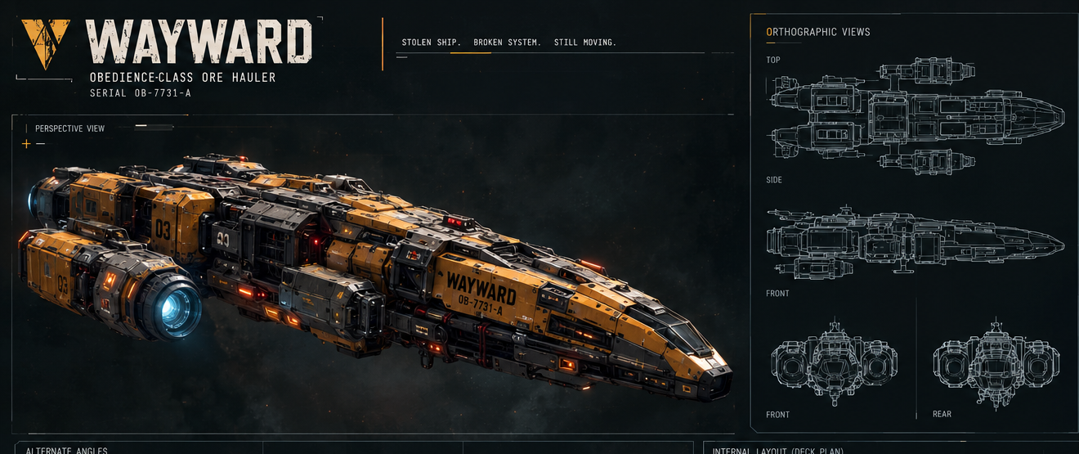
Current Wayward ship reference: perspective, orthographic views, alternate angles and modular loadout language.

1. Brand essence

WAYWARD
A fugitive survival game in a dying frontier.
The visual identity should communicate: Industrial - Oppressive - Scrappy - Mysterious - Human - Dangerous.
The player should feel that they are operating a piece of working equipment, not piloting a pristine science-fiction spacecraft. The technology is advanced, but the world is exhausted.
Everything has a previous owner. Everything carries a warning label. Everything is being repaired. Everything has a serial number.
CORE VISUAL IDEA
Advanced systems living inside exhausted infrastructure.

2. The three visual worlds

INDUSTRIAL
Mining equipment, freight machinery, warning labels, maintenance manuals, shipping containers, electrical panels, military hardware and refinery infrastructure.
Think: ore hauler + industrial control room + old military equipment. Not NASA + luxury spaceship + sleek holographic interface.

CYBERPUNK
The cyberpunk element comes from information, surveillance and corporate/state control: IDs, registries, checkpoints, tracking, signals, tariffs, sanctions, restricted areas, corporate branding and propaganda.
Cyberpunk should exist in the systems and society, not just through neon. Neon is a localized accent in dense human settlements, ports and nightlife districts.

DYSTOPIAN FRONTIER
The Scatter should feel like civilisation has been stretched too thin: overcrowded ports, patched ships, exhausted mining installations and functional infrastructure. The further away from civilisation the player travels, the stranger and less controlled everything becomes.

3. The most important rule: technology should look USED

Someone had to keep this thing running for another 14 years.
- scratches
- dirt
- faded paint
- replacement panels
- exposed fasteners
- cable runs
- warning stickers
- serial numbers
- inspection markings
- maintenance labels
- mismatched components
The same rule applies to interfaces: screens should feel operational, not decorative.

4. Core colour palette

Colour | Purpose | Hex | Ratio
Void Black | Backgrounds, space, major UI fields | #080D0E | 65%
Industrial White | Primary text, ship markings | #D8D5C6 | 20%
Wayward Amber | Brand / ship identification / interaction | #D99A27 | 8%
Signal Teal | Navigation / known information | #39AEB7 | 5%
Alert Red | Continuance / danger / pursuit | #C94A3F | 2%
Dust Grey | Secondary UI / inactive elements | #596160 | -
Hazard Green | Mining / resource systems | #748841 | -
Deep Brown | Rust / worn machinery | #4A3A27 | -

Target colour ratio: 65% black / dark grey; 20% off-white / grey; 8% amber; 5% teal; 2% red.
Red should mean something. It should not be decorative.

5. Wayward Amber

Wayward Amber should feel like construction equipment + hazard paint + old industrial machinery, rather than racing yellow or futuristic gold.
- Wayward hull panels
- player-owned equipment
- interactable objects
- mining equipment
- selected UI states
- important resources
- player identification
The ship should combine amber paint with charcoal / graphite structure and off-white markings rather than becoming a solid yellow object.

6. Teal is information

Teal represents things that are known, detected, operational, navigational and informational.
- radar
- navigation
- scan information
- ship systems
- target information
- mining information
- route indicators
- friendly / neutral contacts
Do not use teal as general decoration.

7. Red is the threat

Red belongs primarily to the Continuance. Their identity is red / black / white, hard geometric symbols, authority, warning triangles, large identification numbers, brutalist typography and official language.
Examples: CONTINUANCE / NOTICE OF VIOLATION / VESSEL FLAGGED / CHECKPOINT ACTIVE / PURSUIT PROTOCOL / SURRENDER REQUIRED.
The Continuance should visually feel like bureaucracy weaponised.

8. Typography

Display
Wide, heavy, geometric / condensed industrial grotesque. Think shipping crate stencil + government department + industrial manufacturer.

Interface
Clean condensed sans-serif; uppercase, tight spacing, compact labels, numerical information and short phrases.

Data
Monospaced typography for serial numbers, coordinates, ship IDs, timestamps, cargo IDs and system information.

9. WAYWARD logo

Bold, horizontal, industrial and imperfect.
- avoid futuristic cursive
- avoid glossy chrome
- avoid excessive sci-fi bevels
- avoid spaceship silhouettes inside the wordmark
- avoid elaborate logo puzzles
Supporting text can read OBEDIENCE-CLASS / ORE HAULER and SERIAL 0B-7731-A. The logo should work on hull panels, menus, ship documentation, loading screens, stickers, advertisements, faction documents and UI headers.

10. Ship design language - updated

The latest concepts establish a long, low, aerodynamic industrial hauler. It is not a boxy tug, not a fighter and not a military gunship.

Silhouette priorities
freighter -> industrial machine -> modular survival vehicle -> combat-capable ship
- long horizontal proportions
- strong wedge-shaped forward prow
- recessed / integrated cockpit
- clear central hull spine
- layered upper hull plating
- separated side-mounted propulsion pods
- modular side / lower utility structures
- exposed mechanical interfaces and hardpoints
- slightly mismatched service modules where useful
- low visual centre of mass
NOTE
ENGINE RULE: Do not use a large central rear engine as the main silhouette feature. Propulsion should read as separated side / rear engine units outside the main cargo body.

The ship can be sleeker and stranger than a conventional industrial spacecraft, but never luxury-sleek. Think cyberpunk freighter + mining hauler + patched commercial transport.
Weapons should look added later; they should read as equipment fitted to a working vessel.
Ship design reference: the long, low, layered Wayward silhouette with separated propulsion pods and technical outline views.

11. Ship markings and physical language

WAYWARD / OBEDIENCE CLASS / 0B-7731-A
Supporting markings: KRAIL HANDLING / MAX LOAD / FIELD REFIT / AUTHORIZED USE / HAZARD / PRESSURE / SERVICE PORT / NO LIFT / DOCKING SIDE.
Surface hierarchy: painted hull panels -> dark mechanical structure -> service doors and access plates -> warning labels and serials -> exposed cables and fittings -> mismatched replacement parts.
The ship should look maintained because somebody had to maintain it, but never cosmetically restored.

12. Gameplay UI direction - current canon

The latest gameplay concepts are calmer and more spacious than the first HUD explorations. The player needs enough negative space to read the ship, asteroid field and destination without interface noise.

Core gameplay view
Third-person, slightly behind and above the Wayward. The ship sits in the lower-middle of the frame, not filling the entire screen. The centre stays comparatively clean.

Six functional zones
Upper left: current objective. Upper centre: target / threat. Upper right: ship status. Lower left: radar + contacts. Right side: operating mode. Centre: the world.
NOTE
CORE UX RULE: The HUD should answer four questions immediately - Where am I? What am I doing? What is threatening me? What condition is my ship in?

Do not display every available piece of information simultaneously. Complex information moves into dedicated screens.
Gameplay target: calmer HUD density, clear objective / contacts / ship status zones, and strong negative space around the ship.

13. Bottom-right operating mode

Current modes: MINING MODE / COMBAT MODE / SCAN MODE / SILENT RUN.
Example actions: [LMB] EXTRACT / [RMB] SCAN / [Q] SIGNAL / [E] CYCLE MODE.
The interface should feel like the player is operating a machine, not navigating a menu.

14. Communications UI

Comms should feel like receiving a transmission, not opening a traditional RPG dialogue box.
Example: INCOMING TRANSMISSION / TERRAN UNION CHECKPOINT / Vessel ID does not match registry.
Options: 01 - RUN IT / 02 - SPOOF REGISTRATION / 03 - PAY INSPECTION / 04 - TALK / 05 - FIGHT.
- keep messages short
- make the situation legible immediately
- show consequences next to options when known
- use colour to communicate risk
- let systems, previous actions, contacts and reputation alter the available options

15. UI language

Use short, functional language.
CONTINUANCE PATROL instead of a full explanatory sentence. FUEL CRITICAL instead of a paragraph. KRAIL TRACE DETECTED instead of a description of the asteroid.
The language should feel like equipment reporting a condition.

16. Faction branding

THE CONTINUANCE
Red / black / white. Institutional, governmental, strict, standardised. Graphics look mass-produced, stamped and regulated.

MINING / INDUSTRIAL COMPANIES
Amber / cream / dark grey. Heavy machinery, shipping, industrial logos, barcode systems, warning symbols.

FRONTIER INDEPENDENTS
Hand-painted marks, modified equipment, different colours, old logos painted over, home-made repairs.

THREN
A completely different visual language: geometry, asymmetry, biological shapes, unfamiliar repetition and strange light. Avoid simply giving them alien text. The reaction should be: What the hell am I looking at?

17. Environment

Human space
Use industrial density: mining rigs, fuel depots, docking arms, cargo lifts, communications towers, maintenance gantries and refinery structures. The frontier feels busy because everyone is trying to survive economically.

Deeper Scatter
Gradually remove human order: less traffic, less signage, more abandoned machinery, strange signals, broken infrastructure, impossible structures and unknown phenomena.
Visual progression: Civilisation -> decay -> isolation -> uncertainty -> alien.

18. Lighting

Dark space + hard industrial light + selective colour.
- amber work lights
- cold teal equipment lights
- red warning lights
- white moon / starlight
- occasional sodium-orange industrial lighting
Neon is a location accent. Use stronger cyan / magenta in dense city ports, nightlife, propaganda signage and corporate spaces; keep mining space and frontier gameplay restrained.

19. Visual effects

- sparks
- exhaust
- dust
- electrical arcs
- warning lights
- impact flashes
- debris
- engine glow
- particulate clouds
Avoid excessive holographic particles, magic-looking shields, giant lens flares and rainbow energy explosions. WAYWARD should feel closer to machinery breaking than a space opera.

20. Graphic design language

Industrial manuals + freight labels + government forms + military documentation + mining equipment + old computer interfaces.
- boxes
- registration numbers
- barcode strips
- technical diagrams
- stamps
- warning triangles
- serial numbers
- inspection marks
- underlines
- measurement ticks
- schematic arrows
- coordinate grids

21. Image composition

Hierarchy: 1) SHIP, 2) WORLD, 3) UI, 4) THREAT, 5) MYSTERY.
Do not overfill the frame. The ship needs room around it. The HUD should be legible without touching every edge. The central focal triangle is usually: WAYWARD -> destination -> threat.

22. What WAYWARD should NOT look like

- generic neon cyberpunk - no endless pink/purple cityscape as the default language
- military sci-fi - the Wayward is not a battleship
- sleek luxury sci-fi - the ship is never factory-fresh or expensive-looking
- pure horror - the frontier also contains commerce and work
- fully futuristic everywhere - old technology is a key aesthetic tool
- boxy for the sake of industrial - industrial can be long, low and aerodynamic
- HUD noise - information must be prioritised

23. The visual test

Could this plausibly have existed for twenty years, been used by fifty different people, repaired six times and still be operating?
Does the silhouette still read clearly when the colour and texture are removed?
Can the player understand the immediate situation in two seconds?
A yes answer means the asset is moving in the right direction.

24. Definitive gameplay screenshot target

CAMERA: Third-person, slightly behind and above the Wayward.
WORLD: Asteroid field / mining environment / industrial station / distant traffic.
SHIP: Long, low, yellow-cream industrial Wayward with dark mechanical structure and separated side / rear engine pods.
HUD: Thin industrial frames, mostly transparent, sparse and prioritised.
COLOUR: Black + off-white + amber + teal.
RED: Reserved almost entirely for immediate danger / Continuance.
TEXT: Condensed uppercase technical typography.
INFORMATION: Hull, fuel, energy, Krail, target, scanner, distance, mode.
UI DENSITY: Low to medium during normal travel; increase density only when the situation becomes operationally complex.
This is the dashboard of a stolen machine that absolutely cannot afford to break.
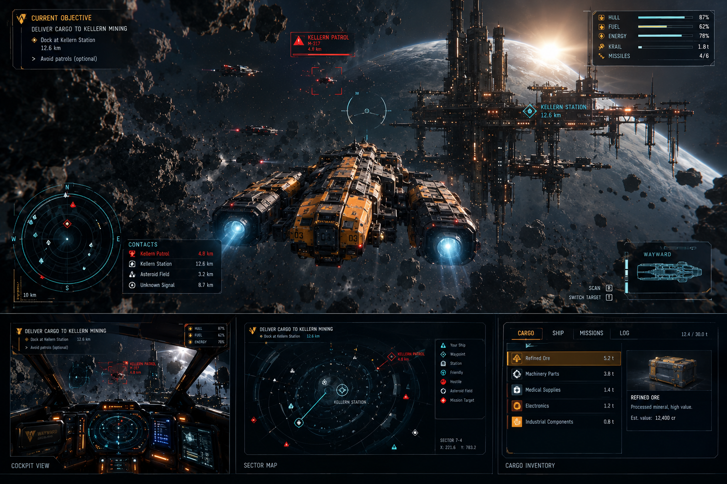
UI composite reference: use dedicated screens for cockpit, sector map and cargo rather than crowding the normal gameplay HUD.

25. Current concept canon

The Wayward ship
- long and low rather than boxy
- strong forward prow
- central hull spine
- side-mounted / rear engine pods
- no large central rear engine dominating the silhouette
- layered industrial plating
- yellow / orange painted panels over dark mechanical structure
- blue-cyan engine glow
- worn surfaces and exposed service hardware
- modular hardpoints
- combat capability visibly secondary to freight / mining function

Gameplay view
- calm third-person framing
- ship centred in the lower-middle rather than filling the frame
- negative space around the ship
- mining station / industrial structure as environmental scale reference
- one clear threat, not a swarm of UI warnings
- teal navigation markers and red threat markers
- objective and ship status readable at a glance

UI presentation
- thin technical frames
- mostly transparent panels
- few large visual blocks
- small labels rather than giant gamey banners
- teal = known / useful information
- amber = player / action / mining
- red = threat
- white = core readability

People / crew
The current visual canon does not make crew portraits or crew panels part of the baseline gameplay presentation. Avoid making crew a visible brand pillar in hero gameplay compositions unless the game later establishes a dedicated crew system.

Reference-sheet treatment
- perspective hero render
- rear three-quarter view
- top / side / front outlines
- alternate loadouts
- component close-ups
- cargo / mining configurations
- physical markings
- material details

26. Brand shorthand

When briefing a new concept artist, UI artist or environment artist:
WAYWARD is industrial cyberpunk in a dying frontier: a stolen ore hauler, patched together with old technology, moving through a world of surveillance, scarcity and pursuit.
Visual shorthand:
LONGER SHIPS. LESS HUD NOISE. MORE INDUSTRIAL DETAIL. RESTRAINED NEON. AMBER FOR WAYWARD. TEAL FOR INFORMATION. RED FOR THE CONTINUANCE.
That is the current visual identity to build from.
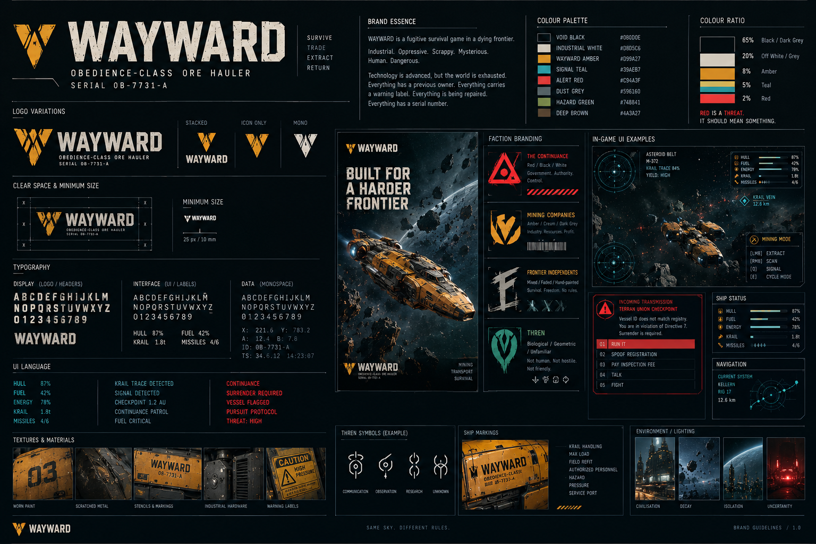
Earlier visual brand-board exploration, retained here as a reference for the overall graphic language.

