链接：https://juejin.cn/post/6931998186513334286

leetcode538 leetcode1038

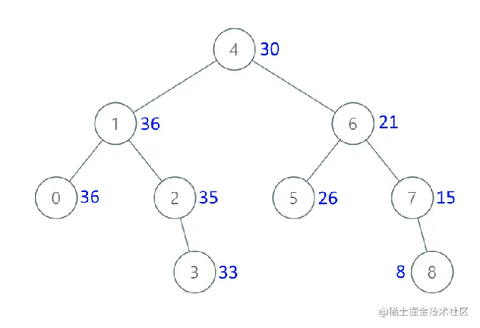

/**
* Definition for a binary tree node.
* public class TreeNode {
* int val;
* TreeNode left;
* TreeNode right;
* TreeNode() {}
* TreeNode(int val) { this.val = val; }
* TreeNode(int val, TreeNode left, TreeNode right) {
* this.val = val;
* this.left = left;
* this.right = right;
* }
* }
*/
class Solution {
//记录前一个节点的值
int preValue =0;
public TreeNode convertBST(TreeNode root) {

//什么是累加树？
//累加树的值是怎么计算的？
if(root==null) return null;
convertBST(root.right);
root.val+=preValue;
preValue=root.val;
convertBST(root.left);

return root;

}
}

