链接：https://juejin.cn/post/6931998186513334286
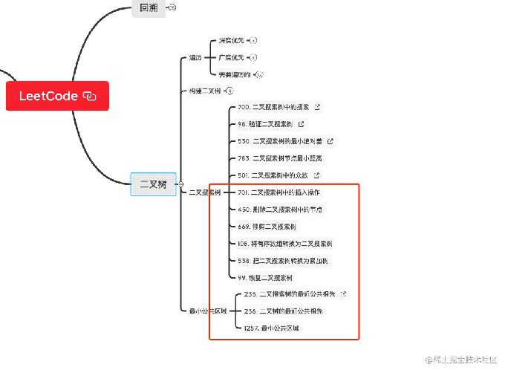
- leetcode538 leetcode1038 convertBST

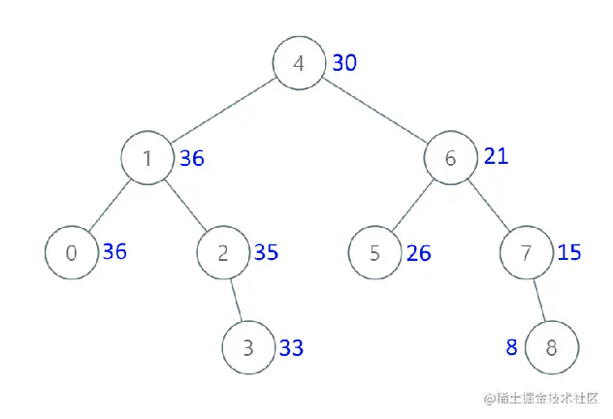

/**
* Definition for a binary tree node.
* public class TreeNode {
* int val;
* TreeNode left;
* TreeNode right;
* TreeNode() {}
* TreeNode(int val) { this.val = val; }
* TreeNode(int val, TreeNode left, TreeNode right) {
* this.val = val;
* this.left = left;
* this.right = right;
* }
* }
*/
class Solution {
//记录前一个节点的值
int preValue =0;
public TreeNode convertBST(TreeNode root) {

//什么是累加树？
//累加树的值是怎么计算的？
if(root==null) return null;
convertBST(root.right);
root.val+=preValue;
preValue=root.val;
convertBST(root.left);

return root;

}
}
- LeetCode236 lowestCommonAncestor
class Solution {
public TreeNode lowestCommonAncestor(TreeNode root, TreeNode p, TreeNode q) {
//递归的退出条件，找到了p或者找到了q，或者没有节点时返回。
if(root==p||root==q||root==null) return root;

//后序
TreeNode left = lowestCommonAncestor(root.left,p,q);
TreeNode right = lowestCommonAncestor(root.right,p,q);
//如果 p、q一个在左 一个在右，那么root肯定就是他们最近的公共祖先
if(right!=null&&left!=null) return root;

return (left!=null)? left:right;
}
}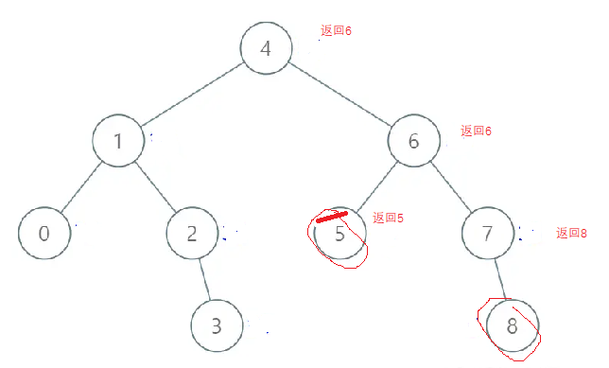

- LeetCode701 insertBSTNode
TreeNode* insertBSTNode(TreeNode* root, int p, CPaintDC* pDC) {
if (root == NULL)
{
TreeNode<int>* newNode = new TreeNode<int>(p);
return newNode;
}
if (root != NULL && (root->value < p))
{
TreeNode* right = insertBSTNode(root->right, p, pDC); //在这里返回节点9，7，6，4
root->setRight(right); //从下往上返回，这个例题中,重复设置right节点,无影响
}
else if (root != NULL && (root->value > p))
{
TreeNode* left = insertBSTNode(root->left, p, pDC); //在这里返回新节点8
root->setLeft(left); //从下往上返回,关联8 这个例题中,设置9的节点8，因为8在9的左节点
}

//print(pDC, root);
return root; //从下往上返回9 7 6 4
}
插入 8
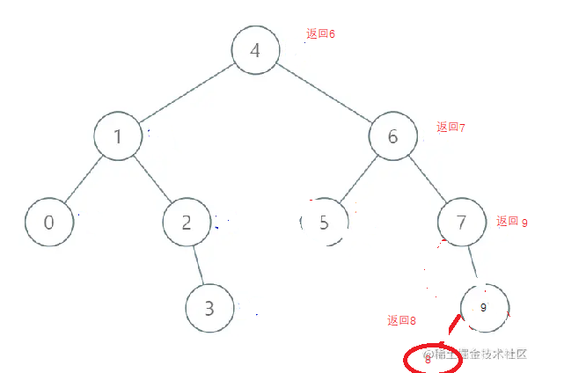

- Leetcode 450. 二叉搜索树中的删除操作
前置节点0
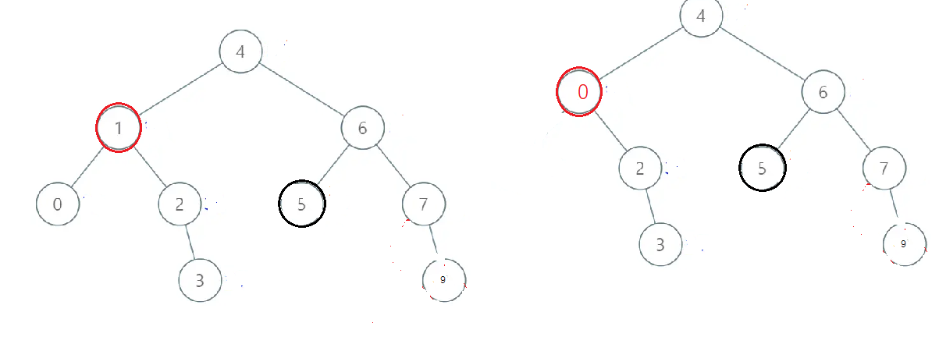

//leetcode450 deleteBSTNode
TreeNode* deleteBSTNode(TreeNode* root, int p, CPaintDC* pDC) {
if (root == NULL)
return NULL;

if (root != NULL && (root->value < p))
{
TreeNode* right = deleteBSTNode(root->right, p, pDC); //
root->setRight(right); //从下往上返回，,重新设置right节点
}
else if (root != NULL && (root->value > p))
{
TreeNode* left = deleteBSTNode(root->left, p, pDC); //
root->setLeft(left); //从下往上返回,关联0
}
else if (root != NULL && (root->value == p))
{
TreeNode* refreshNode = resetSubNode(root); //在这里返回新节点0
return refreshNode;
}

//print(pDC, root);
return root; //从下往上返回9 7 6 4
}
TreeNode* resetSubNode(TreeNode* root) {
if (root->right == NULL && root->left == NULL)
return NULL;
if (root->right == NULL && root->left != NULL)
{
return root->left;
}
if (root->left == NULL && root->right != NULL)
{
return root->right;
}

if (root->left != NULL && root->right != NULL)
{
if (root->left->right != NULL)
{
TreeNode* node = root->left->right;
TreeNode* preNode = root->left;

while(node->right!=NULL)
{
node = node->right;
}
//前置节点的左节点不为空，
if (node->left != NULL) {
preNode->right = node->left;
node->left = root->left;
node->right = root->right;
return node;
}
else {
preNode->right = NULL;
node->left = root->left;
node->right = root->right;
return node;
}
}
else {
//如果前置节点就是该节点的左节点，直接用该左节点作为根节点
root->left->right = root->right;
TreeNode<int>* newNode = root->left;
root = NULL;
return newNode;
}

}
return root;
}
前置节点2

