The mutual effects between two uneven collinear cracks

Jiming Kang and Zheming Zhu

Abstract： Single crack has been popularly investigated by scientists at home and abroad. But in application, there are much more complicated cracks which cause damage and destruction to civil or aerospace engineering. In this paper, an infinite plane containing collinear cracks under axis stretching has been investigated. The analytical complex solution combined numeric method is obtained. The effects of lengths of cracks and distance are analyzed through the theoretical and numeric method.
Key Words: collinear cracks, SIF, complex function

1. Introduction
Fracture is a common phenomenon in engineer and industry. Under stretching, these cracks may interact and induce some new cracks which will cause the decrease of intensity of materials and thus cause accidents. When the cracks are under stretching, they would extend, branch and coalesce. Therefore, in the study of crack interaction, the analytical solution is a critical step in our
understanding of material fracturing.
For the problem of a single crack under stretching , many researchers have presented analytical and numeric solutions[1-5] ,and the effects of length and distance of crack and confining stress were analyzed. But they only considered a single crack, thus their results cannot be directly applied to multiple cracks under stretching. For the problem of collinear cracks under compression, Zhu and Xie give the numeric and analytical results and the effects of crack surface friction and the confining stress on crack were discussed[5-10].
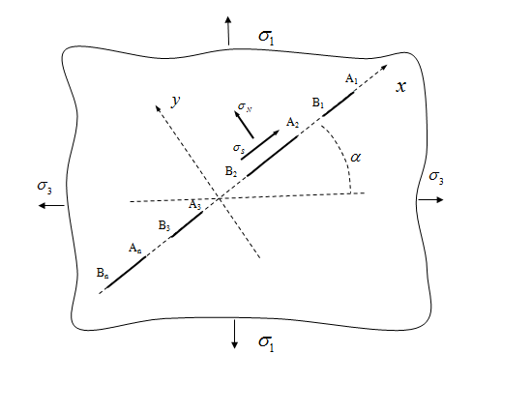
Figure 1. an infinite plane containing a group of collinear cracks under stretching, where 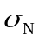is normal stress, 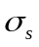 is shear stress
2. Formula of stress intensity factors
In this paper, the stress intensity factors for an infinite plane containing collinear cracks under a far field principal stress 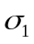 and 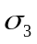 as shown in Fig.2 will be studied by using complex stress functions. According to [11], for the elastic plane problem, the stress can be expressed in terms of the complex stress functions, 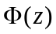 and 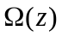, as
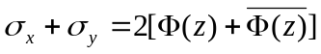 (1)
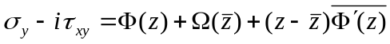 (2)
where 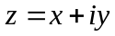.The equilibrium equations and the compatibility conditions are automatically
satisfied, and the resultant force boundary condition can be expressed as
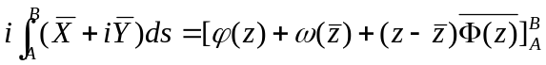 (3)
where 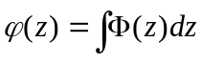 and 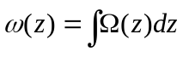, and 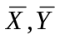 are the surface forces along the boundary in the  direction, respectively, and is an arbitrary point on boundary. The positive direction of the integral is assumed that the region always lies to the left. The displacement boundary condition can be expressed as
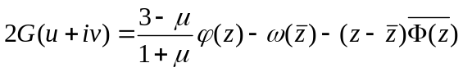 (4)
where 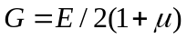 ,  is elastic modules and is Poissons ratio. The stress boundary condition can be written as
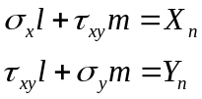 (5)
where l and m are the direction cosines of the normal line of the boundary, and 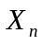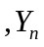 are the force components on the boundary. From Equation (5) and Figure 1, the crack surface
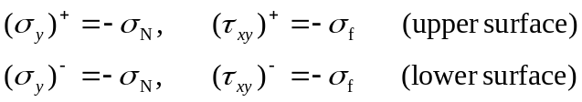 (6)
where 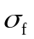 and are the crack surface friction and normal stress, respectively (see Figure 1).Substituting Equation(6) into Equation (2), one can have
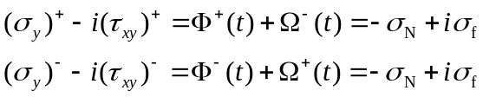
Or
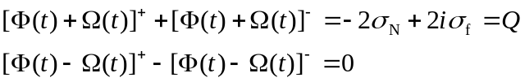
where  is a constant. This is a simple Hilbert problem.
For the problem of multiple cracks shown in Figure 1, the Plemelj function can be written as
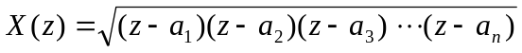
It can be seen that as 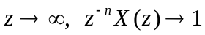, where n is crack number, and on the crack surface , 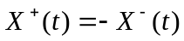, where t is the coordinate of a point on the crack surface. According to [12-15], for the infinite plane under tensile loads, the above Hilbert problem can be formulated as follows:
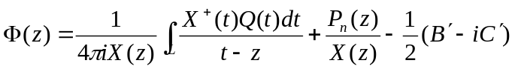 (11)
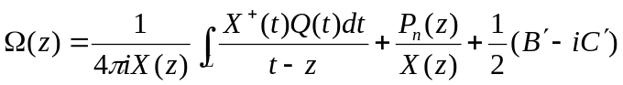 (12)
where
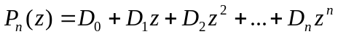 (n is the crack number)
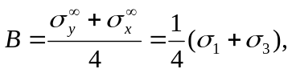
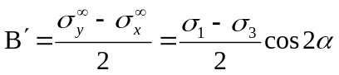
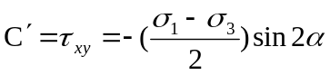
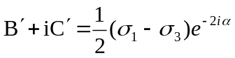
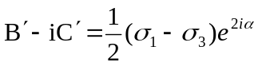
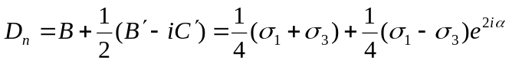
where 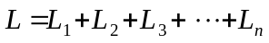is the union of the n cracks , 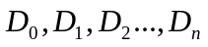are constants, and 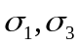 and are shown in Figure 1.The integrals along in Equations (11) and (12) can be expressed in terms of integrals along a laced surrounding these cracks as shows in Figure 2.(see [12-16])
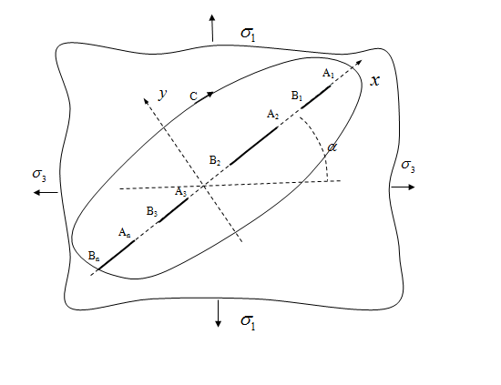
Figure2. a group of collinear cracks and a lanced surrounding cracks.

Then Equation(11) can be rewritten as:
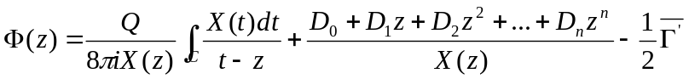 (13)
where 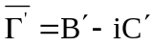.
By using residue theory, the integral in Equation (13) along contour C can be expressed in terms of the sum of the residues at point z and at infinity, thus Equation (13) can be rewritten as:
(14)
If the above residues can be solved and then n coefficients, are known, the function can be obtained.
As the infinite plane contains n cracks, the n coefficients , must satisfy the condition of single-valued displacement. The conditions of single-valued displacements can be expressed as:
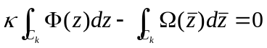(k=1,2,3, n) (15)
where 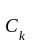 is the contour of the kth crack. If the contour shrinks to a laced around the crack, Equation (15) can be rewritten as:

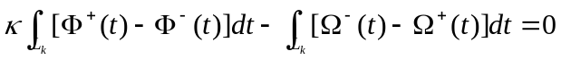 (k=1,2,3, n) (16)
where t is the coordinates of a point on the crack surface. Applying equation (16) for k=1,2,3, n, one can yield n linear equations, from which the n coefficients can be obtained. Therefore, for an infinite plate containing finite collinear cracks under tension, one may obtain the stress function and from Equation(14) and (16). However, because the stress functions contain the Plemelj function X(z), the process of solving the n coefficients maybe difficult due to the high-order integrals involved.

3. SOLUTION FOR TWO UNSYMMETRIC COLLNEAR CRACKS

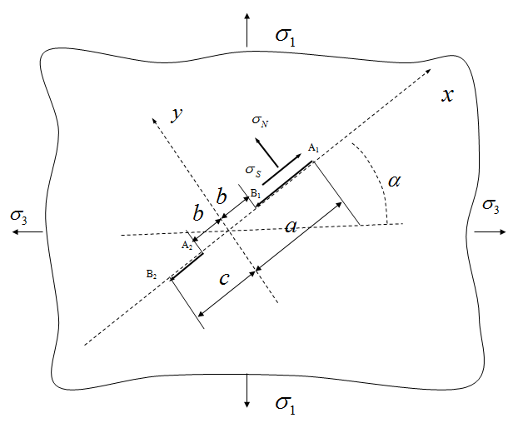
Figure 3. an infinite plane containing two unsymmetrical collinear cracks under stretching, where is normal stress, is shear stress
For the problem of an infinite plane containing collinear cracks, the general formula has been presented [zhu]. Based on the previous result, for an infinite plane as shown in Figure 3, the corresponding function can be simplified as:
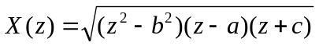 (17)
And the corresponding polynomial 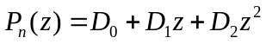, where 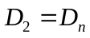. In this case, 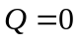 because the plate is under stretching , and can be written as:
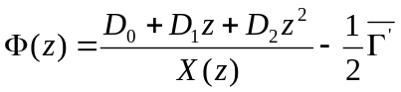 (18)
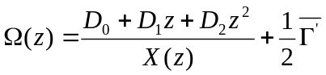 (19)
Substituting Equations (18) and (19) into Equation (16), for crack AB, one can have:
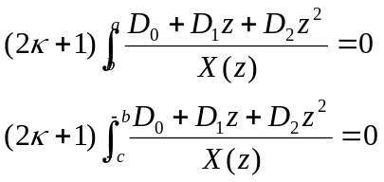 (20)
Where 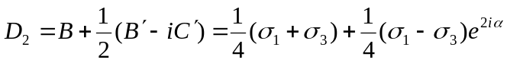. When the cracks is horizontal, i.e. 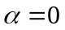, then 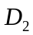 can be simplified as:
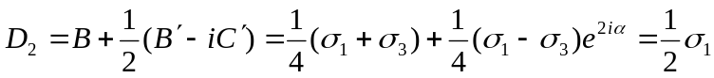 (21)
Equation(20) contains two elliptic integrals, and for each integral readers are referred to[24]. By solving the elliptic integrals, the constants 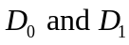 can be obtained respectively.

4. CALCULATION RESULTS AND DISCUSSIONS
4.1 Numeric Solution of elliptic integrals in Matlab
In order to apply the numeric method in elliptic integral, a ,b, c should be numbers instead of symbols. For example, when a ,b, c vary, the relative numeric integrals will be like this:
For crack 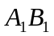
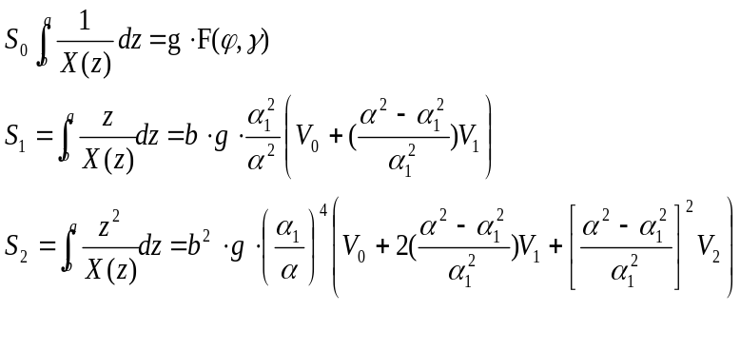
Where
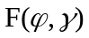 is complete ecliptic integral of the first kind
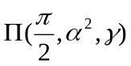 is complete ecliptic integral of the third kind
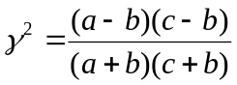
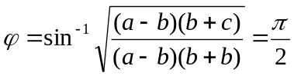
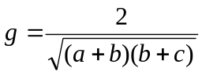
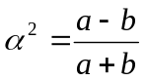
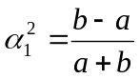
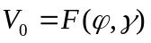
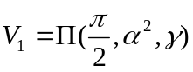
For crack 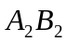
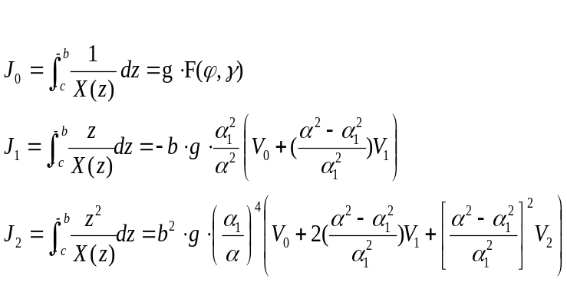
Where
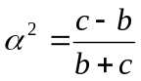
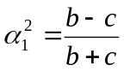
, and other parameters are the same with that on crack .
So 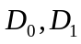 can be known by solving linear equations:
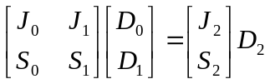.

4.2 Influence of the Length of cracks on Stress Intensify Factors
In this study, the calculation model is an infinite plate containing two collinear cracks as shown in Figure 3. When the ratio of 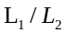 varies ,the SIFs of crack tip 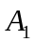() and 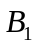 (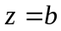)vary as shown in Figure 4.It can be seen that value of 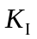 () is a little larger than that of () because is closer to crack 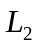 than ;and the limits of () , () approach to that of single crack(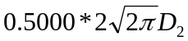) when the length of approaches zero. The result indicates that the SIFs of crack tips on 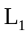 are affected by the existence of ,and the influence will become smaller and smaller and the SIFs on  will approach to (the SIF of single crack) along with the decrease of the length of ,

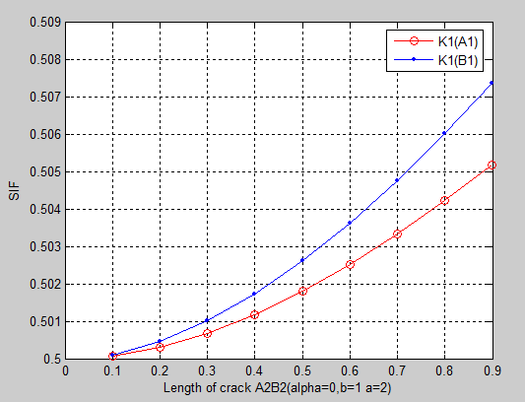

Figure 4. Curves of SIFs on crack tips of versus the length of 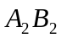 for an infinite plane containing two unsymmetrical collinear cracks under stretching (a=2,b=1,, 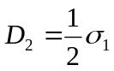)
As for crack tip of the, the (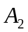) is negative .The negative sign only indicates the direction of the crack propagation. Therefore, the negative sign is disregarded, and only the magnitudes of () and (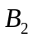) are investigated in this paper. the SIFs of crack tip 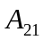(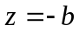) and ()vary as shown in Figure 5.It can be seen that value of () is a little larger than that of () because is closer to crack than; and the limit values of () and () is approaching to that of single crack.
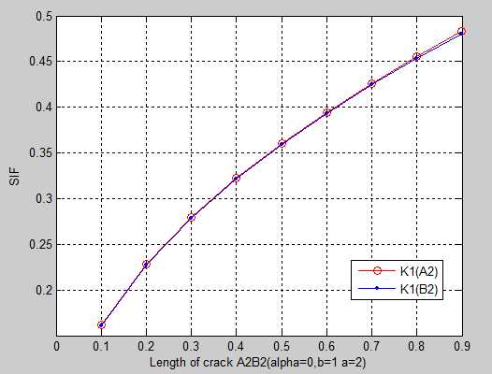
Figure 5. Curves of SIFs on crack tips of versus the length of for an infinite plane containing two unsymmetrical collinear cracks under stretching (a=2,b=1,, )
.

4.3 Influence of the distance of the two cracks on Stress Intensify Factors
For the infinite plate, as b decrease from 1.0m to 0.1m, the SIFs of crack tip , increase slightly; and the SIFs of crack tips , increase sharply and later share the same value because crack tips ,are becoming closer and closer. When the distance of the two cracks approaches to zero, the SIFs of crack tip ,will approach to 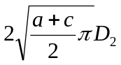,which is the SIF of single crack tip when the two crack are combined into one.

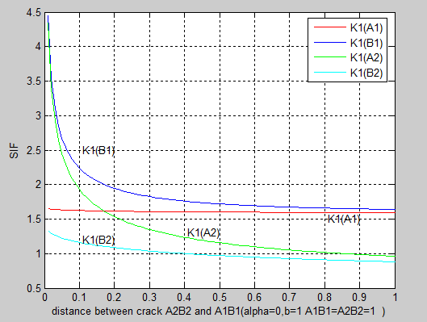
Figure 6. Curves of SIFs on crack tips versus the distance between and for an infinite plane containing two unsymmetrical collinear cracks under stretching (=10, =2,, )

5 CONCLUSION
Recently, the study of multiple-crack fracture behavior under stretching has got much attention. This paper has implemented the theoretical study on the collinear cracks. The influence of crack lengths and distance between two cracks has been investigated. For an infinite plate containing collinear cracks under stretching, numeric solution of stress intensity factor is presented in Figure 4, 5,6.
Further theoretical studies on the topic behavior of multiple cracks under stretching are necessary and realistic, especially when the cracks are not on a straight line ,which is more difficult to get the exact theoretical solution.

REFERENCES
[1] Nemat-Nasser, S. and Horii, H. Compression-induced nonplanar crack extension with application to splitting, exfoliation,
and rockbust. Journal of Geophysical Research, 87(B8), 68056821 (1982).
[2] Steif, P. S. Crack extension under compressive loading. Engineering and Fracture Mechanics, 20, 463473 (1984).
[3] Ashby, M. F. and Hallam, S. D. The failure of brittle solids containing small cracks under compressive stress states.
Acta Metallica, 34, 497510 (1986).
[4] Li, C. and Nordlund E. Deformation of brittle rocks under compression with particular reference to microcracks.
Mechanics of Materials, 15, 223239 (1993).
[5] Germanovich, L. N., Salganik, R. L., Dyskin, A. V. and Lee, K. K. Mechanisms of brittle fracture of rock with
pre-existing cracks in compression. PHGEOPH, 143, 117147 (1994).
[6] Zhu, Z., Wang, L., Mohanty, B. and Huang, C. Stress intensity factor for a cracked specimen under compression.
Engineering and Fracture Mechanics, 73, 482489 (2006).
[7] Zhu, Z. New biaxial failure criterion for brittle materials in compression. Journal of Engineering Mechanics, 125,
12511258 (1999).
[8] Zhu, Z., Ji, S. and Xie, H. An improved method of collocation for the problem of crack surface subjected to uniform
load. Engineering and Fracture Mechanics, 54, 731741 (1996).
[9] Zhu, Z., Xie, H. and Ji, S. The mixed boundary problems for a mixed mode crack in a finite plate. Engineering and
Fracture Mechanics, 56, 647655 (1997).
[10] Zhu, Z. and Xie, H. Calculation method of the SIF and COD for crack surfaces subjected to uniform loading. Journal
of Computing and Structural Mechanics Applications, 14, 182188 (1997).
[11] Muskelishvili, N. I. Some Basic Problems of Mathematical Theory of Elasticity, Noordhoff, Amsterdam, 1953.
[12] Erdogan, F. On the stress distribution in plates with collinear cuts under arbitrary loads, in Proceedings of the 4th
U.S. National Congress of Applied Mechanics, Vol. 1, pp. 547553, American Society of Mechanical Engineers,
New York, 1962.
[13] Gong, S. X. Microcrack interaction with a finite main crack: an exact formulation. International Journal of Fractures,
66, 5166 (1994).
[14] Wang, R. D. The stress intensity factors of a rectangular plate with collinear cracks under uniaxial tension. Engineering
and Fracture Mechanics, 56, 347356 (1997).
[15] England, A. H. Complex Variable Methods in Elasticity, Wiley-Interscience, New York, 1971.

