Data Import Pipeline Adaptation Plan
Author: James Ryan
Date: 7 April 2026
Status: Draft

Summary
This plan describes the adaptation of the Case Sampling data import pipeline from a SharePoint-based ETL flow to an in-memory processing model. The design splits the pipeline into two flows on the 2-minute synchronous boundary:
- Flow A (Synchronous) — Validate flow, modified to call ProcessCSV directly, parse CSV in-memory, validate headers/event codes/date overlap, update the Import Log, and respond to the Canvas App within 2 minutes.
- Flow B (Asynchronous) — A new Import Pipeline flow, triggered by the Canvas App on validation success, handling GUID/NINO translation and OOB Dataverse import with Import Log state tracking throughout.

Phase 1: Synchronous Validation (Flow A)
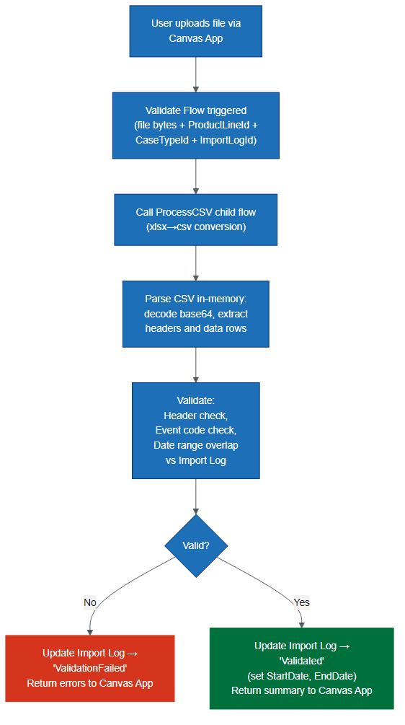
Figure 1: Phase 1: Synchronous Validation (Flow A)

Phase 2: Asynchronous NINO to GUID Translation (Flow B)
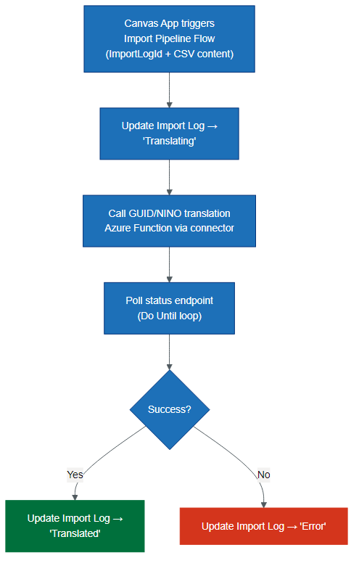
Figure 2: Phase 2: Asynchronous NINO to GUID Translation (Flow B)

Phase 3: Asynchronous Dataverse Import (Flow B continued)
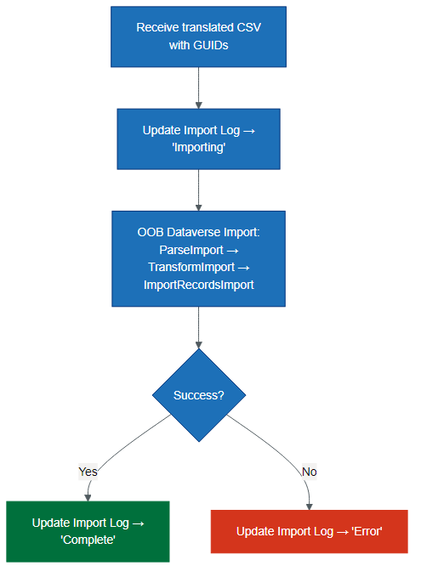
Figure 3: Phase 3: Asynchronous Dataverse Import (Flow B continued)

Sequence Diagram
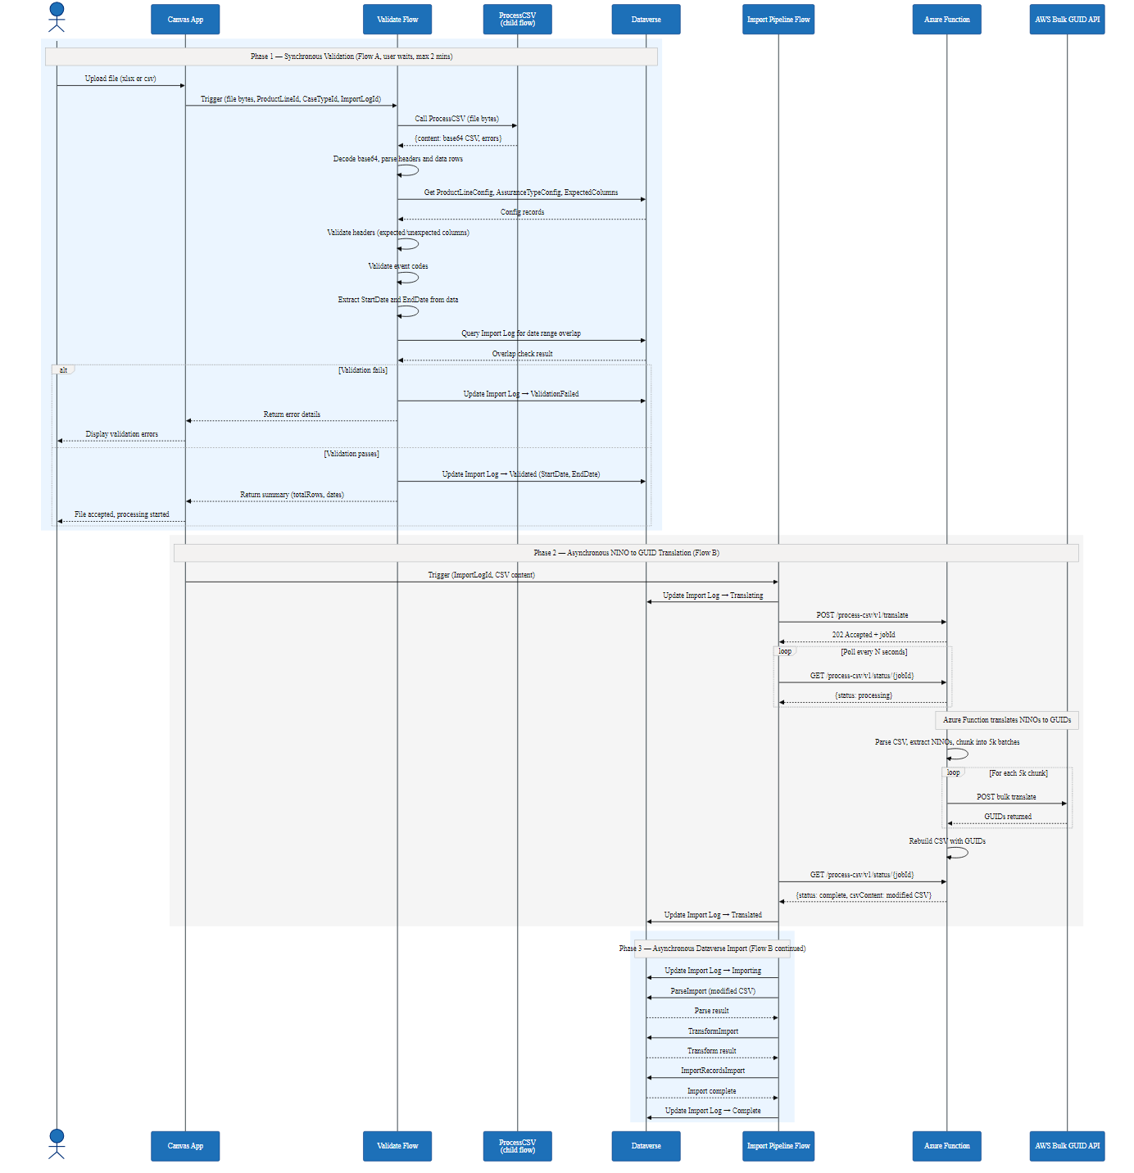
Figure 4: Sequence Diagram

Import Log Lifecycle
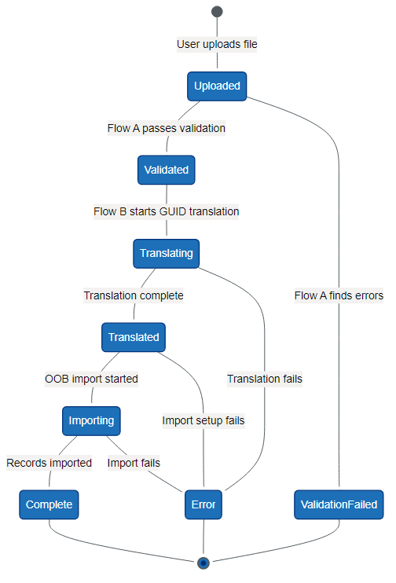
Figure 5: Import Log Lifecycle

Current State

Working Flows (no changes needed)
Flow | ID | Role
ProcessCSV | B8263CFF | Receives file bytes, converts xlsx→csv via child flow, returns base64 CSV
ExcelToCSV | BF5E59C2 | Child of ProcessCSV — uploads xlsx to SharePoint, reads via Graph API, maps columns, returns base64 CSV
ImportData | 06002464 | OOB Dataverse import (ParseImport → TransformImport → ImportRecordsImport). Contains "Placeholder for GUID Service"

Flow Requiring Adaptation
Flow | ID | Issue
Validate | 62D02995 | Currently calls ETL Reader via SharePoint. Validates headers and event codes. Extracts dates but never checks them against existing imports

What Validate Does Today
- Calls ETL Reader (passing ImportLogId) → receives {headers, data, errors, file_type}
- Checks for parse errors from ETL Reader
- Validates expected and unexpected column headers
- Validates event code values (New Claim vs non-New Claim)
- Extracts StartDate and EndDate from data — but never validates them

What Is Missing
- Date range overlap check — query Import Log for same product line where date ranges overlap
- In-memory input — bypass the ETL Reader and SharePoint; accept file bytes directly
- Async pipeline flow — GUID/NINO translation + OOB import with Import Log state tracking

Implementation Steps

Phase A: Adapt Validate Flow as Sync Entry Point
This modifies the existing Validate flow (62D02995) to become the synchronous entry point for the pipeline.
A1. Keep existing trigger — still accepts file (name + contentBytes), ProductLineId, CaseTypeId, ImportLogId from Canvas App.
A2. Add ProcessCSV call at start of Try scope:
- After Run_URL, call ProcessCSV (B8263CFF) as child flow — pass file object
- Receive {content, status, message, errors}
- If errors non-empty, short-circuit to response
A3. Parse CSV output inline (replaces ETL Reader call):
- Decode base64 content to string
- Remove BOM, split by CRLF into lines
- Extract headers from first line (split by comma, trim each)
- Build data array from remaining lines
- Replace IngestionFileHeaders / IngestionFileData compose actions
- Remove Parse_Ingestion_File action (ETL Reader call to 8CE76635)
A4. Keep existing validation logic (minimal changes):
- Header expected/unexpected column checks — no changes
- Event code checks — no changes
- Date extraction — update: CSV from ProcessCSV already has yyyy-MM-dd dates (not Excel serial numbers), so replace addDays('1899-12-30', int(value)) with direct date parsing
A5. Add date range overlap check (new, after Set_variable_EndDate):
- Query dwp_importlogs with filter: _dwp_productlineid_value eq '{ProductLineId}' and statuscode eq {completed} and dwp_startdate le '{EndDate}' and dwp_enddate ge '{StartDate}'
- If results > 0: append DateRangeOverlap error to Errors array
A6. Update Import Log before responding:
- No errors → Update Import Log status to "Validated", set dwp_startdate and dwp_enddate
- Has errors → Update Import Log status to "ValidationFailed"
A7. Response unchanged: {summary: {totalRows, errorCount, StartDate, EndDate}, errors: [...]}

Phase B: Create Async Import Pipeline Flow
This is a new flow that handles the asynchronous portion of the pipeline.
B1. PowerAppV2 trigger accepting:
- ImportLogId (string)
- CsvContent (string, base64-encoded CSV)
- Canvas App triggers this after receiving validation success
B2. GUID/NINO Translation stage:
- Update Import Log → "Translating"
- Call Azure Function via Custom Connector
- Poll for completion (Do Until loop)
- Update Import Log → "Translated"
B3. OOB Dataverse Import stage (reusing pattern from ImportData 06002464):
- Update Import Log → "Importing"
- Create Data Import, Data Map, and Import File records
- Read column mappings from OOB `columnmappings` entity (filtered by product line) instead of hardcoded array
- Create Column Mappings from config
- ParseImport → poll until complete → TransformImport → poll until complete → ImportRecordsImport
- Update Import Log → "Complete"
B4. Error handling:
- Try/Catch/Finally pattern (consistent with all existing flows)
- On any error: Update Import Log → "Error" with error details
- Send GDS-styled error notification email

Phase C: Update Pipeline Diagrams
- Update data-import-pipeline-overview.mmd to reflect the two-flow architecture
- Update data-import-pipeline-sequence.mmd to show separate sync and async flows with Import Log updates

Decisions
Decision | Rationale
No separate orchestrator | Validate calls ProcessCSV directly — KISS
One async flow for translation + import | Avoids unnecessary flow-to-flow overhead
Import Log as state machine | Canvas App can poll for progress updates
ETL Reader bypassed, not deleted | May still be useful for other scenarios
Date overlap = any range overlap | Standard overlap logic: existing.start ≤ new.end AND existing.end ≥ new.start
Column mappings config-driven | Using OOB Column Mapping table. 3 product lines piloting, 26 total. Custom mapping UI needed eventually but not this pass
Only check completed imports for overlap | Exclude failed/error imports to avoid false positives

Verification
# | Test | Expected Outcome
1 | Validate with xlsx file + valid config | ProcessCSV called, CSV parsed, headers validated, Import Log → Validated
2 | Submit file with overlapping date range | DateRangeOverlap error returned, Import Log → ValidationFailed
3 | Submit file with non-overlapping dates | Validation passes
4 | Measure sync flow end-to-end | Completes within 2-minute budget
5 | Upload .csv file (not xlsx) | ProcessCSV passes through without xlsx conversion
6 | Trigger async flow after validation | Import Log progresses: Translating → Translated → Importing → Complete
7 | Simulate GUID translation failure | Import Log → Error
8 | Regression: existing validations | Header, column, and event code checks still produce correct errors

Relevant Files
File | Action
Workflows/CaseSamplingValidateImportDataInstant-62D02995...json | Modify — add ProcessCSV call, inline CSV parsing, date overlap check, Import Log updates
Workflows/CaseSamplingProcessCSVContentForParseImport-B8263CFF...json | No changes — called as child by Validate
Workflows/CaseSamplingExceltoCSVInstant-BF5E59C2...json | No changes — called by ProcessCSV
Workflows/CaseSamplingImportData-06002464...json | Reference — reuse import logic pattern in new async flow
Workflows/CaseSamplingETLExcelReaderInstant-8CE76635...json | No longer called from Validate; can be retired
docs/diagrams/data-import-pipeline-overview.mmd | Update to reflect two-flow architecture
docs/diagrams/data-import-pipeline-sequence.mmd | Update to show sync/async split with Import Log

