### **1. Introduction to Data Visualization**

Data visualization is the graphical representation of information and data. By using visual elements like charts, graphs, and maps, data visualization tools provide an accessible way to see and understand trends, outliers, and patterns in data. It plays a critical role in data analysis, helping users communicate insights effectively.

### 

### **2. Selected Tools**

The tools chosen for analysis are:

1. Matplotlib (Python)
2. Seaborn (Python)
3. Plotly (Python)
4. ggplot2 (R)

## 

## **3. Tool Overviews**

### **a. Matplotlib (Python)**

* **Overview**: A comprehensive 2D plotting library. Offers control over every aspect of a figure.
* **Use Case**: Ideal for simple line graphs, bar charts, and scientific plotting.

**Code:**

import matplotlib.pyplot as plt

import numpy as np

# Mock Data

x_data = np.linspace(0, 10, 100)

y_data = np.sin(x_data) + np.random.normal(0, 0.1, 100) # Sine wave with some noise

# Create the plot

plt.figure(figsize=(8, 5))

plt.plot(x_data, y_data, label='Sine Wave with Noise', color='skyblue')

# Add titles and labels

plt.title('Matplotlib: Simple Line Plot of a Sine Wave')

plt.xlabel('X-axis')

plt.ylabel('Y-axis')

plt.legend()

plt.grid(True, linestyle='--', alpha=0.7)

# Show the plot

plt.show()

**Strengths**:

* Highly customizable
* Good for publication-quality figures

**Weaknesses**:

* Steeper learning curve
* Syntax can be verbose

### 

### **b. Seaborn (Python)**

* **Overview**: Built on top of Matplotlib, offers a high-level API for attractive and informative statistical graphics.
* **Use Case**: Great for visualizing distributions, relationships, and categorical data.

**Code:**

import seaborn as sns

import matplotlib.pyplot as plt

import pandas as pd

import numpy as np

# Mock Data

np.random.seed(42) # for reproducibility

data_size = 100

df = pd.DataFrame({

'Feature A': np.random.rand(data_size) * 10,

'Target B': (np.random.rand(data_size) * 10) + (np.random.rand(data_size) * 5) # some correlation

})

# Create the scatter plot with regression line

plt.figure(figsize=(8, 5))

sns.regplot(x='Feature A', y='Target B', data=df, scatter_kws={'alpha':0.6}, line_kws={'color':'red'})

# Add titles and labels

plt.title('Seaborn: Scatter Plot with Regression Line')

plt.xlabel('Feature A')

plt.ylabel('Target B')

# Show the plot

plt.show()

**Strengths**:

* High-level interface for complex plots
* Integrates well with Pandas

**Weaknesses**:

* Less control over fine-tuned details than Matplotlib
* Somewhat dependent on tidy data format

### 

### **c. Plotly (R)**

* **Overview**: Interactive plotting library. Supports web-based, real-time charts.
* **Use Case**: Ideal for dashboards and interactive data exploration.

**Code:**

# Install if not already installed: install.packages("ggplot2")

library(ggplot2)

# Mock Data

data <- data.frame(

Category = c("A", "B", "C", "D", "E"),

Value = c(15, 28, 10, 35, 20)

)

# Create the bar chart

ggplot(data, aes(x = Category, y = Value, fill = Category)) +

geom_bar(stat = "identity") +

labs(title = "ggplot2: Bar Chart of Categories",

x = "Category",

y = "Value") +

theme_minimal()

**Strengths**:

* Highly interactive visualizations
* Great for web apps and dashboards

**Weaknesses**:

* Slightly more resource-heavy
* Requires JavaScript backend for some features

### 

### **d. ggplot2 (R)**

* **Overview**: Part of the tidyverse in R, based on the Grammar of Graphics. Widely used in statistical analysis.
* **Use Case**: Excellent for layered plots and complex data analysis.

**Code:**

library(plotly)

library(dplyr)

data(iris)

plot_ly(iris, x = ~Sepal.Length, y = ~Sepal.Width, color = ~Species,

type = "scatter", mode = "markers",

marker = list(size = 10, opacity = 0.8)) %>%

layout(title = "Scatter Plot of Sepal Length vs. Sepal Width",

xaxis = list(title = "Sepal Length"),

yaxis = list(title = "Sepal Width"))

**Strengths**:

* Concise syntax
* Strong theoretical foundation (Grammar of Graphics)

**Weaknesses**:

* Slower for very large datasets
* Learning curve for non-R users

## 

## 

## **4. Use Case Scenarios**

| **Tool** | **Use Case Scenario** |
| --- | --- |
| Matplotlib | Academic research visualizations |
| Seaborn | Exploratory data analysis (EDA) |
| Plotly | Interactive dashboards and reports |
| ggplot2 | Statistical visualizations in R-based analysis |

## **5. Strengths and Weaknesses Summary**

| **Tool** | **Strengths** | **Weaknesses** |
| --- | --- | --- |
| Matplotlib | Detailed control, scientific plots | Verbose syntax, steep learning curve |
| Seaborn | Simplified syntax, beautiful statistical plots | Less control, depends on tidy data |
| Plotly | Interactivity, great for web apps | Requires rendering engine, heavier |
| ggplot2 | Grammar-based, concise and elegant | Less performant on big data |

**6. Visual Examples (from the Q3 codes)**

**1.**

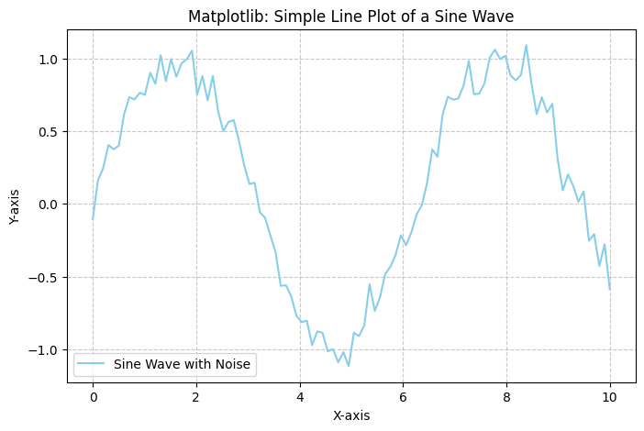

**2.**

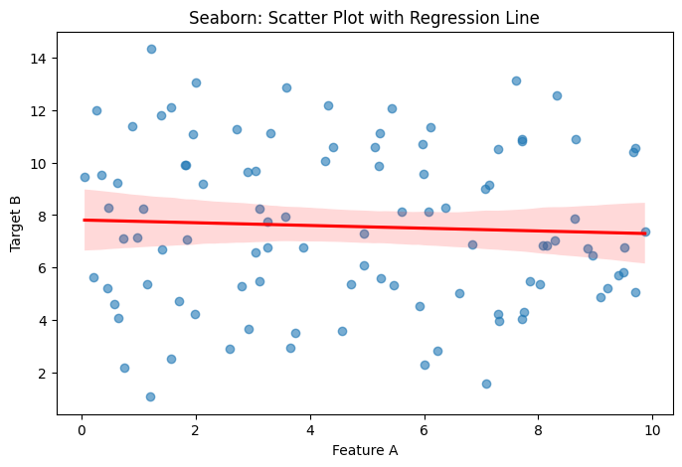

**3.**

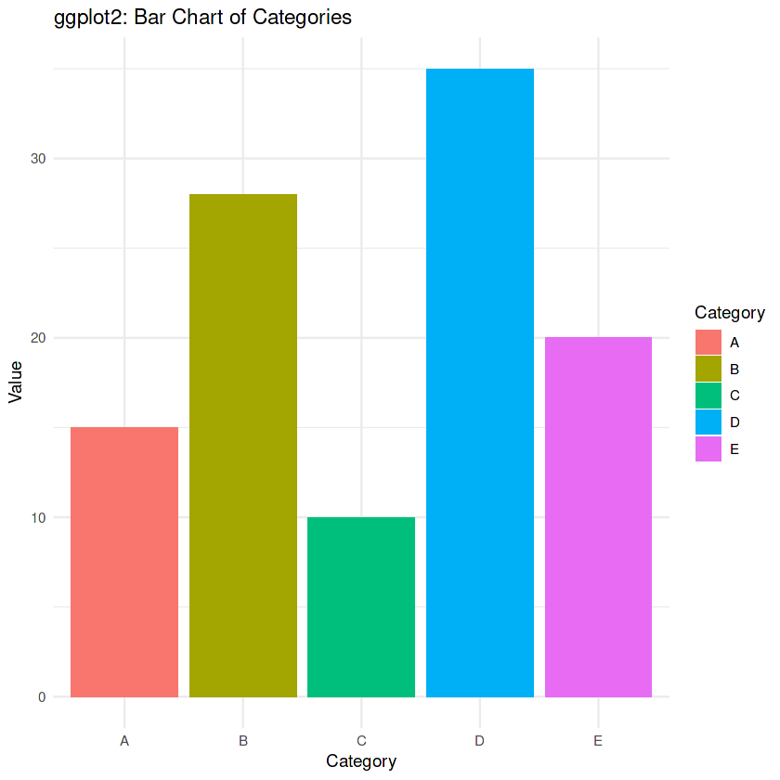

**4.**

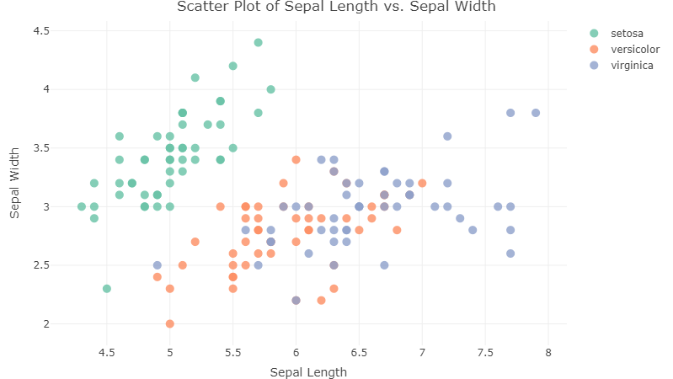

## **7. Best-Fit Tool Scenarios**

* **For academic and scientific visualizations**: Matplotlib is best due to its detailed control.
* **For quick EDA and statistics**: Seaborn excels with clean syntax and ready-to-use statistical plots.
* **For interactive applications**: Plotly offers dynamic and user-friendly visualizations.
* **For statistical modeling in R**: ggplot2 is the standard with excellent support for complex layouts.