LAB ASSIGNMENT-1

Data Visualization Tools

Objective:
To explore and analyze various data visualization tools used for representing and understanding complex datasets. This assignment focuses on gaining insights into the capabilities, applications, and limitations of widely-used visualization tools.

1. Introduction to Data Visualization
Data visualization is the graphical representation of information and data using visual elements like charts, graphs, and maps. It helps users understand patterns, trends, and outliers in data, thereby making it easier to draw conclusions and make decisions. Visualization is crucial for data analysis, reporting, and storytelling.

2. Selected Data Visualization Tools
The following tools are selected for comparison:
- Matplotlib (Python)
- Seaborn (Python)
- Plotly (Python)
- ggplot2 (R)

3. Overview of Tools

a) Matplotlib
- Language: Python
- Type: 2D plotting library
- Features:
  - Highly customizable static plots
  - Supports line charts, bar charts, scatter plots, pie charts, etc.
  - Integration with NumPy and pandas
  - Export to multiple formats (PDF, PNG, SVG)

b) Seaborn
- Language: Python
- Type: Statistical data visualization
- Features:
  - Built on top of Matplotlib
  - Works well with pandas DataFrames
  - Includes themes, color palettes, and statistical plots
  - Supports heatmaps, violin plots, pair plots, and categorical plots

c) Plotly
- Language: Python, R, JavaScript
- Type: Interactive plotting library
- Features:
  - Interactive and web-based plots
  - Dash framework for dashboards
  - 3D plots, choropleth maps, animations
  - Easy export to HTML

d) ggplot2
- Language: R
- Type: Grammar of graphics
- Features:
  - Layered approach to plotting
  - Excellent for statistical graphics
  - Strong support for facets and themes
  - Integrates well with tidyverse

4. Use Case Scenarios
Tool | Use Case
Matplotlib | Creating custom scientific plots for research papers with precise control over elements.
Seaborn | Visualizing relationships in statistical data, such as correlation analysis in social sciences.
Plotly | Creating interactive dashboards for real-time sales or stock market analysis.
ggplot2 | Building detailed and publication-ready plots for epidemiological data in healthcare.

5. Strengths and Weaknesses
Tool | Strengths | Weaknesses
Matplotlib | Fine control, widely used, robust | Verbose syntax, static plots
Seaborn | Concise syntax, built-in themes, great for stats | Limited interactivity
Plotly | Interactive, modern, web-friendly | Larger file size, can be complex for beginners
ggplot2 | Elegant and expressive syntax, great for stats | Learning curve, R-specific

6. Visual Examples

Matplotlib Example:
Code:
import matplotlib.pyplot as plt
x = [10, 20, 30, 40]
y = [20, 25, 35, 55]
plt.plot(x, y)
plt.title("Line Chart")
plt.ylabel('Y-Axis')
plt.xlabel('X-Axis')
plt.show()
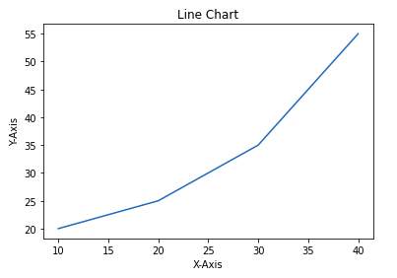

Seaborn Example:
Code:
import pandas as pd
import matplotlib.pyplot as plt
import seaborn as sns

custom_palette = sns.color_palette("husl", 8)
sns.set_style("whitegrid")
sns.set_palette(custom_palette)

data = {'Name': ['ANSH', 'SAHIL', 'JAYAN', 'ANURAG'],
'Age': [21, 23, 20, 24]}
df = pd.DataFrame(data)

sns.lineplot(x=df.index, y='Age', data=df)
plt.show()
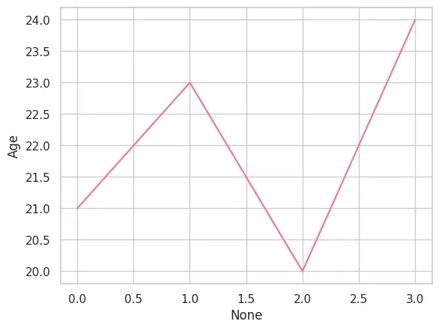

Plotly Example:
import plotly.express as px
df = px.data.tips()
fig = px.bar(df, x='day', y="total_bill")
fig.show()
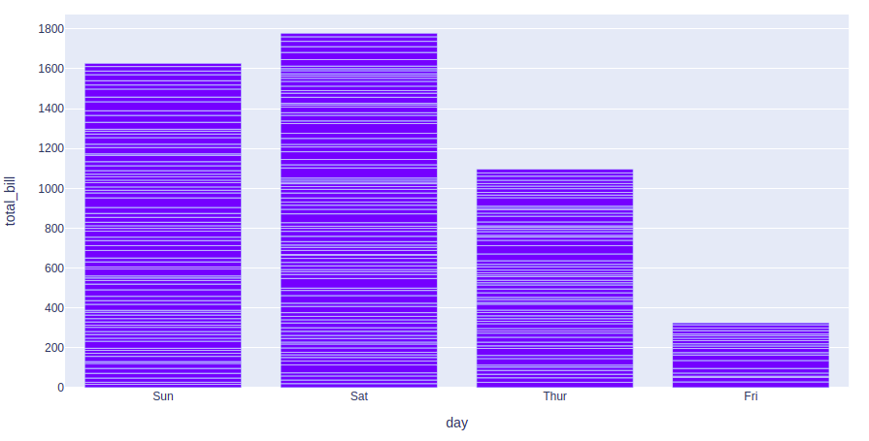

ggplot2 Example (R):

7. Tool Suitability Summary
Scenario | Recommended Tool
Custom static plots | Matplotlib
Quick statistical insights | Seaborn
Interactive dashboards | Plotly
Publication-ready plots | ggplot2

