1. Create a folder (somewhere where you can find it), called simpleMobile ( no spaces)
2. Go to Blackboard and download the “images” into this folder.
3. Open Dreamweaver and create a new site and reference the folder you just created. This will be am empty site because we have yet to add a web page.
4. Now go to the menu and select File | New and use the attached image to start a new jQuery page, and then select create.
5. 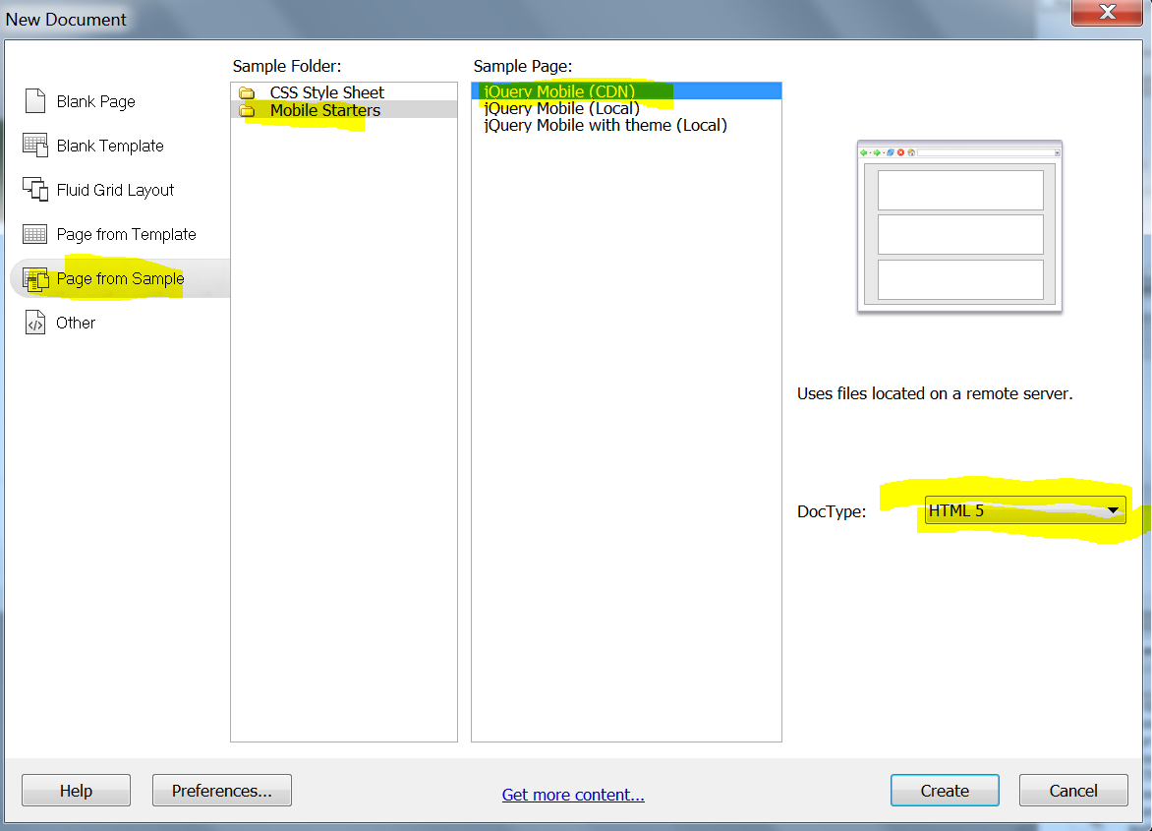
6. You will see a rough mobile web site page that is not named. Select File | Save and save the page as jquery.html
7. Select the Live view button to see what this page would look like in a browser. Then select the smallest mobile size icon at the lower right of the page (see the image below). You should now see what this mobile web page would look like on your phone.
8. 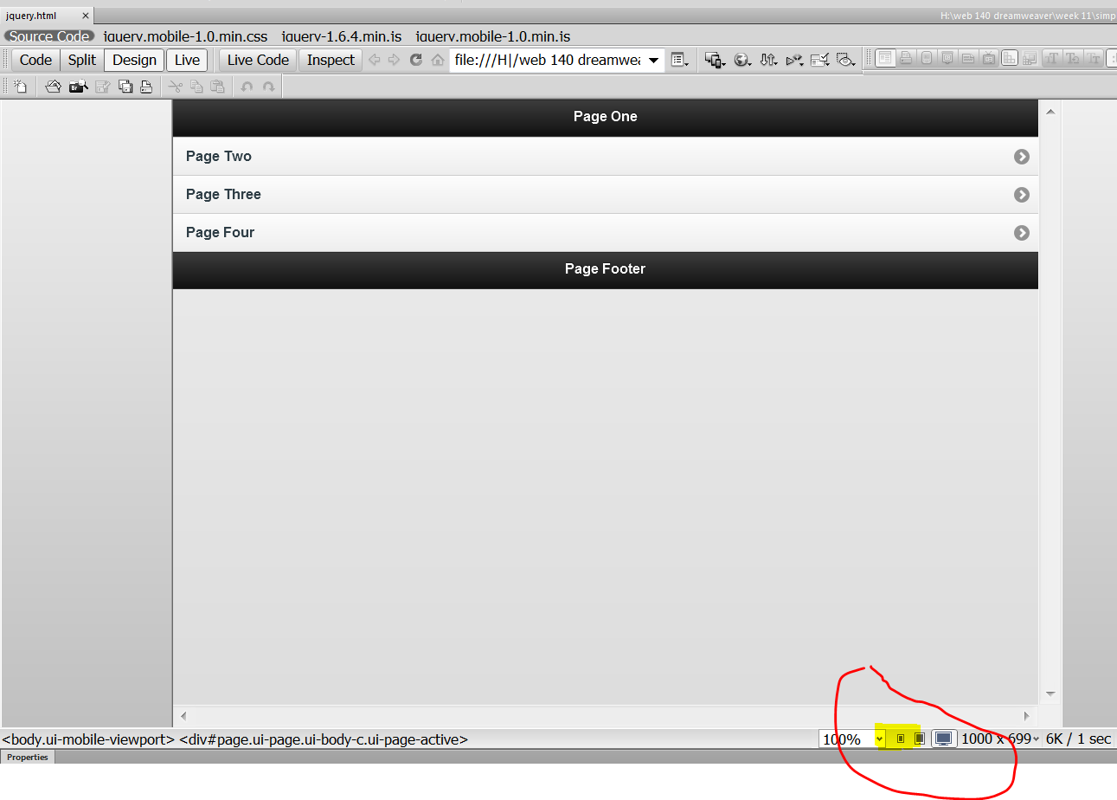
9. Now select the split view. We will change the code in the code split and watch the changes in the design split. Select the Page One header in the design view and it will position the cursor near the text that we will change. Change the phrase ***Page One*** to ***Introduction***.
10. Now position the cursor right below this line of code ***<div data-role="content">*** and type the following***: I love old cars, on the following pages you will find three of my all-time favorites***. ***In the following order my favorites are the 1953 Buick Special, the 1955 Ford Fairlane convertible and the 1955 Chevy Belair. “They” don’t make cars like that anymore.*** Surround this text with an <h4> tag.
11. Change the ***Page Footer*** text to ***www.cccc.edu.***
12. View the page in Dreamweaver at the reduced resolution and you should see the following:
13. 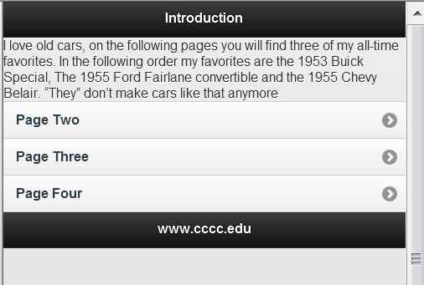
14. Now Select the ***Page Two*** text in the design view and delete it and replace it with the text ***The Buick*** in the split view. Then similarly change ***Page Three*** to ***The Ford*** and change ***Page Four*** to ***The Chevy***.
15. Now in the design view select “The Buick” button and you will be taken to the next page. Change the header text to ***The Buick*** and change the footer text to [*www.cccc.edu*](http://www.cccc.edu)*.*
16. Replace the text ***Content*** with the following text: ***The Buick Special was the last model to receive a new full-width body, in mid-1949 as a 1950 model. Before that the Specials were basically Fisher B-bodies dating back to 1941. The new model was introduced with a “snaggle-tooth” grille, which spilled down over the bumper and was also fitted to Super and Roadmaster models. Specials had three “ventiports” on the hood sides.*** And insert the Buick image after the text. The image should already be in your folder. View your page in the live code view:
17. 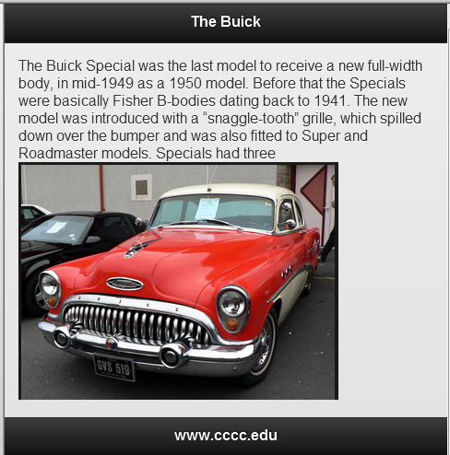
18. Now do the same for the next two pages. Here is the text for page 3 : ***The 1954 Ford Crestline Sunliner Convertible was a pivot point for its man­ufacturer. On one hand, it carried over the styling (albeit facelifted), the body styles, and the series names in place since 1952. On the other hand, the new lineup, including the 1954 Ford Crestline Sunliner convertible, ushered in certain engineering and detail changes that would live on in its successors.***
19. Here is the text for page four: ***The 1953 Chevrolet automobile came in three basic body styles. The 1500 and 2100 series continue from the previous years. However, the new Bel Air or 2400 Series is new for the 1953 Chevrolet models. Because the name, Bel Air, now applies to a series instead of an individual model, changes in the body style have been made.***
20. Insert the respective images on each page and save all you work and it should look something like the images below.
21. Also insert this one line of code in the header of your jquery page:  
    <meta name="viewport" content="width=device-width, initial-scale=1">

|  |  |
| --- | --- |
|  |  |
|  |  |

1. Now start the Opera mobile emulator on your machine, select English if you see a popup , and then Samsung Galaxy S III as you device to emulate
2. In the address box enter the location of my web page: jflan646.zxq.net/simpleMobile/jquery.html.
3. If you would like to see your web page you will need to upload you web site to zymic and enter you url into Opera mobile.
4. Save all your work, upload to Blackboard your zipped project file and zymic link. Next class we will modify this site slightly to get more practice with styles.