Mike Ferraco (mferraco)

Luke Davis (lrdavis)

Inez Foong (ifoong)

Jiunn Haur Lim (jiunnhal)

Lab 10

4/17/13

1.

load('louisiana.Rdata')

library(UScensus2000blkgrp)

data(louisiana.blkgrp10)

2.

dim(louisiana.blkgrp)

dim(louisiana.blkgrp10)

> dim(louisiana.blkgrp)

[1] 3511 90

> dim(louisiana.blkgrp10)

[1] 3471 46

unique(blkgrp)

unique(blkgrp10)

> unique(blkgrp)

[1] 2 1 6 3 4 5 9 7 8

Levels: 1 2 3 4 5 6 7 8 9

> unique(blkgrp10)

[1] "1" "2" "3" "4" "5" "0" "6" "7"

There are more block groups used in the blkgrp 2000 data than in the blkgrp 2010 data.

length(unique(tract))

length(unique(tract10))

> length(unique(tract))

[1] 683

> length(unique(tract10))

[1] 718

There are more tract groups used in the 2010 data than in the 2000 data.

3.

**Asian Race**

asian <- louisiana.blkgrp$asian

asain10 <- louisiana.blkgrp10$P0030005

**Owner Occupied Households**

owner_occ <- louisiana.blkgrp$hh.owner

owner_occ10 <- louisiana.blkgrp10$H0120002

**Population**

pop <- louisiana.blkgrp$pop2000

pop10 <- louisiana.blkgrp10$P0010001

4.

par(mfrow=c(2,1))

plot(louisiana.blkgrp, col=color.total(asian), xlim=c(-90.3414, -89.82), ylim=c(29.77, 30.094))

title("Louisiana Asian Race 2000")

plot(louisiana.blkgrp10, col=color.total(asian10), xlim=c(-90.3414, -89.82), ylim=c(29.77, 30.094))

title("Louisiana Asian Race 2010")

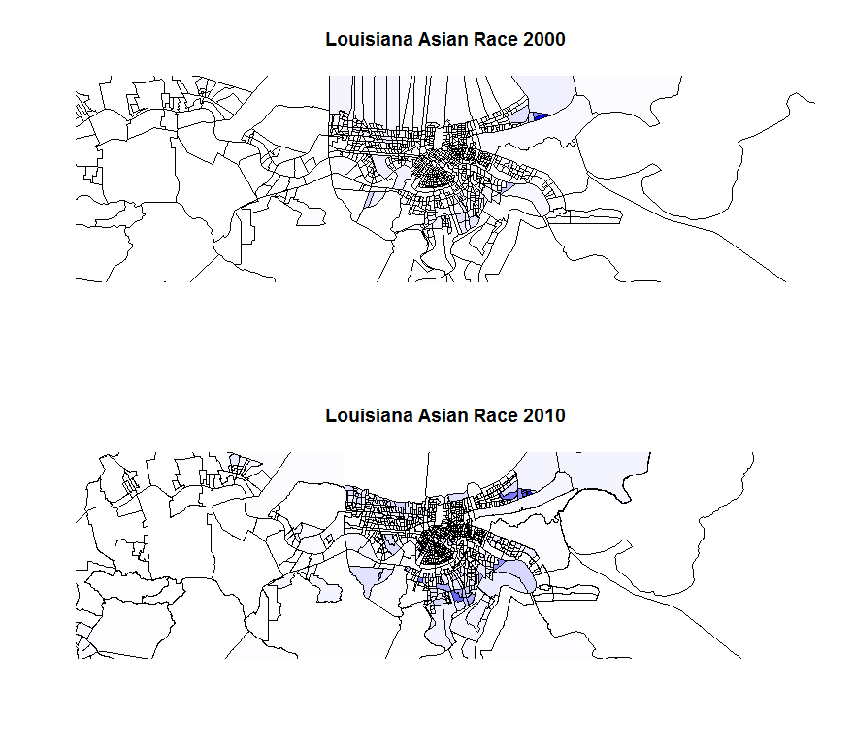

par(mfrow=c(2,1))

plot(louisiana.blkgrp, col=color.total(owner_occ), xlim=c(-90.3414, -89.82), ylim=c(29.77, 30.094))

title("Louisiana Owner Occupied 2000")

plot(louisiana.blkgrp10, col=color.total(owner_occ10), xlim=c(-90.3414, -89.82), ylim=c(29.77, 30.094))

title("Louisiana Owner Occupied 2010")

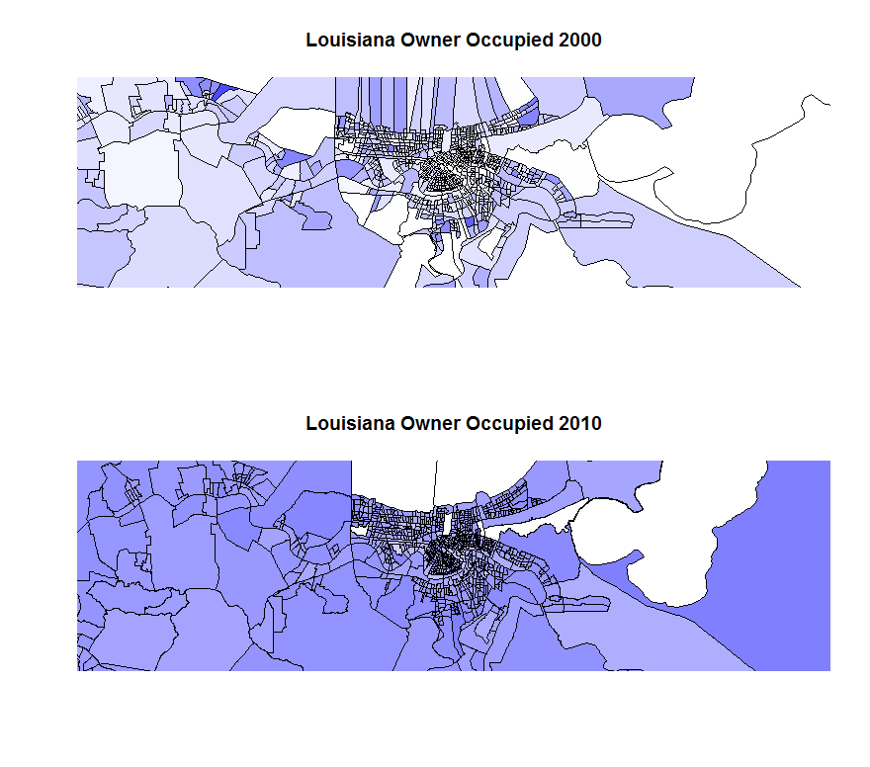

par(mfrow=c(2,1))

plot(louisiana.blkgrp, col=color.total(pop), xlim=c(-90.3414, -89.82), ylim=c(29.77, 30.094))

title("Louisiana Population 2000")

plot(louisiana.blkgrp10, col=color.total(pop10), xlim=c(-90.3414, -89.82), ylim=c(29.77, 30.094))

title("Louisiana Population 2010")

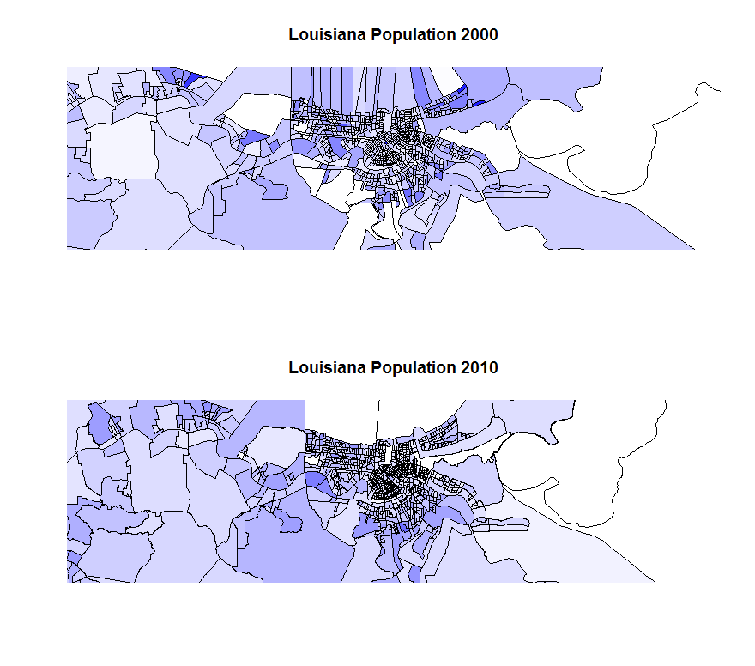5. We can match each entry in the 2010 data set using its FIPS codes with each entry in the 2000 data. If there is a match between the FIPS codes for an entry in the 2000 data set and the FIPS codes for an entry in the 2010 data set, we will append the details for the 2010 entry to the 2000 entry.