**Running instructions**

1. Install Node10 LTS or greater on your PC.
2. Open command line, go to project's root folder and run.

npm install -g expo-cli

1. Go to project root and run the code, waiting until it opens a web page.

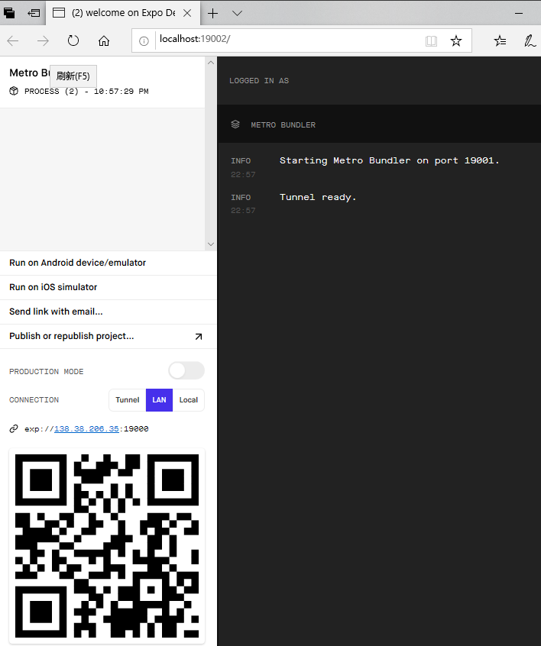

1. Download Expo client on your mobile phone.
2. 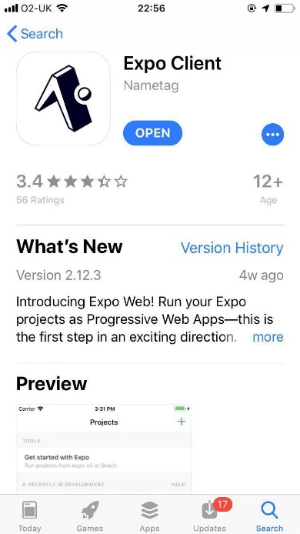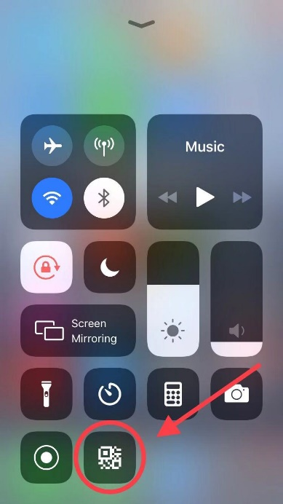Use the camera on your phone to scan the QR code on the command line or the web page.
3. Ready to Go!