James R. Junker^{1,2,✉}, Jeff S. Wesner³, Justin Pomeranz⁴, and Vojsava Gjoni⁵
2026-02-26
¹ Dept. of Biological Sciences, University of North Texas, Denton, TX USA
² Advanced Environmental Research Institute, University of North Texas, Denton, TX USA
³ usd
⁴ cmu
⁵ ital
✉ Correspondence: James R. Junker <james.junker@unt.edu>

Purpose
Start the initial analysis combining ISD, CCSR, and LSD relationships across the NEON sites. This is initial fodder for discussion of next steps.

Introduction
The negative relationship between abundance and body size is one of the most widely observed ecological patterns []. This relationships manifests across biological levels of organization from individuals within a species to whole food webs (white2007?)…
## Data was last updated on 2025-04-29
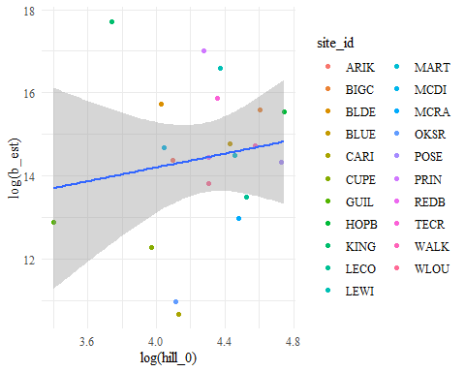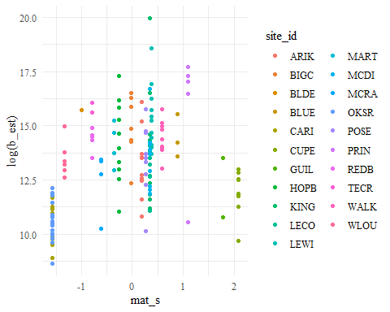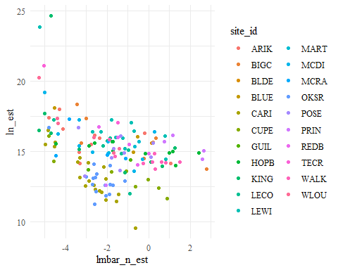
## [1] 0.93925
## 2.5% 97.5%
## -0.4096385 2.8993951
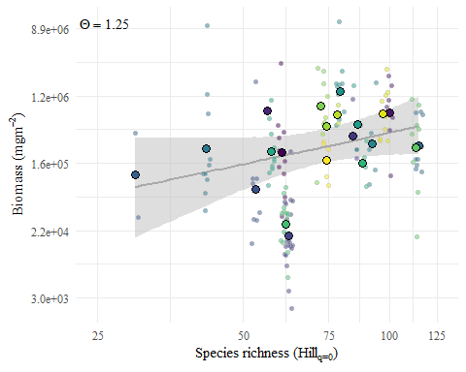
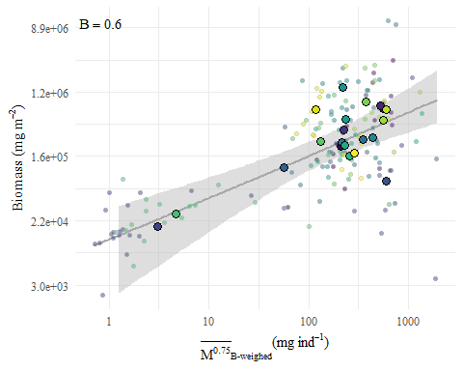
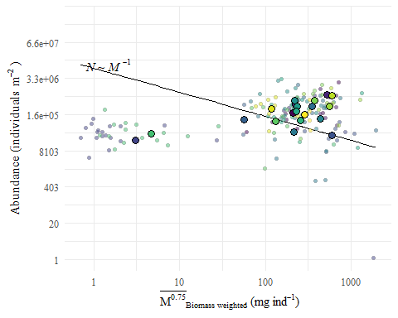
## [1] 0.6689773
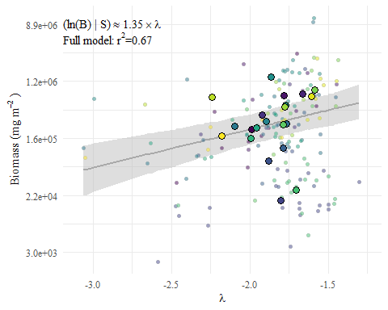
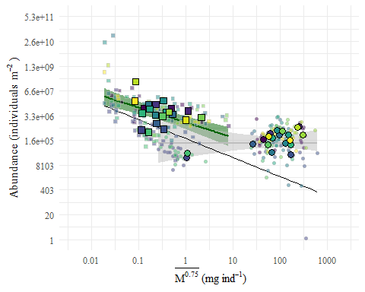
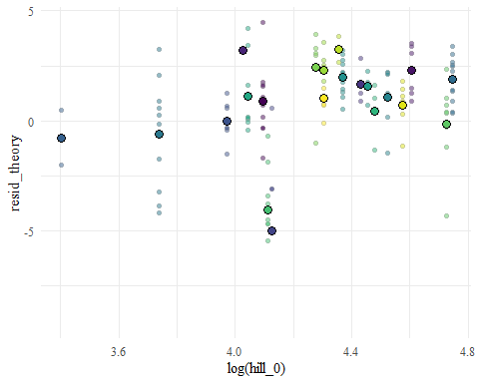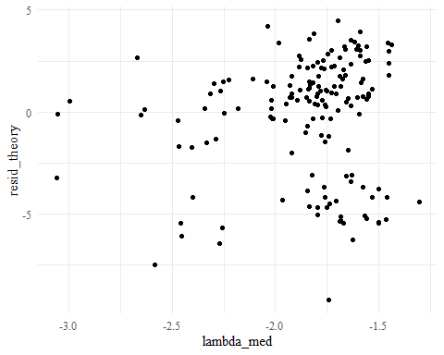
Further, the theories of self-thinning and energy equivalence upon which the CCSR is based upon derive from individual energy use, which body size is only a proxy for. We can adjust body mass, sensu stricto, to metabolic mass by adjusting for the metabolic scaling exponent, $M^{α}$, where $α$ usually takes values in the range of 0.6 – 0.75. Also, care must be taken about how metabolic mass is calculated. Because, individual metabolism is a non-linear function with mass, $f\left(\overline{x}\right)≠\overline{f\left(x\right)}$ (Jensen?) and the proper value to use is to first calculate metabolic mass for each individual, $m_{i}^{α}$, and then average across all individual metabolic mass measurements for a sampling timepoint. The difference in these measurements can be observed below.
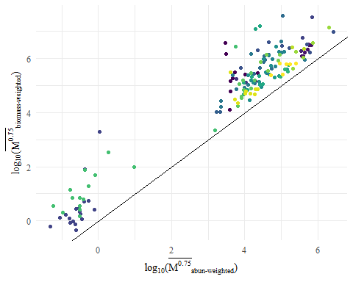

Theory of body size–abundance

Methods

Study sites

Data sets

Macros and fish

Environmental Variables

Temp

GPP

OM

Statistical analyses

community N~M

truncated pareto

Mixed-effects models were fit with

Results
Total community abundances ranged ~15 order of magnitude from 1.1e+00 to 3e+06 with average community abundance of 3.2e+05 $±$ 4.8e+05 individuals m⁻². Community mean body sizes exhibited a similar range from 2.1e-01 to 7e+03 with an average community mean body size of 827.05 $±$ 1089.18 mg dry mass individual⁻¹.
Total community biomass estimates ranged from 43.26 to 49190.98
To explore drivers of over- or under-yielding,
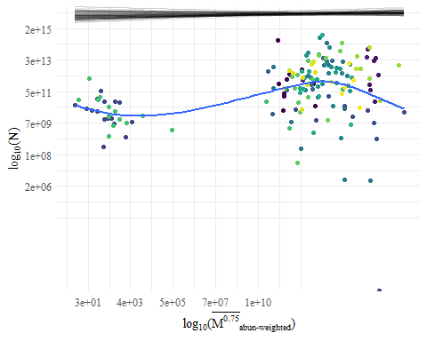
Figure 1. The scaling of community abundances by community abundance-weighted metabolic mass across the NEON streams.

References

Appendix

Body size treatment
While the calculation of total abundance is straightforward, estimating mean body size of the community can be done in multiple ways: 1) by taking the mean of all individuals (i.e., abundance-weighted mean), by calculating the relative biomass of each body size and using this to weight body size by relative biomass (i.e., biomass-weighted), and lastly to correct each mass to metabolic mass (M^{0.75}) and take the abundance- or biomass-weighted mean of these corrected body sizes. The theorized relationship between abundance and body size in $N∝M$ is based on energy use, i.e. metabolism, and metabolism scales non-linearly with body size, therefore, the metabolic correction is most appropriate (white2007?). These differences can have significant influence on the community biomass estimates (Figure S1).
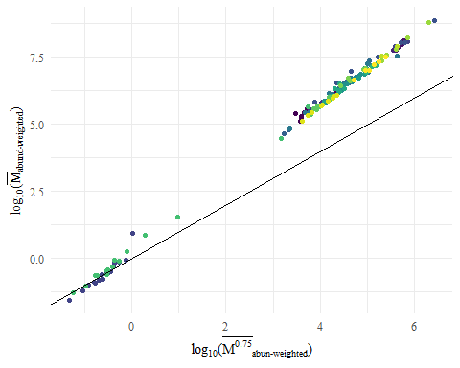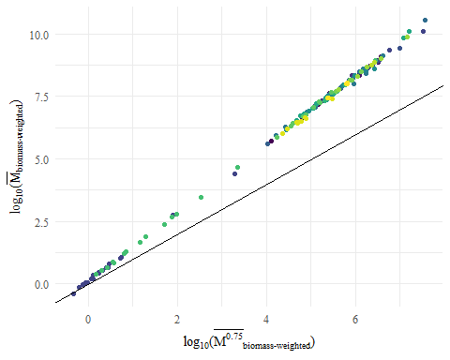

output = capture.output(brm(bf(ln_tot_s~lmbar_b_s),

data = dat,

family = gaussian(link = ‘identity’),

iter = 1000,

thin = 1,

file_refit = ‘never’,

file = here(“data/models/NM_bwt”),

sample_prior = ‘yes’,

chains = 4, cores = 4,

seed = 1312

))

NM_bwt = readRDS(here(“data/models/NM_bwt.rds”))

NM_bwt_int =fixef(NM_bwt)[1,‘Estimate’]

NM_bwt_pred = dat %>%

data_grid(lmbar_b_s = lmbar_b_s) %>%

mutate(pred = NM_bwt_int + lmbar_b_s*-1) %>%

left_join(dat %>% select( site_id, lmbar_b_s, ln_tot_s, lambda_med, log_gpp_s,log_om_s), by = ‘lmbar_b_s’) %>%

mutate(resid_theory = ln_tot_s - pred)

