Appendix S2: Supporting information for Junker, J. R., W. F. Cross, J. M. Hood, J. P. Benstead, A. D. Huryn, D. Nelson, J. S. Ólafsson, and G. M. Gíslason, “*Environmental warming increases the importance of high-turnover energy channels in stream food webs*” for review and publication in *Ecology*.

## Appendix S2

Appendix S2: Figure S1

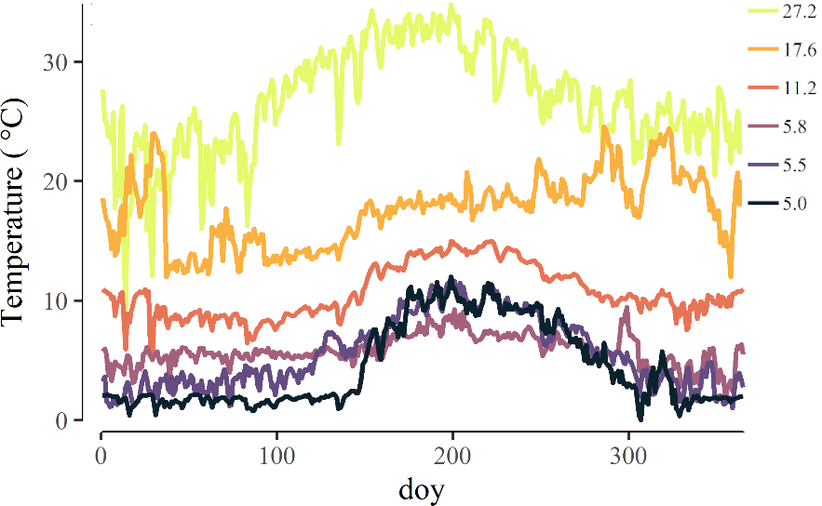

Figure S1. Daily mean temperature (°C) across study streams for each day of year (doy) over the course of the study. Legend represents the annual mean temperate within each stream. This figure was modified from Junker 2019 with permissiom.

Appendix S2: Figure S2

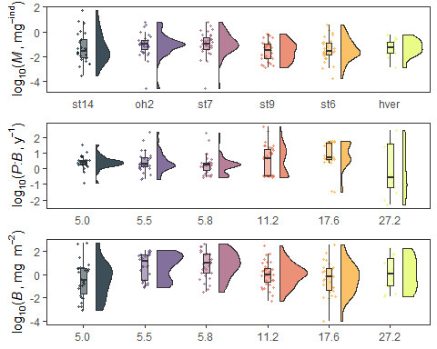

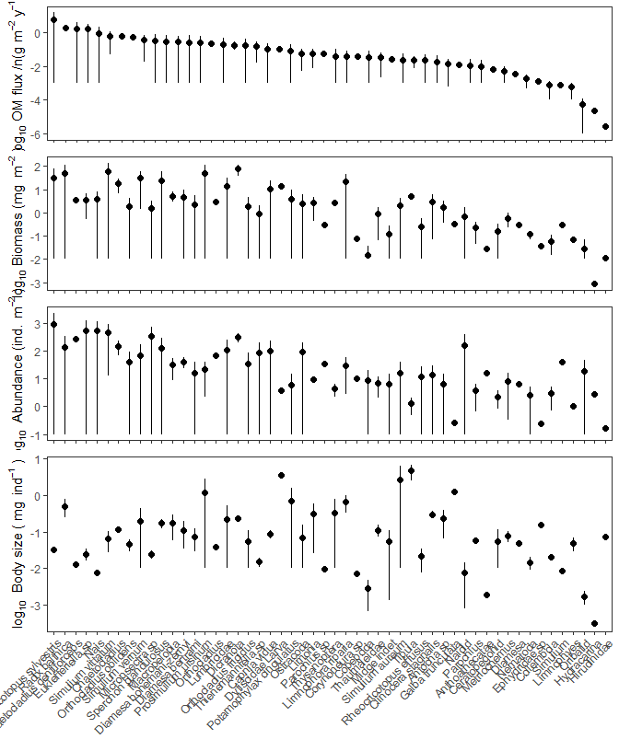

Appendix S2: Figure S3. Species-level distributions of population variables (median $±$ median absolute deviations) observed across all streams in the study. a) total annual organic matter flux, b) standing population biomass, c) population abundance, and d) mean individual body size.

Appendix S2: Table S1

Appendix S2:Table S1. Evenness of organic matter fluxes among consumers within a stream community measured by the Gini index, both raw ('non-normalized') and 'normalized' for consumer richness

| site | Non-normalized Gini | Normalized Gini |
| --- | --- | --- |
| hver | 0.22 ( 0.18 - 0.27 ) | 0.15 ( 0.11 - 0.19 ) |
| oh2 | 0.29 ( 0.25 - 0.32 ) | 0.26 ( 0.23 - 0.3 ) |
| st14 | 0.14 ( 0.097 - 0.21 ) | 0.1 ( 0.059 - 0.17 ) |
| st6 | 0.13 ( 0.11 - 0.16 ) | 0.1 ( 0.079 - 0.13 ) |
| st7 | 0.23 ( 0.2 - 0.26 ) | 0.2 ( 0.18 - 0.23 ) |
| st9 | 0.091 ( 0.073 - 0.11 ) | 0.064 ( 0.045 - 0.082 ) |

Appendix S2: Figure S2

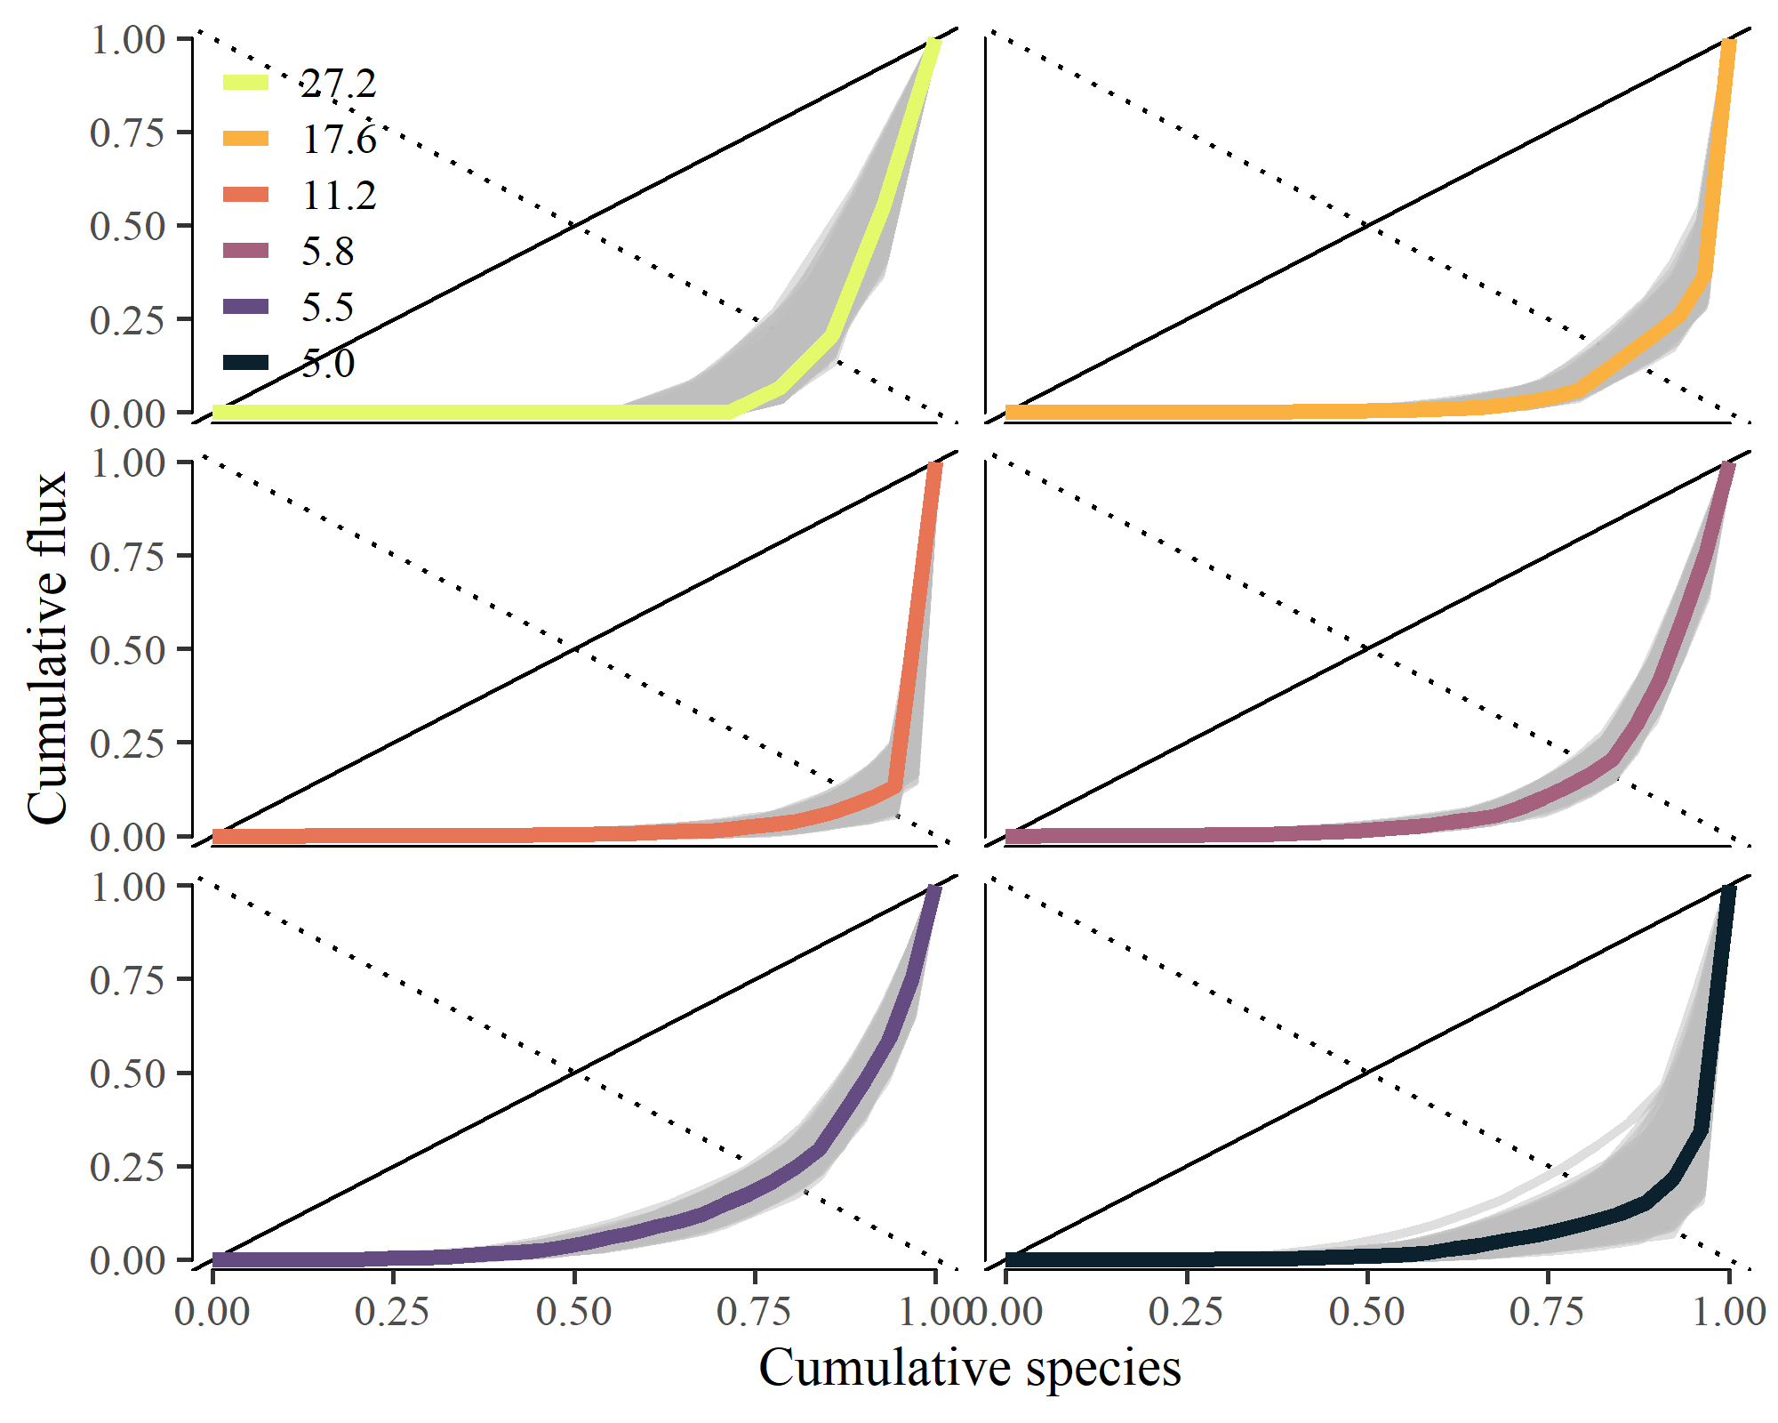

Appendix S2:Figure S2. Lorenz plot of relative community flux by species in ascending order of annual population organic matter flux (g AFDM m-2 y-1)

Appendix S2: Figure S3

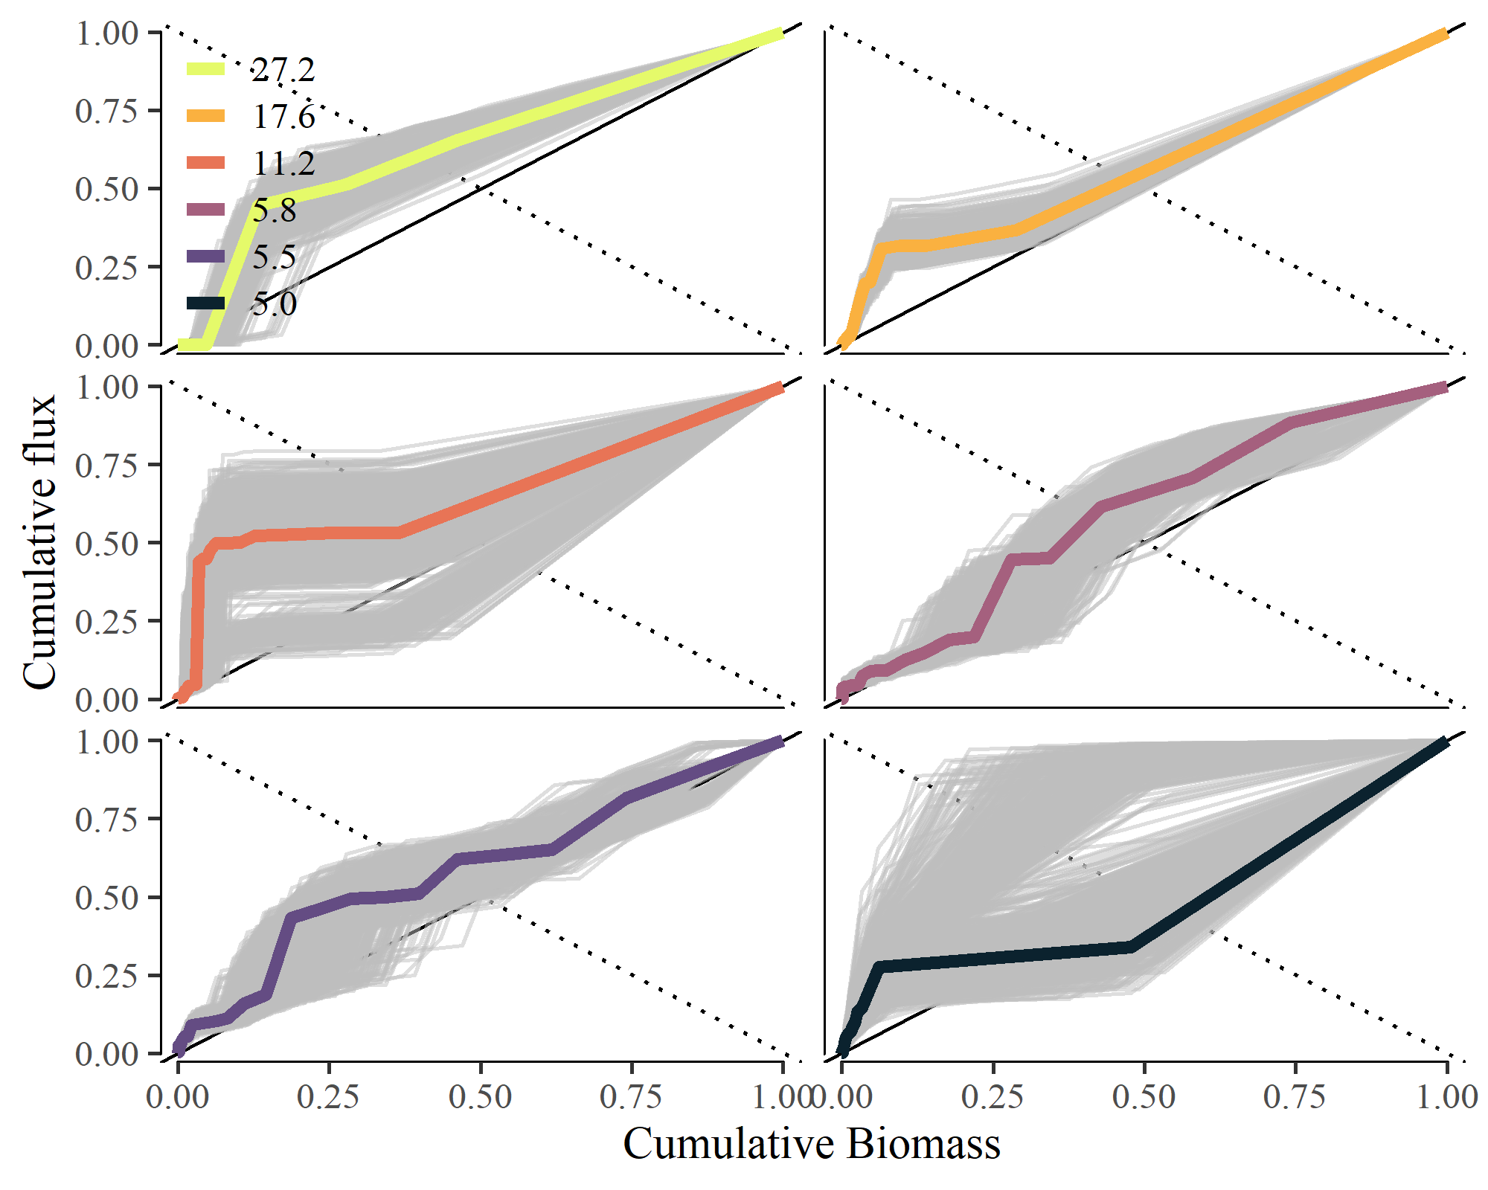

Appendix S2:Figure S3. Cumulative plot of relative community flux by species in relation to mean annual population biomass (mg m-2).

Appendix S2: Figure S4

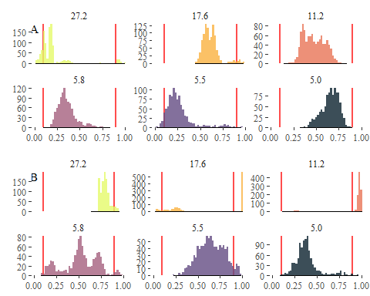

Appendix S2:Figure S4. Probability distribution of empirical Skflux measurements in relation to (a) mean body size and (b) annual P:B compared to random species ordering. The red lines represent the 2.5% and 97.5% percentiles of the Skflux values from random ordering distributions in each stream community.

# References

Junker, J. R. 2019, November. The effects of temperature on stream ecosystem structure, secondary production, and food web dynamics. Doctoral, Montana State University, Bozeman, MT.