*Ecology: ECY22-1350*

**Environmental warming increases the importance of high-turnover energy channels in stream food webs**

Junker, JR, WF, Cross, JM Hood, JP Benstead, AD Huryn, D Nelson, JS Ólafsson, GM Gíslason

**General Comments**

**Please find our response to the Editor and reviewer comments below. For specific line comments, the original text is provided in *black, bold, italic print*.**

**Our response is included in blue text with line numbers representing those in the revised manuscript. We also include the revised text when appropriate.**

**Response to Editor**

**COMMENT**

I received recommendations and comments from two expert reviewers in the field. Both reviewers agree that the manuscript is technically sound and the data support the conclusions. However, the lack of an explanation in the Methods and Results sections was suggested by both reviewers, and I share their concerns. One reviewer also pointed out this study only performed in six streams and was concerned that the ecological focus was not "general" enough. Therefore, I feel rejecting with an offer to resubmit after addressing the points raised by the reviewers is the best avenue for improving the manuscript.

**Response:**

**We thank the editor and reviewers for the helpful comments that have improved the paper. We first wish to elevate our response to a point mentioned by reviewer #1 and highlighted by the editor, specifically the generality of the study system and the number of replicated ecosystems sampled in our study. The tradeoffs among generality, replication, and realism in ecological studies have long been recognized, particularly for ecosystem-scale studies (Schindler 1998). While our work was performed in *only* six streams these six streams cover a large proportion of the global range in stream temperatures (5–27°C). Geothermal regions, such as the Hengill region, have unique utility to global change research (O’Gorman et al. 2014). Our study was able to remove many of the confounding effects of space (either latitude or altitude) and biogeography often found in many natural temperature-gradient studies. Further, Hengill’s streams represent intact ecosystems near biological equilibrium (to the extent possible), free of the experimental artifacts of warming manipulations, ideal for determining general whole-community patterns. Our study has limitations, of course, but these limitations are not unique to this system nor are they new to the field of ecology. We believe these limitations are vastly outweighed by the advantages of this ‘natural laboratory’ and that our results will be of wide general interest to the diverse readership of *Ecology*.**

**Response to Reviewer #1**

**COMMENT**

The introduction does a good job of reviewing relevant literature for this study. What seems to be missing are clear statements about the research gaps that this study is aiming to fill. As there have been lots of recent studies of links between temperature gradients and aspects of production and food web ecology in this Icelandic system (including some by the same group of authors), this is a key omission that needs to be rectified.

**Response:**

**We thank the reviewer for identifying this missing component. We have provided additional clarifying details on the research questions we set out to address in this manuscript in the final paragraph of the introduction (lines 109-113):**

**“Here, we address two overarching and open questions focused on temperature effects on food web dynamics. First, how does ecosystem temperature shape the relationship between organic matter (OM) fluxes and community-level trait distributions, specifically body size and biomass turnover, across ecosystems? Second, how does temperature shape the role of deterministic vs. stochastic sorting processes in driving relative fluxes of OM through consumer communities?”**

**We have also included some additional connection to previous work conducted in this system within the discussion to place our results in further context (lines 400-423).**

**COMMENT**

***“Body size is a fundamental trait that is influenced by temperature and has great potential to influence energy flux (Atkinson 1994, Daufresne et al. 2009, Gardner et al. 2011)”***

Line 85 - perhaps note that all this discussion refers to communities of ectotherms

**Response:**

**We acknowledge that the literature cited here is heavy on ectotherms, and that the generality of this response is questionable in endotherms (Riemer et al. 2018). We have modified this sentence (lines 84-85) to better reflect the current state of knowledge:**

**“Body size is a fundamental trait that is influenced by temperature and has great potential to influence energy flux (for ectotherms see Atkinson 1994, Daufresne et al. 2009, and Gardner et al. 2011, also see Riemer et al. 2018 for deviations across endotherms)”**

**COMMENT**

***“Invertebrates in these streams rely on autotrophs (O’Gorman et al. 2012, Nelson et al. 2020b), thus the dynamics of primary production functions as a strong control on energy flow through consumers (Junker et al. 2020a)”***

Line 115 - explain more why this is the case - Presumably because these Icelandic streams are special cases due to historical deforestation, or can we still use them as models for high-latitude systems more generally? On the flip side, highlight the extent to which this study may not then be relevant to stream food webs that are dominated by terrestrial litter/DOM inputs

**Response:**

**As the reviewer hints, the negligible inputs of terrestrially-derived organic matter to our study ecosystems and their open canopies lead to their dependence on autochthonous energy resources. We have clarified this section on lines 118-121, as:**

**“Due to high light levels and minimal OM inputs from surrounding terrestrial habitat, invertebrates in these streams rely on autochthonous production (O’Gorman et al. 2012, Nelson et al. 2020b); thus the dynamics of in-stream primary production act as a strong control on energy flow through consumers (Junker et al. 2020).”**

**We also contend that the streams studied here are very general analogs to many ecosystems, beyond even just high-latitude systems more generally. With respect to stream ecosystems, unforested headwaters with reduced allochthonous inputs are distributed globally through grassland, urban, and high-altitude environments, in addition to high latitudes. Together, these systems represent >40% of total global land area and ~20% of total runoff (Dodds et al. 2015). Here, the key point is that external subsidies are minimized and autochthonous basal resources within each system are the dominant food resource modifying consumer life histories, a characteristic not limited to high-latitude stream ecosystems.**

**The extent to which these results can extend to ecosystems that are heavily subsidized, such as streams dominated by terrestrial litter and DOM inputs, is certainly open to speculation. Given word count constraints, we have opted not to get into this area.**

**COMMENT**

Line 193 - as the diet proportions are key to the calculations at this point, more information should be given in the main text about how this was obtained rather than leaving it completely to the supplementary files.

**Response:**

**We have expanded the methodology for diet estimation in the main text (lines 201-215) as:**

**“Consumer diets were quantified in numerically dominant taxa through direct inspection of gut contents from multiple individuals throughout the year. Removal and preparation of gut tracts followed the methods outlined in Rosi-Marshall and coauthors (2016). To estimate variability in diet compositions and to impute missing values for non-dominant taxa, we modeled the diet proportions within each stream using a hierarchical multivariate model (Fordyce et al. 2011, Coblentz et al. 2017). Here, diet proportions for food categories were assumed to follow a Dirichlet distribution with model-estimated expected proportions in diet for each food category and a concentration parameter to estimate variability around this expectation. We accounted for the hierarchical data structure by fitting stream-specific random intercepts, as well as, random intercept offsets for taxon nested within each stream. All models were specified in the Stan language (Stan Development Team 2019) using the brms package in R (Bürkner 2017). Further model details can be found in supporting information (Appendix S1). We estimated diet overlap within and across stream food webs by calculating diet overlap from 1000 independent draws from the posterior distributions of modeled diet estimates. Overlap was calculated with the ‘overlap()’ function in the RInSp package (Zaccarelli et al. 2013).”**

**COMMENT**

Line 242-243 - did you check if GLM with error distributions other than Gaussian could do a better job than transformation at this point?

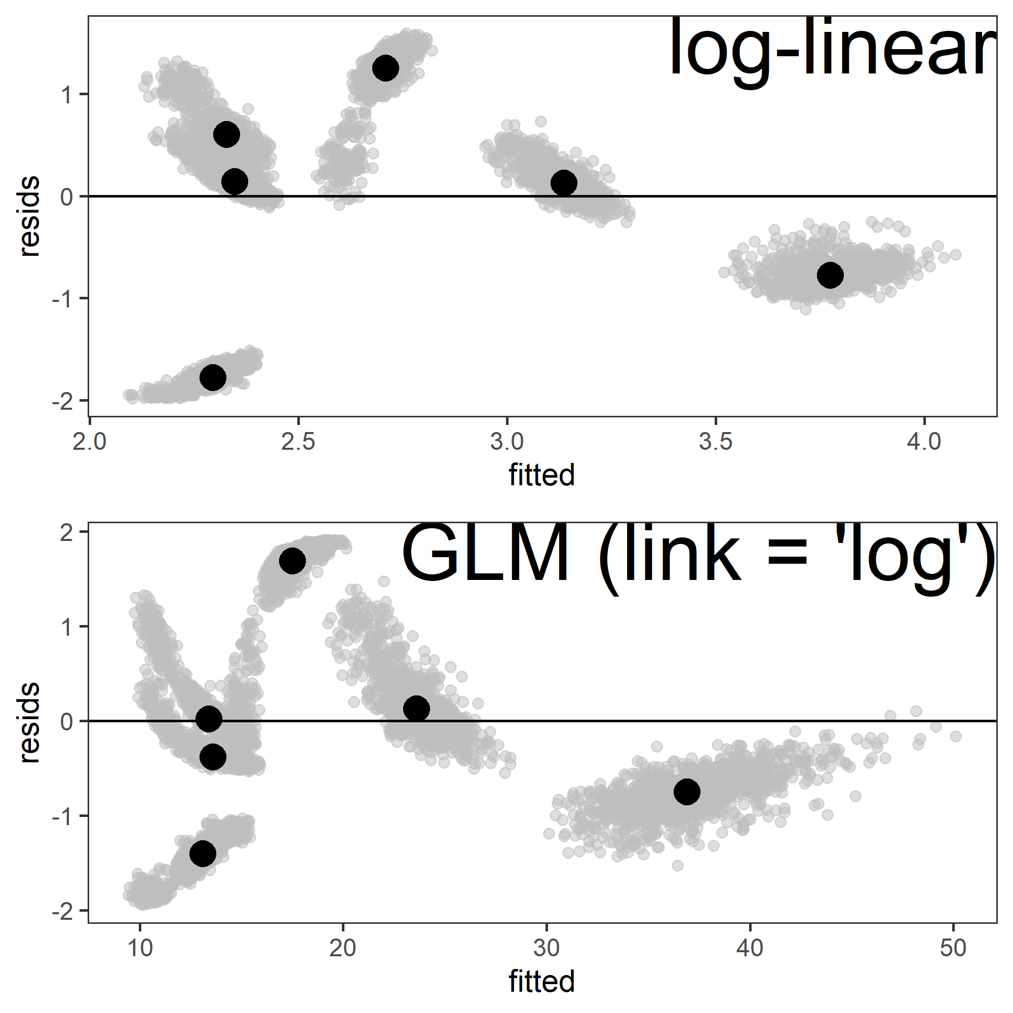

Figure Standardized residuals versus fitted values comparing OLS linear regression on log-transformed mean community P:B ratio and generalized linear models on untransformed mean community P:B ratios with Gaussian error and ‘log’ link function. Large black points represent the median residual estimates from all 1000 bootstrapped regression models shown in grey points.

**Response:**

**Log-transforming these data accomplished two things, 1) it normalized the residual variation, as ecological scaling relationships often have multiplicative log-normal error (Xiao et al. 2011) and, 2) it linearized the relationships between the response (i.e., body size, *M* or production:biomass ratio, *P:B*). A quick exploratory analysis (Figure 1), using a GLM on the untransformed response but with Gaussian error and a “log” link function suggest minimal improvement in fit and no qualitative difference in interpretation. Further, fitting a non-linear model (not shown) also did not alter inferences. Given this and its widespread use, we have kept the original analyses on log-transformed responses. We have clarified this on lines 258-265 as:**

**“We calculated the mean body size or *P:B* of the populations within each stream by first calculating the mean annual body size or annual *P:B* for each taxon and then taking the median across all taxa. We then calculated the least-squares estimate between loge-transformed or and mean annual temperature. Response variables were loge-transformed to conform to assumptions of linearity and normally distributed residual variation and the ordinary least squares estimate was calculated with the ‘lm()’ function in R.”**

**COMMENT**

***“We predicted that species $M$ and $P:B$ would be increasingly important traits structuring OM fluxes within a community and therefore warmer streams would exhibit highly skewed OM distributions that would be unlikely due to chance (i.e., ‘non-random ordering’). In contrast, cooler streams would exhibit OM fluxes with skew values that are more likely due to random chance (‘random ordering’), regardless of raw skewness values, suggesting other traits or processes govern the distribution of OM fluxes within their communities.”***

Line 264 - introduces some predictions/hypotheses. These should be integrated at the end of the introduction along with the other hypotheses. Need to ensure that the introduction text then gives a clear linked rationale and associated research gaps.”

**Response:**

**In our original submission, the predictions in this section were meant as a guide to remind readers of the predictions, with connections to the methodology used to assess them, rather than to introduce new predictions. We recognize the confusion and have revised the introduction and methods section to strengthen and make more explicit these connections. This specific occasion we have revised the introduction (lines 121-130) to reflect similar wording as:**

**“We therefore predicted that annual OM fluxes to consumers would increase with stream temperature, mirroring patterns in resource availability and consumer energy demand. We also hypothesized that temperature would act as a principle environmental filter on community assembly and OM fluxes by favoring ‘fast’ life-history traits associated with small-bodied organisms. Specifically, we predicted that warming temperatures would lead to reduced average body size and increased average biomass turnover (i.e., *P:B* ratio) of populations among streams. We also predicted that *within* communities, OM fluxes would be skewed towards small-bodied and high *P:B* taxa at higher temperatures, and that these patterns would not arise by random sorting, but instead through ‘non-random ordering’, suggesting deterministic filtering of species traits.”**

**We have modified the methods section (lines 251-256) as:**

**“We predicted that warming would favor taxa with smaller body size and higher biomass turnover rates and that OM fluxes would therefore be skewed towards small body size (*M*) and higher *P:B* at higher temperatures across and within communities. To assess the change in the average population trait values and potential for environmental filtering across communities, we used bootstrapped linear regressions between either mean population body size ($\overline{M}$) or biomass turnover ($\overline{P:B}$) of each stream community and mean annual temperature ($​^{∘}$ C).”**

**COMMENT**

It is hard to evaluate the extent to which the streams vary in their temperatures as no time-series data are presented. This is easy to rectify; in contrast, more could probably be done with the data to sensitivity check the effect of any variability on the ecological results. This would be useful (and maybe add novelty) because the whole analysis relies on mean annual temperatures, which always strikes me as problematic - if we did the same with pollutant concentrations year round during a year in which a short pulse of toxic waste came through, we'd perhaps have a near lifeless stream but low mean annual concentrations. As is noted in the results text page 15, maxima reach almost 40 in the warmest stream (vs 25-30 on the plot using mean temperature). The question that arises is to what extent could these even higher temperature pulses (and associated variability within streams) have effects that propagate throughout the rest of the year, but which we miss when just analysing mean temperature?

**Response:**

**We have included time series of the annual temperatures across the streams in the supplemental materials (Appendix S2: Figure S1). We understand the analogy and agree that using mean annual temperature is a simplifying assumption that may overlook some important ecological aspects. The question of how important temperature variability is to the patterns we observe here is a very interesting question; however, we feel that it must be left unanswered, as it is far outside the scope of the current work. Further, while we have only included a single annual cycle of temperatures here, data from ~6 years (*unpublished*) suggest that the mean temperatures (and intra-annual variation) observed in the timeframe of our study are not outside of the normal ranges observed in each stream.**

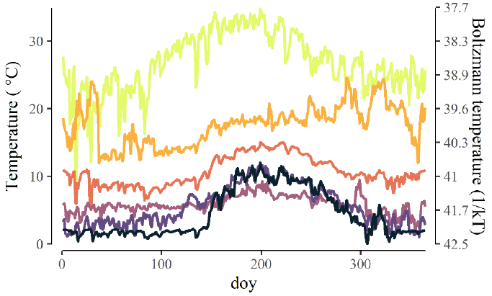

Figure Mean daily temperature (°C) for all stream sites over the course of the study period.

**COMMENT**

The study makes a series of predictions/hypotheses earlier in the manuscript, but it is not clear how these relate to the discussion that is presented. I'd suggest to incorporate some clearer signposting/numbering so that the hypotheses are easier to track through the work.

**Response:**

**We have now added subheadings within the discussion to signpost key results that relate to our questions, and we have clarified our research questions in the introduction (see response above).**

**COMMENT**

Line 349 - "we leveraged a wide natural gradient of ecosystem temperatures  
350 and demonstrated that temperature...": suggest to rewrite in plain English (lose 'leveraged', avoid repetition of terms)

**Response:**

**We have revised this sentence (line 373-374):**

**“Here, we demonstrate that along a wide natural gradient of ecosystem temperatures, warming acts as a strong environmental filter of species traits.”**

**COMMENT**

***“Other studies have reported similar deviations from the “universal” response for other taxonomic groups (e.g., invertebrates: Zeuss et al. 2017, birds: Geist 1987, Riemer et al. 2018, fish: Rypel 2014).* *While there is certainly a strong propensity for reduced body size with warming, clearly other processes can modify the direction and magnitude of body size shifts and how they play out from individual to ecosystem scales.”***

Line 392 - what other processes are being referred to here? Needs more ecological discussion

**Response:**

**We have expanded this discussion by including more ecological context, expanding the discussion of previous work in this study system (lines 410-416):**

**“Interestingly, our results contrast with a warming experiment conducted in one of our study streams showing that a relatively small increase in temperature (3 $​^{∘}$ C) shifted invertebrate community biomass and productivity from smaller to larger organisms (Nelson et al. 2017a, 2017b). Moreover, an additional study at Hengill that examined community size spectra across a much broader range of body sizes and taxonomic groups (i.e., diatoms to fish), but with limited temporal sampling (i.e., August) reported an unexpected shallowing of mass-abundance slopes, suggesting warming may favor larger-bodied individuals (Adams et al. 2013, O’Gorman et al. 2017)”**

**and by highlighting the work of Ohlberger 2013, as (lines 419-425):**

**“While there is a strong propensity for reduced body size with warming, clearly many processes can modify the direction and magnitude of body size shifts and how they play out from individual to ecosystem levels (e.g., growth and developmental rates, resource supply, competition, predation; Ohlberger 2013). In addition, it is evident that the range of temperatures and body sizes considered, as well as the temporal scale of sampling, is likely to influence our understanding of how temperature influences patterns of body size in ecosystems (Jennings et al. 2007).”**

**Response to Reviewer #2**

**COMMENT**

Now, I finished my review of the study by Junker and collaborators. This is a very novel, methodologically rigorous, and conceptually interesting manuscript. The authors used detailed data from invertebrates in geothermal streams to estimate growth rates, secondary production, energy flux and investigate their drivers in a comparative manner. They have six streams with temperature ranging from 5-30ºC where they estimated individual production in the field. With this data, they were able to estimate secondary production and using diet information, the energy fluxes within food webs. Additionally, they used bootstrapping and Monte Carlo simulations to test if energy fluxes were randomly assorted to species with any level of biomass turnover and body sizes. In face of a recent conceptual study in which I am involved (Saito, Perkins and Kratina 2021 - Trends in Ecology and Evolution), this is the first rigorous test of some of our hypotheses, definitely advancing the field and updating us to new hypotheses. In general, I strongly recommend this study after revision due to their novel results concerning how populations and communities change energy allocation and use in face of temperature change and how this is related to a strong environmental filter and not a stochastic flux of energy through random species. Yet, the study of secondary production and energy flux is always methodologically challenging and the methods always have many assumptions, therefore It would be good to have some of them explained in more details before publication. Moreover, the deterministic vs. stochastic debate is full of concepts that may be confusing, and so I have some suggestions for them in this regard.

**Response:**

**We would like to thank the reviewer for their supportive and helpful comments, along with their willingness to have further discussion regarding a few key points.**

**COMMENT**

***“increasing temperatures are predicted to change communities in two fundamental ways: 1) by reducing average body size and 2) by increasing individual metabolic rates. “***

L35: I do not see these two things as separated ways. Temperature changes metabolism which will change energy allocation influencing body size. So, I actually see it as one fundamental way that end up having multiple consequences at multiple levels of organizations.

**Response:**

**We agree with the reviewer that metabolic rate and energy allocation to growth are intimately tied to organismal body size and that these effects alter patterns at multiple levels. At this place in the manuscript, we speak generally to the temperature­-body size response that can arise through multiple mechanisms (i.e., reduced intraspecific body size, increased relative abundance of smaller organisms and life-stages, loss of large species/gain of small species). As such, we chose to keep this sentence as is, recognizing that what it lacks in nuance, it makes up for in generality and clarity.**

**COMMENT**

L39: Please, include min and max temperature for context. A range between 0-25 is very different from 25-50 in terms of biochemical reactions.

**Response:**

**We have modified the text to state that the streams we studied range from 5 - ­27°C (lines 38-39) as:**

**“Here, we quantified patterns and the relative distribution of organic matter fluxes through stream food webs spanning a broad natural temperature gradient (5-27 $​^{∘}$ C).”**

**COMMENT**

L41: By ecosystems do you mean different streams, or streams and terrestrial systems?

**Response:**

**Yes, individual stream ecosystems. We have clarified this sentence by replacing ‘ecosystems’ with ‘streams’ lines 41-42:**

**“We then related these patterns to species and community trait distributions of mean body size and population biomass turnover (*P:B*) within and across streams.”**

**COMMENT**

***“With warming, the relative distribution of organic matter fluxes also appeared to be increasingly ‘non-random’, suggesting stronger selection for traits driving high turnover with increasing temperature.”***

L49: In which sense? Maybe you need some context like saying that it is deterministically flowing through the same species.

**Response:**

**We have reworded this sentence to remove the term “non-random” at this point in the manuscript, because it lacks necessary context. We have revised lines 48-49 as:**

**“With warming, the relative distribution of organic matter fluxes was decreasingly likely to arise through the random sorting of species, suggesting stronger selection for traits driving high turnover with increasing temperature.”**

**COMMENT**

***“organic matter fluxes would be dominated by small-bodied and high P:B taxa at higher temperatures, and that these patterns would not arise by random change (i.e., a ‘selection effect’ sensu Huston 1997)”***

L124: I don't get what was your intention by including this citation of Huston. I really liked the Introduction, but I think the deterministic vs. stochastic comparison is a bit overlooked or not well explained. For instance, in this case, what do you mean by random change? What is a random flux of energy? Do you mean energy flowing through random species to another random species?

**Response:**

**We have modified this sentence and removed this reference.**

**COMMENT**

L142: Could you give more details, please? So, your selected streams were not manipulated, right?

**Response:**

**Correct, the data presented here represent those from un-manipulated years. We have clarified this sentence (lines 146-148):**

**“The two streams sampled from 2010–2011 were part of a separate warming manipulation during the un-manipulated, reference period (Nelson et al. 2017a, 2017b).”**

**COMMENT**

L154: Could you please inform the level of identification for each Order here? In studies using null models and testing deterministic vs. stochastic processes, the level of identification is quite important because it defines what you are considering as the same group. I mean, there is quite a difference in saying that energy is fluxing through Chironomidae and saying that energy is flowing through genus A,B or C of chironomids.

**Author note: We have combined our responses for the above and below comments as they address similar points.**

***“dominated by insects in the families Simuliidae and Chironomidae, pulmonate snails (Radix balthica), and oligochaete worms (Figure 2A & B; Appendix S2: Figure S2)”***

L301: Nice, so now I see that you have a very refined identification of Chironomidae and Simuliidae. I am very interested to see your response to my previous question about deterministic selection acting on species identities and traits. By looking into the Figure 2, I can see that the ordering was not the same for each stream in terms of identities.

**Response:**

**Organisms were identified to varying, but consistent, taxonomic levels (most often genus) across streams.**

**COMMENT**

***“To estimate growth rates of taxa for which growth could not be estimated empirically, we developed stream-specific growth rate models by constructing multivariate linear regressions of empirical growth rates against body size and temperature”***

L183: Smart. Is this idea new? Do you have a reference?

**Response:**

**This idea is not new *per se* and the use of empirical models have been assessed in previous work (Benke et al. 1993, Huryn and Wallace 1986, Morin and Dumont 1994, Morin 1997) and the authors have published previously with similar methodology (Junker and Cross 2014, Junker et al. 2020).**

**COMMENT**

L212: So, are these median values a common assimilation efficiency rate taken from these references?

**Response:**

**Yes, the median values are the values most often used in trophic basis of production studies and these values are most often assumed to be fixed. Here, we draw from distributions to propagate uncertainty in these parameters into our flux estimates.**

**COMMENT**

L216: There are plenty of steps until you get into the NPE with a lot of bootstraping and monte carlo simulations. Could you provide a schematic figure summarizing the steps here (maybe as Supp Mat)? I just think you have multiple assumptions along the steps, that's normal, but it could be better presented.

**Response:**

**We have attempted to visually step through the procedure, highlighting measured and assumed terms, now in the appendix (“Appendix S3: Section 1: Trophic basis of production workflow and assumptions” and “Appendix S3: Figure S1”).**

**COMMENT**

***“Here, 1,000 values of population M or P:B were resampled with replacement from population secondary production vectors (see Secondary Production above) for each taxon within each stream.”***

L240: I imagine that you had to do that because you have 6 streams and so a simple linear regression would have low statistical power. Could you explain it here?

**Response:**

**This procedure was not intended as a response to low statistical power. Rather, the bootstrapping procedure allowed us to more appropriately include the variability from individual samples, across the many sampling dates needed to calculate annual secondary production, into the uncertainty in the parameters (in this case the response of mean body size/P:B to temperature). An alternative often used is to take a single value from the distribution (i.e., mean or median) and run an ordinary least square linear (OLS) regression on single points from each stream. This approach incorrectly assumes that we have perfect measurement of secondary production, with no uncertainty in the response. Parameter uncertainty is estimated in this case as is customary in OLS regression. Alternatively, if we were to run an OLS with all the bootstrapped estimates, we would artificially inflate our sample size and have parameter estimates that are artificially precise (and any *p*-values would be meaningless, as we could reduce them simply by generating more bootstraps.). The approach we applied here is model-free and non-parametric, in that it makes no assumption about the error distributions for parameter precision estimates. These reflect the distribution from the data themselves. The approach does make other, different, assumptions in that it is assumed the sample distribution accurately and completely reflects the potential data distribution. We apply this approach due to its reasonably easy implementation, while also incorporating the uncertainty propagated through the production estimates. Lastly, as the number of bootstraps increases, the parameter distribution (e.g., median, 95% percentiles, etc.) approaches maximum likelihood estimation, yet does so through brute force rather than analytically, an ideal scenario for analytically difficult likelihoods (Hastie et al. 2009). We have also modified the text (lines 258-264) to better reflect the process and reasoning for statistical decisions as:**

**“We calculated the mean body size or *P:B* of the populations within each stream by first calculating the mean annual body size or annual *P:B* for each taxon and then taking the median across all taxa. We then calculated the least-squares estimate between loge-transformed or and mean annual temperature. Response variables were loge-transformed to conform to assumptions of linearity and normally distributed residual variation and the ordinary least squares estimate was calculated with the ‘lm()’ function in R.”**

**COMMENT**

***“where, $f_{Qx}$, is the cumulative flux at some quantile, $Qx$, of the community trait distribution “***

L251: Could you explain in more details why this analysis used quantiles of the distribution of OM?

**Response:**

**We know that secondary production for individual species and communities follow non-normal distributions, as mentioned above in the justification for bootstrapping estimates. Many estimators for the skewness of a distribution assume normality and are biased for non-normal distributions. Therefore, we chose a quantile-based formula to calculate skewness (Groeneveld and Meeden 1984). This estimator is less influenced by parametric assumptions and therefore better suited for this case. We have made this more explicit (lines 273-275) as:**

**“To do this, we ordered taxa based on within-stream rankings of annual population traits (i.e., *M*, *P:B*) and then calculated a measure of skewness, $Sk_{flux}$, based on quartiles of the distribution of OM fluxes in relation to taxon traits as:**

$$Sk_{flux}=f_{Q0.75}-2f_{Q0.5}+f_{Q0.25}/f_{Q0.75}-f_{Q0.25} \left(3\right)$$

**where $f_{Qx}$, is the cumulative flux at some quantile, $Qx$, of the community trait distribution. We chose this quantile-based formula over other parametric or moments-based approaches because it is well defined and requires no assumptions of the moments of the distribution (Groeneveld and Meeden 1984).”**

**COMMENT**

***“We assessed the likelihood of non-random ordering as the distance from the central mass of the random skew distributions within each stream. Therefore, communities in which OM fluxes are likely organized non-randomly are indicated by observed skew values near the tails of these random distributions. All analyses were performed in the statistical program R (R Core Team 2022).”***

L283: Ok, very interesting and very novel! So, this test whether energy flux is non-random in terms of species performances. Is it equal to saying that energy flux is non-random in terms of species identities? Are performances/traits predictable among species?

**Response:**

**Yes, this analysis tests for non-random ordering in population energy fluxes in relation to species’ body size or P:B, not identity. There are certainly differences in the mean and variance of species fluxes, biomasses, and traits. We have included an additional figure in the supplemental (Appendix S2: Figure S2) that displays the variation in fluxes, biomasses, and species traits among streams.**

**COMMENT**

***“ $\overline{M}$ decreased from 2.75 mg AFDM ind-1 (1.03 – 5.08; 95% PI) in the coldest stream to 0.10 mg AFDM ind-1 (0.08 – 0.13) in the warmest stream, corresponding to an -8.7% (-11.1 – -6.4) decrease in mean body size for every 1 $​^{∘}$ C increase in temperature (Figure 1B). “***

L318: That's a nice result to be compared in other places. Imagine that we could have a 50% decrease in body size with only 5ºC change in temperature!

**Response:**

**Yes, we similarly found it interesting and also were surprised by the congruence with other studies (e.g., Deutsch et al. 2022), as outlined in our discussion.**

**COMMENT**

L332: 3A and 4A, I guess.

**Response:**

**3A and 4A represent the accumulation of relative flux with species from low to high M or PB, while 3B and 4B represent the actually skew values estimated with our quartile-based skewness formula for all bootstrapped estimates.**

**COMMENT**

***“The probability of observing a similar or more extreme skew of OM fluxes in relation to body size was variable among streams and ranged from 0.34 (0.19–0.55; 95% PI) to 0.79 (0.07–0.96); there was a very weak positive association between this probability and temperature (Figure 3C)”***

L337: Sorry, I can't really see any association here.

**Response:**

**We have removed the reference to the weak association in lines 359-361 as:**

**“The probability of observing a similar or more extreme skew of OM fluxes in relation to body size was variable among streams and ranged from 0.34 (0.19–0.55; 95% PI) to 0.79 (0.07–0.96); there was little association between this probability and temperature (Figure 3C).”**

**COMMENT**

***“The likelihood of elevated fluxes among high P:B taxa became much more likely with warming, and the probability of random ordering decreased by -4.6% (-5.1%—4.2%) for every 1 $​^{∘}$ C increase in temperature (Figure 4C).”***

L343: I really liked the overall idea here, but I am curious if this is not a circular thinking. Higher energy fluxes happened in higher temperatures. Was it possible to have the energy to flow through other species rather than those with high P:B? Maybe I don't fully got the monte carlo simulation.

**Response:**

**In short, yes, it is possible, but also this analysis derives from the randomization analyses where we are working with the relative distribution of fluxes. By looking at relative fluxes, we account for the reality that fluxes are higher in warmer temperatures in an absolute sense. We have clarified this text in lines 365-367 as:**

**“The likelihood of higher relative fluxes among high *P:B* taxa became much more likely with warming, and the probability of random ordering decreased by -4.6% (-5.1%—4.2%) for every 1 $​^{∘}$ C increase in temperature (Figure 4C).”**

**COMMENT**

**“*At the community level, we observed a ~7% increase in the mean biomass turnover rate (P:B; y-1) of populations for each 1 $​^{∘}$ C of warming “***

L366: But these two things are associated. Biomass turnover and body sizes are affected by metabolism which is governed by themodynamics of biochemical reactions.

**Response:**

**Yes, we agree. We have highlighted this connection in the introduction (line 95) and also specifically the similarity in magnitude of these responses in the discussion (lines 395-396). Further, the contrasting results between body size and turnover in regards to the probability of sorting vs stochastic processes (as discussed lines 436-444) suggest there may be important differences in the sorting of species for body size vs turnover and, while these are related, there are important distinctions between them.**

**COMMENT**

***“In contrast, we found a much clearer pattern with respect to biomass turnover rates, in which OM fluxes were increasingly skewed towards taxa with high turnover within warmer streams. We also found that this pattern was clearly non-random, suggesting that it is not attributed simply to demographic stochasticity (e.g., Hubbell 2001, Shoemaker et al. 2020).”***

L407: I think I get what you meant by non-random in this case - OM fluxes were not distributed randomly among species with high and low turnover rates. It was always in the direction to species with high turnover rates. This is not a test of demographic stochasticity. Demographic stochasticity would change the identity and abundance of species within communities. I understand that you are testing some sort of determinism but I cannot see this directly linked to testing demographic stochasticity.  
  
A more general term - neutral processes - would encapsulates better perhaps. Neutral processes involve any process that changes species relative abundance or biomass irrespectively of species identities (not dependent of species niches). But again, I think you could better link your null models with the theoretical background of deterministic vs. stochastic processes. The terminology is a bit messy in the literature and it is good to have some proper definitions explained in the text.

**Response:**

**We thank the reviewer for their willingness to have further discussions regarding these points. We have modified this section for clarity and to more generally articulate the stochastic processes that would lead to patterns in the data that contrast with what we observed in this study lines XXXX as:**

**“In contrast, we found a much clearer pattern with respect to biomass turnover rates, in which OM fluxes were increasingly skewed towards taxa with high turnover within warmer streams. We also found that this pattern was clearly non-random, suggesting that it is not likely to have arisen from stochastic, neutral processes alone (e.g., Hubbell 2001, Shoemaker et al. 2020). “**

**References:**

Benke, A. C. 1993. Concepts and patterns of invertebrate production in running waters. SIL Proceedings, 1922-2010 25:15–38.

Deutsch, C., J. L. Penn, W. C. E. P. Verberk, K. Inomura, M.-G. Endress, and J. L. Payne. 2022. Impact of warming on aquatic body sizes explained by metabolic scaling from microbes to macrofauna. Proceedings of the National Academy of Sciences 119:e2201345119.

Dodds, W. K., K. Gido, M. R. Whiles, M. D. Daniels, and B. P. Grudzinski. 2015. The Stream Biome Gradient Concept: factors controlling lotic systems across broad biogeographic scales. Freshwater Science 34:1–19.

Groeneveld, R. A., and G. Meeden. 1984. Measuring Skewness and Kurtosis. Journal of the Royal Statistical Society. Series D (The Statistician) 33:391–399.

Hastie, T., R. Tibshirani, and J. Friedman. 2009. The Elements of Statistical Learning. Springer New York, New York, NY.

Huryn, A. D., and J. B. Wallace. 1986. A method for obtaining in situ growth rates of larval Chironomidae (Diptera) and its application to studies of secondary production. Limnology and Oceanography 31:216–221.

Junker, J. R., and W. F. Cross. 2014. Seasonality in the trophic basis of a temperate stream invertebrate assemblage: Importance of temperature and food quality. Limnology and Oceanography 59:507–518.

Junker, J. R., W. F. Cross, J. P. Benstead, A. D. Huryn, J. M. Hood, D. Nelson, G. M. Gíslason, and J. S. Ólafsson. 2020. Resource supply governs the apparent temperature dependence of animal production in stream ecosystems. Ecology Letters 23:1809–1819.

Morin, A. 1997. Empirical Models Predicting Population Abundance and Productivity in Lotic Systems. Journal of the North American Benthological Society 16:319–337.

Morin, A., and P. Dumont. 1994. A Simple Model to Estimate Growth Rate of Lotic Insect Larvae and Its Value for Estimating Population and Community Production. Journal of the North American Benthological Society 13:357–367.

O’Gorman, E. J., J. P. Benstead, W. F. Cross, N. Friberg, J. M. Hood, P. W. Johnson, B. D. Sigurdsson, and G. Woodward. 2014. Climate change and geothermal ecosystems: natural laboratories, sentinel systems, and future refugia. Global Change Biology 20:3291–3299.

Riemer, K., R. P. Guralnick, and E. P. White. 2018. No general relationship between mass and temperature in endothermic species. eLife 7:e27166.

Schindler, D. W. 1998. Replication versus Realism: The Need for Ecosystem-Scale Experiments. Ecosystems 1:323–334.

Xiao, X., E. P. White, M. B. Hooten, and S. L. Durham. 2011. On the use of log-transformation vs. nonlinear regression for analyzing biological power laws. Ecology 92:1887–1894.