Manuscript title here

# Abstract

Anthropogenic activities continue to exert long-term, varied, and increasing pressures on ecosystems causing alterations to biological diversity on broad and local scales. Shifts in biodiversity are variable, nuanced and difficult to predict. Yet, understanding how communities change through time is crucial for predicting current and future changes to biological systems and the services they provide. Explaining the extent and pace of biodiversity change will require identifying the conditions that lead to divergent biological responses, e.g., whether change happens gradually or abruptly and through individual versus cohesive species responses.

# Introduction

Anthropogenic activities continue to exert long-term, varied, and increasing pressures on ecosystems (Steffen et al. 2015) causing alterations to biological diversity on local and global scales. Shifts in biodiversity at local scales are variable and potentially more nuanced than at global scales, but generally local changes manifest primarily as changes to community composition and structure rather than declines in richness (Hillebrand et al. 2018). These shifts in communities through time are difficult to predict, in part, due to the multidimensional nature of biodiversity (Chase et al. 2018). Yet, understanding how communities change through time is crucial for predicting current and future changes to biological systems and ecosystem services. Explaining the extent and pace of biodiversity change will require identifying the conditions that lead to divergent biological responses to environmental change, both natural and anthropogenic. In particular, it will be important to disentangle the roles of intrinsic (e.g., ecological) and extrinsic (e.g., environmental) drivers of biodiversity change. Intrinsic and extrinsic processes can interact, leading to temporal patterns of biodiversity change that vary in response to environmental change. For example, gradual environmental change over time can lead to gradual community shifts or these shifts may be undetectable or abrupt (Williams et al. 2011)(Scheffer and Carpenter 2003).

Disentangling the complexity of drivers and responses in community structure is especially pressing for marine systems. Marine systems have experienced greater changes than other habitats (Antão et al. 2020). Yet, we currently lack linkages between ecological theory, primarily derived from terrestrial systems, and data in marine systems leaving unanswered questions about biodiversity changes in these habitats (Blowes et al. 2019). We propose a framework to explore the nature of biodiversity change in an estuary bay community and connect this change to intrinsic and extrinsic drivers. This research will build towards a more coherent theory of biodiversity change through time (Shoemaker et al. 2020).

Here, we quantified biodiversity changes within a shallow estuarine community over a decade to understand shifts in total species richness, the relative distribution of abundant and rare species, and potential change points in community composition through time…

# Methods

## Sampling area

This study was focused on Terrebonne Bay, located in the northern Gulf of Mexico of Louisiana, USA (2911.200’N, 9036.560’W; Figure S1). Terrebonne Bay is a broad (1,761 km2), shallow estuary (average depth 2m), separated from the Gulf of Mexico by two barrier island chains and connected by four tidal passes. The bay-estuary complex is part of an abandoned distributary of the Mississippi River and therefore no longer receives any significant riverine inputs. Thus, the majority of its freshwater inputs are from the local drainage basin (Bianchi et al. 2009). While water column salinity and density are homogenous, strong salinity gradients exist seaward from the marsh to the barrier islands (Bianchi et al. 2009). Tides in Terrebonne Bay are diurnal with a semidiurnal component, ranging 20-80 cm (Inoue and Wiseman 2000).

## Trawl sampling

Trawl sampling was conducted as part of the Louisiana Universities Marine Consortium’s (LUMCON) educational outreach program (<https://www.lumcon.edu/education-and-outreach>). Individual trawls were conducted using *trawl apparatus description…* for 10 - 20 min. When multiple trawls were conducted on a single day, species counts were summed across all trawls…

## Community characterization

Species names were checked for typos and confirmed using the *gni_parse* function from the *taxize* package (Chamberlain et al. 2020) and further standardized to consistent taxonomic resolution for entire data series (Supplemental materials). We measured multiple aspects of species richness, first to track the uncorrected accumulation of species over time we filtered species from the data set after first occurrence. We then aggregated all trawls within a calendar year and calculated two measures of species richness, accounting for differences in sampling effort among years. The first measure was asymptotic species richness, *Sasymp*, using the Chao1 estimator (**chao1984?**)(Chao 1987). This metric is highly correlated with measured richness, *S* (**mcgill2011?**), but attempts to extrapolate the total species richness based on incomplete sampling. Second, we attempted to account for differences in effort among years by estimating the effort-controlled rarefied species richness, *Sn*, which provides the expected number of species given a defined number of *n* individuals sampled (Gotelli and Colwell 2001). *Sn* estimates for yearly aggregated data, *n* was calculated by the minimum number of trawls within a year multiplied by 50. We calculated *Sasymp* and *Sn* using the mobr package (**mcglinn2019?**)(McGlinn et al. 2021).

Beyond actual and expected numbers of species, we calculated additional measures of biodiversity to capture community change through time. To quantify changes in the distribution of abundant and rare species, we calculated specific orders of diversity, the percentage of rare species, and evenness in species abundances on annually aggregated species abundances. An order of diversity, *qD*, where *q* represents a non-negative integer, captures the “effective numbers of species” based on varying degrees of rarity of the species in a community (Hill 1973). We used the the *hill_taxa* function in the hillR package (Li 2018) to estimate the effective species for diversity order 2 (i.e., *2D*). *2D* is equivalent to the reciprocal of Simpson’s diversity (Simpson 1949) (i.e., 1/Simpson’s index) which emphasizes the importance of dominant (highly abundant) species. At the other end of the abundance spectrum, we calculated the percentage of rare species in the community as the number of species with abundances below a threshold of , divided by the total number of species x 100. Here, *n* is the number of individuals in the sample and the value of 0.05 was chosen because it has been shown to capture rarity well and is generally uncorrelated with other metrics of biodiversity. Lastly, to integrate changes in abundance of dominant and rare species within the community, we calculated the evenness of species abundances with the Gini coefficient (Gini 1921), normalized for differences in species richness among years, (Solomon 1975, Chao and Ricotta 2019), :

where, in a community of *S* species, species’ relative abundances, , are ordered such that for all species of the community. For all metrics, variability was calculated with bootstrapping methods by resampling with replacement 99 times. From these permutations the 2.5% and 97.5% percentiles of yearly statistics were taken to estimate 95% percentile intervals.

## Statistical Analyses

# Results

Over the sampling period from 2007 to 2019, 361 trawls-days were performed yielding 1.4e+05 individuals. Among years, total effort generally increased, both in number of trawl-days and individuals counted, from a minimum effort of 18 (2011) to 41 (2017) days and from 2145 (2010) to 2.4e+04 (2018) individuals. In total, 131 unique species were identified and new species were consistently observed throughout the sampling period (Figure 1). Within a calendar year, we estimated the asymptotic species richness (*Sasymp*) which was relatively stable for the first five years (2007 – 2012), reaching a minimum value of 41 in 2012. Estimated *Sasymp* increased in 2013 to a series maximum of 113 in 2016. However, given the large differences in effort among years, variability in *Sasymp* may be partly attributable to sampling effects among years. Therefore, we also calculated rarefied richness at 900 individuals, *S900*, for each year. Here, effort-controlled species richness, *S900*, diverged qualitatively from *Sasymp* and was generally constant with an apparent slight increase in more recent sampling years. Overall, *S900* ranged from 25.7 to 38 (Figure 1).

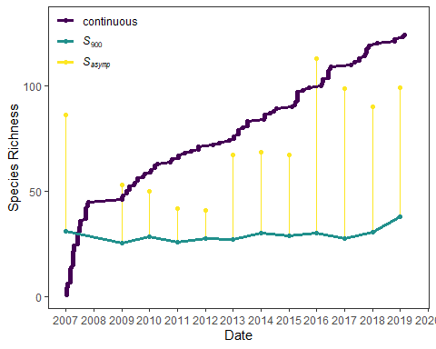

Figure 1. Multiple measures of species richness within the trawl community between the years 2007 to 2019 show continual accumulation of species (purple points and line) through the timeseries. The estimated asymptotic species richness over a calendar year (Sasymp; median values and 95% percentile interval represented by yellow points and area), suggests increasing numbers of species within the community over time. However, rarefied species richness controlled to 900 individuals (S900; median values and 95% percentil interval represented by green line and area) suggests the perceived increase in Sasymp may represent an effect of increased sampling effort

Consistent with the pattern of continued accumulation of new species throughout the sampling series and the relatively stable effort-controlled richness, species gains and losses generally balanced (Figure 2 ). Total turnover averaged 0.46 and decreased with time from a peak turnover of 0.58 in 2009 to 0.4 in the final year of record, 2019 (Figure 2). The contribution of species gains to total turnover averaged 0.25 and ranged from 0.35 to 0.17, whereas, species losses average 0.21 and ranged from 0.33 to 0.1.

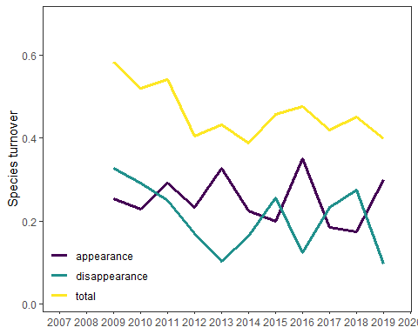

Figure 2. Total species turnover and partitioning

Species turnover was likely confined to species with moderate to low relative abundances. The effective number of highly abundant species, *2D*, was variable but stable through time with calculated values *ca.* 4.6 0.9 (mean 1 SD) (range: 3.42 to 6.9; Figure 3 ***supplemental?***). In contrast, the percentage of rare species increased slightly through time from 87.8 to 94.67. Additionally, the evenness in species abundances showed a clear decline through time from a median value of 0.15 in 2007 to 0.08 in 2019.

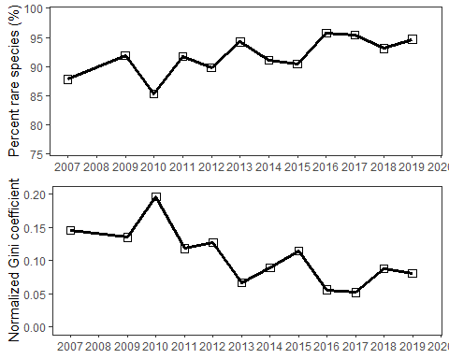

Figure 4. Species rarity and evenness in relative abundances through the data series.

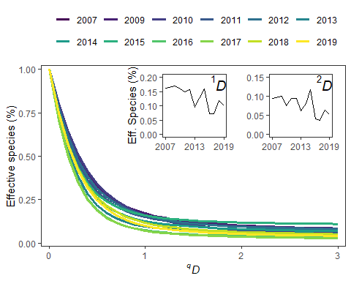

Figure 5. Species evenness profiles based on Hill numbers relative to annual species richness. 0D is equal to the total number of species

# Discussion

# Acknowledgements

# References

Antão, L. H., A. E. Bates, S. A. Blowes, C. Waldock, S. R. Supp, A. E. Magurran, M. Dornelas, and A. M. Schipper. 2020. Temperature-related biodiversity change across temperate marine and terrestrial systems. Nature Ecology & Evolution:1–7.

Bianchi, T. S., S. F. DiMarco, R. W. Smith, and K. M. Schreiner. 2009. A gradient of dissolved organic carbon and lignin from TerrebonneTimbalier Bay estuary to the Louisiana shelf (USA). Marine Chemistry 117:32–41.

Blowes, S. A., S. R. Supp, L. H. Antão, A. Bates, H. Bruelheide, J. M. Chase, F. Moyes, A. Magurran, B. McGill, I. H. Myers-Smith, M. Winter, A. D. Bjorkman, D. E. Bowler, J. E. K. Byrnes, A. Gonzalez, J. Hines, F. Isbell, H. P. Jones, L. M. Navarro, P. L. Thompson, M. Vellend, C. Waldock, and M. Dornelas. 2019. The geography of biodiversity change in marine and terrestrial assemblages. Science 366:339–345.

Chamberlain, S., E. Szoecs, Z. Foster, Z. Arendsee, C. Boettiger, K. Ram, I. Bartomeus, J. Baumgartner, J. O’Donnell, J. Oksanen, B. G. Tzovaras, P. Marchand, V. Tran, M. Salmon, G. Li, and M. Grenié. 2020. Taxize: Taxonomic information from around the web. Manual.

Chao, A. 1987. Estimating the Population Size for Capture-Recapture Data with Unequal Catchability. Biometrics 43:783.

Chao, A., and C. Ricotta. 2019. Quantifying evenness and linking it to diversity, beta diversity, and similarity. Ecology 100:e02852.

Chase, J. M., B. J. McGill, D. J. McGlinn, F. May, S. A. Blowes, X. Xiao, T. M. Knight, O. Purschke, and N. J. Gotelli. 2018. Embracing scale-dependence to achieve a deeper understanding of biodiversity and its change across communities. Ecology Letters 21:1737–1751.

Gini, C. 1921. Measurement of Inequality of Incomes. The Economic Journal 31:124–126.

Gotelli, N. J., and R. K. Colwell. 2001. Quantifying biodiversity: Procedures and pitfalls in the measurement and comparison of species richness. Ecology Letters 4:379–391.

Hill, M. O. 1973. Diversity and Evenness: A Unifying Notation and Its Consequences. Ecology 54:427–432.

Hillebrand, H., B. Blasius, E. T. Borer, J. M. Chase, J. A. Downing, B. K. Eriksson, C. T. Filstrup, W. S. Harpole, D. Hodapp, S. Larsen, A. M. Lewandowska, E. W. Seabloom, D. B. V. de Waal, and A. B. Ryabov. 2018. Biodiversity change is uncoupled from species richness trends: Consequences for conservation and monitoring. Journal of Applied Ecology 55:169–184.

Inoue, M., and W. J. Wiseman. 2000. Transport, Mixing and Stirring Processes in a Louisiana Estuary: A Model Study. Estuarine, Coastal and Shelf Science 50:449–466.

Li, D. 2018. hillR: Taxonomic, functional, and phylogenetic diversity and similarity through Hill Numbers. Journal of Open Source Software 3:1041.

McGlinn, D., X. Xiao, B. McGill, F. May, T. Engel, C. Oliver, S. Blowes, T. Knight, O. Purschke, N. Gotelli, and J. Chase. 2021. Mobr: Measurement of biodiversity. Manual.

Scheffer, M., and S. R. Carpenter. 2003. Catastrophic regime shifts in ecosystems: Linking theory to observation. Trends in Ecology & Evolution 18:648–656.

Shoemaker, L. G., L. L. Sullivan, I. Donohue, J. S. Cabral, R. J. Williams, M. M. Mayfield, J. M. Chase, C. Chu, W. S. Harpole, A. Huth, J. HilleRisLambers, A. R. M. James, N. J. B. Kraft, F. May, R. Muthukrishnan, S. Satterlee, F. Taubert, X. Wang, T. Wiegand, Q. Yang, and K. C. Abbott. 2020. Integrating the underlying structure of stochasticity into community ecology. Ecology 101:e02922.

Simpson, E. H. 1949. Measurement of Diversity. Nature 163:688–688.

Solomon, D. L. 1975. A comparative approach to species diversity:7.

Steffen, W., W. Broadgate, L. Deutsch, O. Gaffney, and C. Ludwig. 2015. The trajectory of the Anthropocene: The Great Acceleration. The Anthropocene Review 2:81–98.

Williams, J. W., J. L. Blois, and B. N. Shuman. 2011. Extrinsic and intrinsic forcing of abrupt ecological change: Case studies from the late Quaternary. Journal of Ecology 99:664–677.