Environmental temperature increases both the absolute and relative importance of high-turnover channels in food web energy fluxes

James R. Junker1,2,✉, Wyatt F. Cross1, James M. Hood3, Jonathan P. Benstead4, Alex D. Huryn4, Daniel Nelson5, Jon S. Olafsson6, and Gisli M. Gislason7

1 Department of Ecology, Montana State University, Bozeman, MT USA  
2 Current address: Great Lakes Research Center, Michigan Technological University, Houghton, MI USA  
3 Department of Evolution, Ecology, and Organismal Biology, The Ohio State University, Translational Data Analytics Institute, The Aquatic Ecology Laboratory, Columbus, OH 43212, USA  
4 Department of Biological Sciences, University of Alabama, Tuscaloosa, AL 35487, USA  
5 National Aquatic Monitoring Center, Department of Watershed Sciences, Utah State University, Logan, UT 84322, USA  
6 Institute of Marine and Freshwater Fisheries, Reykjavik, Iceland  
7 Univeristy of Iceland, Institute of Life and Environmental Sciences, Reykjavik, Iceland

✉ Correspondence: [James R. Junker <[jrjunker@mtu.edu](mailto:jrjunker@mtu.edu)>](mailto:jrjunker@mtu.edu)

# Abstract

Warming temperatures are altering communities and trophic networks globally. While the influence of warming in food webs is often context-dependent, increasing temperatures are predicted to alter food webs and ecosystems in a number of general and fundamental ways, among them, 1) decreasing organism body size and 2) increasing metabolic rates. Both body size and metabolic rate are important drivers of many ecological patterns. Therefore, warming-induced changes have the potential to propagate through countless ecosystem processes thereby altering the distribution of food web fluxes, food web stability, and potentially the importance of environmental and biological factors in community assembly. Here, we quantify the patterning and relative distribution of organic matter fluxes through stream food webs spanning a natural ~25C temperature gradient. We then related patterns in fluxes to species and community traits (body size, *M* and biomass turnover, *P:B*) within and across ecosystems. We predicted 1) warmer communities would skew towards smaller *M* and higher *P:B* across ecosystems, 2) organic matter fluxes within communities would increasingly skew towards smaller, higher *P:B* populations at higher temperatures. Across the temperature gradient, communities in warmer streams were composed of smaller-bodied and higher-turnover populations on average. Additionally, material fluxes of warmer streams were increasingly skewed towards high-turnover populations *within* the community, showing higher temperatures restructured organic matter fluxes in both an absolute and relative sense. Lastly, in warmer ecosystems the relative distribution of organic matter fluxes appears to be increasingly ‘non-random’, evidence of potentially stronger selection for these traits with increasing temperature. The emerging picture is a warmer world that is both smaller and faster. Our study lends further support to this pattern and suggests that temperature will become an increasingly important environmental filter on warming communities in the future.

# Introduction

Increasing global temperatures are altering the provisioning and maintenance of ecosystem services by modifying the network of interactions among species that underpin ecosystem functions (de Ruiter et al. 1995, Woodward et al. 2010, Brose et al. 2012, Thompson et al. 2012). Temperature’s effects permeate across levels of biological organization from its control on individual metabolic rates (Gillooly et al. 2001, Brown et al. 2004) and biological activity (e.g., attack rate, handling time, growth rates, etc.; Dell et al. (2014). Across global climate gradients, these temperature-induced changes mediate the dynamics and stability of food webs (Baiser et al. 2019) by altering the acquisition and allocation of resources among species (Zhang et al. 2017) and ultimately the magnitudes and relative distribution of biomass and energy fluxes among species and trophic levels (May 1972, McCann et al. 1998, Barnes et al. 2018, Gibert 2019).

Crucially, understanding how increasing temperatures alter the absolute and relative distributions of biomass among trophic levels and the energy and organic matter fluxes among them, will depend upon how temperature modifies the connections between ecosystem structure (i.e. biodiversity) and ecosystem functions (BEF). An extensive body of BEF research has largely focused on the effects of species richness on ecosystem function, however, species richness represents only a single facet of biodiversity. Even as temperature appears to have minimal control on species richness across taxonomic groups (e.g., Bastazini et al. 2021), it can have profound effects on the dominance structure (i.e. evenness) of ecological communities, often reducing community evenness as a few well-adapted species become dominant (Hillebrand et al. 2008). The implications of shifting dominance on BEF relationships ultimately relate to connection among species dominance and species traits (Loreau et al. 2001); specifically, how the altered assembly of local communities relates to trait distributions and how trait distributions relate to ecosystem functions (Norberg et al. 2001, Norberg 2004).

The extent to which temperature modifies the relative importance of community assembly processes will mediate changes to ecosystem structure and function with warming within and among ecosystems. These processes are varied–from strictly deterministic ( e.g., environmental/niche filtering, Whittaker 1962), to strictly stochastic ( e.g., neutral theory, Hubbell 2001)–and they operate across multiple scales. As such, there are a multitude of possible relationships between warming and species’ abundance and trait distributions. For example, strong environmental filtering can be expected to mediate the number of species in a community and is likely to skew trait distributions, to some extent, in natural communities (Therriault and Kolasa 1999). However, the relative distribution of traits can be modified by a number of additional processes beyond environmental filtering that alter species relative abundance distributions Hubbell (2001). These additional processes can exaggerate or counter any skew in trait distribution imparted through environmental filtering and may therefore be important for understanding the warming response in species and communities and the absolute and relative distribution of organic matter fluxes across gradients in species traits.

There are numerous traits that appear to be associated with environmental temperature. For example, reduced organismal body size with warming is considered a ‘universal’ response to climate change (Atkinson 1994, Daufresne et al. 2009, Gardner et al. 2011). Body size reductions arise from multiple mechanisms acting at different levels of organization, such as the increased relative abundance of smaller species within warmer communities (Bergmann 1848), or smaller individuals in warmer populations (James 1970), or through reduced body size of warmer individuals (Atkinson 1994). Temperature-size relationships (TSR) are likely to influence the distribution of body sizes both across and within ecosystems, such that warmer communities should contain smaller species and populations, on average, and smaller organisms should be more dominant within a community. These changes can have important implications for ecosystems pattern and processes because body size is a strong determinant of an organism’s biology (Peters 1983) influencing, life history patterns (Altermatt 2010, Zeuss et al. 2017, Nelson et al. 2020a), and developmental (Angilletta et al. 2004) and metabolic rates (Gillooly et al. 2001, Brown et al. 2004).

Organismal metabolic rate, in addition to being controlled by body size, is strongly influenced by temperature (Gillooly et al. 2001). Therefore, temperature may alter metabolic rate indirectly through reductions in body size, as well as directly through its effects on subcellular kinetics (Osmond et al. 2017, Bideault et al. 2019). The interactive effect of these processes has been shown to modify ecosystem patterns through effects on population abundance (Bernhardt et al. 2018), consumer-resource interactions (Bideault et al. 2019), and food web structure (Gibert 2019). Importantly, the kinetic effects of temperature are tied to many biological processes (Dell et al. 2014), among them growth rate (Gillooly et al. 2001), developmental rate (Zuo et al. 2012, Nelson et al. 2020a), voltinism (Zeuss et al. 2017), and population turnover rate (Brown et al. 2004, Huryn and Benke 2007). As such, the emerging picture suggests a smaller, faster world in which warming “speeds up” ecosystem processes through the compounded effects of smaller body size and higher turnover rates.

Here, we measured the patterning and distribution of organic matter fluxes within invertebrate food webs across a natural stream temperature gradient (~5–28C). Previous research in these streams has shown a strong positive effect of temperature on primary production both among streams (Demars et al. 2011, Padfield et al. 2017) and within streams seasonally (O’Gorman et al. 2012, Hood et al. 2018). Consumers rely largely on autochthonous resources (O’Gorman et al. 2012, Nelson et al. 2020b) and therefore the dynamics of primary production have a strong control on consumer energy demand (Junker et al. 2020). As such, we predicted annual organic matter fluxes to consumers would increase with temperature across streams mirroring among-stream patterns in resource availability and consumer energy demand. We hypothesized temperature to be a strong environmental filter of community assembly and the distribution of energy and organic matter fluxes. From this we made a number of predictions regarding the patterning of organic matter fluxes within and across communities of different temperature, with particular focus on two species traits; body size and population biomass turnover (production:biomass ratios, *P:B*). First, we predict warmer temperatures should favor smaller and faster turnover species leading to a decrease in body sizes and increase in *P:B* on average across communities. Second, within communities organic matter fluxes should be increasingly dominated by smaller, higher turnover species at warmer temperatures. Lastly, we quantify the probability that patterns of organic matter fluxes among populations arise from chance versus the potential for temperature to structure the relative distribution of material fluxes along species trait axes.

# Methods

We studied six streams within the Hengill geothermal field of southwestern Iceland (64 03’N 021 18’W) that varied in mean annual temperature. Hengill is characterized by indirect geothermal heating of groundwater (Arnason et al. 1969), leading to natural variability in water temperatures (4.5–54.0 C), but similar solute chemistries (Friberg et al. 2009). These conditions create a “natural laboratory” for isolating the effects of temperature on ecosystem processes (O’Gorman et al. 2014, Nelson et al. 2017b). We selected streams to maximize the temperature range, while minimizing differences in the structural aspects of primary producers. In each stream, we measured temperature and water depth every 15 min from July 2010 through August 2012 (U20-001-01 water-level logger, Onset Computer Corp. Pocasset, MA, USA). Light availability in the watershed was measured every 15 min from atmospheric stations (HOBO pendant temperature/light UA-002-64, Onset Computer Corp. Pocasset, MA, USA).

## Invertebrate sampling

We sampled macroinvertebrate communities approximately monthly from July 2011 to August 2012 in four streams and from October 2010 to October 2011 in two streams used in a previous study (*n* = 6 streams). The two streams were part of an experiment beginning October 2011, therefore overlapping years were not used to exclude the impact of experimental manipulation (Nelson et al. 2017a, 2017b). Inter-annual comparisons of primary and secondary production in previous studies showed minimal differences among years in unmanipulated streams, suggesting that combining data from different years would not significantly bias our results (Nelson et al. 2017a, Hood et al. 2018). We collected five Surber samples (0.023 m2, 250 m mesh) from randomly selected locations within each stream. Within the sampler, inorganic substrates were disturbed to ~10 cm depth and invertebrates and organic matter were removed from stones with a brush. Samples were then preserved with 5% formaldehyde until laboratory analysis. In the laboratory, we split samples into coarse (>1 mm) and fine (<1 mm but >250 m) fractions using nested sieves and then removed invertebrates from each fraction under a dissecting microscope (10–15 x magnification). For particularly large samples, fine fractions were sub-sampled (1/2–1/16th) using a modified Folsom plankton splitter prior to removal of invertebrates. Subsamples were scaled to the rest of the sample assuming similar abundance and body size distributions. Macroinvertebrates were identified to the lowest practical taxonomic level (usually genus) with taxonomic keys (Peterson 1977, Merritt et al. 2008, Andersen et al. 2013). Taxon-specific abundance and biomass were scaled to a per meter basis by dividing by the Surber sampler area.

## Secondary Production

Daily secondary production of invertebrate taxa was calculated using the instantaneous growth rate method (IGR, Benke and Huryn 2017). Growth rates were determined using taxon appropriate approaches described in (Junker et al. 2020). Briefly, growth rates of common taxa (e.g., Chironomidae spp., *Radix balthica*, etc.) were determined using *in situ* chambers (Huryn and Wallace 1986). Multiple individuals (*n* = 5–15) within small size categories (~1 mm length range) were photographed next to a field micrometer, placed into the stream within pre-conditioned chambers for 7–15 days, after which they were again photographed. Individual lengths were measured from field pictures using image analysis software (Schindelin et al. 2012), and body lengths were converted to mass (mg ash-free dry mass [AFDM]) using published length-mass regressions (Benke et al. 1999, O’Gorman et al. 2012, Hannesdóttir et al. 2013). Growth rates (*g*, d-1) were calculated by the changes in mean body size (*M*) over a given time interval (*t*) with the following equation:

Variability in growth rates was estimated by bootstrapping through repeated resampling of individual lengths with replacement (*n* = 1000). For taxa which exhibit synchronous growth and development (e.g., Simuliidae spp., some Chironomidae spp., etc.), we examined temporal changes in length-frequency distributions and calculated growth rates and uncertainty using a bootstrap technique similar to that described in Benke and Huryn (2017). Individual Lengths were converted to mg AFDM using published length-mass regression cited above and size-frequency histograms were visually inspected for directional changes in body size through time. For each date, size-frequency distributions were resampled with replacement and growth rates estimated from equation 1. We prevented the calculation of negative growth rates by requiring > . If this condition was not met after 1e4 resamplings, a minimum growth rate of 0.001 was set. To estimate growth rates of taxa for which growth could not be estimated empirically, we developed stream-specific growth rate models by constructing multivariate linear regressions of empirical growth data against body size and temperature within each stream. To estimate uncertainty in production of each taxon, we used a bootstrapping technique that resampled measured growth rates, in addition to abundance and size distributions from individual samples. For each iteration, size-specific growth rates were multiplied by mean interval biomass for each size class and the number of days between sample dates to estimate size class-specific production. For each interval, size classes were summed for each taxon to calculate total population-level production. Intervals were summed to estimate annual secondary production.

## Organic Matter Consumption Estimates

Organic matter fluxes through the community (g m-2 t-1) were calculated using the trophic basis of production method (TBP, Benke and Wallace 1980). Taxon-specific secondary production estimates were combined with diet proportions (see Supplemental Materials), diet-specific assimilation efficiencies, *AEi*, and assumed net production efficiencies, *NPE*, to estimate consumption of organic matter. For each food category, *i*, diet proportions were multiplied by the gross growth efficiency () to calculate the relative production attributable to each food category. The relative production from each food type was then multiplied by the interval-level production and finally divided by to estimate consumption of organic matter from each food category by a consumer (Benke and Wallace 1980). Consumption was calculated for each taxon across sampling intervals (typically ~1 month). Total interval consumption was calculated by summing across all taxa, while annual consumption was calculated by summing across all taxa and intervals. Variability in consumption estimates was estimated through a Monte Carlo approach, wherein bootstrapped vectors of secondary production for each taxon (see *Secondary production* methods above) were resampled and consumption estimated with the TBP method using modeled diet proportions (see *Diet analysis* in Supplemental Materials), diet-specific assimilation efficiencies, and net production efficiency. Variability in *AEi* was incorporated by resampling values from beta distributions fit to median and 2.5% and 97.5% percentiles for each diet item: diatoms = 0.30 (95% percentile interval (PI): 0.24-0.36), filamentous and green algae = 0.30 (95% PI: 0.24-0.36), cyanobacteria = 0.10 (95% PI: 0.08-0.12), amorphous detritus = 0.10 (95% PI: 0.08-0.12), vascular and non-vascular plants (bryophytes) = 0.1 (95% PI: 0.08-0.12), and animal material = 0.7 (95% PI: 0.56-0.84)(Welch 1968, Benke and Wallace 1980, 1997, Cross et al. 2007, 2011). Variability in *NPE* was incorporated by resampling values from an assumed beta distribution with median *NPE* = 0.45 (95% PI = 0.4-0.5). Beta distributions were fit using the ‘get.beta.par()’ function within the *rriskDistributions* package (Belgorodski et al. 2017).

## Quantifying the distribution of food web fluxes

### Evenness Among consumers

To visualize and quantify how evenly OM fluxes were distributed among consumers within a stream, we constructed Lorenz curves (Lorenz 1905) on rank ordered OM fluxes, such that in a community with species and the relative OM flux of species *i*, , is ordered . The Lorenz curve plots how a value, in this case OM flux, accumulates with increasing cumulative proportion of species. In a community with perfectly equal distribution of OM flux among species, the Lorenz curve is simply a straight diagonal line. Deviation from perfect equality was calculated as the Gini coefficient (Gini 1921), normalized for differences in among streams, (Solomon 1975, Chao and Ricotta 2019):

where represents an index of relative evenness of OM fluxes bounded between zero and one–one representing a community with exactly equal proportion of total community OM flux for all species (), and a value of zero where total community flux is attributed to a single species.

### Distribution of OM fluxes in relation to species’ traits

We predicted that warming would favor species with smaller body size and higher population turnover and therefore OM fluxes would be skewed towards small body size (*M*) and higher *P:B* across and within communities. To assess the potential effects of environmental filtered across communities, we explored the relationships between mean annual temperature (C) and mean population *M* and *P:B* of each community with bootstrapped linear regressions. Here, 1000 values of population *M* or *P:B* were resampled with replacement for each species within each stream. The mean of all populations within a stream was calculated and a linear model was fit between *loge*-transformed *M* or *P:B* and mean annual temperature. Response variables *M* and *P:B* were transformed to meet the assumption of normally distributed residual variation.

To quantify how the distribution of organic matter fluxes were modified ***within*** a community and how this modification was related to temperature, we assessed the extent to which the relative OM fluxes among consumers within a community were skewed towards populations with lower or higher relative *M* or *P:B*. To do this, we ordered species based on within-stream ranking of annual population traits (i.e., , ) and then calculated a measure of skewness, , based on quartiles of the distribution of OM fluxes in relation to species traits as:

where, , is the cumulative flux at some quantile, , of the community trait distribution. We repeated this analysis for all bootstrapped estimates of OM flux in all communities. Skewness coefficients exist in the range [-1, 1], where -1 indicates OM fluxes are skewed perfectly away from a trait and 1 indicates higher relative flux is perfectly associated with higher trait values. To determine if with population *M* and *P:B* was related to mean annual stream temperature, we use bootstrapped beta regression with a simple transformation to meet the assumptions of the model, , thereby standardizing values between 0 and 1. Model coefficients were back-transformed to estimate effect sizes.

To assess how temperature may structure the skew of OM among populations within a community, we quantified how likely it was to observe such a skewed distribution in OM fluxes by random chance. Skewness in OM fluxes may arise through both ecological and random processes. Further, the feasible range of skewness values a community can take is inherently tied to the evenness of OM fluxes within a community. This dependence on evenness can make it difficult to determine the importance of random versus ecological processes on the distribution of OM fluxes in the community through comparison of raw skewness measures alone. Here, we predicted that species’ and would be increasingly important traits structuring OM fluxes within a community and therefore warmer streams would exhibit highly skewed OM distributions that would be unlikely due to chance (i.e., ‘non-random ordering’). In contrast, cooler streams would exhibit OM fluxes with skew values that are more likely due to random chance (‘random ordering’), regardless of raw skewnness values, suggesting other traits govern the distribution of OM fluxes within communities. To accomplish this, we first had to account for statistical constraints that restrict the range of possible outcomes ( i.e., feasible set, Haegeman and Loreau 2008, Diaz et al. 2021), given the number of species and the relative distribution of OM fluxes within a community. The number of unique orderings of species increases to computationally intractable numbers very quickly (e.g., , 10 species ~3.6e6 unique orderings). Therefore, we chose to permute a random subset of each stream community’s feasible set by randomly ordering species and calculating the skewness in the cumulative distribution of annual OM fluxes 100,000 times in each stream. The number of random orderings was chosen as a balance between characterizing the distribution of skewness values within each feasible set and computational and time constrains. This permuted set allowed us to calculate the probability of observing the empirical skewness, , in each stream compared to a random ordering given the distribution of relative OM flux.

# Results

## Community organic matter fluxes

Annual community OM fluxes mirrored patterns of secondary production previously reported (Junker et al. 2020). Organic matter flux demand varied ~45.3-fold across streams (3.91; 2.087 – 6.24 to 177.1; 126 – 236.4 g AFDM mean; 95% percentile interval (PI)) and was positively related to temperature.

Patterns of OM flux among streams were most closely tied to total consumer energy demands as consumer diets exhibited high similarity among streams (Supporting Materials, Figure S1). Diets composition among all streams were dominated by diatoms (44%; 0–75.7 95% PI), amorphous detritus (17.3%;0–32.3 95% PI), and green algae (13.3%;0–42.8 95% PI). Within streams, diet overlap ranged from 0.68% (0.65 – 0.71%) to 0.75% (0.7 – 0.79%) among all consumer taxa. Among streams, diet overlap was similarly high and mean overlap among all streams was 0.89% (0.84 – 0.92% 95% PI). Diet similarity of pairwise comparisons among streams showed little differences in diet among streams and no clear relationship with temperature.

## Evenness of organic matter fluxes within streams

Generally, OM fluxes were dominated by insect species from Simuliidae and Chironomidae families (Figure 2a) and were distributed unevenly (Figure 2b; Figure S2). In an absolute sense, ~85% of total flux was contributed by between 2 and 10 consumer groups. Relatively, this flux was attributed by 3% to 29% of the consumer assemblage within streams. Differences in evenness were partly attributed to variation in consumer species richness among streams which ranged from 14 to 35 consumer groups. Gini inequality coefficients ranged from 0.09 (0.07 – 0.11 95% PI) to 0.29 (0.25 – 0.32 95% PI; Table S1). In warmer streams, OM fluxes shifted toward the black fly, *Simuliium vittatum* and the pulmonate snail, *Radix balthica*. In the warmest stream, where maximum temperatures approach ~40C, species richness was lowest and OM fluxes were dominated by oligochaete worms of family Naididae, the chironomid *Cricotpous sylvestris*, and *Radix balthica*. Yet, even after accounting for differences in consumer richness, patterns of OM flux were still unevenly distributed among consumers (Normalized Gini coefficient: 0.06 (0.05 – 0.08 95% PI) to 0.26 (0.23 – 0.3 95% PI; Table S1). Differences in evenness and dominance were unrelated to temperature, however, species dominance in relation to population traits exhibited important differences along the temperature gradient.

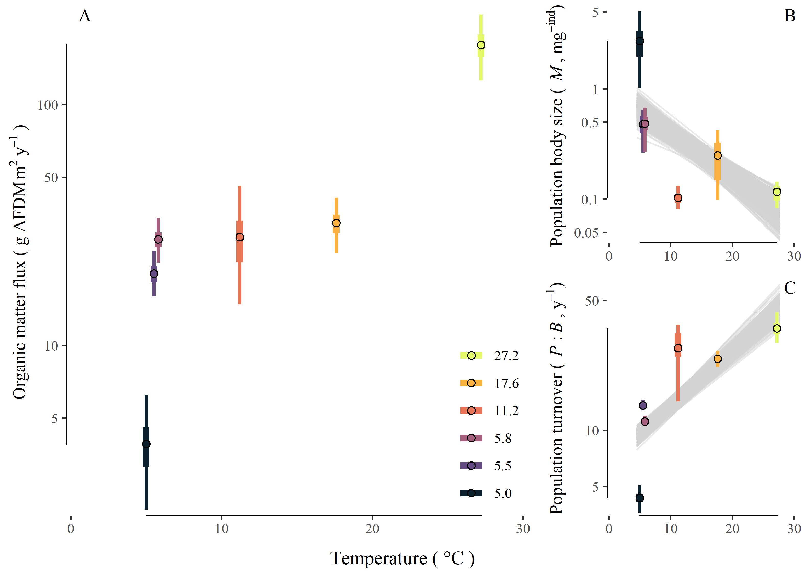

Figure 1. A) Total organic matter flux (g AFDM m-2 y-1) increased with increasing mean annual temperature. This mirrored a cocomitant decrease in B) mean population body size (*M*, mg ind1) and C) increase in population biomass turnover rate (*P:B*, y-1) across the temperature gradient.

## Organic matter fluxes along species trait distributions among sites and taxa

Across communities, average population body size, *M*, decreased and average biomass turnover, *P:B*, increased with increasing temperature (Figure 1B & C). Mean population *M* decreased from 2.75 mg ind-1 (1.03 – 5.08 95% PI) in the coldest stream to 0.1 mg ind-1 (0.08 – 0.13 95% PI) in the warmest stream. This decrease corresponded to a -8.73 (-11.14 – -6.4 95% PI) percent decrease in mean population body size (mg ind-1) for every increase of 1C (Figure 1B). In contrast, the average population *P:B* increased from 4.36 y-1 (3.63 – 5.09 95% PI) in the coldest stream to 35.51 y-1 (29.59 – 0.14 95% PI) in the warmest stream. This increase corresponded to a 6.94% (6.15–7.85 95% PI) increase in mean population biomass turnover (P:B y-1) for every increase of 1C (Figure 1C).

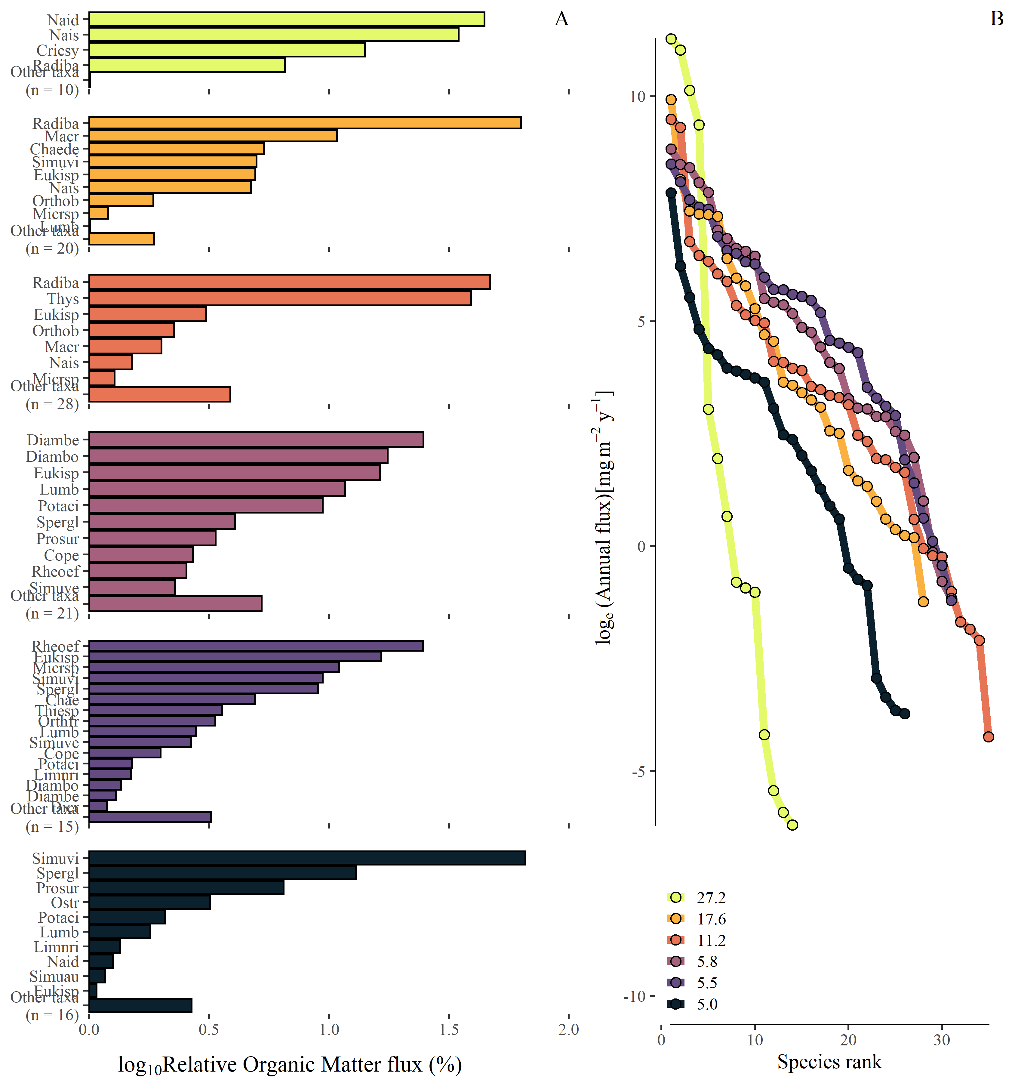

Figure 2. Patterns of OM flux among populations based on (a) relative OM flux among taxonomic groups in consumer communities and descending the temperature gradient from the warmest (27.2C) on top pane to coldest (5.0C) on the botthom. (b) The rank ordering of annual population organic matter flux loge(mg m-2 y-1) of consumer groups. The full key of consumer group abbreviations can be found in supporting materials.

Organic matter fluxes within consumer communities were skewed towards larger body sizes (positive skew), towards smaller body sizes (negative skew), or neutrally in regards to body size among streams (Figure 3A). Skew estimates with body size (*M*) ranging from -0.84 to 0.49 (Figure 3B). The skew of OM fluxes towards populations with smaller/larger body sizes showed little association with stream temperature except at the most extreme temperatures (Figure 3B). Similarly, skew in fluxes towards high *P:B* taxa varied among streams ranging from -0.32 to 1 and organic matter fluxes through the community skewed increasingly toward higher turnover (*P:B*) organisms with increasing temperature (Figure 4A & B).

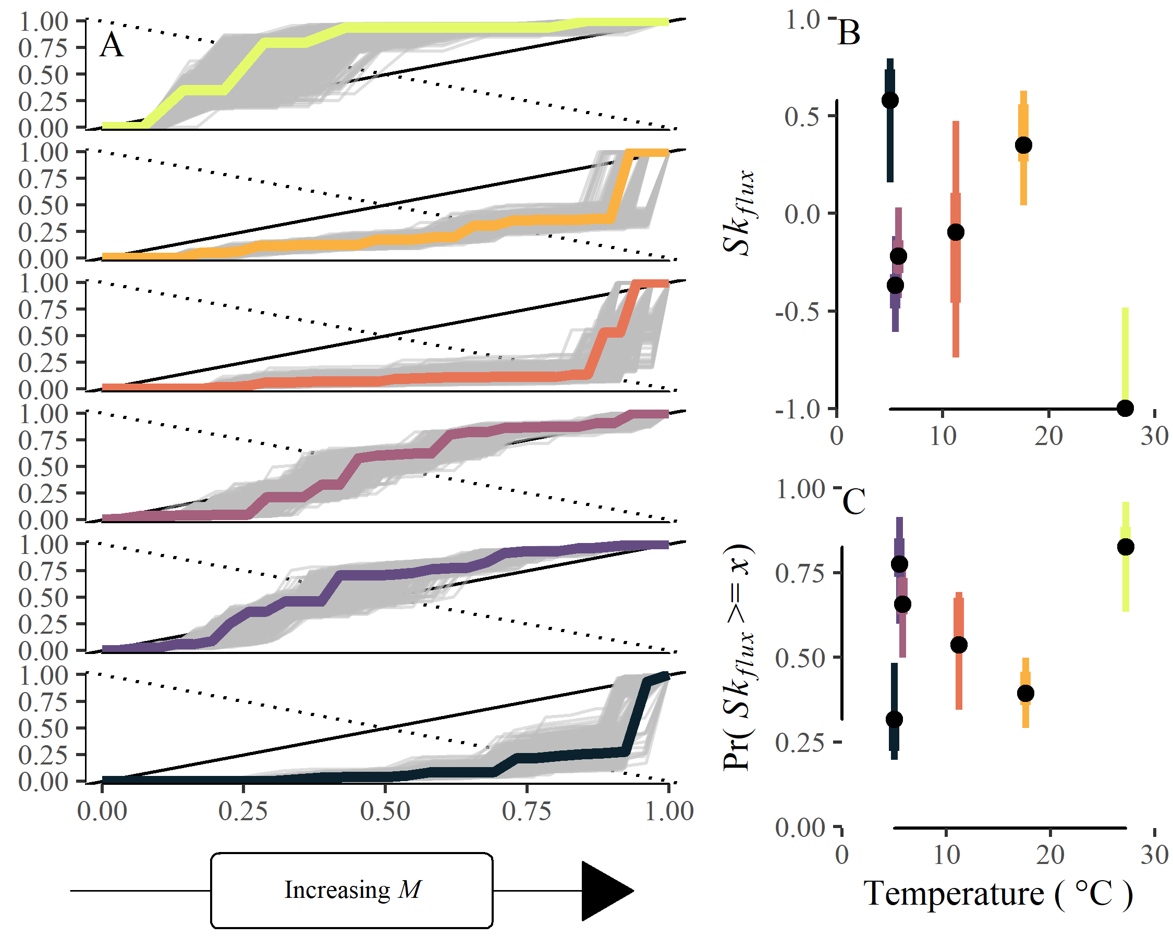

Figure 3. A) Lorenz curves of cumulative relative organic matter flux with increasing cumulative species. Within streams, species are ranked by increasing relative body size (*M*, mg ind-1) such that x1 < x2 < xi <…xS, where x is the mean body size of species *i*. The solid line 1:1 line from the origin represents the line of perfect equality and distributions near this line support minimal structuring of OM fluxes in relation to body size. The dotted line allows for visual approximation of the skewness of the OM distribution based on its intersection with the empirical lorenz curve. B) Empirical estimates of in the skewness of organic matter fluxes in relation to mean body size and C) the probability of observing skewness values compared to a random ordering.

We compared the empirical measurement within streams to a random ordering to detect random vs. non-random structure in community OM fluxes. The probability of observing a similar or more extreme skew of within stream OM fluxes in relation to species body size ranged from 0.34 (0.19–0.55 95% PI) to 0.79 (0.07–0.95 95% PI; Figure 3C). Similarly, the probability of a more extremely skewed distribution in relation to population *P:B* ranged from 0.06 (0 – 0.75 95% PI) to 0.62 (0.22 – 0.82 95% PI; Figure 4C). The probability that OM fluxes were organized randomly or non-randomly in regards to body size showed a slight increase of 1.6% (1.3% – 1.9% 95% PI) change with 1C change in temperature (Figure 3C). In contrast, there was a trend towards a more structured OM flux distribution with regard to population *P:B* at higher temperatures. The probability of observing such skewed OM fluxes randomly became less likely with temperatures, such that the probability of random ordering decreased -4.6% (-5.1% – -4.2% 95% PI) for every 1C increase (Figure 4C).

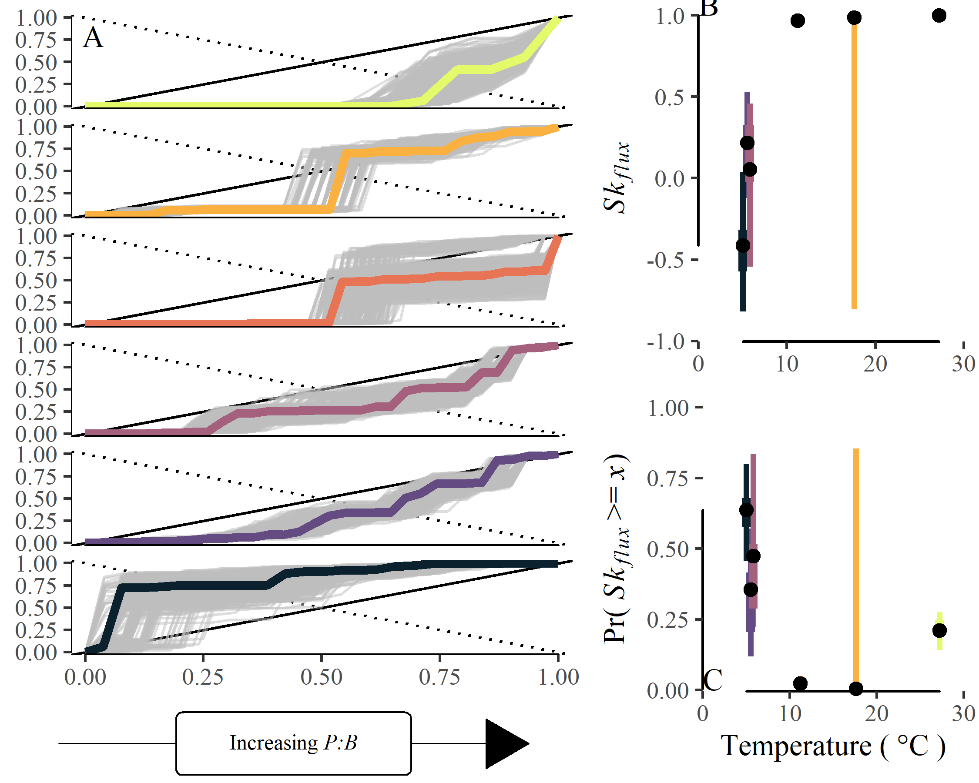

Figure 4. A) Lorenz curves of cumulative relative organic matter flux with increasing cumulative species. Within streams, species are ranked by increasing relative population biomass turnover (*P:B* y-1) such that x1 < x2 < xi <…xS, where x is the *P:B* of species *i*. The solid line 1:1 line from the origin represents the line of perfect equality and distributions near this line support minimal structuring of OM fluxes in relation to body size. The dotted line allows for visual approximation of the skewness of the OM distribution based on its intersection with the empirical lorenz curve. B) Empirical estimates of in the skewness of OM fluxes in relation to mean *P:B* and C) the probability of observing skewness values compared to a random ordering.

# Discussion

Rising global temperatures are altering the pathways of energy and material flow across and within ecosystems with potential consequences for the services they provide. While a growing body of theoretical and empirical study has enhanced our knowledge of temperature-mediated changes to ecosystems ( e.g., O’Connor et al. 2009), general patterns are uncertain and empirical studies often idiosyncratic (Nelson et al. 2017a, Zhang et al. 2017)—especially at higher levels of organizations such as communities and food webs (Walther et al. 2002, Woodward et al. 2010). Here, we document shifts in the pathways of material flow across a wide natural temperature gradient and show that increasing temperatures were associated with reductions in mean population body size and increases in mean population *P:B* across stream consumer communities. Further, increasing temperature also systematically skewed OM fluxes *within* communities such that, food web fluxes were increasingly skewed towards quick turnover populations at warmer temperatures. Lastly, there was evidence that the distribution of fluxes within communities was non-randomly organized, especially at moderate to warm temperatures and in relation to population *P:B*, suggesting that environmental filtering is especially important in community assembly of warm communities–governing both the traits of species present and the relative distribution of energy and materials fluxes among species. This tendency for fluxes to be dominated by relatively higher turnover populations at warmer temperatures and this organization to be increasingly non-random, suggests the speeding up of energy and material fluxes through ecosystems in both an absolute and relative sense may be a general effect of increasing temperature.

Reductions in organism body size with warming has been deemed a “universal” response to warming (Daufresne et al. 2009, Gardner et al. 2011, Uszko et al. 2022). We observed a clear decrease in the average individual body size of populations from cool to warm communities (Figure 1B), corresponding to ~-8.7% decline in the mass of individuals for every 1C increase in temperature. While this change represents a community-level shift, the magnitude of change is consistent with recent work on the effects of warming on organism body size across broad taxonomic groups (Deutsch et al. 2022). This reduction in body size with increasing temperature contrasts results from previous whole-ecosystem warming experiments which observed shifts in community biomass and productivity from smaller to larger organisms following a 3C increase in temperature (Nelson et al. 2017a, 2017b). Our results also counter observational studies in this system that have shown no consistent change in body size within diatom communities at either the population- or community-scale (Adams et al. 2013). These contrasting results are consistent with deviations from the “universal” response observed across taxonomic groups (e.g., diatoms, Adams et al. 2013, invertebrates Zeuss et al. 2017, birds Geist 1987, Riemer et al. 2018, fish Rypel 2014). Explanations for these deviations vary (Ohlberger 2013), some highlight additional processes such as competition and predation (DeLong et al. 2014), while others propose alternative models of organism body size optimization, such as the balance of resource supply and energy demand (e.g., Kozłowski et al. 2004, DeLong 2012). Crucially, these alternative models highlight the trade-off between asymptotic body size and metabolic demand (DeLong 2012) that can shape life history patterns ( i.e., voltinism, Zeuss et al. 2017, Nelson et al. 2020a, lifespan, Munch and Salinas 2009). Considering the connections between organism body size and many other ecological attributes (Peters 1983), reductions in body size with increasing temperatures could have broad implications for ecosystem dynamics with a changing climate (Gibert 2019).

Warmer ecosystems exhibited higher rates of material flux in both an absolute and relative sense. At the community level, we observed a ~6.9% increase in the mean biomass turnover rate (*P:B*; y-1). Temperature has long been recognized as an important driver of ecological rates (Gillooly et al. 2001) and the increase in biomass turnover among communities is likely attributed to the thermodynamic effect of temperature–in part. Biomass turnover rate is also tightly tied to organism body size (Brown et al. 2004, Huryn and Benke 2007) suggesting that temperature may influence the distribution of *P:B*s both directly through its effects on metabolic rates and indirectly by inducing reductions in organism body size. The increase in *P:B* we observed across communities was a similar relative magnitude as the reduction in body size (i.e., +6.9% vs –8.7%, respectively), providing equivocal evidence of the presence and/or importance of this interaction from this broad view. Despite this, the influence of this interaction between the direct and indirect effect of temperature on ecological patterns in increasingly recognized. For example, the effects of temperature on population carrying capacity appear to deviate from metabolic scaling predictions until the effects of concurrent changes to organism body size are taken into account (Bernhardt et al. 2018). Further, there is growing evidence that the interactive effects warming-induced changes to metabolic rates and body size distributions have important implications for the structure and functioning of food webs at higher temperatures (Sentis et al. 2017, Bideault et al. 2019, Gibert 2019) and may reflect shifting selection for species traits.

Temperature was also an important modifier of the relative performance of species and distribution of OM fluxes *within* communities. In addition to the observed decrease in mean body size and increase in biomass turnover rates across communities, species’ OM fluxes exhibited non-random patterning along species’ trait axes. Regarding body size, the pattern was equivocal. In the coldest and warmest streams, we saw a strong skew in material fluxes towards larger and smaller species, respectively. However, at more moderate temperatures (~6–17C), this pattern was not apparent. On the other hand, we observed a clearer relationship between the skewness of OM fluxes in relation to biomass turnover with increasing temperatures. Fluxes became more skewed and less random in relation to population *P:B* at warmer temperatures (Figure 4B & C). The seemingly weak within community patterns with body size and much clearer patterns with *P:B* present a potentially interesting insight into the more proximate processes by which temperature alters ecosystem structure and function. For example, despite the general trend of reduced body sizes at higher temperature (e.g., Daufresne et al. 2009, Gardner et al. 2011, Uszko et al. 2022), there is a lack evidence for persistent evolutionary selection within populations for smaller body sizes with warming (Siepielski et al. 2019). However, warming-induced body size reductions may act as a stabilizing process in consumer-resource interactions through reduced consumer:resource biomass ratios (Gilbert et al. 2014, Sentis et al. 2017, Osmond et al. 2017) and reductions in consumer growth rates relative to resource supply (Kozłowski et al. 2004, McCann 2011, DeLong 2012).

Therefore, the general response of reduced body size with warming or latitudinal temperature gradients may, in fact, mask the true constraints imparted by food web dynamics because of the correlation between body size and other biological traits (e.g., growth rate, mortality rate, lifespan, biomass turnover rate, etc.). In high latitude light-driven systems, such as those here, larger and/or slower populations may destabilize consumer-resource dynamics further through more extreme seasonal autocorrelation of resource growth (Greyson-Gaito et al. 2022), suggesting a connection between warming responses and a more general food web dynamic of increased relative rates of resource supply and consumer demand ( e.g., paradox of enrichment, McCann 2011). The importance of this dynamic may be under-appreciated in high-latitude ecosystems especially (McMeans et al. 2020) where warming is beginning to decouple light regimes and the timing of temperature-driven metabolic demands (McMeans et al. 2015, Huryn and Benstead 2019) likely driving future changes to biodiversity of these systems.

Temperature was not clearly associated with the broad biodiversity metrics of species richness or evenness/dominance of OM fluxes. We observed no clear decrease in species richness with increasing temperature found in other works (Petchey et al. 1999) beyond the warmest stream having the fewest species. However, variability in the taxonomic resolution among groups precludes a more robust analysis of any richness effects. Still, generally OM fluxes were unevenly distributed among consumers. Given the systematic unevenness in the distribution of individuals among species (Diaz et al. 2021), it may not be surprising that this carries over into energy and material fluxes. Interestingly, however, we found important structure in the unevenness of OM fluxes. Organic matter fluxes were increasingly skewed towards high *P:B* populations within warmer streams and this pattern was unlikely related to chance (Figure 4C), suggesting temperature may become an increasingly important environmental filter of community assembly and species relative performance. That the relative distribution was of OM fluxes was unlikely due to chance reduces that likelihood this pattern could be attributable to demographic stochasticity of consumers. This counters recent hypotheses integrating the metabolic theory of ecology (Brown et al. 2004) and neutral theory (Hubbell 2001) that suggest neutral processes should be more important at higher temperatures (Saito et al. 2021). The extent to which the patterns we observe here in the apparent increased importance of environmental/niche filtering at higher temperature represent general patterns or results from the specific context of this “natural laboratory” (O’Gorman et al. 2014) remains an open question.

Here, we documented the important structuring role of temperature in community assembly and the relative distribution of material fluxes across and within streams of a natural temperature gradient. Higher temperatures were associated with increased total flux through the food web as well as reductions in average population body size and increases in population biomass turnover. Further, biomass turnover rate was an increasingly important structuring trait at warmer temperatures, more so than organism body size. Yet, our results give support that warming may reduce organism size and also ‘speed up’ ecosystem dynamics in both an absolute and relative sense. These changes have important implications for the maintenance of biodiversity as well as for the connections between biodiversity and the magnitude and stability of energy and material cycling in ecosystems in a warming world.

# Acknowledgements

We are grateful to Sigurður Guðjonsson, Guðni Guðbergsson, and the staff at the Veiðimlastofnun for providing laboratory space and logistical support. We are also grateful to Sveinbj€orn Steinþorsson at the University of Iceland for super-jeep transport to our field sites during the winter. We thank Lauren David, David Hernandez, Amanda Keasberry, Elena Nava, Camille Perrett, Jackie Pitts, Friðþjófur Árnason, Liliana García, Ragnahildur Magnúsdottír, Ryan McClure, Vija Pelekis, Adam Toomey, Chau Tran, Brooke Weigel, Tanner Williamson and many undergraduate workers for field and laboratory help. Jeff Wesner and Abe Kanz generously provided R code and discussions on modeling diet proportions. This study was supported by the National Science Foundation (DEB-0949774 and DEB-1354624 to JPB and ADH and DEB-0949726 to WFC).

# References

Adams, G. L., D. E. Pichler, E. J. Cox, E. J. O’Gorman, A. Seeney, G. Woodward, and D. C. Reuman. 2013. [Diatoms can be an important exception to temperaturesize rules at species and community levels of organization](https://doi.org/10.1111/gcb.12285). Global Change Biology 19:3540–3552.

Altermatt, F. 2010. [Climatic warming increases voltinism in European butterflies and moths](https://doi.org/10.1098/rspb.2009.1910). Proceedings of the Royal Society B: Biological Sciences 277:1281–1287.

Andersen, T., P. S. Cranston, and J. H. Epler. 2013. Chironomidae of the Holarctic region: Keys and diagnoses, Part 1. Media Tryck, Lund, Sweden.

Angilletta, M. J., Jr., T. D. Steury, and M. W. Sears. 2004. [Temperature, Growth Rate, and Body Size in Ectotherms: Fitting Pieces of a Life-History Puzzle](https://doi.org/10.1093/icb/44.6.498). Integrative and Comparative Biology 44:498–509.

Arnason, B., P. Theodorsson, S. Björnsson, and K. Saemundsson. 1969. [Hengill, a high temperature thermal area in Iceland](https://doi.org/10.1007/BF02596720). Bulletin Volcanologique 33:245–259.

Atkinson, D. 1994. Temperature and organism size: A biological law for ectotherms? Advances in ecological research 25:1–58.

Atkinson, D., and R. M. Sibly. 1997. [Why are organisms usually bigger in colder environments? Making sense of a life history puzzle](https://doi.org/10.1016/S0169-5347(97)01058-6). Trends in Ecology & Evolution 12:235–239.

Baiser, B., D. Gravel, A. R. Cirtwill, J. A. Dunne, A. K. Fahimipour, L. J. Gilarranz, J. A. Grochow, D. Li, N. D. Martinez, A. McGrew, T. Poisot, T. N. Romanuk, D. B. Stouffer, L. B. Trotta, F. S. Valdovinos, R. J. Williams, S. A. Wood, and J. D. Yeakel. 2019. [Ecogeographical rules and the macroecology of food webs](https://doi.org/10.1111/geb.12925). Global Ecology and Biogeography 28:1204–1218.

Barnes, A. D., M. Jochum, J. S. Lefcheck, N. Eisenhauer, C. Scherber, M. I. O’Connor, P. de Ruiter, and U. Brose. 2018. [Energy Flux: The Link between Multitrophic Biodiversity and Ecosystem Functioning](https://doi.org/10.1016/j.tree.2017.12.007). Trends in Ecology & Evolution 33:186–197.

Bastazini, V. A. G., N. Galiana, H. Hillebrand, M. Estiarte, R. Ogaya, J. Peñuelas, U. Sommer, and J. M. Montoya. 2021. [The impact of climate warming on species diversity across scales: Lessons from experimental meta-ecosystems](https://doi.org/10.1111/geb.13308). Global Ecology and Biogeography 30:1545–1554.

Belgorodski, N., M. Greiner, K. Tolksdorf, and K. Schueller. 2017. rriskDistributions: Fitting Distributions to Given Data or Known Quantiles.

Benke, A. C., and A. D. Huryn. 2017. Secondary production and quantitative food webs. Pages 235–254 Methods in Stream Ecology. Elsevier.

Benke, A. C., A. D. Huryn, L. A. Smock, and J. B. Wallace. 1999. [Length-Mass Relationships for Freshwater Macroinvertebrates in North America with Particular Reference to the Southeastern United States](https://doi.org/10.2307/1468447). Journal of the North American Benthological Society 18:308–343.

Benke, A. C., and J. B. Wallace. 1980. [Trophic Basis of Production Among Net-Spinning Caddisflies in a Southern Appalachian Stream](https://doi.org/10.2307/1937161). Ecology 61:108–118.

Benke, A. C., and J. B. Wallace. 1997. [Trophic Basis of Production Among Riverine Caddisflies: Implications for Food Web Analysis](https://doi.org/10.1890/0012-9658(1997)078[1132:TBOPAR]2.0.CO;2). Ecology 78:1132–1145.

Bergmann, C. 1848. Über die Verhältnisse der Wärmeökonomie der Thiere zu ihrer Grösse.

Bernhardt, J. R., J. M. Sunday, and M. I. O’Connor. 2018. [Metabolic Theory and the Temperature-Size Rule Explain the Temperature Dependence of Population Carrying Capacity](https://doi.org/10.1086/700114). The American Naturalist:000–000.

Bideault, A., M. Loreau, and D. Gravel. 2019. [Temperature Modifies Consumer-Resource Interaction Strength Through Its Effects on Biological Rates and Body Mass](https://doi.org/10.3389/fevo.2019.00045). Frontiers in Ecology and Evolution 7.

Brose, U., J. A. Dunne, Montoya José M., O. L. Petchey, F. D. Schneider, and U. Jacob. 2012. [Climate change in size-structured ecosystems](https://doi.org/10.1098/rstb.2012.0232). Philosophical Transactions of the Royal Society B: Biological Sciences 367:2903–2912.

Brown, J. H., J. F. Gillooly, A. P. Allen, V. M. Savage, and G. B. West. 2004. [Toward a Metabolic Theory of Ecology](https://doi.org/10.1890/03-9000). Ecology 85:1771–1789.

Bürkner, P.-C. 2017. [Brms: An R Package for Bayesian Multilevel Models Using Stan](https://doi.org/10.18637/jss.v080.i01). Journal of Statistical Software 80:1–28.

Chao, A., and C. Ricotta. 2019. [Quantifying evenness and linking it to diversity, beta diversity, and similarity](https://doi.org/10.1002/ecy.2852). Ecology 100:e02852.

Coblentz, K. E., A. E. Rosenblatt, and M. Novak. 2017. [The application of Bayesian hierarchical models to quantify individual diet specialization](https://doi.org/10.1002/ecy.1802). Ecology 98:1535–1547.

Cross, W. F., C. V. Baxter, K. C. Donner, E. J. Rosi-Marshall, T. A. Kennedy, R. O. Hall, H. A. W. Kelly, and R. S. Rogers. 2011. [Ecosystem ecology meets adaptive management: Food web response to a controlled flood on the Colorado River, Glen Canyon](https://doi.org/10.1890/10-1719.1). Ecological Applications 21:2016–2033.

Cross, W. F., J. B. Wallace, and A. D. Rosemond. 2007. [Nutrient Enrichment Reduces Constraints on Material Flows in a Detritus-Based Food Web](https://doi.org/10.1890/06-1348.1). Ecology 88:2563–2575.

Daufresne, M., K. Lengfellner, and U. Sommer. 2009. [Global warming benefits the small in aquatic ecosystems](https://doi.org/10.1073/pnas.0902080106). Proceedings of the National Academy of Sciences 106:12788–12793.

de Ruiter, P. C., A.-M. Neutel, and J. C. Moore. 1995. [Energetics, Patterns of Interaction Strengths, and Stability in Real Ecosystems](https://doi.org/10.1126/science.269.5228.1257). Science 269:1257–1260.

Dell, A. I., S. Pawar, and V. M. Savage. 2014. [Temperature dependence of trophic interactions are driven by asymmetry of species responses and foraging strategy](https://doi.org/10.1111/1365-2656.12081). Journal of Animal Ecology 83:70–84.

DeLong, J. P. 2012. Experimental demonstration of a “ratesize” trade-off governing body size optimization:10.

DeLong, J. P., T. C. Hanley, and D. A. Vasseur. 2014. [Predatorprey dynamics and the plasticity of predator body size](https://doi.org/10.1111/1365-2435.12199). Functional Ecology 28:487–493.

Demars, B. O. L., J. R. Manson, J. S. Ólafsson, G. M. Gíslason, R. Gudmundsdóttir, G. Woodward, J. Reiss, D. E. Pichler, J. J. Rasmussen, and N. Friberg. 2011. [Temperature and the metabolic balance of streams](https://doi.org/10.1111/j.1365-2427.2010.02554.x). Freshwater Biology 56:1106–1121.

Deutsch, C., J. L. Penn, W. C. E. P. Verberk, K. Inomura, M.-G. Endress, and J. L. Payne. 2022. [Impact of warming on aquatic body sizes explained by metabolic scaling from microbes to macrofauna](https://doi.org/10.1073/pnas.2201345119). Proceedings of the National Academy of Sciences 119:e2201345119.

Diaz, R. M., H. Ye, and S. K. M. Ernest. 2021. [Empirical abundance distributions are more uneven than expected given their statistical baseline](https://doi.org/10.1111/ele.13820). Ecology Letters n/a.

Fordyce, J. A., Z. Gompert, M. L. Forister, and C. C. Nice. 2011. [A Hierarchical Bayesian Approach to Ecological Count Data: A Flexible Tool for Ecologists](https://doi.org/10.1371/journal.pone.0026785). PLOS ONE 6:e26785.

Friberg, N., J. B. Dybkjær, J. S. Olafsson, G. M. Gislason, S. E. Larsen, and T. L. Lauridsen. 2009. [Relationships between structure and function in streams contrasting in temperature](https://doi.org/10.1111/j.1365-2427.2009.02234.x). Freshwater Biology 54:2051–2068.

Fussmann, K. E., F. Schwarzmüller, U. Brose, A. Jousset, and B. C. Rall. 2014. [Ecological stability in response to warming](https://doi.org/10.1038/nclimate2134). Nature Climate Change 4:206–210.

Gardner, J. L., A. Peters, M. R. Kearney, L. Joseph, and R. Heinsohn. 2011. [Declining body size: A third universal response to warming?](https://doi.org/10.1016/j.tree.2011.03.005) Trends in Ecology & Evolution 26:285–291.

Geist, V. 1987. [Bergmann’s rule is invalid](https://doi.org/10.1139/z87-164). Canadian Journal of Zoology.

Gibert, J. P. 2019. [Temperature directly and indirectly influences food web structure](https://doi.org/10.1038/s41598-019-41783-0). Scientific Reports 9:5312.

Gilbert, B., T. D. Tunney, K. S. McCann, J. P. DeLong, D. A. Vasseur, V. Savage, J. B. Shurin, A. I. Dell, B. T. Barton, C. D. G. Harley, H. M. Kharouba, P. Kratina, J. L. Blanchard, C. Clements, M. Winder, H. S. Greig, and M. I. O’Connor. 2014. [A bioenergetic framework for the temperature dependence of trophic interactions](https://doi.org/10.1111/ele.12307). Ecology Letters 17:902–914.

Gillooly, J. F., J. H. Brown, G. B. West, V. M. Savage, and E. L. Charnov. 2001. [Effects of size and temperature on metabolic rate](https://doi.org/10.1126/science.1061967). Science (New York, N.Y.) 293:2248–2251.

Gini, C. 1921. [Measurement of Inequality of Incomes](https://doi.org/10.2307/2223319). The Economic Journal 31:124–126.

Greyson-Gaito, C. J., G. Gellner, and K. S. McCann. 2022. [Slower organisms exhibit sudden population disappearances in a reddened world](https://doi.org/10.1101/2022.01.27.478031). Preprint, Ecology.

Haegeman, B., and M. Loreau. 2008. [Limitations of entropy maximization in ecology](https://doi.org/10.1111/j.1600-0706.2008.16539.x). Oikos 117:1700–1710.

Hannesdóttir, E. R., G. M. Gíslason, J. S. Ólafsson, Ó. P. Ólafsson, and E. J. O’Gorman. 2013. [Increased Stream Productivity with Warming Supports Higher Trophic Levels](https://doi.org/10.1016/B978-0-12-417199-2.00005-7). Advances in Ecological Research 48:285–342.

Hillebrand, H., D. M. Bennett, and M. W. Cadotte. 2008. [Consequences of dominance: A review of evenness effects on local and regional ecosystem processes](https://doi.org/10.1890/07-1053.1). Ecology 89:1510–1520.

Hood, J. M., J. P. Benstead, W. F. Cross, A. D. Huryn, P. W. Johnson, G. M. Gíslason, J. R. Junker, D. Nelson, J. S. Ólafsson, and C. Tran. 2018. [Increased resource use efficiency amplifies positive response of aquatic primary production to experimental warming](https://doi.org/10.1111/gcb.13912). Global Change Biology 24:1069–1084.

Hubbell, S. P. 2001. The unified neutral theory of biodiversity and biogeography. Princeton University Press.

Huryn, A. D., and A. C. Benke. 2007. Relationship between biomass turnover and body size for stream communities. Body size: the structure and function of aquatic ecosystems. Cambridge University Press, Cambridge, UK:55–76.

Huryn, A. D., and J. P. Benstead. 2019. [Seasonal changes in light availability modify the temperature dependence of secondary production in an Arctic stream](https://doi.org/10.1002/ecy.2690). Ecology 100:e02690.

Huryn, A. D., and J. B. Wallace. 1986. [A method for obtaining in situ growth rates of larval Chironomidae (Diptera) and its application to studies of secondary production](https://doi.org/10.4319/lo.1986.31.1.0216). Limnology and Oceanography 31:216–221.

James, F. C. 1970. [Geographic Size Variation in Birds and Its Relationship to Climate](https://doi.org/10.2307/1935374). Ecology 51:365–390.

Junker, J. R., W. F. Cross, J. P. Benstead, A. D. Huryn, J. M. Hood, D. Nelson, G. M. Gíslason, and J. S. Ólafsson. 2020. [Resource supply governs the apparent temperature dependence of animal production in stream ecosystems](https://doi.org/10.1111/ele.13608). Ecology Letters 23:1809–1819.

Kozłowski, J., M. Czarnołęski, and M. Dańko. 2004. [Can Optimal Resource Allocation Models Explain Why Ectotherms Grow Larger in Cold?1](https://doi.org/10.1093/icb/44.6.480). Integrative and Comparative Biology 44:480–493.

Loreau, M., S. Naeem, P. Inchausti, J. Bengtsson, J. P. Grime, A. Hector, D. U. Hooper, M. A. Huston, D. Raffaelli, B. Schmid, D. Tilman, and D. A. Wardle. 2001. [Biodiversity and Ecosystem Functioning: Current Knowledge and Future Challenges](https://doi.org/10.1126/science.1064088). Science 294:804–808.

Lorenz, M. O. 1905. [Methods of Measuring the Concentration of Wealth](https://doi.org/10.2307/2276207). Publications of the American Statistical Association 9:209.

May, R. M. 1972. [Will a Large Complex System be Stable?](https://doi.org/10.1038/238413a0) Nature 238:413–414.

McCann, K. S. 2011. [Food Webs (MPB-50)](https://doi.org/10.23943/princeton/9780691134178.001.0001). Princeton University Press.

McCann, K., A. Hastings, and G. R. Huxel. 1998. [Weak trophic interactions and the balance of nature](https://doi.org/10.1038/27427). Nature 395:794–798.

McMeans, B. C., K. S. McCann, M. Humphries, N. Rooney, and A. T. Fisk. 2015. [Food Web Structure in Temporally-Forced Ecosystems](https://doi.org/10.1016/j.tree.2015.09.001). Trends in Ecology & Evolution 30:662–672.

McMeans, B., K. McCann, M. Guzzo, T. Bartley, C. Bieg, P. Blanchfield, T. Fernandes, H. Giacomini, T. Middel, M. Rennie, M. Ridgway, and B. Shuter. 2020. [Winter in water: Differential responses and the maintenance of biodiversity](https://doi.org/10.1101/849109).

Merritt, R. W., K. W. Cummins, and M. B. Berg, editors. 2008. An Introduction to the Aquatic Insects of North America. Fourth. Kendall/Hunt Publishing Co., Dubuque, IA.

Munch, S. B., and S. Salinas. 2009. [Latitudinal variation in lifespan within species is explained by the metabolic theory of ecology](https://doi.org/10.1073/pnas.0900300106). Proceedings of the National Academy of Sciences 106:13860–13864.

Nelson, D., J. P. Benstead, A. D. Huryn, W. F. Cross, J. M. Hood, P. W. Johnson, J. R. Junker, G. M. Gíslason, and J. S. Ólafsson. 2017a. [Shifts in community size structure drive temperature invariance of secondary production in a stream-warming experiment](https://doi.org/10.1002/ecy.1857). Ecology 98:1797–1806.

Nelson, D., J. P. Benstead, A. D. Huryn, W. F. Cross, J. M. Hood, P. W. Johnson, J. R. Junker, G. M. Gíslason, and J. S. Ólafsson. 2017b. [Experimental whole-stream warming alters community size structure](https://doi.org/10.1111/gcb.13574). Global Change Biology 23:2618–2628.

Nelson, D., J. P. Benstead, A. D. Huryn, W. F. Cross, J. M. Hood, P. W. Johnson, J. R. Junker, G. M. Gíslason, and J. S. Ólafsson. 2020b. [Thermal niche diversity and trophic redundancy drive neutral effects of warming on energy flux through a stream food web](https://doi.org/10.1002/ecy.2952). Ecology.

Nelson, D., J. P. Benstead, A. D. Huryn, W. F. Cross, J. M. Hood, P. W. Johnson, J. R. Junker, G. M. Gíslason, and J. S. Ólafsson. 2020a. [Contrasting responses of black fly species (Diptera: Simuliidae) to experimental whole-stream warming](https://doi.org/10.1111/fwb.13583). Freshwater Biology 65:1793–1805.

Norberg, J. 2004. [Biodiversity and ecosystem functioning: A complex adaptive systems approach](https://doi.org/10.4319/lo.2004.49.4_part_2.1269). Limnology and Oceanography 49:1269–1277.

Norberg, J., D. P. Swaney, J. Dushoff, J. Lin, R. Casagrandi, and S. A. Levin. 2001. [Phenotypic diversity and ecosystem functioning in changing environments: A theoretical framework](https://doi.org/10.1073/pnas.171315998). Proceedings of the National Academy of Sciences 98:11376–11381.

O’Connor, M. I., M. F. Piehler, D. M. Leech, A. Anton, and J. F. Bruno. 2009. [Warming and Resource Availability Shift Food Web Structure and Metabolism](https://doi.org/10.1371/journal.pbio.1000178). PLOS Biology 7:e1000178.

O’Gorman, E. J., J. P. Benstead, W. F. Cross, N. Friberg, J. M. Hood, P. W. Johnson, B. D. Sigurdsson, and G. Woodward. 2014. [Climate change and geothermal ecosystems: Natural laboratories, sentinel systems, and future refugia](https://doi.org/10.1111/gcb.12602). Global Change Biology 20:3291–3299.

O’Gorman, E. J., D. E. Pichler, G. Adams, J. P. Benstead, H. Cohen, N. Craig, W. F. Cross, B. O. L. Demars, N. Friberg, G. M. Gíslason, R. Gudmundsdóttir, A. Hawczak, J. M. Hood, L. N. Hudson, L. Johansson, M. P. Johansson, J. R. Junker, A. Laurila, J. R. Manson, E. Mavromati, D. Nelson, J. S. Ólafsson, D. M. Perkins, O. L. Petchey, M. Plebani, D. C. Reuman, B. C. Rall, R. Stewart, M. S. A. Thompson, and G. Woodward. 2012. [Impacts of Warming on the Structure and Functioning of Aquatic Communities](https://doi.org/10.1016/B978-0-12-398315-2.00002-8). Pages 81–176 Advances in Ecological Research. Elsevier.

Ohlberger, J. 2013. [Climate warming and ectotherm body size from individual physiology to community ecology](https://doi.org/10.1111/1365-2435.12098). Functional Ecology 27:991–1001.

Osmond, M. M., M. A. Barbour, J. R. Bernhardt, M. W. Pennell, J. M. Sunday, and M. I. O’Connor. 2017. [Warming-Induced Changes to Body Size Stabilize Consumer-Resource Dynamics](https://doi.org/10.1086/691387). The American Naturalist 189:718–725.

Padfield, D., C. Lowe, A. Buckling, R. Ffrench-Constant, S. Jennings, F. Shelley, J. S. Ólafsson, and G. Yvon-Durocher. 2017. [Metabolic compensation constrains the temperature dependence of gross primary production](https://doi.org/10.1111/ele.12820). Ecology Letters 20:1250–1260.

Petchey, O. L., P. T. McPhearson, T. M. Casey, and P. J. Morin. 1999. [Environmental warming alters food-web structure and ecosystem function](https://doi.org/10.1038/47023). Nature 402:69–72.

Peters, R. H. 1983. [The ecological implications of body size](https://doi.org/10.1017/CBO9780511608551). Cambridge University Press, Cambridge.

Peterson, B. V. 1977. Black flies of Iceland (Diptera-Simuliidae). Canadian Entomologist 109:449–472.

Riemer, K., R. P. Guralnick, and E. P. White. 2018. [No general relationship between mass and temperature in endothermic species](https://doi.org/10.7554/eLife.27166). eLife 7:e27166.

Rosi-Marshall, E. J., H. A. Wellard Kelly, R. O. Hall, and K. A. Vallis. 2016. [Methods for quantifying aquatic macroinvertebrate diets](https://doi.org/10.1086/684648). Freshwater Science 35:229–236.

Rypel, A. L. 2014. [The Cold-Water Connection: Bergmann’s Rule in North American Freshwater Fishes](https://doi.org/10.1086/674094). The American Naturalist 183:147–156.

Saito, V. S., D. M. Perkins, and P. Kratina. 2021. [A Metabolic Perspective of Stochastic Community Assembly](https://doi.org/10.1016/j.tree.2021.01.003). Trends in Ecology & Evolution:S0169534721000057.

Schindelin, J., I. Arganda-Carreras, E. Frise, V. Kaynig, M. Longair, T. Pietzsch, S. Preibisch, C. Rueden, S. Saalfeld, B. Schmid, J.-Y. Tinevez, D. J. White, V. Hartenstein, K. Eliceiri, P. Tomancak, and A. Cardona. 2012. [Fiji: An open-source platform for biological-image analysis](https://doi.org/10.1038/nmeth.2019). Nature Methods 9:676–682.

Sentis, A., A. Binzer, and D. S. Boukal. 2017. [Temperature-size responses alter food chain persistence across environmental gradients](https://doi.org/10.1111/ele.12779). Ecology Letters 20:852–862.

Siepielski, A. M., M. B. Morrissey, S. M. Carlson, C. D. Francis, J. G. Kingsolver, K. D. Whitney, and L. E. B. Kruuk. 2019. [No evidence that warmer temperatures are associated with selection for smaller body sizes](https://doi.org/10.1098/rspb.2019.1332). Proceedings of the Royal Society B: Biological Sciences 286:20191332.

Solomon, D. L. 1975. A comparative approach to species diversity:7.

Therriault, T. W., and J. Kolasa. 1999. Physical determinants of richness, diversity, evenness and abundance in natural aquatic microcosms. Oecologia 412:123–130.

Thompson, R. M., U. Brose, J. A. Dunne, R. O. Hall, S. Hladyz, R. L. Kitching, N. D. Martinez, H. Rantala, T. N. Romanuk, D. B. Stouffer, and J. M. Tylianakis. 2012. [Food webs: Reconciling the structure and function of biodiversity](https://doi.org/10.1016/j.tree.2012.08.005). Trends in Ecology & Evolution 27:689–697.

Uszko, W., M. Huss, and A. Gårdmark. 2022. [Smaller species but larger stages: Warming effects on inter- and intraspecific community size structure](https://doi.org/10.1002/ecy.3699). Ecology 103:e3699.

Walther, G.-R., E. Post, P. Convey, A. Menzel, C. Parmesan, T. J. C. Beebee, J.-M. Fromentin, O. Hoegh-Guldberg, and F. Bairlein. 2002. [Ecological responses to recent climate change](https://doi.org/10.1038/416389a). Nature 416:389–395.

Welch, H. E. 1968. [Relationships between Assimiliation Efficiencies and Growth Efficiencies for Aquatic Consumers](https://doi.org/10.2307/1935541). Ecology 49:755–759.

Whittaker, R. H. 1952. [A Study of Summer Foliage Insect Communities in the Great Smoky Mountains](https://doi.org/10.2307/1948527). Ecological Monographs 22:1–44.

Whittaker, R. H. 1962. [Classification of natural communities](https://doi.org/10.1007/BF02860872). The Botanical Review 28:1–239.

Woodward, G., J. P. Benstead, O. S. Beveridge, J. Blanchard, T. Brey, L. E. Brown, W. F. Cross, N. Friberg, T. C. Ings, U. Jacob, S. Jennings, M. E. Ledger, A. M. Milner, J. M. Montoya, E. O’Gorman, J. M. Olesen, O. L. Petchey, D. E. Pichler, D. C. Reuman, M. S. A. Thompson, F. J. F. Van Veen, and G. Yvon-Durocher. 2010. [Ecological Networks in a Changing Climate](https://doi.org/10.1016/B978-0-12-381363-3.00002-2). Pages 71–138 Advances in Ecological Research. Elsevier.

Zeuss, D., S. Brunzel, and R. Brandl. 2017. [Environmental drivers of voltinism and body size in insect assemblages across Europe](https://doi.org/10.1111/geb.12525). Global Ecology and Biogeography 26:154–165.

Zhang, L., D. Takahashi, M. Hartvig, and K. H. Andersen. 2017. [Food-web dynamics under climate change](https://doi.org/10.1098/rspb.2017.1772). Proceedings of the Royal Society B: Biological Sciences 284:20171772.

Zuo, W., M. E. Moses, G. B. West, C. Hou, and J. H. Brown. 2012. [A general model for effects of temperature on ectotherm ontogenetic growth and development](https://doi.org/10.1098/rspb.2011.2000). Proceedings of the Royal Society B: Biological Sciences 279:1840–1846.

# Appendix

## Appendix 1

### Diet analysis

Macroinvertebrate diets were quantified for dominant taxa in each stream. We focused on numerically abundant taxa and/or taxa with relatively high annual production. A minimum of five individuals were selected from samples, and, when possible included individuals of different size classes to account for ontogenetic shifts in diet. We included individuals from different seasons to capture concurrent ontogenetic and seasonal changes. For small-bodied taxa, we combined multiple individuals (*n* = 3–5) to ensure samples contained enough material for quantification. We used methods outlined in Rosi-Marshall (2016) to remove gut tracts and prepare gut contents for quantification. Briefly, we removed the foregut from each individual or collection of individuals and sonicated contents in water for 30 seconds. Gut content slurries were filtered onto gridded nitrocellulose membrane filters (Metricel GN-6, 25 mm, 0.45 m pore size; Gelman Sciences, Ann Arbor, MI, USA), dried at 60 C for 15 min, placed on a microscope slide, cleared with Type B immersion oil, and covered with a cover slip. We took 5–10 random photographs under 200–400x magnification, depending on the density of particles, using a digital camera mounted on a compound microscope. From these photographs we identified all particles within each field and measured the relative area of particles using image analysis software (Schindelin et al. 2012). We classified particles into six categories: diatoms, green and filamentous algae, cyanobacteria, amorphous detritus, vascular and non-vascular plants (e.g., bryophytes), and animal material and then calculated the proportion of each food category in the gut by dividing their summed area by the total area of all particles. Gut contents of many predators were empty or contained unidentifiable, macerated prey. For these taxa, we assumed 100% animal material.

To estimate variability in diet compositions and to impute missing values for non-dominant, yet present, taxa, we modeled the diet proportions within each stream using a hierarchical multivariate model (Fordyce et al. 2011, Coblentz et al. 2017). Here, the diet of a consumer population, *i*, in stream, *j*, is a multinomial vector,, of

where, , is a vector of consumer diet proportions, is a vector of the population’s diet proportions and is a concentration parameter of the Dirichlet process. We used uniform priors for and ,

where, is a vector of ones the same length of basal resource types and is the assumed concentration value. Models were fit in Stan with the ‘brms’ package in R (Bürkner 2017). For non-dominant taxa, diet proportions were imputed from the hierarchical model by resampling from posterior distributions. Importantly, this process allowed to maintain the hierarchical structure of the data when imputing missing values.

From modeled diet compositions, we estimated trophic redundancy within and across stream food webs by calculating proportional similarities ( *PS*, Whittaker 1952) among modeled diet estimates. Proportional similarities were calculated as:

where, *px,i* is the proportion of food resource *i* in the diet of taxon *x*, *py,i* is the proportion of food resource *i* in the diet of taxon *y*, and there are *S* food categories. Proportional similarity was calculated across all taxa within a stream based on modeled diet contributions from each taxon. To calculate *PS* among streams we sampled 1000 estimates of the mean stream-level diet proportions for each stream and calculated *PS* for each.

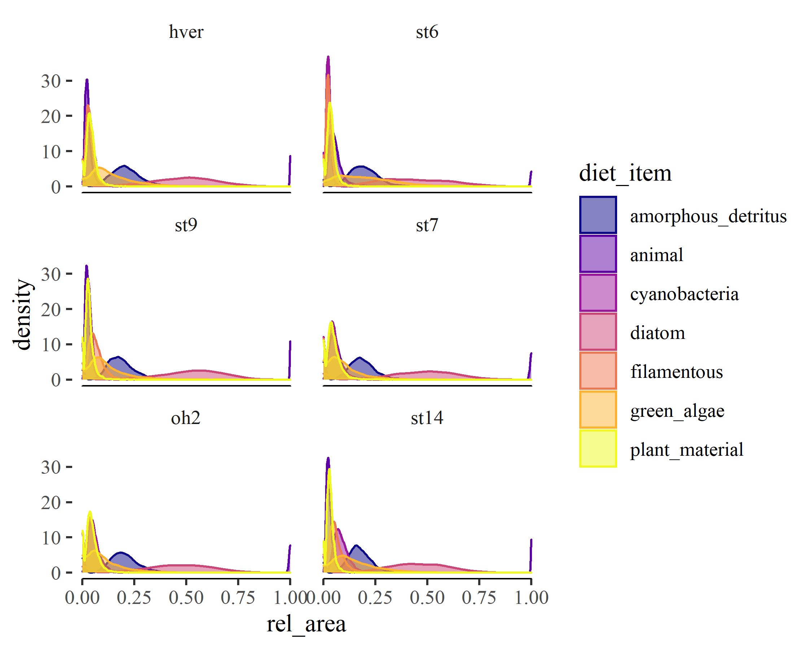

Figure S1. Modeled diet proportions of consumer communities across the temperature gradient.

## Appendix 2

Table 1. Evenness of organic matter fluxes among consumers within a stream community measured by the Gini index, both raw ('non-normalized') and 'normalized' for consumer richness

| site | Non-normalized Gini | Normalized Gini |
| --- | --- | --- |
| hver | 0.22 ( 0.18 - 0.27 ) | 0.15 ( 0.11 - 0.19 ) |
| oh2 | 0.29 ( 0.25 - 0.32 ) | 0.26 ( 0.23 - 0.3 ) |
| st14 | 0.14 ( 0.098 - 0.2 ) | 0.1 ( 0.059 - 0.17 ) |
| st6 | 0.13 ( 0.11 - 0.16 ) | 0.1 ( 0.079 - 0.13 ) |
| st7 | 0.23 ( 0.2 - 0.26 ) | 0.2 ( 0.18 - 0.23 ) |
| st9 | 0.092 ( 0.073 - 0.11 ) | 0.064 ( 0.045 - 0.082 ) |

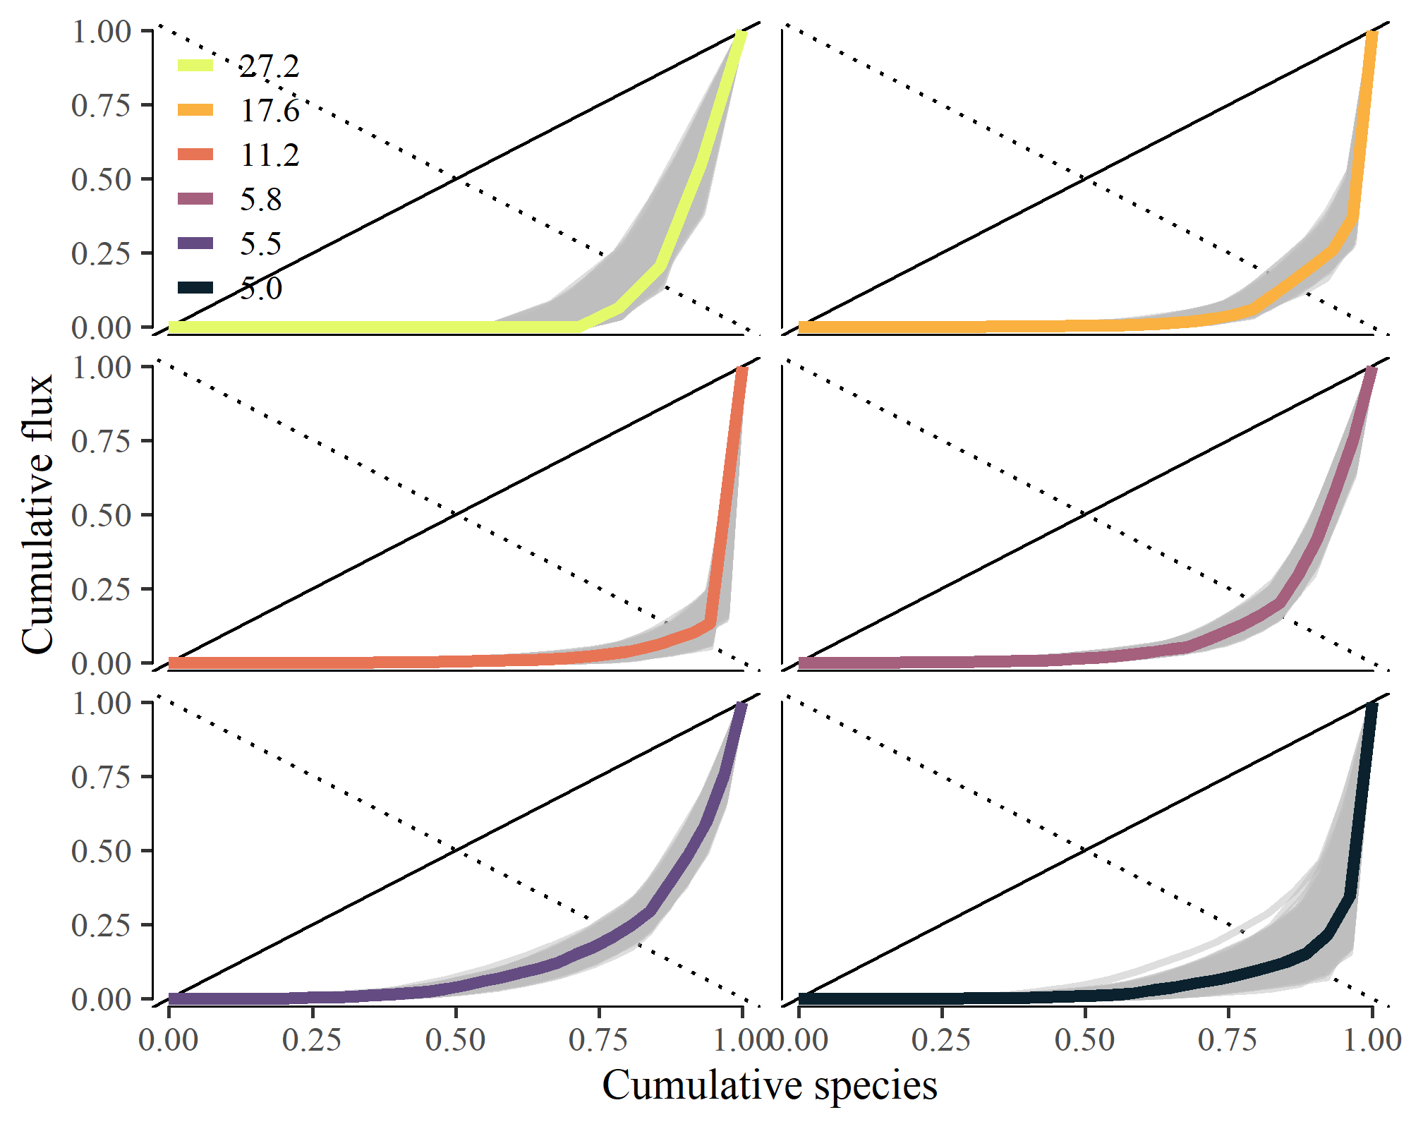

Figure S2. Lorenz plot of relative community flux by species in ascending order of annual population organic matter flux (mg AFDM m-2 y-1)

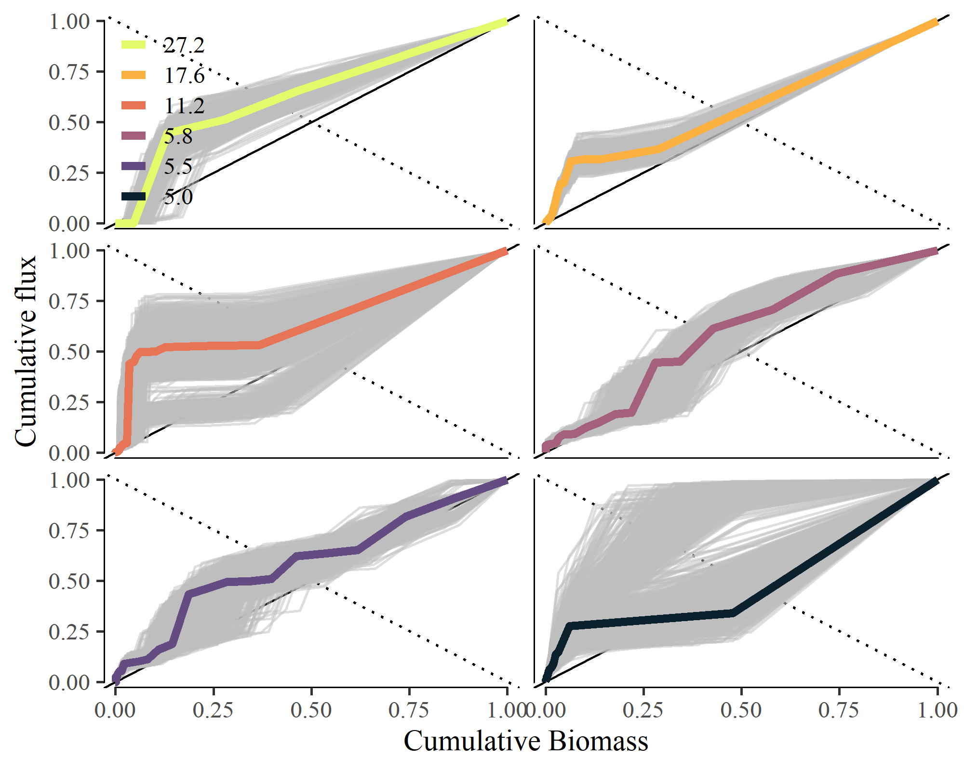

Figure S3. Cumulative plot of relative community flux by species in relation to mean annual population biomass (mg m-2).

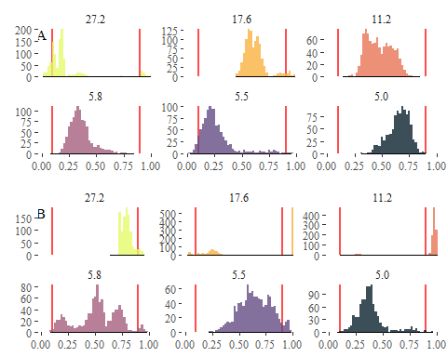

Figure S4. Probability distribution of empirical Skflux measurements in relation to (a) mean body size and (b) annual P:B compared to random species ordering. The red lines represent the 2.5% and 97.5% percentiles of the Skflux values from random ordering distributions in each stream community.

### Construction zone

Possible other themes to layer in:

effects of temperature on species evenness, evenness of fluxes, and the statistical and ecological constraints on the organization of energy fluxes in communities (e.g., (Diaz et al. 2021) SAD are more uneven than their statistical background and energy fluxes are also but there is important structure in this unevenness). This relates to the random vs non-random patterning questions…pull in the concepts of niche filtering and neutral processes in community assembly. Pull a little thinking from Saito et al. (2021).

Below is more of a set-up for the next paper but a little foreshadowing and hand waving may find a place in here:

These maximize energy intake when resources are available (Atkinson and Sibly 1997)

* Seasonal systems have unique constraints
* These seasonal constraints are greater at higher temps

This creates a situation where body sizes are selected for that 1) stabilize c-r dynamics (Osmond et al. 2017), ecological stability response to warming (Fussmann et al. 2014),… 2) optimize for energy availability and demand, 3) and this selection is stronger at extreme temperatures.

### Spare(d) words from previous versions. Keeping around for now.

directly kinetic effects and indirectly through the distribution of species traits, such as body size, within and across species (Nelson et al. 2017a, Bideault et al. 2019).

environmental filtering of compared the observed distributions of material fluxes among consumer populations to random distributions to quantify the likelihood the patterning of organic matter fluxes arise through random ordering of species or measure the potential strength of environmental filtering on the relative distribution of organic matter we tested the potential strength of environmental filtering to determine the distribution of within stream energy fluxes by comparing the how likely it was Third, we hypothesized that the selective pressure from environmental temperature on body sizes and population turnover would be greatest at temperature extremes, therefore, the patterning of energy fluxes will be ‘non-random’ at coldest and warmest temperatures.

Yet, considerable uncertainty remains in the predicted short- and long-term effects of climate warming, especially at higher levels of organization such as communities and food webs (Walther et al. 2002, Woodward et al. 2010). For example, species interactions in food webs may modulate species’ TSRs (DeLong et al. 2014), leading to varied responses among species and trophic levels (Ohlberger 2013). Additionally, warming-induced body size reductions may act as a stabilizing process in some consumer-resource interactions through reduced consumer:resource biomass ratios (Osmond et al. 2017) and reductions in consumer growth rates relative to resource supply (Kozłowski et al. 2004, McCann 2011, DeLong 2012, Greyson-Gaito et al. 2022).

For example, we lack a complete understanding of TSRs to explain deviations that exist across taxonomic groups (e.g., diatoms, Adams et al. (2013); invertebrates Zeuss et al. (2017); birds Geist (1987); and fish Rypel (2014)). Explanations for these deviations vary (Ohlberger 2013), some highlight additional processes such as competition and predation (DeLong et al. 2014), while others propose alternative models of organism body size optimization, such as the balance of resource supply and energy demand (e.g., Kozłowski et al. 2004, DeLong 2012). Crucially, these alternative models highlight the trade-off between asymptotic body size and metabolic demand (DeLong 2012) that can shape life history patterns (i.e., voltinism, Zeuss et al. (2017); Nelson et al. (2020a)). and community structure across ecosystems…

Recent, models have proposed However, - both bottom-up (e.g. resource supply) and top-down (e.g., predation) proceesses - competition and predation (DeLong et al. 2014), stabilize c-r dynamics (Osmond et al. 2017), optimization, such as the balance of resource supply and energy demand (e.g., Kozłowski et al. 2004, DeLong 2012)

To assess the relationship between the probability of ‘non-random ordering’ and temperature, we used beta regression on estimates of the probability of seeing the empirical value or one more extreme based on random ordering of species in the permuted feasible set. Here, values can take the range between 0 and 1 so no transformation was necessary. As necessary when we observed many values near 0 and 1, we implemented a zero-one inflated beta regressions in brms (Bürkner 2017) to test if the probability of observing the empirical was associated with mean annual temperature across streams. We predicted increasingly ‘non-random’ distributions in OM fluxes with increasing temperature.

Warmer streams had communities with smaller mean body sizes and faster turnover rates on average (Figure 2). Both among and within streams, OM fluxes were distributed differently across body sizes and turnover rates (*P:B*). Among streams, mean population body size ranged from 0.1 to 2.66 mg ind-1 and mean population annual P:B ranged from 4.23 to 31.67 (Figure 2).Both, *M* and *P:B* showed associations with mean annual stream temperature that were negative and positive, respectively. Generally, mean *M* of the community decreased -8.7% (95% PI, -11.1% – -6.4%) for each increase in 1C. In contrast, mean population *P:B* of the community increased 6.9% (95% PI, 6.1% – 7.9%) for each 1C in mean annual stream temperature.