Environmental warming increases the importance of high-turnover energy channels in stream food webs

James R. Junker1,2,✉, Wyatt F. Cross1, James M. Hood3, Jonathan P. Benstead4, Alexander D. Huryn4, Daniel Nelson5, Jón S. Ólafsson6, and Gísli M. Gíslason7

1 Department of Ecology, Montana State University, Bozeman, MT 59717, USA  
2 Current address: Great Lakes Research Center, Michigan Technological University, Houghton, MI 49931, USA  
3 Department of Evolution, Ecology, and Organismal Biology, The Ohio State University, Translational Data Analytics Institute, The Aquatic Ecology Laboratory, Columbus, OH 43212, USA  
4 Department of Biological Sciences, University of Alabama, Tuscaloosa, AL 35487, USA  
5 National Aquatic Monitoring Center, Department of Watershed Sciences, Utah State University, Logan, UT 84322, USA  
6 Institute of Marine and Freshwater Fisheries, Hafnarfjördur, Iceland  
7 University of Iceland, Institute of Life and Environmental Sciences, Reykjavík, Iceland

✉ Correspondence: [James R. Junker <[jrjunker@mtu.edu](mailto:jrjunker@mtu.edu)>](mailto:jrjunker@mtu.edu)

Submission journal: Ecology

Submission type: Article

Manuscript details:

* Abstract word count: 256/350
* Main text word count (w/ references): 5625
* Page count w/ references: 32/30
* Appendices: 2

Open Research Statement: All data and code used in this work are publicly available at the following link: <https://github.com/jimjunker1/temperature_energy-flux>.

Key words: energy flux; climate change; food webs; species traits; warming

# Abstract

Warming temperatures are altering communities and trophic networks globally. While the overall influence of warming on food webs is often context-dependent, increasing temperatures are predicted to change communities in two fundamental ways: 1) by reducing average body size and 2) by increasing individual metabolic rates. These warming-induced changes have the potential to influence the distribution of food web fluxes, food web stability, and the relative importance of ecological and stochastic processes shaping community assembly. Here, we quantified patterns and the relative distribution of organic matter fluxes through stream food webs spanning a natural ~25 $​^{∘}$ C temperature gradient. We then related these patterns to species- and community-level trait distributions of mean body size and population biomass turnover (*P:B*) within and across ecosystems. We predicted that 1) communities in warmer streams would skew towards smaller body size and higher *P:B* and 2) organic matter fluxes within warmer communities would increasingly skew towards smaller, higher *P:B* populations. Across the temperature gradient, warmer communities were characterized by smaller (~9% per $​^{∘}$ C) body size and (~7% faster per $​^{∘}$ C) *P:B* populations on average. Additionally, organic matter fluxes *within* warmer streams were increasingly skewed towards higher *P:B* populations, demonstrating that warming can restructure organic matter fluxes in both an absolute and relative sense. With warming, the relative distribution of organic matter fluxes also appeared to be increasingly ‘non-random’, suggesting stronger selection for traits driving high turnover with increasing temperature. Our study suggests that a warming world will favor energy fluxes through ‘smaller and faster’ populations, and that these changes may be more predictable than previously thought.

# Introduction

Increasing global temperatures influence the provision and maintenance of ecosystem services by modifying the network of species interactions that underpin ecosystem functions (de Ruiter et al. 1995, Woodward et al. 2010, Brose et al. 2012, Thompson et al. 2012). Warming effects permeate across multiple levels of biological organization, from control on individual metabolic rates (Gillooly et al. 2001, Brown et al. 2004) and biological activity (e.g., attack rate, handling time, growth rates, etc.; Dell et al. 2014), to broad-scale shifts in community assembly and structure (Nelson et al. 2017b, Gibert 2019, Saito et al. 2021). Across global climate gradients, such temperature-induced changes have the potential to mediate food web stability (Baiser et al. 2019) by altering the acquisition and allocation of resources (Zhang et al. 2017) and the magnitude and relative distribution of energy fluxes in food webs (May 1972, McCann et al. 1998, Barnes et al. 2018).

Understanding how warming alters energy flux in food webs requires information about how temperature modifies relationships between ecosystem structure and function. Such connections likely depend upon how warming influences functional trait distributions and how functional traits translate to patterns of energy demand (Norberg et al. 2001, Loreau et al. 2001, Norberg 2004). Additionally, warming can modify community assembly processes (Saito et al. 2021)—both deterministic (e.g., environmental/niche filtering, Whittaker 1962) and stochastic (e.g., neutral theory, Hubbell 2001)—leading to many possible relationships between warming, the relative abundance of species, and dominance of particular functional traits. For example, although temperature appears to have minimal control on species richness across taxonomic groups (e.g., Bastazini et al. 2021), warming can have profound effects on the dominance structure (i.e., evenness) of ecological communities, often by reducing community evenness and favoring a few well-adapted species (Hillebrand et al. 2008). This strong environmental filtering is likely to skew trait distributions in natural communities (Therriault and Kolasa 1999). However, the relative distribution of traits can be further modified by additional processes unrelated to environmental filtering that alter species relative abundances (e.g., species interactions, Therriault and Kolasa 1999, ; demographic stochasticity, Hubbell 2001). These additional processes can exaggerate or counter any skew in trait distributions driven by environmental filtering and thereby modify the relationship between species’ traits and the absolute and relative energy demands in food webs.

Body size is a fundamental trait that is influenced by temperature and has great potential to influence energy flux (Atkinson 1994, Daufresne et al. 2009, Gardner et al. 2011). Reduced body size in response to warming can arise at multiple levels of organization, including increased relative abundance of smaller species in warmed communities (Bergmann 1848) or smaller individuals in warmer populations (James 1970), or reduced absolute body size of warmed individuals (Atkinson 1994). Thus, warmer communities are likely to contain both smaller species and individuals. These relationships can have important implications for energy and material flux in ecosystems because body size is a strong determinant of species life-history patterns (Peters 1983, Altermatt 2010, Zeuss et al. 2017, Nelson et al. 2020a), as well as developmental (Angilletta et al. 2004) and metabolic rates (Gillooly et al. 2001, Brown et al. 2004).

Metabolic rate, in addition to being controlled by body size, is another key trait that is influenced by temperature and tied to variation in energy flux through food webs (Gillooly et al. 2001, Barnes et al. 2018). Warming can influence metabolic rates indirectly through reductions in body size, as well as directly through its effects on subcellular kinetics (Osmond et al. 2017, Bideault et al. 2019). These processes can modify ecosystem patterns through changes in population carrying capacity (Bernhardt et al. 2018), species’ relative abundances and consequent effects on consumer-resource interactions or food web structure (Bideault et al. 2019, Gibert 2019). Moreover, metabolic rates are also tied to many biological processes (Dell et al. 2014), including growth rate (Gillooly et al. 2001), developmental rate (Zuo et al. 2012, Nelson et al. 2020a), voltinism (Zeuss et al. 2017), and biomass turnover rate (Brown et al. 2004, Huryn and Benke 2007). Taken together, these changes suggest that warming should lead to a smaller, faster world in which ecosystem processes accelerate through the effects of smaller body size and higher turnover rates, with a potentially strong imprint on food web structure and energy fluxes (Gibert 2019).

We quantified patterns of organic matter flux in stream food webs across a natural temperature gradient (~5–28 $​^{∘}$ C) in southwestern Iceland. Previous research in these streams has shown a strong positive effect of warming on primary production both among streams (Demars et al. 2011, Padfield et al. 2017) and seasonally within streams (O’Gorman et al. 2012, Hood et al. 2018). Invertebrates in these streams rely on autotrophs (O’Gorman et al. 2012, Nelson et al. 2020b), thus the dynamics of primary production functions as a strong control on energy flow through consumers (Junker et al. 2020a). We therefore predicted that annual organic matter fluxes to consumers would increase with stream temperature, mirroring patterns in resource availability and consumer energy demand. We also hypothesized that temperature would act as a principle environmental filter on community assembly and organic matter fluxes by favoring ‘fast’ life-history traits associated with small-bodied organisms. Specifically, we predicted that warming temperatures would lead to reduced average body size and increased average biomass turnover (i.e., *P:B* ratio) of populations among streams. We also predicted that *within* communities, organic matter fluxes would be dominated by small-bodied and high *P:B* taxa at higher temperatures, and that these patterns would not arise by random change (i.e., a ‘selection effect’ *sensu* Huston 1997). Our results should help refine general predictions about how ongoing climate warming, and its influence on key traits, is likely to shape energy flux through animal food webs.

# Methods

We studied six streams within the Hengill geothermal field of southwestern Iceland (64 $​^{∘}$ 03’N 021 $​^{∘}$ 18’W) that varied in mean annual temperature from ~5 to 30 $​^{∘}$ C. Hengill is characterized by indirect geothermal heating of groundwater (Árnason et al. 1969), leading to natural variability in stream temperatures (4.5–54.0 $​^{∘}$ C), but similar solute chemistries (Friberg et al. 2009). These conditions create a “natural laboratory” for isolating the effects of temperature on ecosystem processes (O’Gorman et al. 2014, Nelson et al. 2017b). We selected streams to maximize the temperature range, while minimizing differences in the structural aspects of the primary producer community (Junker et al. 2020b). In each stream, we measured temperature and water depth every 15 min from July 2010 through August 2012 (U20-001-01 water-level logger, Onset Computer Corp., Pocasset, MA, USA). Light availability in the watershed was measured every 15 minutes from atmospheric stations (HOBO pendant temperature/light UA-002-64, Onset Computer Corp., Pocasset, MA, USA).

## Invertebrate sampling

We sampled macroinvertebrate communities approximately monthly in six streams, four from July 2011 to August 2012 and two from October 2010 to October 2011 (*n* = 6 streams). The two streams sampled from 2010–2011 were part of a separate warming manipulation during the reference (i.e., non-manipulated) year (Nelson et al. 2017a, 2017b). Inter-annual comparisons of primary and secondary production in previous studies showed minimal differences among years in unmanipulated streams, suggesting that combining data from different years would not significantly bias our results (Nelson et al. 2017a, Hood et al. 2018). We collected five Surber samples (0.023 m2, 250-m mesh) from randomly selected locations within each stream. Within the sampler, inorganic substrates were disturbed to ~10 cm depth and invertebrates and organic matter were removed from stones with a brush. Samples were then preserved with 5% formaldehyde until laboratory analysis. In the laboratory, we split samples into coarse (>1 mm) and fine (>250 $μ$ m–<1 mm) fractions using nested sieves and then removed invertebrates from each fraction under a dissecting microscope (10–15 $×$ magnification). For particularly large samples, fine fractions were sub-sampled (1/2–1/16th) using a modified Folsom plankton splitter prior to removal of invertebrates. Macroinvertebrates were identified to the lowest practical taxonomic level (usually genus) with taxonomic keys (Peterson 1977, Merritt et al. 2008, Andersen et al. 2013). Taxon-specific abundance and biomass were scaled to a per-meter basis by dividing by the Surber sampler area.

## Secondary Production

Daily secondary production of invertebrate taxa was calculated using the instantaneous growth rate method (IGR, Benke and Huryn 2017). Growth rates were determined using taxon-appropriate approaches described in Junker and others (2020a). Briefly, growth rates of common taxa (e.g., Chironomidae spp., *Radix balthica*, etc.) were measured using *in situ* chambers (Huryn and Wallace 1986). Multiple individuals (*n* = 5–15) within small size categories (~1-mm length range) were photographed next to a field micrometer, placed in the stream within pre-conditioned chambers for 7–15 days, and removed and photographed. Individual lengths were measured from field pictures using image analysis software (Schindelin et al. 2012), and body lengths were converted to mass (mg ash-free dry mass [AFDM]) using published length-mass regressions (Benke et al. 1999, O’Gorman et al. 2012, Hannesdóttir et al. 2013). Growth rates (*g*, d-1) were calculated by the changes in mean body size (*M*) over a given time interval (*t*) with the following equation:

$$g=log_{e}\left(M_{t+Δt}/M_{t}\right)/Δt \left(1\right)$$

Variability in growth rates was estimated by bootstrapping through repeated resampling of individual lengths with replacement (*n* = 1000). For taxa that exhibit synchronous growth and development (e.g., Simuliidae spp., some Chironomidae spp., etc.), we examined temporal changes in length-frequency distributions and calculated growth rates and uncertainty using a bootstrap technique similar to that described in Benke and Huryn (2017). Individual lengths were converted to mass (mg AFDM) using published length-mass regression cited above, and size-frequency histograms were visually inspected for directional changes in body size through time. For each date, size-frequency distributions were resampled with replacement and growth rates estimated from equation 1. We prevented the calculation of negative growth rates by requiring $M_{t+Δt}$ > $M_{t}$. If this condition was not met after 10,000 resamplings, a minimum growth rate of 0.001 was used. To estimate growth rates of taxa for which growth could not be estimated empirically, we developed stream-specific growth rate models by constructing multivariate linear regressions of empirical growth rates against body size and temperature. To estimate uncertainty in production of each taxon, we used a bootstrapping technique that resampled measured growth rates, in addition to abundance and size distributions from individual samples. For each iteration, size-specific growth rates were multiplied by mean interval biomass for each size class and the number of days between sample dates to estimate size class-specific production. For each interval, size classes were summed for each taxon to calculate total population-level production. Intervals were summed to estimate annual secondary production (g AFDM m-2 y-1).

## Organic Matter Consumption Estimates

Organic matter fluxes (mg AFDM m-2 y-1) through the community were calculated using the trophic basis of production method (TBP; Benke and Wallace 1980). Taxon-specific secondary production estimates were combined with diet proportions (see Supplemental Materials), diet-specific assimilation efficiencies, *AEi*, and net production efficiencies, *NPE* (e.g., McCullough 1975), to estimate consumption of organic matter. For each food category, *i*, diet proportions were multiplied by the gross growth efficiency ($GGE_{i}=AE_{i}*NPE$) to calculate the relative production attributable to each food category. The relative production from each food type was then multiplied by the interval-level production and finally divided by $GGE_{i}$ to estimate consumption of organic matter from each food category by each taxon (Benke and Wallace 1980). Consumption was calculated for each taxon across sampling intervals (typically ~1 month). Total interval consumption was calculated by summing across all taxa, while annual consumption was calculated by summing across all taxa and intervals. Variability in consumption estimates was estimated through a Monte Carlo approach, wherein bootstrapped vectors of secondary production for each taxon (see *Secondary production* methods above) were resampled and consumption estimated with the TBP method using modeled diet proportions (see *Diet analysis* in Supplemental Materials), diet-specific assimilation efficiencies, and net production efficiency. Variability in *AEi* was incorporated by resampling values from beta distributions fit to median and 2.5% and 97.5% percentiles for each diet item: diatoms = 0.30 (95% percentile interval (PI): 0.24-0.36), filamentous and green algae = 0.30 (95% PI: 0.24-0.36), cyanobacteria = 0.10 (95% PI: 0.08-0.12), amorphous detritus = 0.10 (95% PI: 0.08-0.12), vascular and non-vascular plants (bryophytes) = 0.1 (95% PI: 0.08-0.12), and animal material = 0.7 (95% PI: 0.56-0.84)(Welch 1968, Benke and Wallace 1980, 1997, Cross et al. 2007, 2011). Variability in *NPE* was incorporated by resampling values from an assumed beta distribution with median *NPE* = 0.45 (95% PI = 0.4-0.5). Beta distributions were fit in R (R Core Team 2022) using the ‘get.beta.par()’ function within the *rriskDistributions* package (Belgorodski et al. 2017).

## Quantifying the distribution of food web fluxes

### Evenness among taxa

To visualize and quantify the evenness of OM fluxes among taxa within each stream, we constructed Lorenz curves (Lorenz 1905) on rank-ordered OM fluxes, such that in a community with $S$ species and the relative OM flux of species *i*, $p_{i}$, is ordered $p_{1}≤p_{2}≤...p_{S}$. The Lorenz curve shows how a value, in this case OM flux, accumulates with increasing cumulative proportion of taxa. In a community with an equal distribution of OM flux among taxa, the Lorenz curve is simply a straight diagonal line. Deviation from equality was calculated as the Gini coefficient (Gini 1921), normalized for differences in $S$ among streams, $G^{*}$ (Solomon 1975, Chao and Ricotta 2019):

$$G^{*}=\left(2\sum_{i=1}^{S}{i}p_{i}−2\right)/\left(S−1\right) \left(2\right)$$

where $G^{*}$ represents an index of relative evenness of OM fluxes bounded between zero and one; a value of one represents a community with equal proportion of total community OM flux for all species ($1/S$), and a value of zero represents a community in which the total OM flux is attributed to a single taxon.

### Distribution of OM fluxes in relation to taxa traits

We predicted that warming would favor taxa with smaller body size and higher population turnover and therefore OM fluxes would be skewed towards small body size (*M*) and higher *P:B* across and within communities. To assess the potential importance of environmental filtering across communities, we used bootstrapped linear regressions to quantify the relationship between mean annual temperature ($​^{∘}$ C) and either mean population body size ($\overline{M}$) or biomass turnover ($\overline{P:B}$) of each stream community. Here, 1,000 values of population *M* or *P:B* were resampled with replacement from population secondary production vectors (see *Secondary Production* above) for each taxon within each stream. The mean of all populations within a stream was calculated and a linear model was fit between *loge*-transformed $\overline{M}$ or $\overline{P:B}$ and mean annual temperature. Response variables were transformed to meet the assumption of normally distributed residual variation.

To quantify how the distribution of organic matter fluxes were modified *within* a community and whether this modification was related to temperature, we assessed the extent to which the relative OM fluxes among taxa were skewed towards populations with lower or higher relative *M* or *P:B*. To do this, we ordered taxa based on within-stream rankings of annual population traits (i.e., *M*, *P:B*) and then calculated a measure of skewness, $Sk_{flux}$, based on quartiles of the distribution of OM fluxes in relation to taxon traits as:

$$Sk_{flux}=f_{Q0.75}−2f_{Q0.5}+f_{Q0.25}/f_{Q0.75}−f_{Q0.25} \left(3\right)$$

where, $f_{Qx}$, is the cumulative flux at some quantile, $Qx$, of the community trait distribution. We repeated this analysis for all estimates of OM flux used to calculate *M* and *P:B* in each stream community. Skewness coefficients exist in the range [-1, 1], where -1 indicates that OM fluxes are skewed perfectly away from a trait and 1 indicates that higher relative fluxes are perfectly associated with higher trait values. To determine if the skewness of fluxes with *M* and *P:B* was related to mean annual stream temperature, we use bootstrapped beta regression with a simple transformation, $\left(Sk_{flux}+1\right)/2$, to meet the assumptions of the model and standardize values between 0 and 1. Model coefficients were back-transformed to estimate effect sizes.

To examine whether and how temperature influences the skew of OM flux among populations within each community, we quantified the probability of observing the skewed distributions in OM fluxes by random chance. The feasible range of skewness values within a community is inherently tied to the evenness of OM fluxes. This dependence on evenness can make it difficult to determine the importance of random versus ecological processes on the distribution of OM fluxes by comparison of raw skewness measures alone. We predicted that species $M$ and $P:B$ would be increasingly important traits structuring OM fluxes within a community and therefore warmer streams would exhibit highly skewed OM distributions that would be unlikely due to chance (i.e., ‘non-random ordering’). In contrast, cooler streams would exhibit OM fluxes with skew values that are more likely due to random chance (‘random ordering’), regardless of raw skewness values, suggesting other traits or processes govern the distribution of OM fluxes within their communities. To accomplish this, we first had to account for statistical constraints that restrict the range of possible outcomes (i.e., feasible set, Haegeman and Loreau 2008, Diaz et al. 2021), given the number of species and the relative distribution of OM fluxes within a community. The number of unique orderings of species increases to computationally intractable numbers very quickly (e.g., $S!$ for 10 species $≈3.6×{10}^{6}$ unique orderings). Therefore, we chose to permute a random subset of each stream community’s feasible set by randomly ordering species and calculating skewness in the cumulative distribution of annual OM fluxes 100,000 times in each stream. This permuted set allowed us to calculate the probability of observing the empirical skewness value, $Sk_{flux}$, compared to a random ordering given the distribution of relative OM flux. We assessed the likelihood of non-random ordering as the distance from the central mass of the random skew distributions within each stream. Therefore, communities in which OM fluxes are likely organized non-randomly are indicated by observed skew values near the tails of these random distributions.

# Results

## Community organic matter fluxes

Annual community OM fluxes mirrored patterns of secondary production reported previously (Junker et al. 2020a). Organic matter flux to invertebrates varied ~45-fold among streams, from 3.9 (2.1 – 6.2; mean (95% percentile interval [PI])) to 177.1 (126–236.4) g AFDM $m^{−2}y^{−1}$ and was positively related to temperature (Figure 1A).

Differences in OM flux among streams were driven by variation in total energy demand rather than composition of consumed resources, as consumer diets were highly similar among streams (Figure S1). Across all streams, community-level diets were dominated by diatoms (44%; 0%–75.7%), amorphous detritus (17.3%; 0%–32.3%), and green algae (13.3%; 0%–42.8%). Within streams, diet overlap ranged from 68% (65%–71%) to 75% (70%–79%) among invertebrate taxa. Among streams, diet overlap was similarly high with a mean overlap of 89% (84%–92%). Diet similarities based on pairwise comparisons among streams showed little difference and no clear relationship with temperature.

## Evenness of organic matter fluxes

In general, OM fluxes were unevenly distributed among taxa (Gini inequality coefficients ranged from 0.09 (0.07 – 0.11, 95% PI) to 0.29 (0.25 – 0.32; Table S1) and were dominated by insects in the families Simuliidae and Chironomidae, pulmonate snails (*Radix balthica*), and oligochaete worms (Figure 2A & B; Figure S2). In absolute terms, ~85% of total OM flux was contributed by 2 to 10 taxa, which comprised only 3% to 29% of total taxon richness among streams. Although differences in evenness among streams were partially attributed to variation in taxon richness (range: 14 to 35), fluxes were still highly uneven after accounting for differences in richness (i.e., similar ‘Normalized’ Gini coefficients, Table S1). As average stream temperature increased, OM fluxes shifted from dominance by Simuliidae in the coolest stream to Chironomidae and *R. balthica* at moderate temperatures. In the warmest stream, where maximum temperatures approach ~40 $​^{∘}$ C, taxon richness was lowest and OM fluxes were dominated by oligochaete worms in the family Naididae, the chironomid *Cricotopus sylvestris*, and *R. balthica*. Among-stream differences in evenness and dominance of OM fluxes were not related to temperature (Appendix II Table S1).

## Organic matter fluxes in relation to body size and biomass turnover rate

Across stream communities, average population body size ($\overline{M}$; mg AFDM ind-1) decreased and average population biomass turnover rate (; y-1) increased with increasing temperature (Figure 1B & C). $\overline{M}$ decreased from 2.75 mg AFDM ind-1 (1.03 – 5.08; 95% PI) in the coldest stream to 0.10 mg AFDM ind-1 (0.08 – 0.13) in the warmest stream, corresponding to an -8.7% (-11.1 – -6.4) decrease in mean body size for every 1 $​^{∘}$ C increase in temperature (Figure 1B). $\overline{P:B}$ ratio increased from 4.4 y-1 (3.6 – 5.1) in the coldest stream to 35.5 y-1 (29.6 – 0.1) in the warmest stream corresponding to a 6.9% (6.1–7.9) increase in $\overline{P:B}$ ratio for every 1 $​^{∘}$ C increase (Figure 1C).

Within stream communities, there were diverse body size–OM flux relationships, with some streams showing skew toward larger-bodied taxa (positive skew), others with most OM fluxes through smaller-bodied sizes (negative skew), and some showed no difference among body sizes (skew range: -1 to 0.56; Figure 3A & B). Skew estimates of OM fluxes in relation to body size showed little association with stream temperature except in the warmest stream, where fluxes were heavily skewed toward small-bodied taxa. Similarly, skew in OM fluxes in relation to *P:B* ratios varied among streams, ranging from -0.4 to 1. In this case, OM fluxes to consumers skewed increasingly toward higher turnover (*P:B*) taxa with increasing temperature (Figure 4A & B).

We compared our skew estimates (i.e., $Sk_{flux}$) of OM flux based on ordered data (i.e., ordered from small to large *M* or low to high *P:B* ratios; Figure 3B and Figure 4B) to skew estimates based on randomly sorted data to detect whether OM fluxes through smaller and higher *P:B* taxa could be attributed to these traits vs. random community assembly processes. The probability of observing a similar or more extreme skew of OM fluxes in relation to body size was variable among streams and ranged from 0.34 (0.19–0.55; 95% PI) to 0.79 (0.07–0.95); there was a very weak positive association between this probability and temperature (Figure 3C). In contrast, the probability of a similar or more extreme skew in relation to *P:B* ratios ranged from 0.06 (0–0.75) to 0.62 (0.22–0.82; Figure 4C) and in this case there was a clear trend towards a more structured OM flux distribution—i.e., favoring fluxes through high *P:B* taxa–at warmer temperatures. The likelihood of elevated fluxes among high *P:B* taxa became much more likely with warming, and the probability of random ordering decreased by -4.6% (-5.1%—4.2%) for every 1 $​^{∘}$ C increase in temperature (Figure 4C).

# Discussion

While a growing body of theoretical and empirical research has enhanced our knowledge of temperature-mediated changes to ecosystems (e.g., O’Connor et al. 2009), general patterns remain elusive and empirical studies often show idiosyncratic outcomes (Nelson et al. 2017a, Zhang et al. 2017), especially at higher levels of biological organization (Walther et al. 2002, Woodward et al. 2010). Here, we leveraged a wide natural gradient of ecosystem temperatures and demonstrated that temperature acts as a strong environmental filter of species traits. In particular, we found that increasing temperatures were associated with reduced population body size and increased population biomass turnover among stream invertebrate communities, leading to higher organic matter fluxes through these populations. In addition, we found that warming systematically skewed OM fluxes *within* communities such that, OM flows were increasingly dominated by taxa with rapid life-cycles. Lastly, we discovered that the distribution of fluxes within communities was non-random, especially with respect to *P:B* ratios at moderate to high temperatures, suggesting that temperature was especially important in structuring relative performance and resource acquisition within warm communities. These patterns show that the acceleration of energy and material fluxes through ecosystems in both an absolute (among ecosystems) and relative (within ecosystems) sense may be a general effect of environmental warming.

Warming-induced shifts in community body size distributions were associated with a community-level increase in the absolute rates of material flux. At the community level, we observed a ~7% increase in the mean biomass turnover rate (*P:B*; y-1) of populations for each 1 $​^{∘}$ C of warming. Although this effect among communities may be partially attributed to the thermodynamic influence of temperature (Gillooly et al. 2001), biomass turnover rate is also closely related to organism body size (Brown et al. 2004, Huryn and Benke 2007). Thus, warming may influence the distributions of *P:B* ratios directly through its effects on metabolic rate and indirectly through reductions in organism body size. The increase in *P:B* we observed across communities was similar in magnitude to the reduction in body size (i.e., +7% vs –9%, respectively), reinforcing the fundamental connection between organism body size and *P:B*, but also suggesting increases in mean population *P:B* across communities may, in large part, be attributed to reduced organism body sizes (Figure 1B & C). Organism body size is related to a number of other ecological attributes (Peters 1983) and changes in body size with increasing temperatures are likely to have broad implications for ecosystems in a changing climate (Gibert 2019).

A general reduction in body size has been deemed a “universal” response to warming (Daufresne et al. 2009, Gardner et al. 2011, Uszko et al. 2022), but notable deviations exists across ecosystems (Thresher et al. 2007, O’Gorman et al. 2012, Ohlberger 2013). We observed a clear decrease in the average individual body size of populations from cool to warm communities (Figure 1B), corresponding to ~-9% decline in the mass of individuals for every 1 $​^{∘}$ C increase in temperature. While this change is based on community-level shifts (i.e., different sets of taxa), the magnitude of decline is consistent with intra-taxon patterns measured across broad phylogenetic groups (Deutsch et al. 2022). Interestingly, our results contrast with a previous warming experiment in one of our study streams showing a 3 $​^{∘}$ C increase in temperature shifted community biomass and productivity from smaller to larger organisms (Nelson et al. 2017a, 2017b). Moreover, a study of diatom communities across the same temperature gradient in Iceland that reported no consistent change in body size at either the population- or community-level (O’Gorman et al. 2012, Adams et al. 2013). Other studies have reported similar deviations from the “universal” response for other taxonomic groups (e.g., invertebrates: Zeuss et al. 2017, birds: Geist 1987, Riemer et al. 2018, fish: Rypel 2014). While there is certainly a strong propensity for reduced body size with warming, clearly other processes can modify the direction and magnitude of body size shifts and how they play out from individual to ecosystem scales.

In addition to cross-ecosystem effects of temperature on patterns of species traits and organic matter flux, we found that temperature had strong effects on the relative performance of species *within* communities, leading to an increase OM fluxes through populations with high biomass turnover rates. Generally speaking, OM fluxes were unevenly distributed among populations within communities, which may be expected given the systematic unevenness in the distribution of individuals among species (Diaz et al. 2021). However, we found important residual structure in the unevenness of OM fluxes that appeared to be related to functional trait axes. With respect to body size, the results were somewhat equivocal. In the coldest and warmest streams, we saw a strong skew in material fluxes towards larger and smaller species, respectively, but this pattern was not apparent at moderate temperatures (~6–17 $​^{∘}$ C). In contrast, we found a much clearer pattern with respect to biomass turnover rates, in which OM fluxes were increasingly skewed towards taxa with high turnover within warmer streams. We also foudn that this pattern was clearly non-random, suggesting that it cannot be attributed to simple demographic stochasticity (e.g., Hubbell 2001, Shoemaker et al. 2020). These results suggest that temperature may be a strong environmental filter—and therefore natural selection agent—for taxa with high turnover rates and associated life-history traits ( e.g., multi-voltinism: Zeuss et al. 2017, Nelson et al. 2020a, short lifespan: Munch and Salinas 2009, high growth rate, Donhauser et al. 2020), especially at relatively high temperatures.

We documented the important role of temperature in structuring key functional traits and the relative distribution of material fluxes across a natural stream temperature gradient. Higher temperatures were associated with increased total flux through the food web, as well as reductions in average population body size and increases in population biomass turnover. Further, biomass turnover rate—but not body size—was increasingly important for structuring OM fluxes at warmer temperatures. Our results support the idea that warming may reduce organism size and also ‘speed up’ ecosystem dynamics in both an absolute and relative sense. These changes have important implications for the maintenance of biodiversity as well as for the connections between biodiversity and the magnitude and stability of ecosystem energy and material cycles in a warming world.

# Acknowledgements

We are grateful to Sigurður Guðjonsson, Guðni Guðbergsson, and the staff at the Veiðimlastofnun for providing laboratory space and logistical support. We are also grateful to Sveinbj€orn Steinþorsson at the University of Iceland for super-jeep transport to our field sites during the winter. We thank Lauren David, David Hernandez, Amanda Keasberry, Elena Nava, Camille Perrett, Jackie Pitts, Friðþjófur Árnason, Liliana García, Ragnahildur Magnúsdottír, Ryan McClure, Vija Pelekis, Adam Toomey, Chau Tran, Brooke Weigel, Tanner Williamson and many undergraduate workers for field and laboratory help. Jeff Wesner and Abe Kanz generously provided R code and discussions on modeling diet proportions. This study was supported by the National Science Foundation (DEB-0949774 and DEB-1354624 to JPB and ADH and DEB-0949726 to WFC).

# Conflict of Interest

The authors have no conflict of interest to declare.

# References

Adams, G. L., D. E. Pichler, E. J. Cox, E. J. O’Gorman, A. Seeney, G. Woodward, and D. C. Reuman. 2013. [Diatoms can be an important exception to temperaturesize rules at species and community levels of organization](https://doi.org/10.1111/gcb.12285). Global Change Biology 19:3540–3552.

Altermatt, F. 2010. [Climatic warming increases voltinism in European butterflies and moths](https://doi.org/10.1098/rspb.2009.1910). Proceedings of the Royal Society B: Biological Sciences 277:1281–1287.

Andersen, T., P. S. Cranston, and J. H. Epler. 2013. Chironomidae of the Holarctic region: Keys and diagnoses, Part 1. Media Tryck, Lund, Sweden.

Angilletta, M. J., Jr., T. D. Steury, and M. W. Sears. 2004. [Temperature, Growth Rate, and Body Size in Ectotherms: Fitting Pieces of a Life-History Puzzle](https://doi.org/10.1093/icb/44.6.498). Integrative and Comparative Biology 44:498–509.

Árnason, B., P. Theodorsson, S. Björnsson, and K. Saemundsson. 1969. [Hengill, a high temperature thermal area in Iceland](https://doi.org/10.1007/BF02596720). Bulletin Volcanologique 33:245–259.

Atkinson, D. 1994. Temperature and organism size: A biological law for ectotherms? Advances in ecological research 25:1–58.

Baiser, B., D. Gravel, A. R. Cirtwill, J. A. Dunne, A. K. Fahimipour, L. J. Gilarranz, J. A. Grochow, D. Li, N. D. Martinez, A. McGrew, T. Poisot, T. N. Romanuk, D. B. Stouffer, L. B. Trotta, F. S. Valdovinos, R. J. Williams, S. A. Wood, and J. D. Yeakel. 2019. [Ecogeographical rules and the macroecology of food webs](https://doi.org/10.1111/geb.12925). Global Ecology and Biogeography 28:1204–1218.

Barnes, A. D., M. Jochum, J. S. Lefcheck, N. Eisenhauer, C. Scherber, M. I. O’Connor, P. de Ruiter, and U. Brose. 2018. [Energy Flux: The Link between Multitrophic Biodiversity and Ecosystem Functioning](https://doi.org/10.1016/j.tree.2017.12.007). Trends in Ecology & Evolution 33:186–197.

Bastazini, V. A. G., N. Galiana, H. Hillebrand, M. Estiarte, R. Ogaya, J. Peñuelas, U. Sommer, and J. M. Montoya. 2021. [The impact of climate warming on species diversity across scales: Lessons from experimental meta-ecosystems](https://doi.org/10.1111/geb.13308). Global Ecology and Biogeography 30:1545–1554.

Belgorodski, N., M. Greiner, K. Tolksdorf, and K. Schueller. 2017. rriskDistributions: Fitting Distributions to Given Data or Known Quantiles.

Benke, A. C., and A. D. Huryn. 2017. Secondary production and quantitative food webs. Pages 235–254 Methods in Stream Ecology. Elsevier.

Benke, A. C., A. D. Huryn, L. A. Smock, and J. B. Wallace. 1999. [Length-Mass Relationships for Freshwater Macroinvertebrates in North America with Particular Reference to the Southeastern United States](https://doi.org/10.2307/1468447). Journal of the North American Benthological Society 18:308–343.

Benke, A. C., and J. B. Wallace. 1980. [Trophic Basis of Production Among Net-Spinning Caddisflies in a Southern Appalachian Stream](https://doi.org/10.2307/1937161). Ecology 61:108–118.

Benke, A. C., and J. B. Wallace. 1997. [Trophic Basis of Production Among Riverine Caddisflies: Implications for Food Web Analysis](https://doi.org/10.1890/0012-9658(1997)078[1132:TBOPAR]2.0.CO;2). Ecology 78:1132–1145.

Bergmann, C. 1848. Über die Verhältnisse der Wärmeökonomie der Thiere zu ihrer Grösse.

Bernhardt, J. R., J. M. Sunday, and M. I. O’Connor. 2018. [Metabolic Theory and the Temperature-Size Rule Explain the Temperature Dependence of Population Carrying Capacity](https://doi.org/10.1086/700114). The American Naturalist:000–000.

Bideault, A., M. Loreau, and D. Gravel. 2019. [Temperature Modifies Consumer-Resource Interaction Strength Through Its Effects on Biological Rates and Body Mass](https://doi.org/10.3389/fevo.2019.00045). Frontiers in Ecology and Evolution 7.

Brose, U., J. A. Dunne, Montoya José M., O. L. Petchey, F. D. Schneider, and U. Jacob. 2012. [Climate change in size-structured ecosystems](https://doi.org/10.1098/rstb.2012.0232). Philosophical Transactions of the Royal Society B: Biological Sciences 367:2903–2912.

Brown, J. H., J. F. Gillooly, A. P. Allen, V. M. Savage, and G. B. West. 2004. [Toward a Metabolic Theory of Ecology](https://doi.org/10.1890/03-9000). Ecology 85:1771–1789.

Bürkner, P.-C. 2017. [Brms: An R Package for Bayesian Multilevel Models Using Stan](https://doi.org/10.18637/jss.v080.i01). Journal of Statistical Software 80:1–28.

Chao, A., and C. Ricotta. 2019. [Quantifying evenness and linking it to diversity, beta diversity, and similarity](https://doi.org/10.1002/ecy.2852). Ecology 100:e02852.

Coblentz, K. E., A. E. Rosenblatt, and M. Novak. 2017. [The application of Bayesian hierarchical models to quantify individual diet specialization](https://doi.org/10.1002/ecy.1802). Ecology 98:1535–1547.

Cross, W. F., C. V. Baxter, K. C. Donner, E. J. Rosi-Marshall, T. A. Kennedy, R. O. Hall, H. A. W. Kelly, and R. S. Rogers. 2011. [Ecosystem ecology meets adaptive management: Food web response to a controlled flood on the Colorado River, Glen Canyon](https://doi.org/10.1890/10-1719.1). Ecological Applications 21:2016–2033.

Cross, W. F., J. B. Wallace, and A. D. Rosemond. 2007. [Nutrient Enrichment Reduces Constraints on Material Flows in a Detritus-Based Food Web](https://doi.org/10.1890/06-1348.1). Ecology 88:2563–2575.

Daufresne, M., K. Lengfellner, and U. Sommer. 2009. [Global warming benefits the small in aquatic ecosystems](https://doi.org/10.1073/pnas.0902080106). Proceedings of the National Academy of Sciences 106:12788–12793.

de Ruiter, P. C., A.-M. Neutel, and J. C. Moore. 1995. [Energetics, Patterns of Interaction Strengths, and Stability in Real Ecosystems](https://doi.org/10.1126/science.269.5228.1257). Science 269:1257–1260.

Dell, A. I., S. Pawar, and V. M. Savage. 2014. [Temperature dependence of trophic interactions are driven by asymmetry of species responses and foraging strategy](https://doi.org/10.1111/1365-2656.12081). Journal of Animal Ecology 83:70–84.

Demars, B. O. L., J. R. Manson, J. S. Ólafsson, G. M. Gíslason, R. Gudmundsdóttir, G. Woodward, J. Reiss, D. E. Pichler, J. J. Rasmussen, and N. Friberg. 2011. [Temperature and the metabolic balance of streams](https://doi.org/10.1111/j.1365-2427.2010.02554.x). Freshwater Biology 56:1106–1121.

Deutsch, C., J. L. Penn, W. C. E. P. Verberk, K. Inomura, M.-G. Endress, and J. L. Payne. 2022. [Impact of warming on aquatic body sizes explained by metabolic scaling from microbes to macrofauna](https://doi.org/10.1073/pnas.2201345119). Proceedings of the National Academy of Sciences 119:e2201345119.

Diaz, R. M., H. Ye, and S. K. M. Ernest. 2021. [Empirical abundance distributions are more uneven than expected given their statistical baseline](https://doi.org/10.1111/ele.13820). Ecology Letters n/a.

Donhauser, J., P. A. Niklaus, J. Rousk, C. Larose, and B. Frey. 2020. [Temperatures beyond the community optimum promote the dominance of heat-adapted, fast growing and stress resistant bacteria in alpine soils](https://doi.org/10.1016/j.soilbio.2020.107873). Soil Biology and Biochemistry 148:107873.

Fordyce, J. A., Z. Gompert, M. L. Forister, and C. C. Nice. 2011. [A Hierarchical Bayesian Approach to Ecological Count Data: A Flexible Tool for Ecologists](https://doi.org/10.1371/journal.pone.0026785). PLOS ONE 6:e26785.

Friberg, N., J. B. Dybkjær, J. S. Olafsson, G. M. Gislason, S. E. Larsen, and T. L. Lauridsen. 2009. [Relationships between structure and function in streams contrasting in temperature](https://doi.org/10.1111/j.1365-2427.2009.02234.x). Freshwater Biology 54:2051–2068.

Gardner, J. L., A. Peters, M. R. Kearney, L. Joseph, and R. Heinsohn. 2011. [Declining body size: A third universal response to warming?](https://doi.org/10.1016/j.tree.2011.03.005) Trends in Ecology & Evolution 26:285–291.

Geist, V. 1987. [Bergmann’s rule is invalid](https://doi.org/10.1139/z87-164). Canadian Journal of Zoology.

Gibert, J. P. 2019. [Temperature directly and indirectly influences food web structure](https://doi.org/10.1038/s41598-019-41783-0). Scientific Reports 9:5312.

Gillooly, J. F., J. H. Brown, G. B. West, V. M. Savage, and E. L. Charnov. 2001. [Effects of size and temperature on metabolic rate](https://doi.org/10.1126/science.1061967). Science (New York, N.Y.) 293:2248–2251.

Gini, C. 1921. [Measurement of Inequality of Incomes](https://doi.org/10.2307/2223319). The Economic Journal 31:124–126.

Haegeman, B., and M. Loreau. 2008. [Limitations of entropy maximization in ecology](https://doi.org/10.1111/j.1600-0706.2008.16539.x). Oikos 117:1700–1710.

Hannesdóttir, E. R., G. M. Gíslason, J. S. Ólafsson, Ó. P. Ólafsson, and E. J. O’Gorman. 2013. [Increased Stream Productivity with Warming Supports Higher Trophic Levels](https://doi.org/10.1016/B978-0-12-417199-2.00005-7). Advances in Ecological Research 48:285–342.

Hillebrand, H., D. M. Bennett, and M. W. Cadotte. 2008. [Consequences of dominance: A review of evenness effects on local and regional ecosystem processes](https://doi.org/10.1890/07-1053.1). Ecology 89:1510–1520.

Hood, J. M., J. P. Benstead, W. F. Cross, A. D. Huryn, P. W. Johnson, G. M. Gíslason, J. R. Junker, D. Nelson, J. S. Ólafsson, and C. Tran. 2018. [Increased resource use efficiency amplifies positive response of aquatic primary production to experimental warming](https://doi.org/10.1111/gcb.13912). Global Change Biology 24:1069–1084.

Hubbell, S. P. 2001. The unified neutral theory of biodiversity and biogeography. Princeton University Press.

Huryn, A. D., and A. C. Benke. 2007. Relationship between biomass turnover and body size for stream communities. Body size: the structure and function of aquatic ecosystems. Cambridge University Press, Cambridge, UK:55–76.

Huryn, A. D., and J. B. Wallace. 1986. [A method for obtaining in situ growth rates of larval Chironomidae (Diptera) and its application to studies of secondary production](https://doi.org/10.4319/lo.1986.31.1.0216). Limnology and Oceanography 31:216–221.

Huston, M. A. 1997. [Hidden treatments in ecological experiments: Re-evaluating the ecosystem function of biodiversity](https://doi.org/10.1007/s004420050180). Oecologia 110:449–460.

James, F. C. 1970. [Geographic Size Variation in Birds and Its Relationship to Climate](https://doi.org/10.2307/1935374). Ecology 51:365–390.

Junker, J. R., W. F. Cross, J. P. Benstead, A. D. Huryn, J. M. Hood, D. Nelson, G. M. Gíslason, and J. S. Ólafsson. 2020a. [Resource supply governs the apparent temperature dependence of animal production in stream ecosystems](https://doi.org/10.1111/ele.13608). Ecology Letters 23:1809–1819.

Junker, J. R., W. F. Cross, J. P. Benstead, A. D. Huryn, J. M. Hood, D. Nelson, G. M. Gíslason, and J. S. Ólafsson. 2020b. [Flow is more Important than Temperature in Driving Patterns of Organic Matter Storage and Stoichiometry in Stream Ecosystems](https://doi.org/10.1007/s10021-020-00585-6). Ecosystems.

Loreau, M., S. Naeem, P. Inchausti, J. Bengtsson, J. P. Grime, A. Hector, D. U. Hooper, M. A. Huston, D. Raffaelli, B. Schmid, D. Tilman, and D. A. Wardle. 2001. [Biodiversity and Ecosystem Functioning: Current Knowledge and Future Challenges](https://doi.org/10.1126/science.1064088). Science 294:804–808.

Lorenz, M. O. 1905. [Methods of Measuring the Concentration of Wealth](https://doi.org/10.2307/2276207). Publications of the American Statistical Association 9:209.

May, R. M. 1972. [Will a Large Complex System be Stable?](https://doi.org/10.1038/238413a0) Nature 238:413–414.

McCann, K., A. Hastings, and G. R. Huxel. 1998. [Weak trophic interactions and the balance of nature](https://doi.org/10.1038/27427). Nature 395:794–798.

McCullough, D. A. 1975. [Bioenergetics of three aquatic insects determined by radioisotopic analyses](https://doi.org/10.2172/7299553).

Merritt, R. W., K. W. Cummins, and M. B. Berg, editors. 2008. An Introduction to the Aquatic Insects of North America. Fourth. Kendall/Hunt Publishing Co., Dubuque, IA.

Munch, S. B., and S. Salinas. 2009. [Latitudinal variation in lifespan within species is explained by the metabolic theory of ecology](https://doi.org/10.1073/pnas.0900300106). Proceedings of the National Academy of Sciences 106:13860–13864.

Nelson, D., J. P. Benstead, A. D. Huryn, W. F. Cross, J. M. Hood, P. W. Johnson, J. R. Junker, G. M. Gíslason, and J. S. Ólafsson. 2017a. [Shifts in community size structure drive temperature invariance of secondary production in a stream-warming experiment](https://doi.org/10.1002/ecy.1857). Ecology 98:1797–1806.

Nelson, D., J. P. Benstead, A. D. Huryn, W. F. Cross, J. M. Hood, P. W. Johnson, J. R. Junker, G. M. Gíslason, and J. S. Ólafsson. 2017b. [Experimental whole-stream warming alters community size structure](https://doi.org/10.1111/gcb.13574). Global Change Biology 23:2618–2628.

Nelson, D., J. P. Benstead, A. D. Huryn, W. F. Cross, J. M. Hood, P. W. Johnson, J. R. Junker, G. M. Gíslason, and J. S. Ólafsson. 2020b. [Thermal niche diversity and trophic redundancy drive neutral effects of warming on energy flux through a stream food web](https://doi.org/10.1002/ecy.2952). Ecology.

Nelson, D., J. P. Benstead, A. D. Huryn, W. F. Cross, J. M. Hood, P. W. Johnson, J. R. Junker, G. M. Gíslason, and J. S. Ólafsson. 2020a. [Contrasting responses of black fly species (Diptera: Simuliidae) to experimental whole-stream warming](https://doi.org/10.1111/fwb.13583). Freshwater Biology 65:1793–1805.

Norberg, J. 2004. [Biodiversity and ecosystem functioning: A complex adaptive systems approach](https://doi.org/10.4319/lo.2004.49.4_part_2.1269). Limnology and Oceanography 49:1269–1277.

Norberg, J., D. P. Swaney, J. Dushoff, J. Lin, R. Casagrandi, and S. A. Levin. 2001. [Phenotypic diversity and ecosystem functioning in changing environments: A theoretical framework](https://doi.org/10.1073/pnas.171315998). Proceedings of the National Academy of Sciences 98:11376–11381.

O’Connor, M. I., M. F. Piehler, D. M. Leech, A. Anton, and J. F. Bruno. 2009. [Warming and Resource Availability Shift Food Web Structure and Metabolism](https://doi.org/10.1371/journal.pbio.1000178). PLOS Biology 7:e1000178.

O’Gorman, E. J., J. P. Benstead, W. F. Cross, N. Friberg, J. M. Hood, P. W. Johnson, B. D. Sigurdsson, and G. Woodward. 2014. [Climate change and geothermal ecosystems: Natural laboratories, sentinel systems, and future refugia](https://doi.org/10.1111/gcb.12602). Global Change Biology 20:3291–3299.

O’Gorman, E. J., D. E. Pichler, G. Adams, J. P. Benstead, H. Cohen, N. Craig, W. F. Cross, B. O. L. Demars, N. Friberg, G. M. Gíslason, R. Gudmundsdóttir, A. Hawczak, J. M. Hood, L. N. Hudson, L. Johansson, M. P. Johansson, J. R. Junker, A. Laurila, J. R. Manson, E. Mavromati, D. Nelson, J. S. Ólafsson, D. M. Perkins, O. L. Petchey, M. Plebani, D. C. Reuman, B. C. Rall, R. Stewart, M. S. A. Thompson, and G. Woodward. 2012. [Impacts of Warming on the Structure and Functioning of Aquatic Communities](https://doi.org/10.1016/B978-0-12-398315-2.00002-8). Pages 81–176 Advances in Ecological Research. Elsevier.

Ohlberger, J. 2013. [Climate warming and ectotherm body size from individual physiology to community ecology](https://doi.org/10.1111/1365-2435.12098). Functional Ecology 27:991–1001.

Osmond, M. M., M. A. Barbour, J. R. Bernhardt, M. W. Pennell, J. M. Sunday, and M. I. O’Connor. 2017. [Warming-Induced Changes to Body Size Stabilize Consumer-Resource Dynamics](https://doi.org/10.1086/691387). The American Naturalist 189:718–725.

Padfield, D., C. Lowe, A. Buckling, R. Ffrench-Constant, S. Jennings, F. Shelley, J. S. Ólafsson, and G. Yvon-Durocher. 2017. [Metabolic compensation constrains the temperature dependence of gross primary production](https://doi.org/10.1111/ele.12820). Ecology Letters 20:1250–1260.

Peters, R. H. 1983. [The ecological implications of body size](https://doi.org/10.1017/CBO9780511608551). Cambridge University Press, Cambridge.

Peterson, B. V. 1977. Black flies of Iceland (Diptera-Simuliidae). Canadian Entomologist 109:449–472.

R Core Team. 2022. R: A Language and Environment for Statistical Computing. R Foundation for Statistical Computing, Vienna, Austria.

Riemer, K., R. P. Guralnick, and E. P. White. 2018. [No general relationship between mass and temperature in endothermic species](https://doi.org/10.7554/eLife.27166). eLife 7:e27166.

Rosi-Marshall, E. J., H. A. Wellard Kelly, R. O. Hall, and K. A. Vallis. 2016. [Methods for quantifying aquatic macroinvertebrate diets](https://doi.org/10.1086/684648). Freshwater Science 35:229–236.

Rypel, A. L. 2014. [The Cold-Water Connection: Bergmann’s Rule in North American Freshwater Fishes](https://doi.org/10.1086/674094). The American Naturalist 183:147–156.

Saito, V. S., D. M. Perkins, and P. Kratina. 2021. [A Metabolic Perspective of Stochastic Community Assembly](https://doi.org/10.1016/j.tree.2021.01.003). Trends in Ecology & Evolution:S0169534721000057.

Schindelin, J., I. Arganda-Carreras, E. Frise, V. Kaynig, M. Longair, T. Pietzsch, S. Preibisch, C. Rueden, S. Saalfeld, B. Schmid, J.-Y. Tinevez, D. J. White, V. Hartenstein, K. Eliceiri, P. Tomancak, and A. Cardona. 2012. [Fiji: An open-source platform for biological-image analysis](https://doi.org/10.1038/nmeth.2019). Nature Methods 9:676–682.

Shoemaker, L. G., L. L. Sullivan, I. Donohue, J. S. Cabral, R. J. Williams, M. M. Mayfield, J. M. Chase, C. Chu, W. S. Harpole, A. Huth, J. HilleRisLambers, A. R. M. James, N. J. B. Kraft, F. May, R. Muthukrishnan, S. Satterlee, F. Taubert, X. Wang, T. Wiegand, Q. Yang, and K. C. Abbott. 2020. [Integrating the underlying structure of stochasticity into community ecology](https://doi.org/10.1002/ecy.2922). Ecology 101:e02922.

Solomon, D. L. 1975. A comparative approach to species diversity:7.

Therriault, T. W., and J. Kolasa. 1999. Physical determinants of richness, diversity, evenness and abundance in natural aquatic microcosms. Oecologia 412:123–130.

Thompson, R. M., U. Brose, J. A. Dunne, R. O. Hall, S. Hladyz, R. L. Kitching, N. D. Martinez, H. Rantala, T. N. Romanuk, D. B. Stouffer, and J. M. Tylianakis. 2012. [Food webs: Reconciling the structure and function of biodiversity](https://doi.org/10.1016/j.tree.2012.08.005). Trends in Ecology & Evolution 27:689–697.

Thresher, R. E., J. A. Koslow, A. K. Morison, and D. C. Smith. 2007. [Depth-mediated reversal of the effects of climate change on long-term growth rates of exploited marine fish](https://doi.org/10.1073/pnas.0610546104). Proceedings of the National Academy of Sciences 104:7461–7465.

Uszko, W., M. Huss, and A. Gårdmark. 2022. [Smaller species but larger stages: Warming effects on inter- and intraspecific community size structure](https://doi.org/10.1002/ecy.3699). Ecology 103:e3699.

Walther, G.-R., E. Post, P. Convey, A. Menzel, C. Parmesan, T. J. C. Beebee, J.-M. Fromentin, O. Hoegh-Guldberg, and F. Bairlein. 2002. [Ecological responses to recent climate change](https://doi.org/10.1038/416389a). Nature 416:389–395.

Welch, H. E. 1968. [Relationships between Assimiliation Efficiencies and Growth Efficiencies for Aquatic Consumers](https://doi.org/10.2307/1935541). Ecology 49:755–759.

Whittaker, R. H. 1952. [A Study of Summer Foliage Insect Communities in the Great Smoky Mountains](https://doi.org/10.2307/1948527). Ecological Monographs 22:1–44.

Whittaker, R. H. 1962. [Classification of natural communities](https://doi.org/10.1007/BF02860872). The Botanical Review 28:1–239.

Woodward, G., J. P. Benstead, O. S. Beveridge, J. Blanchard, T. Brey, L. E. Brown, W. F. Cross, N. Friberg, T. C. Ings, U. Jacob, S. Jennings, M. E. Ledger, A. M. Milner, J. M. Montoya, E. O’Gorman, J. M. Olesen, O. L. Petchey, D. E. Pichler, D. C. Reuman, M. S. A. Thompson, F. J. F. Van Veen, and G. Yvon-Durocher. 2010. [Ecological Networks in a Changing Climate](https://doi.org/10.1016/B978-0-12-381363-3.00002-2). Pages 71–138 Advances in Ecological Research. Elsevier.

Zeuss, D., S. Brunzel, and R. Brandl. 2017. [Environmental drivers of voltinism and body size in insect assemblages across Europe](https://doi.org/10.1111/geb.12525). Global Ecology and Biogeography 26:154–165.

Zhang, L., D. Takahashi, M. Hartvig, and K. H. Andersen. 2017. [Food-web dynamics under climate change](https://doi.org/10.1098/rspb.2017.1772). Proceedings of the Royal Society B: Biological Sciences 284:20171772.

Zuo, W., M. E. Moses, G. B. West, C. Hou, and J. H. Brown. 2012. [A general model for effects of temperature on ectotherm ontogenetic growth and development](https://doi.org/10.1098/rspb.2011.2000). Proceedings of the Royal Society B: Biological Sciences 279:1840–1846.

# Figure captions

Figure 1. (A) Total organic matter flux (mg AFDM m-2 y-1) increased with mean annual temperature. Higher stream temperatures also led to (B) a decrease in mean population body size ($\\overline{M}$, mg ind-1) and (C) an increase in mean population biomass turnover rate ($\\overline{P:B}$, y-1). For all panels, points represent the mean value, wide bars represent the 25th and 75th percentile bounds, and narrow bars represent the 2.5th and 97.5th percentile bounds.

Figure 2. (A) Percent contribution of taxa to OM flux (loge[mg AFDM m-2 y-1])in each stream; colors correspond to mean annual temperature shown in the legend; (B) rank-ordered organic matter flux (loge[g AFDM m-2 y-1]) by taxon. Taxa abbreviations: F:Naid, Family Naididae; N comm, *Nais communis*; C syl, *Cricotopus sylvestris*; R balt, *Radix balthica*; Macro sp., *Macropelopia* sp.; C dent, *Chaetocladius dentiforceps*; S vitt, *Simulium vittatum*; Euk spp., *Eukiefferiella* spp.; O obl, *Orthocladius oblidens*; Micro sp. *Micropsectra* sp.; D bert, *Diamesa bertrami*; D boh-zer, *Diamesa bohemani-zernyi*; F: Lumb, Family Lumbricidae; P cing, *Potamophylax cingulatus*; S gland, *Sperchon glandulosus*; P urs, *Prosimulium ursinum*; SC: Cope, Subclass Copepoda; R eff, *Rheocricotopus effusus*; S vern, *Simulium vernum*; Chaet sp., *Chaetocladius* sp.; Thien sp., *Thienemanniella* sp.; O frig, *Orthocladius frigidus*; Limn rip, *Limnophora riparia*; Dicra, *Dicranota* sp.; C: Ost, Class Ostracoda; S aur, *Simulium aurem*.

Figure 3. (A) Lorenz curves showing cumulative relative organic matter flux among taxa with increasing body size (from left to right; *M*, mg AFDM ind-1). The solid line 1:1 line from the origin represents the line of equality. Distributions near this line suggest minimal structuring of OM fluxes in relation to body size. The dotted line allows for visualization of skewness in OM fluxes based on its intersection with the empirical Lorenz curve. (B) Empirical estimates of body size-related OM flux skewness in relation to stream temperature. (C) The probability of observing these skewness values when compared to a random ordering. For panels B and C, points represent the median value, wide bars represent the 25^{th} and 75^{th} percentile bounds, and narrow bars represent the 2.5^{th} and 97.5^{th} percentile bounds.

Figure 4. (A) Lorenz curves showing cumulative relative organic matter flux among taxa with increasing *P:B* ratio (from left to right; y^{-1}). The solid 1:1 line from the origin represents the line of equality. Distributions near this line suggest minimal structuring of OM fluxes in relation to *P:B* ratio. The dotted line allows for visualization of skewness in OM fluxes based on its intersection with the Lorenz curve. (B) Estimates of *P:B*-related OM flux skewness in relation to stream temperature. (C) The probability of observing these skewness values when compared to a random (i.e., stochastic) ordering. For panels B and C, points represent the median value, wide bars represent the 25th and 75th percentile bounds, and narrow bars represent the 2.5th and 97.5th percentile bounds.

Figure 1

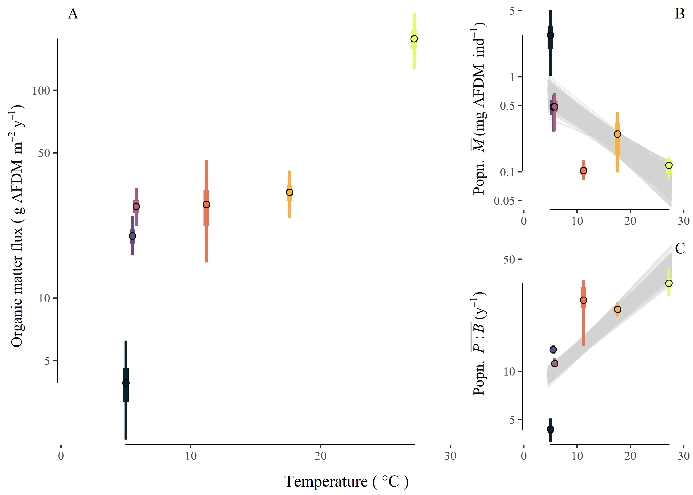

Figure 1. (A) Total organic matter flux (g AFDM m-2 y-1) increased with mean annual temperature. Higher stream temperatures also led to (B) a decrease in mean population body size (, mg ind-1) and (C) an increase in mean population biomass turnover rate (, y-1). For all panels, points represent the mean value, wide bars represent the 25th and 75th percentile bounds, and narrow bars represent the 2.5th and 97.5th percentile bounds.

Figure 2

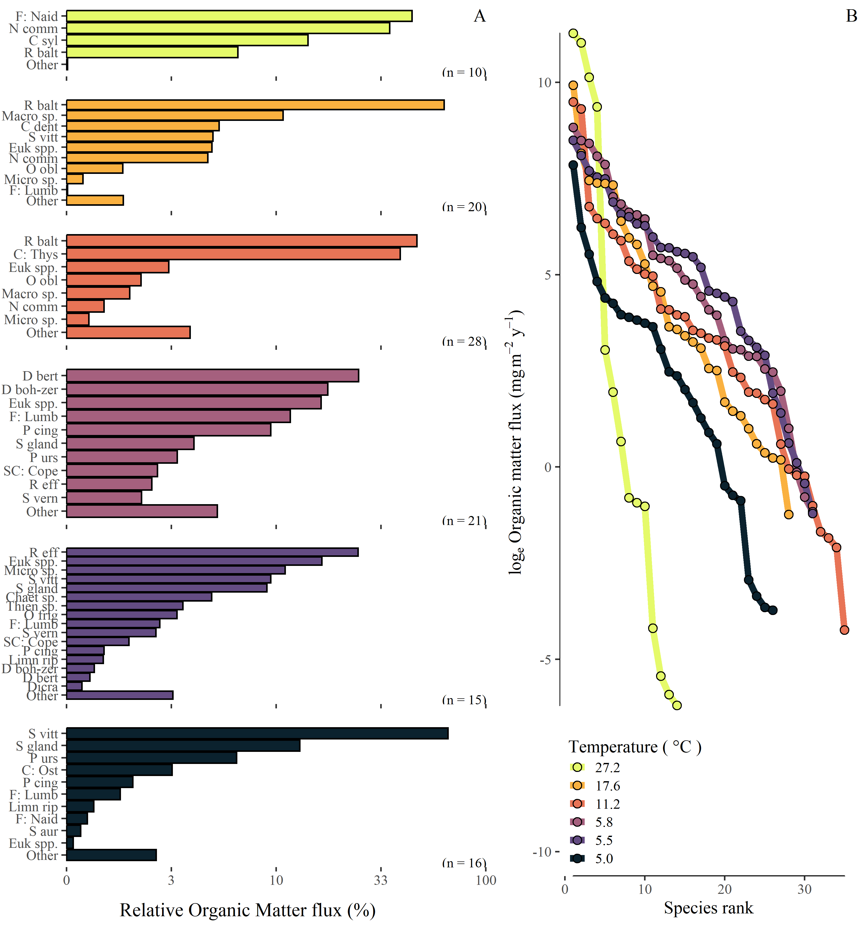

Figure 2. (A) Percent contribution of taxa to OM flux (loge[g AFDM m-2 y-1])in each stream; colors correspond to mean annual temperature shown in the legend; (B) rank-ordered organic matter flux (loge(mg AFDM m-2 y-1) by taxon. Taxa abbreviations: F:Naid, Family Naididae; N comm, *Nais communis*; C syl, *Cricotopus sylvestris*; R balt, *Radix balthica*; Macro sp., *Macropelopia* sp.; C dent, *Chaetocladius dentiforceps*; S vitt, *Simulium vittatum*; Euk spp., *Eukiefferiella* spp.; O obl, *Orthocladius oblidens*; Micro sp. *Micropsectra* sp.; D bert, *Diamesa bertrami*; D boh-zer, *Diamesa bohemani-zernyi*; F: Lumb, Family Lumbricidae; P cing, *Potamophylax cingulatus*; S gland, *Sperchon glandulosus*; P urs, *Prosimulium ursinum*; SC: Cope, Subclass Copepoda; R eff, *Rheocricotopus effusus*; S vern, *Simulium vernum*; Chaet sp., *Chaetocladius* sp.; Thien sp., *Thienemanniella* sp.; O frig, *Orthocladius frigidus*; Limn rip, *Limnophora riparia*; Dicra, *Dicranota* sp.; C: Ost, Class Ostracoda; S aur, *Simulium aurem*.

Figure 3

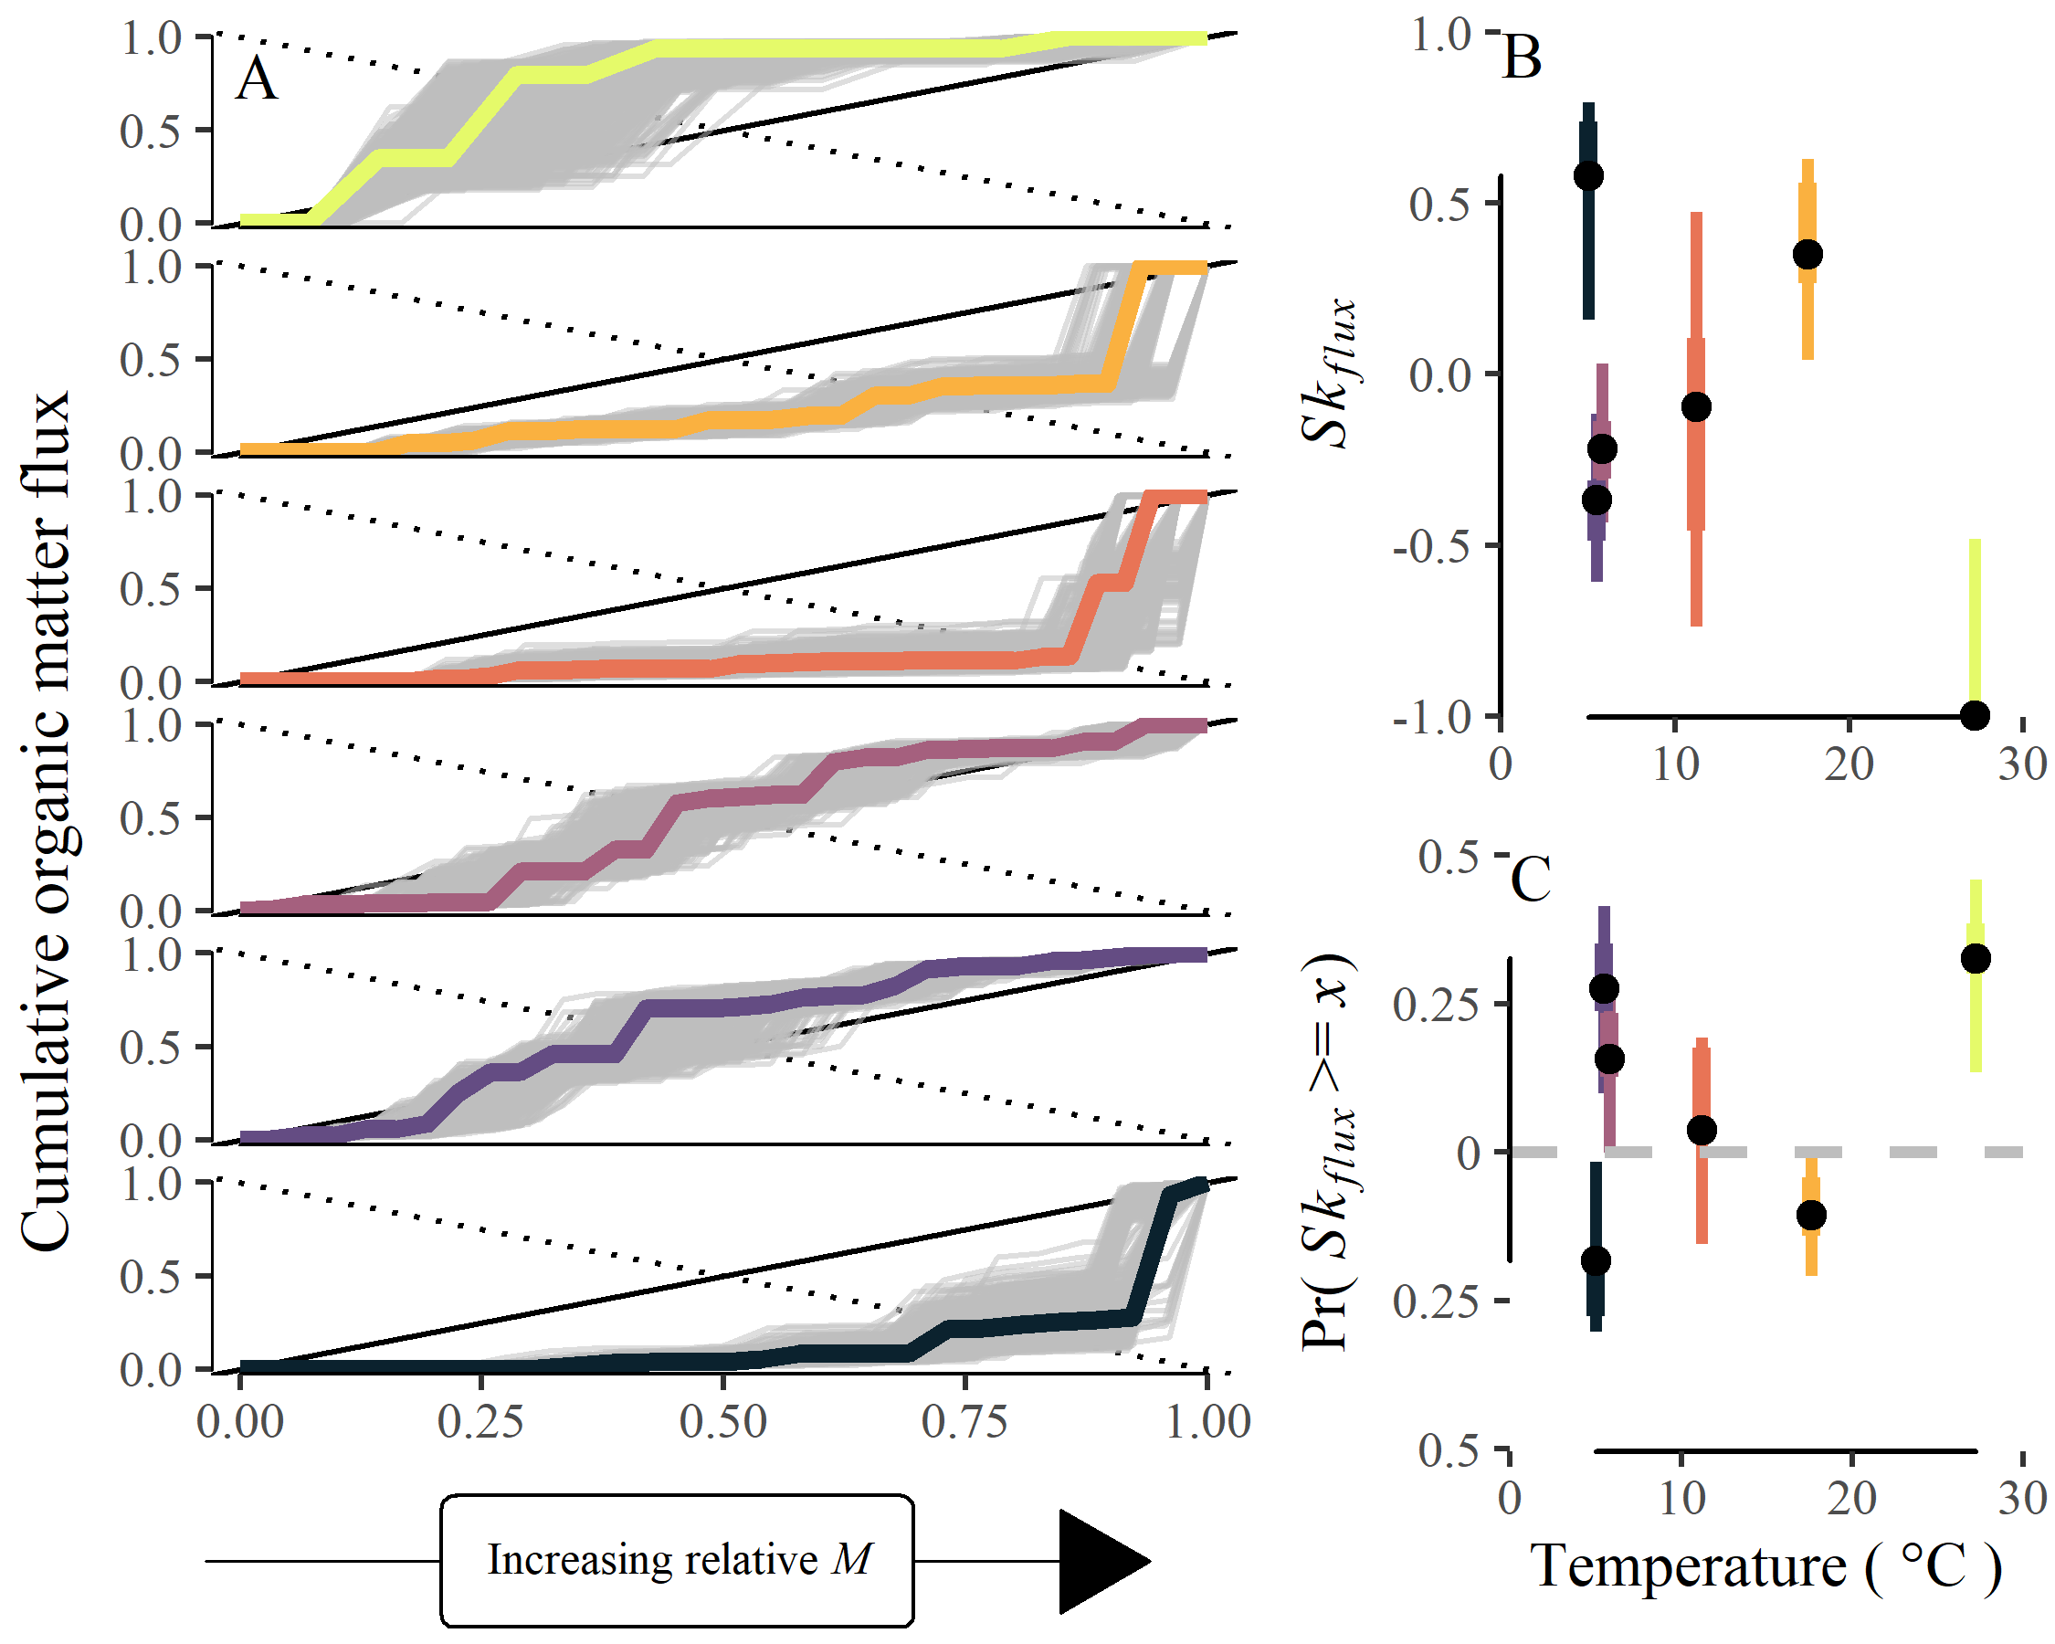

Figure 3. (A) Lorenz curves showing cumulative relative organic matter flux among taxa with increasing body size (from left to right; *M*, mg AFDM ind-1). The solid line 1:1 line from the origin represents the line of equality. Distributions near this line suggest minimal structuring of OM fluxes in relation to body size. The dotted line allows for visualization of skewness in OM fluxes based on its intersection with the empirical lorenz curve. (B) Empirical estimates of body size-related OM flux skewness in relation to stream temperature. (C) The probability of observing these skewness values when compared to a random ordering. For panels B and C, points represent the median value, wide bars represent the 25th and 75th percentile bounds, and narrow bars represent the 2.5th and 97.5th percentile bounds.

Figure 4

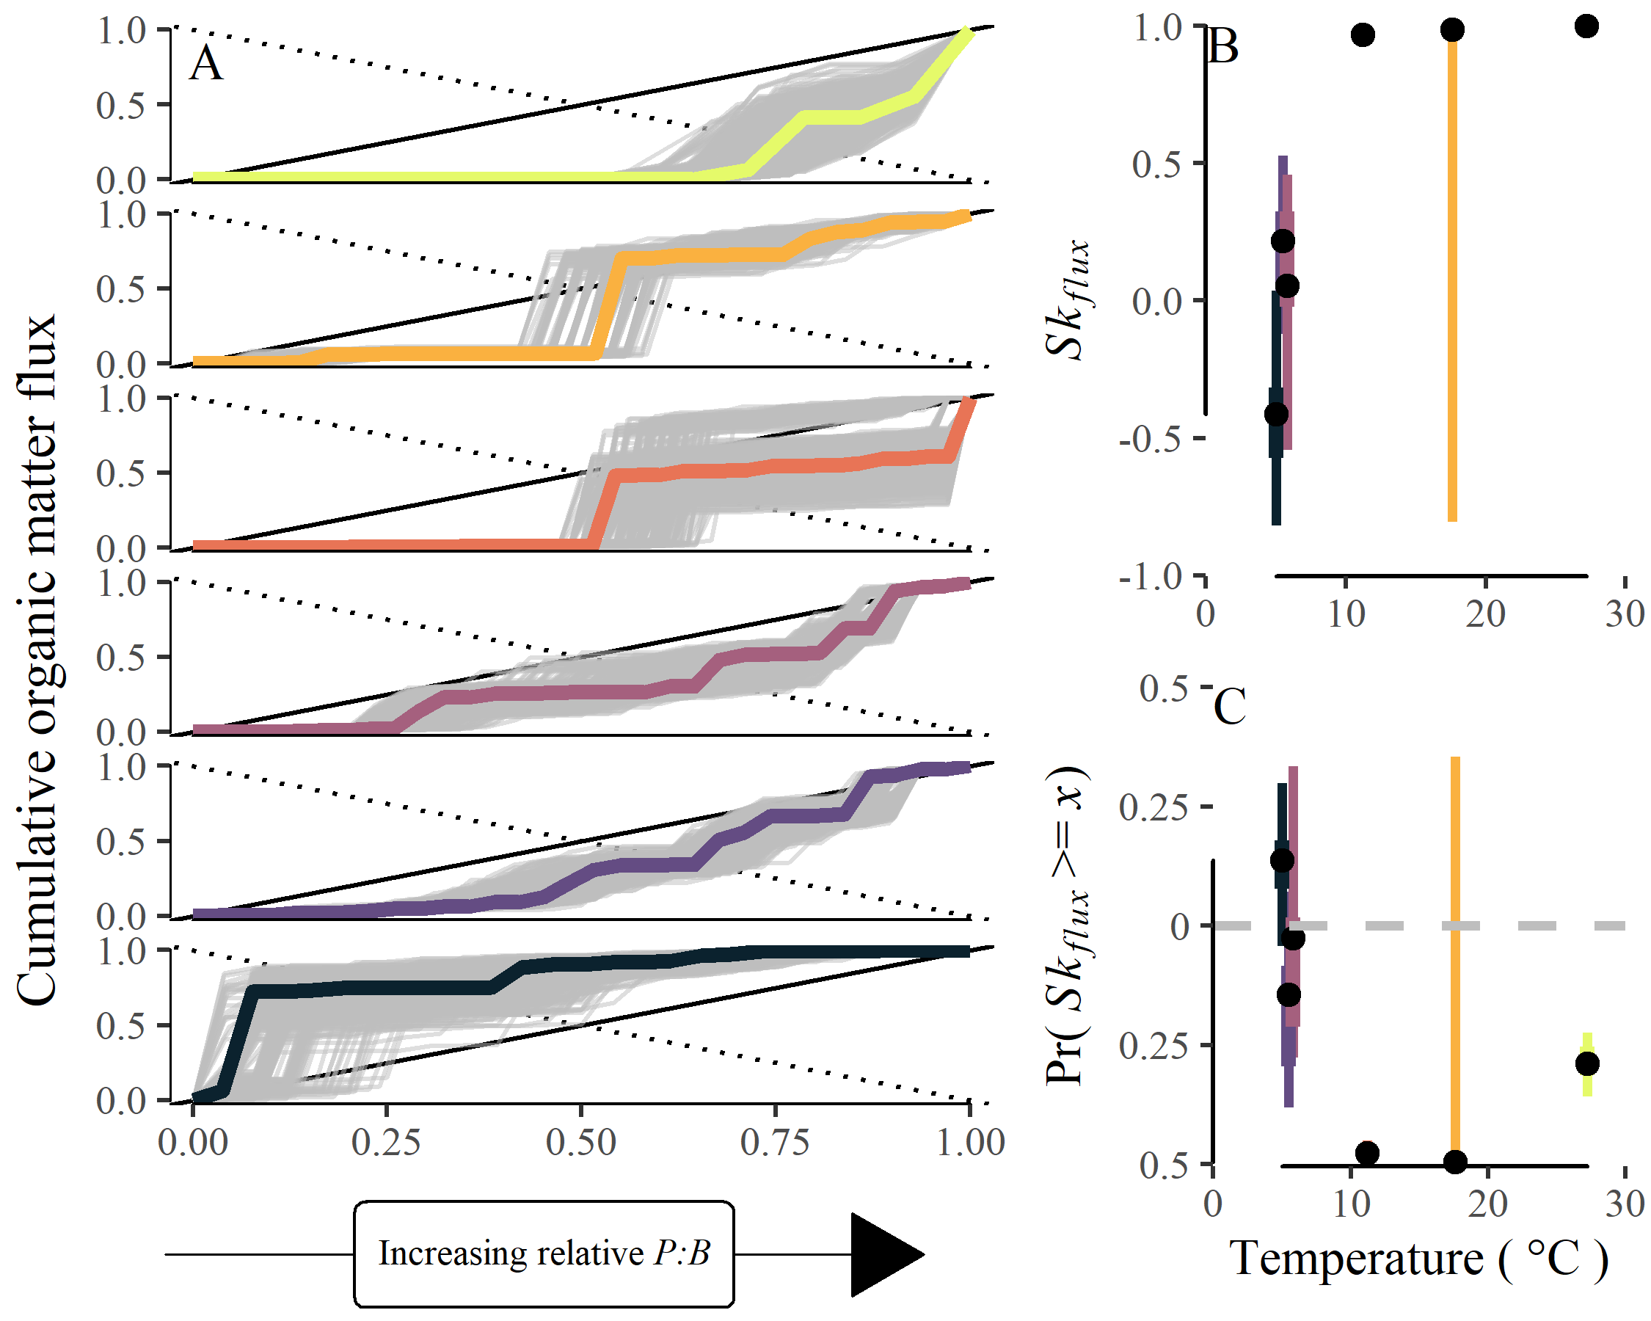

Figure 4. (A) Lorenz curves showing cumulative relative organic matter flux among taxa with increasing *P:B* ratio (from left to right; y-1). The solid 1:1 line from the origin represents the line of equality. Distributions near this line suggest minimal structuring of OM fluxes in relation to *P:B* ratio. The dotted line allows for visualization of skewness in OM fluxes based on its intersection with the Lorenz curve. (B) Estimates of *P:B*-related OM flux skewness in relation to stream temperature. (C) The probability of observing these skewness values when compared to a random (i.e., stochastic) ordering. For panels B and C, points represent the median value, wide bars represent the 25th and 75th percentile bounds, and narrow bars represent the 2.5th and 97.5th percentile bounds.

# Appendix

## Appendix S1

Appendix S1: Supporting information for Junker, J. R., W. F. Cross, J. M. Hood, J. P. Benstead, A. D. Huryn, D. Nelson, J. S. Ólafsson, and G. M. Gíslason, “*Environmental warming increases the importance of high-turnover energy channels in stream food webs*” for review and publication in *Ecology*.

### Diet analysis

Macroinvertebrate diets were quantified for dominant taxa in each stream. We focused on numerically abundant taxa and/or taxa with relatively high annual production. A minimum of five individuals were selected from samples, and, when possible included individuals of different size classes to account for ontogenetic shifts in diet. We included individuals from different seasons to capture concurrent ontogenetic and seasonal changes. For small-bodied taxa, we combined multiple individuals (*n* = 3–5) to ensure samples contained enough material for quantification. We used methods outlined in Rosi-Marshall (2016) to remove gut tracts and prepare gut contents for quantification. Briefly, we removed the foregut from each individual or collection of individuals and sonicated contents in water for 30 seconds. Gut content slurries were filtered onto gridded nitrocellulose membrane filters (Metricel GN-6, 25 mm, 0.45 $μ$ m pore size; Gelman Sciences, Ann Arbor, MI, USA), dried at 60 $​^{∘}$ C for 15 min, placed on a microscope slide, cleared with Type B immersion oil, and covered with a cover slip. We took 5–10 random photographs under 200–400x magnification, depending on the density of particles, using a digital camera mounted on a compound microscope. From these photographs we identified all particles within each field and measured the relative area of particles using image analysis software (Schindelin et al. 2012). We classified particles into six categories: diatoms, green and filamentous algae, cyanobacteria, amorphous detritus, vascular and non-vascular plants (e.g., bryophytes), and animal material and then calculated the proportion of each food category in the gut by dividing their summed area by the total area of all particles. Gut contents of many predators were empty or contained unidentifiable, macerated prey. For these taxa, we assumed 100% animal material.

To estimate variability in diet compositions and to impute missing values for non-dominant, yet present, taxa, we modeled the diet proportions within each stream using a hierarchical multivariate model (Fordyce et al. 2011, Coblentz et al. 2017). Here, the diet of a consumer population, *i*, in stream, *j*, is a multinomial vector, $\vec{y_{ij}}$, of

$$\vec{y_{ij}}∼Multinomial\left(\vec{p_{ij}},n_{ij}\right)$$

$$\vec{p_{i}}∼Dirichlet\left(\vec{q_{i}}×α\right)$$

where, $\vec{p_{i}}$, is a vector of consumer diet proportions, $\vec{q_{i}}$ is a vector of the population’s diet proportions and $α$ is a concentration parameter of the Dirichlet process. We used uniform priors for $\vec{q_{i}}$ and $α$,

$$\vec{q_{i}}∼Dirichlet\left(\vec{\text{1}}\right)$$

$$α∼Uniform\left(0,\text{c}\right)$$

where, $\vec{\text{1}}$ is a vector of ones the same length of basal resource types and $\text{c}$ is the assumed concentration value. Models were fit in Stan with the ‘brms’ package in R (Bürkner 2017). For non-dominant taxa, diet proportions were imputed from the hierarchical model by resampling from posterior distributions. Importantly, this process allowed to maintain the hierarchical structure of the data when imputing missing values.

From modeled diet compositions, we estimated trophic redundancy within and across stream food webs by calculating proportional similarities ( *PS*, Whittaker 1952) among modeled diet estimates. Proportional similarities were calculated as:

$$PS=1−0.5\sum_{j=1}^{S}{\left|p_{x,i}−p_{y,i}\right|}$$

where, *px,i* is the proportion of food resource *i* in the diet of taxon *x*, *py,i* is the proportion of food resource *i* in the diet of taxon *y*, and there are *S* food categories. Proportional similarity was calculated across all taxa within a stream based on modeled diet contributions from each taxon. To calculate *PS* among streams we sampled 1000 estimates of the mean stream-level diet proportions for each stream and calculated *PS* for each.

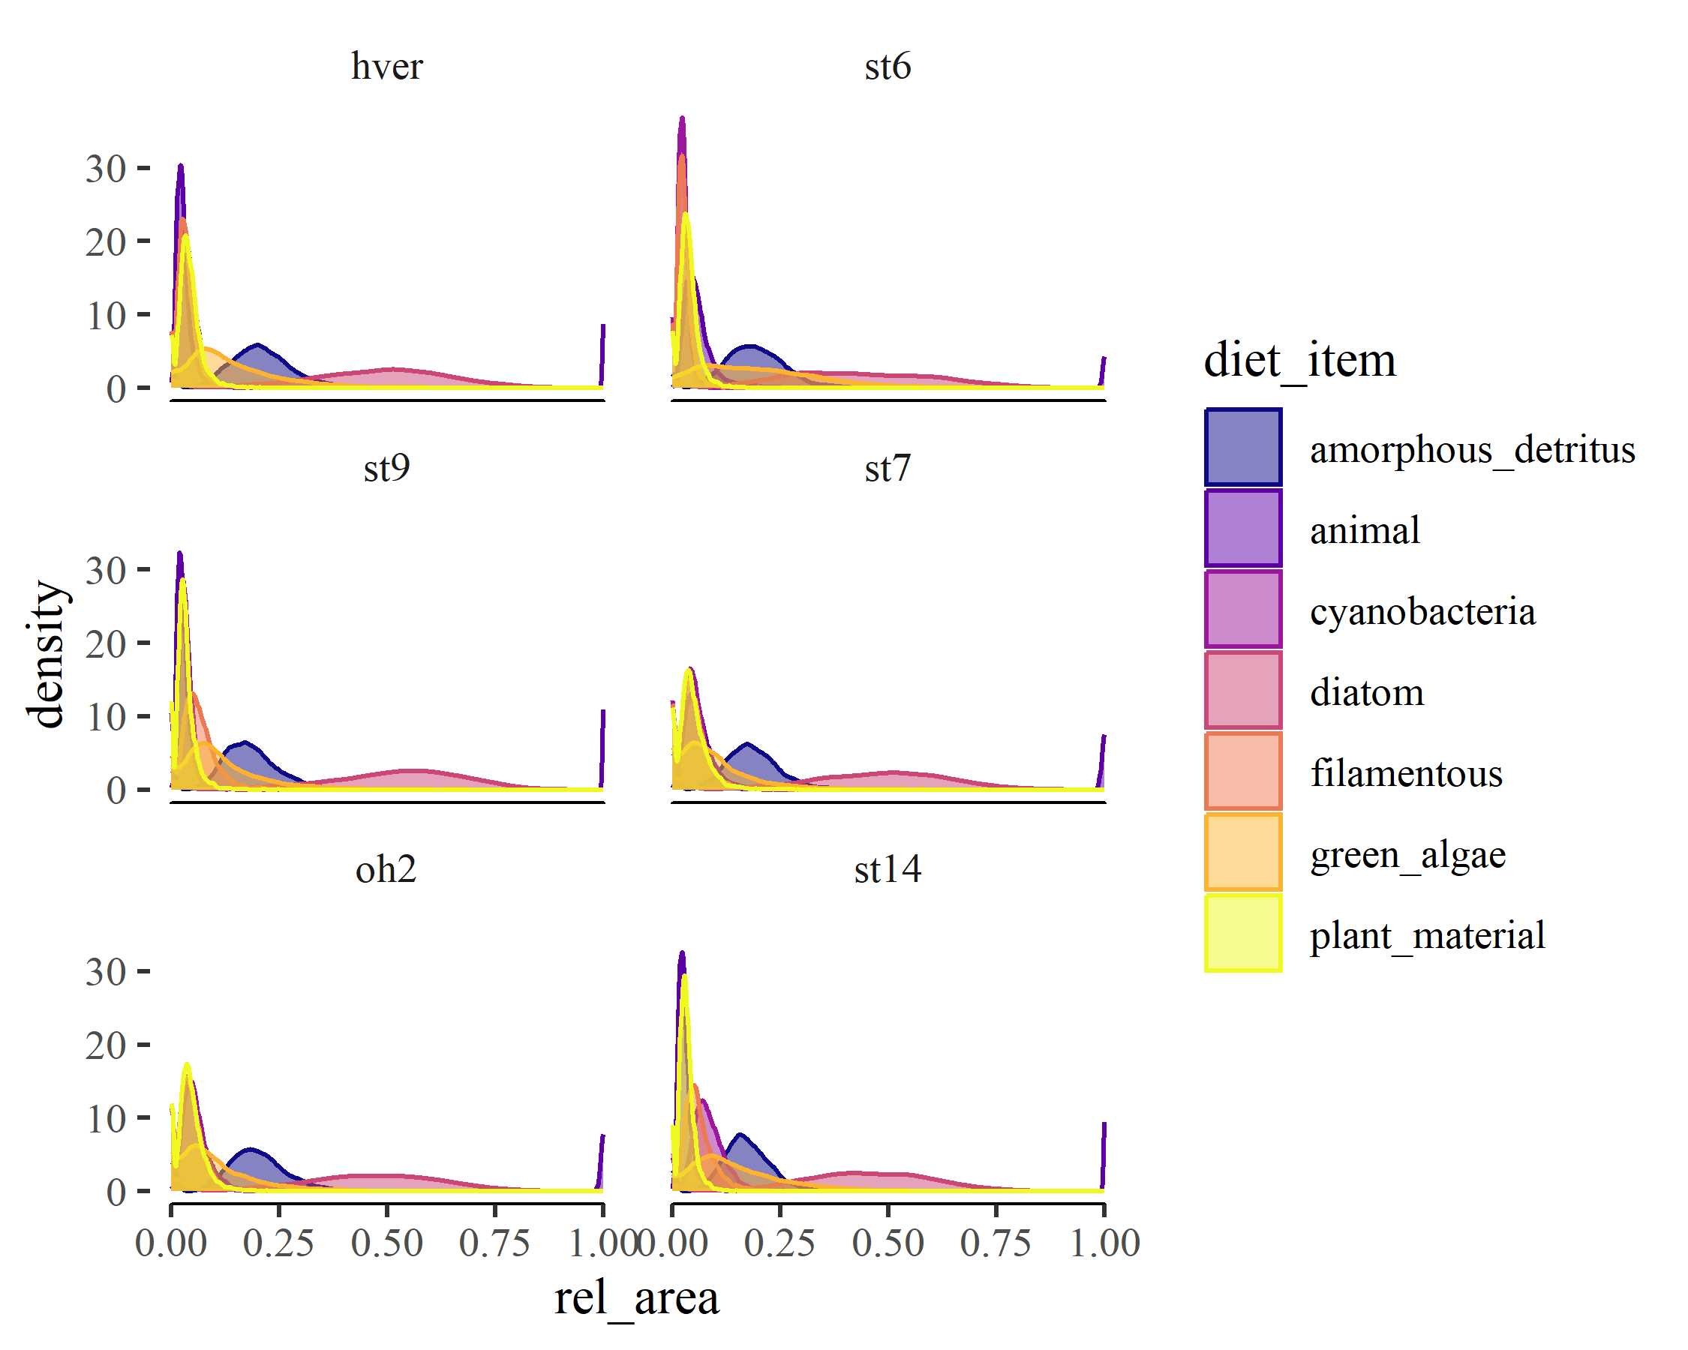

Appendix S1:Figure S1. Posterior distributions of site-level diet proportions for consumer communities across the temperature gradient.

## Appendix S2

Appendix S2: Supporting information for Junker, J. R., W. F. Cross, J. M. Hood, J. P. Benstead, A. D. Huryn, D. Nelson, J. S. Ólafsson, and G. M. Gíslason, “*Environmental warming increases the importance of high-turnover energy channels in stream food webs*” for review and publication in *Ecology*.

Appendix S2:Table S1. Evenness of organic matter fluxes among consumers within a stream community measured by the Gini index, both raw ('non-normalized') and 'normalized' for consumer richness

| site | Non-normalized Gini | Normalized Gini |
| --- | --- | --- |
| hver | 0.22 ( 0.18 - 0.27 ) | 0.15 ( 0.11 - 0.19 ) |
| oh2 | 0.29 ( 0.25 - 0.32 ) | 0.26 ( 0.23 - 0.3 ) |
| st14 | 0.14 ( 0.098 - 0.2 ) | 0.1 ( 0.059 - 0.17 ) |
| st6 | 0.13 ( 0.11 - 0.16 ) | 0.1 ( 0.079 - 0.13 ) |
| st7 | 0.23 ( 0.2 - 0.26 ) | 0.2 ( 0.18 - 0.23 ) |
| st9 | 0.092 ( 0.073 - 0.11 ) | 0.064 ( 0.045 - 0.082 ) |

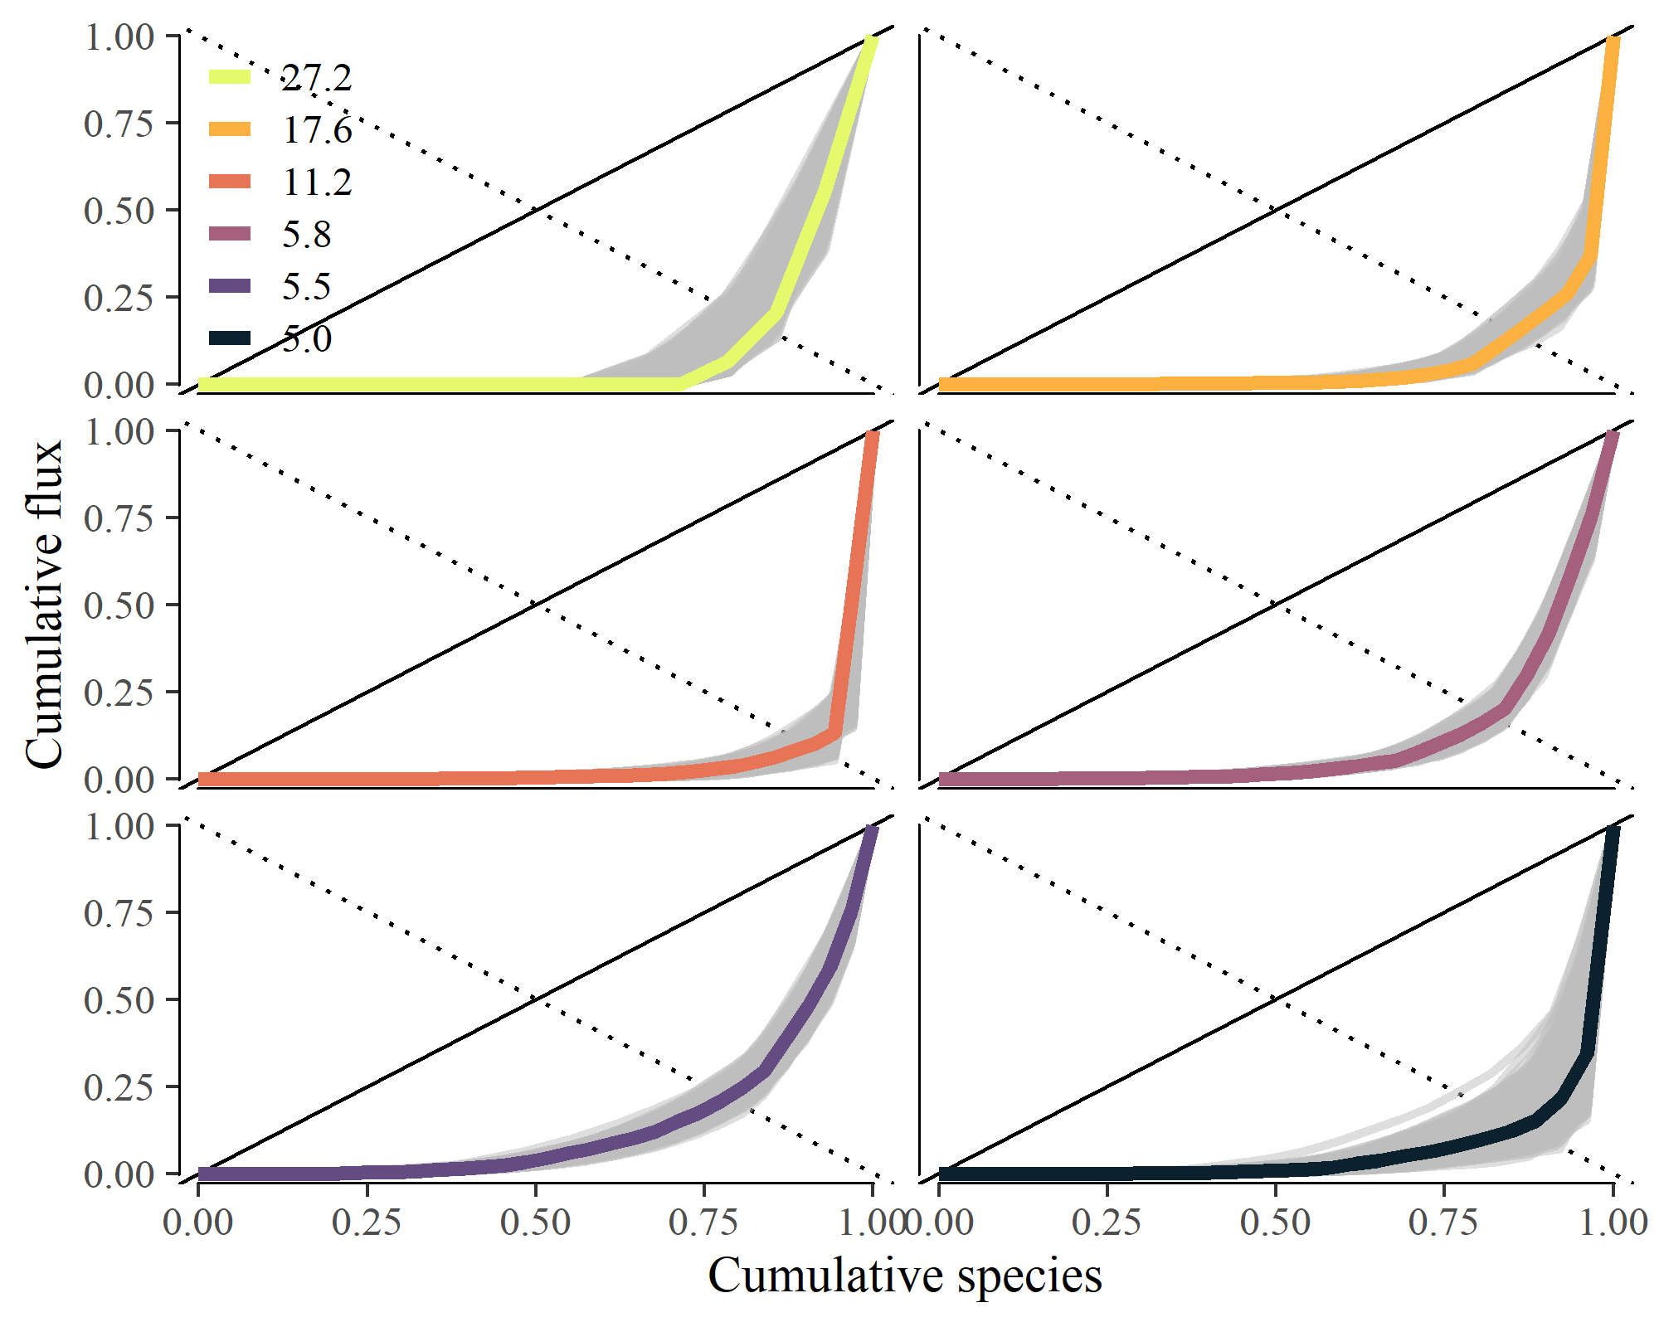

Appendix S2:Figure S1. Lorenz plot of relative community flux by species in ascending order of annual population organic matter flux (g AFDM m-2 y-1)

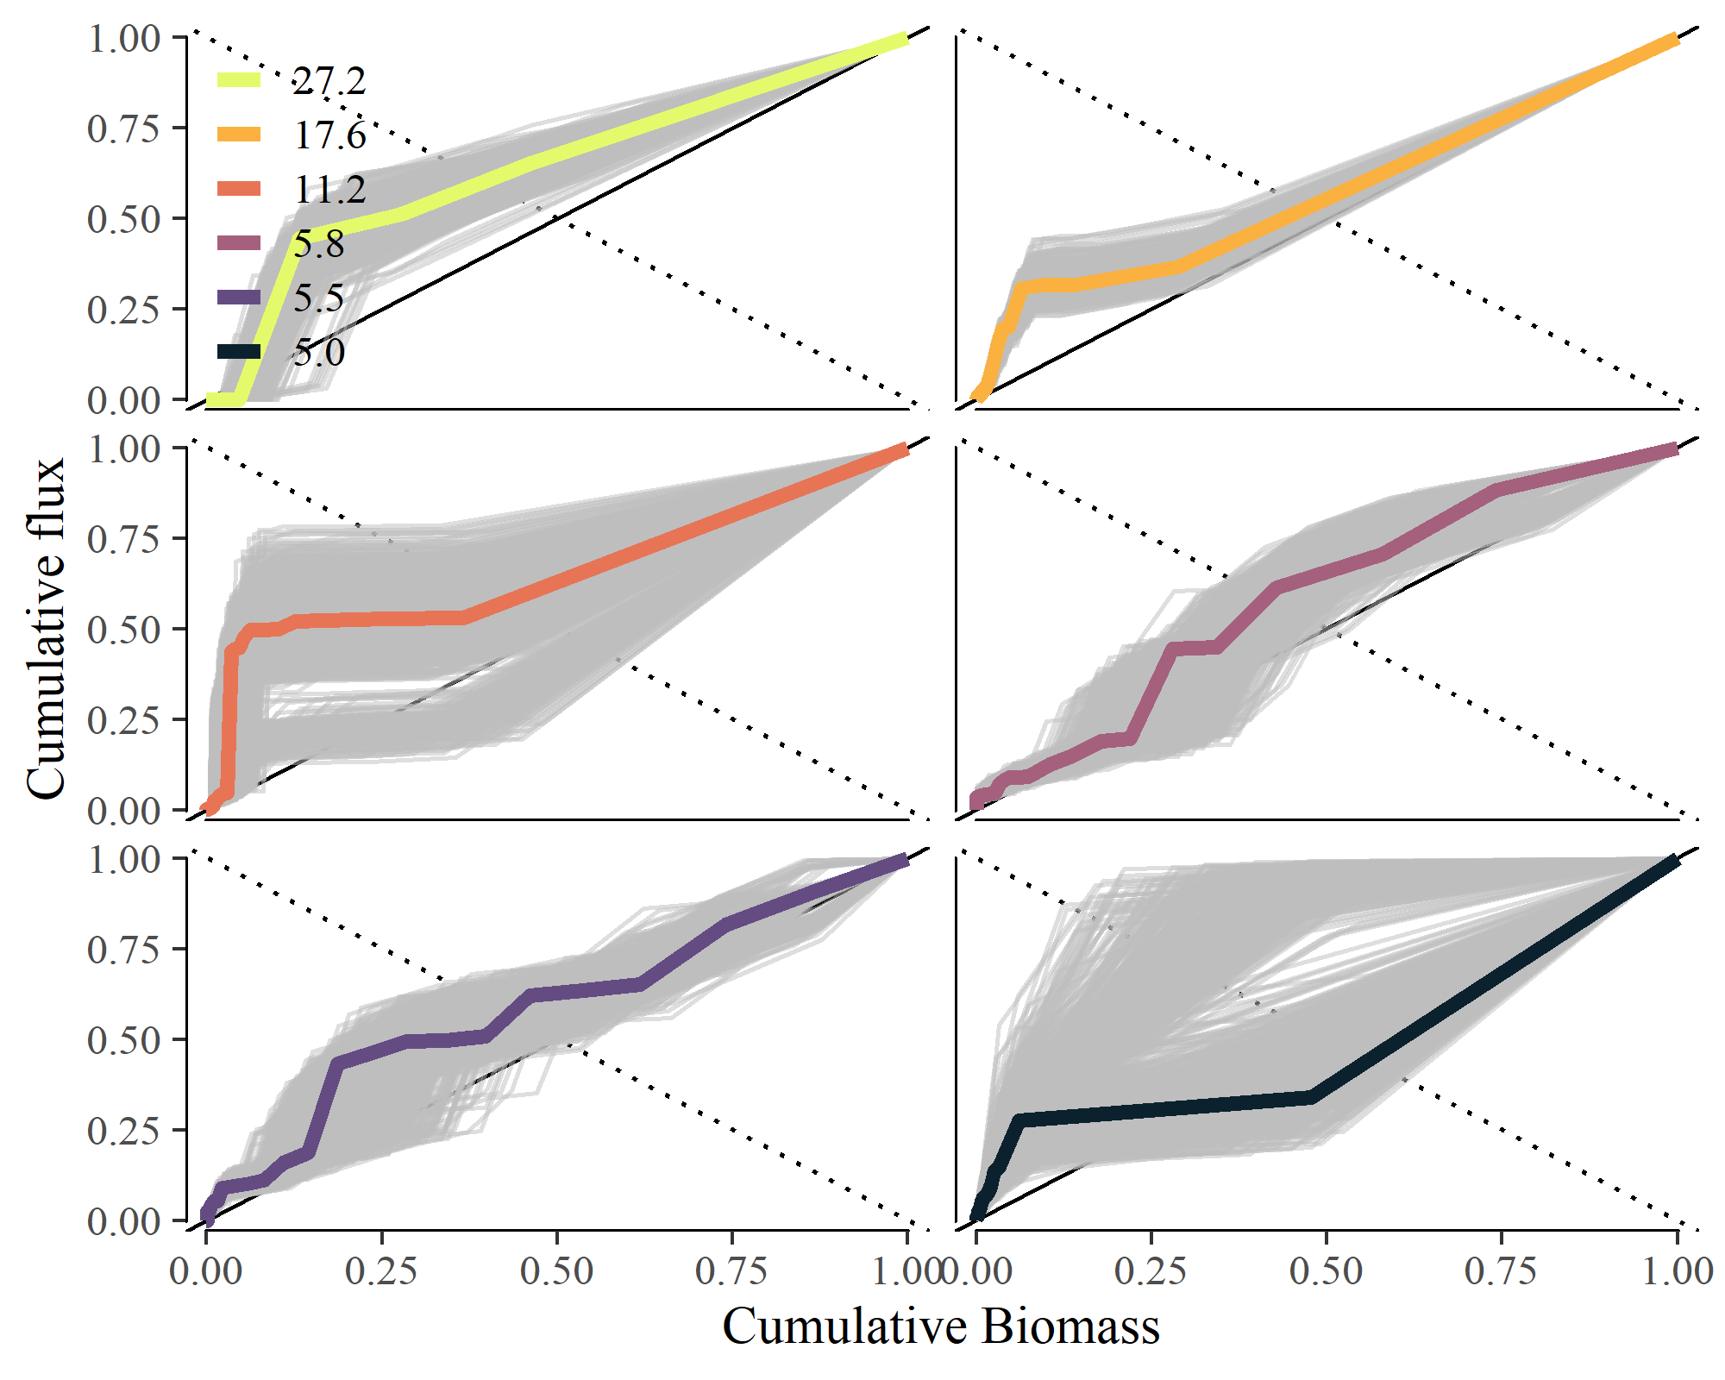

Appendix S2:Figure S2. Cumulative plot of relative community flux by species in relation to mean annual population biomass (mg m-2).

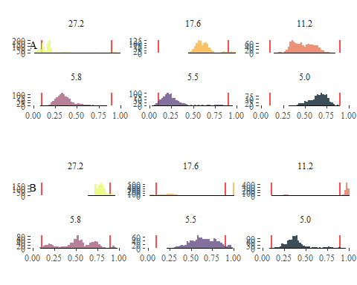

Appendix S2:Figure S3. Probability distribution of empirical Skflux measurements in relation to (a) mean body size and (b) annual P:B compared to random species ordering. The red lines represent the 2.5% and 97.5% percentiles of the Skflux values from random ordering distributions in each stream community.