Report Author

07 June, 2021

## Tables

Table 1.

|  |  |  |
| --- | --- | --- |
| site | Non-normalized Gini | Normalized Gini |
| hver | 0.22 ( 0.18 - 0.27 ) | 0.15 ( 0.11 - 0.19 ) |
| oh2 | 0.27 ( 0.24 - 0.31 ) | 0.25 ( 0.21 - 0.28 ) |
| st14 | 0.14 ( 0.098 - 0.21 ) | 0.1 ( 0.059 - 0.17 ) |
| st6 | 0.13 ( 0.11 - 0.16 ) | 0.1 ( 0.079 - 0.13 ) |
| st7 | 0.25 ( 0.22 - 0.28 ) | 0.22 ( 0.19 - 0.25 ) |
| st9 | 0.069 ( 0.054 - 0.098 ) | 0.04 ( 0.024 - 0.069 ) |

Table 2.

Figure descriptions

Figure 1. Species rank-flux plots among streams. Within each stream, species are ranked by descending annual total organic matter flux (mg AFDM ).

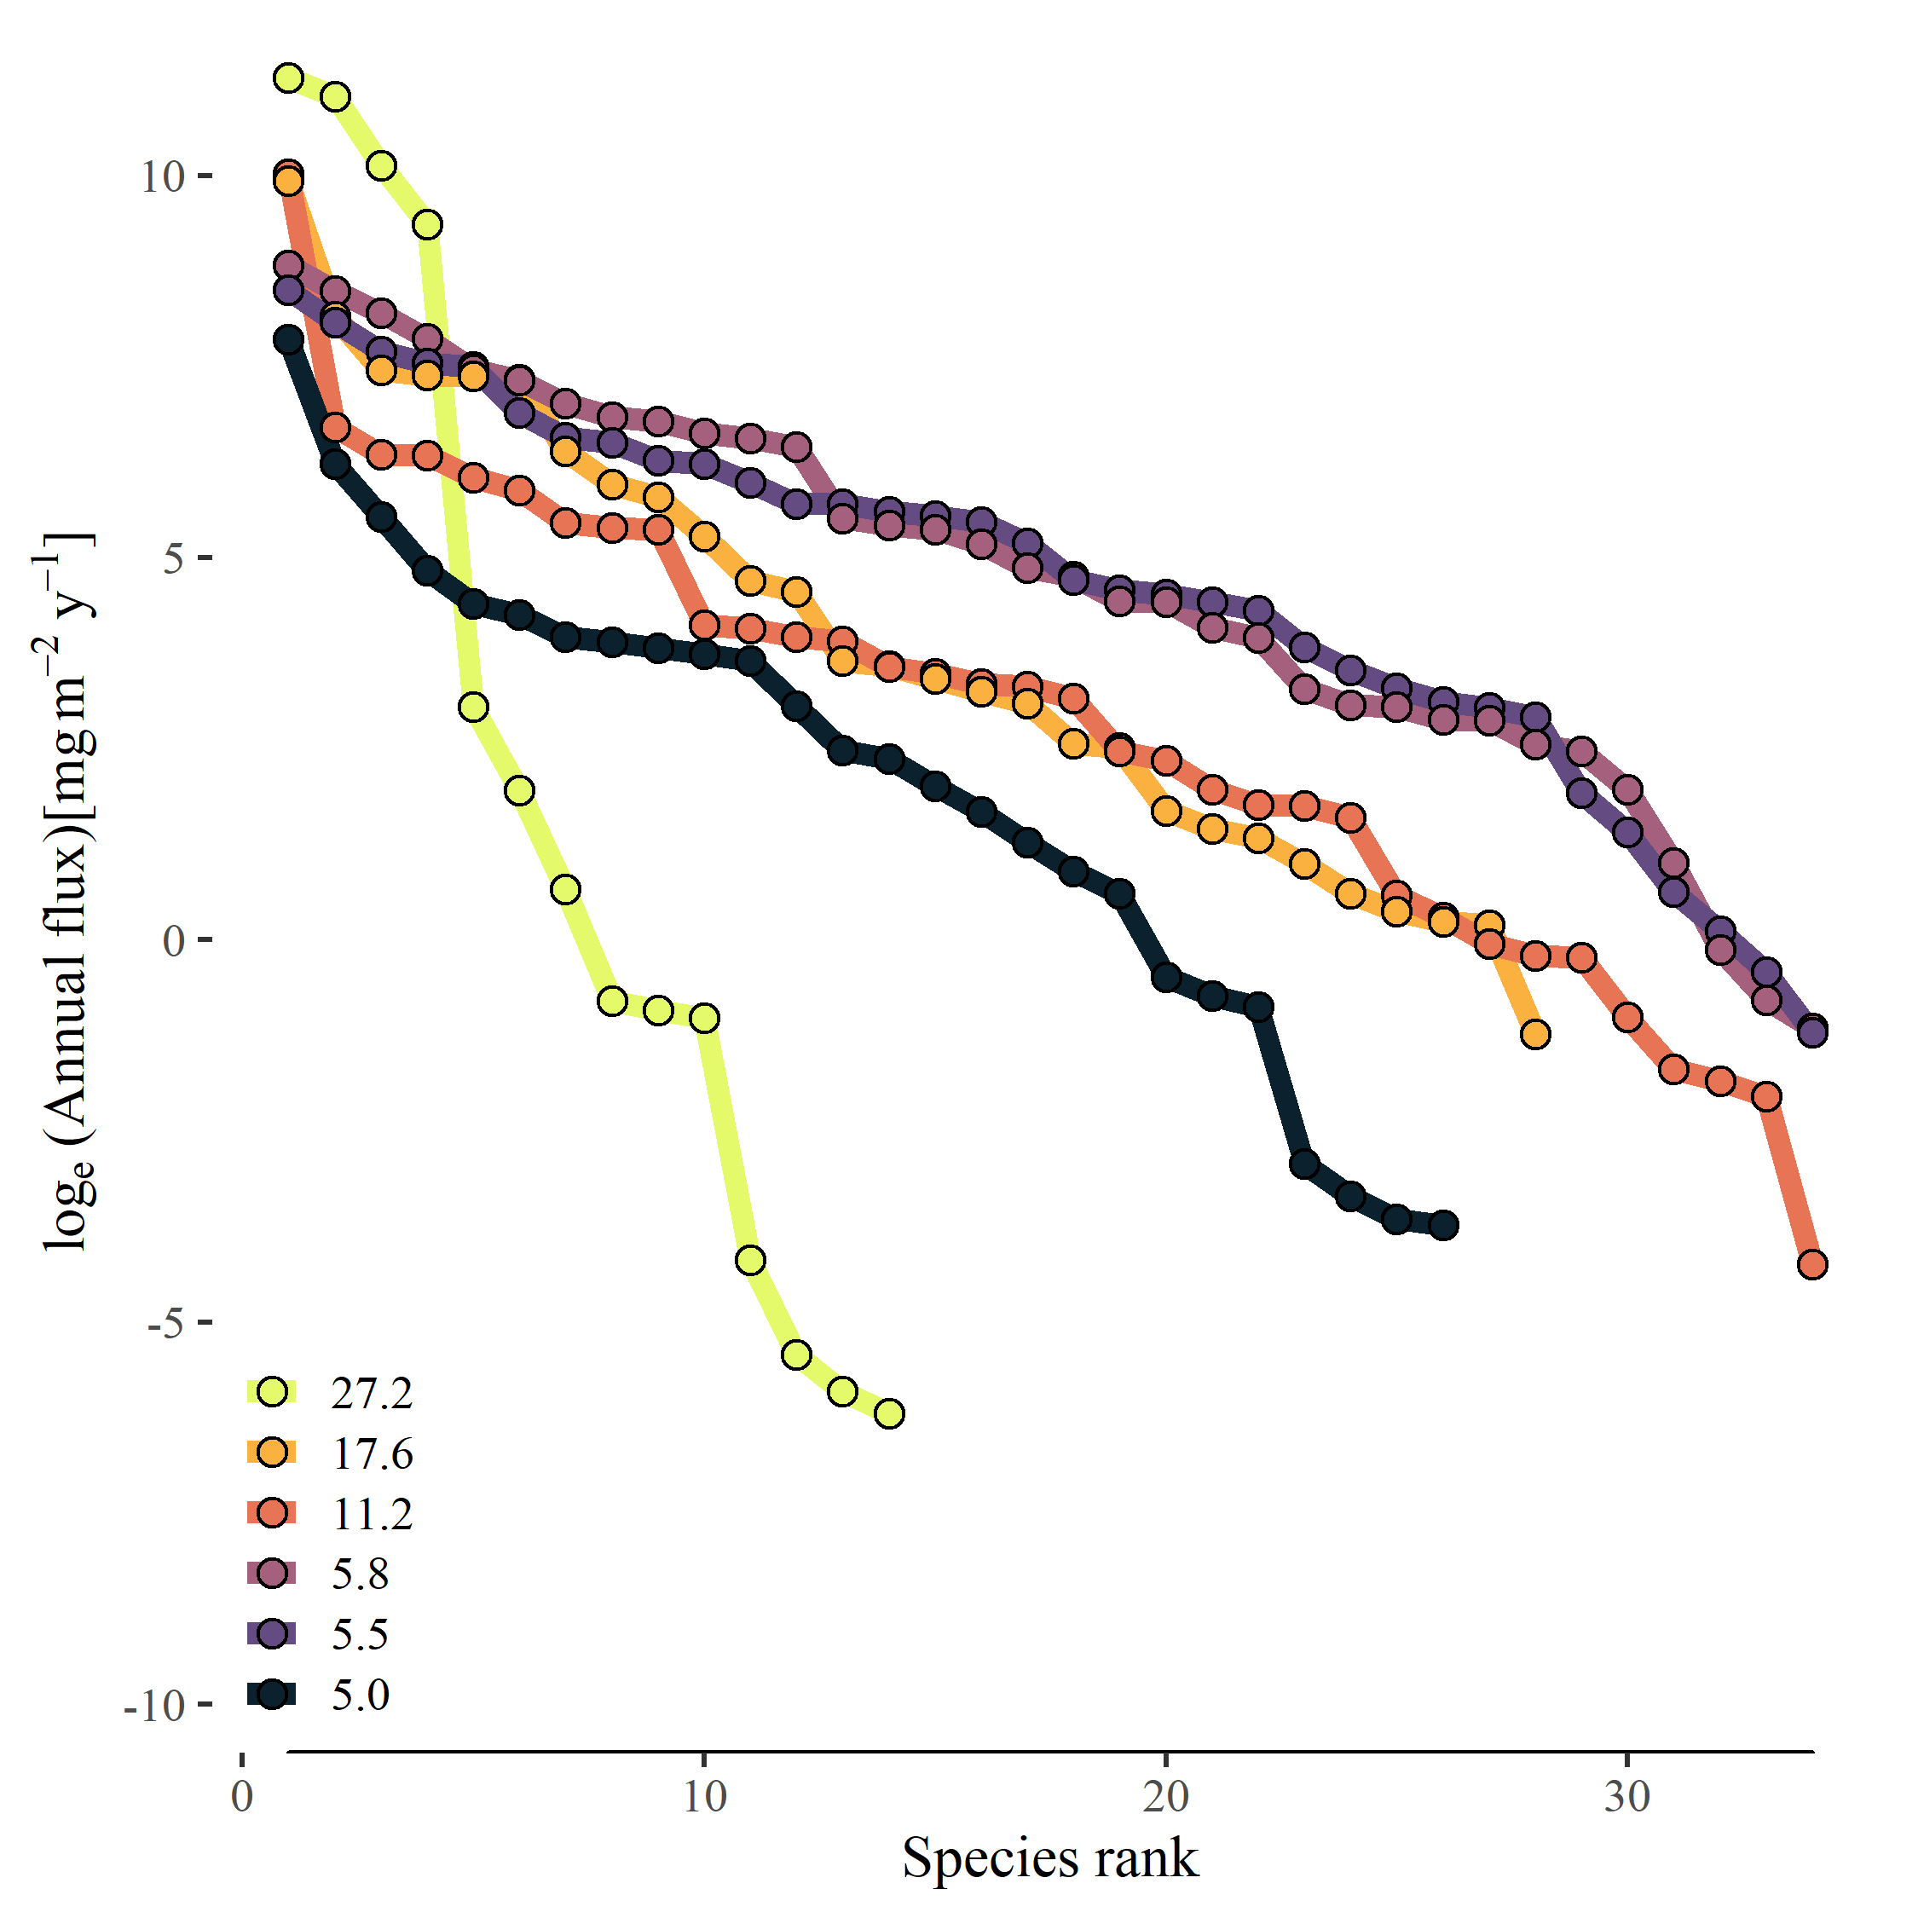

Figure 3. Histograms of species trait distributions of (a) log10 annual production:biomass ratio (y-1), (b) log10 mean body mass (mg ind-1), and (c) log10 annual mean population biomass (mg m-2).

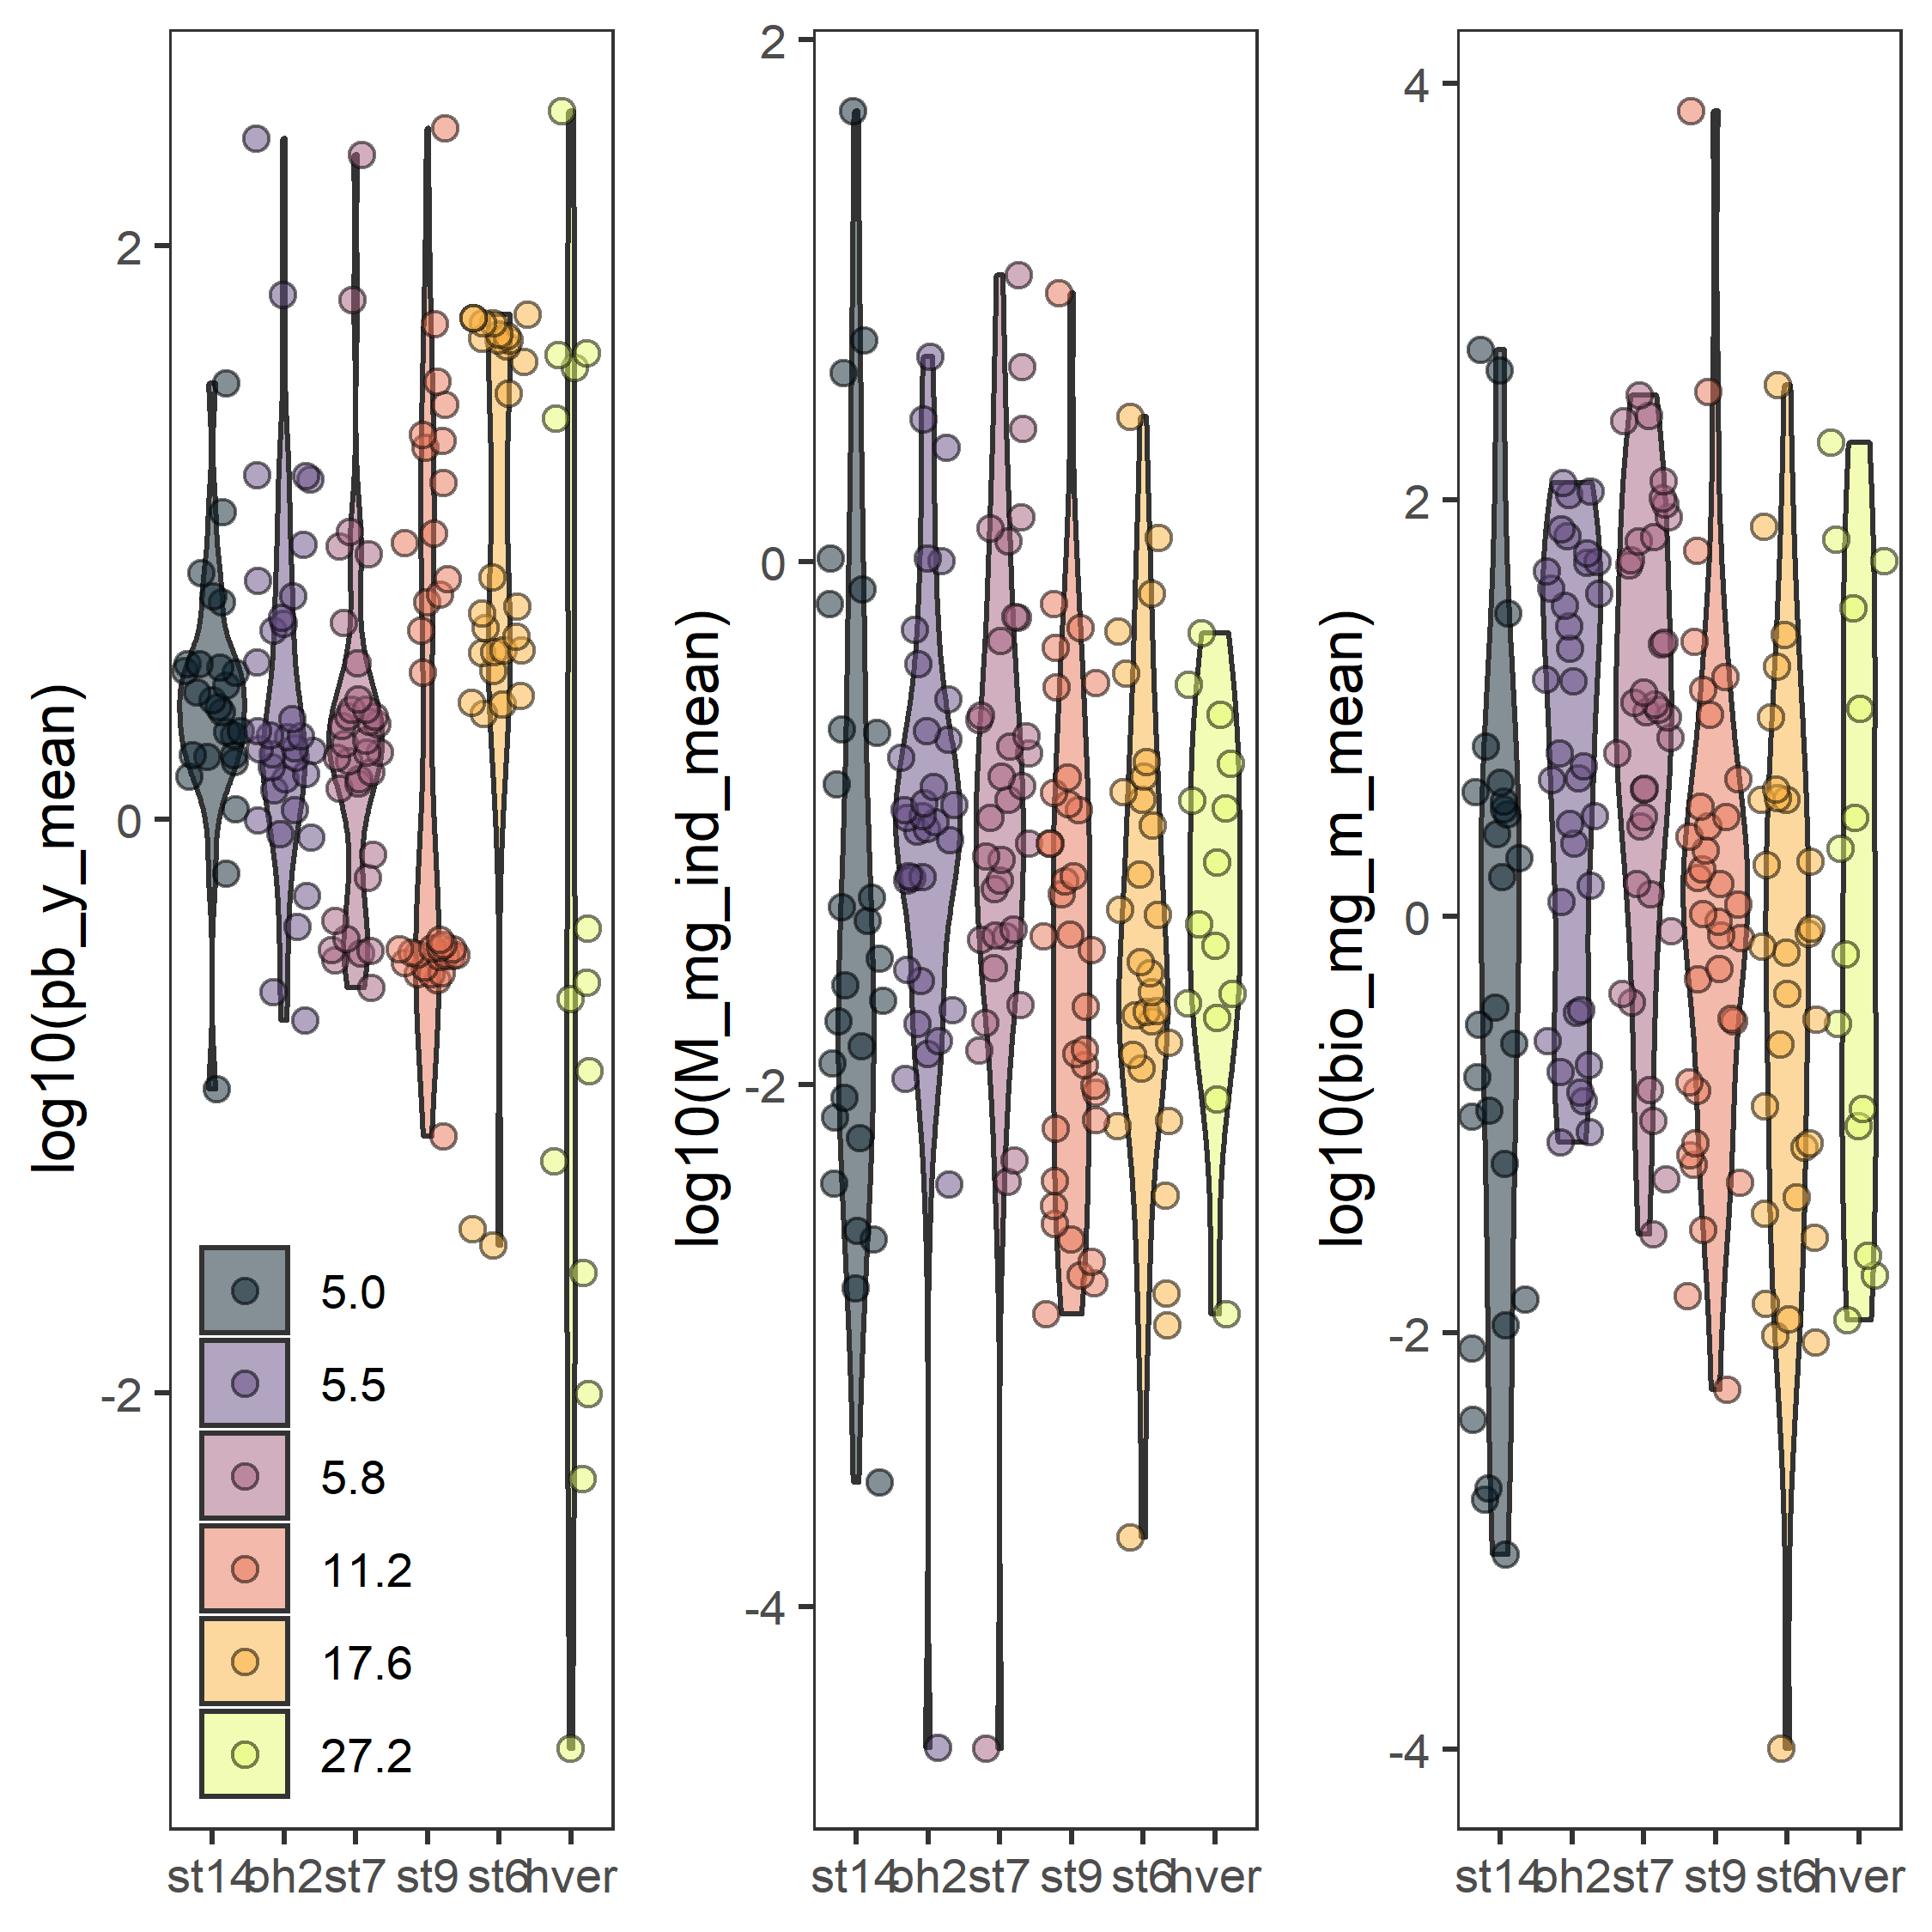

Figure 4. Relative cumulative fluxes among species in relation to ranked order of (a) annual production:biomass ratio (y-1) and (b) mean body size (mg ind-1).

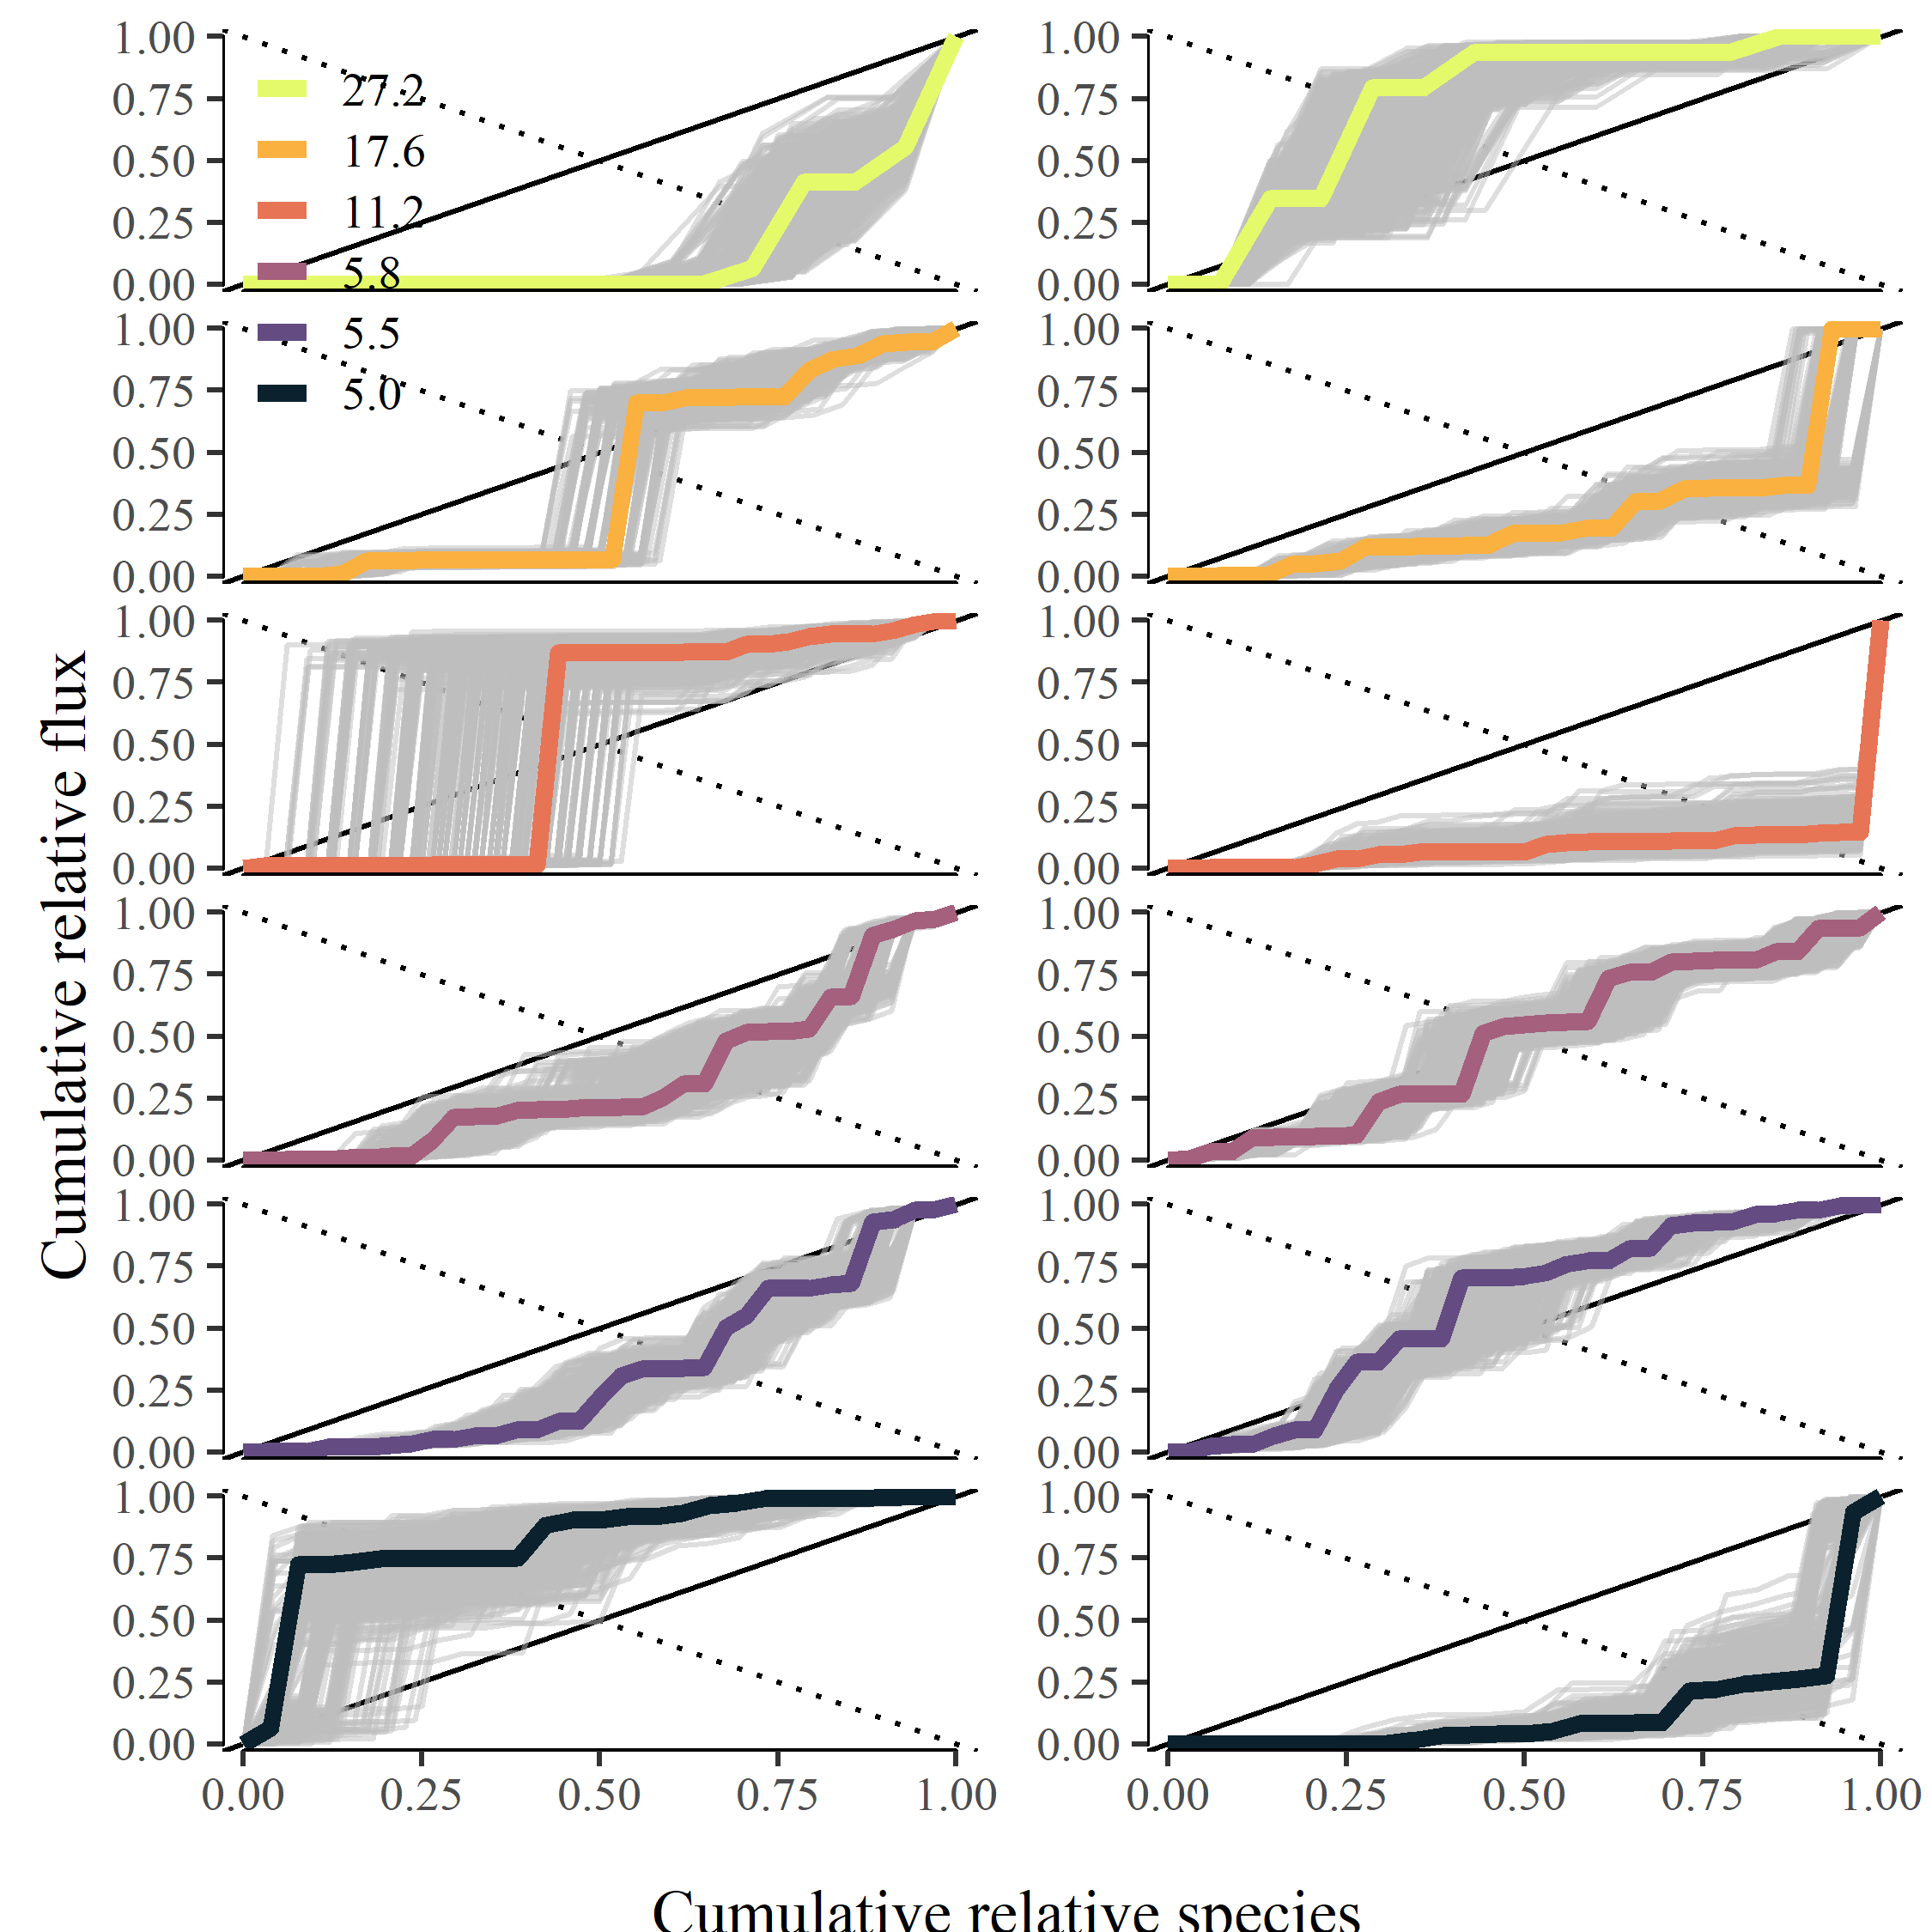

Figure 4. Bootstrapped distribution of skew statistics from OM fluxes with body size, *M*, and (b) population annual production:biomass ratio relative to the distribution of skew statistics of 100,000 random orderings.

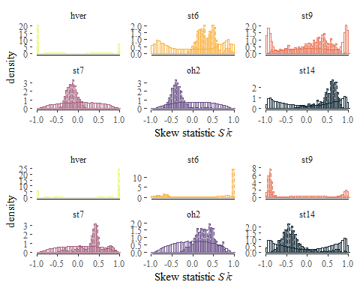

Figure 5. Non-random organization of community energy fluxes in relation to population biomass turnover (*P:B*) with mean annual temperature (C). Non-random organization is measured by the proportion of randomly generated skew statistics, , of equal or greater value. Observing an empirical value of with a low probability of occurrence by random chance suggests non-random organization of community energy fluxes.

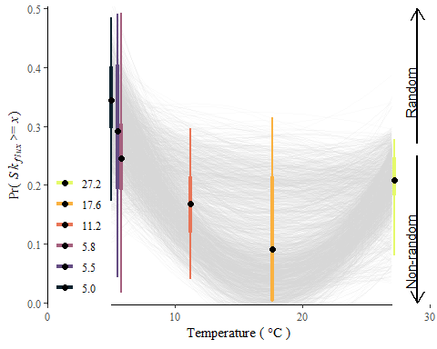

Figure S1. Modeled diet proportions among streams

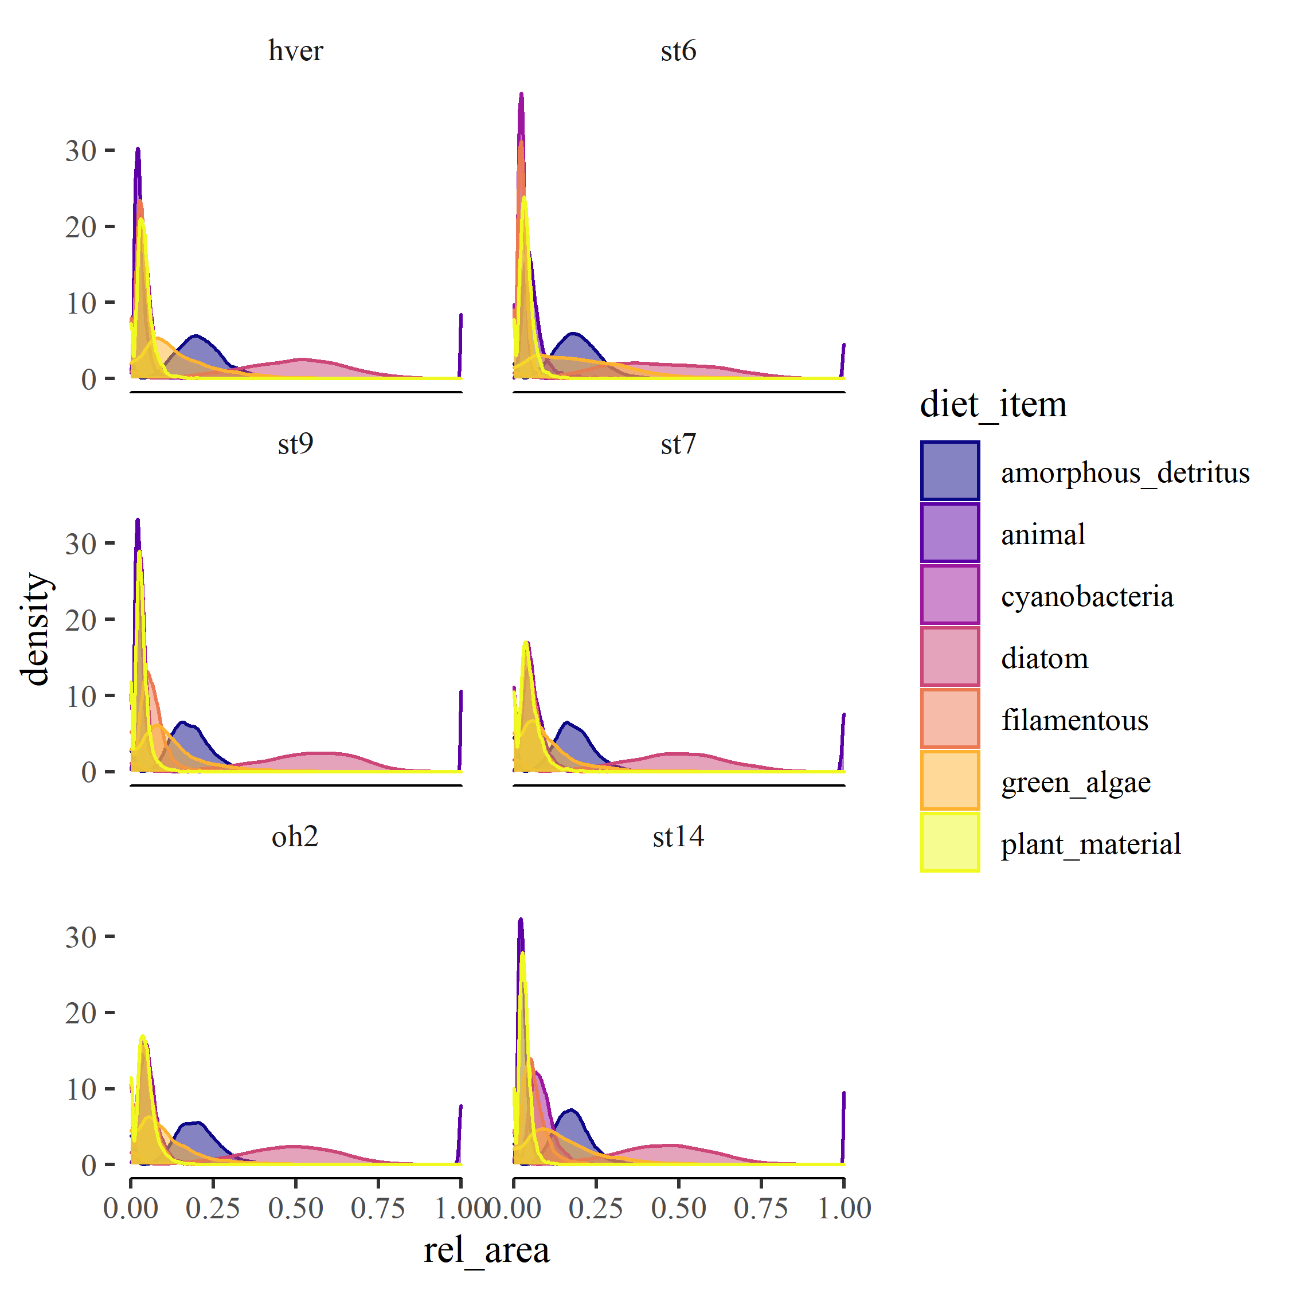

Figure S2. Lorenz plot of relative community flux by species in ascending order of annual population organic matter flux (mg AFDM m-2 y-1).

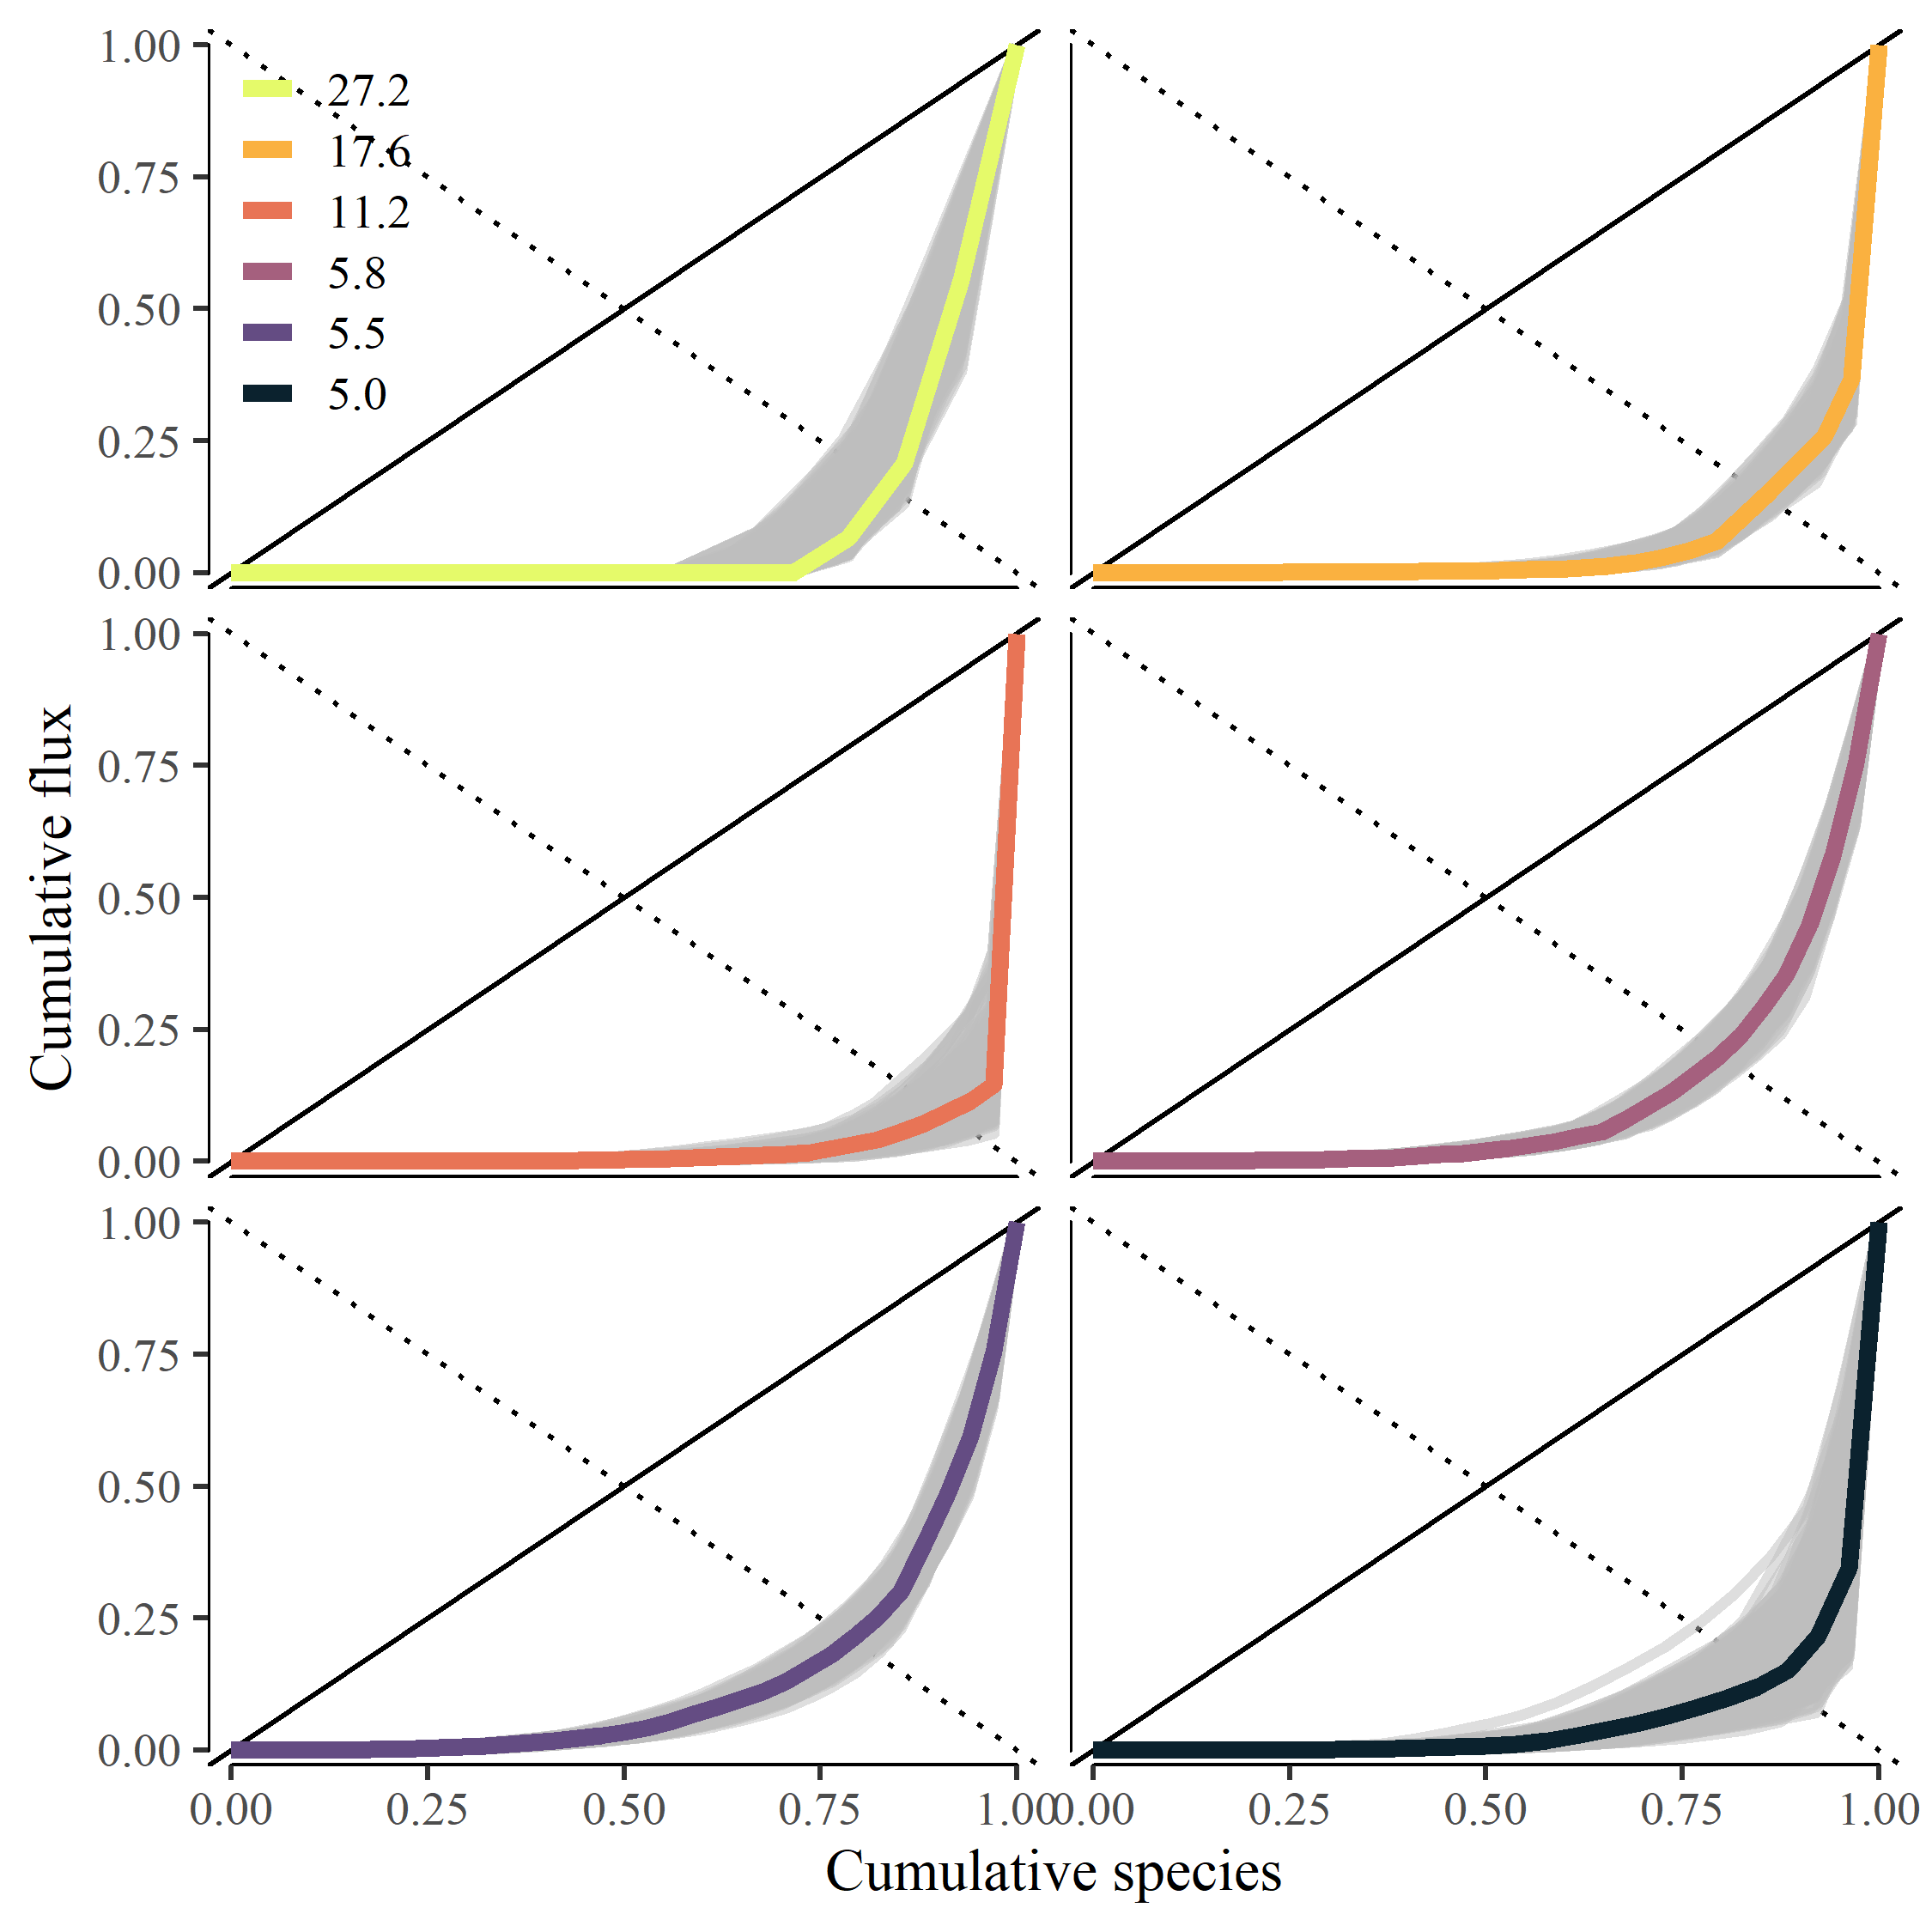

Figure S3. Cumulative plot of relative community flux by species in relation to mean annual population biomass (mg m-2).

