02/11/2018

ECSE 321: Introduction to Software Engineering

Deliverable 1: Requirements and Domain Modeling

Barry Chen

Jimmy Khairallah

Hieu Chau Nguyen

Ryan Ren

Ivraj Tathgur

**Outline:**

1. **Functional Requirements / Non-functional Requirements**(Jimmy, Ryan)
2. **Domain Model**(Chau)
3. **Statechart of Tree**(Chau)
4. **Use Case Diagram**(Barry, Ivraj)
5. **Activity Diagram**(Ryan)
6. **Work plan and preparation for next deliverable**  
   (Barry)
7. **Functional Requirements / Non-functional Requirements**

**TreePLE Functional Requirements**

|  |  |
| --- | --- |
| **Req. ID** | **Requirement** |
| TFR.01 | The system shall store the tree data including the exact geographic coordinates, municipality, species, status, the kind of land use, the height of the tree and the diameter of its canopy. |
| TFR.02 | The system shall store the timestamp of the data modification and the reporting person name. |
| TFR.03 | The system shall allow users to load initial tree data from a text file via web frontend. |
| TFR.04 | The system shall allow users to update tree data within the database via web frontend. |
| TFR.05 | The system shall list all (or specific subset of) trees and optionally, locate trees on a map. |
| TFR.06 | The system shall automatically calculates sustainability attributes including biodiversity index, canopy and carbon sequestration. |
| TFR.07 | The system shall allow users to report a tree is planted or cut down by owner via Android frontend. |
| TFR.08 | The system shall allow users with specialist permission to mark a diseased tree or a tree to be cut down via Android frontend. |
| TFR.09 | The system can predict and analyze sustainability impacts of infrastructural changes in the area. |
| TFR.10 | The system can analyze and provide information on how to improve biodiversity by planting what type of tree and where. |

**TreePLE Non-Functional Requirements**

|  |  |
| --- | --- |
| **Req. ID** | **Requirement** |
| TNR.01 | The system shall be a web based application containing two user interface, web frontend and Android frontend. |
| TNR.02 | The mobile frontend shall be implemented in Java on the Android platform using the UI development framework that comes with Android Studio. |
| TNR.03 | The system shall store the data in text files by using the code generation facilities offered by Umple or in a real database. |
| TNR.04 | The web application shall be available in English/French languages. |
| TNR.05 | Forecasting is supported by the application via a web based frontend. |

1. **Domain Model**

(Umple code can be found on Github)

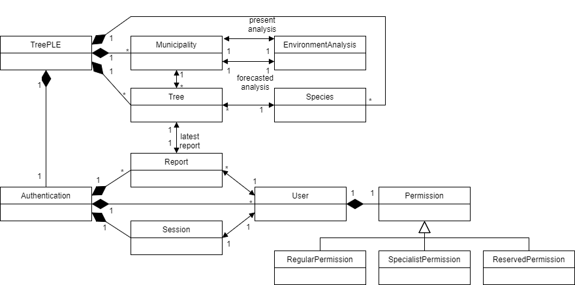

1. **Statechart of Tree**

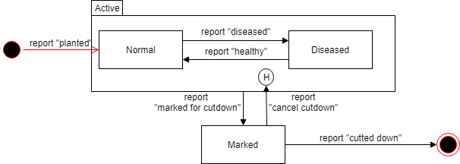

1. **Use Case Diagram**

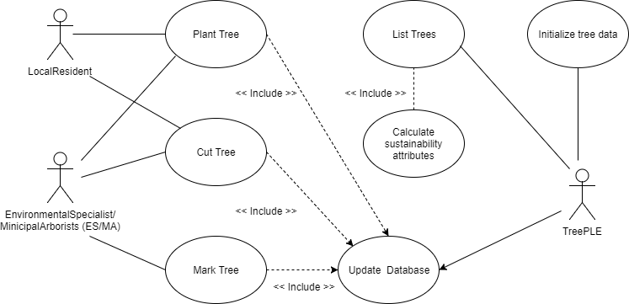

Use Case: Plant tree

Successful Outcomes: PrimaryActor adds tree to TreePLE database.

|  |  |
| --- | --- |
| **Use Case Package** | TreePLE |
| **ID** | UC-TreePLE-01 |
| **Use Case Goal** | PrimaryActor: successfully adds a tree to the TreePLE database. |
| **Actor(s)** | PrimaryActor: LocalResident, MA/ES    SecondaryActor: TreePLE |
| **Level** | User Goal |
| **Precondition** | None. |
| **Domain Entities** | LocalResident, MA/ES, Tree, Database |

Use Case: Cut tree

Successful Outcomes: PrimaryActor adds tree to TREEPLE database.

|  |  |
| --- | --- |
| **Use Case Package** | TreePLE |
| **ID** | UC-TreePLE-02 |
| **Use Case Goal** | PrimaryActor successfully removes a tree from the TreePLE database. |
| **Actor(s)** | PrimaryActor: LocalResident, MA/ES |
| **Level** | User Goal |
| **Precondition** | Tree has been marked to be cut-down. |
| **Domain Entities** | LocalResident, MA/ES, Tree, Database |

Use Case: Mark tree for cut-down.

Successful Outcomes: PrimaryActor changes “status” attribute for a particular tree in database.

|  |  |
| --- | --- |
| **Use Case Package** | TreePLE |
| **ID** | UC-TreePLE-03 |
| **Use Case Goal** | PrimaryActor successfully changes attribute of trees from the TREEPLE database. |
| **Actor(s)** | PrimaryActor: LocalResident, MA/ES |
| **Level** | User Goal |
| **Precondition** | Tree must exist in database. |
| **Domain Entities** | MA/SE, Tree, Database |

Use Case: TreePLE lists trees.

Successful Outcomes: PrimaryActor TreePLE lists trees from database to frontend.

|  |  |
| --- | --- |
| **Use Case Package** | TreePLE |
| **ID** | UC-TreePLE-04 |
| **Use Case Goal** | PrimaryActor successfully lists trees from database to web/Android frontend. |
| **Actor(s)** | PrimaryActor: TreePLE |
| **Level** | User Goal |
| **Precondition** | None. |
| **Domain Entities** | TreePLE, Database, Frontend |

Use Case: Calculate sustainability attributes.

Successful Outcomes: PrimaryActor calculates various key sustainability attributes for each tree, including biodiversity index, canopy.

|  |  |
| --- | --- |
| **Use Case Package** | TreePLE |
| **ID** | UC-TreePLE-05 |
| **Use Case Goal** | PrimaryActor successfully calculates key sustainability attributes. |
| **Actor(s)** | PrimaryActor: TreePLE |
| **Level** | User Goal |
| **Precondition** | List of trees action has been executed. |
| **Domain Entities** | TreePLE, Database, Frontend |

1. **Activity Diagram**

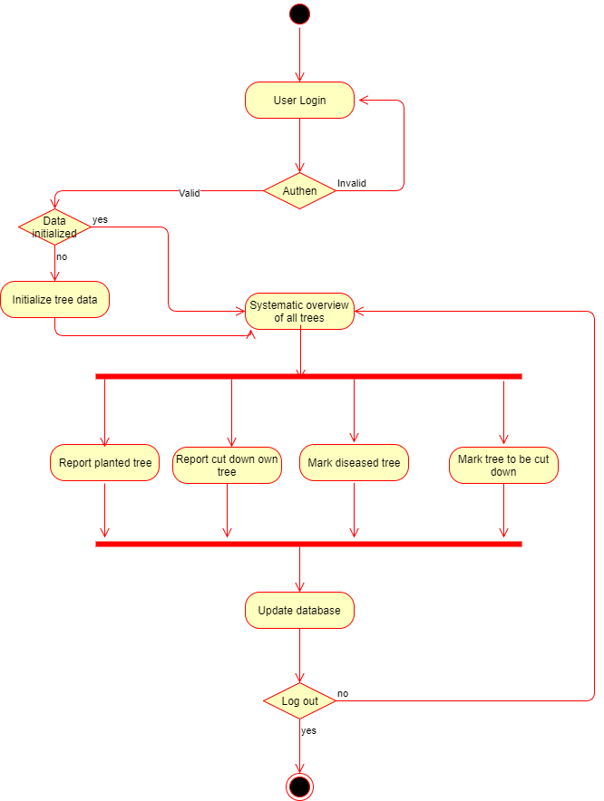

1. **Work plan and preparation for next deliverable**

* **Meeting #1**

Date: February 10, 2018

Time: 5:30 pm -

Location: Schulich Library 5th floor group study area

Attendance: Barry Chen, Ryan Ren, Jimmy Khairallah, Hieu Chau Nguyen, Ivraj Tathgur

Purpose of this meeting: discuss about the project and distribute the work

Task distribution:

Barry Chen: Traceability of use cases to requirements, Demonstration of individual and teamwork, Work plan for remaining iterations

Ryan Ren: Functional and non-functional system requirements, Requirements-level activity diagram for entire scenario

Jimmy Khairallah: Functional and non-functional system requirements

Ivraj Tathgur: Use case diagram(s) with Actors, Use case specifications

Hieu Chau Nguyen: Domain model in Umple and class diagram, Domain-level statechart for class Tree

* **Future Meetings**

Deliverable 2, due February 26th

Estimated meetings for deliverable 2:

Meeting #2: Thursday, February 15, 2018. 5:00 pm - 8:00 pm. Schulich Library 5th floor group study area

Meeting #3: Monday, February 19, 2018. 4:00 pm - 6:00 pm. Location TBD

Meeting #4: Wednesday, February 25, 2018. 2:00 pm - 4:00 pm. Location TBD