Ch. 3 Demo Programs
C# WinForms — what we build together in the demo video
These demos are similar to the lab assignments, but they are not a replacement. The intent is for you to see something similar, but you will still need to follow the specific directions laid out in your assignment.
Each program below uses a named constant, reads values the user types into text boxes, does the math inside a button's Click event, and shows the answer in a label. Watch for those four steps in every demo.

Demo 1 — Weight Converter
A C# WinForms program that converts weights between pounds and kilograms:
- Declare a constant named KG_PER_POUND that holds the number of kilograms in a pound (0.45).
- The user can enter a weight in pounds or in kilograms.
- The user can convert pounds to kilograms.
- The user can convert kilograms to pounds.
- The program displays the weight in both units. For example: “10.0 pounds is 4.5 kilograms”
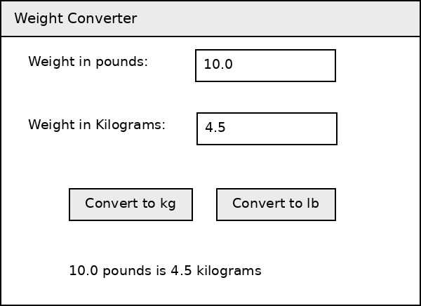
Controls used: txtWeightInPounds, txtWeightInKilograms, btnConvertToKilograms, btnConvertToPounds, lblResult

Demo 2 — Vending Machine Snack Report
A C# WinForms program that adds up the snacks sold by four vending machines:
- Declare a constant named SNACKS_PER_CASE and assign it a value of 24.
- Prompt the user for the number of snacks sold by each of four machines.
- Add up the snacks sold and display the total in cases and snacks. For example, a total of 100 snacks would be displayed as “100 snacks total, or 4 cases and 4 snacks”
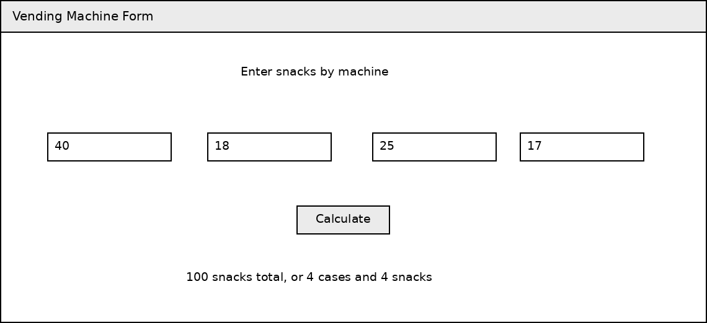
Controls used: txtMachine1, txtMachine2, txtMachine3, txtMachine4, btnCalculate, lblResult

Demo 3 — Savings Growth Calculator
A C# WinForms program that projects how three savings accounts grow:
- Declare a constant named INTEREST_RATE and assign it a value of 3% (or 1.03).
- Prompt the user for the names and starting balances of three accounts.
- Display the projected balances for these three accounts over the next 3 years in a table, assuming each account earns 3% interest every year.
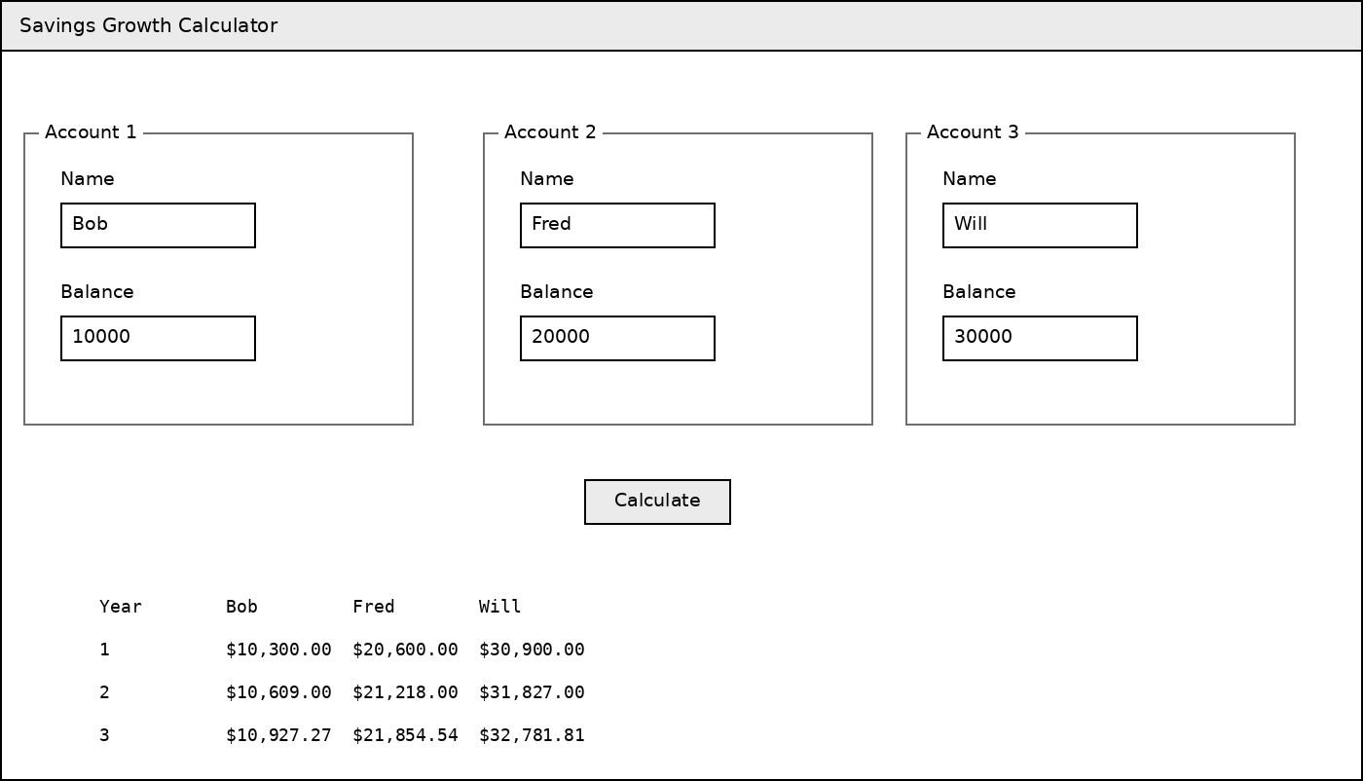
Controls used: txtName1-3, txtBalance1-3, btnCalculate, lblResult

Naming Your Controls
Rename every control you use in your code so the name says what it is. Leave the plain caption labels alone — you never touch those in code.
- Labels start with lbl — lblResult
- Text boxes start with txt — txtWeightInPounds
- Buttons start with btn — btnCalculate
- Constants are ALL_CAPS with underscores — KG_PER_POUND

