Chapter 6 — In-Class Demonstration Programs
Arrays, Parallel Arrays, Loops, and Linear Search
These five demo programs practice exactly the same skills as the Chapter 6 labs, using different data and different problem domains. Work through a demo in class, then apply the same pattern to the matching lab on your own.
Demo | Skill it practices | Matching lab
DEMO1 — Shipping Quote | Parallel arrays + linear search for an exact match; not-found message | LAB1
DEMO2 — Kayak Rental | Parallel arrays + range match (tiered pricing) | LAB2
DEMO3 — BookNook | Partial, case-insensitive keyword search across two fields | LAB3
DEMO4 — Plant Finder | Keyword search + an accumulator that counts matches | LAB4
DEMO5 — Privacy Masker | Walking a string one character at a time; building a new string | LAB5

Rules that apply to every demo
- C# Windows Forms application, one form per project.
- All data is stored in parallel arrays declared inside the button's Click event handler.
- All of the work happens in the button's Click event handler. Do not write your own methods and do not create your own classes — we have not covered those yet.
- Use a for loop to walk the arrays. Do not use LINQ, List<T>, or Dictionary.
- Money is displayed with .ToString("C").
- An error message must clear itself the next time a search succeeds.

DEMO1 — Rapid Parcel Shipping Quote
Write a C# WinForms GUI application that looks up a flat shipping charge for a two-letter state code, based on the table below.

Requirements
- Store the state codes and the shipping charges in a pair of parallel arrays, and search them with an appropriate loop.
- The user types a two-letter state code and clicks Look Up.
- If the state code is found, display the shipping charge formatted as currency.
- The search must be case insensitive — "mo" and "MO" must both work.
- If the state code is not found, display a not-found message.
- The not-found message must disappear when a later lookup succeeds.

Data
State Code | Shipping Charge ($) | State Code | Shipping Charge ($)
MO | 5.50 | AR | 6.75
IL | 6.25 | OK | 10.25
KS | 7.00 | TN | 11.00
IA | 8.75 | KY | 12.50
NE | 9.50 | IN | 9.00

Screen mockup
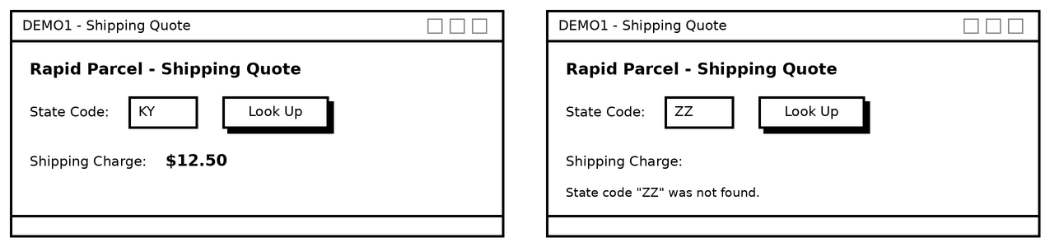

Test these values
Input | Expected result
MO | $5.50
mo | $5.50 (case insensitive)
ky | $12.50 (extra spaces trimmed)
ZZ | not-found message, charge blank
MO after ZZ | $5.50 and the error message disappears

DEMO2 — Riverbend Kayak Rental
Write a C# WinForms GUI application that calculates the cost of a kayak rental based on the number of hours rented.

Requirements
- Store the rate table in a pair of parallel arrays and use an appropriate loop to find the matching tier.
- The user enters the number of hours rented and clicks Calculate.
- Display both the hourly rate that applies and the total rental cost, formatted as currency.
- The longer the rental, the cheaper the hourly rate — the rate applies to every hour, not just the extra hours.
- If the entry is not a whole number, or is less than 1, display an error message and no cost.
- Hint: store the last hour of each tier in the array, and use a very large number such as 9999 for the open-ended top tier.

Data
Hours Rented | Hourly Rate
1 – 2 hours | $18.00 per hour
3 – 5 hours | $15.00 per hour
6 – 8 hours | $12.00 per hour
9 or more hours | $9.00 per hour

Screen mockup
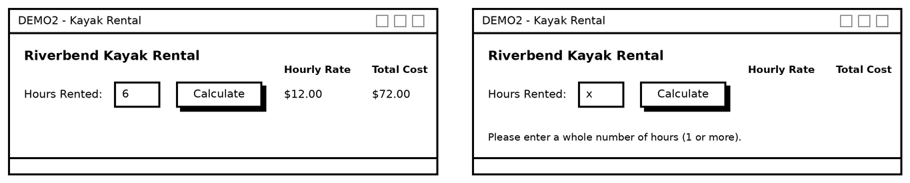

Test these values
Hours | Hourly rate | Total
1 | $18.00 | $18.00
2 | $18.00 | $36.00
3 | $15.00 | $45.00
5 | $15.00 | $75.00
6 | $12.00 | $72.00
8 | $12.00 | $96.00
9 | $9.00 | $81.00
40 | $9.00 | $360.00
0, -3, or abc | error message | error message

DEMO3 — BookNook
Create a searchable database for a bookstore as a C# WinForms GUI application.

Requirements
- Store the book data in three parallel arrays: titles, authors, and prices.
- The user can search by either the title of the book or the author.
- The user must be able to perform partial keyword searches. "mar" should return "Project Hail Mary".
- The search must be case insensitive.
- If a book is found, display the title, author, and price.
- If a book is not found, display an error message in all three output labels.
- If the search box is empty, prompt the user instead of searching.
** Hint ** Research String.Contains() and String.ToLower()

Data
Title | Author | Price
The Silent Patient | Alex Michaelides | $16.99
Project Hail Mary | Andy Weir | $18.50
The Martian | Andy Weir | $12.99
Educated | Tara Westover | $14.25
Where the Crawdads Sing | Delia Owens | $15.75
A Brief History of Time | Stephen Hawking | $11.00

Screen mockup
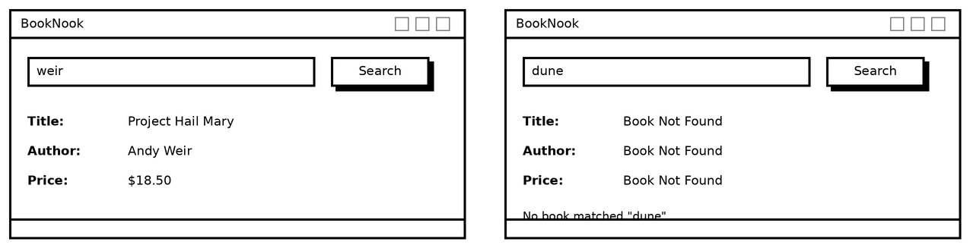

Test these values
Search text | Expected result
mar | Project Hail Mary — the FIRST match in array order wins, not the closest one
WEIR | Project Hail Mary — case insensitive, matches the author field
hawking | A Brief History of Time
the | The Silent Patient
dune | Book Not Found in all three labels
(empty) | prompt message, no search performed

DEMO4 — Trailside Nursery Plant Finder
Create a searchable database for a plant nursery as a C# WinForms GUI application.

Requirements
- Store the plant data in four parallel arrays: names, types, light needs, and prices.
- The user can search by either the plant name or the plant type, using a partial, case-insensitive keyword.
- If a plant is found, display the name, type, light needs, and price of the FIRST match.
- Also display how many plants matched the search. Use an accumulator that starts at 0 and adds 1 for every match.
- Because you have to count every match, the loop must NOT break early. Remember the first match's index in a separate variable instead.
- If no plant is found, display an error message.

Data
Plant Name | Type | Light Needs | Price
Purple Coneflower | Perennial | Full Sun | $9.99
Blue Hosta | Perennial | Full Shade | $12.49
Cherry Tomato | Vegetable | Full Sun | $4.99
Sweet Basil | Herb | Full Sun | $3.99
Boston Fern | Houseplant | Indirect Light | $18.00
Red Maple | Tree | Full Sun | $89.95
Lavender Mist | Perennial | Part Shade | $7.50

Screen mockup
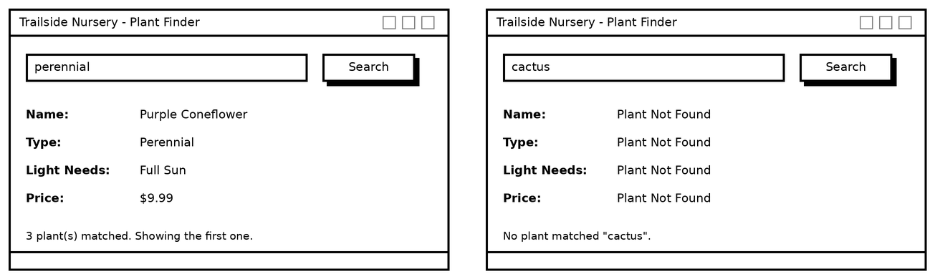

Test these values
Search text | Expected result
perennial | Purple Coneflower, count = 3
BASIL | Sweet Basil, count = 1
fern | Boston Fern, count = 1
e | Purple Coneflower, count = 7 — every plant contains the letter e
cactus | Plant Not Found in all four labels
(empty) | prompt message, no search performed

DEMO5 — Contact Privacy Masker
Write a C# WinForms GUI application that masks all but the last 3 characters of a phone number with an asterisk.

Requirements
- The program must support phone numbers with spaces, dashes, dots, parentheses, or no separator at all.
- Leave the last 3 characters exactly as they are.
- Leave any space, dash, dot, or parenthesis exactly as it is, no matter where it appears.
- Replace every other number or letter with an asterisk.
- The program must work for entries of any length, including entries shorter than 3 characters.
- Build the answer one character at a time in a string accumulator.
** Hints **
A string can be broken into characters with a subscript:
string name = "Bob";
char letter = name[0]; // letter equals 'B'
char letter2 = name[1]; // letter2 equals 'o'
char letter3 = name[2]; // letter3 equals 'b'

Research the Char.IsDigit() and Char.IsLetter() methods.
The last 3 characters start at position input.Length - 3.

Screen mockup
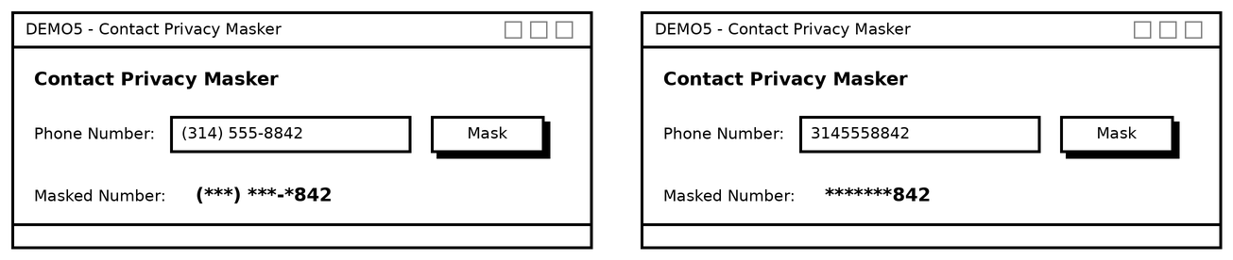

Test these values
Input | Expected output
(314) 555-8842 | (***) ***-*842
314.555.8842 | ***.***.*842
314-555-8842 | ***-***-*842
3145558842 | *******842
555-CALL-NOW | ***-****-NOW
55 | 55 (shorter than 3 — nothing is masked)
8 | 8
(empty) | (empty)

Running the demo projects
All five demos are in one solution. The projects target .NET 10 and need Visual Studio 2022 17.14 or newer (or Visual Studio 2026), which is what reads the .slnx solution format.

To open all five at once:
- Double-click Ch6_Demos.slnx. All five projects load into one Solution Explorer.
- Right-click the demo you want to run, choose Set as Startup Project, then press F5.

To open just one demo:
- Double-click the .csproj file in that demo's folder (for example DEMO1.csproj).
- Press F5 to build and run.

To build one by hand instead, create a new Windows Forms App project on .NET 10 with the matching name, then replace Program.cs, Form1.cs, and Form1.Designer.cs with the files from the demo folder.
File | What it is
Form1.cs | The only file you would write yourself — the button's Click event handler and all of the array logic.
Form1.Designer.cs | Auto-generated by the Visual Studio form designer. It creates the labels, textbox, and button. You normally build this by dragging controls onto the form, not by typing it.
Program.cs | The application entry point. Visual Studio creates this for you.
DEMOn.csproj | The project file. Targets net10.0-windows.
Ch6_Demos.slnx | The solution file that holds all five projects. It sits one level up, beside the demo folders.

Control names used in the demos
Demo | Controls
DEMO1 | txtStateCode, btnLookup, lblCharge, lblError
DEMO2 | txtHours, btnCalculate, lblRate, lblTotal, lblError
DEMO3 | txtSearch, btnSearch, lblTitleOut, lblAuthorOut, lblPriceOut, lblMessage
DEMO4 | txtSearch, btnSearch, lblNameOut, lblTypeOut, lblLightOut, lblPriceOut, lblCount, lblMessage
DEMO5 | txtPhone, btnMask, lblMasked

