Chapter 5 — Loops
Instructor Demo Requirements (parallel to Labs 1–6)
Purpose. These six demo programs exercise the same Chapter 5 concepts as the assigned labs — definite and indefinite loops, sentinel-controlled input, input validation, accumulators, counters, running min/max, switch structures inside a loop, and nested loops — but in different problem domains with different sentinels, data types, and output requirements. Working any demo end to end in class does not hand a student the code for the corresponding lab.
Controls. The GUI demos use only labels, text boxes, and buttons — the same controls the labs use, and nothing the class has not covered yet. No radio buttons, group boxes, list boxes, or grids. Results appear in plain labels that update after each entry, and errors in a single label, matching the Lab 2, Lab 4, and Lab 5 screenshots.
Screenshots. Each demo is followed by a picture of the finished program, produced from the demo source code. Console output follows the same plain style as the labs: one prompt per line, a short error message, one result per line. The Demo 1, 3, and 6 sessions deliberately include the error cases, since those are the parts students skip.
How to use these. Live-code the demo that pairs with the lab students are about to start. Each demo below is written as a student-facing spec so it can also be handed out as a guided walkthrough, a make-up exercise, or an alternate-section assignment. Suggested project names: Demo1, Demo2, Demo3, etc.
Terms reinforced: definite loop, indefinite loop, infinite loop, iteration, accumulator, sentinel value, range check, scope, block, control statement, switch structure, nesting, short-circuit evaluation, data type, declaration, initialization, assignment.
Demo 1. Rainfall Log (console)
Pairs with Lab 1 — indefinite loop, sentinel, range validation, accumulators
Write a C# console application that accepts an indefinite number of daily rainfall readings (in inches) and then reports statistics about the month:
- Prompt the user for a rainfall reading until they enter -1
  - If the reading is inside the range of 0.0 through 20.0
    - Accept the reading
    - Prompt for another reading
  - If the reading is outside the range of 0.0 through 20.0
    - Ignore the reading
    - Display the error message "Invalid reading"
    - Prompt for another reading
  - If the user enters -1
    - Do not treat -1 as a reading and do not display an error message
    - Display the summary and stop the program
- The summary must display, one item per line:
  - the number of readings entered
  - the total rainfall for the period
  - the average rainfall per reading, displayed to two decimal places
  - the wettest reading (largest value)
  - the number of dry days (readings equal to 0.0)
- If no readings were entered before the sentinel, display "No readings entered" instead of the statistics (do not divide by zero).
Demo notes: Differs from Lab 1 in data type (double, not int), sentinel value, valid range, and statistic set — it replaces min with a conditional counter, so students still have to work out the min/max pattern themselves. The empty-input case is the natural place to talk about priming a loop and guarding a division.
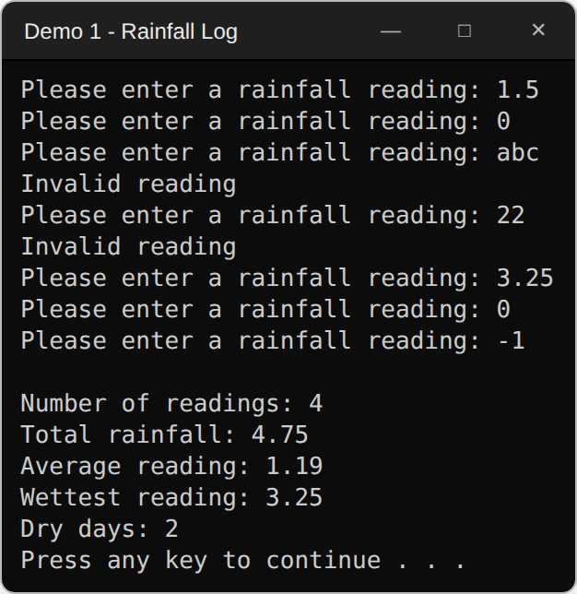
Demo 1: a non-numeric entry, an out-of-range entry, the sentinel, then the summary. Note that -1 produces no error message.
Demo 2. Rainfall Log (WinForms)
Pairs with Lab 2 — the same problem as an event-driven GUI
Implement Demo 1 as a C# WinForms GUI program. Use labels, one text box, and one button — nothing else.
- A label prompts for a reading; a text box accepts it; an Enter button records it.
- Invalid entries (non-numeric, or outside 0.0 through 20.0) display "Invalid reading" in a label and are not recorded.
- Five labels display the number of readings, total rainfall, average reading, wettest reading, and dry days.
- Those five labels update after every accepted reading, so the results are always on screen.
- There is no sentinel value in the GUI version, and no Done button — the running labels replace both.
Demo notes: The teaching point is that the indefinite loop disappears: the user's clicking is the loop, so the accumulators must live at form scope rather than inside the event handler. Show what breaks when they are declared inside the handler instead — that mistake is the single most common one on Lab 2 and Lab 4. Setting the form's AcceptButton to the Enter button makes the keyboard behave the way students expect.
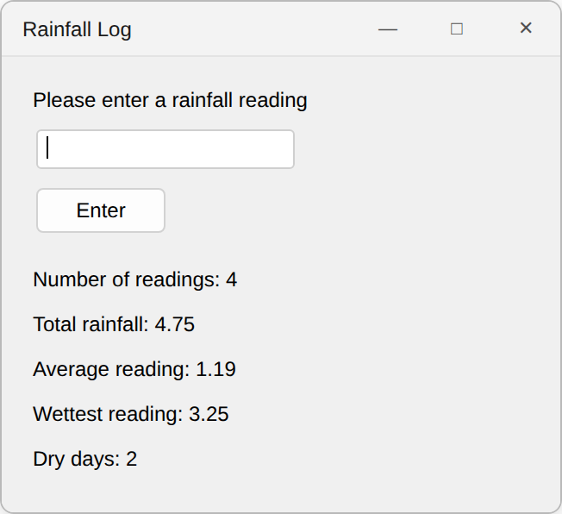
Demo 2, after the same four readings. Labels only — no list box and no summary panel.
Demo 3. Campus Kiosk Donations (console)
Pairs with Lab 3 — parallel accumulators selected by a switch
Write a C# console application that tracks donations collected at three campus kiosks (Atrium, Bookstore, Commons):
- The program prompts the user for a kiosk letter (a, b, or c) and then a donation amount, and updates that kiosk's running total.
- Any kiosk can receive multiple donations.
- A donation amount must be at least $0.01 and no more than $500.00; otherwise display "Invalid donation" and start over at the kiosk prompt.
- If the user enters "q" for the letter, the program displays:
  - the total donations and the number of donations for each of the three kiosks
  - the grand total for all kiosks
  - which kiosk has the most donations
- If the user enters a letter other than "a", "b", "c", or "q", display "Invalid kiosk" and prompt for a new letter.
- All letters must be treated in a case-insensitive manner.
- Currency values must be displayed in currency format.
Demo notes: Same shape as Lab 3 with a different sentinel, a validated amount, an extra per-kiosk counter, and currency formatting. The tie case for "the most donations" is worth raising out loud — the labs do not specify it either, so let students decide and defend a rule. A kiosk that received nothing still reports $0.00, as Lab 3's screenshot does.
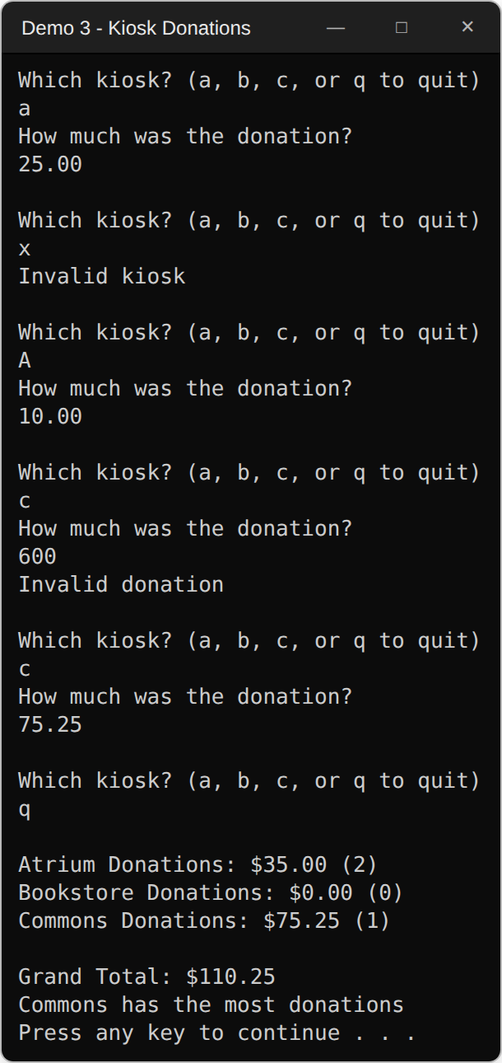
Demo 3: an invalid letter, a case-insensitive "A", an amount over the limit, then "q" to report. Bookstore received nothing and still reports $0.00.
Demo 4. Campus Kiosk Donations (WinForms)
Pairs with Lab 4 — GUI version, testable logic
Implement Demo 3 as a C# WinForms GUI program. Use labels, one text box, and three buttons — nothing else.
- A text box accepts the donation amount.
- One button per kiosk — Atrium, Bookstore, Commons — records the amount to that kiosk. There is no separate Record button and no kiosk letter to type.
- Invalid amounts display "Invalid donation" in a label and change no total.
- Labels display each kiosk's running total and donation count, the grand total, and which kiosk has the most donations.
- Those labels update after every accepted donation.
- The three button handlers must not each repeat the accumulate logic. Each one names its own kiosk and calls one shared method.
- The accumulate and validate logic must live in its own class, not in the form's event handlers, so it can be exercised by unit tests.
- A test project must cover those rules without opening the form:
  - a valid donation is recorded, and repeat donations accumulate
  - an amount outside the range is rejected and changes no total
  - the lowest and highest legal amounts are both accepted
  - kiosk selection is case-insensitive
  - the leading kiosk is correct, including a tie and before any donation
- Program must pass all provided unit tests.
Demo notes: Because Lab 4 is graded against provided unit tests, use this demo to show the separation of logic from UI — build the class first, test it, then wire the form to it. The demo ships with an MSTest project (Demo4.Tests) holding eleven tests against the logic class and none against the form; running them in front of the class is the fastest way to make the point that testable code is code the UI does not own. The three-button design also removes the temptation to write the same eight lines three times, which is the other thing Lab 4 punishes.
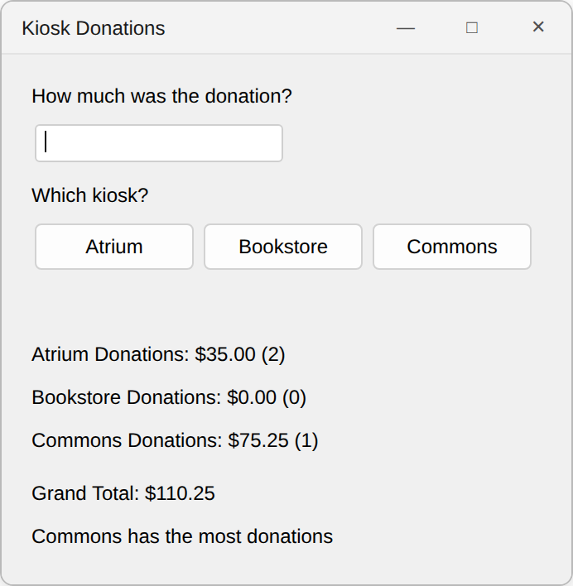
Demo 4, after the same donations. One button per kiosk, mirroring the Lab 4 screenshot.
Demo 5. Punctuation Counter (WinForms)
Pairs with Lab 5 — loop over a string with a switch structure
Write a C# WinForms GUI application that counts the punctuation marks in a phrase entered by the user. Use labels, one text box, and one button — nothing else.
- A label prompts for a phrase; a text box accepts it; an Enter button counts the punctuation.
- Count six marks: period, exclamation point, and question mark (sentence-ending); comma, semicolon, and colon (separators).
- Display the results in four labels:
  - the sentence-ending total, with each mark's individual count
  - the separator total, with each mark's individual count
  - everything that is not punctuation: how many other characters, and how many spaces
  - a summary line: "There are N punctuation marks in your phrase"
- Use a loop that inspects one character position at a time.
- Hint: Research and use String.Substring().
- Hint: Use a switch statement, and stack the case labels that share a category.
Demo notes: Same mechanic as the Lab 5 vowel counter — Substring inside a loop feeding a switch — but with stacked case labels, which is exactly the switch feature Lab 5 does not require and the one students ask about. The fourth label exists so that every branch of the switch, the default case included, is visible on screen: a counter nobody displays is a counter nobody checks. Do not demo a vowel count; the six punctuation counters make the pattern obvious without writing their answer.
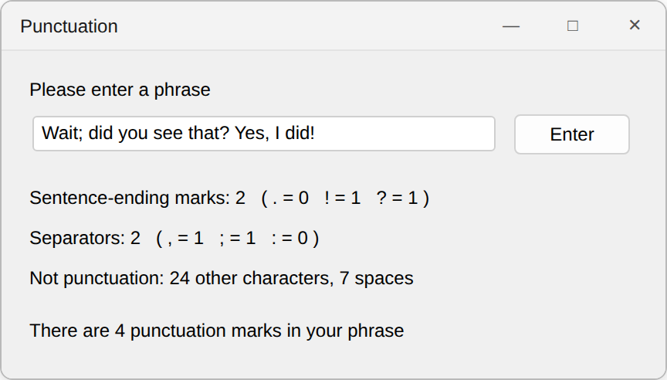
Demo 5, counting one phrase. Four result labels, in the same style as the Lab 5 vowel count.
Demo 6. Seating Chart (console)
Pairs with Lab 6 — nested loops and exact output formatting
Write a C# console-based program that prints a formatted seating chart for a room:
- Prompt the user for the number of rows (1 through 26).
- Prompt the user for the number of seats per row (1 through 30).
- Reject and re-prompt any entry outside those ranges.
- Print the chart in the same table style as the Lab 6 multiplication table:
  - a header row numbering the seat positions, then a dashed separator line
  - one row per letter — A, B, C, and so on — labeled in the left column
  - every cell right-aligned and followed by a "|", so the columns line up at any size
- Each seat is labeled with its row letter and a two-digit seat number — A01, A02, … B01, B02.
- Below the chart, display the total number of seats in the room.
Demo notes: Nested loops plus alignment, without being a multiplication table. This is the right place to demo composite format strings and width specifiers — the same technique Lab 6's extra credit is graded on — and to show why the inner loop's counter must be re-initialized on every pass of the outer loop.
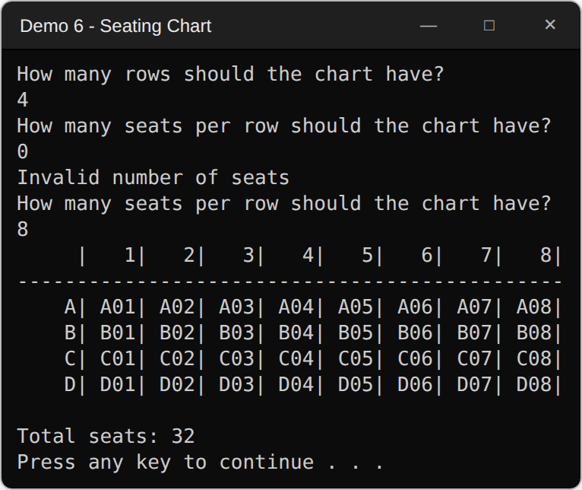
Demo 6, four rows of eight seats, after a rejected seat count. Same header, separator and pipe layout as the multiplication table.

Optional variations, if you need a second demo of the same concept
- Demo 1: change the sentinel to a word ("done") and read input as a string, so the demo also covers double.TryParse.
- Demo 1: add a running count of readings above the average — impossible in a single pass, which motivates the next chapter.
- Demo 3: add a fourth kiosk to show why parallel individual variables stop scaling, again motivating arrays.
- Demo 5: count digits instead of punctuation, and validate that a serial number contains exactly eight of them.
- Demo 6: print a right triangle or a diamond of characters before the seating chart as a warm-up on nested loops.

