CH07 – Method Demos
Demo requirements and reference programs
These seven demos are walked through in class. Each one practices the same method skills you need for the Part 1 labs — declaring a method, calling it, passing data in through parameters, and returning data back — using a different problem. Use the demo code as a reference for how methods are built and connected, then apply those ideas to your own labs.
Getting the Demo Code
- Open CH07_Demos.sln in Visual Studio. It contains seven Windows Forms projects: Demo1 through Demo7
- To run one demo, right-click its project in Solution Explorer and choose Set as Startup Project, then press F5.
- All the logic is in each project’s Form1.cs. Every method has a comment block describing its parameters and return value.
Things to Watch For in Every Demo
- The calling method (usually a button’s Click event) gathers and validates input, then calls the method.
- Arguments are passed in the same order and with the same data types as the method’s parameter list.
- A method with a return type other than void must send a value back with a return statement, and the caller must use that value.
- Local variables declared inside a method only exist inside that method (scope). Class-level arrays, Lists, and constants are available to every method in the form.

Demo1. Lunch Special Picker
Write a C# WinForms GUI application that stores the cafeteria’s lunch specials in an array and, with the click of a button, randomly selects two different specials to feature today.
Store the following items in a class-level string array:
- Chicken Quesadilla with Rice
- Tomato Basil Soup & Grilled Cheese
- BBQ Pulled Pork Sandwich
- Veggie Stir Fry with Noodles
- Spaghetti and Meatballs
- Turkey Club Wrap with Chips
- Chili Cheese Baked Potato
- Caesar Salad with Grilled Chicken
Create a method named ShowDailySpecials() that accepts no parameters, returns void, and displays two different random items from the array.
Method Signature
private void ShowDailySpecials()
Concepts demonstrated: class-level array, initializer list, Random.Next(), array index, do-while loop, void method with no parameters.
Try It
- Click Pick Specials several times — two specials appear and they are never the same item.
Screen Mockup
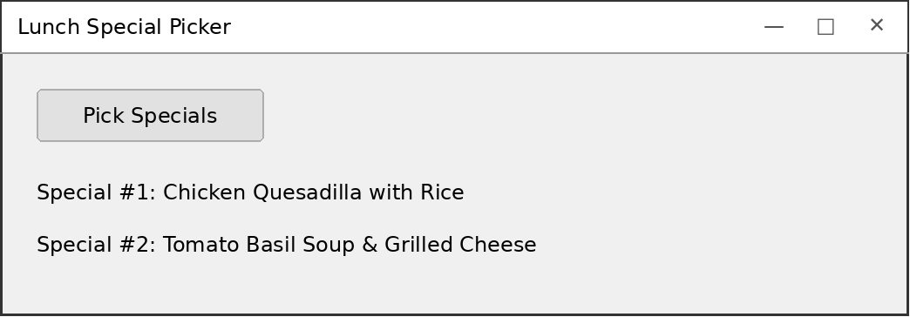

Demo2. Loan Approval Checker
Write a C# WinForms GUI program that decides whether a loan applicant is approved:
- Prompt the user for a credit score (300–850) and annual income.
- Display “Approved” if the credit score is 680 or higher and annual income is $35,000 or more.
- Display “Approved” if the credit score is below 680 and annual income is $70,000 or more.
- Otherwise display “Denied”.
Create a method named IsLoanApproved() that accepts a credit score and an annual income as parameters and returns a boolean indicating whether the loan was approved.
Method Signature
private bool IsLoanApproved(int creditScore, double annualIncome)
Concepts demonstrated: multiple parameters, bool return type, compound conditions with &&, named constants, range check, TryParse validation.
Try It
- 650 / 72000 → Approved
- 700 / 35000 → Approved
- 700 / 34999 → Denied
- 679 / 69999 → Denied
- abc → error message, nothing is calculated
Screen Mockup
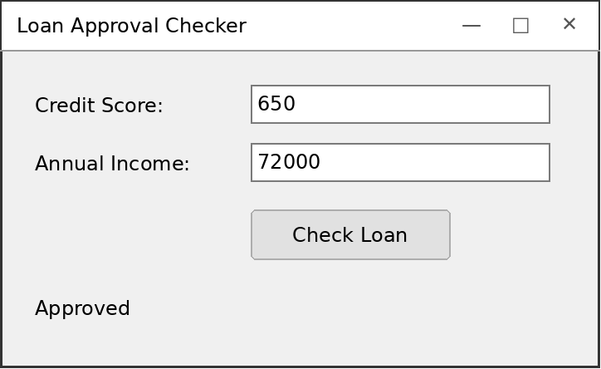

Demo3. Letter Counter
Write a C# WinForms GUI application that counts how many times a specific letter appears in a phrase entered by the user. Uppercase and lowercase should be treated as the same letter (‘S’ and ‘s’ both count).
Create a method named CountLetter() that accepts a phrase and the letter to look for as parameters, and returns the number of times that letter appears.
Hint: A string can be indexed just like an array of characters.
Method Signature
private int CountLetter(string phrase, char letter)
Concepts demonstrated: string and char parameters, int return type, treating a string as an array of chars, for loop, accumulator, char.ToLower().
Try It
- “Mississippi River”, letter s → 4
- “Mississippi River”, letter I → 5
- Leaving the letter box empty → error message
Screen Mockup
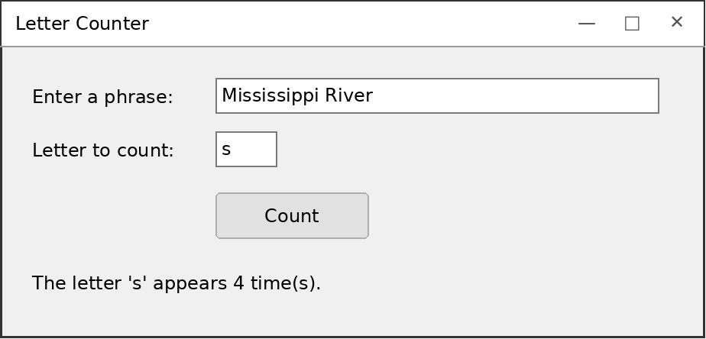

Demo4. Fence Estimator
Write a C# WinForms GUI application that estimates the cost of fencing a rectangular yard. Fencing costs $12.50 per linear foot.
Create the following methods:
- A method named CalculatePerimeter() that accepts the length and width of the yard in feet and returns the perimeter in feet.
perimeter = (length * 2) + (width * 2)
- A method named CalculateFenceCost() that accepts the perimeter in feet and returns the total cost of the fence in dollars.
Method Signatures
private int CalculatePerimeter(int length, int width)
private double CalculateFenceCost(int perimeter)
Concepts demonstrated: passing the value returned by one method into another method, nested method calls, constants, currency formatting with ToString("C").
Try It
- Length 20, Width 15 → Perimeter 70 ft, Cost $875.00
- Length 0 or text → error message
Screen Mockup
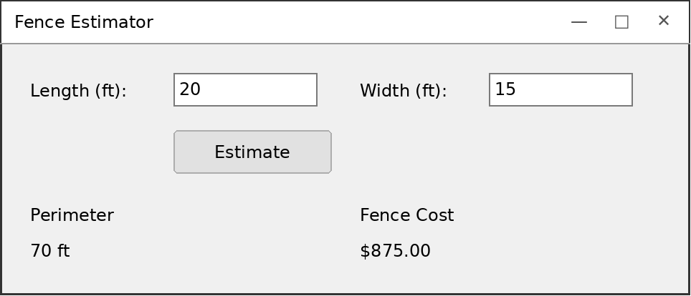

Demo5. Email Masker
Write a C# WinForms GUI application that partially hides an email address (or any text) by leaving only the first few letters and digits visible.
- Leave the first N letters/digits exactly as they are (N is entered by the user).
- Replace every remaining letter or digit with the replacement character the user enters.
- Leave every other character (@ . - _ spaces) exactly as it is.
HINT** Look at how Char.IsDigit() and Char.IsLetter() are used.
- The program must work for text of any length, including text shorter than N.
Create a method named MaskText() that accepts the text to mask, a replacement character, and the number of characters to show, then returns the masked string.
Method Signature
private string MaskText(string text, char replacementChar, int numCharsToShow)
Concepts demonstrated: three parameters of different types, string return type, building a new string in a loop, Char.IsLetter() / Char.IsDigit(), a counter variable.
Try It
- student42@college.edu, *, 3 → stu******@*******.***
- jim.k-99, X, 0 → XXX.X-XX
- ab, #, 3 → ab (shorter than N, nothing masked)
Screen Mockup
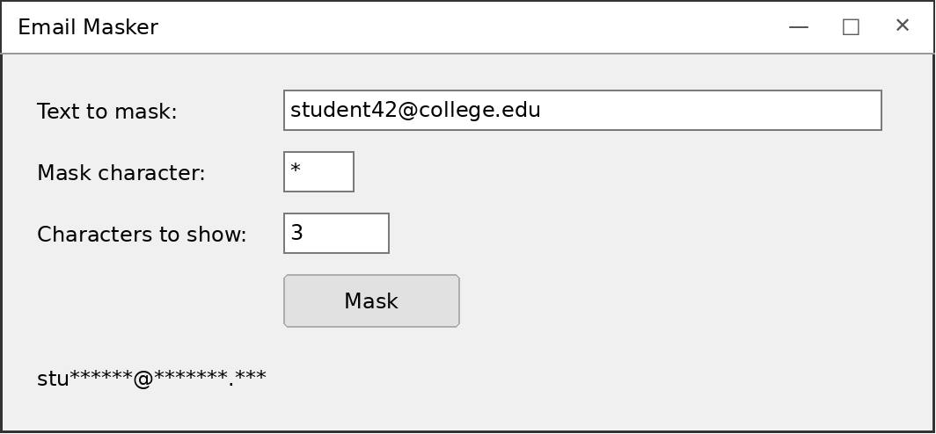

Demo6. Pizza Price Estimator
Write a C# WinForms GUI application that estimates the price of a pizza.
The user enters a size code:
- Enter “s” for small — $8.00
- Enter “m” for medium — $10.00
- Enter “l” for large — $13.00
- Enter anything else for personal — $6.00
Each topping adds $1.50.
Create the following methods:
- GetSize() accepts no parameters and returns the size as a string (“small”, “medium”, “large”, “personal”).
- GetToppings() accepts no parameters and returns the number of toppings as an int.
- CalculateSizeCost() accepts the size as a string and returns its cost as a double.
- CalculateToppingCost() accepts the number of toppings as an int and returns their cost as a double.
- CalculateTotalCost() accepts the size as a string and the number of toppings as an int, and returns the total cost as a double.
Method Signatures
private string GetSize()
private int GetToppings()
private double CalculateSizeCost(string size)
private double CalculateToppingCost(int numToppings)
private double CalculateTotalCost(string size, int numToppings)
Concepts demonstrated: breaking a problem into small methods, methods that return values read from the form, switch statement, a method that calls other methods.
Try It
- m, 3 toppings → $10.00 / $4.50 / $14.50
- L, 0 toppings → $13.00 / $0.00 / $13.00
- x, 2 toppings → $6.00 / $3.00 / $9.00 (personal)
Screen Mockup
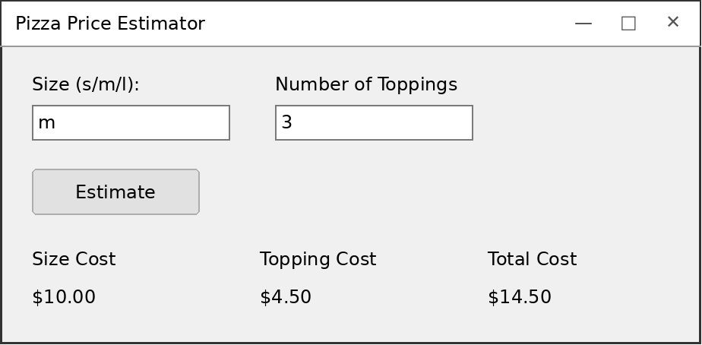

Demo7. Campus Cafe Card
Create a C# WinForms GUI application for a campus cafeteria meal card. The account data is stored in parallel Lists.
- A student signs in with a Student ID and PIN.
- Once signed in, the student can add funds to the card or buy a meal.
- A meal cannot be purchased if the card does not have enough money.
- When finished, the student can sign out. Only one student can be signed in at a time.
Sample Data
- S1001 / 1234 – Maria Lopez – $45.00
- S1002 / 5678 – Devon Carter – $12.50
- S1003 / 2468 – Priya Patel – $0.00
Methods
SignIn() accepts a student ID and PIN as strings. If valid, signs the student in, displays a welcome message and the card balance. If invalid, signs out the previous student and displays an error message.
SignOut() signs out the active student.
AddFunds() accepts an amount as a decimal and displays the updated balance.
BuyMeal() accepts a meal price as a decimal and displays the updated balance (or an “insufficient funds” message).
Method Signatures
private void SignIn(string studentId, string pin)
private void SignOut()
private void AddFunds(decimal amount)
private void BuyMeal(decimal mealPrice)
Concepts demonstrated: parallel Lists, linear search, tracking the active record with an index (-1 = nobody), decimal for money, enabling/disabling controls.
Try It
- Sign in as S1001 / 1234 → welcome message, balance $45.00
- Add 20 → $65.00; buy a 7.50 meal → $57.50
- Buy a 100.00 meal → Insufficient funds
- Sign in as S1002 / 0000 → error, Maria is signed out
Screen Mockup
