Ch. 4 Demo Programs — Conditionals
C# WinForms — what we build together in the demo video
These demos are similar to the lab assignments, but they are not a replacement. The intent is for you to see something similar, but you will still need to follow the specific directions laid out in your assignment.
All three programs make decisions. Watch how each condition is written, and pay attention to the order the conditions are tested in — with ranges, the order changes the answer.

Demo 1 — Loan Approval
A C# WinForms program that decides whether a loan application is approved:
- Prompt the user for the applicant's credit score and annual income.
- Display “Approve” if the credit score is 700 or higher and the income is at least $30,000.
- Display “Approve” if the credit score is below 700 and the income is at least $60,000.
- Otherwise display “Deny”.
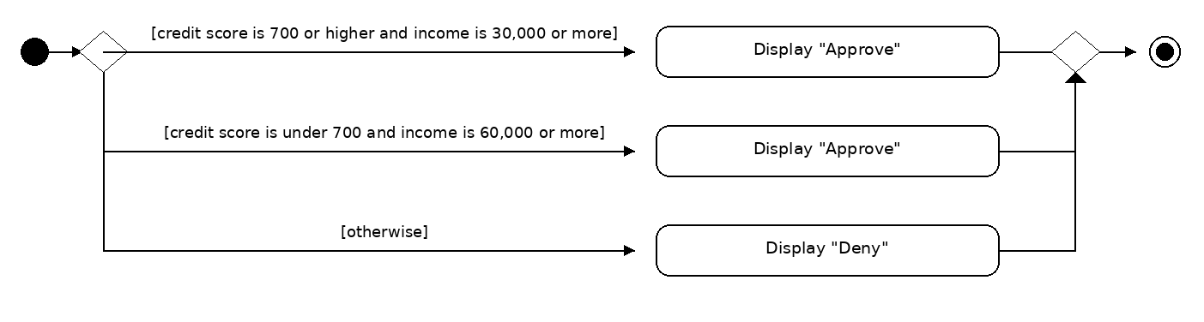
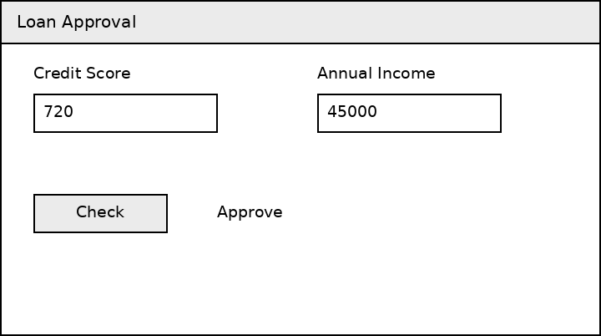
Controls used: txtCreditScore, txtAnnualIncome, btnCheck, lblResult

Demo 2 — Air Quality Index
A C# WinForms program that reports the air quality category for an AQI reading (based on the EPA's Air Quality Index):
- “Hazardous” is an AQI of 301 or higher.
- “Very Unhealthy” is an AQI of at least 201.
- “Unhealthy” is an AQI of at least 151.
- “Unhealthy for Sensitive Groups” is an AQI of at least 101.
- “Moderate” is an AQI of at least 51.
- Anything below 51 is “Good”.
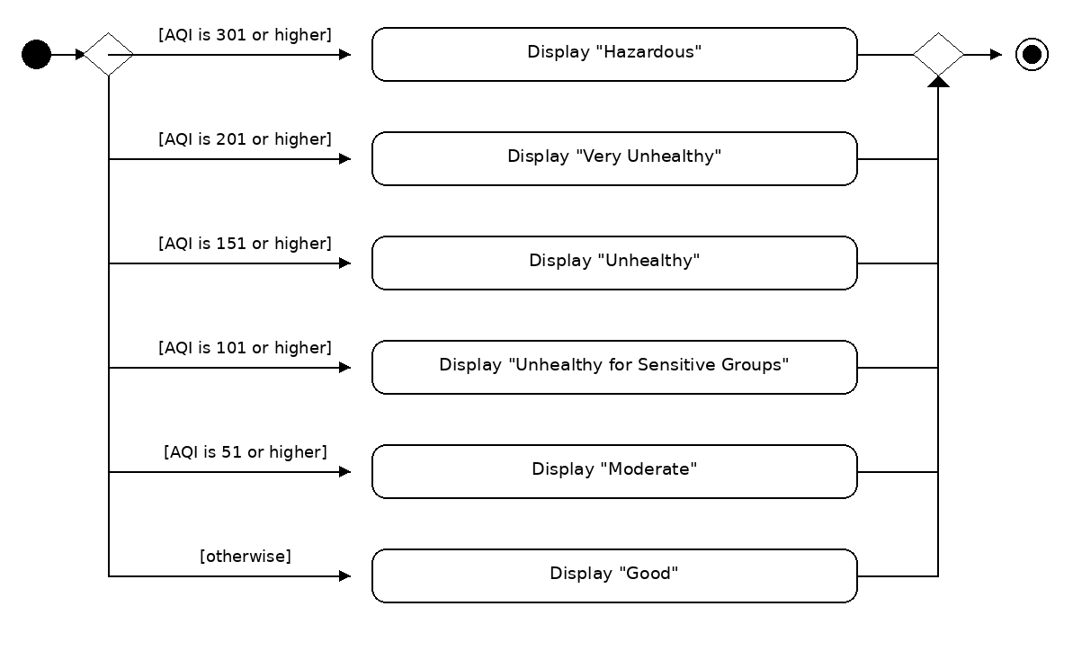
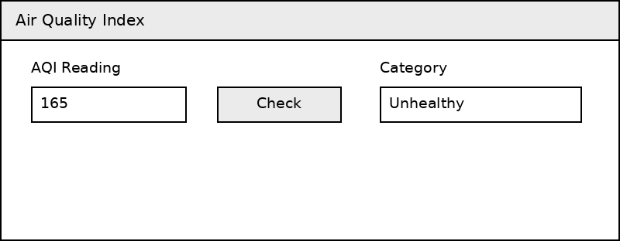
Controls used: txtAqi, btnCheck, txtCategory

Demo 3 — Dice Bands
A C# WinForms program that lets the user play three rounds of a dice guessing game. Once all three rounds are over, display the winner.
- Each round, the player picks a band: Low (1-2), Middle (3-4), or High (5-6).
- The computer rolls a die — a random number from 1 to 6.
- If the roll lands in the band the player picked, the player scores a point. Otherwise the computer scores the point.
- Show the roll and both scores after each round.
- After the third round, display who won.
Use a random number generator for the computer's roll:
Random randGenerator = new Random();
int roll = randGenerator.Next(1, 7);
Official documentation for the Random class: https://learn.microsoft.com/en-us/dotnet/api/system.random
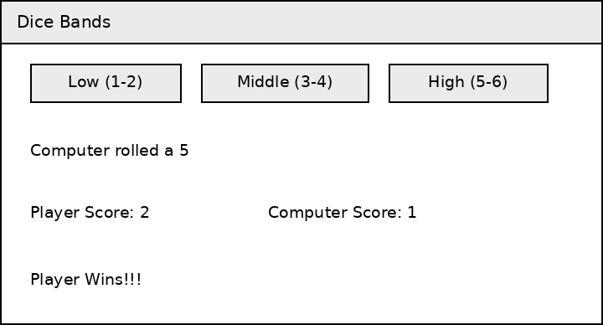
Controls used: btnLow, btnMiddle, btnHigh, lblRoll, lblPlayerScore, lblComputerScore, lblWinner

What to Watch For
- if / else if / else — and where each block’s { } braces start and end.
- && (and), || (or), ! (not) for combining two tests in one condition.
- Range checks: test the highest range first, or every reading will match the lowest one.
- A switch statement as an alternative to a long else-if chain.
- Scope: the scores and the round counter in Demo 3 have to be declared outside the button’s Click event, or they reset every click.
- Control names still use the prefixes — lbl, txt, btn.

